All Occurence!
You are given an integer array of size N. Your aim is to find all the occurrences (indices) of a given element.

Input format:
Vector V and integer k (to find) are passed as parameters.

Output parameter:
Return a vector of integers containing all the indices in sorted manner.

Sample Input:
3
1 2 5 3 1 2 3 8 6 3 6 7 9
Sample Output:
3 6 9
Solution: allOcc.cpp

Print Increasing Numbers

Given an integer N. Your task is to return an integer vector containing numbers from 1 to N in increasing order.
Sample Input
5
Sample Output
1 2 3 4 5
Solution: increasingNumbers.cpp

Tiling Problem!

You are given N tiles of size 1 x M, There is a floor of size N x M which you have to cover with tiles. Find the number of ways the floor can be completely covered if you can place the tiles in both horizontal and vertical manner.

Input Format:
In the function, two integers N and M are passed.

Output Format:
Return a single integer denoting the number of ways.

Sample Input:
4 3

Sample Output:
3
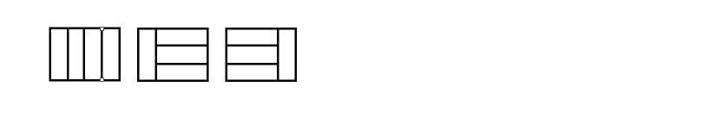
Solution: tiling.cpp

Binary Strings!

You are given an integer N. Your task is to print all binary strings of size N without consecutive ones.

Constraints:
N<=12
Input Format
In the given function an integer N is passed as parameter.
Output Format
Return a vector of strings, with all possible strings in a sorted order.

Sample Input
3
Sample Output
000001010100101
Solution: binaryStrings.cpp

Friends' Party!

Given n friends, each one can remain single or can be paired up with some other friend. Each friend can be paired only once. Find out the total number of ways in which friends can remain single or can be paired up.
Input Format
In the function an integer N is passed as parameter.
Output Format
Return an integer representing the total no. of ways

Sample Input
3
Sample Output
4
Explanation
{1}, {2}, {3} : all single
{1}, {2,3} : 2 and 3 paired but 1 is single.
{1,2}, {3} : 1 and 2 are paired but 3 is single.
{1,3}, {2} : 1 and 3 are paired but 2 is single.
Note that {1,2} and {2,1} are considered same.
Solution: friendsParty.cpp

