Optimized Bubble Sort
In simple bubble sort algorithm, the time complexity will remain O(n^2) every time, even if the given array is already sorted.
Your task is to optimized the bubble sort such that its best case time complexity becomes O(n).
Input Format
In the function an integer vector is passed.
Output Format
Return an integer vector in non decreasing order.

Sample Input
{1, 3, 5, 7, 9}
Sample Output
{1, 3, 5, 7, 9}}

Explanation
given vector is already sorted
Solution: optimizedBubbleSort.cpp

Sorting with Comparator

Given an integer vector and a bool variable flag, your task is to sort the vector in accordance to the boolean value. If the bool value passed is true then sort it in non-decreasing order or vice versa.
You can use any sorting technique of your choice.
Input Format
In the function an integer vector and a boolean is passed.

Output Format
Return an integer vector.

Sample Input
{111, 33, 5, 7, 29}, flag = 1

Sample Output
{5, 7, 29, 33, 111}
Solution: sortWithComparator.cpp

Sorting Cartesian Points

Given co-ordinates of N points on X-Y axis, your task is to sort them in accordance to the x-coordinate. If the x-coordinates are same then compare y-coordinates.
Input Format
In the function an integer vector of pairs is passed.
Output Format
Return the vector in sorted order.

Sample Input
{ (3, 4), (2, 3), (3, 7), (1, 5), (3, 4) }

Sample Output
{ (1, 5), (2, 3), (3, 4), (3, 4), (3, 7) }
Solution: sortCoords.cpp

Chopsticks
Given N sticks and an array length where each length[i] represents length of each stick. Your task is to make maximum number of pairs of these sticks such that the difference between the length of two sticks is at most D. A stick can't be part of more than one pair of sticks.
Input Format
In the function an integer vector length and number D is passed.
Output Format
Return an integer representing total number of such pairs.

Sample Input
{1, 3, 3, 9, 4}, x = 2

Sample Output
2
Solution: chopsticks.cpp

Defense Kingdom
Theodore implements a new strategy game “Defense of a Kingdom”. On each level a player defends the Kingdom that is represented by a rectangular grid of cells. The player builds crossbow towers in some cells of the grid. The tower defends all the cells in the same row and the same column. No two towers share a row or a column.
The penalty of the position is the number of cells in the largest undefended rectangle. For example, the position shown on the picture has penalty 12.
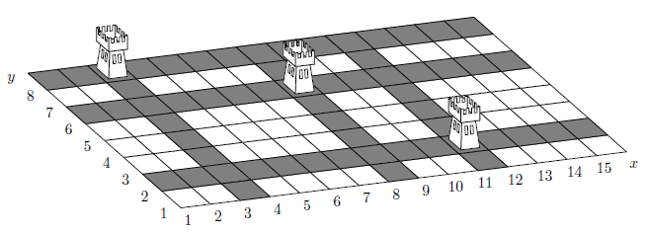
Your task is to find the penalty of the give position.
Input Format
In the function an width and height of the kingdom and a vector of pairs representing positions of towers is passed.
Output Format
Return an integer representing the number of cells in the largest rectangle that is not defended by the towers.

Sample Input
15 8 {(3, 8), (11, 2), (8, 6)}

Sample Output
12
Solution: defenceKingdom.cpp

