Reverse a number using stack
Given a number , write a program to reverse this number using stack.
Input Format
In the function an integer is passed
Output Format
Return an integer

Sample Input
456
Sample Output
654
Solution: reverseNumber.cpp

Stock Span Problem

Write a class StockSpanner which collects daily price quotes for some stock, and returns the span of that stock's price for the current day.
The span of the stock's price today is defined as the maximum number of consecutive days (starting from today and going backwards) for which the price of the stock was less than or equal to today's price.
For example, if the price of a stock over the next 7 days were [100, 80, 60, 70, 60, 75, 85], then the stock spans would be [1, 1, 1, 2, 1, 4, 6].

Input Format
In the function an integer vector is passed representing daily prices.
Output Format
Return an integer vector representing the span of that stock's price
Solution: stockSpannerStack.cpp & stockSpanner.cpp

Next Greater Element

Given an array, return the Next Greater Element for every element. The Next greater Element for an element x is the first greater element on the right side of x in the array. Elements for which no greater element exist, consider the next greater element as -1.
Input Format
In the function an integer vector is passed
Output Format
Return an integer vector containing the next greater element for each element

Sample Input
v = { 4, 5, 2, 25 }
Sample Output
{ 5, 25, 25, -1 }
Solution: nextGreaterElement.cpp

Duplicate Parentheses

Given a balanced expression, find if it contains duplicate parenthesis or not. A set of parenthesis are duplicate if the same subexpression is surrounded by multiple parenthesis.
Input Format
In the function a balanced string str is passed.
Output Format
Return a true if it contains duplicates else return false.

Sample Input 1
((a+b)+((c+d)))
Sample Output 1
true
Sample Input 2
(((a+(b)))+(c+d))
Sample Output 2
true
Explanation
sample 1: The subexpression "c+d" is surrounded by twopairs of brackets.sample 2: The subexpression "a+(b)" is surrounded by two pairs of brackets.
Solution: duplicateParantheses.cpp

Maximum Rectangular Area in Histogram

Find the largest rectangular area possible in a given histogram where the largest rectangle can be made of a number of contiguous bars. Assume that all bars have width of 1 unit.
Input Format
In the function an integer vector representing height of the bars is passed.
Output Format
Return an integer representing the maximum possible area.

Sample Input
{6, 2, 5, 4, 5, 1, 6}
Sample Output
12
Explanation
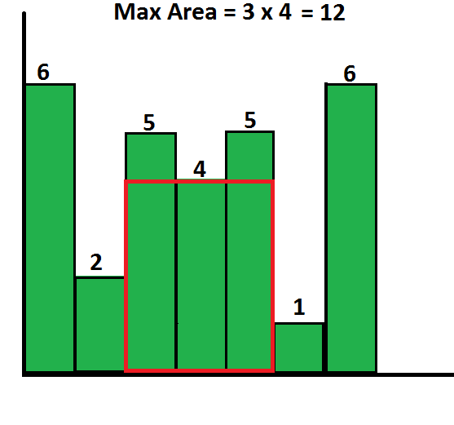
Solution: maxRectAreaHist.cpp

