KEYS AND ROOMS
There are n rooms labeled from 0 to n - 1 and all the rooms are locked except for room 0. Your goal is to visit all the rooms. However, you cannot enter a locked room without having its key.
When you visit a room, you may find a set of distinct keys in it. Each key has a number on it, denoting which room it unlocks, and you can take all of them with you to unlock the other rooms.
Given an array rooms where rooms[i] is the set of keys that you can obtain if you visited room i, return true if you can visit all the rooms, or false otherwise.
Input Format
In the function an integer vector of vectors is passed.
Output Format
Return true or false.
Constraints:
- n == rooms.length
- 2 <= n <= 1000
- 0 <= rooms[i].length <= 1000
- 1 <= sum(rooms[i].length) <= 3000
- 0 <= rooms[i][j] < n
- All the values of rooms[i] are unique.

Sample Input
[[1],[2],[3],[]]

Sample Output
true

Explanation
We visit room 0 and pick up key 1. We then visit room 1 and pick up key 2. We then visit room 2 and pick up key 3. We then visit room 3. Since we were able to visit every room, we return true.
Solution: keysAndRooms.cpp

All Paths From Source to Target

Given a directed acyclic graph (DAG) of n nodes labeled from 0 to n - 1, find all possible paths from node 0 to node n - 1 and return them in any order.
The graph is given as follows: graph[i] is a list of all nodes you can visit from node i (i.e., there is a directed edge from node i to node graph[i][j]).

Example :
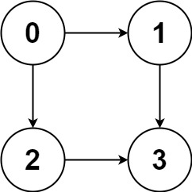
Input: graph = [[1,2],[3],[3],[]]
Output: [[0,1,3],[0,2,3]]
Explanation: There are two paths: 0 -> 1 -> 3 and 0 -> 2 -> 3.
Example 2:
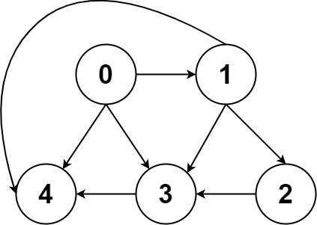
Input: graph = [[4,3,1],[3,2,4],[3],[4],[]]
Output: [[0,4],[0,3,4],[0,1,3,4],[0,1,2,3,4],[0,1,4]]
Constraints:
- n == graph.length
- 2 <= n <= 15
- 0 <= graph[i][j] < n
- graph[i][j] != i (i.e., there will be no self-loops).
- All the elements of graph[i] are unique.
- The input graph is guaranteed to be a DAG.

Solution: allPaths.cpp

Find Star in the graph

There is an undirected star graph consisting of n nodes labeled from 1 to n. A star graph is a graph where there is one center node and exactly n - 1 edges that connect the center node with every other node.
You are given a 2D integer array edges where each edges[i] = [ui, vi] indicates that there is an edge between the nodes ui and vi. Return the center of the given star graph.

Example :
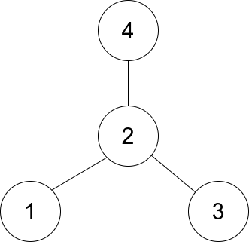
Input: edges = [[1,2],[2,3],[4,2]]
Output: 2
Explanation: As shown in the figure above, node 2 is connected to every other node, so 2 is the center.

Constraints:
- 3 <= n <= 105
- edges.length == n - 1
- edges[i].length == 2
- 1 <= ui, vi <= n
- ui != vi
The given edges represent a valid star graph.
Solution: findStar.cpp

