WEEK 2 ASSIGNMENT
Data Collection, Cleaning and Preprocessing for Logistics Analysis
A simulated shipment-data pipeline in Python (pandas, NumPy, Matplotlib)
Prepared by: Amol Elkunchwar
Course / Programme: Logistics Data Analytics Intern
Date: 13 October 2026
Deliverables: this report, logistics_preprocessing.py (full pipeline), raw_shipments.csv, clean_shipments.csv

1. Introduction and Objectives
Logistics decisions such as which carrier to use, how much safety stock to hold, or how to price a lane are only as good as the data behind them. Operational data from transport management systems, warehouse systems and carrier feeds is rarely analysis-ready: fields are missing, units and labels are inconsistent, records are duplicated, and data-entry errors create extreme values that distort every average and model.
This report documents a complete, reproducible preprocessing pipeline for shipment-level logistics data. The objectives are to:
- Describe the collection of a logistics dataset and its characteristics.
- Identify common data-quality problems (missing values, duplicates, inconsistent labels, impossible values, outliers, skew and scale differences).
- Apply and justify techniques to correct each problem, using pandas.
- Measure the effect of cleaning with before/after evidence, and reflect on the consequences for logistics analytics.

2. Data Collection (Simulation)

2.1 Reference dataset
The reference is a typical public shipment and supply-chain dataset of the kind available on Kaggle or government open-data portals (for example, shipment pricing and delivery-performance records). Such datasets contain one row per shipment with origin, destination, transport mode, distance, weight, transit time, freight cost, inventory position and delivery status. Because the assignment asks for a simulation of collection, the data used here was generated programmatically to match those characteristics, and realistic quality defects were deliberately injected (Section 2.3). This makes the pipeline fully verifiable: the defects are known, so we can check that each one was found and fixed. No real company data was used.

2.2 Dataset characteristics
The simulated extract covers 5,000 shipments across calendar year 2025 between eight Indian cities. After injecting 100 duplicate rows, the raw file has 5,100 rows and 12 columns.
Column | Type | Description / simulated distribution
shipment_id | Text (key) | Unique identifier, SH100000 onwards
order_date | Date | Uniform over 2025
origin, destination | Categorical | Eight cities (Mumbai, Delhi, Chennai, Kolkata, Bengaluru, Nagpur, Pune, Hyderabad)
mode | Categorical | Road 55%, Rail 20%, Air 15%, Sea 10%
carrier | Categorical | BlueDart, Delhivery, DTDC, VRL, SafeExpress
distance_km | Numeric | Gamma-distributed, mean about 1,000 km
weight_kg | Numeric | Log-normal (right-skewed), median about 400 kg
transit_days | Numeric | Distance / (mode speed x 24) plus about 1.5 days handling
freight_cost_inr | Numeric | Distance x mode rate x weight factor plus noise
stock_on_hand | Numeric (count) | Poisson, mean 120 units at destination
status | Categorical | Delivered (92%) or Delayed (8%)

2.3 Injected data-quality problems
To mimic what real extracts look like, the following defects were introduced before saving raw_shipments.csv:
Defect | How it was injected | Real-world cause
Missing values | 2% to 8% blanks in carrier, weight, transit time, cost and stock | Sensor/EDI failures, optional form fields
Extreme outliers | About 0.6% of weights x100, 0.5% of costs x40, 0.4% of transit times set to 60-200 days | Unit mix-ups (g vs kg), extra zeros, stale shipments
Impossible values | About 0.3% of distances made negative | Sign or formula errors in source system
Inconsistent labels | 5% of modes lower-case; 3% of origins UPPER-CASE with trailing space; 2% status in lower-case | Manual entry, multiple source systems
Duplicates | 2% of rows copied | Repeated file loads or retried API calls
Mixed date formats | 1% of dates as DD/MM/YYYY instead of ISO | Different regional systems

3. Methodology Overview
The pipeline follows the standard order of operations in data preparation. Order matters: for example, outliers are treated before imputation so that extreme values do not contaminate the medians used to fill gaps, and normalisation is done last because it depends on the final value ranges.
- Profile the raw data: shape, missing counts, duplicates, summary statistics, label frequencies.
- Remove duplicates and standardise text labels and data types.
- Flag impossible values (negative distance) as missing.
- Detect and treat outliers (IQR rule on a log scale, winsorising).
- Impute missing values using group-aware medians and an explicit "Unknown" category.
- Engineer features and normalise: log transform, Min-Max scaling, z-score standardisation, one-hot encoding.
- Validate with assertions and before/after comparison.

4. Data Profiling: What Is Wrong with the Raw Data?
Profiling is the discovery step: before changing anything we measure what is wrong. The following code loads the raw file and summarises its quality.
df = pd.read_csv("raw_shipments.csv")
print(df.shape) # (5100, 12)
print(df.isna().sum()) # missing values per column
print(df.duplicated().sum()) # exact duplicate rows
print(df.describe().round(2)) # min/max/quartiles reveal outliers
print(df["mode"].value_counts()) # reveals inconsistent labels
print((df["distance_km"] < 0).sum()) # impossible values

Profiling findings for the simulated raw data:
Issue | Finding | Evidence
Missing values | 1,174 blank cells in 5 columns | stock_on_hand 406 (8.0%), weight_kg 314 (6.1%), transit_days 200 (3.9%), freight_cost_inr 152 (3.0%), carrier 102 (2.0%)
Duplicates | 99 exact duplicate rows | df.duplicated().sum()
Inconsistent labels | 8 distinct values for 4 transport modes | "Road" and "road" counted separately (139 lower-case Road rows)
Impossible values | 15 negative distances | Minimum distance = -2,117 km
Outliers | Maximum weight 147,900 kg vs median 415 kg; maximum cost INR 1,659,415 vs median 6,741; maximum transit 173 days vs median 2.4 days | describe() output; boxplots

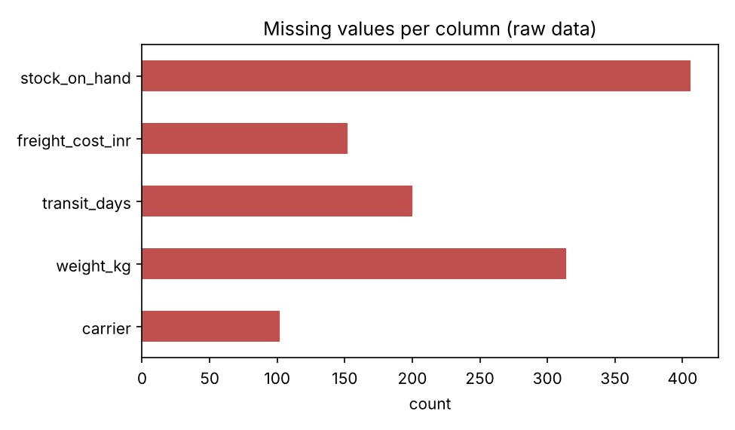
Figure 1: Count of missing values per column in the raw data.
Two observations from the summary statistics are especially important. First, the mean weight (789.7 kg) is nearly double the median (414.8 kg), a classic signature of extreme values pulling the mean upward. Second, transit time has a standard deviation of 7.9 days against an interquartile range of only about 1.1 days, which cannot be explained by genuine variation and points to data-entry errors.

5. Data Cleaning

5.1 Removing duplicates
Why: duplicate shipments double-count volume, cost and demand, inflating totals and biasing any frequency-based analysis such as lane volumes or carrier shares. Exact duplicates carry no extra information, so they are safe to drop.
df = df.drop_duplicates().reset_index(drop=True) # 5,100 -> 5,001 rows

Note that 99 rows were removed rather than the 100 that were injected: one duplicated row happened to also be the one chosen for a later edit, so it was no longer an exact copy. This is a reminder that drop_duplicates() only removes exact duplicates; near-duplicates (for example, same shipment_id with different values) would need a key-based rule such as drop_duplicates(subset="shipment_id").

5.2 Standardising categories and data types
Why: grouping, joining and one-hot encoding treat "Road", "road" and "Road " as different categories, silently splitting one category into several and producing misleading group statistics. Date columns stored as text cannot be used for time-based analysis.
for c in ["origin", "destination", "mode", "carrier", "status"]:
df[c] = df[c].astype("string").str.strip().str.title()

df["order_date"] = pd.to_datetime(df["order_date"], format="mixed",
dayfirst=False, errors="coerce")

After this step the mode column has exactly four values (Road 2,731; Rail 1,068; Air 710; Sea 492) and all dates parsed successfully. The errors="coerce" option converts anything unparseable to a missing value rather than crashing. One caution is that ambiguous dates such as 05/06/2025 would be read month-first; in a real project the source format should be confirmed with the data owner.

5.3 Handling impossible values
Why: a negative distance is physically impossible, so it is an error rather than an outlier. Replacing it with a missing value lets the imputation step handle it consistently, instead of keeping a wrong number or deleting the whole shipment.
df.loc[df["distance_km"] <= 0, "distance_km"] = np.nan # 15 values flagged

5.4 Outlier detection and treatment
Detection. Boxplots give a quick visual check, and the interquartile-range (IQR) rule gives a formal threshold: values beyond Q1 - k x IQR or Q3 + k x IQR are flagged. Because weight, cost and transit time are right-skewed, a standard IQR rule on the raw scale would wrongly flag many legitimate heavy or long-distance shipments. The rule was therefore applied to log(1 + x), where the distribution is closer to symmetric, with a deliberately conservative multiplier of k = 3 so that only extreme values are flagged.
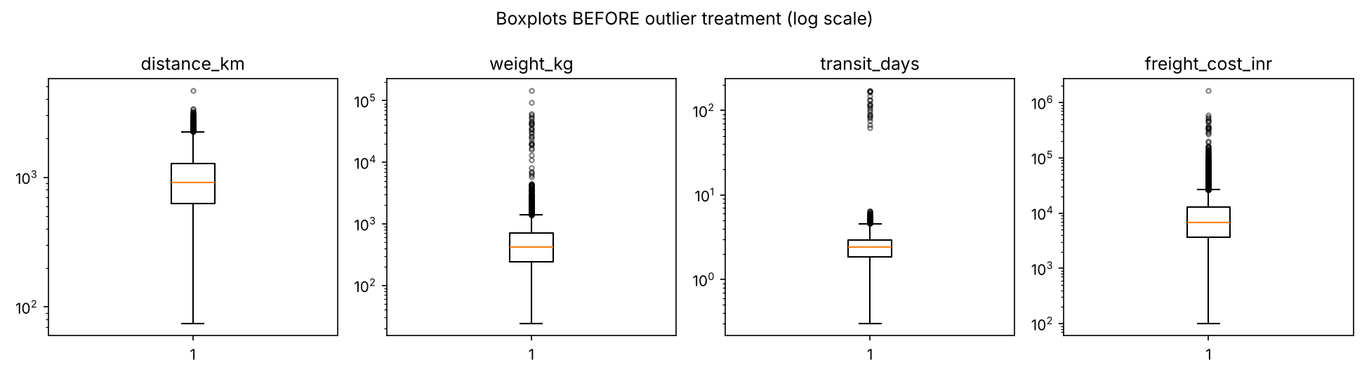
Figure 2: Boxplots of the numeric variables before outlier treatment (log scale). The isolated points far above the boxes are the data-entry errors.
def iqr_bounds(s, k=1.5):
q1, q3 = s.quantile([.25, .75]); iqr = q3 - q1
return q1 - k * iqr, q3 + k * iqr

for c in ["weight_kg", "transit_days", "freight_cost_inr"]:
s = np.log1p(df[c].dropna()) # work on the log scale
lo, hi = iqr_bounds(s, k=3.0) # k=3 -> extreme outliers only
lo_o, hi_o = np.expm1(lo), np.expm1(hi) # convert bounds back to original units
mask = (df[c] > hi_o) | (df[c] < lo_o) # flag
df[c] = df[c].clip(lower=max(lo_o, 0), upper=hi_o) # winsorise (cap)

Treatment choice: winsorising. There are three common options: delete the row, replace the value with a missing value and impute it, or cap it at the boundary (winsorise). Deleting rows throws away the other, valid fields of the shipment. Capping keeps the row and limits the damage the extreme value can do, while still recording that the shipment was heavy or costly. Capping is therefore used here; in a production setting, high-value outliers should also be investigated with the data owner, since some may be real (for example, a genuine 17-tonne consignment).
Variable | Upper bound (original units) | Values capped | Maximum before | Maximum after
weight_kg | 17,528.8 kg | 23 | 147,900.0 | 17,528.8
transit_days | 9.4 days | 20 | 173.0 | 9.4
freight_cost_inr | INR 562,971 | 2 | 1,659,415 | 562,971

Limitations of this choice. The multiplier k = 3 is conservative, so some injected errors remain undetected. For example, a 24 kg shipment multiplied by 100 becomes 2,400 kg, which is unusual but inside the bound. That is why only 23 weight values were capped even though about 30 were corrupted. Choosing k = 1.5 would catch more but also cap more genuine heavy shipments. This trade-off between false positives and false negatives is a decision that should be tuned with domain knowledge, and it is one of the main judgement calls in the pipeline.

5.5 Handling missing values
Why not just delete rows with missing values? Dropping every incomplete row would discard a large part of the dataset (1,070 of the 5,100 rows, about 21%, have at least one blank), reduce statistical power, and may bias the result if data is not missing at random. Instead, imputation strategies were matched to the nature of each column:
Column | Missing % | Method | Reason
weight_kg, transit_days, freight_cost_inr, distance_km | 6.0%, 4.0%, 3.0%, 0.3% | Median within each transport mode | Median is robust to the skew and any remaining extremes; mode-specific because Air, Road, Rail and Sea differ by an order of magnitude in cost and transit time, so a global median would be misleading
stock_on_hand | 8.0% | Overall median, rounded to integer | Symmetric count variable (Poisson-like, skew near 0) with no strong group structure; rounding keeps the value a whole number of units
carrier | 2.0% | Constant "Unknown" | A carrier cannot be inferred; keeping an explicit category preserves the information that it was missing
order_date | 0% | Median date (fallback) | Safety net so the pipeline does not fail if a date cannot be parsed

for c in ["distance_km", "weight_kg", "transit_days", "freight_cost_inr"]:
df[c] = df[c].fillna(df.groupby("mode")[c].transform("median"))

df["stock_on_hand"] = (df["stock_on_hand"]
.fillna(df["stock_on_hand"].median()).round().astype(int))
df["carrier"] = df["carrier"].fillna("Unknown")

After imputation the dataset contains zero missing values. A caveat is that median imputation reduces variance slightly and ignores relationships between variables. For modelling work where that matters, model-based methods such as KNN or iterative imputation (scikit-learn KNNImputer, IterativeImputer) are a sensible next step.

6. Feature Engineering and Normalisation

6.1 Derived features
A new feature cost_per_km (freight cost divided by distance) and order_month were created. Ratios such as cost per kilometre are standard logistics KPIs and allow lanes of different length to be compared fairly.
df["cost_per_km"] = (df["freight_cost_inr"] / df["distance_km"]).round(3)
df["order_month"] = df["order_date"].dt.month

6.2 Log transformation for skewed variables
Even after winsorising, weight and freight cost remain strongly right-skewed (skewness 10.65 and 11.43 respectively; a value near 0 indicates symmetry). Many statistical methods, including linear regression and distance-based algorithms, assume roughly symmetric inputs. Applying log(1 + x) reduced skewness to 0.48 and 0.27.
for c in ["weight_kg", "freight_cost_inr"]:
df[f"log_{c}"] = np.log1p(df[c])

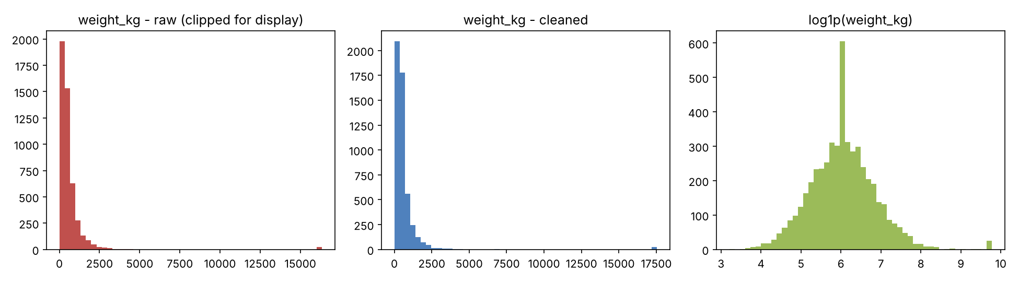
Figure 3: Weight distribution raw (left, clipped for display), after cleaning (centre) and after log transform (right).

6.3 Min-Max scaling and z-score standardisation
Distance (hundreds to thousands), weight (tens to thousands) and stock (about 120) are on very different scales. Algorithms that use distances or gradients (k-means, KNN, SVM, neural networks, regularised regression) would be dominated by the largest-scale variable. Two scalers were implemented in plain pandas, so no extra library is needed:
- Min-Max scaling, (x - min) / (max - min), maps values to [0, 1]. It preserves the shape of the distribution and suits bounded inputs, but is sensitive to extremes, which is another reason outliers were handled first.
- Z-score standardisation, (x - mean) / std, gives mean 0 and standard deviation 1. It is the usual choice for methods that assume roughly Gaussian features.
feat = ["distance_km", "weight_kg", "transit_days",
"freight_cost_inr", "stock_on_hand"]
for c in feat:
mn, mx = df[c].min(), df[c].max()
df[f"{c}_minmax"] = (df[c] - mn) / (mx - mn)
df[f"{c}_z"] = (df[c] - df[c].mean()) / df[c].std()

Verification confirmed that all five Min-Max columns span exactly [0, 1] and all five z-score columns have mean 0.000 and standard deviation 1.000. In a real machine-learning project the min, max, mean and standard deviation should be computed on the training split only and then reused on the test split, to avoid data leakage.

6.4 Encoding categorical variables
Transport mode and carrier were one-hot encoded with pd.get_dummies, producing indicator columns that numeric algorithms can use. The final modelling table has 5,001 rows and 34 columns.
model_df = pd.get_dummies(df, columns=["mode", "carrier"],
prefix=["mode", "carrier"], dtype=int)

7. Validation and Results
The pipeline ends with assertions that fail loudly if any quality rule is violated, so problems are caught immediately instead of surfacing later as wrong results.
assert df["distance_km"].gt(0).all()
assert df.duplicated().sum() == 0
assert df.isna().sum().sum() == 0

Measure | Raw data | Cleaned data
Rows | 5,100 | 5,001
Duplicate rows | 99 | 0
Missing cells (excluding invalid distances) | 1,174 | 0
Negative distances | 15 | 0
Distinct transport-mode labels | 8 | 4
Mean weight (kg) | 789.7 | 652.1
Std. dev. of weight | 3,617.2 | 1,327.0
Max weight (kg) | 147,900.0 | 17,528.8
Mean transit time (days) | 2.94 | 2.47
Std. dev. of transit time | 7.89 | 0.93
Max transit time (days) | 173.0 | 9.4
Mean freight cost (INR) | 13,268 | 12,922
Max freight cost (INR) | 1,659,415 | 562,971

The cleaned data tells a more reliable story. Transit-time variability falls from 7.89 days to 0.93 days, which is a believable spread for a network of this kind, and the mean weight drops by about 17% once corrupted entries are capped. The cleaned dataset also yields sensible business results: average freight cost per shipment is highest by air (about INR 38,560), followed by road (10,564), rail (6,187) and sea (3,638), matching the cost structure used to generate the data.

8. Reflection: Impact of Data Quality on Logistics Analytics
The numbers in Section 7 illustrate a general principle: analytics can only be as accurate as its inputs. In logistics, the consequences of poor data quality are direct and costly.
- Forecasting and inventory. Duplicates inflate demand, and unfilled or extreme values distort the mean and variance used to set safety stock and reorder points. Overstated variance means too much working capital held in inventory; understated variance means stock-outs.
- Lead-time and service-level reporting. A handful of 100+ day transit records inflated the standard deviation of transit time roughly eight-fold. Any promised delivery window built from the raw figures would have been far too wide, hiding real performance and making carrier comparisons unfair.
- Cost and pricing decisions. One mistyped freight cost of INR 1.66 million is enough to move the average cost of a lane. Inconsistent mode labels split volume across "Road" and "road", so carrier negotiations or mode-shift analyses would be based on incomplete totals.
- Machine learning and optimisation. Models trained on unscaled, skewed data are dominated by the largest-magnitude feature and outliers, giving poor ETA predictions or routing recommendations. Normalisation and transformation make the signal usable.
- Trust. If decision-makers discover wrong numbers once, they stop trusting dashboards. Documented, repeatable cleaning rules, such as those in this pipeline, are what make results auditable.
Equally important is that cleaning involves judgement, not just mechanics. Choosing the outlier multiplier, deciding whether to cap or investigate, and selecting an imputation method all change the results. These choices should be documented (as done here), tested for sensitivity, and agreed with the people who understand the operation. Over-cleaning can be as harmful as under-cleaning: removing real extreme shipments would hide exactly the exceptional events that logistics managers need to see.

9. Limitations and Next Steps
- The dataset is simulated, so the defects are cleaner and more regular than in real systems. The same pipeline should be re-tested on a real public dataset (for example a Kaggle supply-chain shipment file) where missingness is rarely random.
- Outlier thresholds were fixed once; a sensitivity analysis over k and over capping vs. deleting would show how conclusions change.
- Imputation was simple (median-based). Model-based imputation and a missingness indicator column could be added.
- The steps can be wrapped in a scikit-learn Pipeline with ColumnTransformer so that the same transformations are fitted on training data and applied unchanged to new data in production.
- Business-rule checks (for example, delivery date not before order date, cost per km within expected range for the mode) would catch errors that purely statistical rules miss.

10. Conclusion
A seven-step pipeline of profiling, de-duplication, standardisation, invalid-value handling, outlier treatment, imputation and normalisation turned a defective 5,100-row shipment file into a 5,001-row analysis-ready dataset with no missing values, consistent labels and well-behaved distributions. Each step was selected for a stated reason and its effect was measured. The central lesson is that data preparation is not a preliminary chore but a core part of analysis: it determines whether the resulting numbers can be trusted when logistics decisions are made.

References
- McKinney, W. (2022). Python for Data Analysis, 3rd ed. O'Reilly Media.
- pandas documentation: https://pandas.pydata.org/docs/
- scikit-learn documentation, Preprocessing data: https://scikit-learn.org/stable/modules/preprocessing.html
- Tukey, J. W. (1977). Exploratory Data Analysis. Addison-Wesley (origin of the IQR outlier rule).

Appendix A: Complete Python Pipeline
The full script below generates the simulated dataset, runs every step in this report and saves raw_shipments.csv, clean_shipments.csv, the figures and a statistics file. It uses a fixed random seed (42), so every number in this report can be reproduced exactly. Requirements: Python 3, pandas, NumPy, Matplotlib.
"""
Week 2 - Data Collection, Cleaning and Preprocessing for Logistics Analysis
Simulated shipment-level dataset modelled on a typical public logistics /
supply-chain shipment dataset (e.g. Kaggle "Supply Chain Shipment Pricing" /
"Logistics and Supply Chain" style records).

Run: python logistics_preprocessing.py
Outputs: raw_shipments.csv, clean_shipments.csv, figures/*.png, report_stats.json
"""
import json
import os
import numpy as np
import pandas as pd
import matplotlib
matplotlib.use("Agg")
import matplotlib.pyplot as plt

rng = np.random.default_rng(42)
os.makedirs("figures", exist_ok=True)
stats = {}

# ---------------------------------------------------------------------------
# STEP 1: DATA COLLECTION (SIMULATION)
# ---------------------------------------------------------------------------
N = 5000
cities = ["Mumbai", "Delhi", "Chennai", "Kolkata", "Bengaluru", "Nagpur", "Pune", "Hyderabad"]
modes = ["Road", "Rail", "Air", "Sea"]
carriers = ["BlueDart", "Delhivery", "DTDC", "VRL", "SafeExpress"]

origin = rng.choice(cities, N)
dest = rng.choice(cities, N)
mode = rng.choice(modes, N, p=[0.55, 0.20, 0.15, 0.10])
distance = rng.gamma(shape=4, scale=250, size=N).round(1) # km
weight = rng.lognormal(mean=6, sigma=0.8, size=N).round(1) # kg
speed = pd.Series(mode).map({"Road": 45, "Rail": 35, "Air": 600, "Sea": 25}).values # avg km/h
transit = (distance / (speed * 24) + rng.normal(1.5, 0.5, N)).clip(0.3) # days = travel + handling
cost_rate = pd.Series(mode).map({"Road": 9, "Rail": 5, "Air": 38, "Sea": 3}).values
cost = (distance * cost_rate * (weight / 500) ** 0.5 + rng.normal(0, 400, N)).clip(100)
order_date = pd.to_datetime("2025-01-01") + pd.to_timedelta(rng.integers(0, 365, N), unit="D")
inventory = rng.poisson(120, N).astype(float)
delivered = np.where(rng.random(N) < 0.92, "Delivered", "Delayed")

raw = pd.DataFrame({
"shipment_id": [f"SH{100000 + i}" for i in range(N)],
"order_date": order_date.strftime("%Y-%m-%d"),
"origin": origin, "destination": dest, "mode": mode, "carrier": rng.choice(carriers, N),
"distance_km": distance, "weight_kg": weight, "transit_days": transit.round(2),
"freight_cost_inr": cost.round(2), "stock_on_hand": inventory, "status": delivered,
})

# ---- inject realistic data-quality problems ----
def idx(frac): return rng.choice(N, int(N * frac), replace=False)

# missing values (MCAR-style + one column missing more often)
for col, frac in [("weight_kg", 0.06), ("transit_days", 0.04), ("freight_cost_inr", 0.03),
("stock_on_hand", 0.08), ("carrier", 0.02)]:
raw.loc[idx(frac), col] = np.nan
# extreme outliers / data-entry errors
raw.loc[idx(0.006), "weight_kg"] *= 100
raw.loc[idx(0.005), "freight_cost_inr"] *= 40
raw.loc[idx(0.004), "transit_days"] = rng.uniform(60, 200, int(N * 0.004))
raw.loc[idx(0.003), "distance_km"] = -abs(raw["distance_km"].sample(int(N * 0.003), random_state=1).values)
# inconsistent categorical labels + whitespace
raw.loc[idx(0.05), "mode"] = raw["mode"].str.lower()
raw.loc[idx(0.03), "origin"] = raw["origin"].str.upper() + " "
raw.loc[idx(0.02), "status"] = "delivered"
# duplicate rows
dups = raw.sample(int(N * 0.02), random_state=7)
raw = pd.concat([raw, dups], ignore_index=True).sample(frac=1, random_state=3).reset_index(drop=True)
# wrong dtype: dates/numbers stored as text in places
raw.loc[idx(0.01), "order_date"] = "13/05/2025"
raw.to_csv("raw_shipments.csv", index=False)

# ---------------------------------------------------------------------------
# STEP 2: DATA INSPECTION / PROFILING
# ---------------------------------------------------------------------------
df = pd.read_csv("raw_shipments.csv")
stats["raw_shape"] = list(df.shape)
stats["missing_before"] = df.isna().sum()[df.isna().sum() > 0].to_dict()
stats["duplicates"] = int(df.duplicated().sum())
stats["raw_describe"] = df[["distance_km", "weight_kg", "transit_days", "freight_cost_inr", "stock_on_hand"]] \
.describe().round(2).to_dict()
stats["mode_labels_before"] = df["mode"].value_counts().to_dict()
stats["negative_distance"] = int((df["distance_km"] < 0).sum())

# ---------------------------------------------------------------------------
# STEP 3: CLEANING
# ---------------------------------------------------------------------------
# 3.1 remove exact duplicates
df = df.drop_duplicates().reset_index(drop=True)
stats["after_dedup_rows"] = len(df)

# 3.2 standardise text + types
for c in ["origin", "destination", "mode", "carrier", "status"]:
df[c] = df[c].astype("string").str.strip().str.title()
df["order_date"] = pd.to_datetime(df["order_date"], format="mixed", dayfirst=False, errors="coerce")
stats["mode_labels_after"] = df["mode"].value_counts().to_dict()
stats["bad_dates"] = int(df["order_date"].isna().sum())

# 3.3 impossible values -> NaN (negative distance is physically impossible)
df.loc[df["distance_km"] <= 0, "distance_km"] = np.nan

# 3.4 outlier detection (IQR rule + visual check); done BEFORE imputation
num_cols = ["distance_km", "weight_kg", "transit_days", "freight_cost_inr"]

fig, ax = plt.subplots(1, 4, figsize=(13, 3.6))
for a, c in zip(ax, num_cols):
a.boxplot(df[c].dropna(), flierprops=dict(marker="o", markersize=3, alpha=.5))
a.set_title(c); a.set_yscale("log")
plt.suptitle("Boxplots BEFORE outlier treatment (log scale)")
plt.tight_layout(); plt.savefig("figures/boxplots_before.png", dpi=150); plt.close()

def iqr_bounds(s, k=1.5):
q1, q3 = s.quantile([.25, .75]); iqr = q3 - q1
return q1 - k * iqr, q3 + k * iqr

outlier_counts = {}
for c in ["weight_kg", "transit_days", "freight_cost_inr"]:
# work on log scale for right-skewed variables so the rule is not over-aggressive
s = np.log1p(df[c].dropna())
lo, hi = iqr_bounds(s, k=3.0) # k=3 -> "extreme" outliers only
lo_o, hi_o = np.expm1(lo), np.expm1(hi)
mask = (df[c] > hi_o) | (df[c] < lo_o)
outlier_counts[c] = {"n": int(mask.sum()), "upper_bound": round(float(hi_o), 1)}
# winsorise: cap to bound instead of dropping -> preserves the row
df[c] = df[c].clip(lower=max(lo_o, 0), upper=hi_o)
stats["outliers"] = outlier_counts

# 3.5 missing values
stats["missing_pct_before_impute"] = (df.isna().mean() * 100).round(2)[df.isna().sum() > 0].to_dict()
# numeric: median imputation within transport mode (groups differ strongly)
for c in ["distance_km", "weight_kg", "transit_days", "freight_cost_inr"]:
df[c] = df[c].fillna(df.groupby("mode")[c].transform("median"))
# inventory: Poisson-like count -> overall median, rounded
df["stock_on_hand"] = df["stock_on_hand"].fillna(df["stock_on_hand"].median()).round().astype(int)
# categorical: mode (most frequent) / explicit 'Unknown'
df["carrier"] = df["carrier"].fillna("Unknown")
df["order_date"] = df["order_date"].fillna(df["order_date"].median())
stats["missing_after"] = int(df.isna().sum().sum())

# ---------------------------------------------------------------------------
# STEP 4: FEATURE ENGINEERING + NORMALISATION
# ---------------------------------------------------------------------------
df["cost_per_km"] = (df["freight_cost_inr"] / df["distance_km"]).round(3)
df["order_month"] = df["order_date"].dt.month

# right-skew fix: log transform
for c in ["weight_kg", "freight_cost_inr"]:
df[f"log_{c}"] = np.log1p(df[c])

feat = ["distance_km", "weight_kg", "transit_days", "freight_cost_inr", "stock_on_hand"]
stats["skew_before"] = df[feat].skew().round(2).to_dict()
stats["skew_log"] = df[["log_weight_kg", "log_freight_cost_inr"]].skew().round(2).to_dict()

# min-max (0-1) and z-score, implemented with pandas so no extra dependency
for c in feat:
mn, mx = df[c].min(), df[c].max()
df[f"{c}_minmax"] = (df[c] - mn) / (mx - mn)
df[f"{c}_z"] = (df[c] - df[c].mean()) / df[c].std()
stats["minmax_range"] = {c: [round(df[f"{c}_minmax"].min(), 2), round(df[f"{c}_minmax"].max(), 2)] for c in feat}
stats["z_mean_std"] = {c: [round(df[f"{c}_z"].mean(), 3), round(df[f"{c}_z"].std(), 3)] for c in feat}

# one-hot encode categoricals for modelling
model_df = pd.get_dummies(df, columns=["mode", "carrier"], prefix=["mode", "carrier"], dtype=int)
stats["final_shape_encoded"] = list(model_df.shape)

# ---------------------------------------------------------------------------
# STEP 5: VALIDATION + BEFORE/AFTER VISUALS
# ---------------------------------------------------------------------------
assert df["distance_km"].gt(0).all()
assert df.duplicated().sum() == 0
assert df.isna().sum().sum() == 0

fig, ax = plt.subplots(1, 3, figsize=(13, 3.6))
raw_w = pd.read_csv("raw_shipments.csv")["weight_kg"].dropna()
ax[0].hist(raw_w.clip(upper=raw_w.quantile(.995)), bins=50, color="#c0504d"); ax[0].set_title("weight_kg - raw (clipped for display)")
ax[1].hist(df["weight_kg"], bins=50, color="#4f81bd"); ax[1].set_title("weight_kg - cleaned")
ax[2].hist(df["log_weight_kg"], bins=50, color="#9bbb59"); ax[2].set_title("log1p(weight_kg)")
plt.tight_layout(); plt.savefig("figures/weight_distributions.png", dpi=150); plt.close()

fig, ax = plt.subplots(figsize=(6.5, 3.8))
miss_before = pd.Series(stats["missing_before"])
miss_before.plot(kind="barh", color="#c0504d", ax=ax)
ax.set_title("Missing values per column (raw data)"); ax.set_xlabel("count")
plt.tight_layout(); plt.savefig("figures/missing_before.png", dpi=150); plt.close()

stats["clean_sample"] = df[["shipment_id", "mode", "distance_km", "weight_kg", "transit_days",
"freight_cost_inr", "cost_per_km"]].head(5).round(2).astype(str).values.tolist()
stats["raw_sample"] = pd.read_csv("raw_shipments.csv")[["shipment_id", "mode", "distance_km", "weight_kg",
"transit_days", "freight_cost_inr"]].head(5).astype(str).values.tolist()
stats["clean_describe"] = df[feat].describe().round(2).to_dict()
stats["avg_cost_by_mode"] = df.groupby("mode")["freight_cost_inr"].mean().round(0).to_dict()

df.to_csv("clean_shipments.csv", index=False)
with open("report_stats.json", "w") as f:
json.dump(stats, f, indent=2, default=str)
print(json.dumps(stats, indent=2, default=str))

