**Concepts of Operating System**

***Assignment 1***

Problem 1: Read the instructions carefully and answer accordingly. If there is any need to insert some data then do that as well.

1. Navigate and List:
   1. Start by navigating to your home directory and list its contents. Then, move into a directory named "LinuxAssignment" if it exists; otherwise, create it.

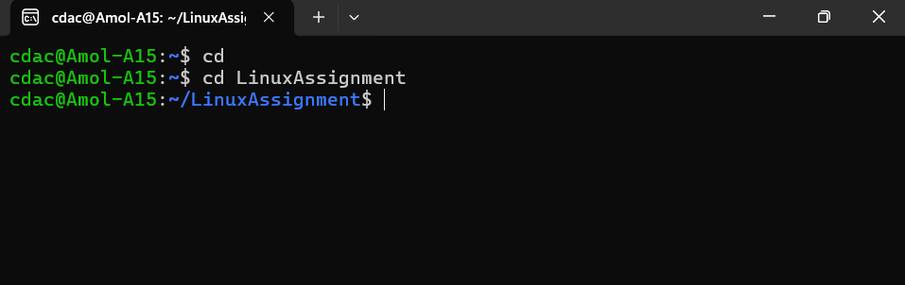

cd: This Command is use to change the directory, if the directory doesn’t exists it create new directory of that name.

1. File Management:
   1. Inside the "LinuxAssignment" directory, create a new file named "file1.txt". Display its contents.

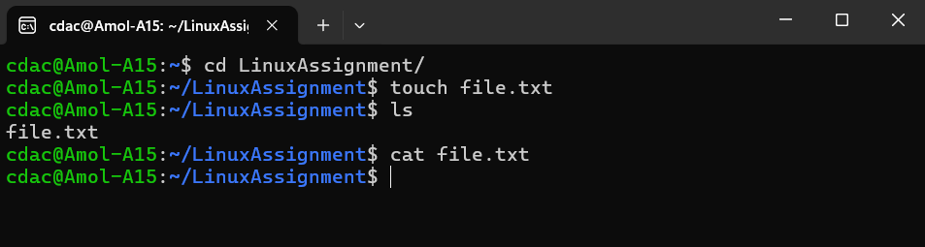

touch: This command is use to create a new file.

ls: This command is use to print the list the content in the present directory.

cat: This command is use to print the contains of the specific file.

1. Directory Management:
   1. Create a new directory named "docs" inside the "LinuxAssignment" directory.

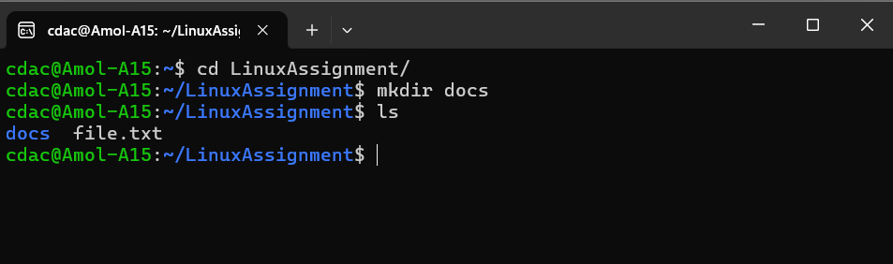

mkdir: This command is use to create a new directory with the given name.

1. Copy and Move Files:
   1. Copy the "file1.txt" file into the "docs" directory and rename it to "file2.txt".

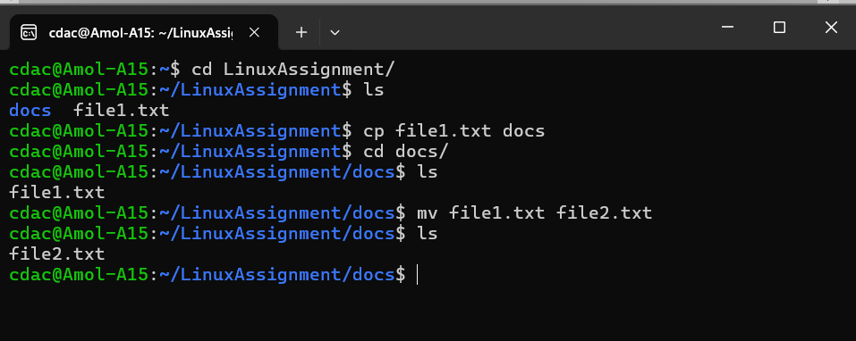

cp: This command is use to copy the file into given directory.

mv: This command is use to rename the given file name with another name.

1. Permissions and Ownership:
   1. Change the permissions of "file2.txt" to allow read, write, and execute permissions for the owner and only read permissions for others. Then, change the owner of "file2.txt" to the current user.

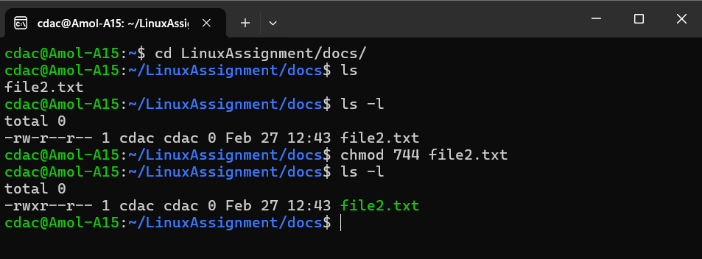

ls -l: ls command with -l is use to print detail information about the files present in the current directory.

chmod: This command is use to modify the permissions of any given file.

Permissions: Read:- 4, Write:- 2, Execute:- 1

First is Owner, Second is Group, Third is Other User

So the number will come out to be 744 according to the problem.

1. Final Checklist:
   1. Finally, list the contents of the "LinuxAssignment" directory and the root directory to ensure that all operations were performed correctly.

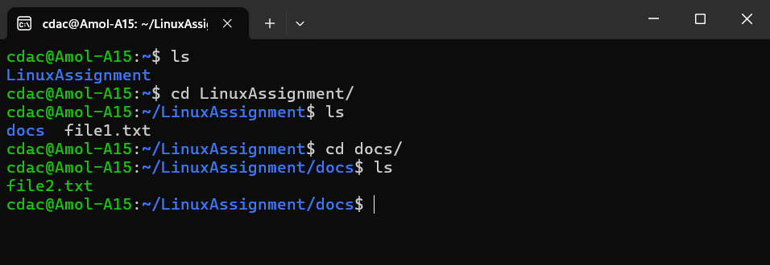

1. File Searching:
   1. Search for all files with the extension ".txt" in the current directory and its subdirectories.
   2. 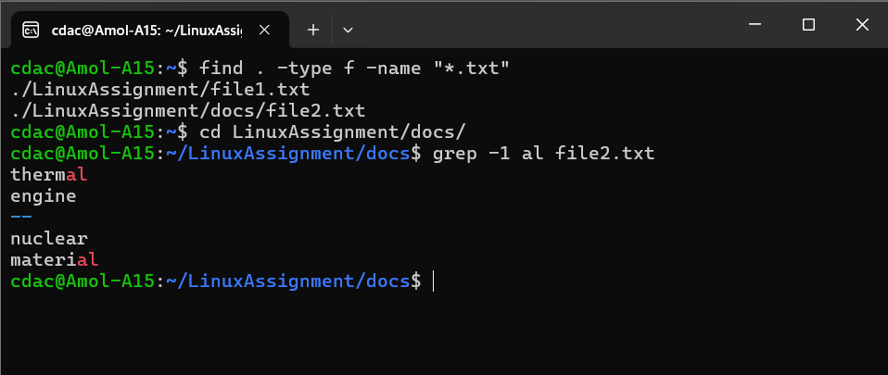Display lines containing a specific word in a file (provide a file name and the specific word to search).
2. System Information:
   1. Display the current system date and time.

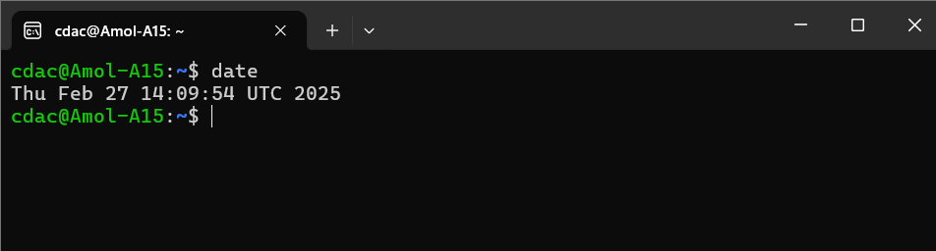

date: This command is use to print the today date and current timestamp.

1. Networking:
   1. Display the IP address of the system.
   2. Ping a remote server to check connectivity (provide a remote server address to ping).

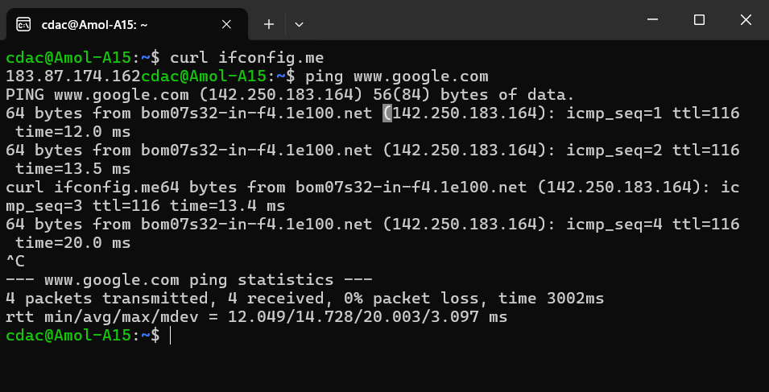

curl ifconfig.me: This command is use to print IP address of the system. (183.87.174.162)

ping: This command is use to check the connectivity of the server.

1. File Compression:
   1. Compress the "docs" directory into a zip file.
   2. 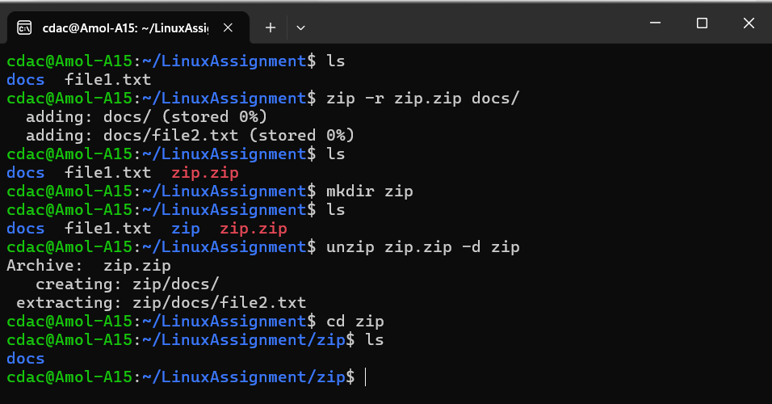Extract the contents of the zip file into a new directory.

zip: This command is use to to compress the directory

unzip: This command is use to extract the compressed file and create a new directory with same name.

1. File Editing:
   1. Open the "file1.txt" file in a text editor and add some text to it.
   2. 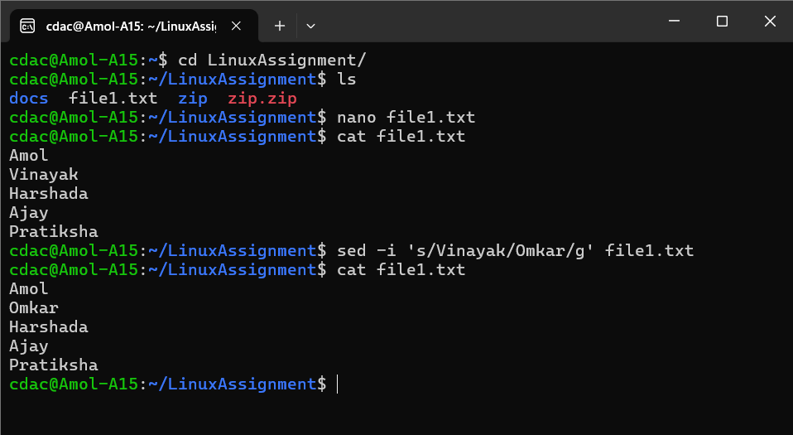Replace a specific word in the "file1.txt" file with another word (provide the original word and the word to replace it with).

nano: This command is use to open the text editor.

cat: This command is use to print the contents of the given file.

Problem 2: Read the instructions carefully and answer accordingly. If there is any need to insert some data then do that as well.

1. 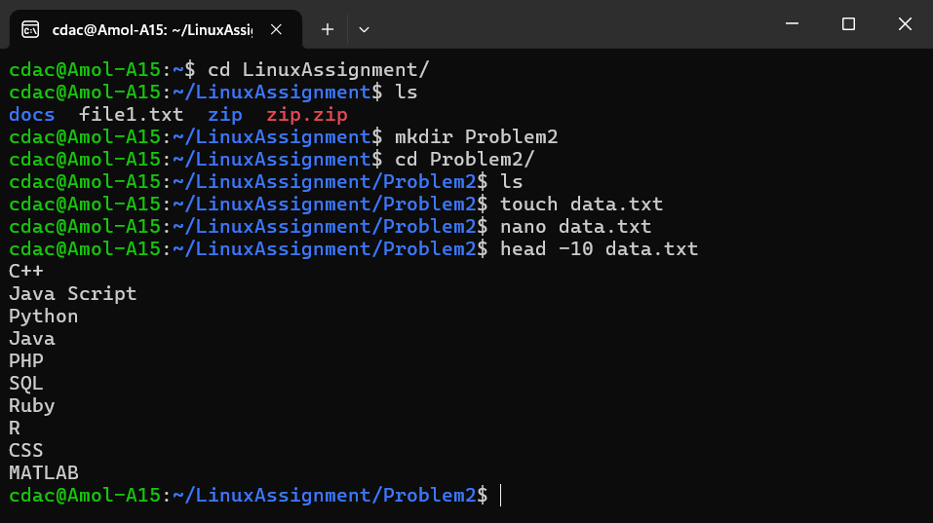Suppose you have a file named "data.txt" containing important information. Display the first 10 lines of this file to quickly glance at its contents using a command.

head: This command is use to print the first lines of the given file. In this case (-10) first 10 lines.

1. Now, to check the end of the file for any recent additions, display the last 5 lines of "data.txt" using another command.

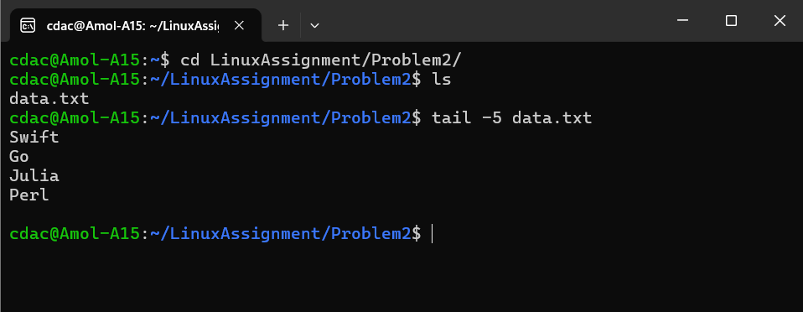

tail: This command is use to print the last lines of the given file. In this case (-5) last 5 lines.

1. 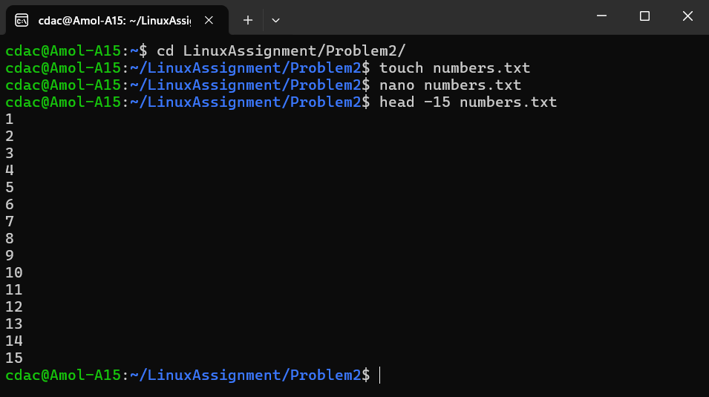In a file named "numbers.txt," there are a series of numbers. Display the first 15 lines of this file to analyze the initial data set.
2. To focus on the last few numbers of the dataset, display the last 3 lines of "numbers.txt".

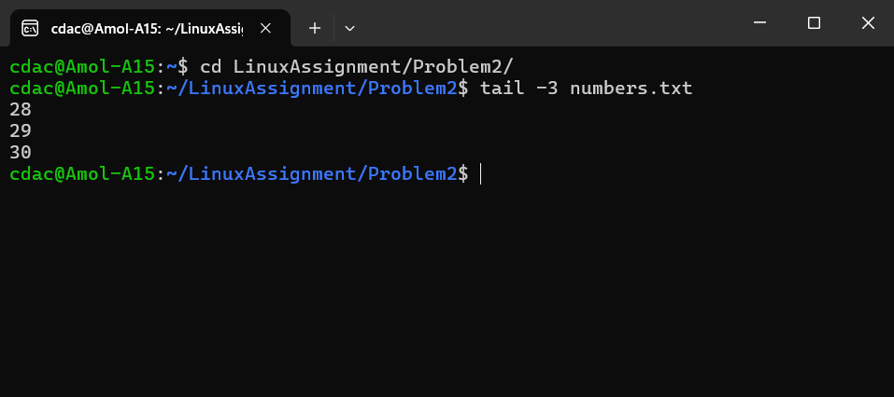

1. 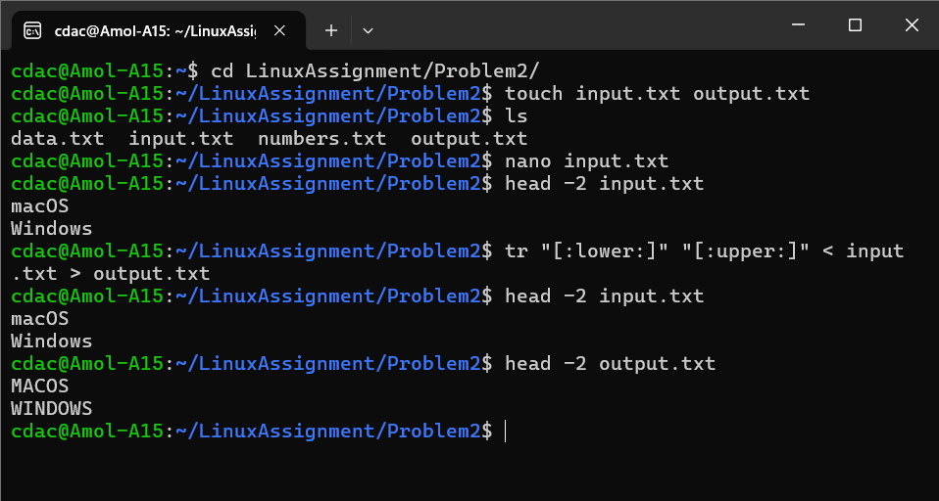Imagine you have a file named "input.txt" with text content. Use a command to translate all lowercase letters to uppercase in "input.txt" and save the modified text in a new file named "output.txt."

tr: This command is use to translate the given text.

We are using {tr “[:lower:]” “[:upper:]” } meaning the whole file. {<} from this file to {>} redirect it to new file

1. In a file named "duplicate.txt," there are several lines of text, some of which are duplicates. Use a command to display only the unique lines from "duplicate.txt."

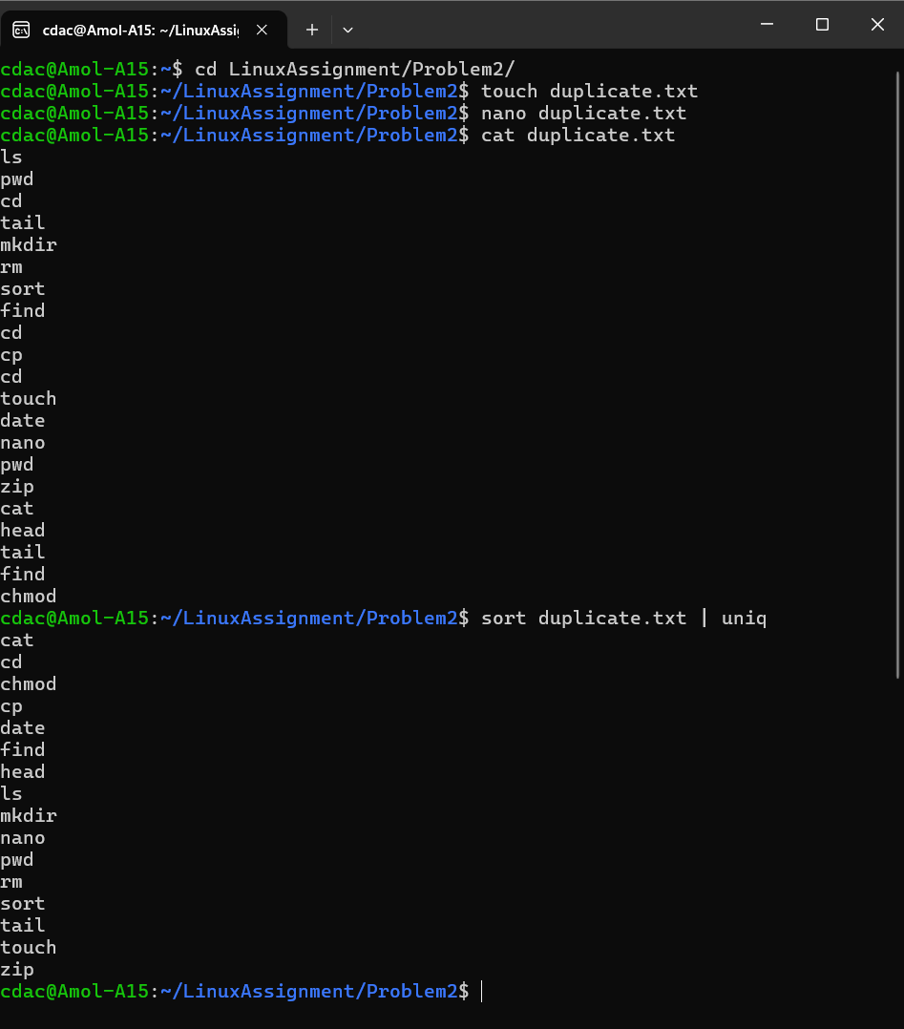

To eliminate the duplicate values first we need use{ sort } to arrenge the text in alphabetical order the using piping { | } with the { uniq } command we can print the unique values from the given text.

1. In a file named "fruit.txt," there is a list of fruits, but some fruits are repeated. Use a command to display each unique fruit along with the count of its occurrences in "fruit.txt."

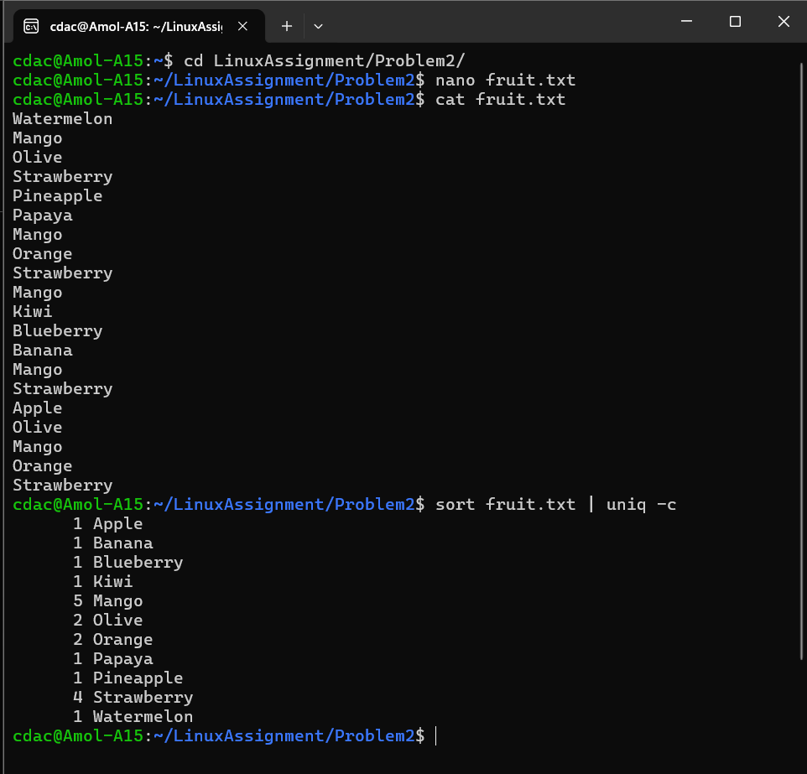

By using { -c } option with the { uniq } command we can find the number of occurrences.