**JIRA Link:**

[**https://amolbdeshmukh.atlassian.net/jira/software/c/projects/FA/boards/10/backlog?atlOrigin=eyJpIjoiNTRiZDM4MzY4MTgwNDg1OGFkYWNiMmQzMGEwYTJlNWEiLCJwIjoiaiJ9**](https://amolbdeshmukh.atlassian.net/jira/software/c/projects/FA/boards/10/backlog?atlOrigin=eyJpIjoiNTRiZDM4MzY4MTgwNDg1OGFkYWNiMmQzMGEwYTJlNWEiLCJwIjoiaiJ9)

**Mission 1 - Product Vision**

1. Consider any product

2. Define Clear, Concise and inspiring Product vision

3. Define who are Target market of your product

4. Define what needs your product going to solve



**Mission 2 - Product Roadmap**

1. Create Product Roadmap for the product you have considered as part of Assignment 1

2. Use attached Roman Pitchler Product Roadmap template

3. Create JIRA account Here: <https://www.atlassian.com/soft>...

4. Create Project, Epics and Product Goal Issue type and timeline view as shown in session.



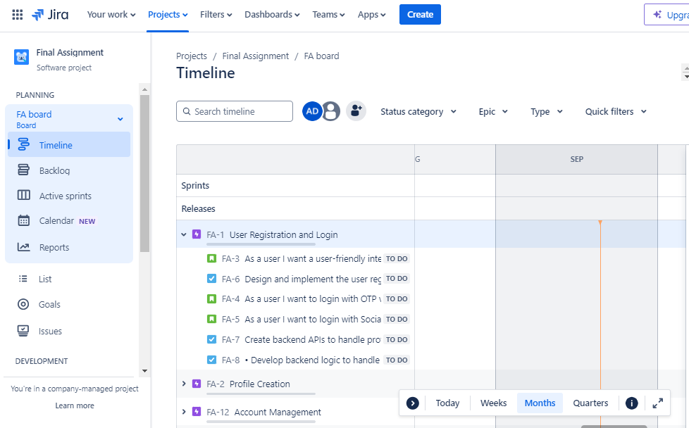

**Mission 3 - User Story Mapping & Release Planning**

**Assignment:**

1. Create account on Miro : <https://miro.com/>

2. Use User Story Mapping template and create User story map for your own product goal

3. Define MVP user stories as shown in session

4. Transform Features in to epics in JIRA and User stories as user stories in JIRA

5. Create 2-3 epics with 3-4 user stories of MVP

6. Create release plan in JIRA as shown in session

7. Map user stories with MVP

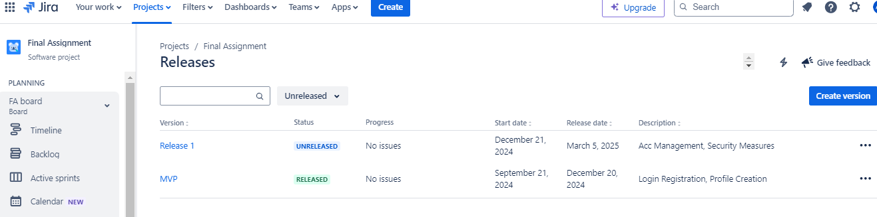

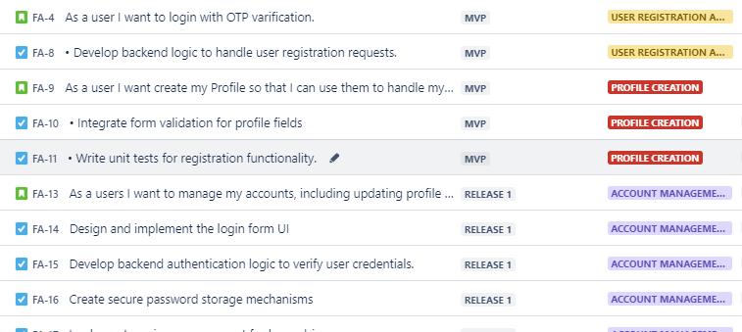

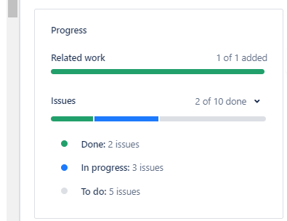

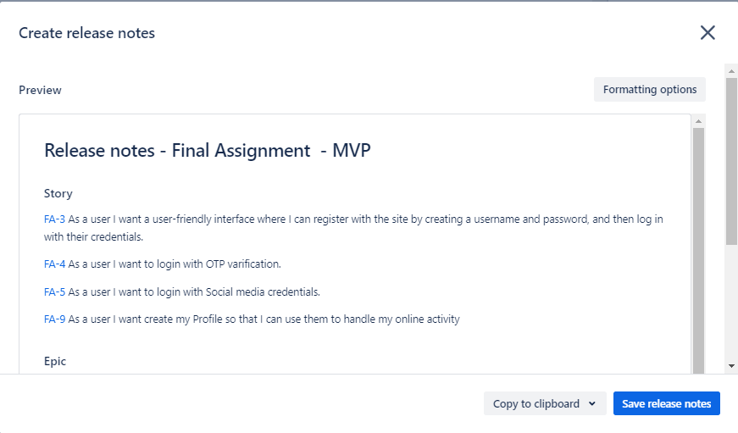

**Mission 4 - User Story Writing & Estimation**

1. Write 2-3 user stories using INVEST, vertical slicing, acceptance criteria under each epic.

2. Add subtasks

3. Add other details as shown in session

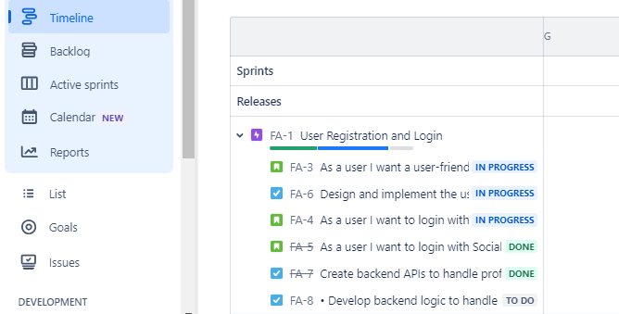

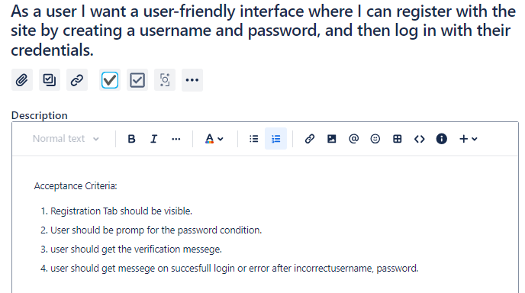

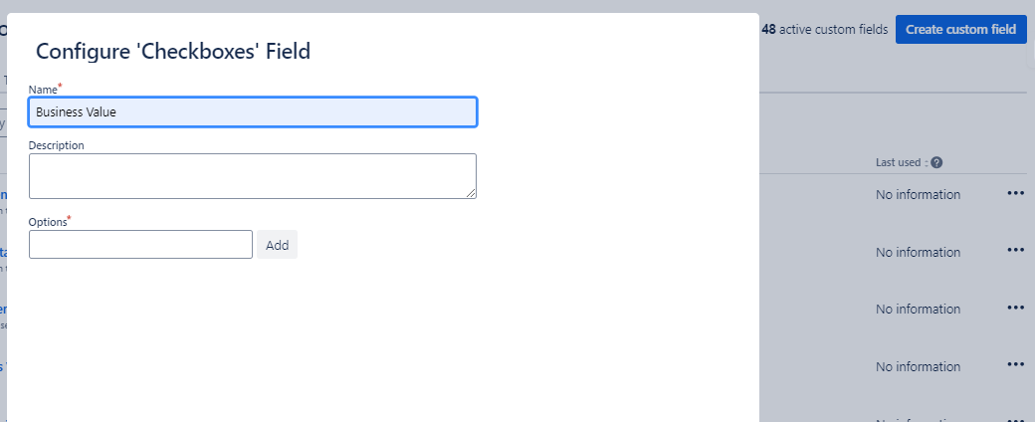

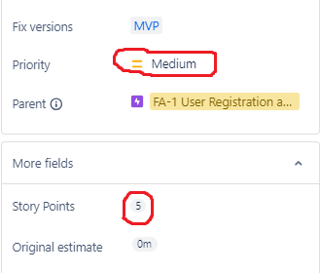

**Mission 5 - Product Backlog Refinement**

**Assignment:**

1. Refine 4-5 user stories following all standards in JIRA as shown in session.

2. Install "Scrumpy planning poker" plugin and just play around with this.

3. Play around with onlineplanningpoker website

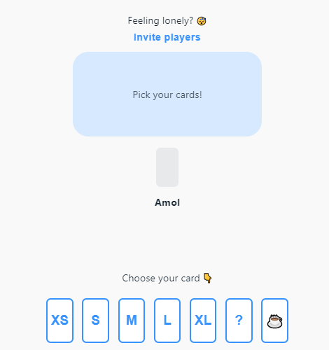

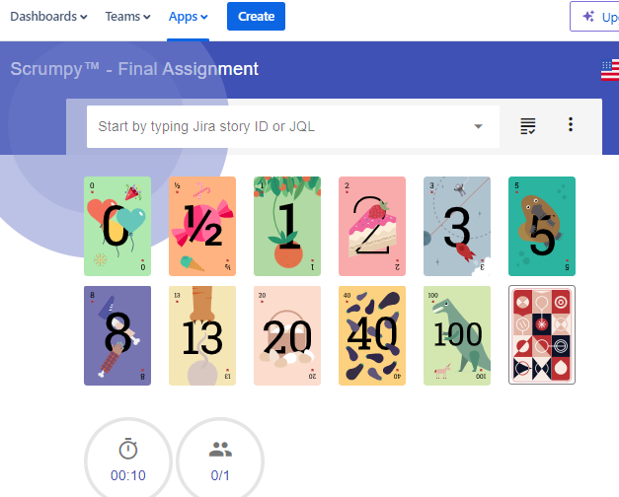

**Mission 6 - Sprint Planning**

1. Create Sprint in JIRA

2. Create Sprint Goal and select Sprint backlogs

3. Verify all sprint backlog have subtasks and al the necessary details

4. Start Sprint

5. Create your own DOD and Capacity planning

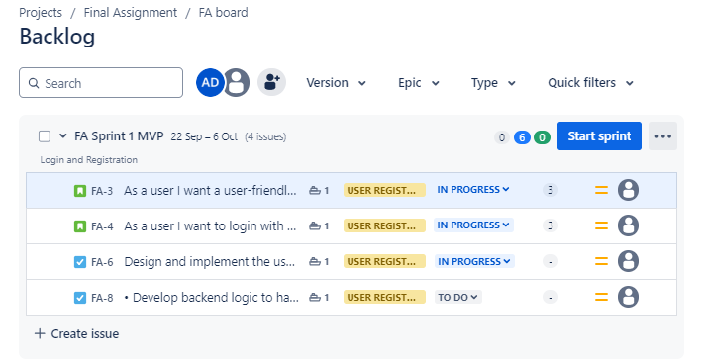

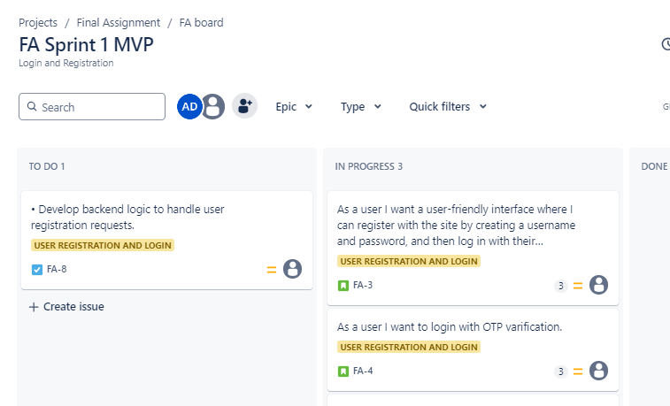

|  |  |  |  |  |  |
| --- | --- | --- | --- | --- | --- |
|  |  |  | **Sprint 1 MVP (Week 2)** | |  |
| **NAME** | **TOTAL HRS** | **DAYS** | **HRS/DAY FOR PLANNED WORK** | **HRS/DAY FOR UNPLANNED WORK** | **PRODUCTIVE HRS.** |
| Ramesh | 9 | 10 | 6 | 3 | 60 |
| Suresh | 9 | 10 | 6 | 3 | 60 |
| Pritesh | 9 | 10 | 6 | 3 | 60 |
| Jitesh | 9 | 10 | 6 | 3 | 60 |
| Geetesh | 9 | 10 | 6 | 3 | 60 |
| Current Sprint capacity | | | | | 360 |
|  |  |  |  |  |  |
|  | **Capacity** | **S Points** |  |  |  |
| Sprint 1 | 360 | 45 |  |  |  |
| Sprint 2 | 330 | 40 |  |  |  |
| Sprint 3 | 340 | 38 |  |  |  |
| Sprint 4 | 310 | 32 |  |  |  |
| Avg. Sprint Velocity |  | 38.7 |  |  |  |
|  |  |  |  |  |  |
|  |  |  |  |  |  |
| **Velocity of current sprint=** | Avg. sprint Velocity/ Max capacity* current capacity | | |  |  |
|  | 34.4 |  |  |  |  |

**DOD Checklist:**

1. Increment passes SonarCube test with no major errors.
2. Increment meets agreed engineering standards.
3. Acceptance tests of the increment are checked.
4. Security checks pass on increment.
5. Increment meets agreed architecture guidelines.
6. Unit testing done and unit testing results are attached.
7. All acceptance criteria are met.
8. All QA testing results are attached.
9. Code is merged to code repository.
10. Browser compatibility testing is done.
11. All security checks are done.

**Mission 7 - Daily Scrum**

**Assignment:**

1. Add different columns and status on your sprint board

2. Move tickets from 'To Do' to different columns

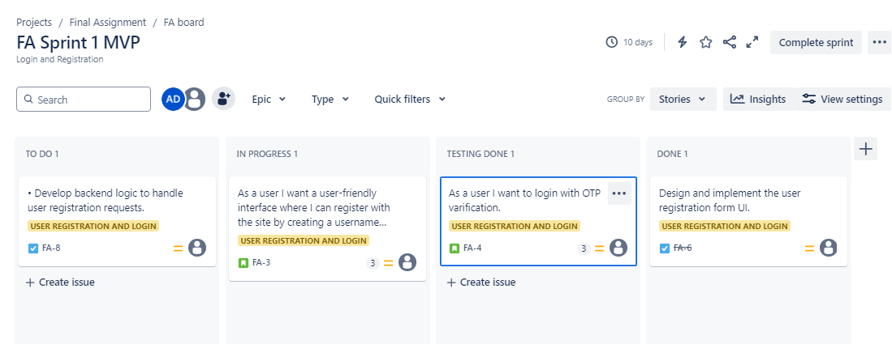

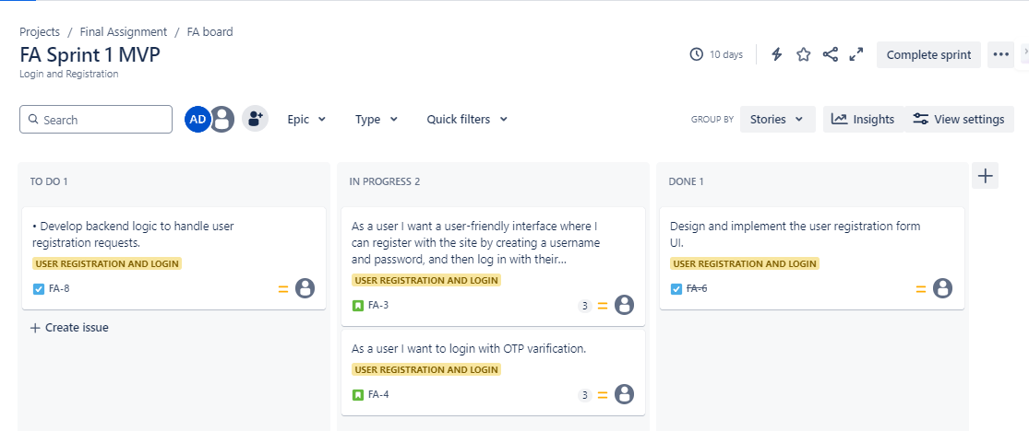

**Mission 8 - Sprint Review**

Assignement: 1. Enable DOD checklist at user story level by following my youtube video: <https://youtu.be/pNmkDvZiFAU>

2. Move some tickets to Done column on your board.

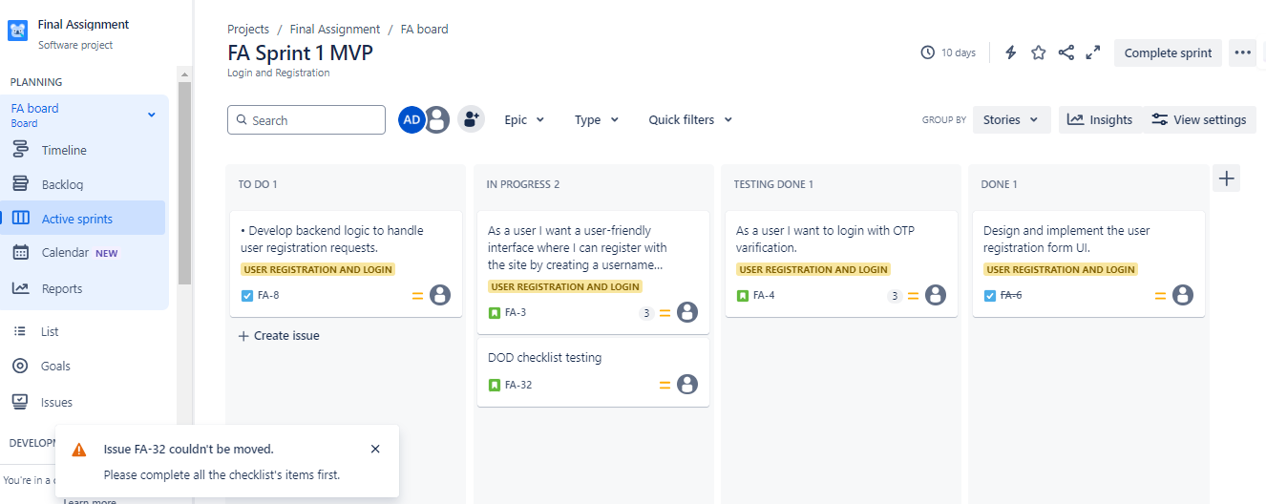

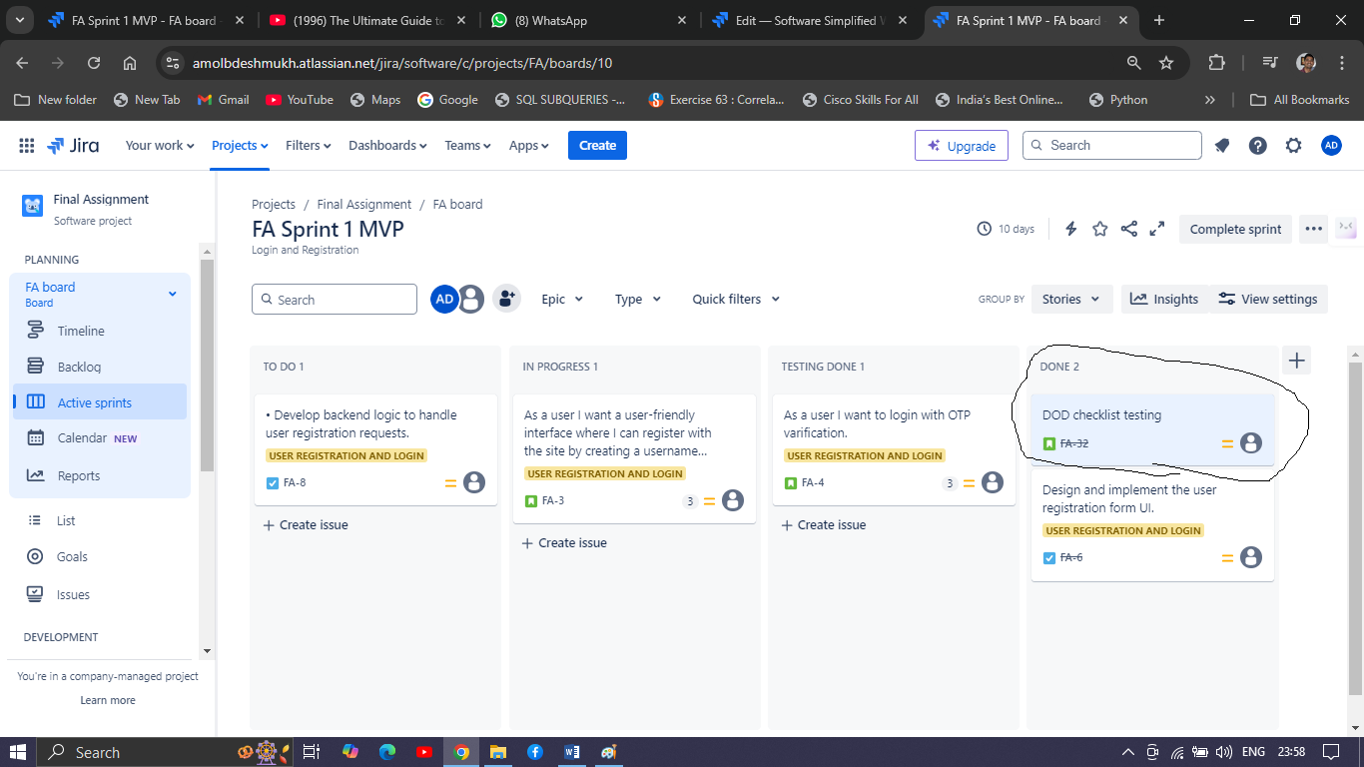

**Mission 9 - Sprint Retrospective**

**Assignment:**

1. Create your free account on miro tool here: <https://miro.com/>

2. Search for Sailboat retro template

3. Just play around with this template

4. Go to <https://reetro.io/>, create free account

5. Use poll, board features

6. Try Mood check in Icebreaker from Miro tool

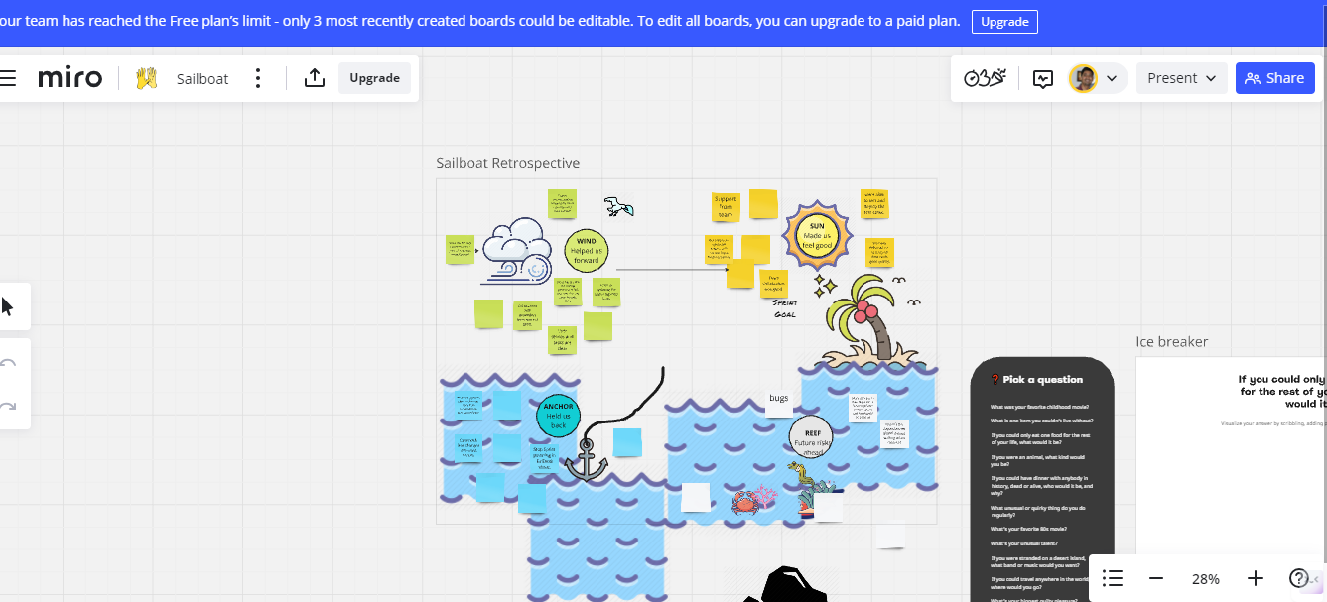

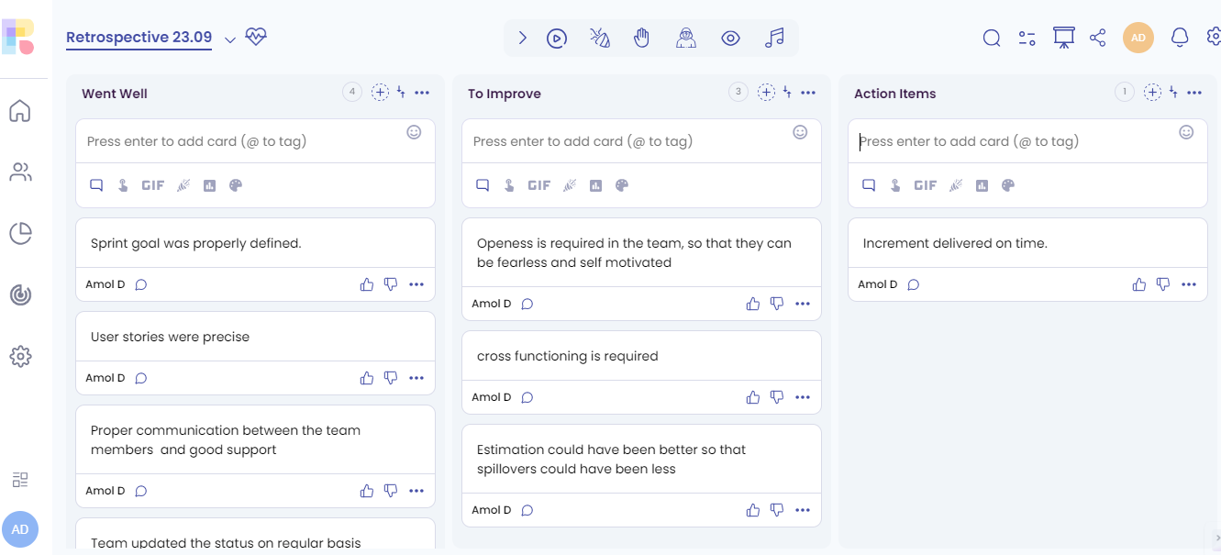

**Ice Breaker**

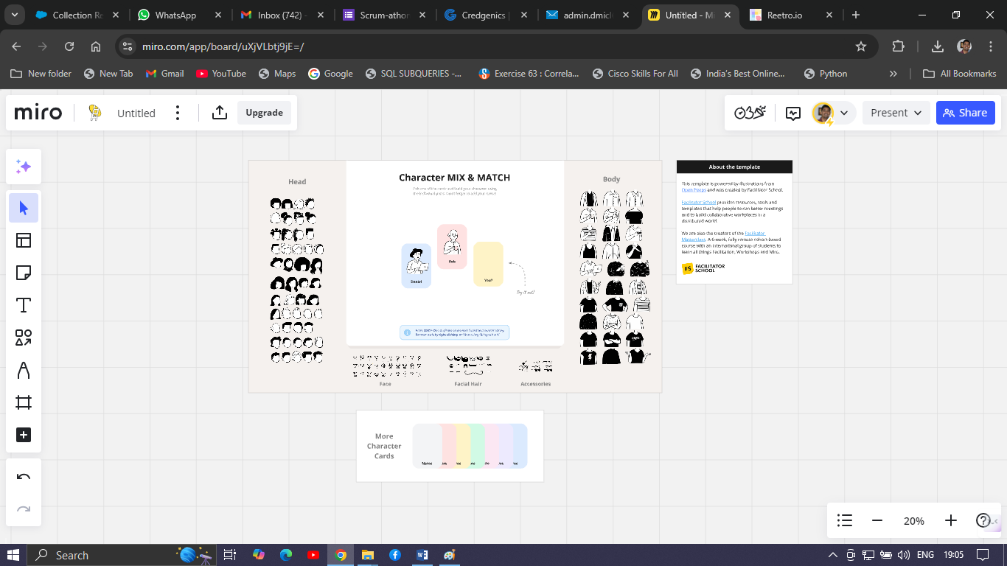

**Mission 10 - Metrics**

