Name: Amol Gokhale

Unique ID:2005362

Email id: amolgokhale14@gmail.com

Anti-Lock Breaking System(ABS) model

Equations:

$$ \omega_v = \frac{V_v}{R_r}$$

$$slip=1-\frac{\omega_w}{\omega_v}$$

$$\omega_v = \mbox{ vehicle speed divided by wheel radius}$$

$$ V_v = \mbox{ vehicle linear velocity}$$

$$ R_r = \mbox{ wheel radius}$$

$$ \omega_w = \mbox{ wheel angular velocity}$$

ABS Model

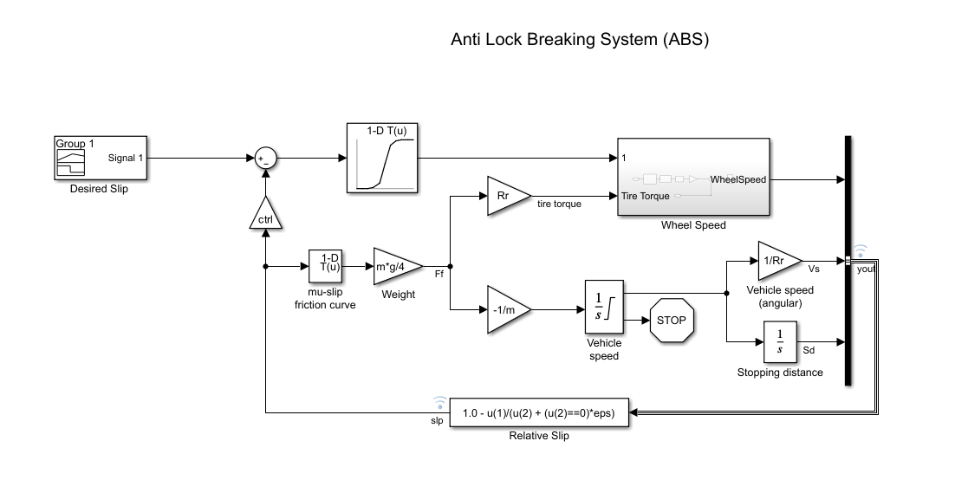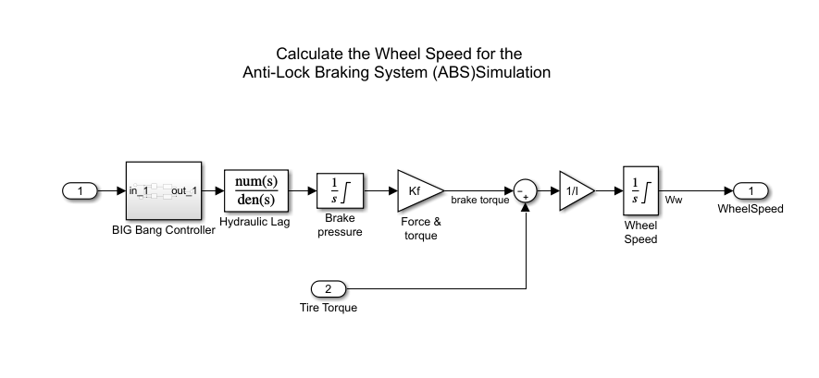

If Slip is 0.4.

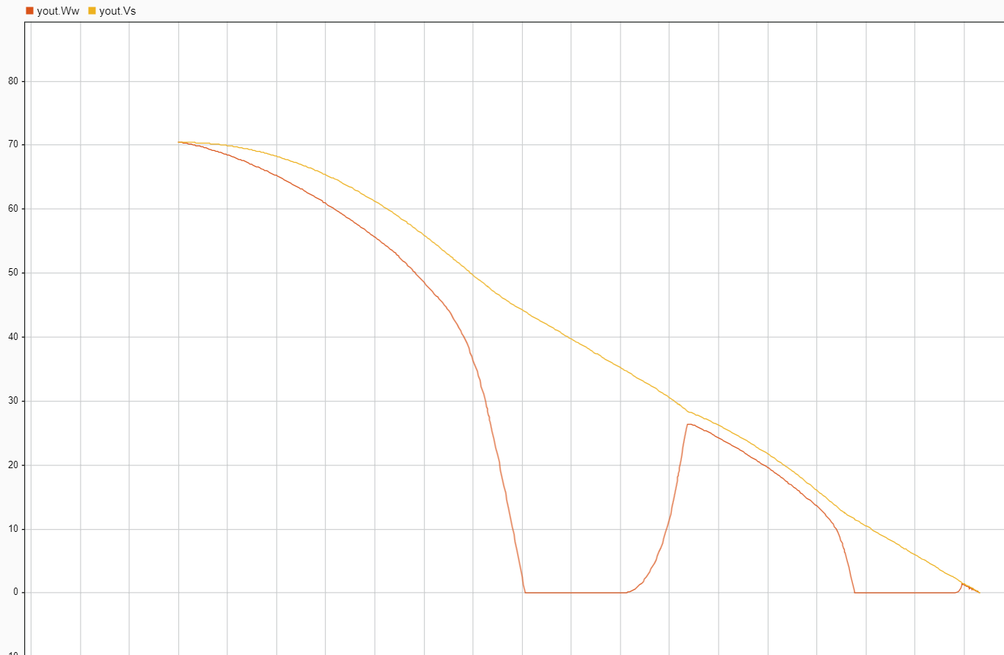

In this case the vehicle is taking more time to stop but the wheel speed is zero twice when the vehicle is still in speed which may cause accident.

Desired Slip given as 0.2 in Signal Builder. The number of wheel revolutions equals 0.8 times the number of revolutions under non-braking conditions with the same vehicle velocity. This maximizes the adhesion between the tire and road and minimizes the stopping distance with the available friction.

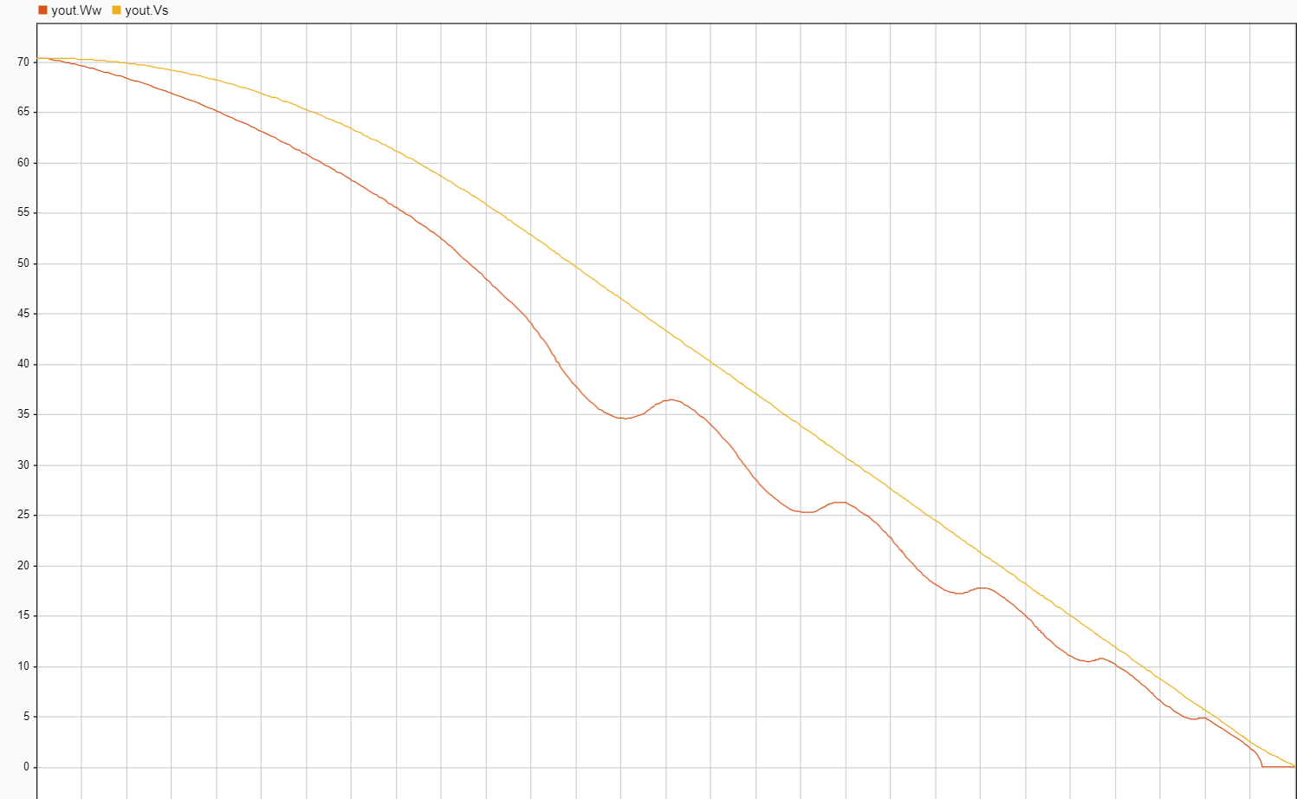

Data Inspector result for Wheel Speed and Vehicle Speed.

The Wheel speed is always lower than vehicle speed without locking up. Vehicle speed reaches to zero before 15 Seconds.

Therefore 0.2 slip gives better results in stopping time for vehicle as well as the comfort and safety.