Input required and output expected:

How to run?
There are two ways of running the given program.

1.
cc dictionary.c
./a.out

Then following screen will appear

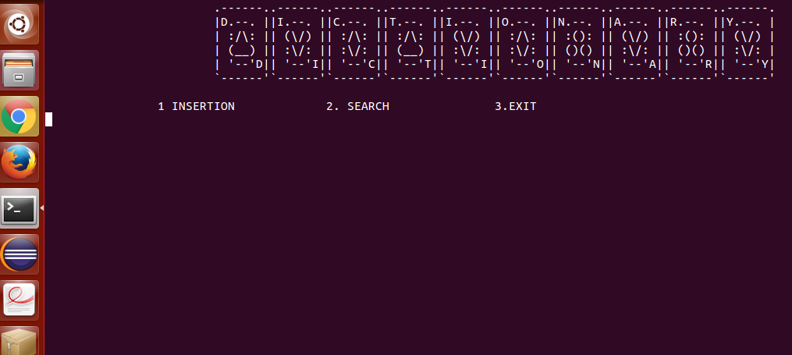

Insert option will let you to insert the word.
Insertion of word include adding meaning to the word , along with adding specified number of synonym with synonym's maximum limit 4.

Search option will let you to search the word.

Exit will have you terminate the program.

2.

cc dictionary.c
./a.out <input.txt

This command will take all the input fom file and terminate the program . This command is for demo purpose.

--------------------------------------------------------------------------------------------------------------------------------------------------------------

Introduction and abstract:

DICTIONARY:
A book or electronic resource that lists the words of a language (typically in alphabetical order) and gives their meaning, or gives the equivalent words in a different language, often also providing information about pronunciation, origin, and usage.

In our program we have implemented dictionary in which we can insert and search word . Insertion also include inserting synonym and also specification like nouns, adjectives etc.
--------------------------------------------------------------------------------------------------------------------------------------------------------

Design model:

For the entire implemention , data structure used are hashing and tree.

Every bucket of tree points to every tree with starting alphabet a,b,c,d..........z.
Therefore, makes total of 26 trees with each tree pointed by every block of array.

For searching there are two phases:

Simple Seach : It will let you search by name.

Advance Search: It will let you search by synonym.

......................................................................................................................................................................

Design techniques used in implementation of design models:

During Insertion, the word to be inserted is decided by it's starting alphabet . It is then to be inserted in tree by hashing. O(1) is the time taken to hash.

def binary_tree_insert(node, key, value
if node is None:
return NodeTree(None, key, value, None)
if key == node.key:
return NodeTree(node.left, key, value, node.right)
if key < node.key:
return NodeTree(binary_tree_insert(node.left, key, value), node.key, node.value, node.right)
else:
return NodeTree(node.left, node.key, node.value, binary_tree_insert(node.right, key, value))
This has a time complexity of O(logn).

For searching,

def search_iteratively(key, node):
current_node = node
while current_node is not None:
if key == current_node.key:
return current_node
elif key < current_node.key:
current_node = current_node.left
else: # key > current_node.key:
current_node = current_node.right
return None

This has time complexity of O(n) for worst case.

For searching time complexity is O(n), where n is the length of word.

------------------------------------------------------------------------------------------------------------------------------------

Test cases:

1. It takes make than 150 input which is verified by giving cat command in which it directly inputs from file.

2. Search by synonym is also enabled which gives you required word.

---------------------------------------------------------------------------------------------------------------------------------------

Applications:

The given program gives you basic back end to store word with their meaning.
This program can be further developed to implement higher level dictionary with advance features.

-------------------------------------------------------------------------------------------------------------------------------------

Limitation of the model:
1. The word that is to be searched should be less than 30 characters.

2. The word's meaning limit is 130 characters.

3 . Maximum number of synonym to be entered is four.

4.This model is only limited to adding word with their synonym , futher development can be made to this dictionary model to add specialization to word using this as back end.

----------------------------------------X---------------------------------------

