Ubuntu Hosted on Oracle VM,

Along with Visual Code installed

Model Trained and Saved

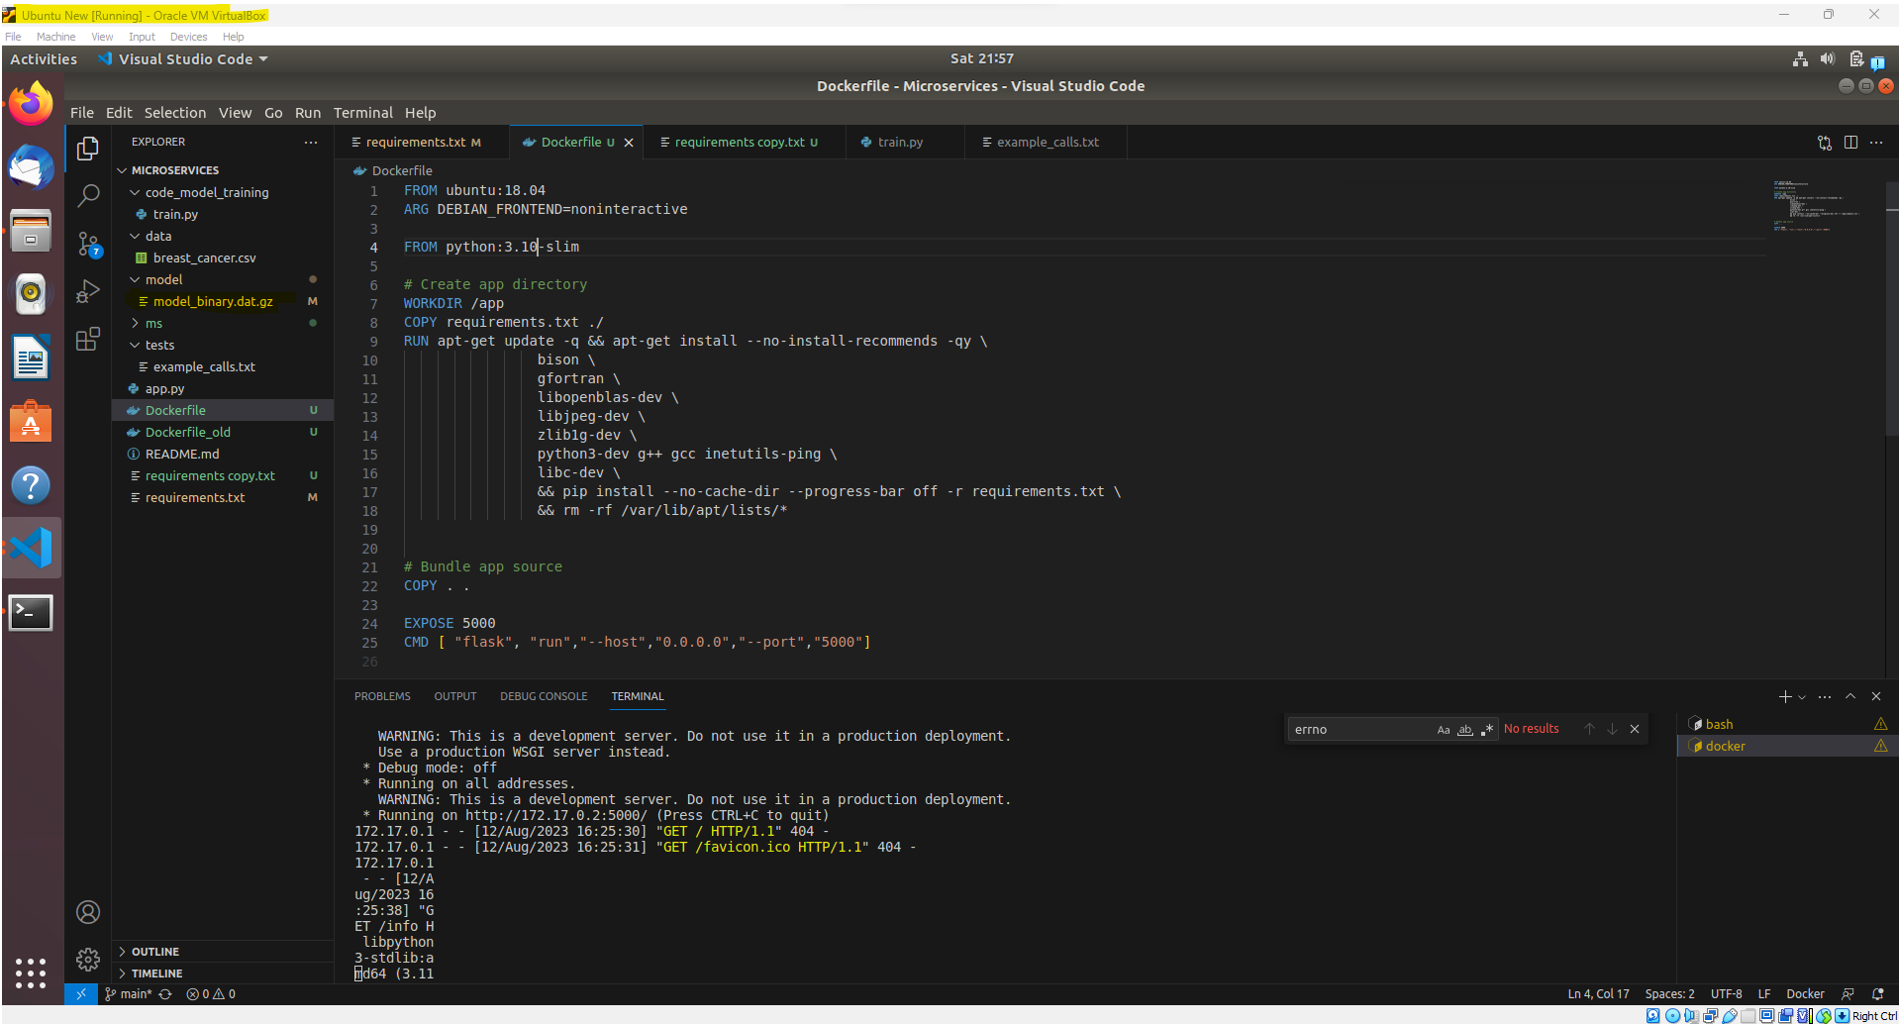

Deployed Locally

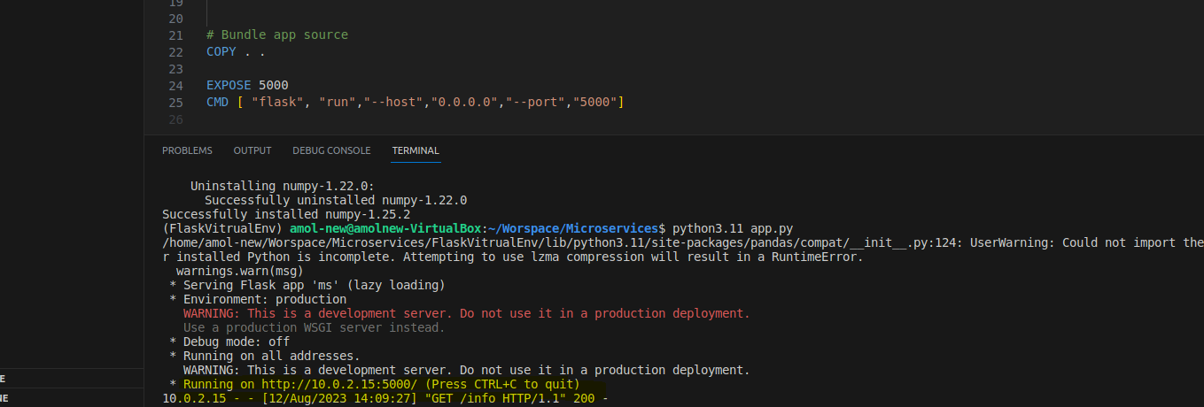

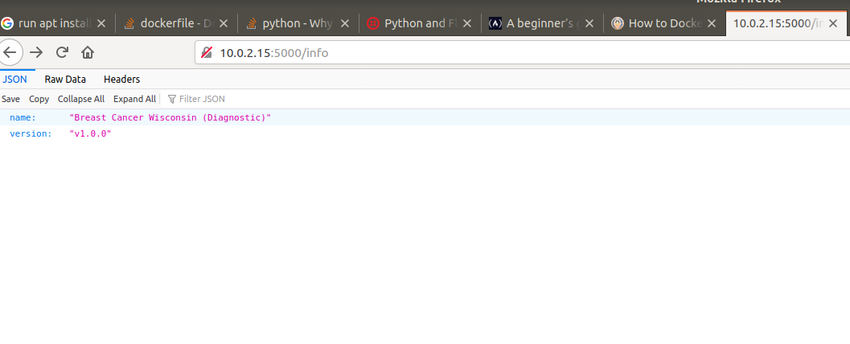

Docker Image created with the web application

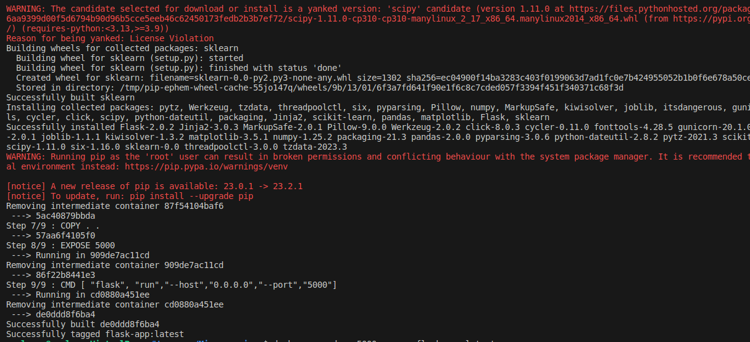

Application Started Screenshots below next page

Application started on Docker

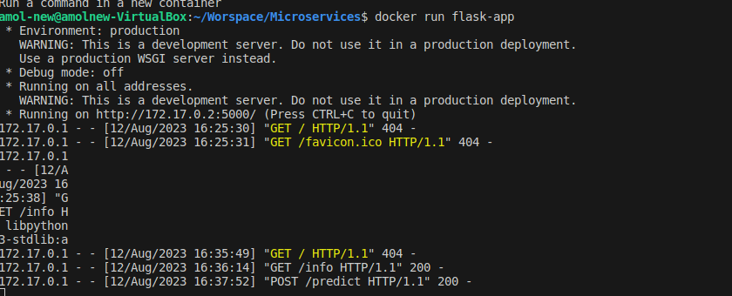

Application Tested from Docker

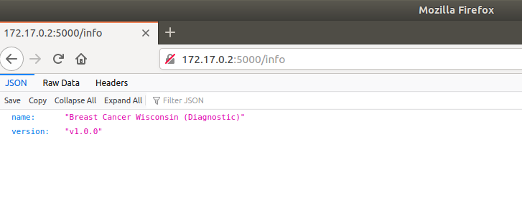

Application tested with curl command, and with prediction

