Order Tracking System

Project Proposal:
Client: Mead Johnson Nutrition
Scope: The request is to have an electronic order tracking system. It should accept a unique order ID, a username, a date, order status, and a lab designation. The program output should be a text file that is appended with each new order.
Purpose: The system will accomplish the following tasks: It will allow user input for order ID (with a unique constraint), username, data, order status and lab designation. The system will display the 10 most recent orders in a table format. Orders should be able to be edited with their order status. The system should allow the user to move between screens, display error messages and allow users to exit with a button.

Class Diagram:
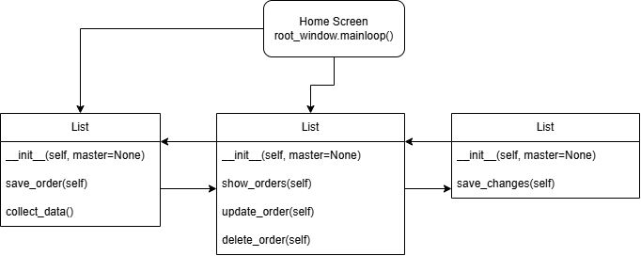

Sample test data:
Order ID | User Name | Date Order Submitted | Cost | Lab Group | Order Status
12345
SR-0001 | Ashleigh Molinet | 9/22/2026 | 123 | GC | Approved-Ordered
SR-0001 | Ashleigh Molinet | 9/23/2026 | 123 | ICP/MS | Approved-Ordered
SR-0002 | Bob Dylan | 9/30/2026 | 326 | GC | Approved - Partially Received
SR-0003 | Dallas Sassy-Pants | 10/1/2026 | 24,000 | LC/MS | Closed
SR-0004 | Ripley McBeagle | 10/1/2026 | 432 | Micro | Revision Requested
SR-0005 | Brian Molinet | 10/2/2026 | 903 | LC/MS | Rejected
SR-0006 | Jacqueline Kempf | 10/2/2026 | 845 | Wet Chem | Rejected
SR-0007 | Dolly Parton | 10/6/2026 | 786 | Micro | Approved - Partially Received
SR-0008 | Charles Barktree | 10/6/2026 | 905,341 | Wet Chem | Rejected
SR-0009 | Ashleigh Molinet | 10/7/2026 | 23,456 | HPLC | Closed
SR-00010 | Ashleigh Molinet | 10/7/2026 | 56,789 | LC/MS | Revision Requested
SR-0011 | Ashleigh Molinet | 10/7/2027 | 34,567 | HPLC | Approved - Ordereed
SR-00012 | Ashleigh Molinet | 9/22/2026 | 34,567 | LC/MS | Closed

Test Scripts and Results:
Script | Result | Screenshot
The system will open to a home screen showing 2 buttons. A “New Orders” and a “Recent Orders” button | Pass. The home screen shows both buttons. | 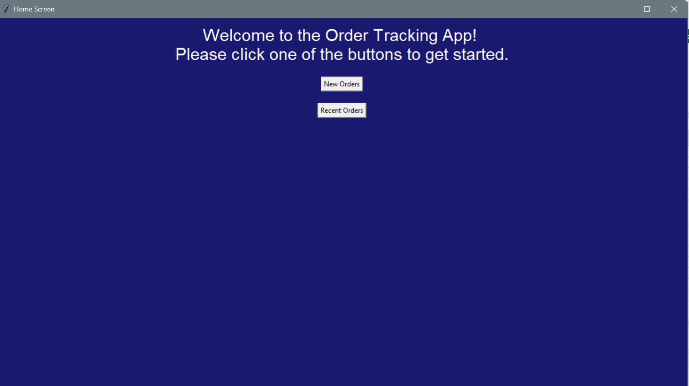
The New Orders button opens a data entry screen. | Pass. The button opens the new orders window. | 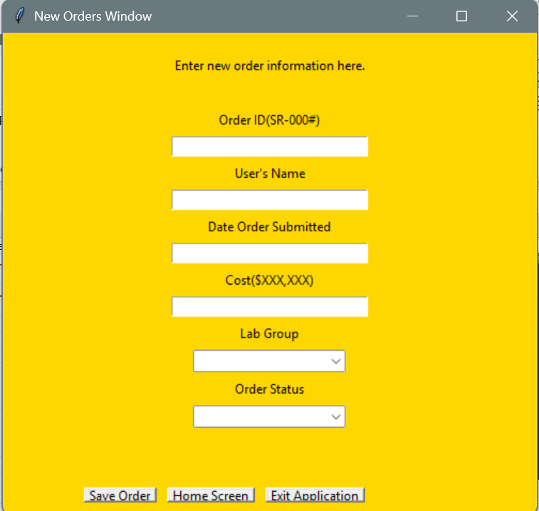
The Recent Orders button opens a window with a viewing pane for the 10 most recent orders. | Pass. The window opens and a viewing pane is present. As of testing there was no data to display. | 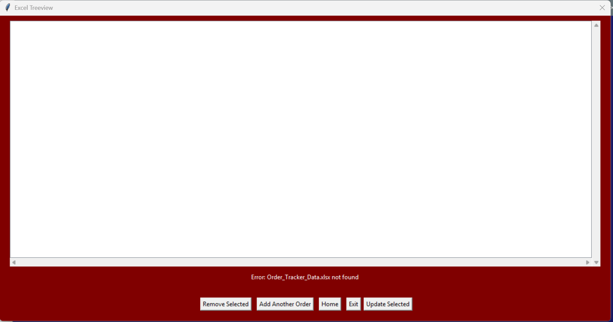
The data entry in “New Orders” enforces all fields required. | Pass. If lines are missing a “Please complete every field” message appears in red. | 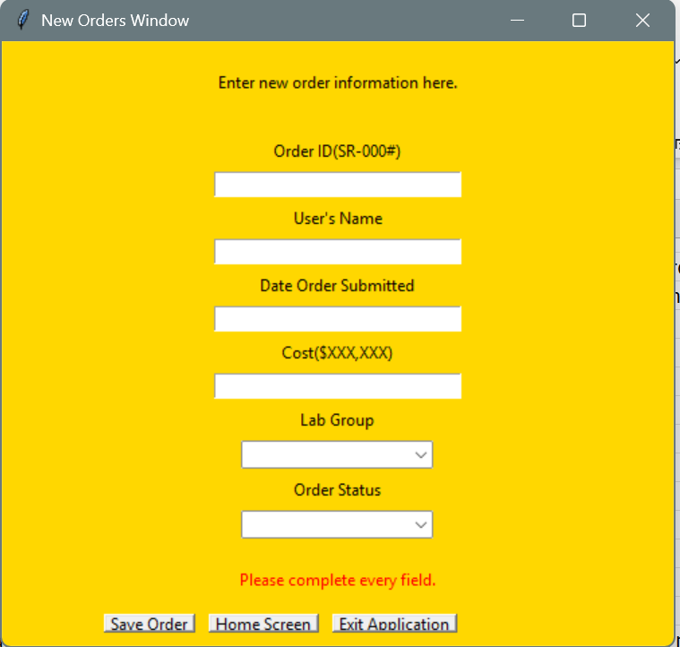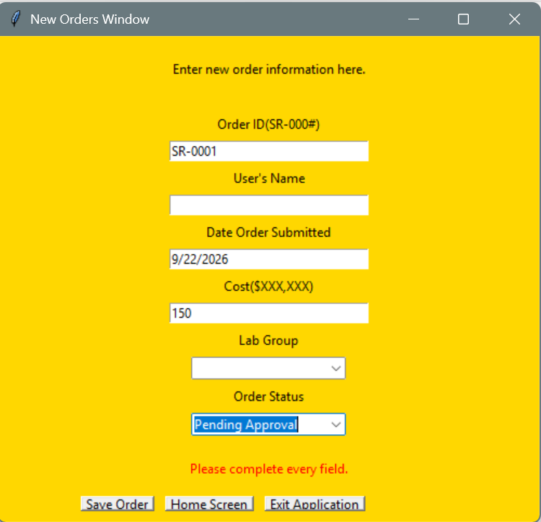
Successful orders display a message in green and clears the form for the next entry. | Pass. Message is displayed and fields are cleared upon success. | 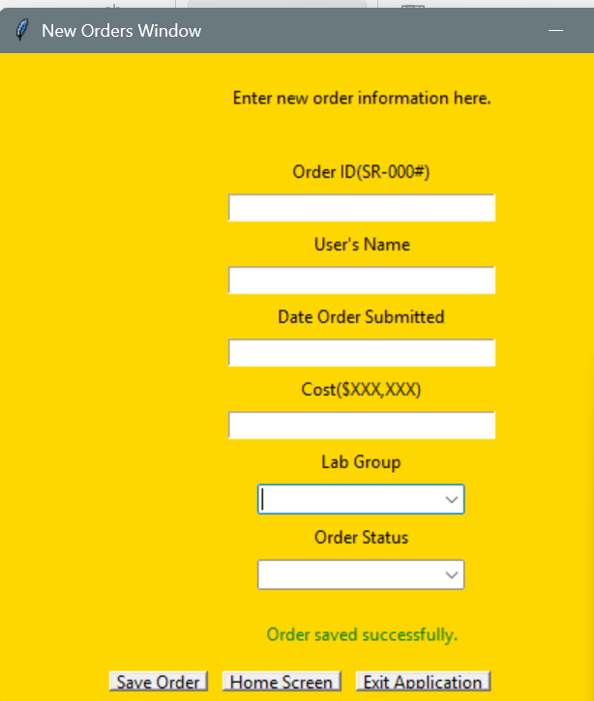
Order ID entry enforces format and uniqueness. An error message displays. | Pass. The system does not allow non-unique Order IDs. The system does not allow IDs that do not match the format. | 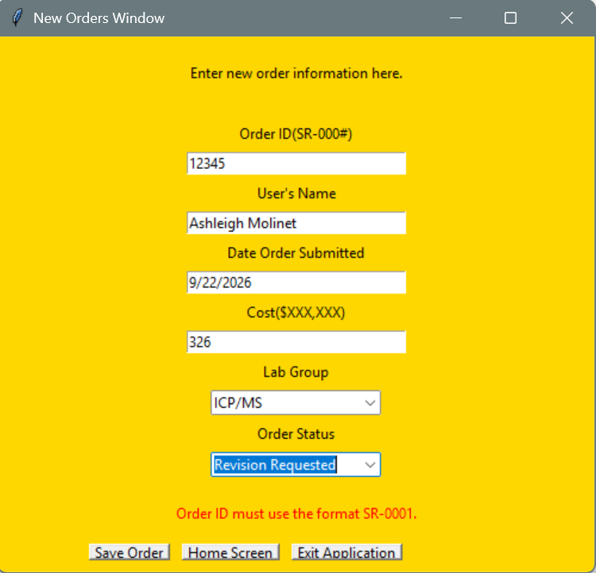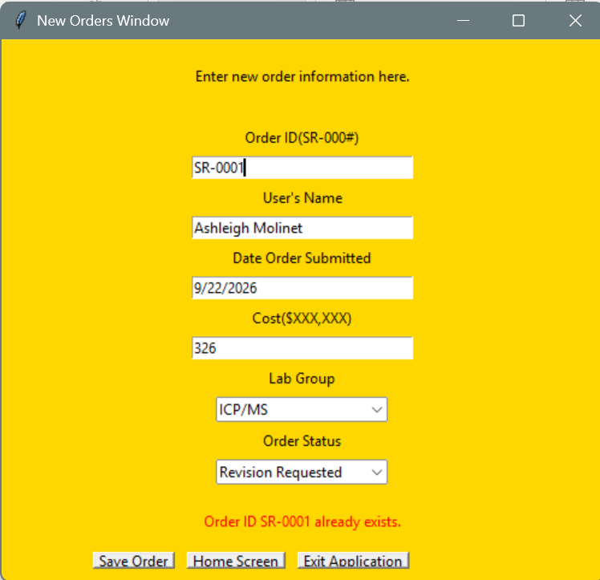  A bug was found during testing, once the system reaches 2 digit order the formatting breaks. Fixed by changing  If not re.fullmatch(r”SR-\d{4}”, order_id):  To  If not re.fullmatch(r”SR-000\d+”, order_id):
Recent orders screen shows 10 most recently added lines. | Pass. The screen shows the 10 newest lines in the excel sheet. | 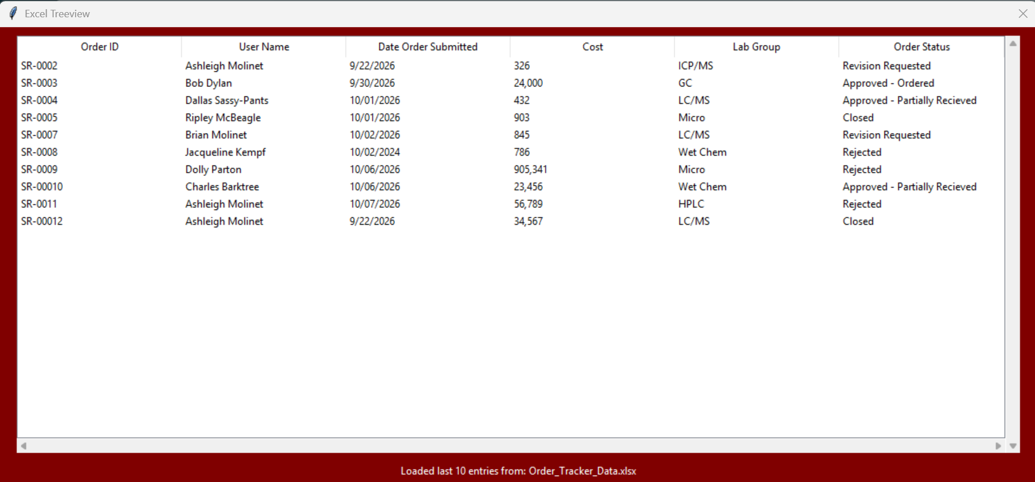
Highlighting an order and clicking “Remove Selected” displays a warning message. | Pass. The system confirms that you wish to delete the selected line before doing so. | 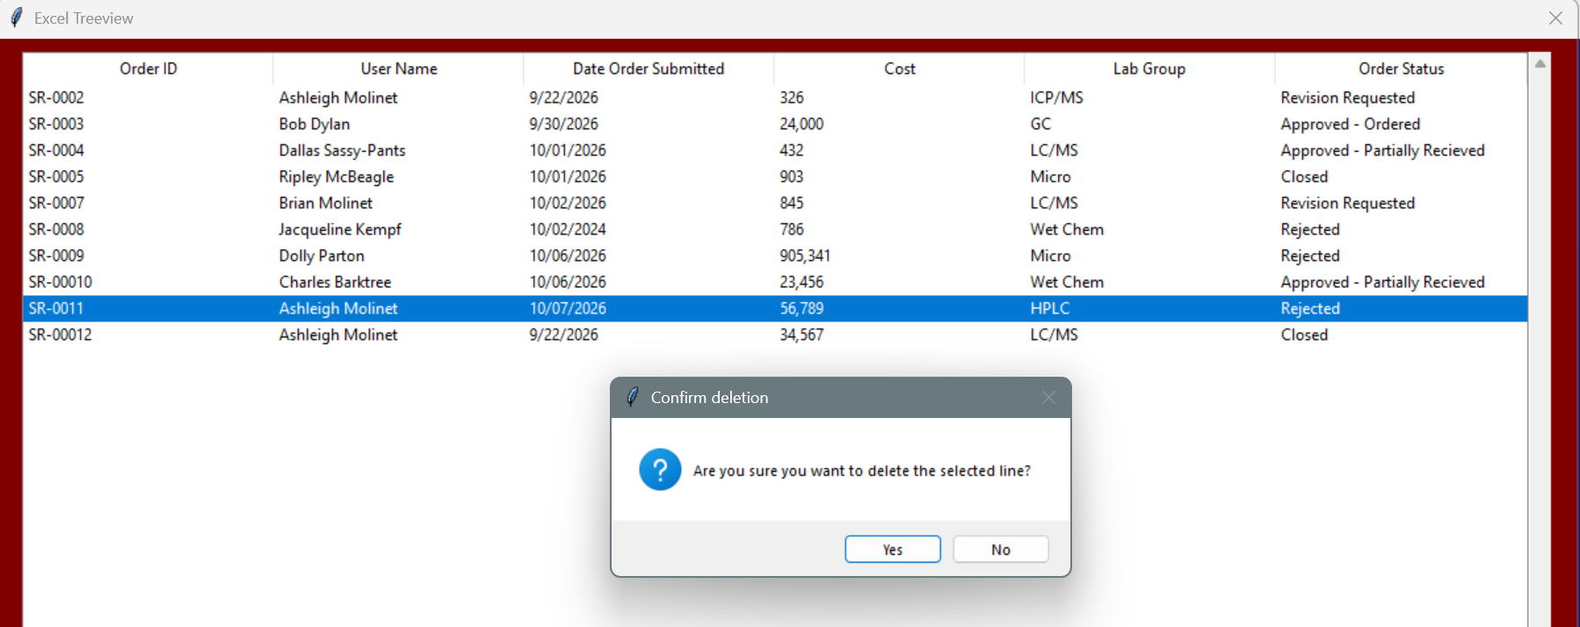
The screen updates and confirms the line was deleted. | Pass. The screen updated and a message is displayed confirming success. | 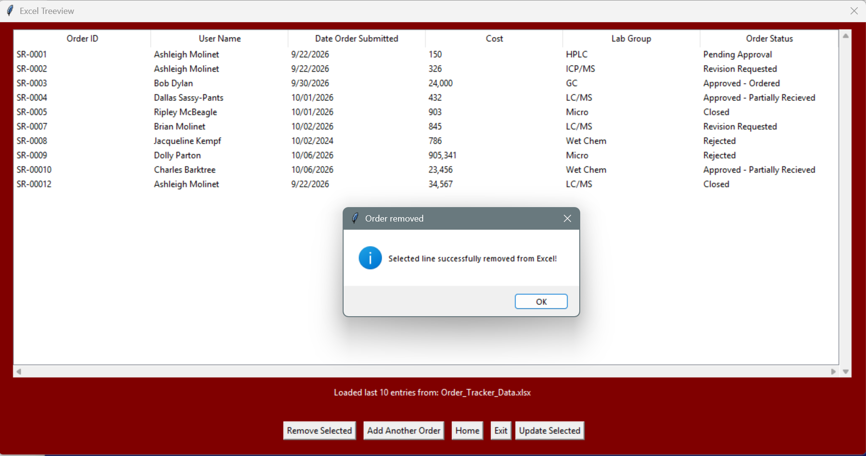
Selecting an order and clicking “Update Selected” opens a new window with the information from the order already populated. | Pass. A new window opens and all fields except for “Modified by” are populated. | 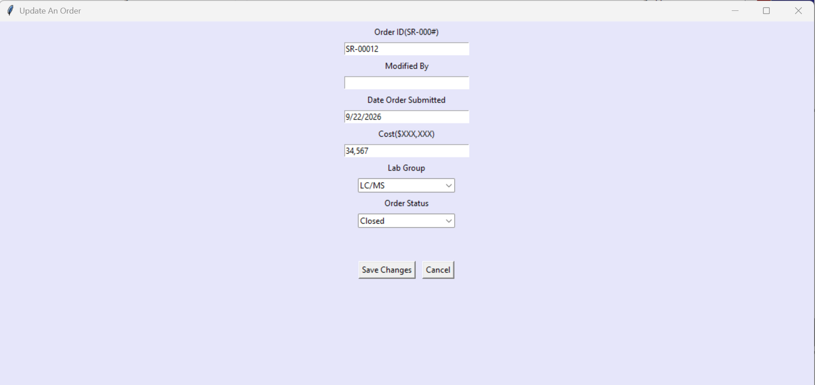
Update screen will not allow user to change order ID. | Pass. When an order ID is changed, once “Save Changes” is clicked an error message appears. | 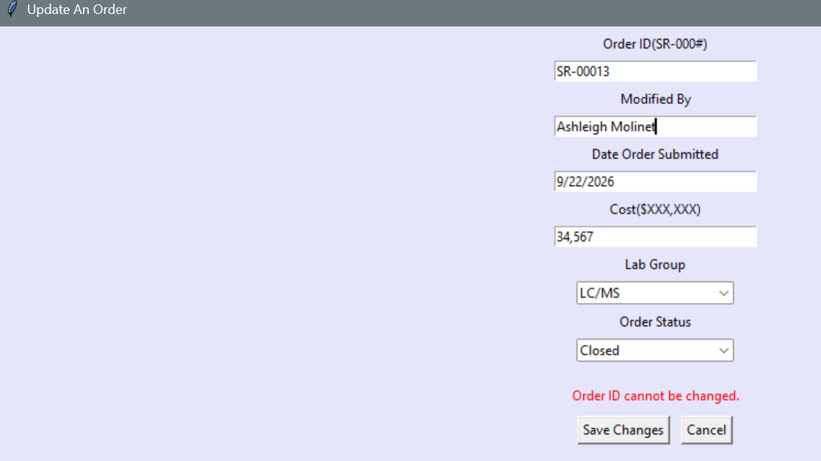
When an order update is successful, the Recent Orders screen is updated to reflect changes. New columns for Modified By and Date Modified are populated. | Pass. The screen updated and both Modified By and Date Modified are populated. | 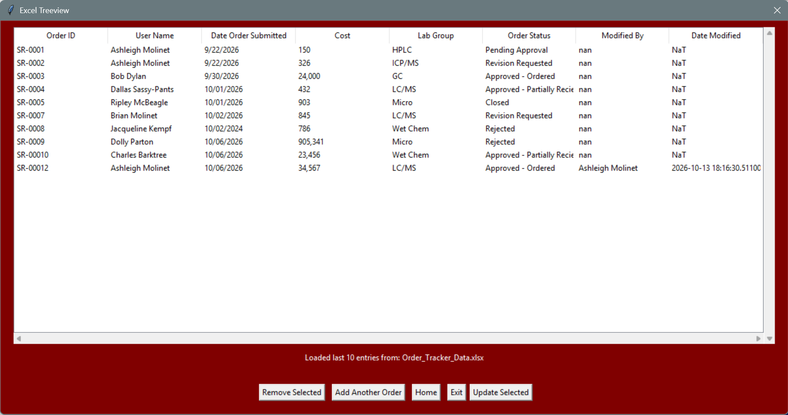

Conclusion
All testing passed and one bug was identified and resolved. System is ready for use.
Future Updates
The system is very basic and limited in scope. The purpose of tracking total lab supply spending is met but can be improved. In the future, including order details with line items will allow the lab to break costs down into further categories such as instrument maintenance, method consumables, and general lab supplies. It will also allow the lab to analyze which items are consumed the fastest and make decisions on how much to keep in stock.
Additional updates can include aesthetic updates, PyQt5 is a GUI package that allows developers to create more modern and professional looking applications, refactoring the GUI for PyQt5 could improve aesthetics. Additional data validation for date (date-picker) and currency format would help keep entries consistent and reduce time cleaning data for analysis.

