**AMOLI N VANI**

**PROJECT 1**

**FACE RECOGNITION**

**Part1:**

**Programming language used and details to run the program:**

This program is coded in MATLAB R2017b and here are the details to run the program.

* In the files submitted, there is a faceRecogMain.m file. This file needs to be in the MATLAB folder that is created while installing MATLAB.
* The path of the Training dataset folder and Test dataset folder needs to be provided in the code. (mentioned in the comments in the code)
* Once the above steps are done, then we just need to click on the run command in the Editor toolbar.



* The manually chosen threshold is t0 = 90000000000. When we run the code using the threshold condition we can classify the images as non-face, unknown face and known face. All the values of mean face m, eigenface matrix U etc, can be seen in the workplace column in the right corner after running the code in MATLAB.

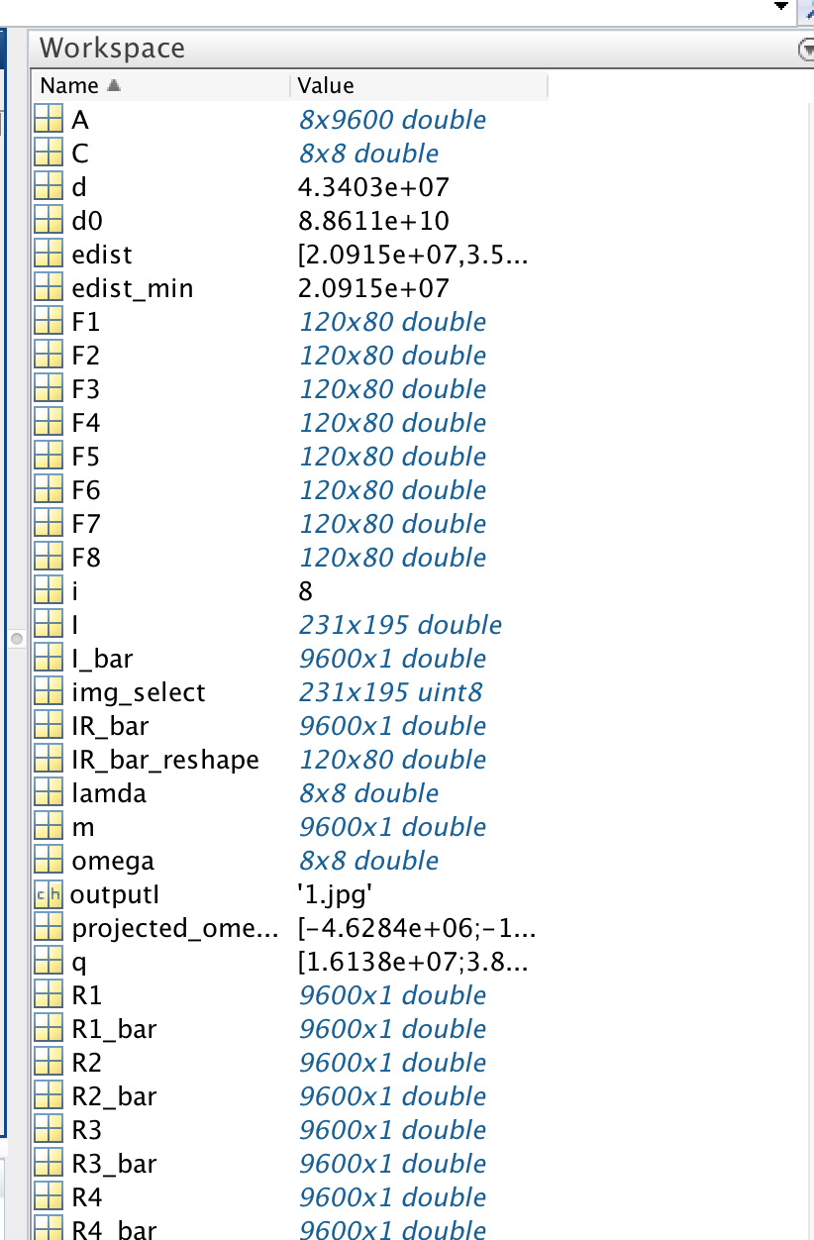

* By double clicking on any variable name, a new window opens in the editor displaying the values it contains.

**Program Source Code:**

close all; %closes all the previous open windows

clc %clears command window

TrainingDatabasePath = '/Users/amolivani/Documents/MATLAB/Training/';%give path of the folder containing training dataset images

TestDatabasePath = '/Users/amolivani/Documents/MATLAB/Test/'; %give path of the folder containing test dataset images

% Training

% Considering the 8 training data images provided

trainI1 = strcat(TrainingDatabasePath,'1','.jpg');

TI1 = imresize(double(imread(trainI1)),[120,80]);

R1= reshape(TI1,120*80,1);

trainI2 = strcat(TrainingDatabasePath,'2','.jpg');

TI2 = imresize(double(imread(trainI2)),[120,80]);

R2= reshape(TI2,120*80,1);

trainI3 = strcat(TrainingDatabasePath,'3','.jpg');

TI3 = imresize(double(imread(trainI3)),[120,80]);

R3= reshape(TI3,120*80,1);

trainI4 = strcat(TrainingDatabasePath,'4','.jpg');

TI4 = imresize(double(imread(trainI4)),[120,80]);

R4= reshape(TI4,120*80,1);

trainI5 = strcat(TrainingDatabasePath,'5','.jpg');

TI5 = imresize(double(imread(trainI5)),[120,80]);

R5= reshape(TI5,120*80,1);

trainI6 = strcat(TrainingDatabasePath,'6','.jpg');

TI6 = imresize(double(imread(trainI6)),[120,80]);

R6= reshape(TI6,120*80,1);

trainI7 = strcat(TrainingDatabasePath,'7','.jpg');

TI7 = imresize(double(imread(trainI7)),[120,80]);

R7= reshape(TI7,120*80,1);

trainI8 = strcat(TrainingDatabasePath,'8','.jpg');

TI8 = imresize(double(imread(trainI8)),[120,80]);

R8= reshape(TI8,120*80,1);

% calculating mean face

m = (R1+R2+R3+R4+R5+R6+R7+R8)/8;

%R_m = reshape(m,120,80);

% subtracting mean face from all the training images

R1_bar = R1-m;

R2_bar = R2-m;

R3_bar = R3-m;

R4_bar = R4-m;

R5_bar = R5-m;

R6_bar = R6-m;

R7_bar = R7-m;

R8_bar = R8-m;

% putting all training faces into a single matrix A

A = [reshape(R1_bar,1,120*80)

    reshape(R2_bar,1,120*80)

    reshape(R3_bar,1,120*80)

    reshape(R4_bar,1,120*80)

    reshape(R5_bar,1,120*80)

    reshape(R6_bar,1,120*80)

    reshape(R7_bar,1,120*80)

    reshape(R8_bar,1,120*80)];

% calculating the covariance matrix

C = (A)*(A');

% finding eigenvalues and putting eigenvectors into a single matrix V

[V,lamda] = eigs(C,8,'largestabs');

%calculating the face space u

u = V*A;

U = u';

% displaying each training face onto face space

figure('Name','Training images after subtracting mean face')

subplot(3,3,1), F1=reshape(U(:,1),120,80); pcolor(flipud(F1)), shading interp, colormap(gray), set(gca, 'Xtick', [], 'Ytick', []); title('1.jpg');

subplot(3,3,2), F2=reshape(U(:,2),120,80); pcolor(flipud(F2)), shading interp, colormap(gray), set(gca, 'Xtick', [], 'Ytick', []); title('2.jpg');

subplot(3,3,3), F3=reshape(U(:,3),120,80); pcolor(flipud(F3)), shading interp, colormap(gray), set(gca, 'Xtick', [], 'Ytick', []); title('3.jpg');

subplot(3,3,4), F4=reshape(U(:,4),120,80); pcolor(flipud(F4)), shading interp, colormap(gray), set(gca, 'Xtick', [], 'Ytick', []); title('4.jpg');

subplot(3,3,5), F5=reshape(U(:,5),120,80); pcolor(flipud(F5)), shading interp, colormap(gray), set(gca, 'Xtick', [], 'Ytick', []); title('5.jpg');

subplot(3,3,6), F6=reshape(U(:,6),120,80); pcolor(flipud(F6)), shading interp, colormap(gray), set(gca, 'Xtick', [], 'Ytick', []); title('6.jpg');

subplot(3,3,7), F7=reshape(U(:,7),120,80); pcolor(flipud(F7)), shading interp, colormap(gray), set(gca, 'Xtick', [], 'Ytick', []); title('7.jpg');

subplot(3,3,8), F8=reshape(U(:,8),120,80); pcolor(flipud(F8)), shading interp, colormap(gray), set(gca, 'Xtick', [], 'Ytick', []); title('8.jpg');

% calculating the PCA coefficient omega

omega = horzcat(u*R1_bar,u*R2_bar,u*R3_bar,u*R4_bar,u*R5_bar,u*R6_bar,u*R7_bar,u*R8_bar);

% Recognition

% Reading the image to be tested

test_image = strcat(TestDatabasePath,'1','.jpg');%give the test image name

I = imresize( double( imread(test_image)), [120,80]);

I = reshape(I,120*80,1);

% subtracting mean face m from input face I

I_bar = I-m;

% computing its projection onto face space

projected_omega = u*I_bar;

% reconstructing input face image from eigenfaces

IR_bar = U*projected_omega;

IR_bar_reshape = reshape(IR_bar,120,80);

%displaying the reconstructed image

figure('Name','Reconstructed Image'), imshow(IR_bar_reshape);

%manually chosen threshold

t0 = 9.0000e+10;

% calculating distance between input face image and its reconstruction

d0 = norm( IR_bar - I );

% calculating distance between input face and training images in face space

edist = [];

for i = 1 : 8

    q = omega(:,i);

    d = ( norm( projected_omega - q ) );

    edist = [edist d];

end

% finding the minimum distance and recognizing its index for classification

[edist_min , Recognized_index] = min(edist);

outputI = strcat(int2str(Recognized_index),'.jpg');

img_select = strcat(TrainingDatabasePath,outputI);

img_select = imread(img_select);

% displaying the output and its classification result

figure('Name','Output Image');

I = imresize(double(imread(test_image)),[231,195]);

subplot(1,2,1), pcolor(flipud(I)), shading interp, colormap(gray), set(gca, 'Xtick', [], 'Ytick', []), title('Known face detected');

subplot(1,2,2), pcolor(flipud(img_select)), shading interp, colormap(gray), set(gca, 'Xtick', [], 'Ytick', []), title('Classification Result');

str = strcat('Test image classified to the following training image: ',outputI);

disp(str)

**Part 2:**

The PCA coefficients for the 8 training images:

**For Test Image : subject01.normal.jpg**

|  |
| --- |
| -7922673.05416522 |
| 13229673.1384532 |
| 6600669.68783935 |
| -3926277.97703927 |
| -22960953.5393542 |
| -375900.400998234 |
| 6760175.03852448 |
| -7922673.05416522 |

**For Test Image : subject02.normal.jpg**

|  |
| --- |
| 3392887.45040669 |
| -14188671.1795121 |
| 9614742.63147488 |
| 2774163.87298454 |
| 17010103.1747608 |
| -6477946.45601395 |
| 7081565.56025872 |
| 3392887.45040669 |

**For Test Image : subject03.normal.jpg**

|  |
| --- |
| -4422432.75373573 |
| -5852078.65558291 |
| -3476338.61734747 |
| -6184823.52790725 |
| 791608.339932218 |
| -869596.983974621 |
| 13038850.5580624 |
| -4422432.75373573 |

**For Test Image : subject07.normal.jpg**

|  |
| --- |
| 9749194.50515018 |
| -27644130.2381088 |
| -3901941.29312922 |
| 8638589.67706363 |
| 14908464.1444032 |
| 1616917.20252462 |
| 10375138.2894303 |
| 9749194.50515018 |

**For Test Image : subject10.normal.jpg**

|  |
| --- |
| -2111643.86313928 |
| -1931010.94061614 |
| 3869832.74922021 |
| -13350512.5727828 |
| -3292384.90708861 |
| 12181068.3675146 |
| -12980311.8313238 |
| -2111643.86313928 |

**For Test Image : subject11.normal.jpg**

|  |
| --- |
| 1018390.70497715 |
| 43815092.7442895 |
| -14110542.6212187 |
| 7300085.39832737 |
| -12026571.0139520 |
| -22367671.7770649 |
| -40760119.9791861 |
| 1018390.70497715 |

**For Test Image : subject14.normal.jpg**

|  |
| --- |
| -3543290.96595410 |
| 4287300.92672801 |
| -10308796.3378749 |
| -8147192.70648713 |
| -10542511.8605603 |
| 11053615.3511282 |
| -1969429.04787823 |
| -3543290.96595410 |

**For Test Image : subject15.normal.jpg**

|  |
| --- |
| 3839567.97646025 |
| -11716175.7956508 |
| 11712373.8010359 |
| 12895967.8358410 |
| 16112245.6618590 |
| 5239514.69688410 |
| 18454131.4121123 |
| 3839567.97646025 |

**Part 3:**

**For Test Image : subject01.normal.jpg**

1. Image after subtracting mean face

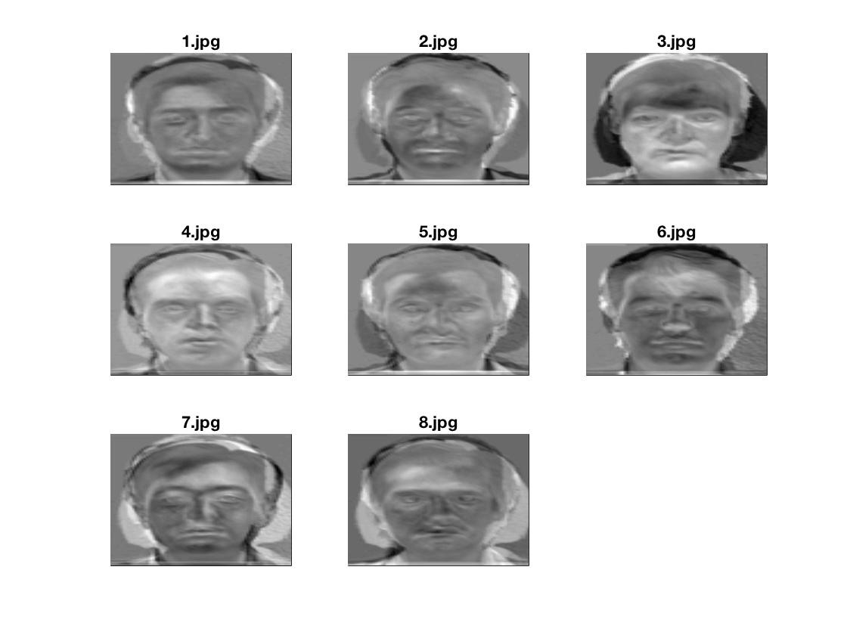

1. PCA coefficients

|  |
| --- |
| -9524388.33732406 |
| -7922673.05416522 |
| 13229673.1384532 |
| 6600669.68783935 |
| -3926277.97703927 |
| -22960953.5393542 |
| -375900.400998234 |
| 6760175.03852448 |

1. Reconstructed Face Image

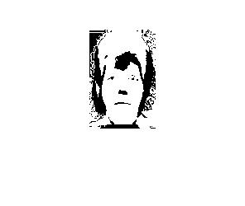

1. Distances di for i = 0 to M

|  |  |  |  |  |  |  |  |
| --- | --- | --- | --- | --- | --- | --- | --- |
| 0 | 50865884.31 | 41010896.23 | 64855994.11 | 36800210.43 | 66962013.94 | 27663531.31 | 58508955.23 |

1. Final classification result

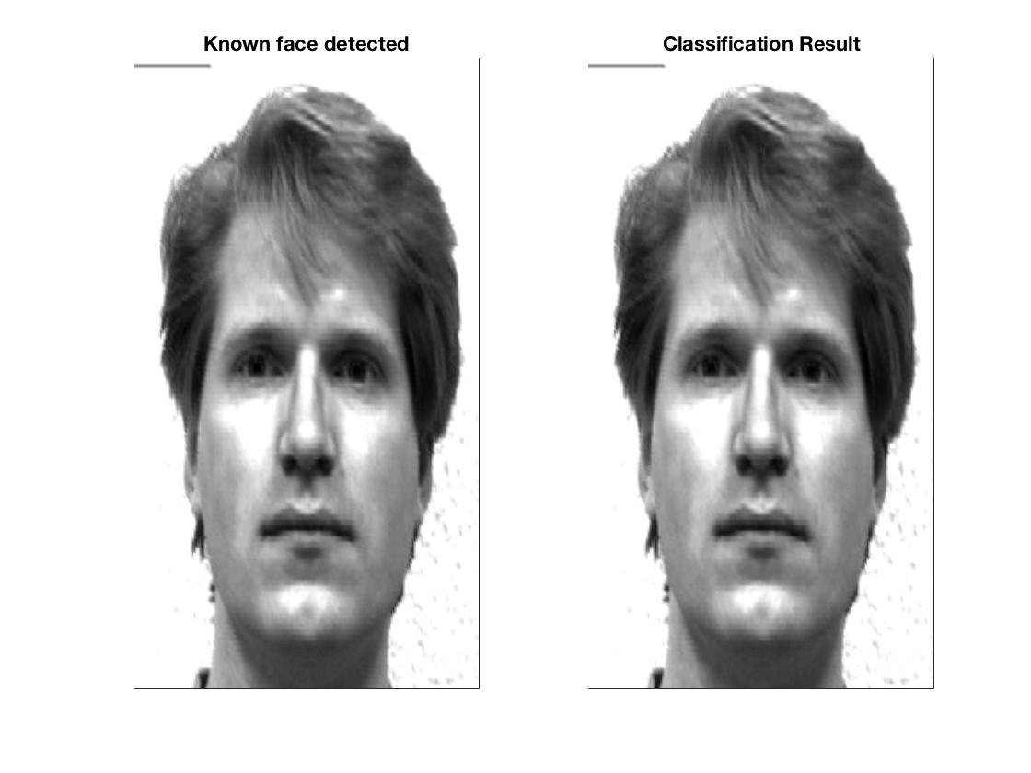

**For Test Image : subject01.happy.jpg**

1. Image after subtracting mean face



1. PCA coefficients

|  |
| --- |
| -6700997.714 |
| -4986028.801 |
| 5608593.653 |
| 6594137.99 |
| -1860176.178 |
| -13574755.9 |
| -1401604.756 |
| 8046162.448 |

1. Reconstructed Face Image

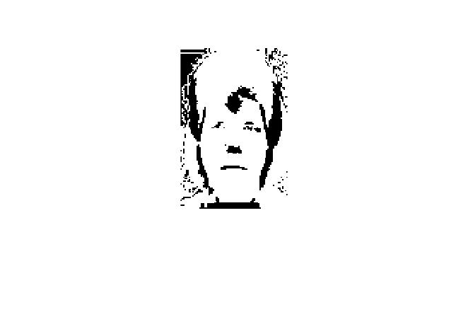

1. Distances di for i = 0 to M

|  |  |  |  |  |  |  |  |
| --- | --- | --- | --- | --- | --- | --- | --- |
| 13028876.59 | 38171524.79 | 30800065.15 | 52481564.69 | 31003445.55 | 70237404.74 | 24687835.83 | 46661862.09 |

1. Final classification result

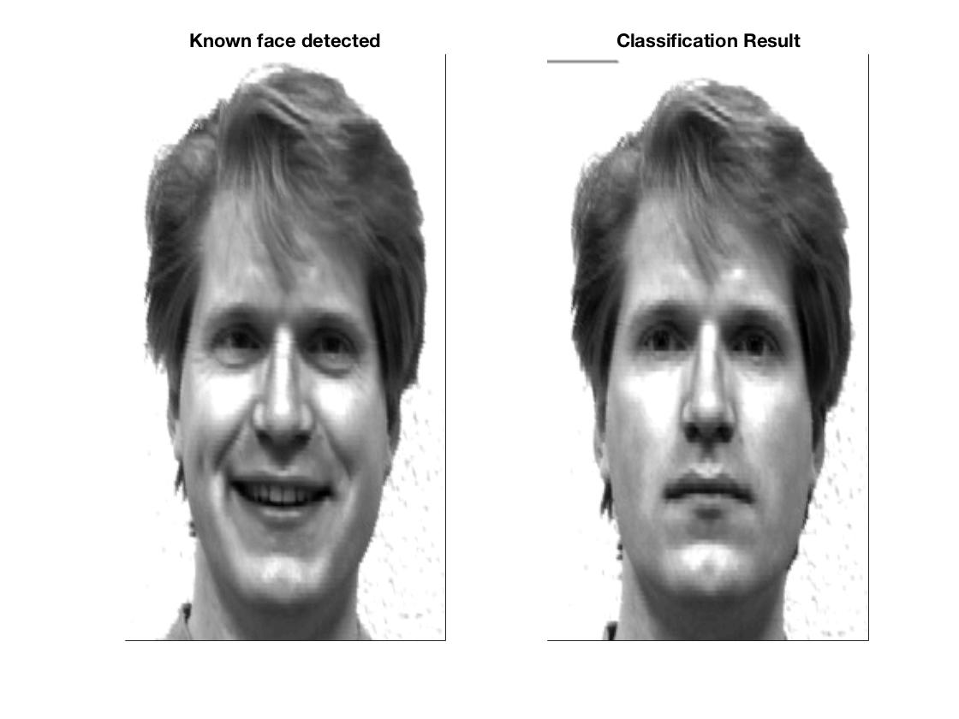

**For Test Image : subject01.centerlight.jpg**

1. Image after subtracting mean face



1. PCA coefficients

|  |
| --- |
| -6379438.11161003 |
| -1666273.68723821 |
| 6195823.74203019 |
| 3153094.46875014 |
| -221300.028586534 |
| -4684595.91760699 |
| -3205825.53127508 |
| -1806337.92826703 |

1. Reconstructed Face Image

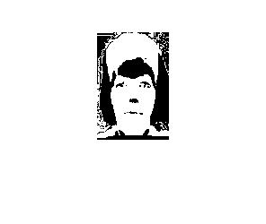

1. Distances di for i = 0 to M

|  |  |  |  |  |  |  |  |
| --- | --- | --- | --- | --- | --- | --- | --- |
| 23227995.77 | 32458496.13 | 30652553.79 | 48290429.82 | 24978890.89 | 61829971.71 | 22523923.91 | 44920090.91 |

1. Final classification result

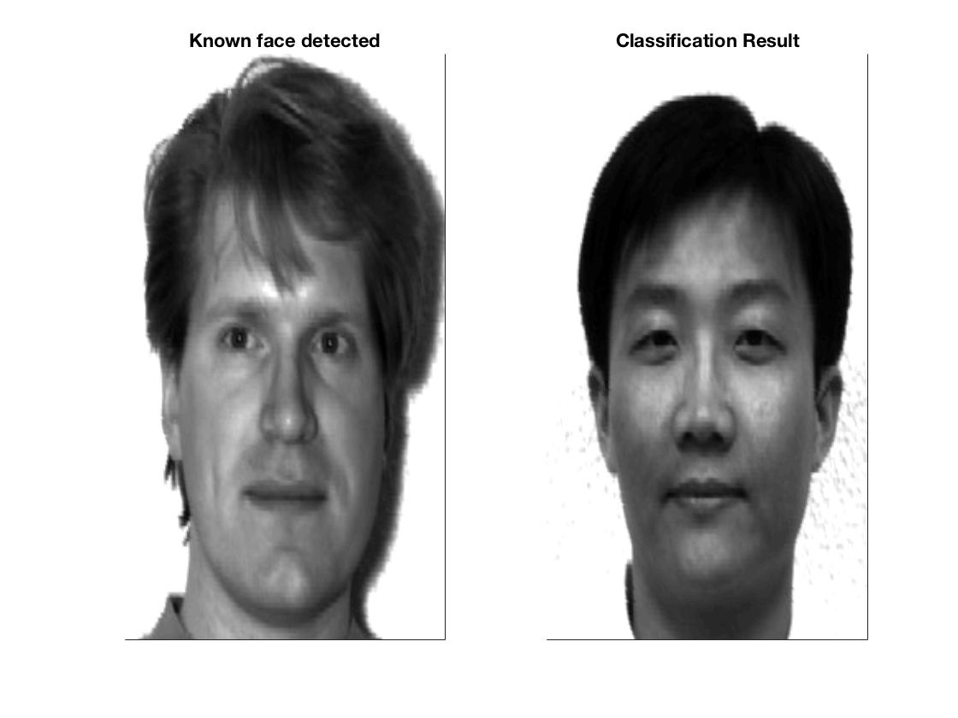

**For Test Image : subject02.normal.jpg**

1. Image after subtracting mean face



1. PCA coefficients

|  |
| --- |
| -5220148.21905885 |
| 3392887.45040669 |
| -14188671.1795121 |
| 9614742.63147488 |
| 2774163.87298454 |
| 17010103.1747608 |
| -6477946.45601395 |
| 7081565.56025872 |

1. Reconstructed Face Image

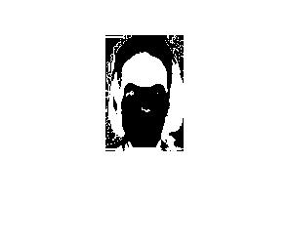

1. Distances di for i = 0 to M

|  |  |  |  |  |  |  |  |
| --- | --- | --- | --- | --- | --- | --- | --- |
| 50865884.31 | 0 | 33403137.33 | 29131116.07 | 40599267.03 | 86433270.47 | 45649381.28 | 28926768.95 |

1. Final classification result

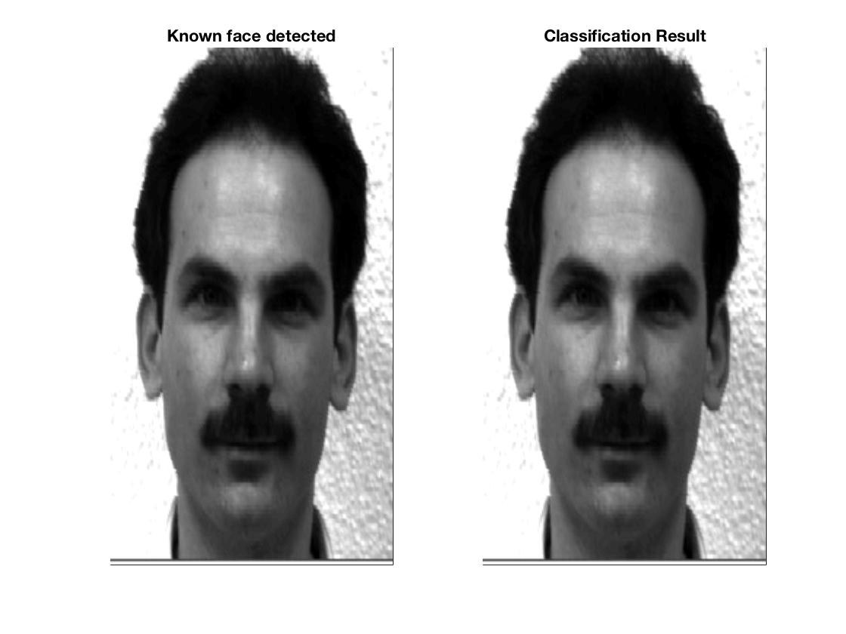

**For Test Image : subject03.normal.jpg**

1. Image after subtracting mean face



1. PCA coefficients

|  |
| --- |
| 14868886.4092696 |
| -4422432.75373573 |
| -5852078.65558291 |
| -3476338.61734747 |
| -6184823.52790725 |
| 791608.339932218 |
| -869596.983974621 |
| 13038850.5580624 |

1. Reconstructed Face Image

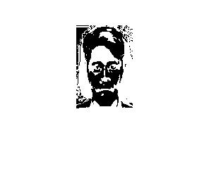

1. Distances di for i = 0 to M

|  |  |  |  |  |  |  |  |
| --- | --- | --- | --- | --- | --- | --- | --- |
| 41010896.23 | 33403137.33 | 0 | 33346385.09 | 35592599.78 | 85507913.27 | 36089348.24 | 31629100.22 |

1. Final classification result

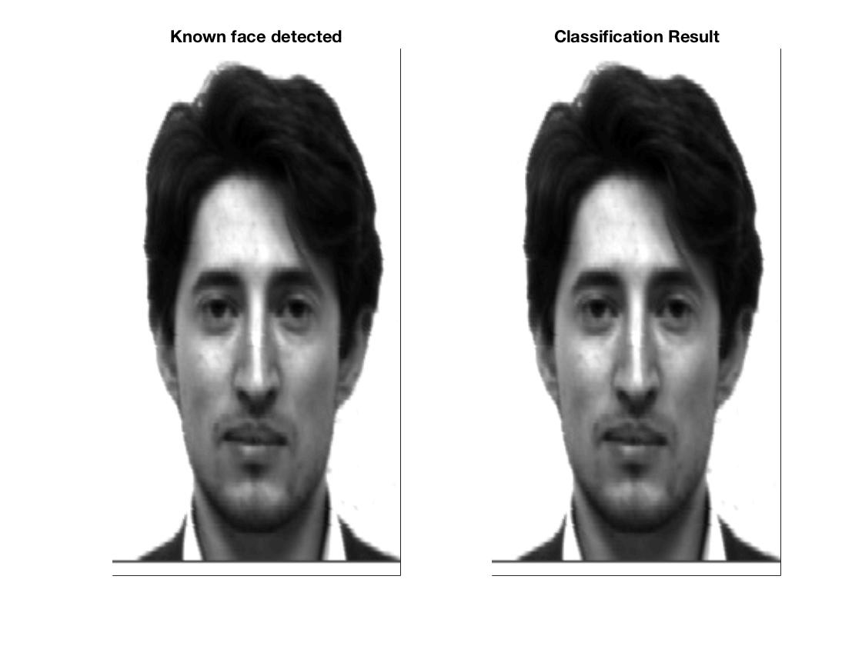

**For Test Image : subject07.normal.jpg**

1. Image after subtracting mean face



1. PCA coefficients

|  |
| --- |
| 12926100.5850306 |
| 9749194.50515018 |
| -27644130.2381088 |
| -3901941.29312922 |
| 8638589.67706363 |
| 14908464.1444032 |
| 1616917.20252462 |
| 10375138.2894303 |

1. Reconstructed Face Image

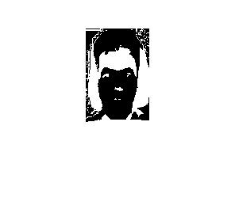

1. Distances di for i = 0 to M

|  |  |  |  |  |  |  |  |
| --- | --- | --- | --- | --- | --- | --- | --- |
| 64855994.11 | 29131116.07 | 33346385.09 | 0 | 50498037.57 | 100422126.9 | 54454450.23 | 25312284.82 |

1. Final classification result

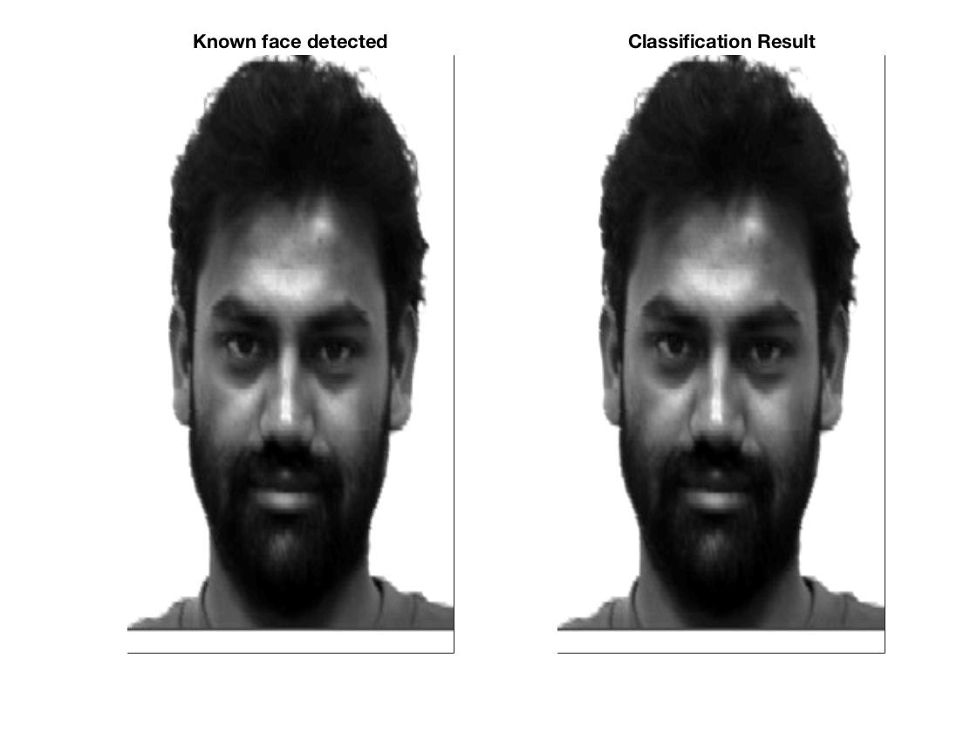

**For Test Image : subject07.happy.jpg**

1. Image after subtracting mean face



1. PCA coefficients

|  |
| --- |
| 6663169.65840953 |
| 3444631.96398947 |
| -16516796.4187672 |
| 1219429.96744463 |
| 1354482.96144991 |
| 9576616.06177309 |
| 5367890.55810524 |
| 8452405.95514463 |

1. Reconstructed Face Image

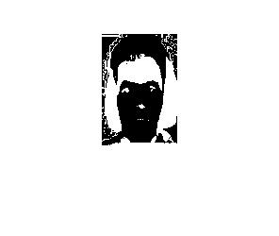

1. Distances di for i = 0 to M

|  |  |  |  |  |  |  |  |
| --- | --- | --- | --- | --- | --- | --- | --- |
| 49269640.76 | 20410601.3 | 21423589.11 | 18118259.56 | 34775960.66 | 90121910.29 | 39384418.6 | 22339207.38 |

1. Final classification result

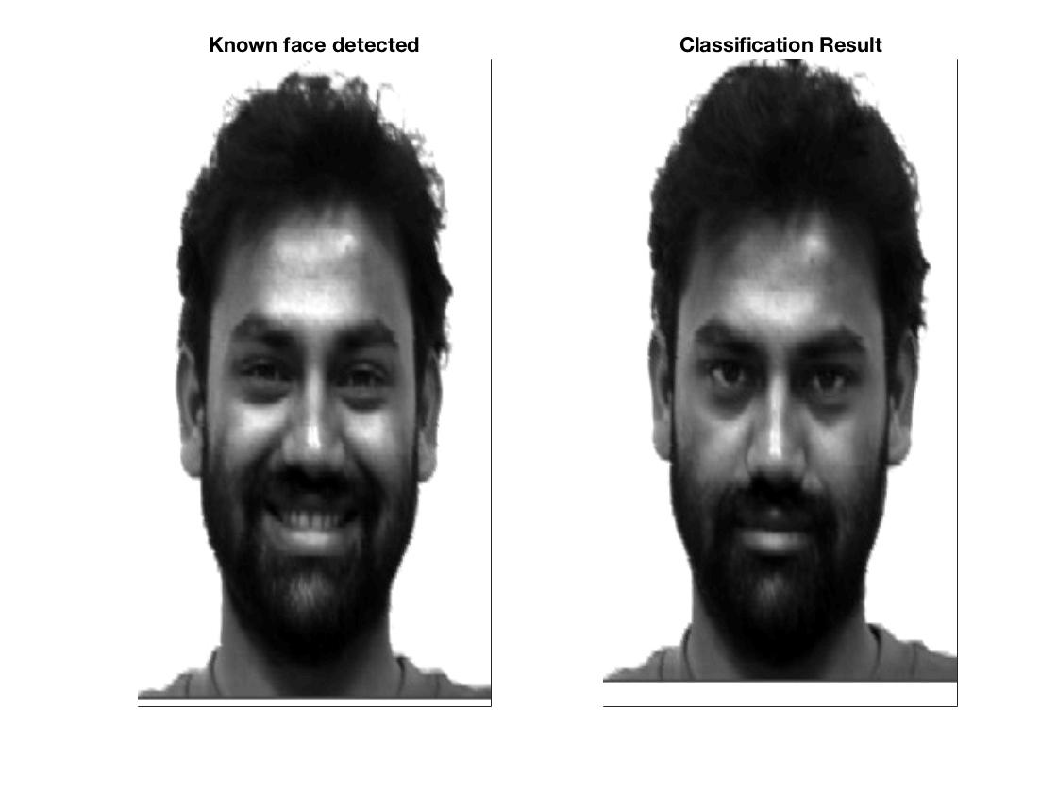

**For Test Image : subject07.centerlight.jpg**

1. Image after subtracting mean face



1. PCA coefficients

|  |
| --- |
| -3784732.07417315 |
| 2232358.19882585 |
| -7260195.53381200 |
| -6668024.88224016 |
| -4232999.55559425 |
| 1507842.14906664 |
| 7184556.00064618 |
| -5173417.60303653 |

1. Reconstructed Face Image

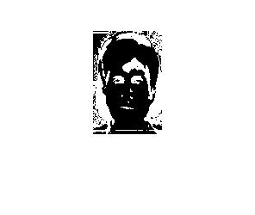

1. Distances di for i = 0 to M

|  |  |  |  |  |  |  |  |
| --- | --- | --- | --- | --- | --- | --- | --- |
| 39119668.49 | 30705187.87 | 28377668.67 | 37106892.08 | 18827249.02 | 72728672.93 | 20327104.46 | 42730693.05 |

1. Final classification result

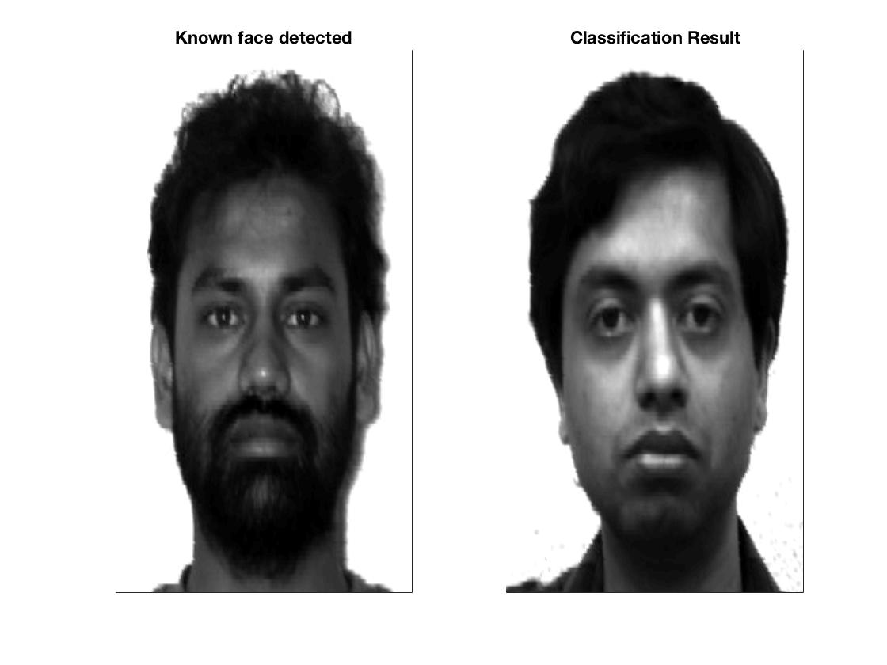

**For Test Image : subject10.normal.jpg**

1. Image after subtracting mean face



1. PCA coefficients

|  |
| --- |
| -1768710.47237705 |
| -2111643.86313928 |
| -1931010.94061614 |
| 3869832.74922021 |
| -13350512.5727828 |
| -3292384.90708861 |
| 12181068.3675146 |
| -12980311.8313238 |

1. Reconstructed Face Image

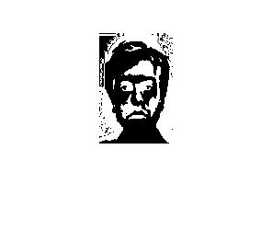

1. Distances di for i = 0 to M

|  |  |  |  |  |  |  |  |
| --- | --- | --- | --- | --- | --- | --- | --- |
| 36800210.43 | 40599267.03 | 35592599.78 | 50498037.57 | 0 | 71541277.67 | 22873773.6 | 51137413.21 |

1. Final classification result

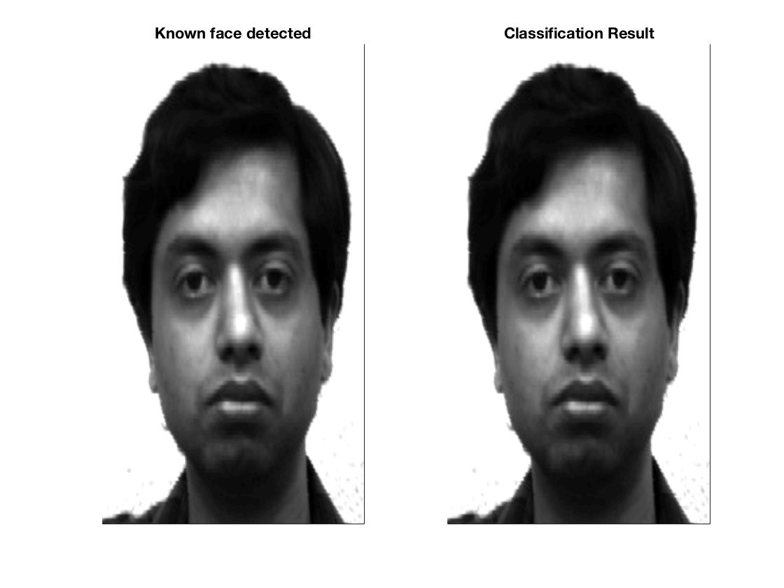

**For Test Image : subject11.normal.jpg**

1. Image after subtracting mean face



1. PCA coefficients

|  |
| --- |
| -16745058.6339780 |
| 1018390.70497715 |
| 43815092.7442895 |
| -14110542.6212187 |
| 7300085.39832737 |
| -12026571.0139520 |
| -22367671.7770649 |
| -40760119.9791861 |

1. Reconstructed Face Image

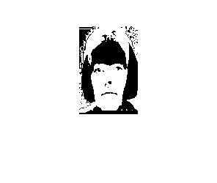

1. Distances di for i = 0 to M

|  |  |  |  |  |  |  |  |
| --- | --- | --- | --- | --- | --- | --- | --- |
| 66962013.94 | 86433270.47 | 85507913.27 | 100422126.9 | 71541277.67 | 0 | 67060298.96 | 99656234.65 |

1. Final classification result

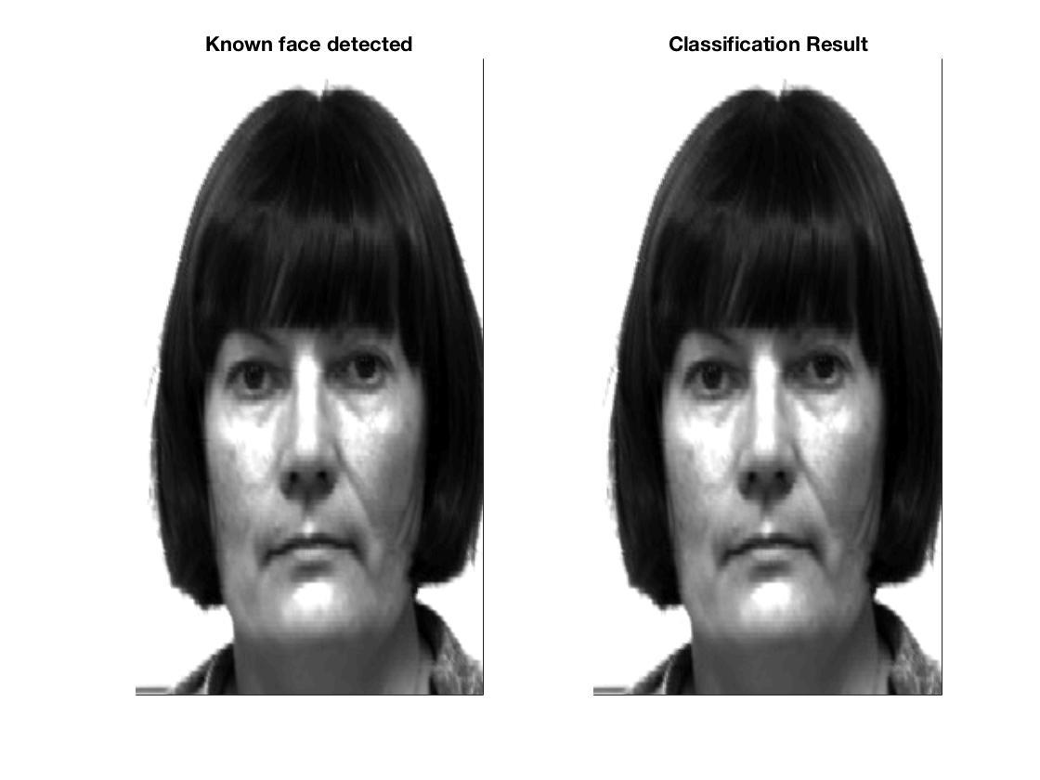

**For Test Image : subject11.happy.jpg**

1. Image after subtracting mean face



1. PCA coefficients

|  |
| --- |
| -16996334.1690199 |
| 1746200.23186573 |
| 41360393.5302715 |
| -13904320.3637774 |
| 8435600.24530289 |
| -9455694.68828813 |
| -22843908.6491498 |
| -38636019.2831402 |

1. Reconstructed Face Image

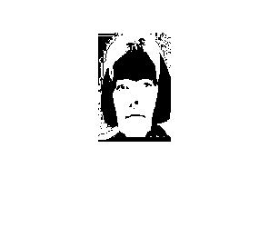

1. Distances di for i = 0 to M

|  |  |  |  |  |  |  |  |
| --- | --- | --- | --- | --- | --- | --- | --- |
| 65283558.69 | 82889490.58 | 82844017.32 | 97031700.57 | 69529958.6 | 4392986.038 | 64999538.99 | 96421762.35 |

1. Final classification result

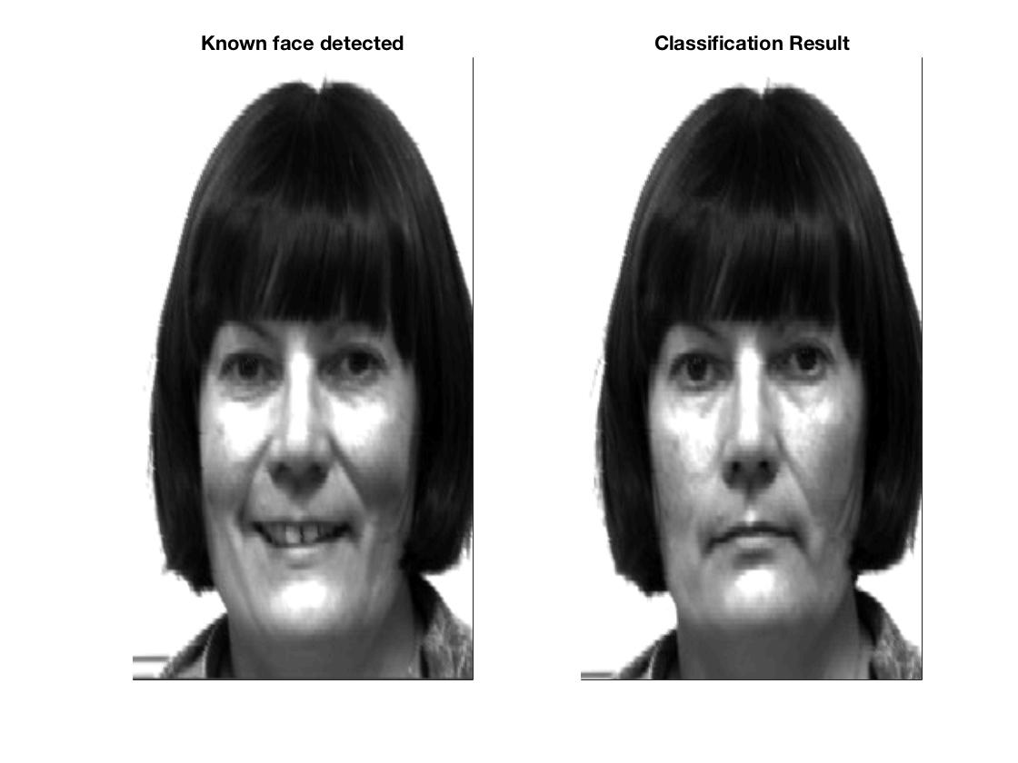

**For Test Image : subject11.centerlight.jpg**

1. Image after subtracting mean face



1. PCA coefficients

|  |
| --- |
| -12438020.4747380 |
| 4654426.63095265 |
| 25551259.8185059 |
| -9320139.33247299 |
| 10713473.9182407 |
| 2080318.48626669 |
| -21770133.8489943 |
| -28059739.2422295 |

1. Reconstructed Face Image

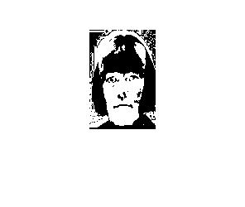

1. Distances di for i = 0 to M

|  |  |  |  |  |  |  |  |
| --- | --- | --- | --- | --- | --- | --- | --- |
| 55529214.32 | 61206000.07 | 65280287.75 | 75640347.19 | 55469623.27 | 27578962.39 | 52882984.84 | 75783762.69 |

1. Final classification result

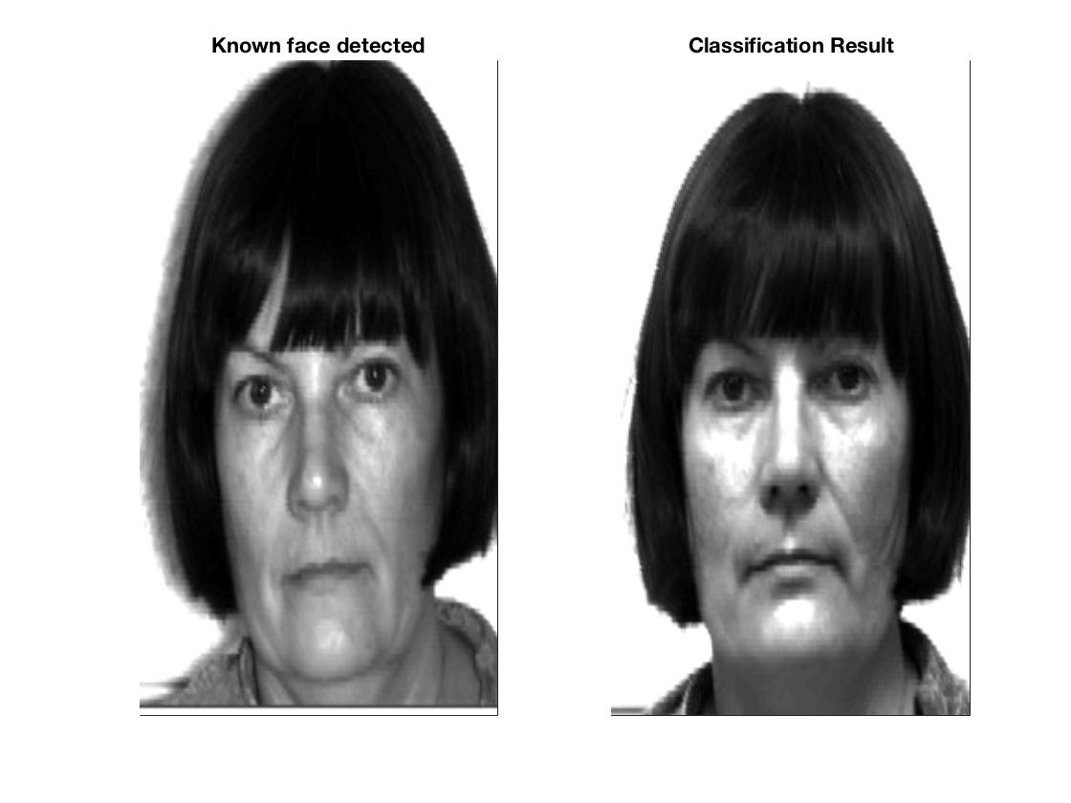

**For Test Image : subject12.normal.jpg**

1. Image after subtracting mean face



1. PCA coefficients

|  |
| --- |
| -12865216.3600947 |
| -1543101.93422303 |
| 9229586.60537734 |
| -303113.326818627 |
| -2592301.28989946 |
| -8477042.81889317 |
| 406427.023494517 |
| -8670298.64732439 |

1. Reconstructed Face Image

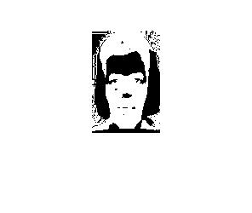

1. Distances di for i = 0 to M

|  |  |  |  |  |  |  |  |
| --- | --- | --- | --- | --- | --- | --- | --- |
| 23786502.26 | 41273467.34 | 39833735.64 | 56590982.92 | 23775329.22 | 55383133.11 | 18075619.84 | 55288761.34 |

1. Final classification result

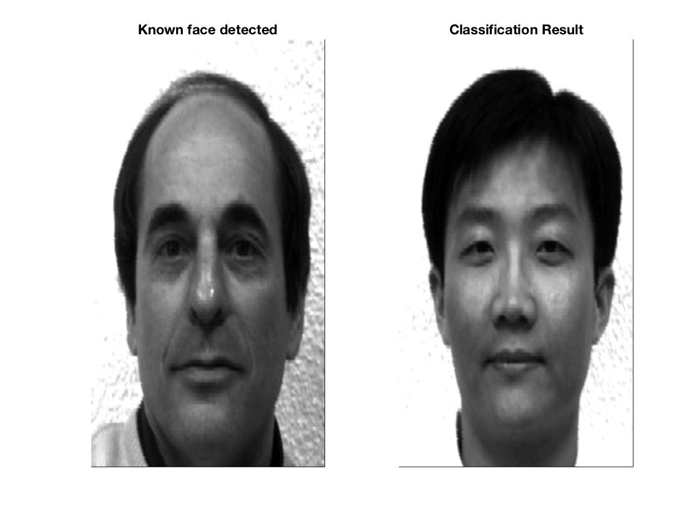

**For Test Image : subject14.normal.jpg**

1. Image after subtracting mean face



1. PCA coefficients

|  |
| --- |
| -10674293.6392060 |
| -3543290.96595410 |
| 4287300.92672801 |
| -10308796.3378749 |
| -8147192.70648713 |
| -10542511.8605603 |
| 11053615.3511282 |
| -1969429.04787823 |

1. Reconstructed Face Image



1. Distances di for i = 0 to M

|  |  |  |  |  |  |  |  |
| --- | --- | --- | --- | --- | --- | --- | --- |
| 27663531.31 | 45649381.28 | 36089348.24 | 54454450.23 | 22873773.6 | 67060298.96 | 0 | 55844824.3 |

1. Final classification result

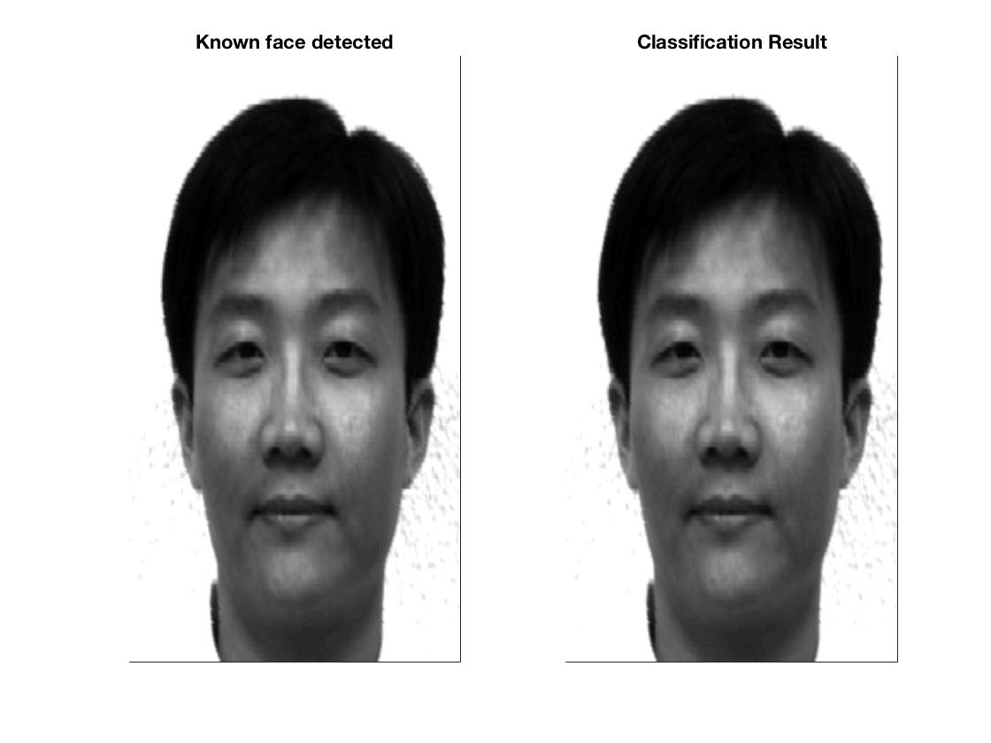

**For Test Image : subject14.happy.jpg**

1. Image after subtracting mean face



1. PCA coefficients

|  |
| --- |
| -8029927.26410538 |
| -3393974.04210122 |
| 2260069.09801656 |
| -7836724.74812525 |
| -6596467.18318794 |
| -11530888.1083036 |
| 8229561.55355497 |
| 1577582.86623295 |

1. Reconstructed Face Image

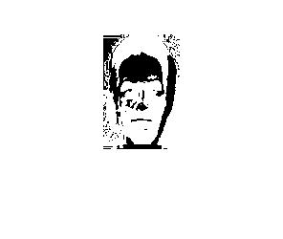

1. Distances di for i = 0 to M

|  |  |  |  |  |  |  |  |
| --- | --- | --- | --- | --- | --- | --- | --- |
| 24294086.58 | 42167198.68 | 31247432.15 | 50733736.24 | 23162310.23 | 69163826.55 | 6416695.92 | 51495173.69 |

1. Final classification result

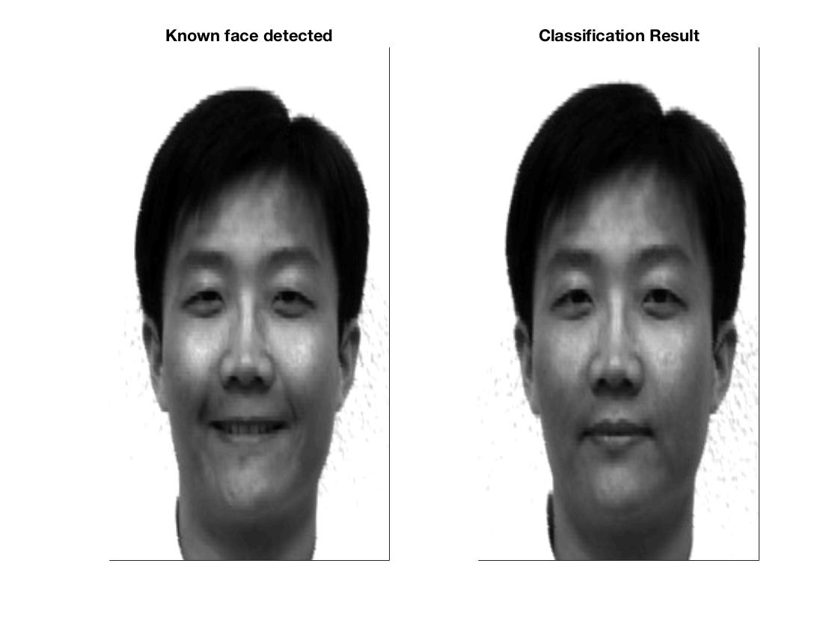

**For Test Image : subject14.sad.jpg**

1. Image after subtracting mean face



1. PCA coefficients

|  |
| --- |
| -8105631.30421782 |
| -2626784.38340415 |
| 353244.205493355 |
| -9352784.12212049 |
| -7804746.83762334 |
| -7798015.48532449 |
| 9272567.99331117 |
| -702712.041783479 |

1. Reconstructed Face Image

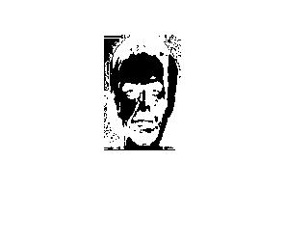

1. Distances di for i = 0 to M

|  |  |  |  |  |  |  |  |
| --- | --- | --- | --- | --- | --- | --- | --- |
| 29053730.5 | 40642669.97 | 31179982.41 | 48747908.19 | 20754093.8 | 69650792.48 | 6021212.78 | 51014024.52 |

1. Final classification result

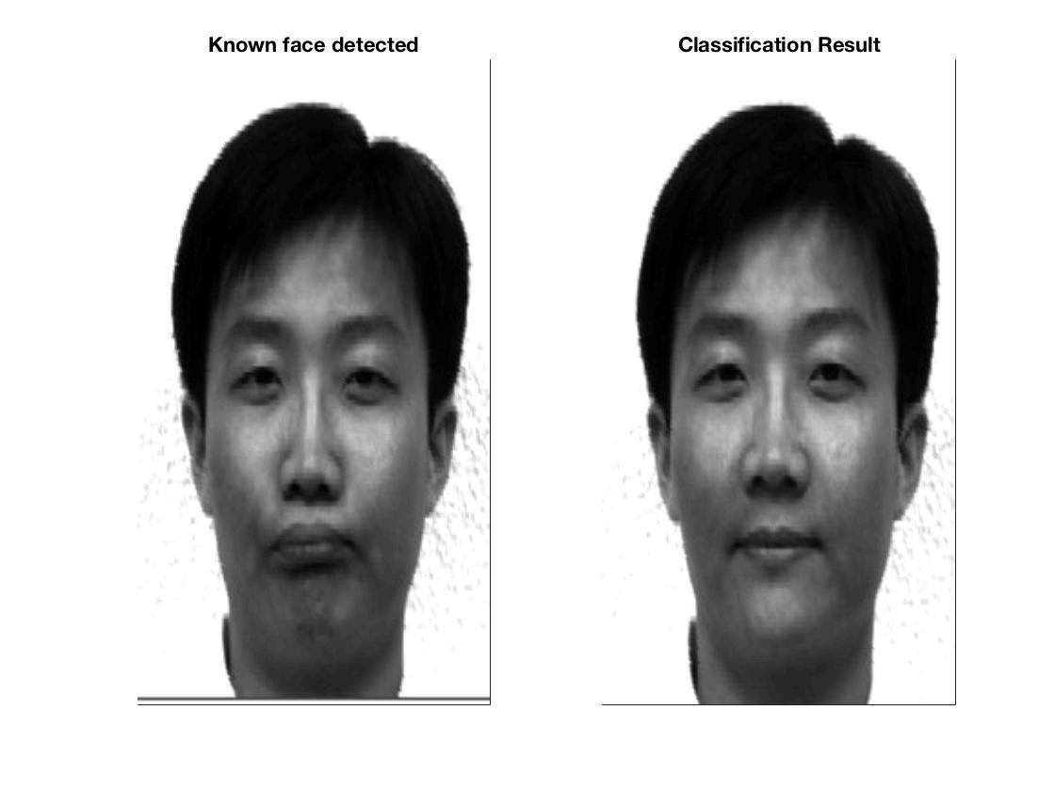

**For Test Image : subject15.normal.jpg**

1. Image after subtracting mean face



1. PCA coefficients

|  |
| --- |
| 16137612.3076437 |
| 3839567.97646025 |
| -11716175.7956508 |
| 11712373.8010359 |
| 12895967.8358410 |
| 16112245.6618590 |
| 5239514.69688410 |
| 18454131.4121123 |

1. Reconstructed Face Image

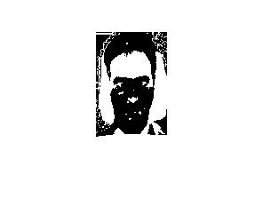

1. Distances di for i = 0 to M

|  |  |  |  |  |  |  |  |
| --- | --- | --- | --- | --- | --- | --- | --- |
| 58508955.23 | 28926768.95 | 31629100.22 | 25312284.82 | 51137413.21 | 99656234.65 | 55844824.3 | 0 |

1. Final classification result

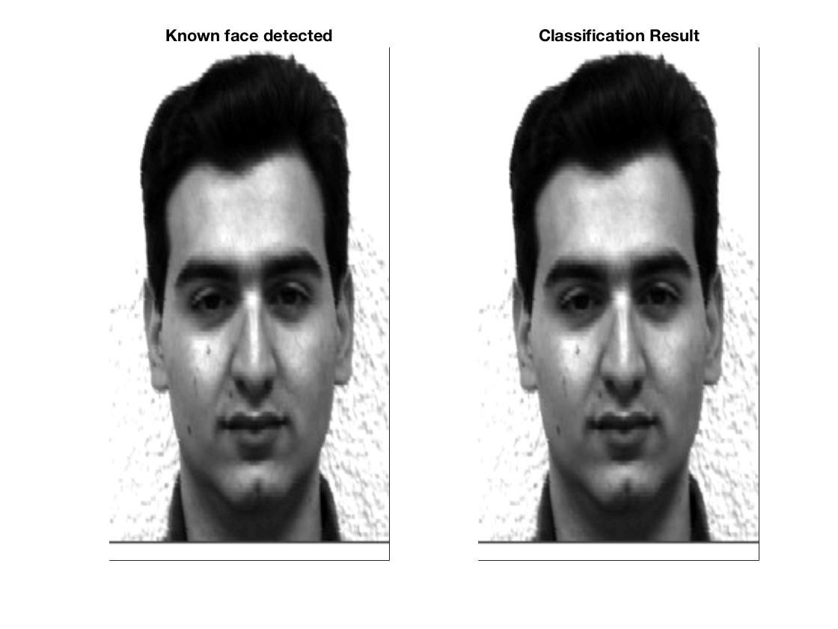

**For Test Image : subject15.normal.jpg**

1. Image after subtracting mean face



1. PCA coefficients

|  |
| --- |
| -4628375.19758766 |
| -1007621.36483177 |
| 4141669.09329603 |
| -593748.406747662 |
| 4724509.79448531 |
| -11088337.5736099 |
| -4297523.36509360 |
| 7113534.39125386 |

1. Reconstructed Face Image

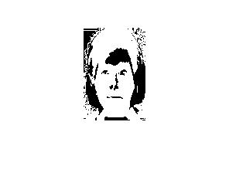

1. Distances di for i = 0 to M

|  |  |  |  |  |  |  |  |
| --- | --- | --- | --- | --- | --- | --- | --- |
| 20915053.96 | 35468448.31 | 28407660.71 | 46711050.89 | 33600409.23 | 67331522.56 | 24930352 | 43403249.42 |

1. Final classification result without using threshold

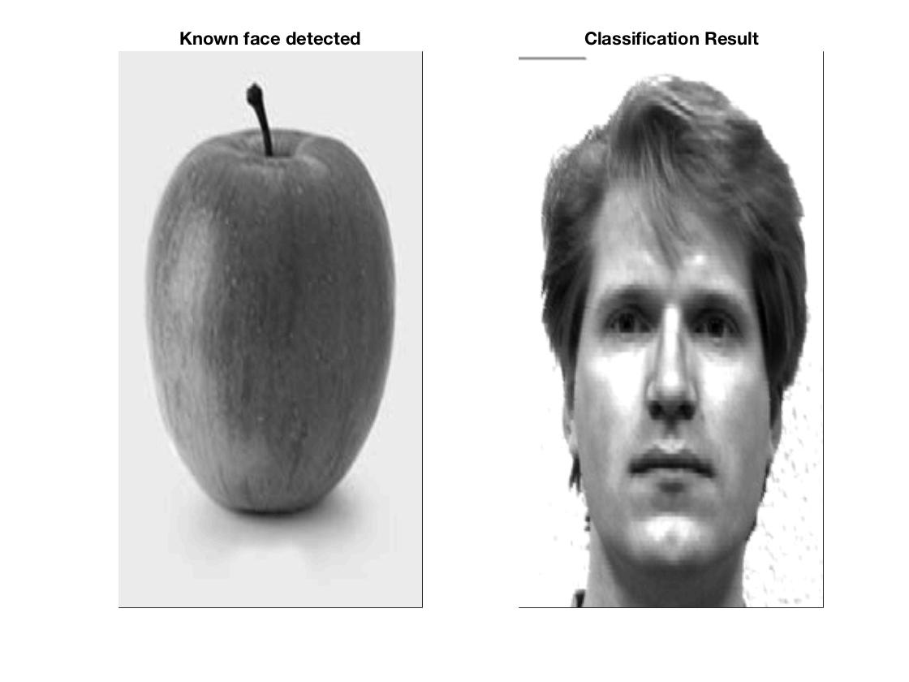

1. Final classification result using threshold t0 = 90000000000, it classifies as non-face.

