Section 1

Name: *Amol Jadhav*

Years of Experience: *12 Years*

Section 2:

Build IDE: *Eclipse Java EE IDE (*Oxygen.2 Release (4.7.2)Build id: 20171218-0600*)*

JDK Version: *java version "1.8.0_144"*

Section 3

1. EclEmma scan Snapshot –
2. Final Output Snapshot

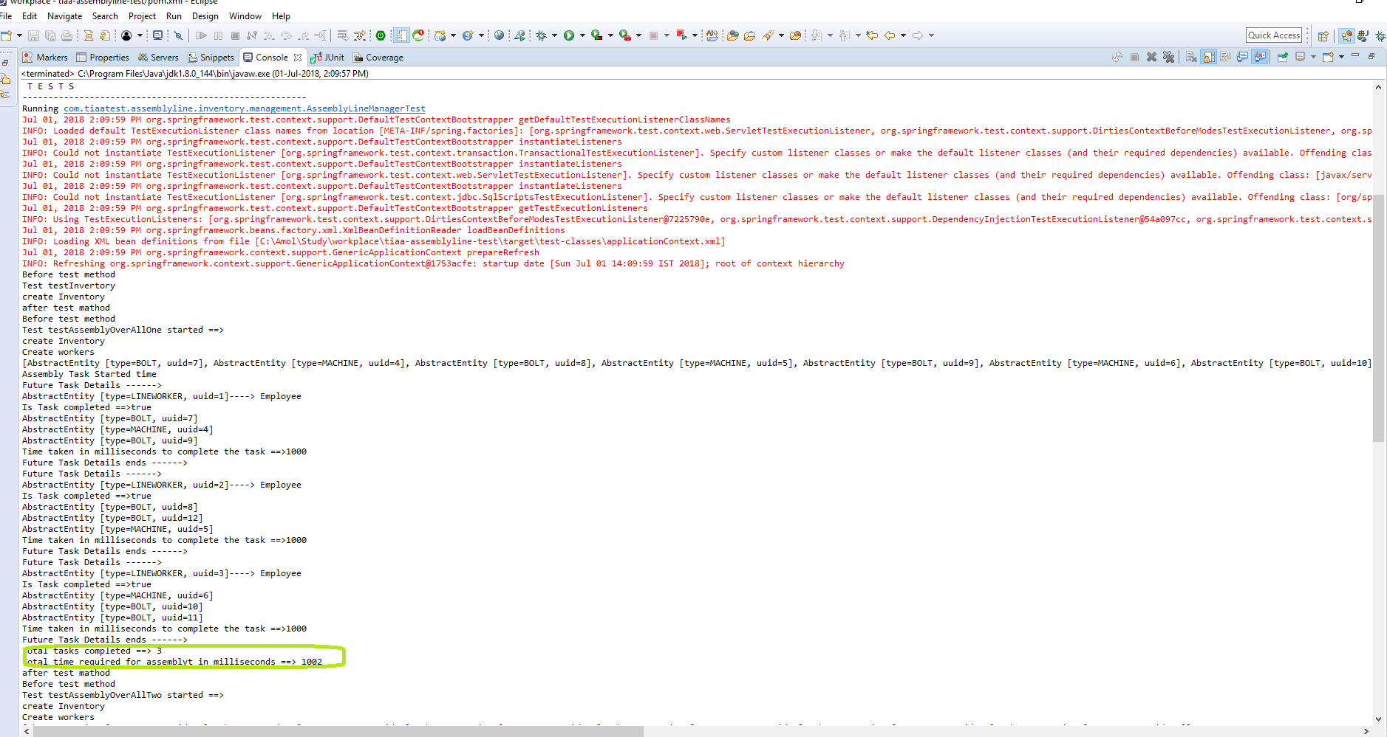

1. Junit Coverage Snapshot

