META ADS STRATEGY & IMPLEMENTATION - V5
House of Bunkar x PULA Bazaar | Diwali Collection 2026
Campaign Detail | Final / Current Setup
Event | PULA Bazaar - Season 49 | Dussehra Special Exhibition
Dates | 10 & 11 October 2026
Venue | Mahalaxmi Lawns, 100 FT DP Road, near Rajaram Bridge, Karvenagar, Pune - 411052
Timing | 11:00 AM - 9:00 PM
Stall | House of Bunkar - Stall No. 85
Media budget | ₹300/day | one ad set
Meta status at latest capture | Preparing

EXECUTIVE STATUS
The campaign build is substantially complete in Meta Ads Manager: one Awareness campaign, one ad set and one existing-post video ad. The current objective is maximum local reach among women aged 35-55 around Karve Nagar, with a ₹300/day budget, a 3 impressions / 7 days cap and a Send Message CTA. Final QA should focus on hard audience controls, the WhatsApp identity mismatch and placement-safe creative adaptation.

Final Campaign Architecture
Level | Name / Setting
Campaign | HOB_PULA_Awareness_10-11Oct2026_KarveNagar_W35-55
Ad Set | PULA_W35-55_KarveNagar_10-12KM_₹300
Ad | HOB_PULA_EventPoster_Stall85_V1
Structure | 1 Campaign → 1 Ad Set → 1 Ad
Objective | Awareness
Performance goal | Maximize reach of ads

This V5 document updates the earlier strategy with the actual Meta campaign build, current creative/video preview, messaging flow, placement previews and final pre-launch controls.

1. Campaign-Level Configuration
Meta Field | Current / Final Setting | V5 Decision
Campaign name | HOB_PULA_Awareness_10-11Oct2026_KarveNagar_W35-55 | Keep
Buying type | Auction | Keep
Campaign objective | Awareness | Correct for local footfall awareness
Budget strategy | Ad set budget | Correct for one-ad-set structure
Advantage+ campaign controls | Shown as enabled in current interface | Accept; budget remains controlled at ad set
Campaign frequency control | Off | Fine; frequency is controlled at ad set
A/B test | Off | Correct at ₹300/day
Special Ad Categories | None declared | Correct for this retail exhibition
Campaign recommendation status | All recommended settings applied | No action required

BUDGET LOGIC
Keep the full ₹300/day in one ad set. Do not split this small event budget into separate cold, retargeting and lookalike ad sets. The purpose of this test is to build a clean benchmark for local reach, frequency, messages and attributed walk-ins.

Operating Window
Date | Suggested Spend | Execution
8 Oct | ₹300 | Launch / stabilize delivery; “this weekend” reminder
9 Oct | ₹300 | Reminder; avoid structural edits unless delivery is broken
10 Oct | ₹300 | Event Day 1; paid reach + organic “today” content
11 Oct | ₹300 | Final day; organic urgency; end paid delivery before event close if desired

Approximate four-day media spend: ₹1,200 before platform taxes/charges, subject to the actual start/end time and Meta delivery.

2. Ad Set - Audience, Frequency & Local Geography
Field | Final Intended Setup
Ad set name | PULA_W35-55_KarveNagar_10-12KM_₹300
Performance goal | Maximize reach of ads
Facebook Page | House of Bunkar
Budget | ₹300/day
Gender | Women only
Age | 35-55
Languages | All / leave blank
Core geography | Mahalaxmi Lawns / Karve Nagar local catchment
Radius logic | 10-12 km primary; expand toward 15 km only if delivery is genuinely constrained
Frequency cap | 3 impressions every 7 days
Dynamic creative | Off

AUDIENCE QA FLAG
Meta currently shows an estimated audience of approximately 1.6M-1.8M in the captured ad-set summary. That is large for a ₹300/day hyper-local exhibition test. Before relying on the final build, reconfirm that India and any “Pune +25 mi” location are not still active and that Women 35-55 is enforced as a hard control rather than only an Advantage+ suggestion.

Priority Local Catchment
Priority | Localities to Cover
Tier 1 - closest | Karve Nagar, Kothrud, Erandwane, Warje / Warje Malwadi, Deccan Gymkhana, Prabhat Road, Bhandarkar Road, Dattawadi, Anand Nagar
Tier 2 - strong nearby | Shivajinagar, Model Colony, Pashan, Bavdhan, Aundh, Sinhagad Road, Navi Peth, Parvati, Sahakar Nagar, Bibwewadi
Tier 3 - optional edge | Baner, Balewadi, Dhankawadi, Vadgaon Budruk, Dhayari, Narhe, Katraj, Camp, Koregaon Park, Kalyani Nagar - only if the actual radius/map supports them

Preferred execution: use the venue pin + radius as the controlling geography. Use locality names as a coverage check, not as a reason to broaden the campaign beyond the intended catchment.

3. Locality & PIN Reference
Planning reference for the Karve Nagar catchment. Meta location options can vary by account; the venue pin + radius remains the preferred control.
Locality | PIN | Locality | PIN | Locality | PIN
Karve Nagar | 411052 | Hingne | 411052 | Kothrud | 411038
Erandwane | 411038 | Mayur Colony | 411038 | Ideal Colony | 411038
Paud Road | 411038 | Warje | 411058 | Anand Nagar | 411051
Sinhagad Road | 411051 | Vadgaon Budruk | 411041 | Dhayari | 411041
Narhe | 411041 | Deccan Gymkhana | 411004 | Prabhat Road | 411004
Shivajinagar | 411005 | Model Colony | 411016 | Sadashiv Peth | 411030
Navi Peth | 411030 | Parvati | 411009 | Sahakar Nagar | 411009
Bibwewadi | 411037 | Gultekdi / Market Yard | 411037 | Dhankawadi | 411043
Katraj | 411046 | Aundh | 411007 | Pashan | 411021
Bavdhan | 411021 | Baner | 411045 | Balewadi | 411045
Camp | 411001 | Koregaon Park | 411001 | Kalyani Nagar | 411006

Detailed Targeting Approach
KEEP IT BROAD WITHIN THE HARD FILTERS
For this first ₹300/day event test, age + gender + geography should do most of the work. Do not stack multiple “AND” interest layers. If Meta requires or benefits from suggestions, use a light OR-group such as Saree, Silk, Ethnic Wear, Indian Clothing, Women’s Clothing, Handloom, Fashion and Shopping - only where those interests are actually available in the account.

- Do not add household-income filters in the first test.
- Do not force separate lookalike or retargeting ad sets at ₹300/day.
- Existing customers can remain eligible; they are valuable event visitors.
- If Advantage+ Audience can expand beyond the agreed demographic, use hard controls / original audience options where available.

4. Ad-Level Build - Identity, Existing Post & Messaging
Field | Current Setup | V5 QA
Ad name | HOB_PULA_EventPoster_Stall85_V1 | Keep
Partnership ad | Off | Correct
Facebook identity | House of Bunkar | Correct
Instagram identity | @houseofbunkar | Correct
Threads | Use Instagram account | Accept
Ad setup | Use existing post | Keep if placement preview remains healthy
Selected Instagram post | Post ID 18587154259068213 - 7 Oct 2026 | Correct selected event post
CTA | Send message | Appropriate secondary action for enquiries
Messenger destination | House of Bunkar | Active
Instagram destination | @houseofbunkar | Active
WhatsApp destination | +91 86001 34546 | Correct HOB customer number

CRITICAL IDENTITY CHECK
The Identity section in the current Meta screen still shows the WhatsApp identity as growthikmedia.com / +91 80557 54054, while the actual messaging destination is House of Bunkar / +91 86001 34546. If Meta allows the identity number to be changed, switch it to the House of Bunkar number before final delivery so the client-facing identity is consistent.

Destination / Click Behaviour
The ad summary currently displays “Website” in the Destination section, while the live CTA and conversation setup are configured for “Send message.” Use the shared “Show Ad” preview to confirm the actual tap behaviour on the major placements before relying on website tracking or UTMs.
- If a tap opens Messenger / Instagram / WhatsApp as intended, website UTMs are not required.
- If a website destination is intentionally used later, add a real House of Bunkar / event URL - not a Growthik Media URL.
- Do not create a website destination only to satisfy a preview field if the real user journey is messaging / event awareness.

5. Creative, Video & Copy
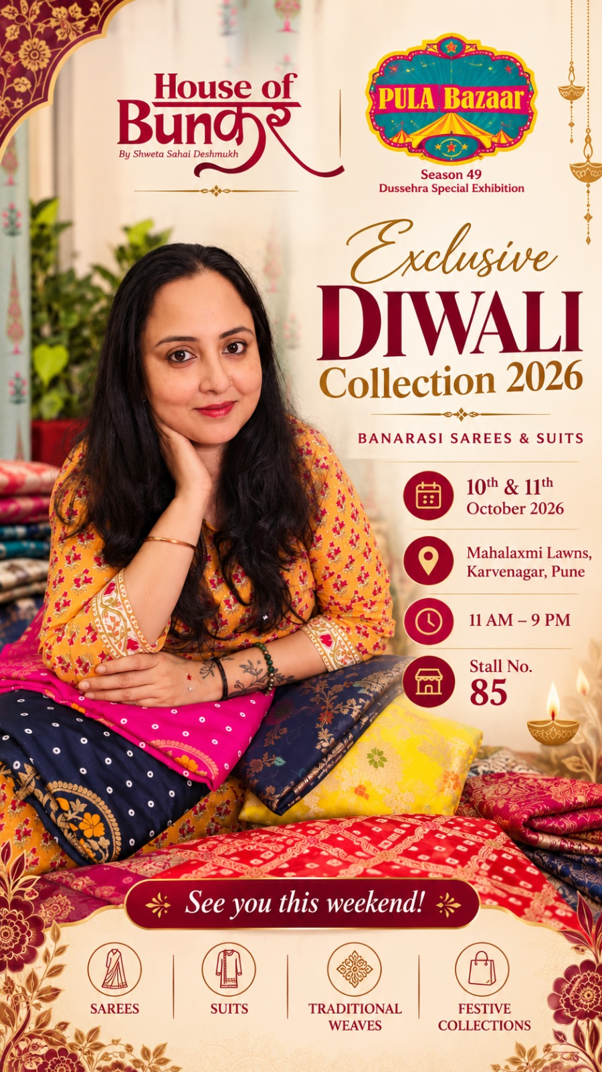
Core House of Bunkar x PULA Bazaar event creative supplied for the campaign.
Creative Element | Current / Approved Direction
Format in Meta preview | Video / animated execution - 0:47 shown in Mobile Feed preview
Core message | Celebrating Banarasi Heritage this Diwali
Event callout | 10 & 11 October 2026 | 11 AM-9 PM | Stall No. 85
Venue | Mahalaxmi Lawns, 100 FT DP Road, near Rajaram Bridge, Karvenagar, Pune - 411052
Visitor benefit | Free Entry | Valet Parking
Products | Rangkaat, Jamawaar, Mashru Silk, Bandhej Silk, Kashi Darshan, Jamdani, Linen Zari and Banarasi Silk suits/sarees
Branding | House of Bunkar + PULA Bazaar both visible

Primary Text - Final Paid Version
RECOMMENDED CONCISE AD COPY
✨ Celebrating Banarasi Heritage this Diwali ✨
This weekend, discover House of Bunkar’s Diwali Bestsellers Collection 2026 at PULA Bazaar - Season 49.
Explore Rangkaat, Jamawaar, Mashru Silk, Bandhej Silk, Kashi Darshan, Jamdani, Linen Zari and Banarasi Silk sarees & suits.
📅 10th & 11th October 2026 | ⏰ 11 AM-9 PM
🛍️ House of Bunkar - Stall No. 85
📍 Mahalaxmi Lawns, 100 FT DP Road, near Rajaram Bridge, Karvenagar, Pune - 411052
🎫 Free Entry | 🚗 Valet Parking Available
Save the date and visit Stall 85 to experience authentic Banarasi weaves for the festive season. ✨

Ad Text Fields
Field | Recommended
Headline | Diwali Bestsellers at PULA Bazaar ✨
Description | 10-11 Oct | Karvenagar | Stall No. 85
CTA | Send message
Hashtags | #HouseOfBunkar #BanarasiSarees #BanarasiSilk #Diwali2026 #PuneShopping #PuneExhibition #KarveNagar #PulaBazaar

Organic Posting & Tagging
- Instagram: tag PULA Bazaar and Sonia Konjeti in the main post and Stories; verify the exact handles before publishing.
- Facebook: tag Pula Ladies and PULA Bazaar wherever tagging is available.
- Cross-post to PULA Bazaar surfaces where their social-media team has approved access.
- Use Mahalaxmi Lawns, Karvenagar, Pune as the event location and keep Stall No. 85 visible in every reminder.

6. Advantage+ Creative Enhancements - Current State & QA
Enhancement | Current State | V5 Recommendation
Add details to ad layout | OFF | Keep OFF
Video touch-ups | ON | Review preview; keep only if product colours / logos are not altered
Text improvements | ON | Prefer OFF for fixed event copy if Meta changes date / venue emphasis
Adapt multi-image format | ON | Review carefully; disable if the single event creative is being reformatted awkwardly
Relevant comments | ON | Keep ON if comments are appropriate and moderated
Enhance CTA | ON | Accept if it does not overpower the artwork
Add video effects | ON | Review; disable if effects distract from date, venue or Stall 85

CREATIVE QA RULE
For this event, clarity beats novelty. The date, venue, time, Stall 85 and brand logos must remain readable in every placement. If an automated enhancement crops, recolours, overlays or animates those elements in a way that reduces clarity, switch that enhancement off even if Meta recommends it.

Current Conversation Template
Element | Approved Text
Greeting | Hi! 👋 Welcome to House of Bunkar ✨  We’ll be at PULA Bazaar - Season 49 on 10th & 11th October 2026 at Mahalaxmi Lawns, Karvenagar, Pune - Stall No. 85.  How can we help you today?
FAQ 1 | Can I see the collection before visiting?
Auto answer 1 | Yes. Please message us here or on WhatsApp +91 86001 34546 and we can share available collection details.
FAQ 2 | Where is the exhibition?
Auto answer 2 | Mahalaxmi Lawns, Karvenagar, Pune - Stall No. 85.

7. Shared Ad Preview - Video / Mobile Feed
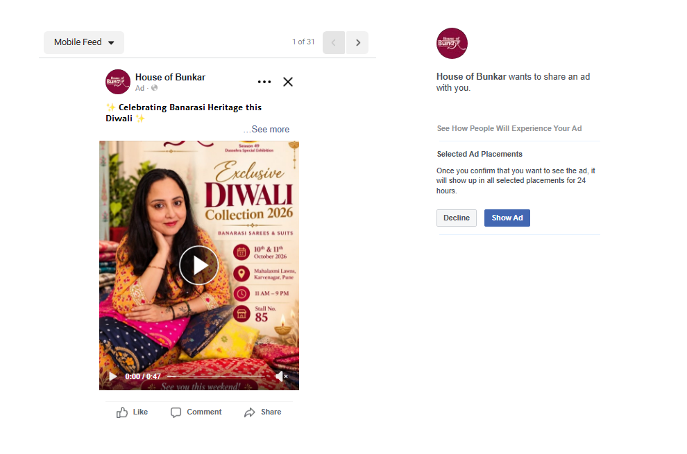
Shared Meta ad preview. The mobile feed preview shows the House of Bunkar ad with a play button and 0:47 video duration.
Preview Check | Result
Brand identity | House of Bunkar displays correctly in the ad header
Creative visibility | Event creative is clearly visible in Mobile Feed
Video state | Play button visible; 0:47 duration shown
Primary copy | Opening “Celebrating Banarasi Heritage this Diwali” visible above the creative
Share preview | Meta shared preview can be shown for selected placements for 24 hours

PREVIEW CONCLUSION
The shared preview is usable and the main event information is visible. The first frame should continue to communicate “Diwali Collection 2026”, date, Karvenagar and Stall 85 without requiring the viewer to watch the full 47 seconds.

8. Placement Preview & Delivery Surfaces
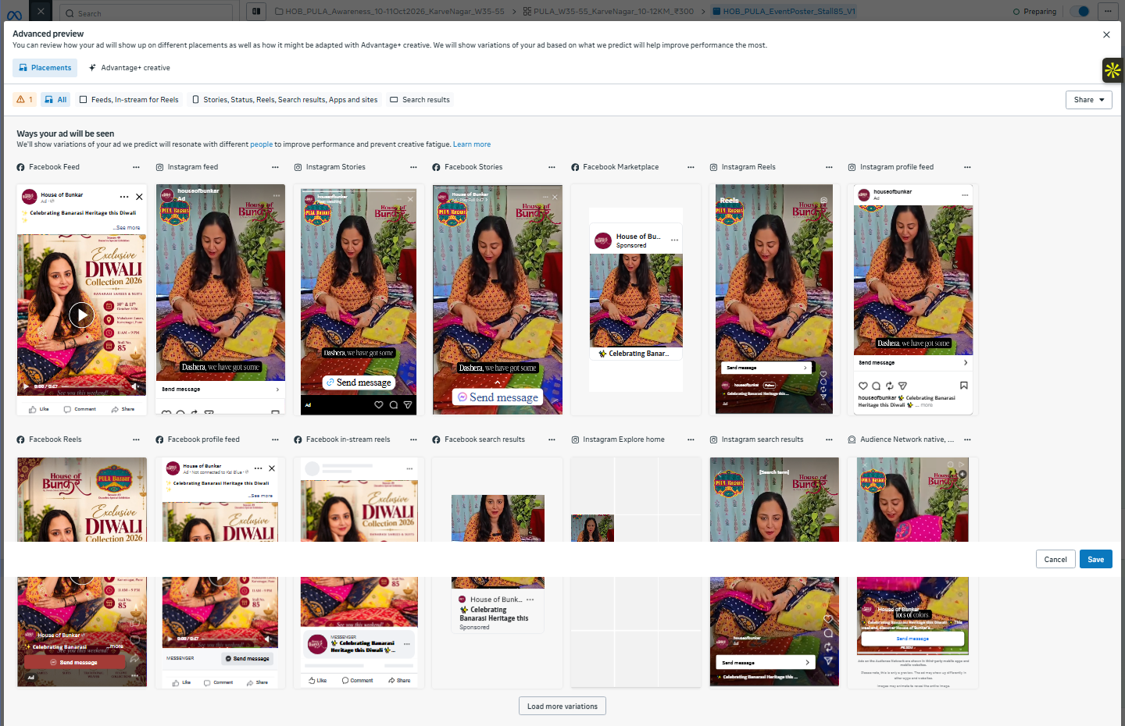
Meta Advanced Preview showing the creative adapted across key Facebook and Instagram placements.
Visible preview surfaces include Facebook Feed, Instagram Feed, Instagram Stories, Facebook Stories, Facebook Marketplace, Instagram Reels, Instagram profile feed, Facebook Reels, Facebook profile feed, Facebook in-stream reels, Facebook search results, Instagram Explore home, Instagram search results, Audience Network and additional eligible surfaces.

Placement Decision
Placement Group | V5 Guidance
Facebook Feed | Priority - strong fit for women 35-55 and event detail reading
Instagram Feed | Priority - product / brand visual discovery
Instagram Stories & Reels | Priority - urgency, reminders and full-screen creative
Facebook Stories & Reels | Keep if 9:16 crop remains readable
Marketplace / Search / Profile feeds | Allow under Advantage+ if they deliver inexpensive reach; monitor spend
Audience Network / other surfaces | Do not optimize around them; exclude only if they take material budget without useful response
WhatsApp Status | Keep only if the creative and CTA preview correctly

9. All-Placement Visual QA
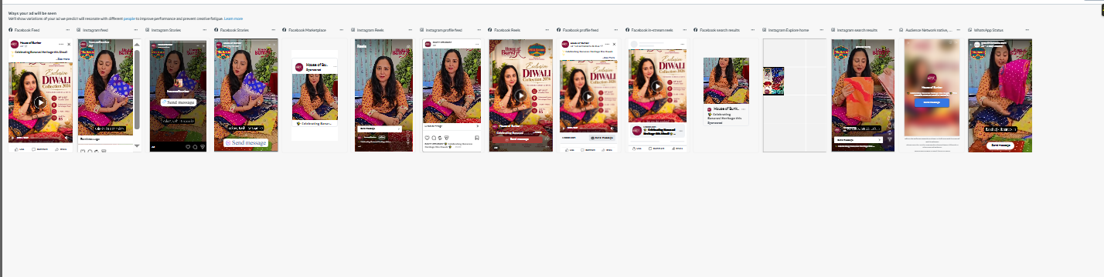
Placement strip supplied from the Meta Advanced Preview. The same campaign creative is shown across multiple feed, story, reel, search, marketplace and messaging surfaces.
WHAT THE PREVIEW CONFIRMS
The earlier “link field required” issue has been substantially resolved: the ad is now rendering across the major placements rather than failing across the entire placement set. Continue to check the final warning count before launch, but the current screenshots show working previews for the core surfaces that matter most.

Placement-Safe Creative Checklist
- Keep House of Bunkar and PULA Bazaar logos inside safe zones.
- Make 10 & 11 Oct, Karvenagar and Stall 85 readable on a phone without zooming.
- Do not place critical text at the very top or bottom of 9:16 Story/Reel assets.
- Check that the Send Message button does not cover event details.
- Check Facebook Feed and Instagram Feed separately; their crops can differ.
- If any automated version hides the address, disable that specific enhancement or placement adaptation.

10. Tracking, Reporting & Attribution
Metric | Why It Matters | How to Review
Reach | Primary delivery KPI | Unique nearby people reached
Frequency | Controls reminder intensity | Target cap already set at 3 / 7 days
CPM | Efficiency benchmark | Compare future exhibitions against this test
Messages | High-intent response | Split by Messenger / Instagram / WhatsApp where available
Profile activity | Brand interest | Profile visits, follows, saves, shares
Placement spend | Quality control | Check whether Feed/Stories/Reels receive meaningful delivery
Walk-ins | Business outcome | Ask visitors how they heard about House of Bunkar
Sales | Commercial outcome | Tag sales source where practical

UTM - Use Only if a Website Destination Is Added
DYNAMIC UTM STRING
utm_source={{site_source_name}}&utm_medium=paid_social&utm_campaign={{campaign.name}}&utm_content={{ad.name}}&utm_term={{adset.name}}&utm_placement={{placement}}&campaign_id={{campaign.id}}&adset_id={{adset.id}}&ad_id={{ad.id}}

If the final ad opens messaging rather than a website, leave URL parameters blank. Meta can still report reach, frequency, CPM, message activity and placement delivery.

Simple Event Attribution
At Stall | Record
Ask | “How did you hear about us?”
Source options | Meta ad / PULA Bazaar page / Instagram organic / Facebook organic / Friend / Existing customer / Other
If purchase occurs | Add sale value and source tag
Post-event | Calculate attributed walk-ins, attributed sales and cost per attributed visit

11. Final Pre-Launch / Preparing-State QA
# | Control | Status / Action
1 | Campaign objective = Awareness | PASS
2 | Performance goal = Maximize reach of ads | PASS
3 | One ad set with ₹300/day | PASS
4 | Frequency cap = 3 impressions / 7 days | PASS
5 | Gender = Women only; Age = 35-55 | RECONFIRM hard controls in Audience section
6 | Location = Karve Nagar / Mahalaxmi Lawns 10-12 km | RECONFIRM no India / Pune +25 mi broad location remains
7 | Estimated audience = 1.6M-1.8M | HIGH - review geo/audience controls
8 | Facebook Page = House of Bunkar | PASS
9 | Instagram = @houseofbunkar | PASS
10 | WhatsApp destination = +91 86001 34546 | PASS
11 | WhatsApp identity still shows Growthik +91 80557 54054 | FIX if selectable
12 | CTA = Send message | PASS
13 | Existing event post selected | PASS
14 | Conversation FAQs configured | PASS
15 | Major placement previews render correctly | PASS based on supplied screenshots
16 | Creative enhancements reviewed for cropping / overlays | REVIEW before final publish

FINAL V5 DECISION
The campaign is in a launchable structure, but the final control check should not be skipped. The two highest-priority items are: (1) confirm the ad set is truly Women 35-55 within the intended 10-12 km local catchment, because the 1.6M-1.8M estimate is unusually broad; and (2) align the WhatsApp identity with the House of Bunkar number if Meta permits. Once those are confirmed, keep the setup stable and monitor delivery rather than repeatedly editing it.

Posting & Tagging Execution
- Instagram: tag PULA Bazaar and Sonia Konjeti in relevant posts and Stories; verify exact handles before publishing.
- Facebook: tag Pula Ladies and PULA Bazaar where tagging is available.
- Cross-post / publish on PULA Bazaar surfaces where their social-media team has given access or approval.
- Use location: Mahalaxmi Lawns, Karvenagar, Pune.
- Keep Stall No. 85 visible in every final reminder.
- Organic reminder cadence: “This weekend” → “Tomorrow” → “Today” → “Last day”.
Prepared by Growthik Media | Pune | www.growthikmedia.com

