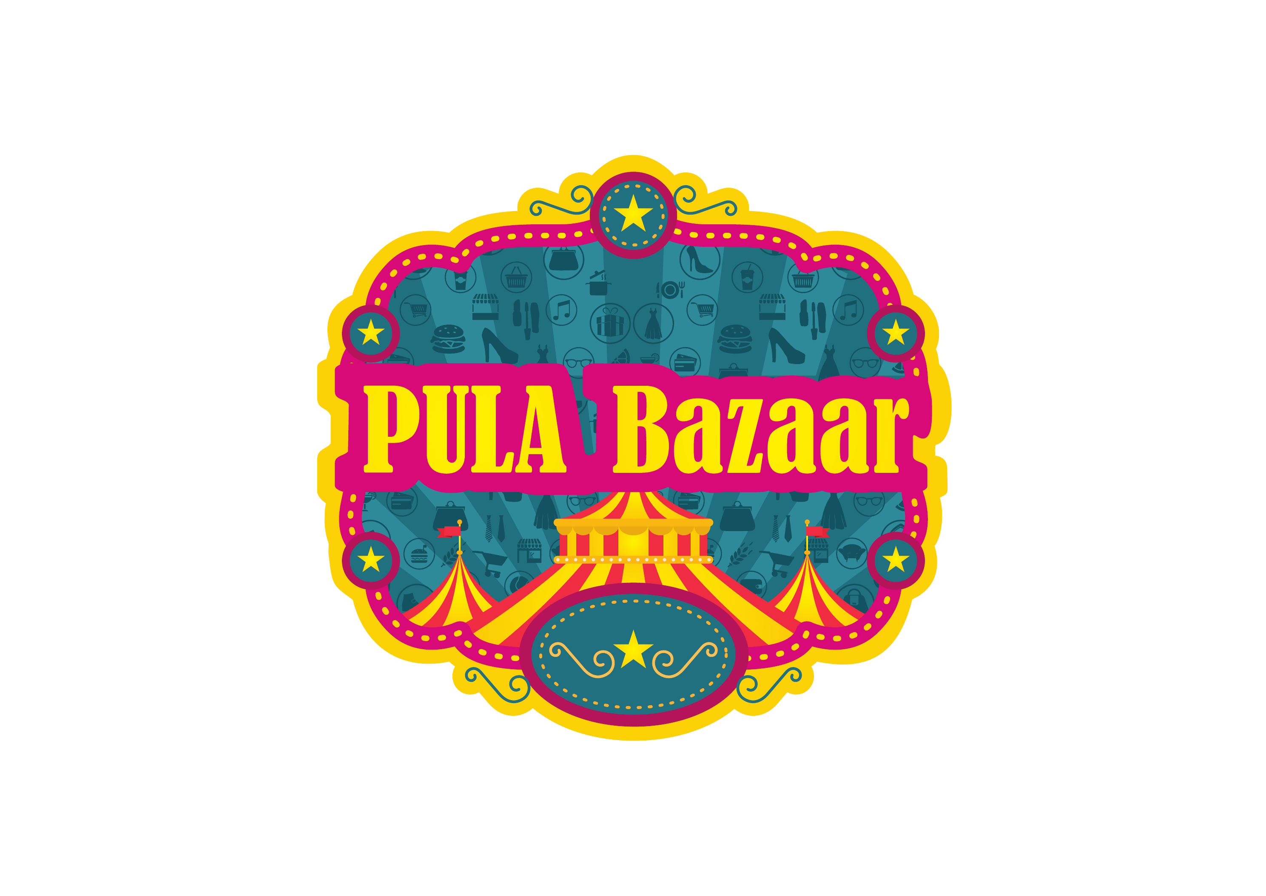
HOUSE OF BUNKAR × PULA BAZAAR
META ADS STRATEGY — V3
Diwali Collection 2026 | PULA Bazaar Season 49
10–11 October 2026 • Mahalaxmi Lawns, Karvenagar, Pune • Stall 85
PRIMARY RECOMMENDATION
Run ONE Meta Ads Manager Awareness campaign optimized for local reach. Target women aged 35–55 within a 10–12 km radius of Mahalaxmi Lawns. Use ₹300/day, one ad set, and no budget split into retargeting or lookalikes for this exhibition. With only a few days remaining, concentration and repetition matter more than a complex funnel.

Setting | Recommended
Objective | Awareness → maximize reach
Audience | Women only, age 35–55
Geo | Venue pin + 10–12 km radius; widen to 15 km only if needed
Budget | ₹300/day; approx. ₹1,200 for 8–11 Oct
Creative | Poster + one 9:16 Story/Reel cut-down
CTA | Visit Stall 85 / Get Directions if available / WhatsApp as secondary

Prepared for immediate launch on 7–8 October 2026

1. Current Creative Review
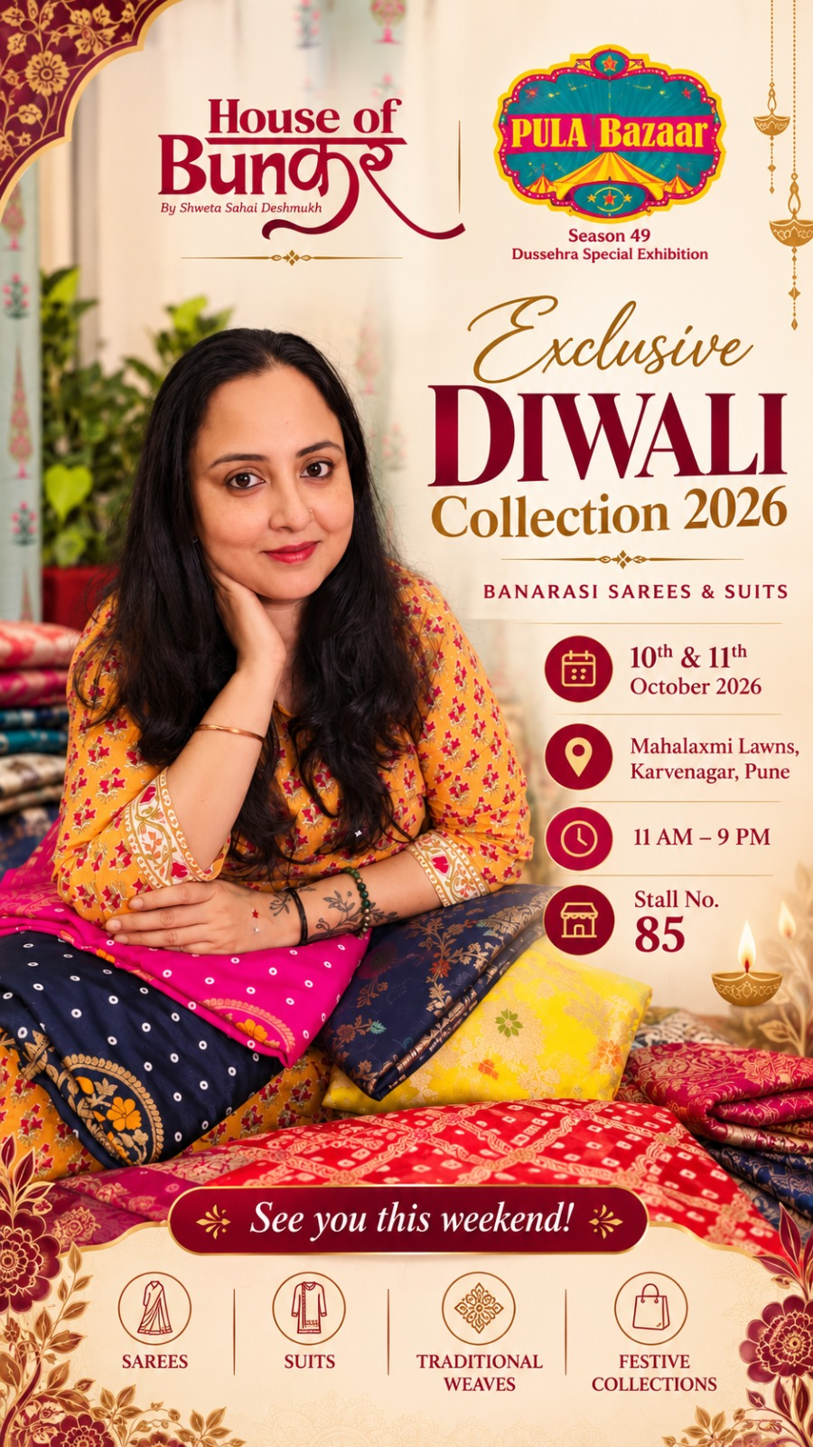
Creative correction requested by the client
Move the PULA Bazaar logo to the top-left and House of Bunkar branding to the top-right. Keep both logos clearly separated and equal in visual importance. This should be the master layout used across Feed, Story and Reel versions.

What is already strong
- The event date, venue, timing and Stall No. 85 are clearly visible.
- The model + product display immediately communicates the category and festive mood.
- The “Exclusive Diwali Collection 2026” message gives a clear seasonal reason to visit.
- The visual style is premium and suitable for Banarasi sarees and suits.
Changes before using it as a paid ad
- Add “FREE ENTRY” and “VALET PARKING” in a small but readable badge; these are strong visit drivers from PULA Bazaar’s event copy.
- Shorten the top section so the viewer can read the core message in 2–3 seconds: “Diwali Collection | 10–11 Oct | Karvenagar | Stall 85”.
- Keep the phone number and @houseofbunkar handle in the caption/CTA rather than adding more text to the artwork.
- Create a 9:16 version for Stories/Reels instead of forcing the vertical poster into all placements.
- Use a second “LAST DAY – 11 OCT” Story/Reel organically on Sunday morning; do not create a separate campaign for it.
2. Which Campaign Type Is Best?
Campaign type | Decision | Reason
Awareness / Reach | BEST | Primary goal is physical footfall; short event window; low daily budget; easiest way to buy repeated local exposure.
Engagement / Messages | SECONDARY | Useful only if WhatsApp enquiries are the main KPI. It can optimize for people likely to message, not necessarily visit.
Traffic | NOT PRIMARY | Can send users to Google Maps/website, but Meta may optimize for clicks rather than actual exhibition visits.
Leads | NO | Too much friction for a two-day walk-in exhibition and too little time/budget to build a lead funnel.
Sales | NO | No direct purchase event for the exhibition; conversion optimization would have weak signal.
Boost Post | AVOID | Faster, but Ads Manager provides better control over location, age, schedule, placements and reporting.

Recommended objective in Ads Manager
Campaign objective: AWARENESS. Performance goal: MAXIMIZE REACH (or the closest reach-focused option visible in the current Ads Manager interface). This matches the real business objective: get nearby women to know the exhibition is happening and remember the date/location.

Why this is the right choice for ₹300/day
- One campaign lets Meta spend the full budget against one goal instead of starving multiple ad sets.
- Women 35–55 + a 10–12 km venue radius is already a meaningful filter; extra interest layers are not necessary for the first test.
- The event is only two days away, so learning time is limited. A simple reach setup is less dependent on conversion history.
- This first exhibition should be treated as a controlled test: learn cost, reach, response and walk-in attribution before scaling future exhibitions.
3. Exact Campaign Build — Field by Field
Field | Setting
Campaign name | HOB_PULA_S49_Oct2026_AWR_W35-55_KarveNagar
Buying type | Auction
Objective | Awareness
Special ad category | None
Campaign budget | Keep simple. One ad set only; ₹300/day at ad-set level is fine.
Ad set name | W35-55_10-12KM_MahalaxmiLawns
Performance goal | Maximize reach / reach-focused option
Start | Immediately after approval; ideally 8 Oct morning
End | 11 Oct around 6–7 PM; event closes at 9 PM
Gender | Women only
Age | 35–55
Language | Leave blank — do not restrict to English; include Marathi/Hindi/English app users
Location | Pin Mahalaxmi Lawns / 100 FT DP Road near Rajaram Bridge, Karvenagar, Pune 411052
Radius | Start 10–12 km; widen to 15 km only if estimated audience/delivery is too limited
Detailed targeting | Broad first. Do not stack 8–10 interests.
Placements | Facebook + Instagram Feed, Stories and Reels. Advantage+ placements may be used if the creative is adapted; review where spend is going.
Ads | 2 max: master poster + 9:16 motion/Story version

4. Target Audience Strategy
Core audience — use this for the current exhibition
Women aged 35–55 who are physically within the selected local radius around Karvenagar. Keep the audience broad inside those hard filters. For this first ₹300/day test, location + age + gender are more important than dozens of interests.

Audience settings
Dimension | V3 setting | Reason
Gender | Women only | Hard requirement from client
Age | 35–55 | Matches requested shopper profile
Location | 10–12 km from venue | Best concentration for ₹300/day
Language | All / blank | Avoid excluding Marathi or Hindi users whose Meta interface is not English
Interests | Broad; optional light signal only | Do not over-narrow a local event audience
Existing customers | Include | Previous buyers are highly valuable for exhibitions; do not exclude them

Optional interest signals — only if Ads Manager requires or broad audience is too large
Search for these terms and use only what actually appears in Meta’s current detailed-targeting list. Do not use all of them at once.
- Sarees / Sari / Silk / Banarasi saree / Handloom / Indian clothing / Ethnic wear / Traditional clothing
- Women’s clothing / Fashion accessories / Jewellery / Boutiques / Shopping
- Diwali / Indian festivals / Festive shopping
- Relevant premium ethnic-fashion brands, only if they are available as interests in Ads Manager
Recommended approach: broad local audience first. If testing interests later, create one separate test — not multiple tiny ad sets.
5. Geographic Targeting — Karvenagar 10–15 km
Do not manually add every neighbourhood and PIN code in the ad set if you are already using the venue pin + radius. The list below is a coverage/checklist for the media plan and organic communication. Meta radius targeting is cleaner and avoids overlaps.
Priority band | Key localities | Common PINs
Tier 1: 0–7 km | Karve Nagar, Kothrud, Erandwane, Deccan Gymkhana, Prabhat Road, Law College Road, Dattawadi, Hingne, Anand Nagar, Warje | 411052, 411038, 411004, 411030, 411051, 411058
Tier 2: 7–12 km | Shivajinagar, Model Colony, Aundh, Pashan, Bavdhan, Baner, Parvati, Sahakar Nagar, Bibwewadi, Dhankawadi, Vadgaon Budruk, Dhayari, Narhe | 411005, 411016, 411007, 411021, 411045, 411009, 411037, 411043, 411041, 411046
Tier 3: 12–15 km | Balewadi, Camp, Koregaon Park, Kalyani Nagar, Katraj and outer pockets depending on actual radius map | 411045, 411001, 411006, 411046

V3 geo recommendation
Start at 10–12 km, not 15 km. A 15 km circle adds more distant parts of Pune and can dilute ₹300/day. Expand only if the ad is under-delivering or the estimated audience is too small. For future exhibitions with ₹800–₹1,000+/day, test 10 km vs 15 km separately.

6. Budget & Schedule
Because today is 7 October and the event is on 10–11 October, the campaign should launch immediately after creative approval.
Date | Budget | Message role
8 Oct | ₹300 | Build local awareness; “This weekend” message
9 Oct | ₹300 | Reminder + urgency; keep same audience/ad set
10 Oct | ₹300 | Event Day 1; “Today” organic Stories + paid master ad
11 Oct | ₹300 | Final day; “Last day” organic Story/Reel; stop paid ad around 6–7 PM
TOTAL | ₹1,200 | Media budget before applicable taxes/charges

Do not split ₹300/day like this
- ₹100 prospecting + ₹100 retargeting + ₹100 lookalike — each set becomes too small to deliver reliably.
- Separate Instagram and Facebook campaigns — let one campaign distribute spend between placements.
- Multiple interest ad sets — not enough budget or time for statistically useful comparison.
If results are good at this exhibition
For future events, increase budget and test a simple funnel rather than changing everything at once:
Future bucket | Budget share | Audience
Prospecting / local broad | 60–70% | Women in event radius
Warm retargeting | 20–25% | IG/FB engagers, website visitors, video viewers, customers
1% lookalike test | 10–15% | High-quality source only; still restrict to event geography

7. Retargeting, Website, Facebook & Lookalikes
Important for this event
Build these audiences now if the accounts/pixel are available, but do not create separate paid retargeting and lookalike ad sets at ₹300/day. The current event should remain one concentrated local campaign.

Audience | Build | Use
Instagram engagers | People who engaged with @houseofbunkar, ideally up to 365 days | Future exhibition warm audience
Facebook Page engagers | People who engaged with House of Bunkar Page, up to 365 days | Future warm audience
Video viewers | People who watched 25%/50%+ of Reels/videos | Useful after more video volume is built
Website visitors | All visitors 180 days; product viewers 30–90 days if Pixel/CAPI is installed | Future retargeting
Customer list | Past buyers / enquiries with valid permissions and lawful basis | Strong source for retargeting + lookalike
WhatsApp / messaging | Use eligible messaging engagement audience options if available in the account | Warm high-intent pool

Lookalike strategy
- Best source: past purchasers / repeat customers / high-value customers, not simply all followers.
- Start with a 1% lookalike. A tighter source is usually more useful than a very broad “all visitors” source.
- For a Pune exhibition, still apply the local event location at ad-set level. A lookalike should not turn the campaign into all-India targeting.
- Do not use a lookalike if the seed audience is too small, low quality or poorly matched. Build the first-party audience first.
8. Placements & Creative System
Placement | V3 | Execution
Instagram Feed | YES | Use square/4:5 crop; event details must remain readable
Instagram Stories | YES | 9:16 design; strong for reminders and urgency
Instagram Reels | YES | Best if converted into a short 6–10 sec motion creative
Facebook Feed | YES | Important for women 35–55; keep copy clear and local
Facebook Stories/Reels | YES | Use 9:16 version
Messenger / Audience Network | OPTIONAL | Keep off in manual setup if you want the spend concentrated on FB/IG event surfaces

Creative 1 — Master event poster
- PULA Bazaar logo top-left; House of Bunkar top-right.
- Headline: Exclusive Diwali Collection 2026.
- Must-show details: 10 & 11 October, 11 AM–9 PM, Mahalaxmi Lawns, Karvenagar, Stall 85.
- Add small “Free Entry • Valet Parking” badge.
- Use for Feed + as backup for Stories.
Creative 2 — 9:16 Reel/Story (recommended)
- 6–10 seconds total; fast cuts of Banarasi sarees/suits or subtle motion created from the poster.
- Frame 1: “Pune — This Weekend”
- Frame 2: “Exclusive Banarasi Sarees & Suits”
- Frame 3: “10–11 Oct | Mahalaxmi Lawns | Stall 85”
- Frame 4: “11 AM–9 PM | Free Entry | Valet Parking”
- Final frame: “House of Bunkar × PULA Bazaar”
9. Recommended Ad Copy
PRIMARY TEXT — SHORT PAID VERSION
Pune, see you this weekend! ✨ Discover House of Bunkar’s Diwali Best Sellers 2026 — Banarasi sarees, festive suits, rich silks and traditional weaves at PULA Bazaar Season 49.
10th & 11th October | 11 AM–9 PM
Mahalaxmi Lawns, Karvenagar, Pune
Stall No. 85 | Free Entry | Valet Parking
Visit us and explore the festive collection in person. 💛

Ad element | Recommended
Headline | Exclusive Diwali Collection 2026 — Stall 85
Description | PULA Bazaar • 10–11 Oct • Karvenagar, Pune
CTA | Get Directions if available; otherwise Learn More / Send WhatsApp Message
Destination | Google Maps pin or WhatsApp depending CTA setup

Organic caption — full-detail version
Use the client’s detailed product list in organic posts, but paid copy should remain shorter. Organic content can include Rangkaat, Jamawaar, Mashru Silk, Bandhej Silk, Kashi Darshan, Jamdani, Linen Zari and Banarasi Silk. Keep “See you this weekend” near the top.
Tagging / collaboration instructions
- Instagram: tag PULA Bazaar and Sonia Konjeti in every relevant post and Story. Verify the exact handles in Instagram before publishing.
- Facebook: tag Pula Ladies and PULA Bazaar. Verify the exact Page names before publishing.
- Post/cross-post on PULA’s page wherever access/approval is available. If collaboration is available, use an Instagram Collab post so engagement accumulates on one post.
- Tag House of Bunkar consistently and add the location “Mahalaxmi Lawns, Karvenagar, Pune”.
- Hashtags support organic discovery but do not replace paid targeting. Keep them focused rather than using a very large block.
10. Measurement — What to Track
Metric | Role | How to use it
Reach | Primary | How many unique nearby women saw the event
Frequency | Primary | Aim for repeated exposure without excessive repetition
CPM | Primary efficiency | Compare future exhibitions against this first test
Profile visits | Secondary | Shows brand interest
Saves / shares | Secondary | Strong intent for an event reminder
WhatsApp clicks/messages | Secondary | Track if CTA is connected
Google Maps clicks | Secondary | Track with link/UTM where possible
Walk-ins / sales | Business result | Ask at stall: “How did you hear about us?” and record Meta/PULA/other

Simple decision rules during the campaign
- Do not make major changes in the first few hours unless there is a clear setup error.
- If spend is happening but reach is very low, check location radius, age/gender restrictions and placement delivery before changing creative.
- If frequency rises quickly while reach stalls, widen from ~10 km toward 12–15 km rather than adding many interests.
- If one creative receives clearly stronger saves/shares/profile activity, keep it active and pause the weaker one.
- Do not judge an Awareness campaign only on clicks; the final test is event footfall and assisted sales.
11. Launch Checklist — 7 October Night / 8 October Morning
# | Action
1 | Finalize master artwork: PULA left, House of Bunkar right, add Free Entry + Valet Parking.
2 | Create 9:16 Story/Reel version with readable text in safe zones.
3 | Confirm House of Bunkar Facebook Page + Instagram account are linked in Meta Business Suite.
4 | Create Awareness campaign in Ads Manager; women 35–55; venue radius 10–12 km; ₹300/day.
5 | Use only 1 ad set and maximum 2 ads.
6 | Publish the same event post organically on House of Bunkar and PULA surfaces where permitted.
7 | Tag PULA Bazaar + Sonia Konjeti on Instagram; Pula Ladies + PULA Bazaar on Facebook.
8 | Post Stories daily: 8 Oct “This weekend”, 9 Oct “Tomorrow”, 10 Oct “Today”, 11 Oct “Last day”.
9 | Check delivery next morning: spend, reach, frequency, placement split and any messages/comments.
10 | After the exhibition, record footfall/sales attributed to Meta and decide whether to scale the next exhibition.

FINAL V3 DECISION
For this PULA Bazaar exhibition, do NOT build a complicated retargeting + lookalike funnel. Run a single local Awareness/Reach campaign at ₹300/day, women 35–55, approximately 10–12 km around the venue, with a corrected event poster and one 9:16 asset. Build warm audiences in the background for the next exhibition, when budget and time are larger.

Appendix A — Suggested Locality / PIN Reference
Locality | PIN | Locality | PIN | Locality | PIN
Karve Nagar | 411052 | Hingne | 411052 | Kothrud | 411038
Erandwane | 411038 | Mayur Colony | 411038 | Ideal Colony | 411038
Paud Road | 411038 | Warje | 411058 | Anand Nagar | 411051
Sinhagad Road | 411051 | Vadgaon Budruk | 411041 | Dhayari | 411041
Narhe | 411041 | Deccan Gymkhana | 411004 | Prabhat Road | 411004
Shivajinagar | 411005 | Model Colony | 411016 | Sadashiv Peth | 411030
Navi Peth | 411030 | Parvati | 411009 | Sahakar Nagar | 411009
Bibwewadi | 411037 | Gultekdi / Market Yard | 411037 | Dhankawadi | 411043
Katraj | 411046 | Aundh | 411007 | Pashan | 411021
Bavdhan | 411021 | Baner | 411045 | Balewadi | 411045
Camp | 411001 | Koregaon Park | 411001 | Kalyani Nagar | 411006

Note: PIN codes are included as planning references. For the actual Meta ad set, the venue pin + radius is the preferred method because postcode and locality targeting options can vary inside Ads Manager.
Appendix B — Meta Setup Notes
- Meta’s available targeting options and labels can change by account/region. Use the closest current option if the exact wording differs.
- For customer-list Custom Audiences, only upload data you have the right and lawful basis to use.
- For Reels, use native 9:16 creative with key text in safe zones and audio where appropriate.
- If Advantage+ placements are used, review delivery after launch; if third-party placements dominate without useful engagement, concentrate manually on Facebook and Instagram for the next test.
Reference sources reviewed: Meta for Business – Reels Ads guidance; Meta Custom Audience Terms; Meta audience targeting / lookalike guidance.

