Task 1
- Installed htop
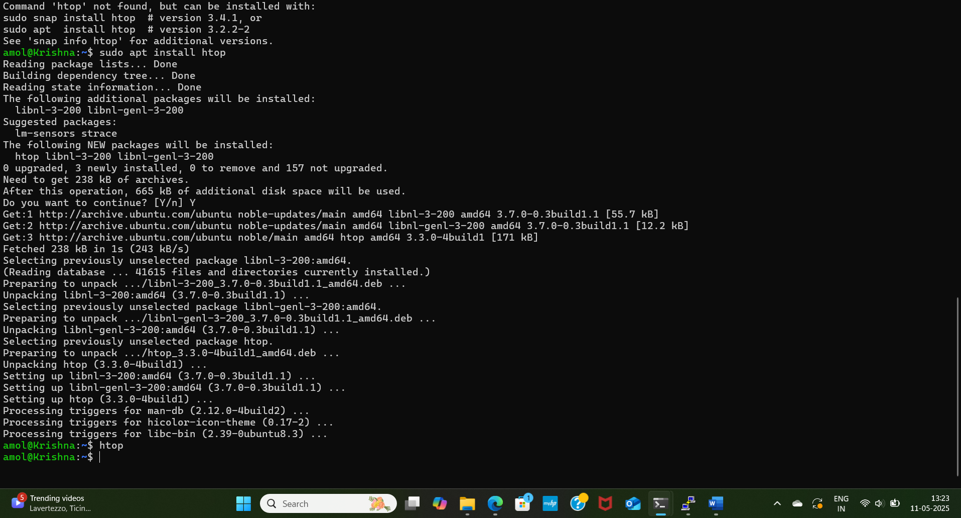

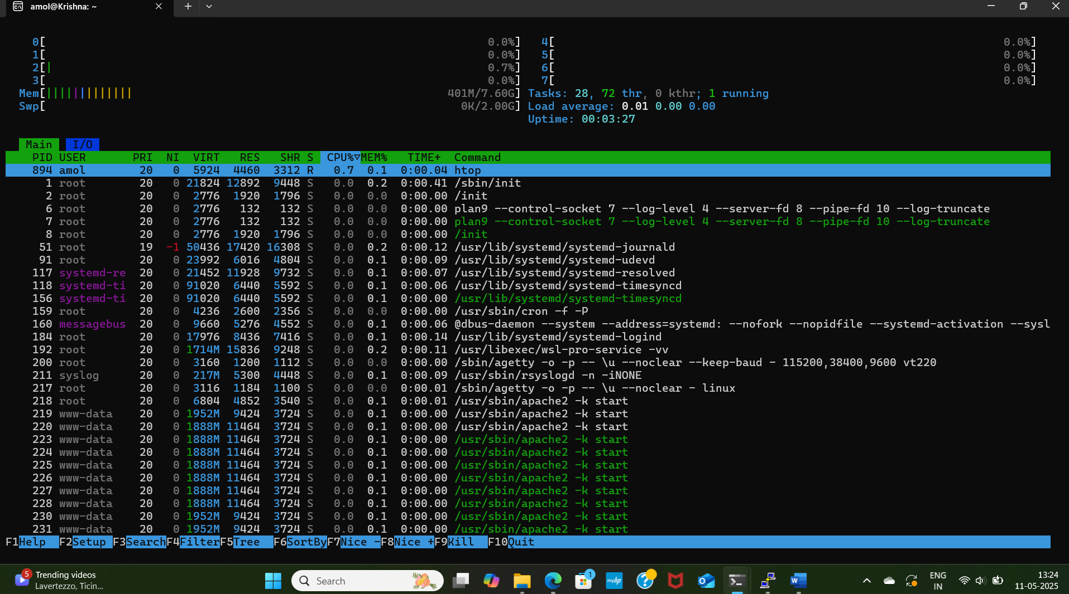

- Install nmon
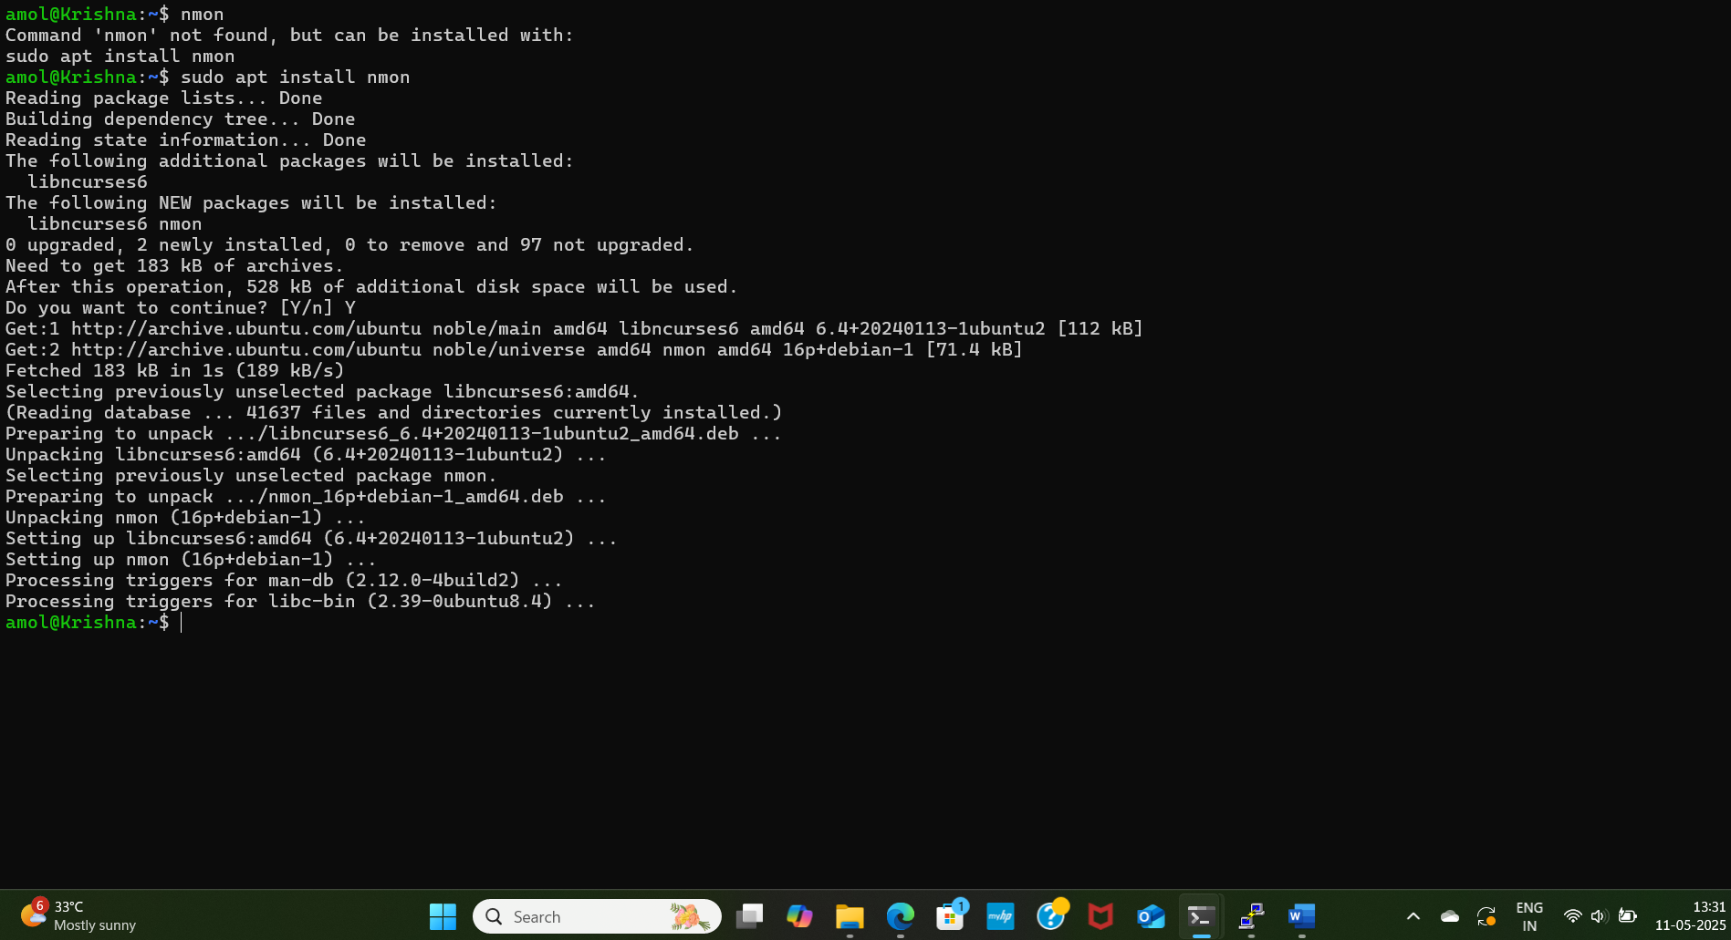

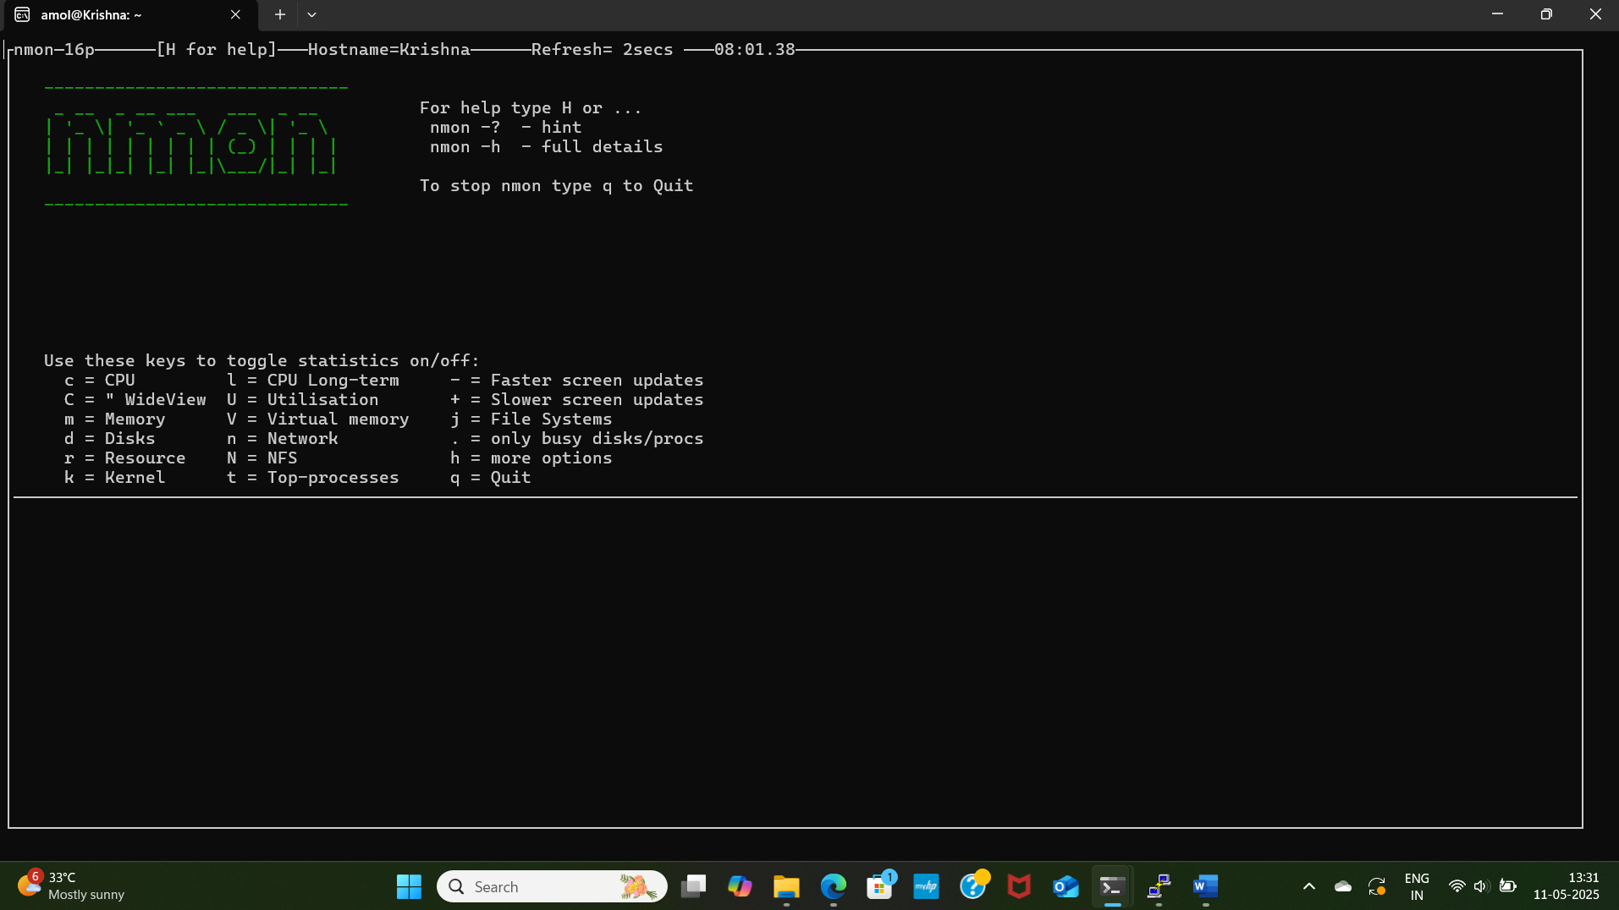

I created EC2 Machine and installed htop and nmon there as well.
Created below cron job to monitor and capture logs every 5 mins
#Capture storage
*/5 * * * * df -h > /var/log/disk_usage.log
*/5 * * * * du -sh /* > /var/log/directory_usage.log
#Display Top 20 processes consuming more cpu
*/5 * * * * ps -eo pid,ppid,cmd,%mem,%cpu --sort=-%cpu | head -20 > /var/log/cpu_intensive.log
#Display Top 20 processes consuming more memory
*/5 * * * * ps -eo pid,ppid,cmd,%mem,%cpu --sort=-%mem | head -20 > /var/log/memory_intensive.log

Below are Output logs:
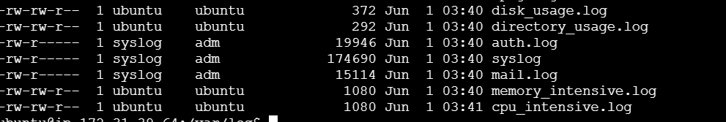

Sample Output
