Daily checkout steps for GEMMA

1. **Click Online dashboard on GEMMA prod application to check all files are running or not:**

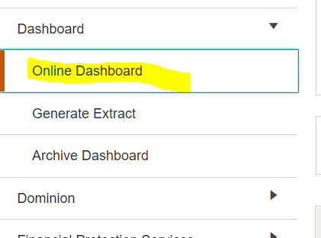

1. **Check Spunk logs for any exception or error**

<https://phi-splunk.optum.com/en-US/app/optum_gemma/search?q=search%20index%20%3D%20cba_gemma%20exception&display.page.search.mode=smart&dispatch.sample_ratio=1&earliest=%40d&latest=now&sid=1617607267.304496_10F7D6F9-0064-406A-996A-DBC1568BA661>

use: index = cba_gemma exception in search

check using index = "cba_gemma" "<FILE_ID>"

1. **Check the batch window indicator after or facets core schedule completed.**

**select** **\*** **from** scst_eiei_batch_wind_status;

1. **To change file status from backend (File canceled/ Marked Complete).**

**/**111-Canceled*/**

CALL SCSP_EIEI_DASHBOARD_UPD_STATUS (203769,111,'GEMMA_AUTO',@SWP_Ret_Value);

**/**112-Completed*/**

CALL SCSP_EIEI_DASHBOARD_UPD_STATUS (203769,112,'GEMMA_AUTO',@SWP_Ret_Value);

1. **To check “Waiting For Prior File” file status.**

​

CALL SCSP_EIEI_FILE_PRIOR_STATUS (206830);

1. **To check audit file status.**

select * from SCST_EIEI_AUD_FILE_STATUS

select top 11 * from SCST_EIEI_FILE_STATS

1. **Replication table to check status.**

select * from sym_data_gap -- sys replication table

1. **Dashboard table**

SCST_EIEI_DASHBOARD

1. **SYS_Warning table**

SCST_EIEI_SYS_WARNING

**Few IMP tables:**

1.        SCST_EIEI_GRGR_POL_NO_CONV

2.        scst_ehb_grgr_pol

KFM:

3.        SCST_EIEI_KFM_CSMAPPING

4.        SCST_EIEI_KFM_GRGRMAPPING

UPDATEABLE FIELDS:

5.        SCST_EIEI_CSP_UPDATE_FLDS

BIZ RULES:

6.        SCST_EIEI_BRM_CLR_FDFN_XREF

7.        SCST_EIEI_BRM_RULE_DETAIL

8.        SCST_EIEI_BRM_RULES

9.        SCST_EIEI_BRM_RLS_BS_XREF

THRESHOLD SETTING & AUTO TERMINATION

10.        SCST_EIEI_THRESHOLD_LIMIT

AUTO TERM PROTECTION

11.        SCST_EIEI_CSP_ATERM_PRTCTN

**ACTION_PERFORMED**

----------------

799 - Auto-term protected

800 - No change

801 - Auto term

803 - New

804 - Update

**RECORD_STATUS**

-------------

201 - No fatal errors or warnings

202 - Warnings

203 - Fatal error

205- cancelled

206 - Success without warning

207 - Success with warning

211/212 - elig corr record

**FILE_STATUSES:**

**--------------**

101 -- Expected

102 -- Not_Started

103 -- Non_Arrival

104 -- Processing

105 -- Sent_For_Load

106 -- Processed_With_Error

107 -- Waiting_For_Prior_File

108 -- Waiting_After_Rawdata_Load

109 -- Waiting_Before_Facets_Load

110 -- Cancelled_Automatic

111 -- Cancelled_Manual

112 -- Completed

113 -- Kick_Off_Required

114 -- System_Error

116 -- Waiting_for_Batch_Window

117 -- Waiting_For_Eligibility_File

118 -- Eligibility_File_Missing_Error

119 -- Audit_File_Completed

120 -- Scheduled

121 -- Exceeded_Threshold

**ELIG correction SP's :**

SCSP_EIEI_ELIG_CORR_UPD

SCSP_EIEI_ELIG_CORR_UPD_PRM

SCSP_EIEI_ELIG_CORR_UPD_LIDI

SCSP_EIEI_ELIG_CORR_UPD_CH1

SCSP_EIEI_GRL_LOAD_MAIN

Replication Status check/issues:

Replication is happening

Facets-fakpfpr0 (Sql server) -- > GEMMA-gemmafprd (mySQL)

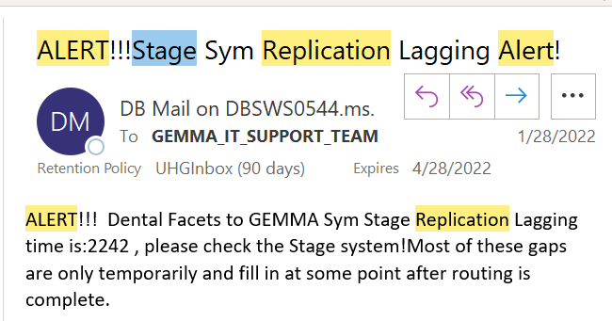

select * from sym_data_gap

First check timing in gap table in facets fakpfpr0. time lag not more than 30 min

**Facets:** select * from fakpfpr0..sym_data_gap

**GEMMA:** select * from gemmafprd.sym_data_gap

One more check we can do

Update CMC_PDPT_DESC value in facets database and wait for a min and check same changes are reflecting in gemma or not.

Run below query in facets fakprpr0.

-- SELECT * FROM CMC_PDPT_DESC

update CMC_PDPT_DESC

set PDPT_DESC = 'Warning Messages 123'

where PDBC_TYPE = 'WMWM'

Wait a min and run below query in gemmafpd database in GEMMA

select * from CMC_PDPT_DESC where PDBC_TYPE = 'WMWM'

Those changes should reflect in gemma as well.

Once confirmed please revert changes in facets

update CMC_PDPT_DESC

set PDPT_DESC = 'Warning Messages'

where PDBC_TYPE = 'WMWM'

You can check now one more time. Just check revert changes are reflected in GEMMA or not.

**Note:** CTASK0932845 for sample restart request after patching

Contact details for Reaching out DBA

INC20905178 - sym process is down on rp000017256.uhc.com.

**SN group** - UHC EAI-Clinical-INC-ORA-MYSQL

**Email DL** - EnI_Oracle_Dba_Support [EnI_Oracle_Dba_Support_DL@ds.uhc.com](mailto:EnI_Oracle_Dba_Support_DL@ds.uhc.com)

**Personal** : YOUSUF AYAZ

MMSCleanupsteps**:**

**Step 1 :** First go to below path and check how many xml files are in stuck/present. Take backup of those files in some other location.

\\nasv1004\uhcsb_prd\GEMMAPROD58\OutFiles

**Note:** If issue is going on and taking time to resolve then please stop Auto file processing and inform users to process manually

**Step 2** : Query the WORK QUE table (CER_QWK0_WORK_QUE)

Connect to the Facets DB:  **fakpfpr0**

If the MMS load didn’t complete successfully, the process may not be able to remove the TM rows in the “CER_QWK0_WORK_QUE” PZPZ_ID column. Check the QWK0_STS column for the TM rows, if they have a “0” but all the records for that MMS engine are in “99” status (meaning completed), then we will need to change the status from “0” to “99” (completed).

Below query will show if any TM records have been left behind by the process.

Each MMS engine will have their own TM records, these are created when a file is processing thru the MMS engine.

Select *

From CER_QWK0_WORK_QUE

Where PZAP_APP_ID like 'MMS%'

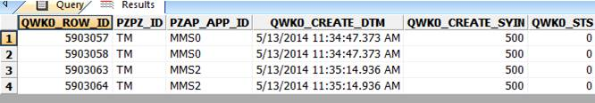

We used to have a batch job that we could execute, we can do is update the status from 0 to 99.

Please be extremely careful with the below script. If we have a file actively processing on any of the MMS engines, and only one of the MMS is having the issue you MUST adjust the script below to reflect the correct MMS engine and **NOT** use a wild card.

Before running query, please check in GEMMA frontend is there any file is send for load status.

 update CER_QWK0_WORK_QUE

Set QWK0_STS = 99

where QWK0_STS = 0

and PZAP_APP_ID **like 'MMS%'**

QWK0_STS status of '0' are for queues that have not been processed; '10' for queues that are assigned to an engine and are being process; '99' are for the completed.

**Step 3:** Second we will need to check the Multi Instance table this table is on the EIEI DB to make sure the failed file id released that instance.

Check MMS Multi Instance Table from GEMMA DB: **gemmap**

1. SCST_EIEI_MMS_MULT_INSTANCE

SELECT * FROM SCST_EIEI_MMS_MULT_INSTANCE

If the FILE ID that failed (System Error) still showing on this table SCST_EIEI_MMS_MULT_INSTANCE under the FILE_ID column for the corresponding MMS that we already validated from the Facets CER_QWK0_WORK_QUE table, then we will have to manually released the instance, by updating that filed for that MMS to reflect [NULL]

Select *

From SCST_EIEI_MMS_MULT_INSTANCE

UPDATE SCST_EIEI_MMS_MULT_INSTANCE

SET FILE_ID = NULL

WHERE INST_SEQ_ID = <#>

Once that is done query the table once again to make sure the FILE_ID was cleared.

SELECT * FROM SCST_EIEI_MMS_MULT_INSTANCE

**Testing after cleanup:**

1. Ask business to cancel all system error files. If Business not able to do then please do it from backend

CALL SCSP_EIEI_DASHBOARD_UPD_STATUS (<File_ID>,111,'GEMMA_AUTO',@SWP_Ret_Value);

1. Once cancelled all file run AAAA client file if ran successfully then ask business to process small file first and monitor it.
   1. Once file went for "send for load" then check xml is crated on \\nasv1004\uhcsb_prd\GEMMAPROD58\OutFiles with time filter
   2. Once file is completed it will get renamed with its format.
   3. If test file is completed, then asked business to process all file manually which is are in error out.
   4. select * from scst_eiei_mms_mult_instance semmi ; -- check mms instance respect to file
2. Start/enable Auto processing if we stop/disable

GEMMA-BPM service down check:

1. Ge to the Chrome and put "https://" and server name which we need to check

e.g <https://wn000013035/>

1. If Service is UP/Running then this URL will become as below

<https://wn000013035/app/welcome/GEMMABPM/#!/welcome/>

**Note:** If service is down/not running then this site will not open

1. Once Site is open then **Camunda Welcome** page will open and asking for credential

Machine generated alternative text:
Please sign in 
Username 
Password 
Sign in 

1. Put Admin admin then click on sign in. it will open below page. This is open that's mean BPM service is up and running on particular server.

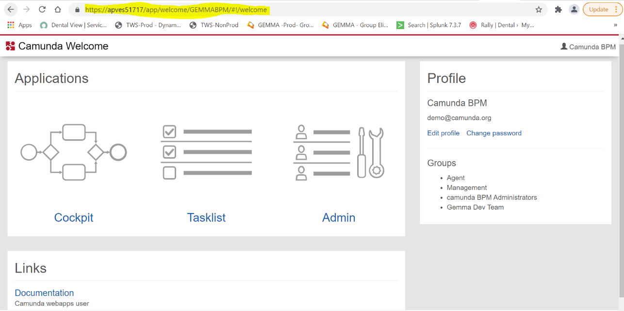

**One more way:** login on the server and open services from start menu and check status for “GEMMA-BPM”

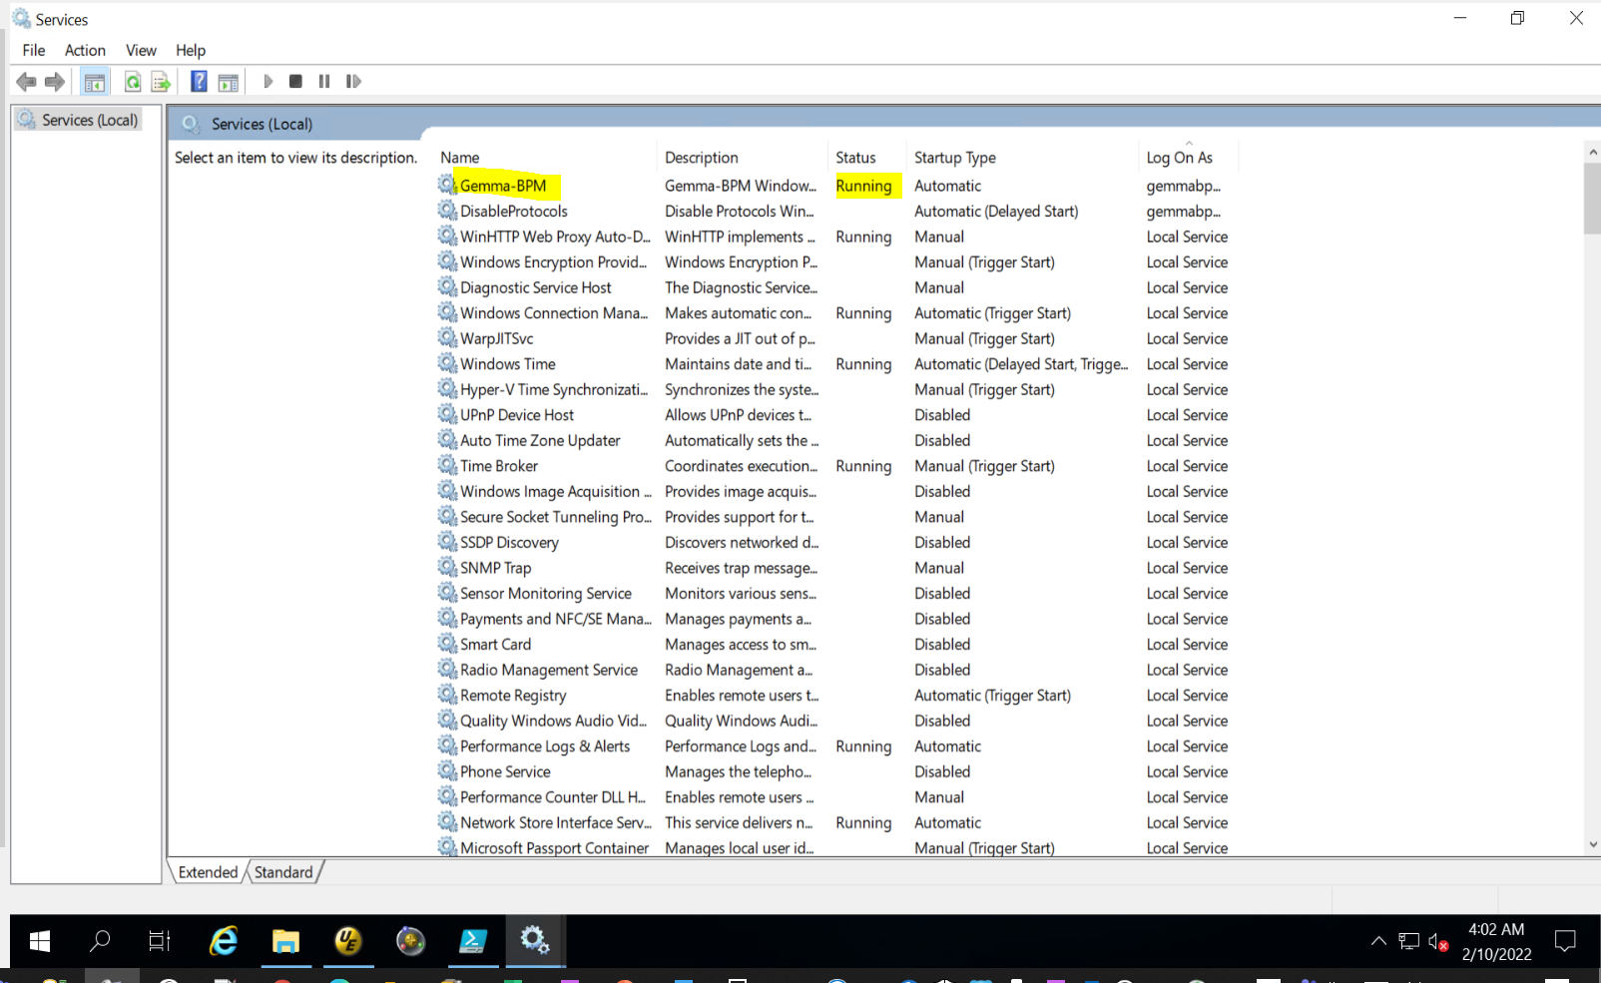

ACIS/UNET File issue/ Details:

File Name : UHSB_ACIS_Dental_Daily_*.xml

Profile : 12DNH

file will be coming on below location trough ecg:

\\nasv1004\uhcsb_prd\prod\DropOff\unet\

UHD_SCS_W4_ACIS_CES_ETS_IN_PRD will run and move above file from above Dropoff location to below input location.

Note : This is file watcher job it will check for file every 5 min

\\nasv1004\uhcsb_prd\prod\OHD_EIEI\Input

second UHD_SCS_W4_ACIS_XML2FLATFILE_PRD job will run and process files and generate output files on below output location.

Note : this is perl job, It will check system timestamps and process only current date file.

\\nasv1004\uhcsb_prd\prod\OHD_EIEI\Output

Z:\stage\OHD_EIEI\Input

UHD_SCS_LLCORE8 job steam is schedule on 11pm if there is delay and job run after 12am then it will complete with no input file

if it happen then we need to process file manually

1) check file UHSB_ACIS_Dental_Daily_20210617.xml is present in input location. If present then rename with today's date.

2) Run UHD_SCS_W4_ACIS_XML2FLATFILE_PRD from bat file.(OHD_ACIS_XML_TO_FLAT_FILE.BAT)

3) check below files are generated on output location or not.

ACIS_RejectFile_20210603.dat

UHSB_ACIS_Dental_Daily_20210603.dat

4)now rename input file with it's original date and rename with above file with input file date

e.g. input file is for 06/01/2021 and you are running on 06/02/2021

then you need to make input file name to 06/02 and once job completed revert back it to 06/01.

5)move above 2 files from output location to below Dropoff\unet location.

6)move log file from Z:\prod\OHD_EIEI\Outfiles location to DropOff\unet location. Please rename with its input file date.

\\nasv1004\uhcsb_prd\prod\DropOff\unet

\\nasv0418\uhcsb_stg\stage\DropOff\unet

Issue : We are getting file late from ecg due to that job is running after 12am. as perl script is checking file for current date and file is not found

due to this main job is completed with no input file.

Archive location : \\nasv1004\uhcsb_prd\prod\Archive

GEMMA file filter

Machine generated alternative text:
Filter For: 
Select Date: Expected Date (CST) v 
Client System: UNET 
From. 
• 2021-07-13 
File Status. 
Through: 
• All Status 
Starts with 
2021-07-20 
Retrieve 
UHSB ACIS Dental I 
Reset 
Advance Filters 
Apply 
Clear 
Orig File Name 

New/Copy BR rule Profile creation:

**call** CREATE_LIFE_PROFILES(**:number_of_profiles**, **:starting_file_profile**, **:source_file_profile_id**, **:v_counter**)

**:number_of_profiles –** Provide how many profile need to create**.**

**:starting_file_profile --** to get max starting_file_profile use below query

**select** **MAX**(FILE_COLL_ID ) **from** scst_eiei_csp_file_coll

**:source_file_profile_id –** Provide source profile id from which we are creating new profile.

**:v_counter –** It will be 1 only

**Example : call** CREATE_LIFE_PROFILES (1, 812, 210, 1)

 -- INSERT INTO gemmap.scst_eiei_file_fps_extr_clnt

(SERVER_NAME, USER_NAME, **PASSWORD**, IN_PATH, OUT_PATH, EXTRACT_NAME, FILE_DEFN_ID, EXTR_TYPE, CLIENT_SYSTEM_ID, FORMAT_FILE_NAME, VIEW_NAME, EXTRACT_TABLE_NAME)

**select** SERVER_NAME, USER_NAME, **PASSWORD**, IN_PATH, OUT_PATH, EXTRACT_NAME, 812, EXTR_TYPE, CLIENT_SYSTEM_ID, FORMAT_FILE_NAME, VIEW_NAME, EXTRACT_TABLE_NAME

**from** gemmap.scst_eiei_file_fps_extr_clnt

**where** FILE_DEFN_ID = 264

update gemmap.scst_eiei_file_fps_extr_clnt

set OUT_PATH = '\\\\uwbfs01\\Unimerica\\FPS CLIENT OPS\\Facets Case Installation\\EDI\\EDI Groups\\EIEI Errors\\Errors\\264 Errors'

where FILE_DEFN_ID = <neW_PROFILE>