* **Payroll: -**
* Click on Payroll

1. **Advance Management**

* Click on Advance Management

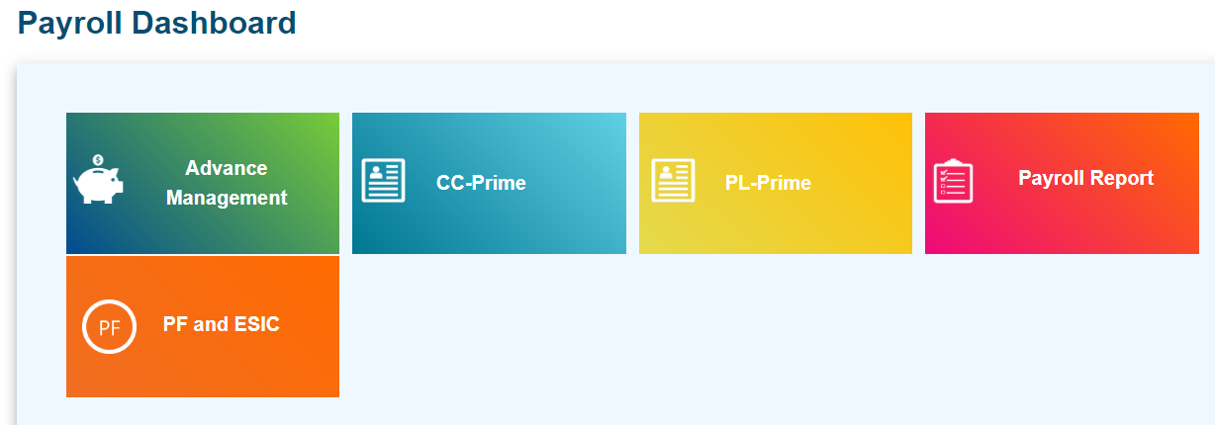

* Click on Add
* Note: Add button is not visible to super admin,
* Super admin approved/ Disapproved the advance (It is mandatory).

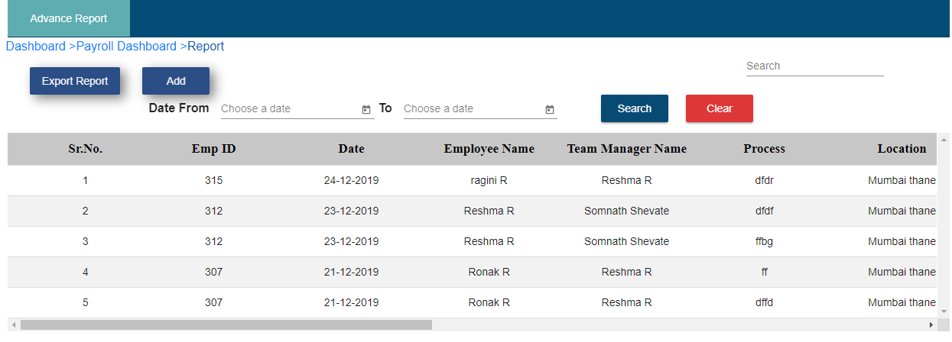

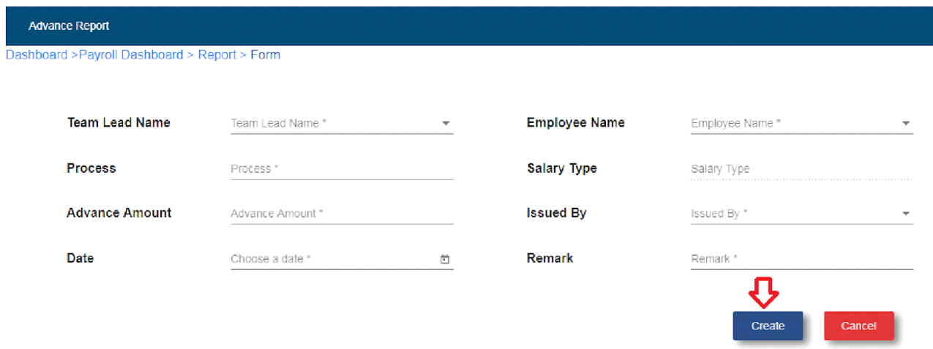

* Select team lead name.
* Select employee name.

Note: Employee should be team member of any one of the team lead.

* Enter process.
* Salary type will be auto generated.
* Enter advance amount.
* Select issued by.
* Select date.
* Enter remark.
* Click on create button.
* After click on create button, record will be displayed in the advance report table.
* If user wants to see details then click on view details icon
* Click on cancel

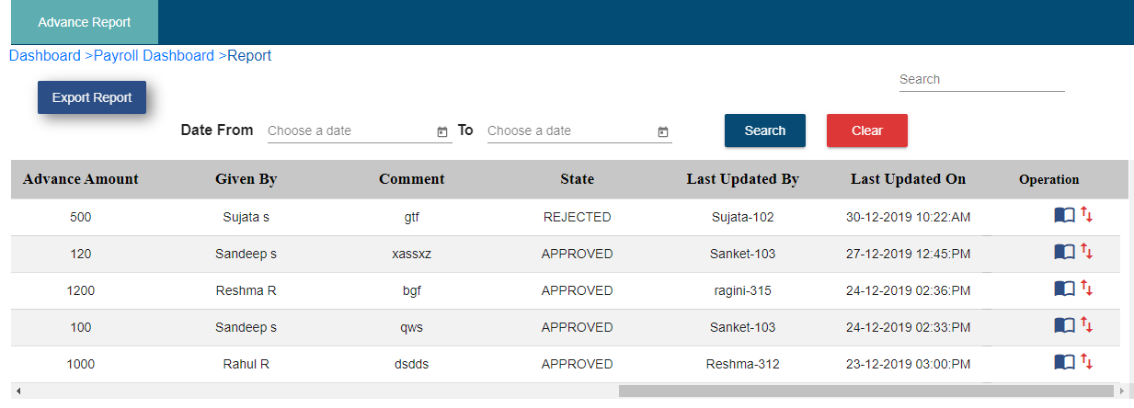

Fig. Advance Report view details and download action log

* If user wants to download action log then follow below steps
* Click on upward/downward arrows
* Click on OK
* Click on OK
* Advance Log Report get downloaded which is shown below:

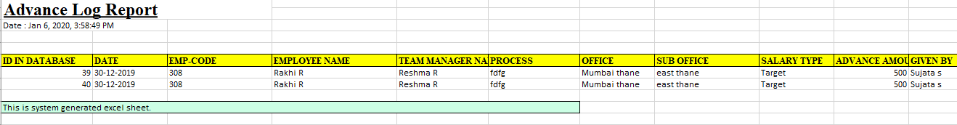

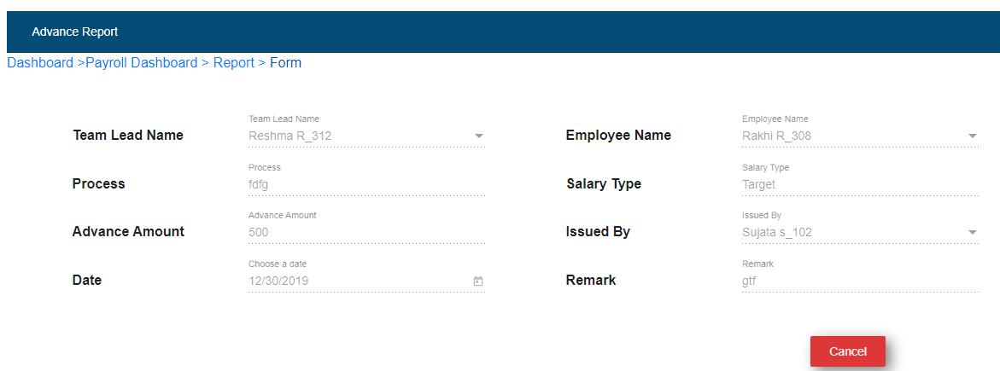

* Select date from and date to.
* Click on search button.
* After click on search button user is able to search the records.



Fig. Advance Report Search Records

* **Export Report: -**
* Click on Export Report



* Click on Export
* Click on Ok
* Advance prime report gets downloaded which is shown below.

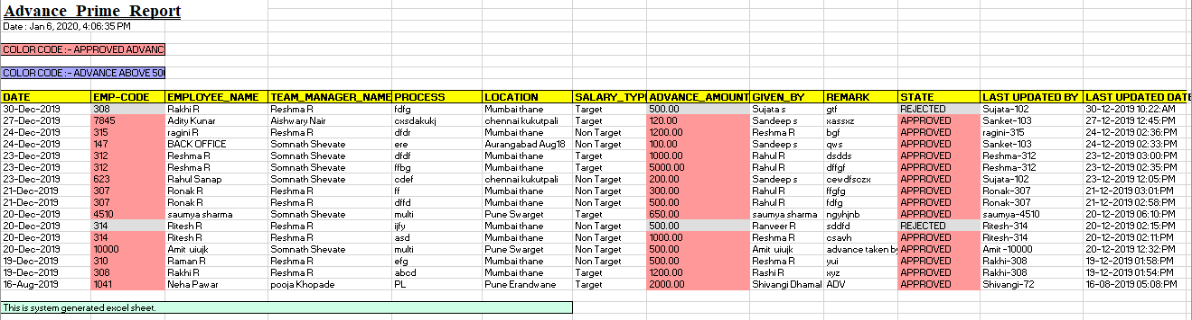

1. **CC Prime: -**



* Click on CC-prime
  1. **Master Prime Report:**
* It contains report of FOS Target, FOS Freelancer, Pick up Executive, Business Partners
* Select Designation
* Select From and To Date
* Select Location
* Click on search

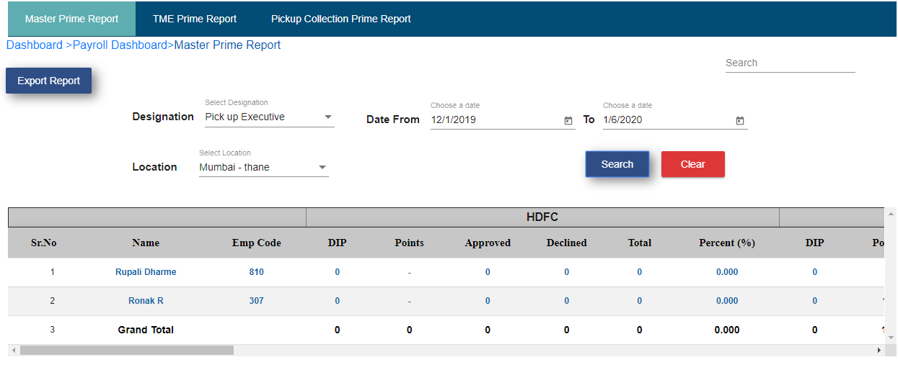

* **Export Report: -**
* Click on Export Report
* Click on export
* Click on OK
* CC Master Prime Report get downloaded which is shown below

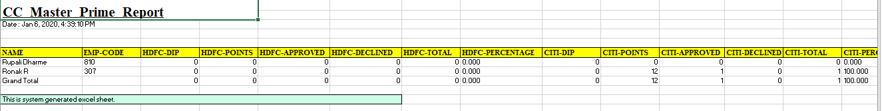

**ii) TME Prime Report: -**

* Click on TME Prime Report sub module.

**a. Prime Report**

Note: 1. Name column shows team lead name in bold and TME name.

2. TME should be a member of team lead and TME should be assigned to any one of the  team lead.

3. ICICI bank declined code – MAR – Status – Multiapproved

4. SCB bank declined code – SR00 – Status – Multiapproved

5. Declined code means promo code – It will come from MIS Import master Table

6. Yes bank column show only DIP and point count.

7. RBL bank is not present in prime report.

8. Final DIP count present only for ICICI bank.

* DIP count comes from MIS import master table to that particular record. This count is count of team member DIP count.
* Points will calculate as per card master, which bank will have how much card points according to that.
* Approved count comes from MIS import master table.
* Declined count comes from MIS import master table.
* Total = Approved +Declined
* Percent (%) – Approved/Total

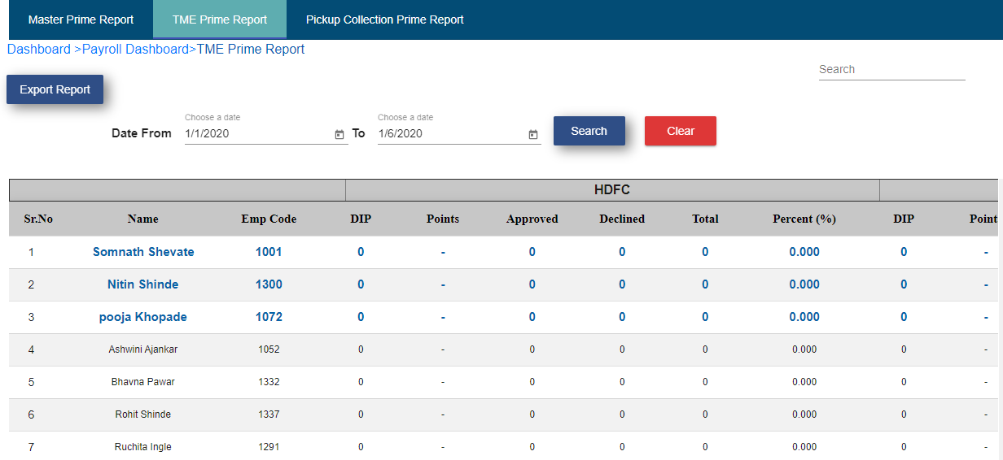

Fig. TMEs prime report

* **Total**

1. DIP – Total DIP count

2. Points – Total points count

3. Approved – total count of approved

4. Declined – Total count of declined

5. Total – Approved total + Declined total

6. Percent – Approved/ total *100

* **Grand Total**

1. Grand total calculate as per column.

2. In grand total only team lead count will be calculated which is display bold in the table.

3. Grand total is addition of all team lead records.

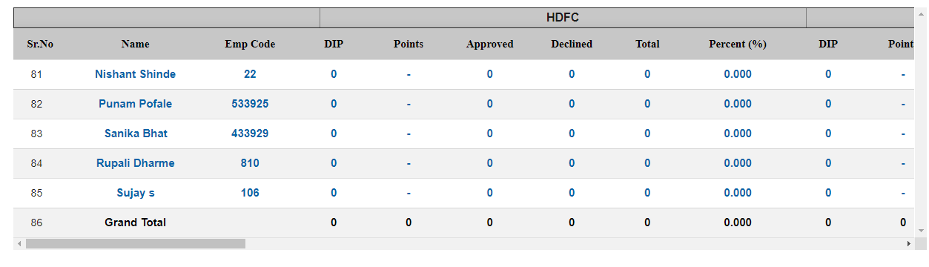

Fig. Prime Report Grand Total

* Date from and date to display one-month record.
* User will able to search date as per month.
* User will able to export prime report in excel sheet format.



Fig. Prime Report Search and Export

**iii) Pick up Collection Prime Report: -**

* It contains pickup collection prime report.
* Click on Pickup Collection Prime Report

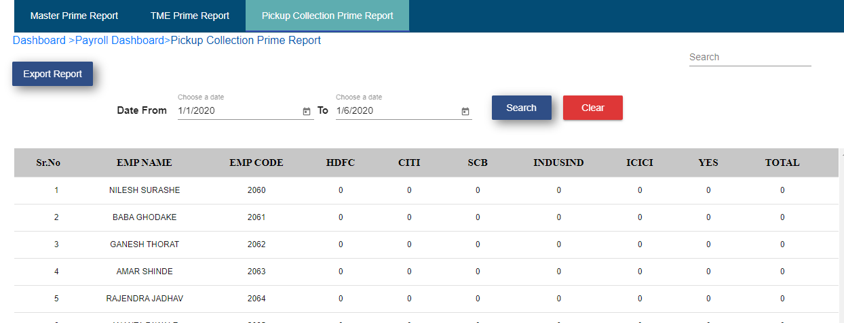

Fig. Pick up collection prime report

User is able to download CC pickup collection prime report follow below steps:

* Click on Export Report
* Click on export
* Click on ok
* CC pickup collection prime report get downloaded which is shown below

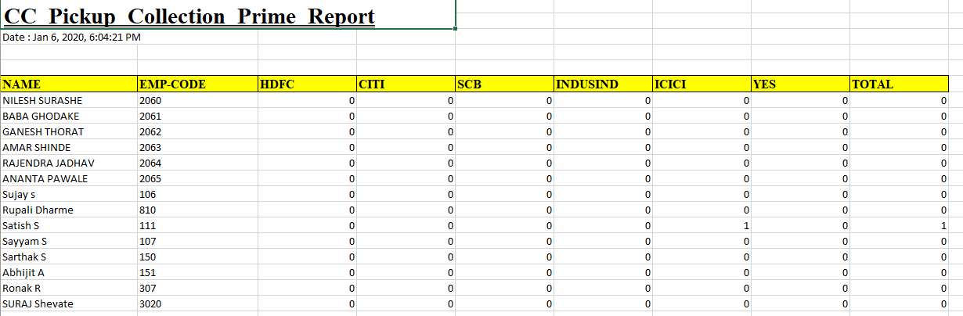

* + 1. **PL Prime: -**

Click on PL Prime



* 1. **Self Prime Report: -**

It contains employee name, employee code and total disbursed amount of that employee.

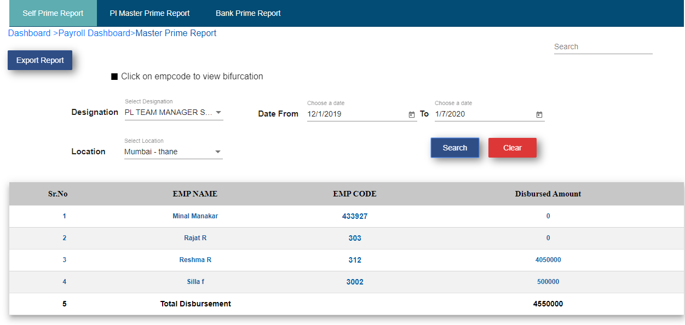

* Select Designation
* Choose date
* Select Location
* Click on search
* User will get the total disbursed amount of employee of selected date and location.
* User is able to download PL master prime report follow below steps:
* Click on Export Report
* Click on export
* Click on ok
* PL master prime report get downloaded which is shown below

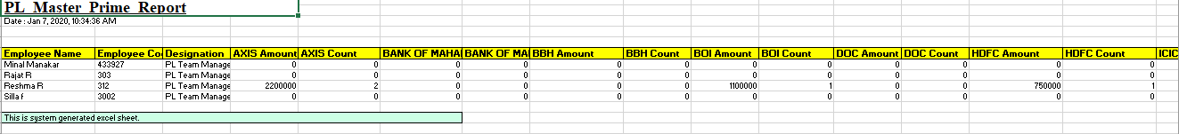

* 1. **PL Master Prime Report: -**

It consists of PL Product Head Prime Report I.e. Product head name, emp code and total disbursed amount of team.

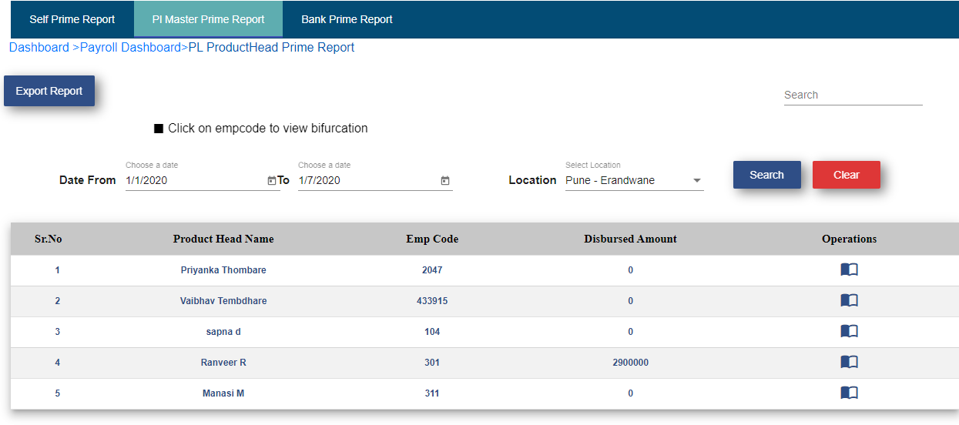

* User is able to download PL product head prime report follow below steps:
* Click on Export Report
* Click on export
* Click on ok
* PL product head prime report get downloaded which is shown below

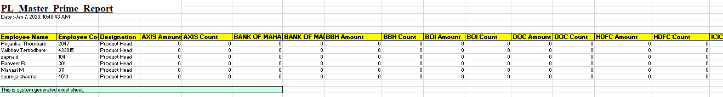

* Click on view details icon present in operation column



* Unit manager under that product head prime report is displayed.

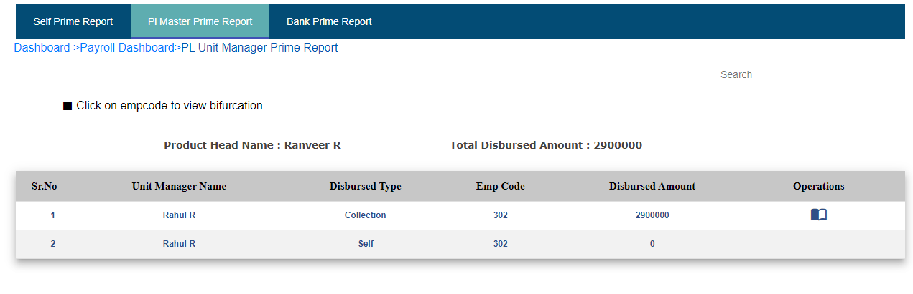

* It contains unit managers team collection and self-disbursed amount.
* Click on view details icon present in operation column



* Team manager under that unit manager report is displayed.
* It contains unit managers team collection and self-disbursed amount.

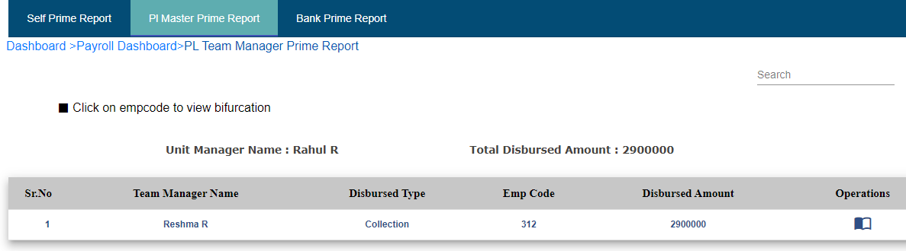

**C. Bank Prime Report:**

This report contains Bank name, application count and total disbursed amount of that bank at particular location.

* Select date
* Select location
* Click on search

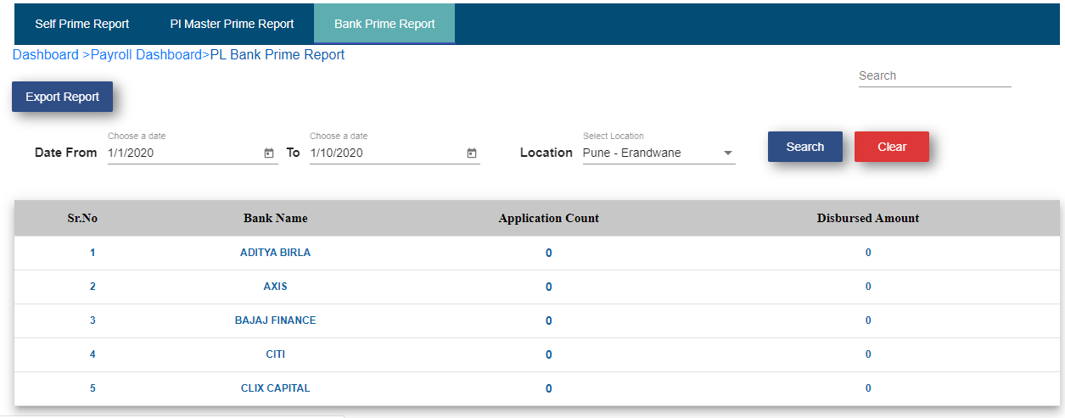

* User is able to download Bank prime report follow below steps:
* Click on Export Report
* Click on ok
* Click on ok
* PL Bank prime report get downloaded which is shown below

