Pulling a repository from remote system

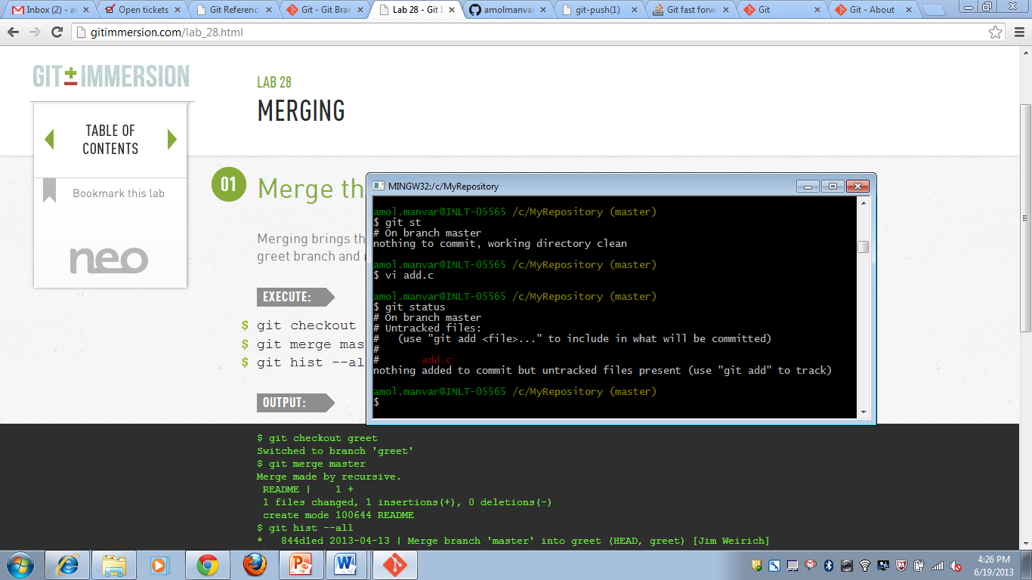

Git status and adding a new file