Contents

DevOps-ILP1-346617 Details 2

1. Git commands: 2

2. Jenkins Console Output 4

3. Maven Commands: 8

4. GitHub Settings 11

# DevOps-ILP1-346617 Details

## Git commands:

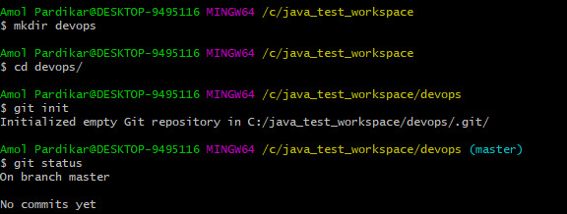

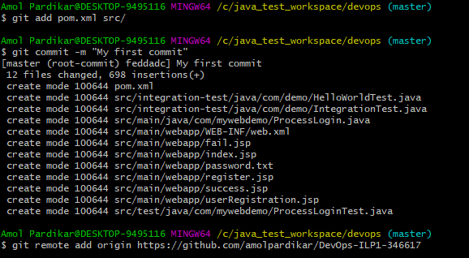

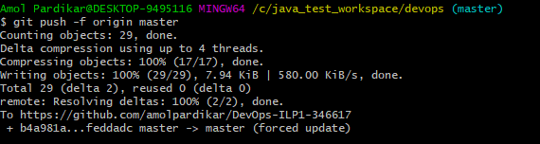

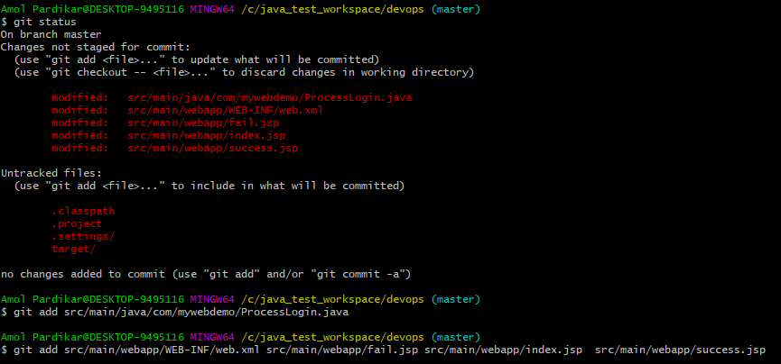

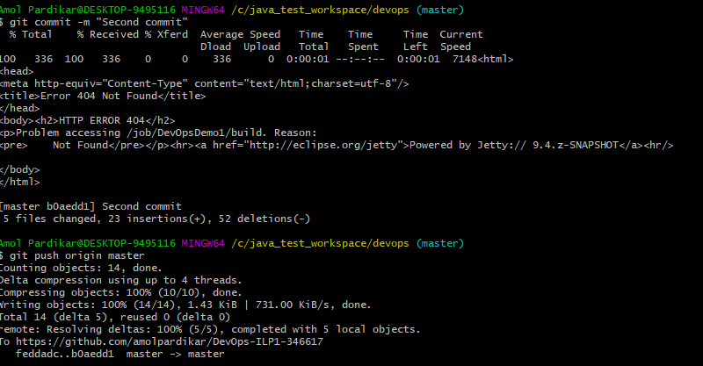

## Jenkins Console Output

Console Output

Started by user [anonymous](http://localhost:8090/user/null)

Building in workspace C:\Users\Amol Pardikar\.jenkins\workspace\DevOpsDemo

Cloning the remote Git repository

Cloning repository <https://github.com/amolpardikar/DevOps-ILP1-346617>

> C:\Program Files\Git\bin\git.exe init C:\Users\Amol Pardikar\.jenkins\workspace\DevOpsDemo # timeout=10

Fetching upstream changes from <https://github.com/amolpardikar/DevOps-ILP1-346617>

> C:\Program Files\Git\bin\git.exe --version # timeout=10

using GIT_ASKPASS to set credentials

> C:\Program Files\Git\bin\git.exe fetch --tags --progress <https://github.com/amolpardikar/DevOps-ILP1-346617> +refs/heads/*:refs/remotes/origin/*

> C:\Program Files\Git\bin\git.exe config remote.origin.url <https://github.com/amolpardikar/DevOps-ILP1-346617> # timeout=10

> C:\Program Files\Git\bin\git.exe config --add remote.origin.fetch +refs/heads/*:refs/remotes/origin/* # timeout=10

> C:\Program Files\Git\bin\git.exe config remote.origin.url <https://github.com/amolpardikar/DevOps-ILP1-346617> # timeout=10

Fetching upstream changes from <https://github.com/amolpardikar/DevOps-ILP1-346617>

using GIT_ASKPASS to set credentials

> C:\Program Files\Git\bin\git.exe fetch --tags --progress <https://github.com/amolpardikar/DevOps-ILP1-346617> +refs/heads/*:refs/remotes/origin/*

> C:\Program Files\Git\bin\git.exe rev-parse "refs/remotes/origin/master^{commit}" # timeout=10

> C:\Program Files\Git\bin\git.exe rev-parse "refs/remotes/origin/origin/master^{commit}" # timeout=10

Checking out Revision b0aedd10a5036b3731fce884a742c71bda79bddb (refs/remotes/origin/master)

> C:\Program Files\Git\bin\git.exe config core.sparsecheckout # timeout=10

> C:\Program Files\Git\bin\git.exe checkout -f b0aedd10a5036b3731fce884a742c71bda79bddb

Commit message: "Second commit"

First time build. Skipping changelog.

[DevOpsDemo] $ cmd.exe /C "C:\Softwares\apache-maven-3.5.2\bin\mvn.cmd -f C:\java_test_workspace\devops\pom.xml compile && exit %%ERRORLEVEL%%"

[INFO] Scanning for projects...

[INFO]

[INFO] ------------------------------------------------------------------------

[INFO] Building devopsdemo Maven Webapp 0.0.1-SNAPSHOT

[INFO] ------------------------------------------------------------------------

[INFO]

[INFO] **--- maven-resources-plugin:2.6:resources (default-resources) @ devopsdemo ---**

**[WARNING] Using platform encoding (Cp1252 actually) to copy filtered resources, i.e. build is platform dependent!**

[INFO] Copying 0 resource

[INFO]

[INFO] **--- maven-compiler-plugin:3.1:compile (default-compile) @ devopsdemo ---**

[INFO] Changes detected - recompiling the module!

**[WARNING] File encoding has not been set, using platform encoding Cp1252, i.e. build is platform dependent!**

[INFO] Compiling 1 source file to C:\java_test_workspace\devops\target\classes

[INFO] ------------------------------------------------------------------------

[INFO] BUILD SUCCESS

[INFO] ------------------------------------------------------------------------

[INFO] Total time: 3.401 s

[INFO] Finished at: 2018-02-03T23:58:48Z

[INFO] Final Memory: 15M/183M

[INFO] ------------------------------------------------------------------------

Parsing POMs

Discovered a new module com:devopsdemo devopsdemo Maven Webapp

Modules changed, recalculating dependency graph

Established TCP socket on 61068

[devops] $ "C:\Program Files\Java\jdk1.8.0_121/bin/java" -cp "C:\Users\Amol Pardikar\.jenkins\plugins\maven-plugin\WEB-INF\lib\maven35-agent-1.12-alpha-1.jar;C:\Softwares\apache-maven-3.5.2\boot\plexus-classworlds-2.5.2.jar;C:\Softwares\apache-maven-3.5.2/conf/logging" jenkins.maven3.agent.Maven35Main C:\Softwares\apache-maven-3.5.2 "C:\Users\Amol Pardikar\.jenkins\war\WEB-INF\lib\remoting-3.14.jar" "C:\Users\Amol Pardikar\.jenkins\plugins\maven-plugin\WEB-INF\lib\maven35-interceptor-1.12-alpha-1.jar" "C:\Users\Amol Pardikar\.jenkins\plugins\maven-plugin\WEB-INF\lib\maven3-interceptor-commons-1.12-alpha-1.jar" 61068

<===[JENKINS REMOTING CAPACITY]===>channel started

Executing Maven: -B -f C:\java_test_workspace\devops\pom.xml test

[INFO] Scanning for projects...

[INFO]

[INFO] ------------------------------------------------------------------------

[INFO] Building devopsdemo Maven Webapp 0.0.1-SNAPSHOT

[INFO] ------------------------------------------------------------------------

[INFO]

[INFO] **--- maven-resources-plugin:2.6:resources (default-resources) @ devopsdemo ---**

**[WARNING] Using platform encoding (Cp1252 actually) to copy filtered resources, i.e. build is platform dependent!**

[INFO] Copying 0 resource

[INFO]

[INFO] **--- maven-compiler-plugin:3.1:compile (default-compile) @ devopsdemo ---**

[INFO] Nothing to compile - all classes are up to date

[INFO]

[INFO] **--- build-helper-maven-plugin:1.9.1:add-test-source (add-integration-test-sources) @ devopsdemo ---**

[INFO] Test Source directory: C:\java_test_workspace\devops\src\integration-test\java added.

[INFO]

[INFO] **--- build-helper-maven-plugin:1.9.1:add-test-resource (add-integration-test-resources) @ devopsdemo ---**

[INFO]

[INFO] **--- maven-resources-plugin:2.6:testResources (default-testResources) @ devopsdemo ---**

**[WARNING] File encoding has not been set, using platform encoding Cp1252, i.e. build is platform dependent!**

**[WARNING] Using platform encoding (Cp1252 actually) to copy filtered resources, i.e. build is platform dependent!**

[INFO] skip non existing resourceDirectory C:\java_test_workspace\devops\src\test\resources

[INFO] Copying 0 resource

[INFO]

[INFO] **--- maven-compiler-plugin:3.1:testCompile (default-testCompile) @ devopsdemo ---**

[INFO] Nothing to compile - all classes are up to date

[INFO]

[INFO] **--- maven-surefire-plugin:2.18.1:test (default-test) @ devopsdemo ---**

[INFO] Surefire report directory: C:\java_test_workspace\devops\target\surefire-reports

[INFO] parallel='none', perCoreThreadCount=true, threadCount=0, useUnlimitedThreads=false, threadCountSuites=0, threadCountClasses=0, threadCountMethods=0, parallelOptimized=true

-------------------------------------------------------

T E S T S

-------------------------------------------------------

Running com.mywebdemo.ProcessLoginTest

Tests run: 3, Failures: 0, Errors: 0, Skipped: 0, Time elapsed: 0.004 sec - in com.mywebdemo.ProcessLoginTest

Results :

Tests run: 3, Failures: 0, Errors: 0, Skipped: 0

[JENKINS] Recording test results

[INFO] ------------------------------------------------------------------------

[INFO] BUILD SUCCESS

[INFO] ------------------------------------------------------------------------

[INFO] Total time: 24.866 s

[INFO] Finished at: 2018-02-03T23:59:48Z

[INFO] Final Memory: 15M/126M

[INFO] ------------------------------------------------------------------------

Waiting for Jenkins to finish collecting data

[JENKINS] Archiving C:\java_test_workspace\devops\pom.xml to com/devopsdemo/0.0.1-SNAPSHOT/devopsdemo-0.0.1-SNAPSHOT.pom

channel stopped

Finished: SUCCESS

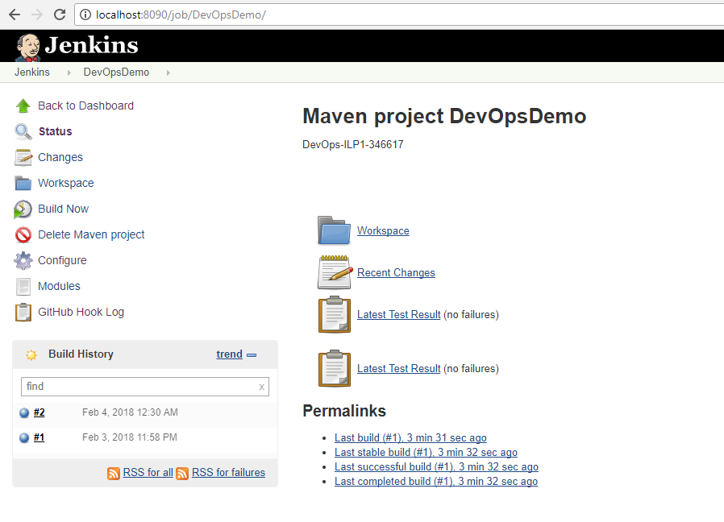

## Maven Commands:

C:\java_test_workspace\devops>mvn clean

[INFO] Scanning for projects...

[INFO]

[INFO] ------------------------------------------------------------------------

[INFO] Building MyWebUnInD Maven Webapp 0.0.1-SNAPSHOT

[INFO] ------------------------------------------------------------------------

[INFO]

[INFO] --- maven-clean-plugin:2.5:clean (default-clean) @ MyWebUnInD ---

[INFO] Deleting C:\java_test_workspace\devops\target

[INFO] ------------------------------------------------------------------------

[INFO] BUILD SUCCESS

[INFO] ------------------------------------------------------------------------

[INFO] Total time: 1.831 s

[INFO] Finished at: 2018-02-03T20:02:20Z

[INFO] Final Memory: 6M/92M

[INFO] ------------------------------------------------------------------------

C:\java_test_workspace\devops>mvn test

[INFO] Scanning for projects...

[INFO]

[INFO] ------------------------------------------------------------------------

[INFO] Building devopsdemo Maven Webapp 0.0.1-SNAPSHOT

[INFO] ------------------------------------------------------------------------

[INFO]

[INFO] --- maven-resources-plugin:2.6:resources (default-resources) @ devopsdemo ---

[WARNING] Using platform encoding (Cp1252 actually) to copy filtered resources, i.e. build is platform dependent!

[INFO] Copying 0 resource

[INFO]

[INFO] --- maven-compiler-plugin:3.1:compile (default-compile) @ devopsdemo ---

[INFO] Changes detected - recompiling the module!

[WARNING] File encoding has not been set, using platform encoding Cp1252, i.e. build is platform dependent!

[INFO] Compiling 1 source file to C:\java_test_workspace\devops\target\classes

[INFO]

[INFO] --- build-helper-maven-plugin:1.9.1:add-test-source (add-integration-test-sources) @ devopsdemo ---

[INFO] Test Source directory: C:\java_test_workspace\devops\src\integration-test\java added.

[INFO]

[INFO] --- build-helper-maven-plugin:1.9.1:add-test-resource (add-integration-test-resources) @ devopsdemo ---

[INFO]

[INFO] --- maven-resources-plugin:2.6:testResources (default-testResources) @ devopsdemo ---

[WARNING] File encoding has not been set, using platform encoding Cp1252, i.e. build is platform dependent!

[WARNING] Using platform encoding (Cp1252 actually) to copy filtered resources, i.e. build is platform dependent!

[INFO] skip non existing resourceDirectory C:\java_test_workspace\devops\src\test\resources

[INFO] Copying 0 resource

[INFO]

[INFO] --- maven-compiler-plugin:3.1:testCompile (default-testCompile) @ devopsdemo ---

[INFO] Changes detected - recompiling the module!

[WARNING] File encoding has not been set, using platform encoding Cp1252, i.e. build is platform dependent!

[INFO] Compiling 3 source files to C:\java_test_workspace\devops\target\test-classes

[INFO]

[INFO] --- maven-surefire-plugin:2.18.1:test (default-test) @ devopsdemo ---

Downloading from central: https://repo.maven.apache.org/maven2/org/apache/maven/maven-toolchain/2.2.1/maven-toolchain-2.2.1.jar

Downloaded from central: https://repo.maven.apache.org/maven2/org/apache/maven/maven-toolchain/2.2.1/maven-toolchain-2.2.1.jar (38 kB at 20 kB/s)

[INFO] Surefire report directory: C:\java_test_workspace\devops\target\surefire-reports

[INFO] parallel='none', perCoreThreadCount=true, threadCount=0, useUnlimitedThreads=false, threadCountSuites=0, threadCountClasses=0, threadCountMethods=0, parallelOptimized=true

-------------------------------------------------------

T E S T S

-------------------------------------------------------

Running com.mywebdemo.ProcessLoginTest

Tests run: 3, Failures: 0, Errors: 0, Skipped: 0, Time elapsed: 0.045 sec - in com.mywebdemo.ProcessLoginTest

Results :

Tests run: 3, Failures: 0, Errors: 0, Skipped: 0

[INFO] ------------------------------------------------------------------------

[INFO] BUILD SUCCESS

[INFO] ------------------------------------------------------------------------

[INFO] Total time: 23.489 s

[INFO] Finished at: 2018-02-03T20:40:02Z

[INFO] Final Memory: 21M/125M

[INFO] ------------------------------------------------------------------------

## GitHub Settings

URL: <https://github.com/amolpardikar/DevOps-ILP1-346617>

