**Why is it justified to use the LU or QR-factorizations as opposed of calculating an inverse matrix?**

Calculating the inverse of a matrix without either of these methods is a tedious task that, when using Gauss – Jordan elimination/row reduction, requires many calculations, so using either LU or QR decomposition greatly speeds up calculation time by requiring fewer operations to be done. For LU decomposition (after L and U are found), finding the inverse is a simple matter of forward and backward substitution “n” times with the identity matrix (requires O(n2) calculations). For QR decomposition (once Q and R have been calculated), the inverse is calculated via R-1 * Qt, which is a simple calculation since R is an upper triangular matrix (also requires O(n2) calculations). Something else to note for QR decomposition is that, on average, QR decomposition via Givens rotations requires twice as many calculations as Householder reflections. So this may be something to note for calculations on a much larger scale (Linear Algebra: Numerical Methods, p. 43).

In addition to this speed up in computation time, error/conditioning is also a huge factor in why LU and QR decompositions are preferred over the more traditional way of calculating the inverse of a matrix, and this factor is discussed below.

**What is the benefit of using LU or QR-factorizations in this way?**

Finding the inverse of a matrix using Gauss – Jordan elimination/row reduction can be unstable because this method can greatly amplify any error already present in the problem from the first step; even a well-conditioned problem can turn into an ill conditioned problem. One can use attempt to reduce the error that results from this method by having the largest value of each column at or below the diagonal be a pivot in the matrix (since this way, the row operations have to use some multiplier less than one when row reducing, therefore error is amplified to a lesser extent), but LU and QR decompositions provide a much better alternative.

On LU decomposition, the page 10 of Linear Algebra: Numerical Methods mentions the following equation: “cond(A) = cond(LU) ≤ cond(L)cond(U)” What this equation means is that the amount of error in the original matrix is, at most, equal to the condition of L and U multiplied together. Therefore, we can observe that LU decomposition does not introduce any error into our computations, so we only have to worry about the error that is inherent in our original problem.

On QR decomposition, this method gives a huge benefit to calculating the inverse in terms error amplification. Given a matrix A whose inverse is being calculated, the Webnotes (Linear Algebra: Numerical Methods, p. 1) supplies the following equations:

A = Q * R

A-1 = R-1 * Q-1

||A-1|| = ||R-1|| * ||Q-1||

Because Q is an orthogonal matrix, its inverse is equal to Qt. Therefore, the condition number is calculated by the following:

cond(Q) = σmax / σmin = √(λmax(Qt * Q)) / √(λmin(Qt * Q)) = 1

Therefore, there is no error added to our calculations involving Q. So in terms of the condition number, cond(A) = cond(R). . Minimal error amplification arises in computations involving R (namely Rx = y). And to be clear, the computation of QR, when using Householder reflections or Givens rotations, doesn’t add any error as well since Q­­n * … * Q1 * A = R, and we just established that the condition number of Qn is equal to 1. This method of calculating an inverse is considered to be very stable since it uses orthogonal transformations.

To compare the two methods of QR decomposition, it is worth noting the following observations taken from Linear Algebra: Numerical Methods (p. 43):

*(i) Householder is faster, especially for larger matrices, but*

*(ii) Givens is slightly more accurate.*

*The reason is that Householder is a “greedier” algorithm: it tries to zero more elements at the same time. Hence it is faster, but “lousier”. Givens is a slow but more accurate algorithm. However, the error is in fact almost negligible in both cases.*

Below are the plots requested for part 1 of the project.

All three methods have a big increase in error some Hilbert matrix size of 12 or higher, and this is most likely because Hilbert matrices are ill conditioned. Therefore, this error could not have been avoided. But the error for the other values of the Hilbert matrix dimensions is incredibly low and near zero.

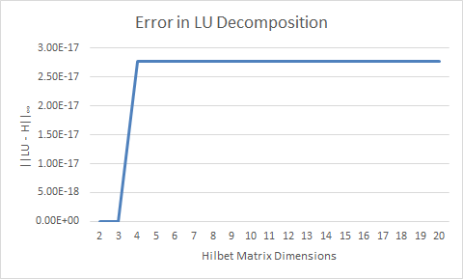

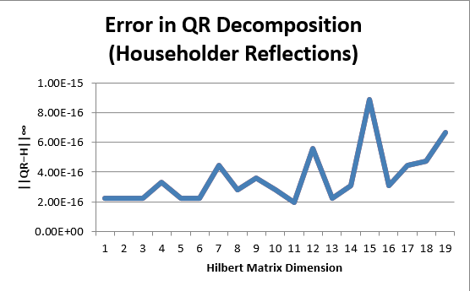

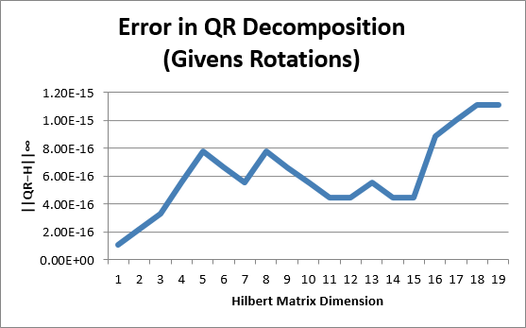

As a conclusion to this set of graphs, LU decomposition appears to be the most stable way of decomposing Hilbert matrices while using Givens rotations appears to be just slightly more stable than using Householder reflections (for reasons that are addressed in the two questions at the beginning). Although there is this small difference in the error between Givens rotations and Householder reflections, the error is negligible. Therefore, these results are consistent with the expected results.

References

For pages 19 through 29 of Linear Algebra: Numerical Methods,

http://www-old.math.gatech.edu/academic/courses/core/math2601/Web-notes/2num.pdf

For pages 30 through 44 of Linear Algebra: Numerical Methods,

http://www-old.math.gatech.edu/academic/courses/core/math2601/Web-notes/3num.pdf