HTML

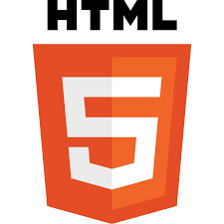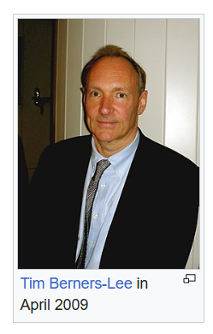
-HTML was created by Sir Tim Berners-Lee in late 1991 but was not officially released. It was published in 1995 as HTML 2.0. HTML 4.01 was published in late 1999 and was a major version of HTML.
In 1980, physicist Tim Berners-Lee, a contractor at CERN, proposed and prototyped ENQUIRE, a system for CERN researchers to use and share documents. In 1989, Berners-Lee wrote a memo proposing an Internet-based hypertext system.^{[3]} Berners-Lee specified HTML and wrote the browser and server software in late 1990. That year, Berners-Lee and CERN data systems engineer Robert Cailliau collaborated on a joint request for funding, but the project was not formally adopted by CERN. In his personal notes of 1990, Berners-Lee listed "some of the many areas in which hypertext is used"; an encyclopedia is the first entry.^{[4]}
The first publicly available description of HTML was a document called "HTML Tags",^{[5]} first mentioned on the Internet by Tim Berners-Lee in late 1991.

HTML
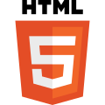
Official logo of HTML5^{[1]}
Filename extension | - .html  - .htm
Internet media type | text/html
Type code | TEXT
Uniform Type Identifier (UTI) | public.html
Developed by | - WHATWG  - World Wide Web Consortium (W3C; formerly)
Initial release | 1993; 31 years ago
Latest release | Living Standard
Type of format | Document file format
Container for | HTML elements
Contained by | Web browser
Extended from | SGML
Extended to | XHTML
Open format? | Yes
Website | html.spec.whatwg.org
ABOUT
HyperText Markup Language (HTML) was initially developed by Sir Tim Berners-Lee in late 1991. It was designed as a standard language for creating and formatting documents on the World Wide Web. All the web pages on the internet are made from HTML.
From 1990 to 1995, HTML underwent changes and extensions, initially at CERN and then at the IETF. The World Wide Web Consortium (W3C) became the new home for HTML development.
HyperText
We must first examine the idea of hypertext in order to comprehend the origins of HTML. Early 20th-century pioneers like Vannevar Bush proposed the concept of tying information together through hypertext, envisioning a "memex" machine that could organize enormous volumes of information using linked microfilm.
However, Ted Nelson, an American philosopher and sociologist, first used the word "hypertext" in the 1960s. Nelson's idea of hypertext was to develop a network of connected text and multimedia that permitted non-linear information navigation.

HISTORY
-The history of HTML, or Hypertext Markup Language, includes the following milestones:
- 1980: Tim Berners-Lee, a physicist at CERN, proposed a system for CERN researchers to share documents.
- 1989: Berners-Lee wrote a memo proposing an Internet-based hypertext system.
- 1991: Berners-Lee invented HTML 1.0 and first publicly described it in a document called "HTML Tags".
- 1993: The first version of HTML was released.
- 1995: HTML 2.0 was published, which included new features in addition to those of HTML 1.0.
- 1997: HTML 3.0 was invented, which improved existing features and gave webmasters more tools for designing websites.
- 1999: HTML 4.0 was released and became widely used.
- 2000: XHTML, an XML version of HTML, became an official standard.
- 2014: HTML 5.0 was released and used worldwide.
HTML was originally developed to help CERN researchers organize scientific information. However, it quickly became clear that HTML could be used to change how information is presented online.

History and Evolution
Here you will see the evolution of HTML over the past couple of decades. The major upgrade was done in HTML5 in 2012.
Year | Progress
1991 | Tim Berners-Lee created HyperText Markup Language but it was not officially released.
1993 | Tim Berners-Lee created the first version of HTML that was published and available to the public.
1995 | HTML 2.0 was released with a few additional features along with the existing features.
1997 | There was an attempt to extend HTML with HTML 3.0, but it was replaced by the more practical HTML 3.2.
1998 | The W3C (World Wide Web Consortium) decided to shift focus to an XML-based HTML equivalent called XHTML.
1999 | HTML 4.01, which became an official standard in December 1999, was the most widely used version in the early 2000s.
2000 | XHTML 1.0, completed in 2000, was a combination of HTML4 in XML.
2003 | The introduction of XForms reignited interest in evolving HTML itself rather than replacing it with new technologies. This new theory recognized that XML was better suited for new technologies like RSS and Atom, while HTML remained the cornerstone of the web.
2004 | A W3C workshop took place to explore reopening HTML's evolution. Mozilla and Opera jointly presented the principles that later influenced HTML5.
2006 | The W3C expressed interest in HTML5 development and formed a working group to collaborate with the WHATWG. The W3C aimed to publish a "finished" HTML5 version, whereas the WHATWG focused on a Living Standard, continuously evolving HTML.
2012 | HTML5 can be seen as an extended version of HTML 4.01, which was officially published in 2012.
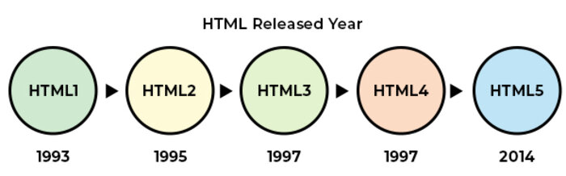
Evolution of HTML Features: From HTML 1.2 to HTML 5
With the introduction of new versions of HTML, support for additional features was added, and the user experience was enhanced. The following table shows the features introduced in later versions of HTML:
Type of Content | HTML 1.2 | HTML 4.01 | HTML 5 | Description
Image | Yes | Yes | Yes | The img tag allows to add images to HTML document
Paragraph | Yes | Yes | Yes | Paragraph element in HTML is used to represent a paragraph of text on a webpage.
Heading | Yes | Yes | Yes | Heading are used in HTML to define variable length headings. (h1 to h6)
Address | Yes | Yes | Yes | Address element in HTML is used to contain contact information of user.
Anchor | Yes | Yes | Yes | Anchor tag is used to define hyperlink in webpage.
List | Yes | Yes | Yes | List is used in HTML to display list of related items.
Table | No | Yes | Yes | Table is used to organize data into rows and columns
Style | No | Yes | Yes | Style is used to add CSS styling to webpage
Script | No | Yes | Yes | Script is used to add JavaScript to HTML.
Audio | No | No | Yes | Enables introduction of audio to webpage
Video | No | No | Yes | Enables introduction of video to webpage.
Canvas | No | No | Yes | Enables introduction of graphics elements to webpage.

HTML editors are used to create, edit, and manage HTML code. In this tutorial, you will learn about the popular HTML editors that can be used to manage your HTML documents. Here, we are explaning the steps to create and run HTML code in the specific editors.
What are HTML Editors?
HTML editors are tools/software to create, edit, manage, and run (in some cases) HTML documents. HTML editors provide many features, such as auto-indenting, syntax highlighting, autocompletion, etc.
You can use any of the HTML editors mentioned below to write and manage your HTML codes. You need to save the file with an extension .htm or .html.

Popular HTML Editors
-There are several HTML editors available to the user (paid and unpaid, both). The following is the list of some popular editors:
- Notepad
- TextEdit
- Notepad++
- Sublime
- Visual Studio Code
- Atom
- Brackets
- Adobe Dreamweaver CC
- CoffeeCup

1. Notepad
Notepad is a basic free text editor which is preinstalled in Windows systems. Notepad can be used as an HTML Editor.
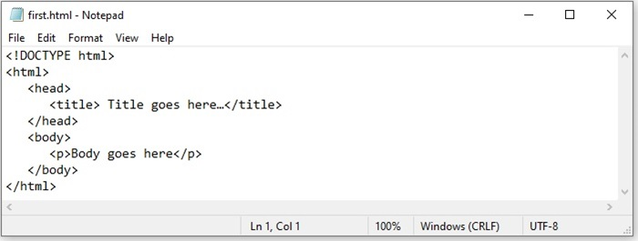
Steps to Create and Run HTML Code in Notepad
The following are the steps to create and run an HTML document in Notepad:
- Open notepad application.
- Write your HTML code.
- Save the file with an extension ".htm" or ".html" and set the encoding to UTF-8.
- Now, you can open this HTML document in any web browser.
2. TextEdit
TextEdit is a default text editor and an open-source word processor that comes with MacOS. You can use TextEdit as an HTML editor to create, edit, and manage your HTML code. You can also use it to display HTML documents like you see them in a browser or in code-editing mode.
The only limitation in TextEdit is that it doesn't display images when you use it to browse webpages.
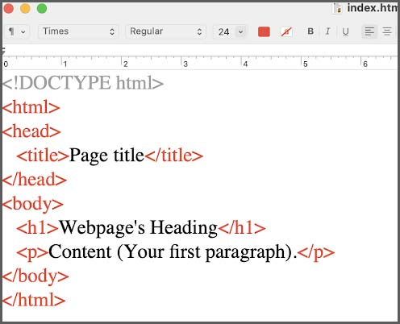
Steps to Create and Run HTML Code in TextEdit
The following are the steps to create and run an HTML document in TextEdit:
- Open TextEdit
- Create a new file
- Go to the "format" then Make Plain Text
- Write your HTML code
- Save the with an extension ".htm" or ".html"
3. Notepad++
Notepad++ is a free source code editor. It is written in C++ and supports features like, syntax highlighting, limited auto completion for programming, scripting, etc. Notepad++ is one of the best HTML code editors where you can create and manage HTML documents.
Notepad++ does not come with preinstallation, you need to download it manually from the different devices from its official website: notepad-plus-plus.org
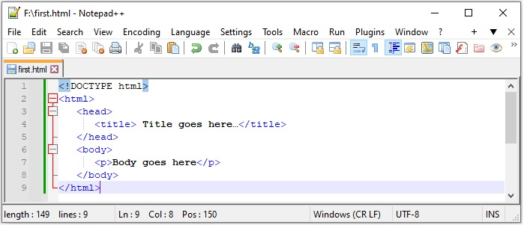
Steps to Create and Run HTML Code in Notepad++
To create an HTML document in Notepad++:
- Open Notepad++
- Open a new file, write your HTML code, and save the file as ".html"or ".htm"
- Click on the file and select the browser in which you want to view the results.
4. Sublime Editor
Subline editor is a cross-platform source code editor. It is used to write Codes, markup, and prose. It is written in C++ and Python.
Sublime editor provides features like quick navigation to files, symbols, or lines. It allows you to simultaneously edit multiple selected area.
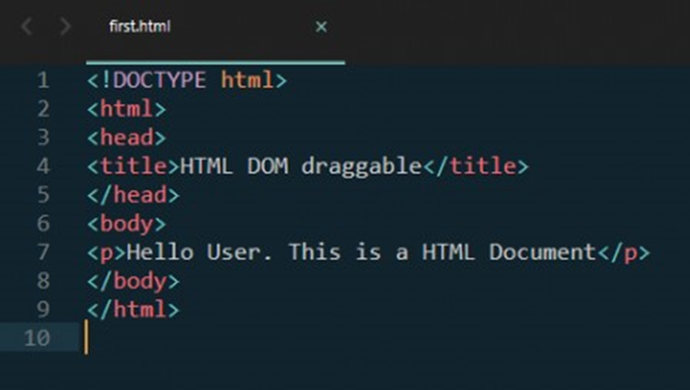
Sublime editor can be downloaded from this link: Sublime Text
5. Visual Studio Code
Visual Studio Code (VS Code) is also a source-code editor developed by Microsoft. It supports Windows, Linux, and macOS. VS code is widely used for creating and managing HTML documents due to its amazing features like debugging support, syntax highlighting, code refactoring, intelligent code completion, etc.
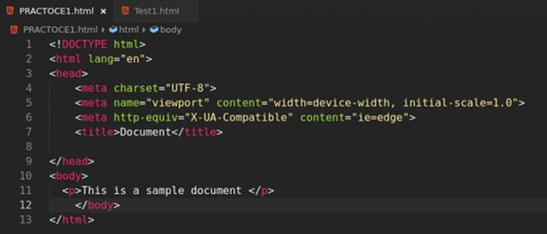
VS Code is not preinstalled software; you need to download it from code.visualstudio.com/download
6. Atom Editor
Atom is an open-source text and source code editor for MacOS. Atom can also be used in Windows systems after downloading and installing. Atom is also a free editor and can be used as an HTML editor where you can create and manage HTML documents. It provides various features such as syntax highlighting, code completion, find and replace, auto detect indentation, and different themes.
The steps to write and run HTML in the Atom editor are:
Steps to Create and Run HTML Code in Atom
- Create/open a file
- Write or paste HTML code.
- Save file with ".htm" or ".html" extension.
- And, press "CTRL + Shift + B" (in Windows) to run and see the preview.
7. Brackets Editor
Brackets is a source code editor that can be used for creating and managing HTML documents. Brackets is created by Adobe, and it is useful for web development. Brackets features include auto saving, code beautification, live preview, and many more.
Steps to Create and Run HTML Code in Brackets
The steps to create an HTML document in brackets editors are:
- Download & Install Bracket Editor
- Create a new file.
- Write HTML code and save the files with the extension ".htm" or ".html".
8. Adobe Dreamweaver CC
Adobe Dreamweaver CC is a premium IDE application for web development and source code editing, like HTML editors. It offers toolkits for designing and creating websites that combine a visual design interface with a code editor.
It supports many programming languages like Python and HTML, enabling efficient coding for both beginners and advanced users, and also provides Git support. It is a subscription-based model as it ensures access to regular updates and customer support for assistance.
9. CoffeeCup
CoffeeCup is a paid HTML editor software known for its user-friendly interface and powerful features. It offers a range of tools for web development, including code editing, site management, and responsive design support.
With CoffeeCup, users can create and edit HTML, CSS, and JavaScript code efficiently. It provides live previews, code validation, and an integrated FTP client for seamless website management.
Advantages of Using HTML Editors
There are several advantages to using HTML editors to write and manage your HTML codes. Some of the main advantages are as follows:
- Error Reduction: HTML editors are useful to identify and correct the syntax errors during writing the HTML codes.
- Syntax Highlighting: Most of the HTML editors come with the syntax highlighting features that enable color-coding to distinguish HTML tags, attributes, and content that makes the code clear and readable.
- Code Autocompletion: Most of the HTML editors autocomplete the tags or attributes while writing the code. For example, if you start writing a paragraph and type <p>, editors will automatically insert a closing tag </p>. The editors also suggest the syntax of the elements.
- Code Validation: Most of the HTML editors have code validating features; you don't need any other tool to validate your code. This feature helps to validate the errors.
- Collaboration Tools: Some of the HTML editors come with version control systems that make it easier for teams to collaborate and track changes.
THE FIRST WEBBROWSER

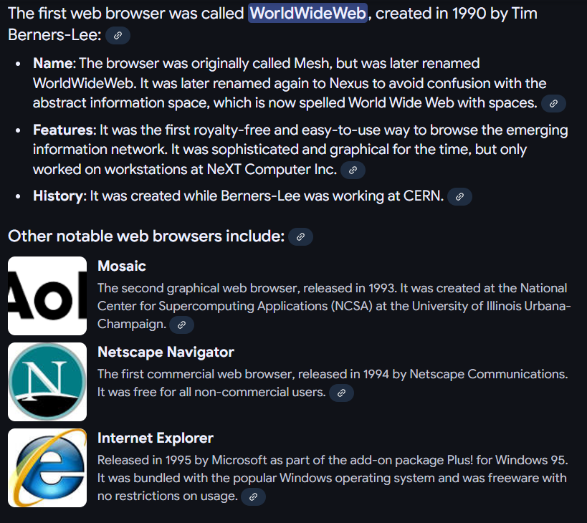
Year | Web browsers
1990 | WorldWideWeb (Nexus)
1991 | Line Mode Browser
1992 | Erwise, MacWWW (Samba), MidasWWW, ViolaWWW
1993 | AMosaic 1.0, Arena, Cello,^{[46]} Lynx 2.0, Mosaic
1994 | Agora (Argo), IBM WebExplorer, IBrowse, MacWeb, Minuet, Netscape Navigator, SlipKnot 1.0
1995 | Grail, Internet Explorer 1, Internet Explorer 2, Netscape Navigator 2.0, OmniWeb, UdiWWW,^{[47]}
1996 | Amaya 0.9,^{[48]} Arachne 1.0, AWeb, Cyberdog, Internet Explorer 3.0, Netscape Navigator 3.0, Opera 2.0, PowerBrowser 1.5,^{[49]} Voyager
1997 | Amaya 1.0, ^{[48]} Internet Explorer 4.0, Netscape Navigator 4.0, Netscape Communicator 4.0, Opera 3.0^{[50]}
1998 | iCab, Mozilla
1999 | Amaya 2.0,^{[48]} Mozilla M3, Internet Explorer 5.0
2000 | Amaya 3.0^{[48]}, Amaya 4.0,^{[48]} K-Meleon 0.2, Konqueror, Netscape 6, Opera 4,^{[51]} Opera 5,^{[52]}
2001 | Amaya 5.0,^{[48]} Internet Explorer 6, Galeon 1.0, Opera 6,^{[53]}
2002 | Amaya 6.0,^{[48]} Amaya 7.0,^{[48]}Phoenix 0.1, Netscape 7, Mozilla 1.0, Links 2.0
2003 | Amaya 8.0,^{[48]} Epiphany 1.0, Opera 7,^{[54]} Apple Safari 1.0,
2004 | Firefox 1.0, Netscape Browser, OmniWeb 5.0
2005 | Amaya 9.0,^{[48]} AOL Explorer 1.0, Epiphany 1.8, Maxthon 1.0, Netscape Browser 8.0, Opera 8,^{[55]} Apple Safari 2.0, Shiira 1.0
2006 | Camino 1.0, Galeon 2.0, iCab 3, K-Meleon 1.0, Mozilla Firefox 2.0, Internet Explorer 7, Opera 9,^{[56]}, SeaMonkey 1.0
2007 | Conkeror, Flock 1.0, Apple Safari 3.0, Netscape Navigator 9, NetSurf 1.0
2008 | Google Chrome 1, Maxthon 2.0, Mozilla Firefox 3, Opera 9.5,^{[57]}, Apple Safari 3.1, Konqueror 4, Amaya 10.0^{[48]}, Flock 2, Amaya 11.0^{[48]}
2009 | Google Chrome 2–3, Mozilla Firefox 3.5, Internet Explorer 8, Opera 10,^{[58]}, Apple Safari 4, SeaMonkey 2, Camino 2, surf, Pale Moon 3.0^{[59]}
2010 | Google Chrome 4–8, Mozilla Firefox 3.6, Opera 10.50,^{[60]}, Opera 11, Apple Safari 5, K-Meleon 1.5.4, xxxterm
2011 | Google Chrome 9–16, Mozilla Firefox 4–9, Internet Explorer 9, Opera 11.50, Apple Safari 5.1, Maxthon 3.0, SeaMonkey 2.1–2.6
2012 | Google Chrome 17–23, Mozilla Firefox 10–17, Internet Explorer 10, Opera 12, Apple Safari 6, Maxthon 4.0, SeaMonkey 2.7–2.14
2013 | Google Chrome 24–31, Mozilla Firefox 18–26, Internet Explorer 11, Opera 15–18, Pale Moon 15.4–24.2.2^{[61]}, Apple Safari 7, SeaMonkey 2.15–2.23
2014 | Google Chrome 32–39, Mozilla Firefox 27–34, Opera 19–26, Pale Moon 24.3.0–25.1.0^{[61]}, Apple Safari 8, SeaMonkey 2.24–2.30
2015 | Google Chrome 40–47, Microsoft Edge, Mozilla Firefox 35–43, Opera 27–34, Pale Moon 25.2.0–25.8.1^{[61]}, Vivaldi
2016 | Google Chrome 48–55, Mozilla Firefox 44–50, Microsoft Edge 14, Opera 35–42, Pale Moon 26.0.0–27.0.3, Apple Safari 9–10, SeaMonkey 2.24–2.30
2017 | Google Chrome 56–60, Microsoft Edge 15, Mozilla Firefox 51–55.0.2, Opera 43–45, Opera Neon, Pale Moon 27.1.0–27.6.2, Safari 10–11
2018 | Chrome 64–71, Firefox 58–64, Microsoft Edge 42–44, Opera 50–57, Pale Moon 27.7.0–28.2.2, Safari 11–12, Vivaldi 1.14–2.2
2019 | Chrome 72–79, Firefox 65–71, Microsoft Edge, Opera 58–65, Pale Moon 28.3.0–28.8.0, Safari 12–13, SeaMonkey, Vivaldi 2.2–2.10, Yandex.browser
2020 | Chrome 80–87, Firefox 72–84, Microsoft Edge, Opera 66–73, Pale Moon 28.8.1–28.17.0, Safari 13–14, SeaMonkey, Vivaldi 2.10–3.5, Yandex.browser
2021 | Chrome 88–96, Firefox 85–95, Microsoft Edge 88–96, Opera 74–82, Pale Moon 29.0.0–29.4.3, Safari 15, Vivaldi 3.6–5.0
2022 | Chrome 97–107, Firefox 96–107, Microsoft Edge 97–107, Opera 83–93, Pale Moon 29.4.4-31.4.2, Safari 15.4–16.2, Vivaldi 5.1–5.6
2023 | Chrome 108–120.0.6099.129, Firefox 108–121.0, Microsoft Edge 108–120.0.2210.61, Opera 94–106.0.4998.19, Pale Moon 31.4.3-32.5.2, Safari 16.3–17.2, Vivaldi 5.7–6.5, Arc 1.10-1.21.0
2024 | Chrome 120–Current, Firefox 122–Current, Microsoft Edge 121–Current, Opera 106-Current, Pale Moon 33-Current, Safari 17.3–Current, Vivaldi 6.6-Current, Arc 1.21.1-Current, Ecosia Browser 1.0.0.31–Current

WEB BROWSRS

-A web browser is a software application used to access, retrieve, and view websites on the World Wide Web, such as Google Chrome, Apple Safari, and Mozilla Firefox. It translates raw code from web servers into readable text, images, and interactive pages.
OR
-Application software that allows users to access, search, and view information on the World Wide Web by communicating with web servers is known as a web browser.
OR
-A web browser is software that allows users to access, retrieve, and display web pages from the internet.
-It interprets technologies such as HTML, CSS, and JavaScript to present websites.

Popular Examples
- Google Chrome: Developed by Google; holds the highest global market share.
- Apple Safari: Built by Apple for Mac and iOS devices.
- Mozilla Firefox: A free, open-source privacy-focused option managed by the Mozilla Foundation.
- Microsoft Edge: The default built-in browser for Windows devices

-How a Browser Works
- URL Entry: You type a web address into the address bar.
- DNS Lookup: The browser finds the server's numeric IP address.
- Data Fetch: It requests and receives files (like HTML and CSS) using secure HTTP protocols.
- Rendering: It builds and displays the final visual page on your screen
Working of a Web Browser
- The user enters a website URL into the browser.
- The browser contacts a DNS (Domain Name System) server to convert the domain name into an IP address.
- Using the IP address, the browser sends a request to the web server .
- The server responds with web content such as HTML, CSS, images and scripts.
- The browser processes and renders this content into a readable webpage.
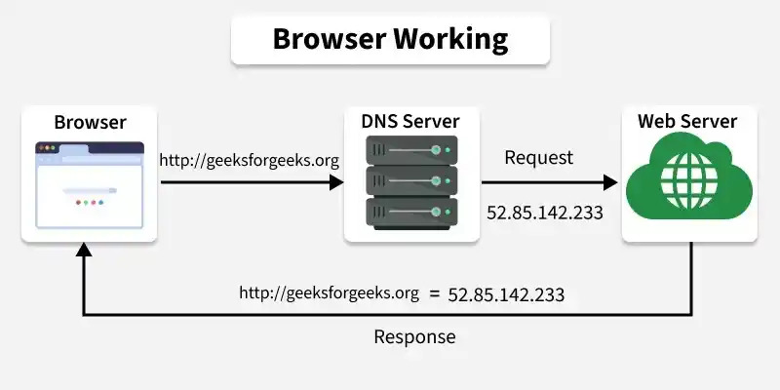

Popular Examples
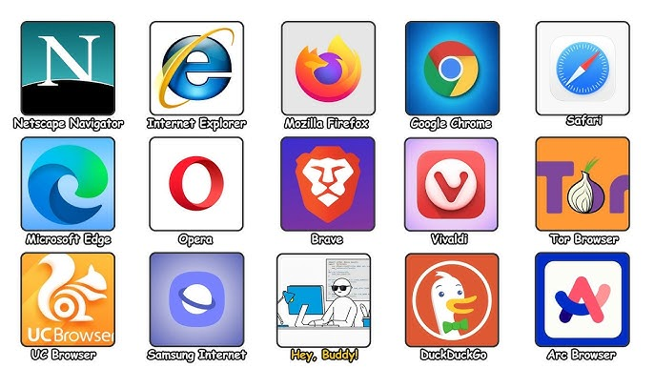

WORLD WIDE WEB (WWW)


-The World Wide Web (WWW) is a system of interconnected web pages and resources that can be accessed over the Internet using web browsers and protocols like HTTP or HTTPS.
OR
-The World Wide Web (WWW) is a global system of interconnected web pages, websites, and multimedia files that you can access through the Internet using a web browser. Invented in 1989 by Tim Berners-Lee at CERN, it uses hyperlinks to let people easily move from one piece of information to another

Difference from the Internet
- The Internet: A massive physical network of computers and cables connected all over the world.
- The Web (WWW): Just one of the services—like a collection of virtual pages—that runs on top of that Internet network

URL (Uniform Resource Locator)

- A URL stands for Uniform Resource Locator.
- A URL is the address of a resource on the Internet that helps users and browsers locate and access specific web pages, files, images, videos, or other online resources.
- It tells the browser:
  - Where the resource is located.
  - Which protocol should be used to access it.
  - How to communicate with the server.
- Example of URL:
https://www.example.com/about

Components of a URL
A URL consists of different parts:
1. Protocol (Scheme):
- Defines the method used to access the resource.
- Specifies how communication happens between client and server.
- Examples:
  - http://
  - https://
  - ftp://

2. Domain Name:
- The human-readable name of a website.
- Identifies the specific server where the website is hosted.
- Examples:
  - google.com
  - github.com
  - example.com

3. Subdomain:
- An additional part before the main domain.
- Used to organize different sections of a website.
- Examples:
  - www.example.com
  - blog.example.com
  - mail.example.com

4. Path:
- Specifies the exact location of a page or resource on a website.
- Example:
https://example.com/products/mobile
- Here:
  - /products/mobile → Path

5. Query Parameters:
- Used to send additional information to the server.
- Starts with a question mark (?).
- Example:
https://example.com/search?name=phone
- Here:
  - name=phone → Query parameter

6. Fragment (Anchor):
- Points to a specific section of a webpage.
- Starts with #.
- Example:
https://example.com/page#contact
- Here:
  - #contact → Specific section of the page

Types of URLs
1. Absolute URL:
- Contains the complete address of a resource.
- Includes protocol, domain, and path.
- Example:
https://www.example.com/about

2. Relative URL:
- Provides only the path of a resource.
- Used within the same website.
- Example:
/about

How URL Works
- User enters a URL in the browser.
- Browser identifies the protocol (HTTP/HTTPS).
- DNS converts the domain name into an IP address.
- Browser connects to the web server.
- Server sends the requested resource.
- Browser displays the webpage.

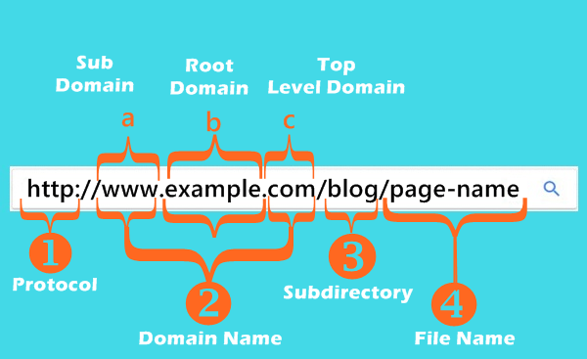

REQUEST & RESPONSE

1.REQUEST
-A request is a message sent by the client (browser) to the server asking for a resource or service.

Ways to Send Requests
- Typing a URL
- Clicking a hyperlink
- Submitting a form
- Refreshing a page
- Fetching data via JavaScript (AJAX/Fetch)
Common Request Methods
- GET
- POST
- PUT
- DELETE
- PATCH

2.Response
-A response is the message sent by the server back to the client after processing a request.
- Response Contains
- Status code
- HTML
- CSS
- JavaScript
- JSON
- Images
- Headers
Response Contains
- Status code
- HTML
- CSS
- JavaScript
- JSON
- Images
- Headers
Types of Responses
1.Static Response
-Pre-built files.
Example:
about.html

2Dynamic Response
-Generated at runtime.
Example:
Hello Amol!

-The server creates the page based on the logged-in user or current data.
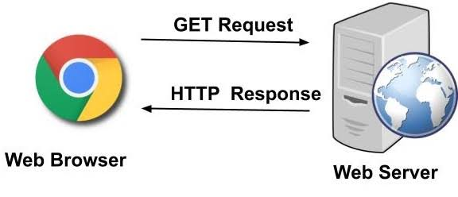

SERVER
-A server is a computer, device, or program that provides data, services, or resources to other computers (called clients) over a network
Types of Servers
1. Web Server
Stores websites and serves web pages.
Examples:
- Apache
- Nginx
- IIS

2. Database Server
Stores data.
Example:
- MySQL
- PostgreSQL
- MongoDB

3. File Server
Stores shared files.

4. Mail Server
Handles emails.

5. Application Server
Runs backend applications.

-Can Be Hardware or Software:
1.Hardware Server: A powerful physical machine designed to handle multiple client requests.
2.Software Server: A program that performs server functions (e.g., a web server like Apache or Nginx).
Characteristics of a Server
- Runs 24/7
- Stores website files
- Handles multiple users simultaneously
- Has powerful hardware
- Uses high-speed internet
- Provides security and backup

Working of Server
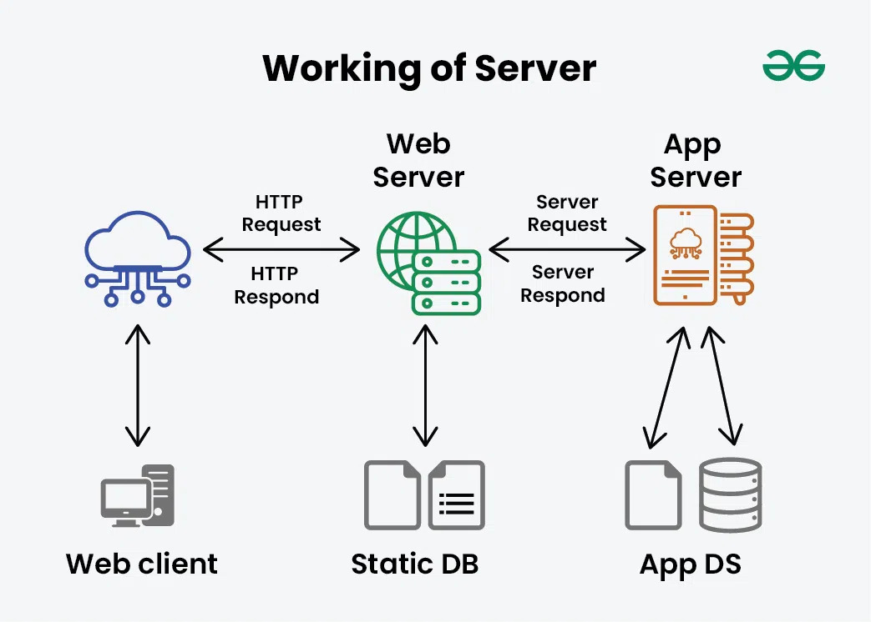

PROTOCOL
- A protocol is a set of rules and guidelines that define how data is transmitted, received, and processed between devices on a network.
- Purpose of Protocols:
  - Ensures communication between different devices is accurate and reliable.
  - Defines the format, timing, and sequence of data exchange.
  - Helps devices understand and communicate with each other.
- Network Protocol:
  - A network protocol is a standard method used by computers and devices to communicate over a network.
  - It controls how information is divided, sent, received, and interpreted.
- Common Types of Protocols:
- HTTP (HyperText Transfer Protocol):
  - Used for transferring web pages and data between a web browser and a web server.
  - Example:
    - Browser requests a webpage → Web server sends webpage data.
- HTTPS (HyperText Transfer Protocol Secure):
  - A secure version of HTTP.
  - Encrypts data to protect sensitive information.
  - Used for online banking, shopping websites, and login pages.
- FTP (File Transfer Protocol):
  - Used to transfer files between computers over a network.
  - Allows uploading and downloading of files from a server.
- SMTP (Simple Mail Transfer Protocol):
  - Used for sending emails from one server to another.
  - Works with email services for message delivery.
- TCP/IP (Transmission Control Protocol / Internet Protocol):
  - The fundamental communication protocol of the Internet.
  - TCP ensures reliable data delivery.
  - IP handles addressing and routing of data packets.
- How Protocol Works:
  - Sender device follows protocol rules to prepare data.
  - Data is transmitted through the network.
  - Receiver device follows the same protocol rules to understand the data.
- Importance of Protocols:
  - Provides standardized communication.
  - Allows different devices and systems to work together.
- Examples of Protocol Usage:
  - Opening a website → HTTP/HTTPS protocol.
  - Sending an email → SMTP protocol.
  - Downloading files → FTP protocol.
  - Connecting to the Internet → TCP/IP protocol.
Why Do We Need Protocols?
- Imagine two people speaking different languages.
- One speaks English.
- The other speaks Japanese.
- Communication becomes difficult.
- Similarly, computers need common rules.
- Protocols provide these rules

HTTP

HTTP (HyperText Transfer Protocol)
- HTTP stands for HyperText Transfer Protocol.
- HTTP is a communication protocol used for transferring data between a client (web browser) and a server (web server) over the Internet.
- It defines how messages are sent and received between browsers and servers.
- When a user enters a website address:
  - Browser sends an HTTP request to the web server.
  - Server processes the request.
  - Server sends the requested webpage data back to the browser.
- Example:
  - User opens: http://example.com
  - Browser requests the webpage.
  - Server returns HTML, CSS, JavaScript, and images.
Features of HTTP:
- Simple and fast communication protocol.
- Used mainly for accessing websites.
- Transfers different types of data:
  - Text
  - Images
  - Videos
  - Files
  - API data
- HTTP is a stateless protocol, which means:
  - The server does not remember previous requests.
  - Each request is treated as a new request.

HTTPS
HTTPS (HyperText Transfer Protocol Secure)
- HTTPS stands for HyperText Transfer Protocol Secure.
- HTTPS is the secure version of HTTP that protects communication between a browser and a server.
- It uses SSL/TLS encryption to secure data transfer over the Internet.
- HTTPS prevents attackers from:
  - Stealing sensitive information.
  - Reading private communication.
  - Modifying data during transmission.
- Example:
  - User opens: https://bankwebsite.com
  - Data between browser and server is encrypted and protected.

Difference Between HTTP and HTTPS
SrNo | HTTP | HTTPS
 | HyperText Transfer Protocol | HyperText Transfer Protocol Secure
 | Data is transferred without encryption | Data is encrypted using SSL/TLS
 | Less secure | More secure
 | Uses port 80 | Uses port 443
 | Website URL starts with http:// | Website URL starts with https://
 | Suitable for simple websites | Used for banking, shopping, login pages

WEBPAGE
-A web page is a single digital document displayed by a web browser, made using HTML, and used to show text, images, and links
Core Components
- HTML: Builds the basic layout and content.
- CSS: Adds colors, fonts, and style.
- JavaScript: Creates moving parts and buttons that do things. [1]
Main Types
- Static: Shows the exact same information to every person who visits it.
- Dynamic: Changes its content based on what you do or what time it is
Types of Web Pages
-Web pages can be classified based on their functionality. The two main types of web pages are:
1. Static Web Pages
-Static web pages are simple and do not contain dynamic content or interactive elements. They are also called flat or stationary web pages. These pages stay the same and show the same content to all users, no matter what actions they take. Static web pages are created using HTML and CSS.
For example: Simple Portfolio websites, Landing Pages, About Pages, Personal Blogs, etc.
-This GeeksforGeeks About page(geeksforgeeks.org/about) is an perfect example of static web page
2. Dynamic Web Pages
-Dynamic web pages display different content depending on user actions or other factors. They make websites more interactive and engaging. For example, content such as image slideshows, videos, or user-specific data can change each time a page is loaded. For example: Social Media websites, E-commerce websites, News websites, etc.
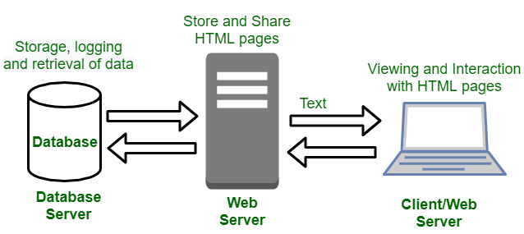-Dynamic web pages connect the client with the web server, which fetches and updates data from the database server to provide real-time content and interaction
-Dynamic web pages can be further divided into two categories:
- Server-Side Scripting: Server-side scripting involves languages like PHP, ASP.Net, and JSP. It enables web pages to interact with databases, modify their content, and respond to user actions.
- Client-Side Scripting: This method involves JavaScript or other languages like Dart to create web pages that can update in real-time based on events such as user clicks, mouse movements, or keyboard presses.
Difference between Static Web Pages and Dynamic Web Pages
SrNo | Feature | Static Web Pages | Dynamic Web Pages
 | Content | Fixed and does not change unless edited manually | Changes based on user interaction or server response
 | Programming Languages | HTML and CSS | HTML, CSS and JavaScript
 | User Interaction | Limited or none | High – responds to user input
 | Speed | Loads faster (simple structure) | May load slower (depends on backend processing)
 | Maintenance | Manual updates required | Easier to update with frontend and/or backend logic
 | Example | Portfolio website, landing page | Social media sites, e-commerce platforms

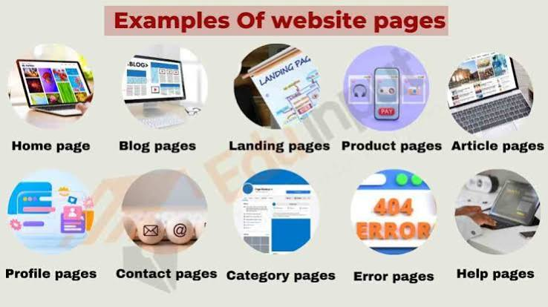

WEBSITE

-A website is a collection of related web pages connected under one domain name.
Core Parts of a Website
- Domain Name: The web address (like google.com) used to find the site.
- Web Hosting: The computer server where the website files live and run 24/7.
- Web Pages: Files written in code like HTML, CSS, and JavaScript that show text, pictures, and videos
How It Works
- Request: You type an address into your browser.
- Find: The internet finds the correct server.
- Display: The server sends the code back, and your browser turns it into a visual page.
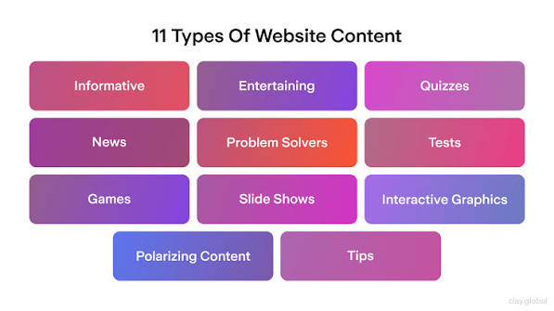

SEARCH ENGINE
-A search engine is an online service that helps users find web pages by searching an index of information using keywords.
-Examples
- Google
- Bing
- Yahoo
- DuckDuckGo

How It Works
Search engines typically:
- Crawl web pages.
- Index their content.
- Rank relevant results for user queries.

INTERNET
-The Internet is a worldwide network of interconnected computers and devices that communicate using the Internet Protocol (IP) suite.
-It enables services such as the World Wide Web, email, online gaming, cloud computing, and file sharing.

Internet vs WWW
Internet = Infrastructure
WWW = One service running on the Internet
INTRANET

-An intranet is a private network that uses internet technologies but is accessible only to authorized users within an organization.
Uses
- Employee portal
- Internal documents
- Company announcements
- HR systems
EXTRANET

-An extranet is an extension of an organization's intranet that provides secure, controlled access to selected external users such as customers, suppliers, or business partners.

Example
A company allows suppliers to log in and check inventory or place orders through a secure portal.

HTML FILE EXTENSION
What is a File Extension?
-A file extension is the group of letters that appears after the dot (.) in a file name.
-It tells the operating system, browser, or application what type of file it is and how it should be opened
Examples
File Name | Extension | File Type
index.html | .html | HTML Document
style.css | .css | CSS Stylesheet
script.js | .js | JavaScript File
logo.png | .png | Image
resume.pdf | .pdf | PDF Document
data.json | .json | JSON Data

-Types of HTML File Extensions
There are four common HTML-related file extensions:
- .html
- .htm
- .xhtml
- .shtml
Each has its own history and purpose.

1.html
-Full form Hyper Text Markup Language.
-.html is the standard file extension used to create web pages.
Why is it used?
It tells the browser that the file contains HTML markup.
The browser then:
- Reads the HTML
- Builds the DOM
- Renders the webpage

Features
- Modern standard
- Supported by all browsers
- Easy to use
- SEO friendly
- Works with CSS and JavaScript
- Recommended by W3C

Advantages
✅ Easy to identify
✅ Industry standard
✅ Used by almost every website
✅ Supported by every browser

2.htm
What is .htm?
-.htm is simply a shorter version of .html.
-Both represent HTML documents.

Why was .htm created?
-Years ago, computers used MS-DOS.
-MS-DOS followed the 8.3 filename rule.

What is the 8.3 Rule?
-A file name could contain:
- Maximum 8 characters before the dot.
- Maximum 3 characters after the dot.
Allowed ✅
-index.html
Not allowed ❌
-index.htm
Because
-contains 4 letters.
-So developers shortened it to
htm

Why does .htm still work?
-Modern browsers still support .htm because of backward compatibility.
-Millions of older websites still use .htm.
-If browsers stopped supporting it,those websites would break.

Browser Example
-Both of these open exactly the same webpage.
index.html
index.htm
-No difference.

Should You Use .htm?
No.
Use
.html
-because it is the industry standard.

3.xhtm

-Full Form eXtensible HyperText Markup Language

What is XHTML?
-XHTML is a combination of HTML and XML
-It follows very strict XML rules.

Why was XHTML introduced?
-In the early 2000s,
-developers wanted HTML documents to be more structured and error-free.
-XML already enforced strict syntax.
-So XHTML was created to combine the flexibility of HTML with the discipline of XML.
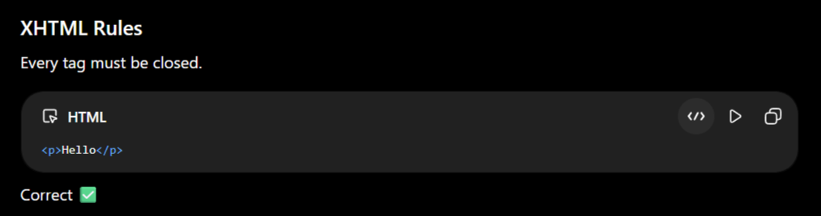
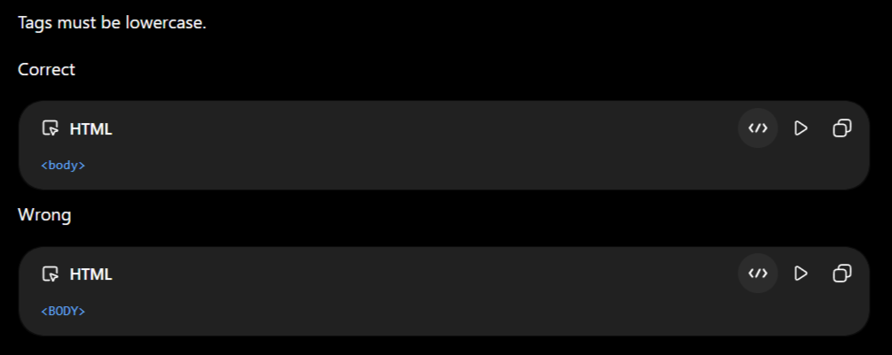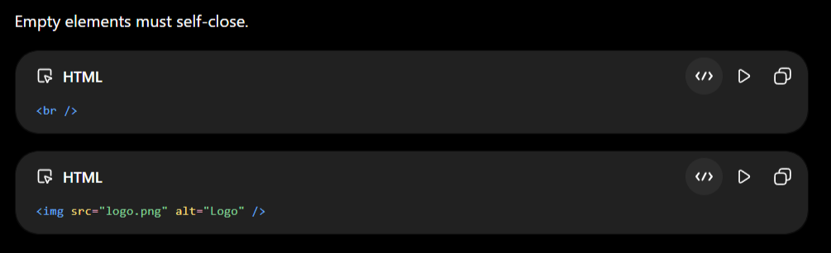
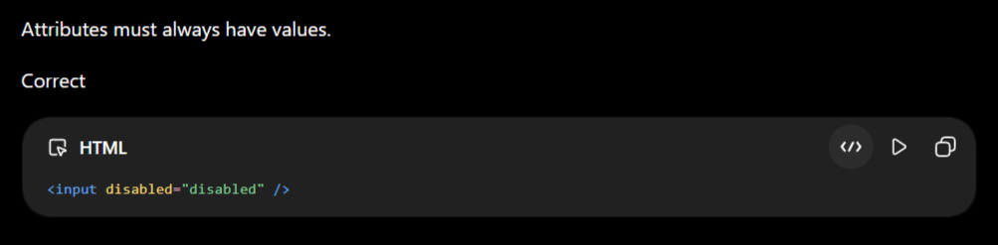

Why is XHTML rarely used today?
-HTML5 became much more powerful and forgiving.
-Modern browsers can automatically handle many small HTML mistakes.
-Because of this,most developers now use HTML5 instead of XHTML.

4.shtm

-Full Form Server Side Includes HTML

What is .shtml?
-An .shtml file is an HTML document that contains Server Side Includes (SSI).
-Before the page reaches the browser,the web server processes special SSI commands.
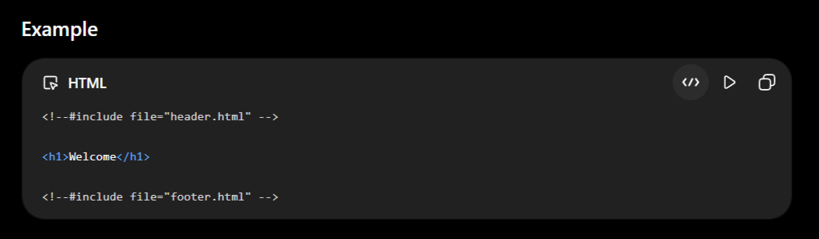
What Happens?
Step 1
Browser requests
index.shtml
↓
Step 2
Server reads SSI commands
↓
Step 3
Header and footer are inserted
↓
Step 4
Final HTML page is generated
↓
Step 5
Browser receives normal HTML
Why was .shtml used?
-Before PHP, Node.js, and modern frameworks,developers used SSI to reuse common page sections.
-Instead of writing the same navigation bar on every page,they included it using SSI.
Modern Alternatives
-Today developers use
- PHP
- Node.js
- Express
- Next.js
- React
- Template Engines
-SSI is now considered a legacy technology.

Browser Compatibility
Extension | Chrome | Firefox | Edge | Safari
.html | ✅ | ✅ | ✅ | ✅
.htm | ✅ | ✅ | ✅ | ✅
.xhtml | ✅ | ✅ | ✅ | ✅
.shtml | ✅* | ✅* | ✅* | ✅*

comparison Table
Extension | Full Form | Purpose | Current Status
.html | HyperText Markup Language | Standard HTML documents | ⭐ Recommended
.htm | HyperText Markup Language | Legacy 3-letter extension | ✅ Supported
.xhtml | eXtensible HyperText Markup Language | HTML with XML rules | ⚠️ Rarely Used
.shtml | Server Side Includes HTML | HTML with SSI processing | ⚠️ Legacy Technology

STRUCTURE OF THE HTML

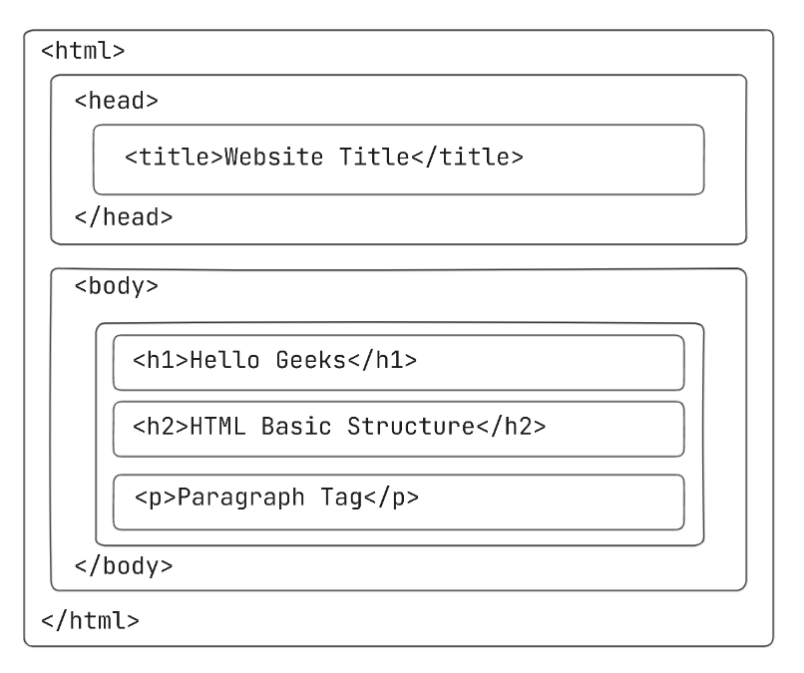
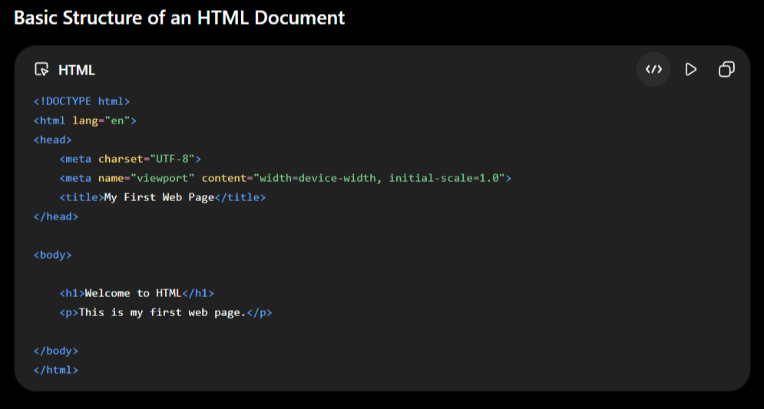
Component Breakdown
1. <!DOCTYPE html>

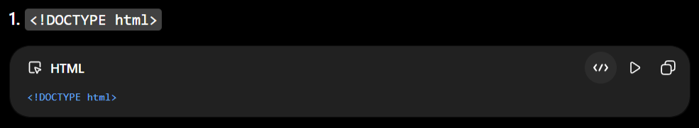
Purpose
- Declares the document type.
- Tells the browser that this page uses HTML5.
- Must always be the first line of the document.
- Prevents the browser from rendering in "quirks mode".
Why is it Important?
- -Without it, browsers may switch to Quirks Mode, causing inconsistent rendering.

2. <html> Tag

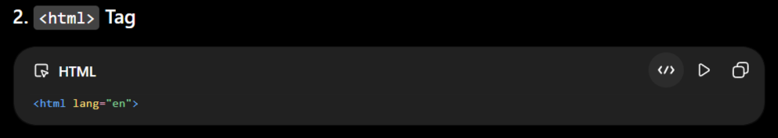
Purpose
- Root element of the HTML document.
- Everything on the page is placed inside this tag.
lang Attribute
<html lang="en">
-Specifies the language of the webpage.
Examples
- <html lang="en">
- <html lang="fr">
- <html lang="hi">
Benefits
- Better SEO
- Helps screen readers
- Improves browser translation

<html lang="en">
  - The root element that wraps all other code.
  - The lang attribute defines the primary language for screen readers.

3. <head>

-The <head> contains metadata, which provides information about the webpage but is not displayed directly on the screen.
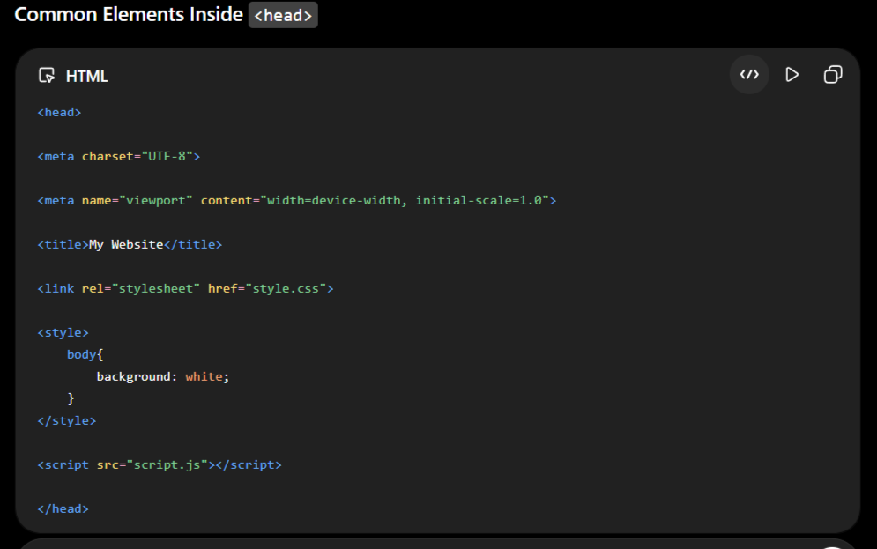

-Contains background technical data (metadata) about the page.
-Items inside here do not appear directly on the main webpage window.
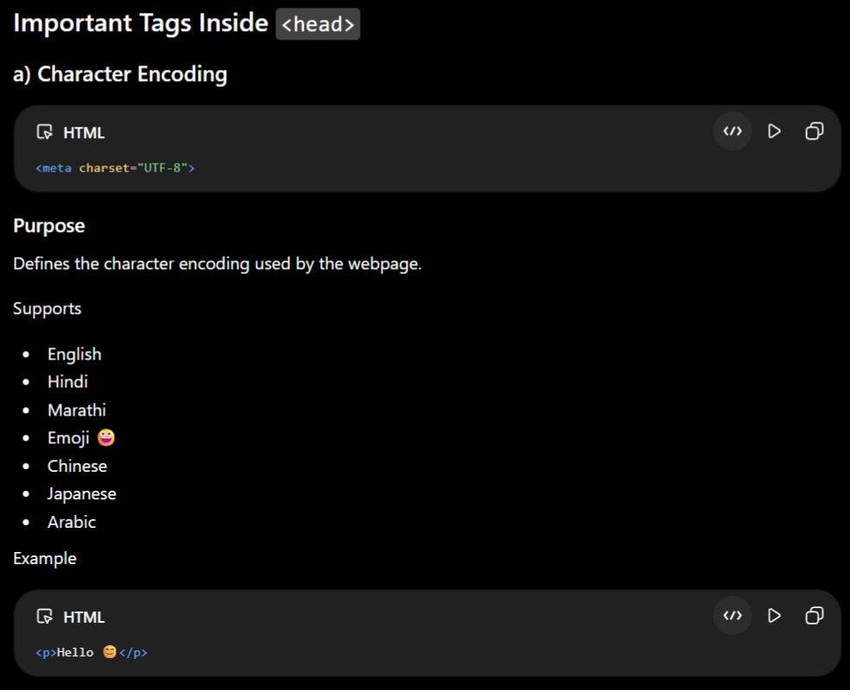
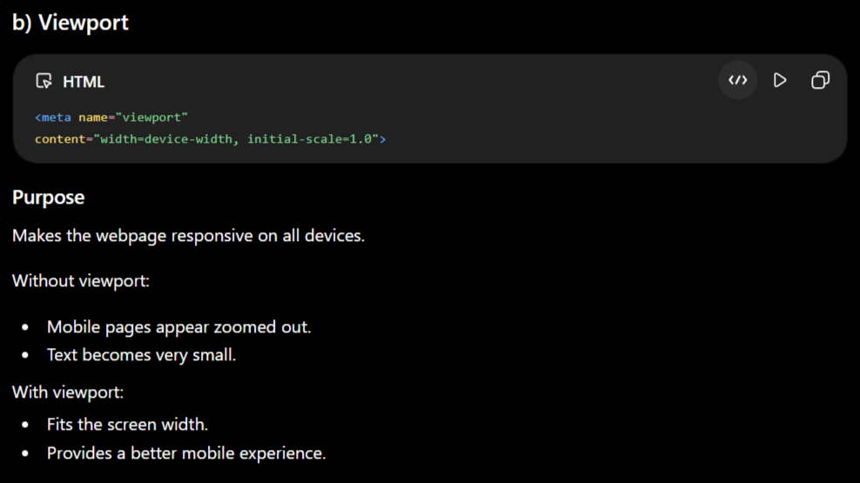
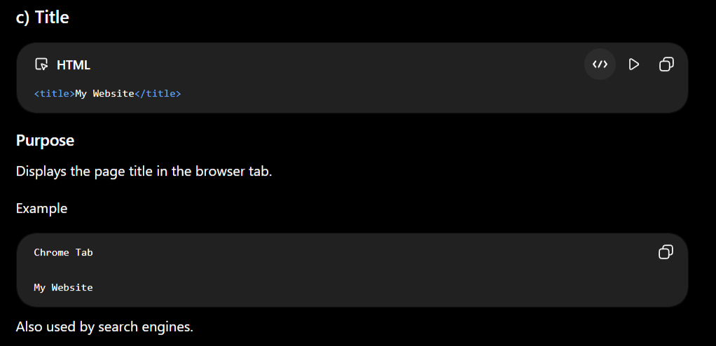
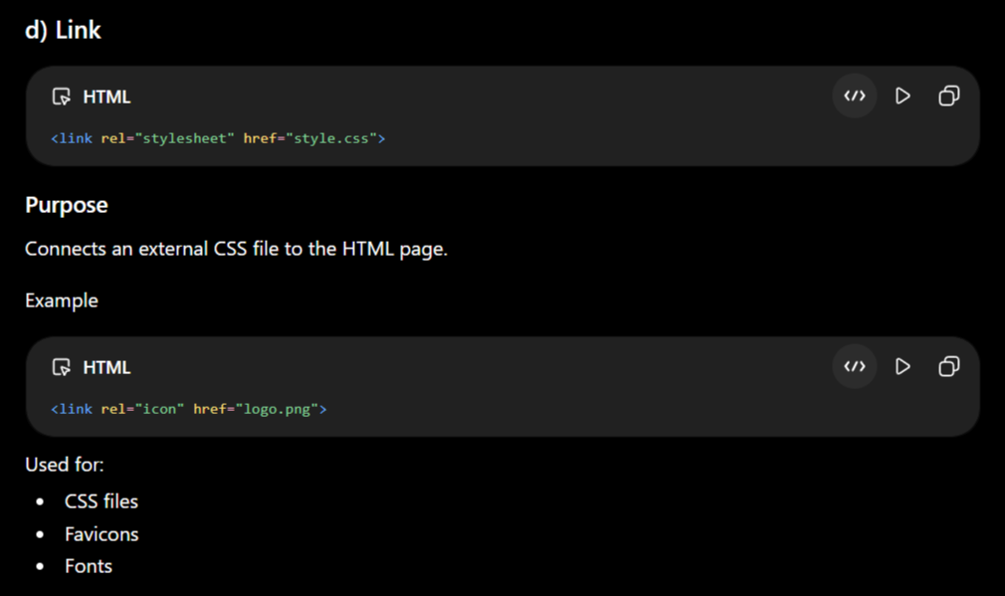
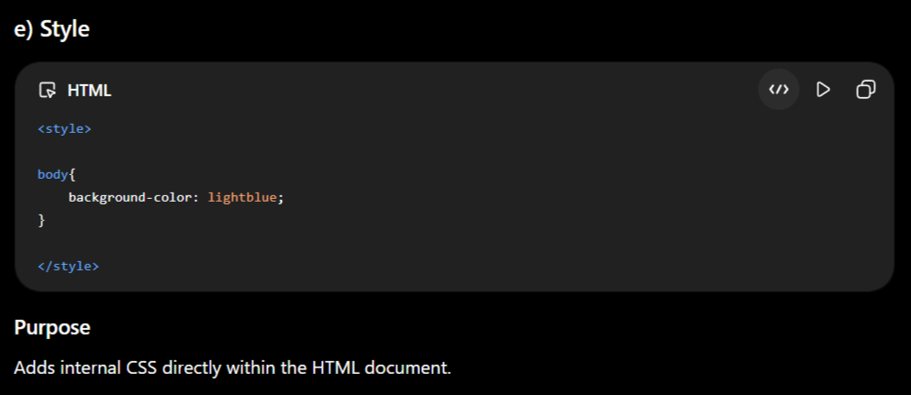
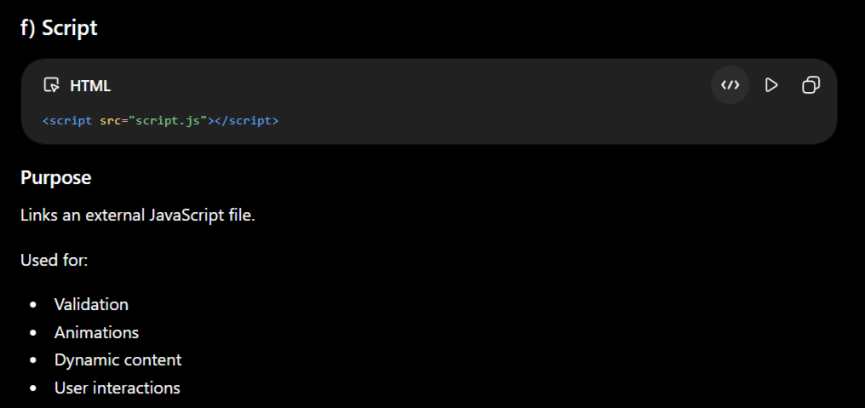

4. <body>

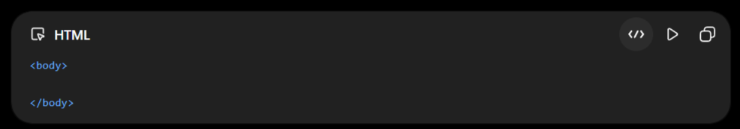
-The <body> contains all the visible content shown in the browser.
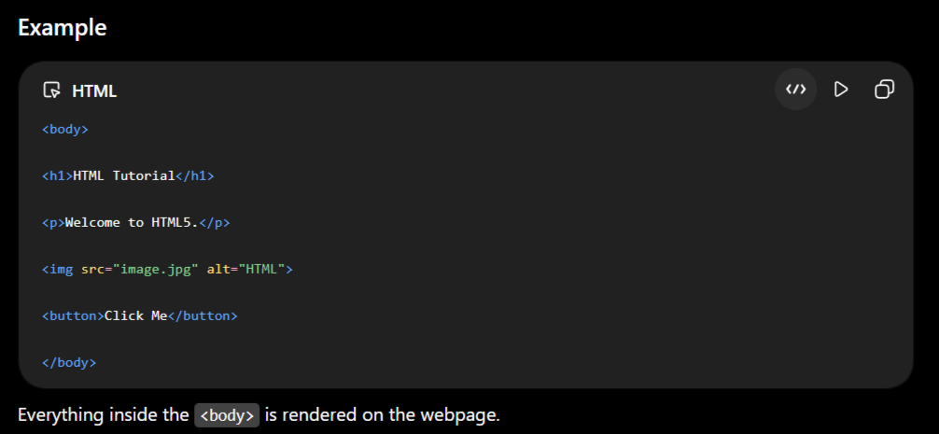
Examples:
- Headings
- Paragraphs
- Images
- Videos
- Buttons
- Forms
- Tables
- Navigation menus
- Footer

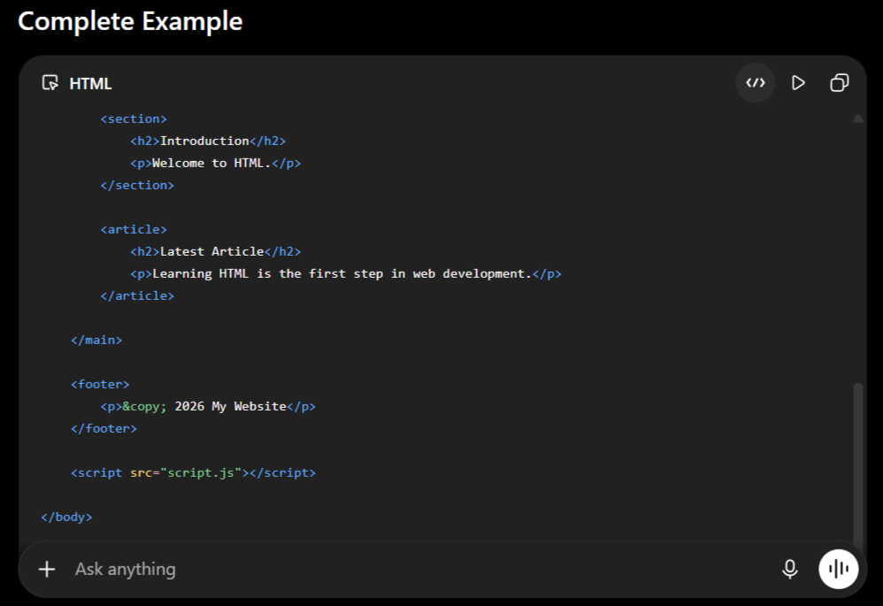
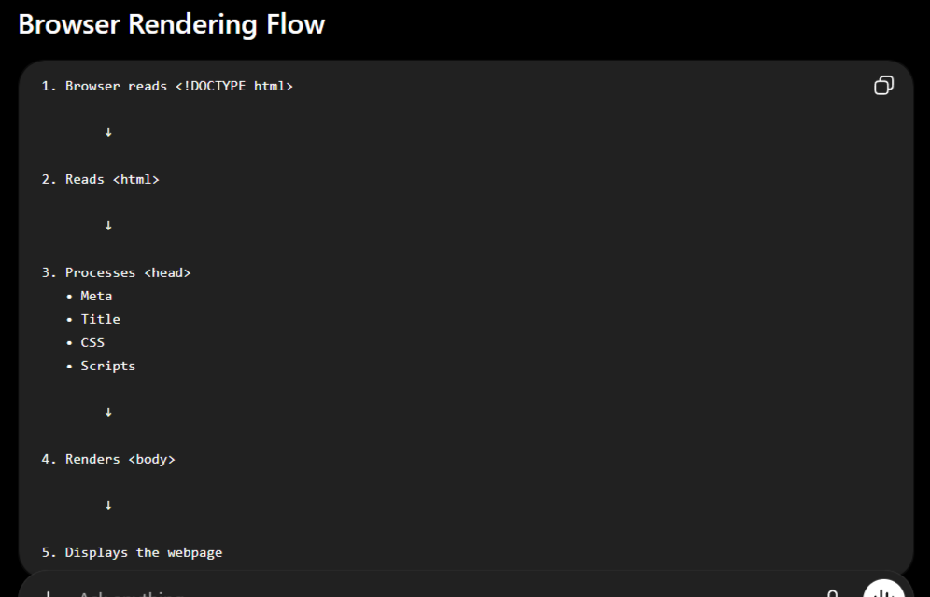

Modern Semantic Structure (Inside the Body)
-To improve accessibility and search engine ranking, modern web developers replace generic boxes with semantic tags from GeeksforGeeks to organize the <body> layout:
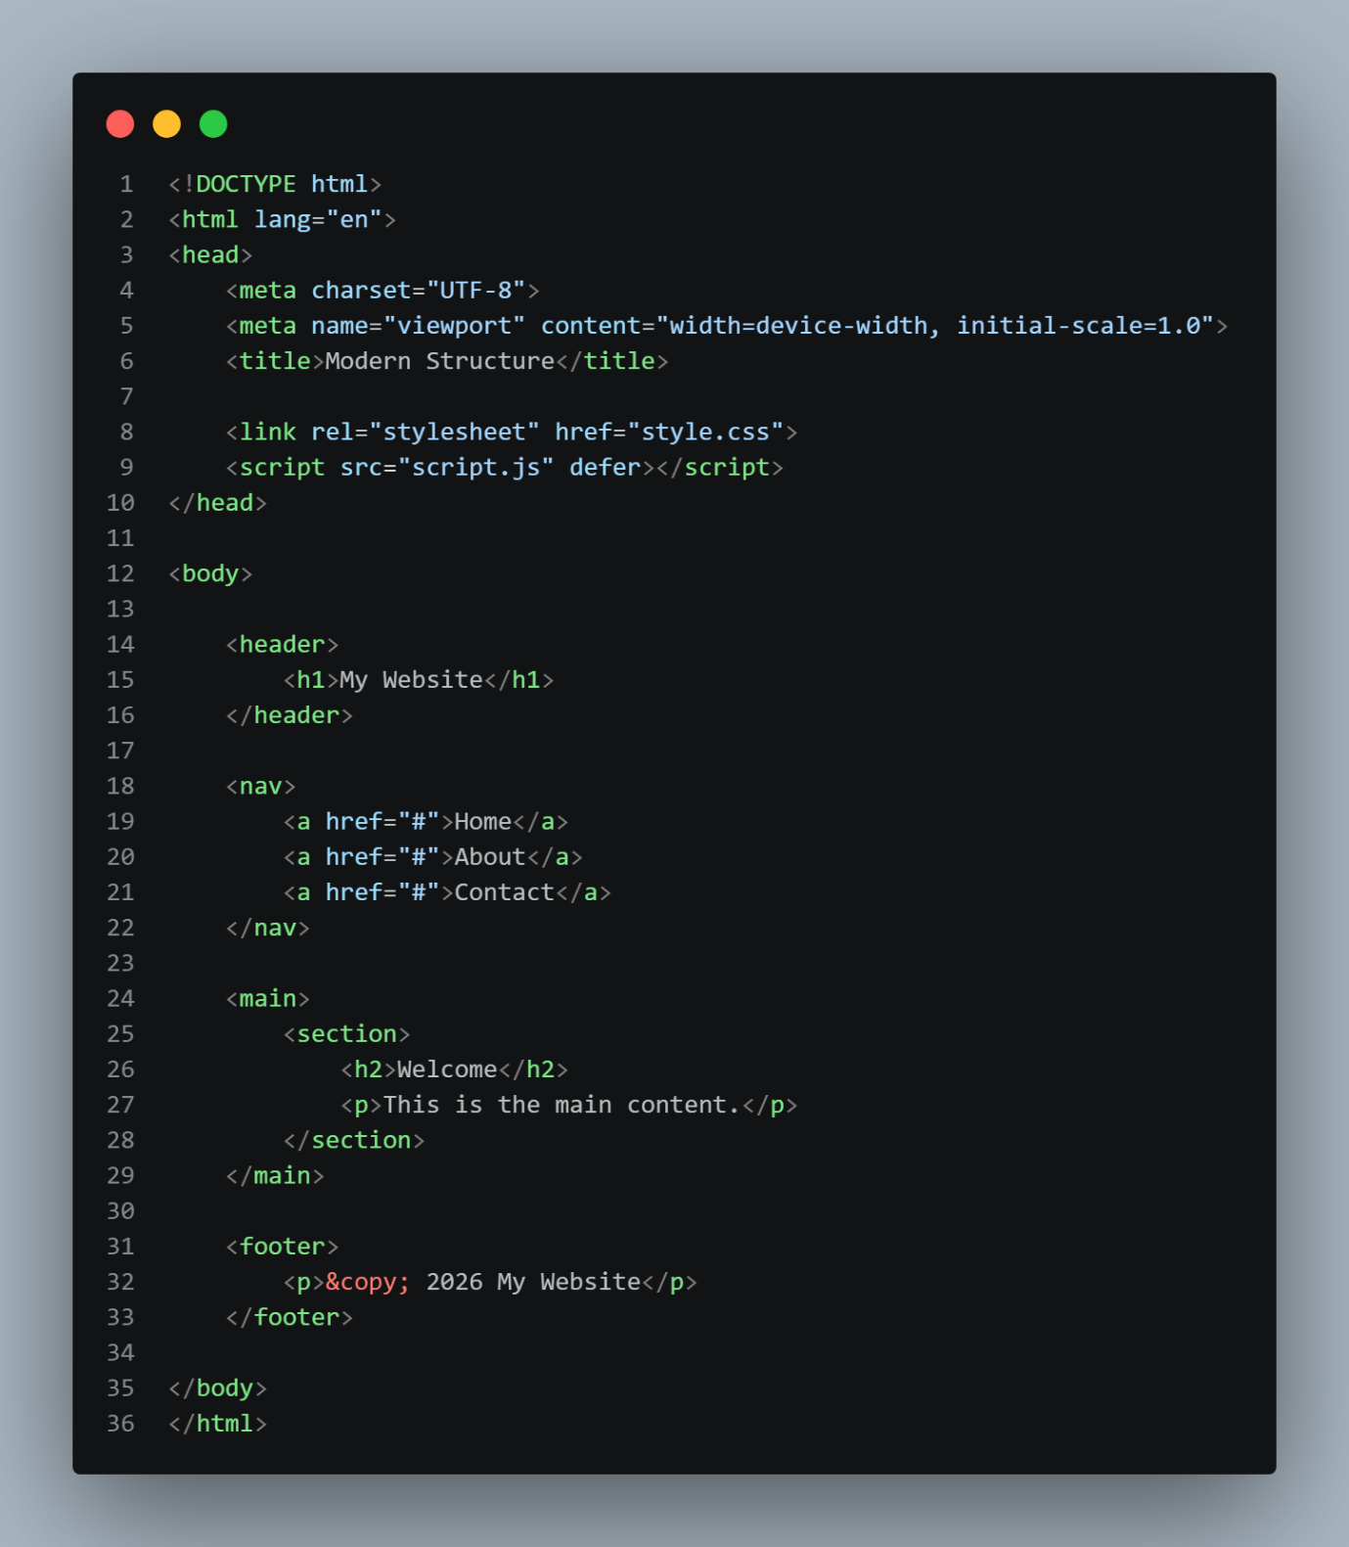
- <header>: Introductory content, logos, or navigation menus.
- <nav>: Navigational link containers.
- <main>: The dominant, unique content of the individual page.
- <section>: Thematic groupings of content.
- <article>: Self-contained compositions (like blog posts).
- <aside>: Secondary sidebar content or callout boxes.
- : End-of-page elements like copyright details or contact links.

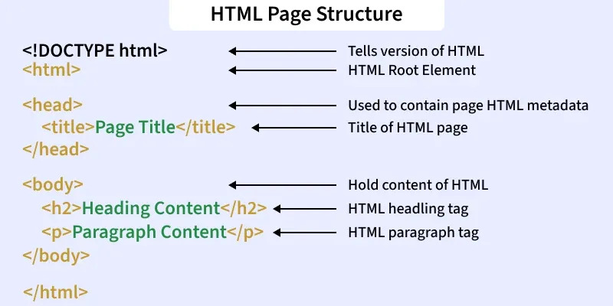

BOILERPLATE
-An HTML Boilerplate is the basic template or starter code required to create a new HTML webpage.
-It contains the essential structure that every HTML document should have before adding any content.
Example :-Think of it as the foundation of a house—before decorating or adding furniture, you first build the basic structure.
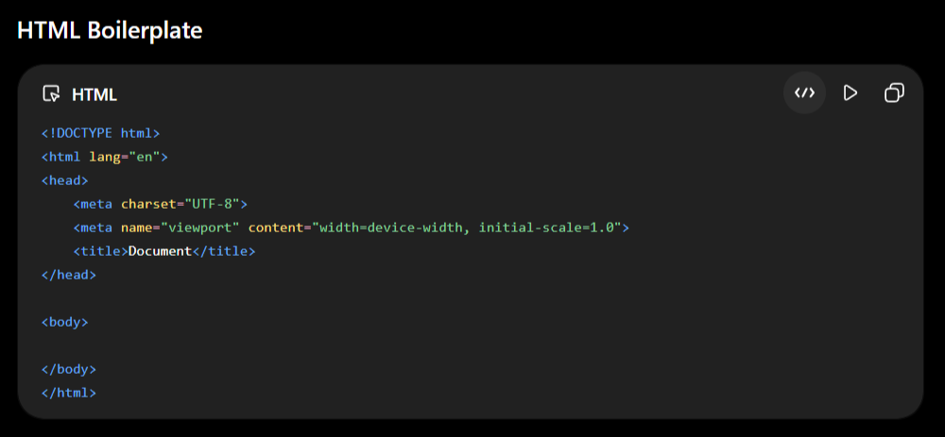

Why Do We Use an HTML Boilerplate?
- Provides the basic structure for every HTML page.
- Ensures compatibility with modern browsers.
- Makes the webpage responsive.
- Improves accessibility and SEO.
- Saves time by avoiding rewriting the same code for every new page.

Different Ways to Generate an HTML Boilerplate
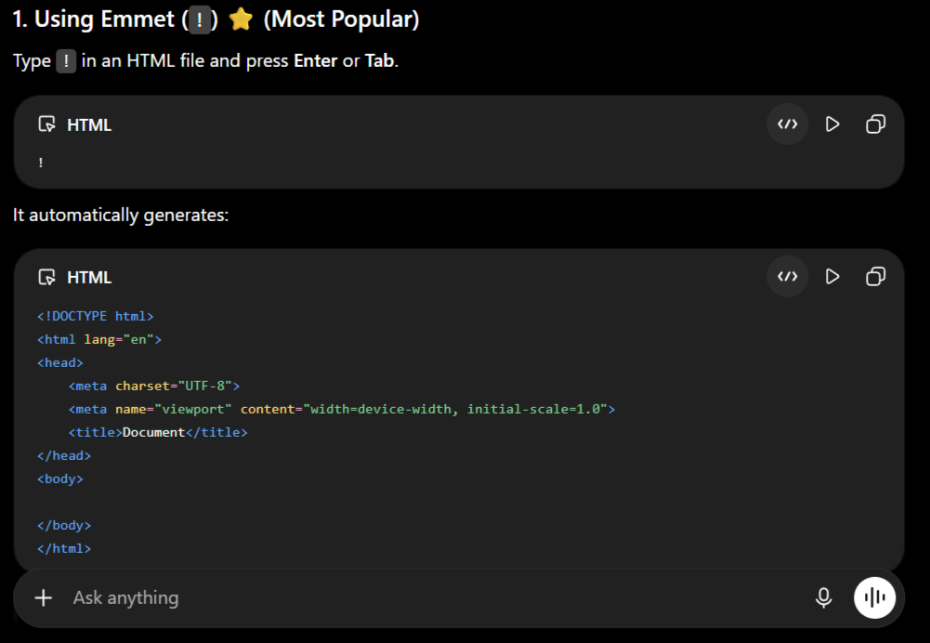
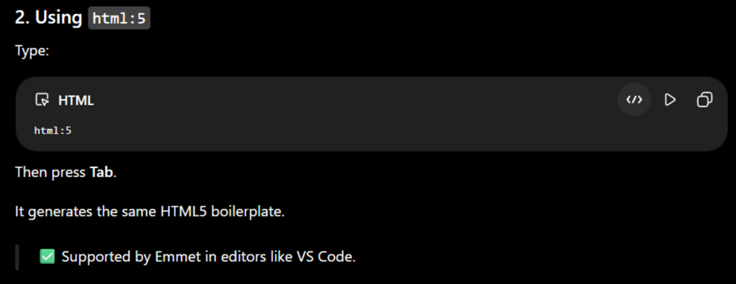
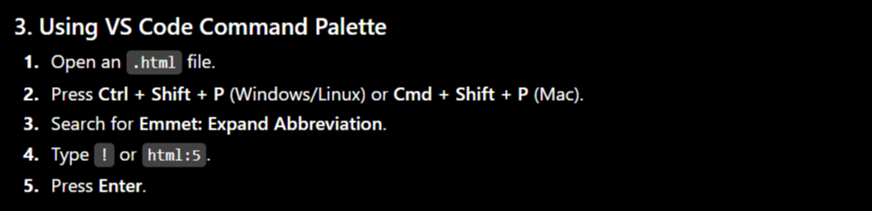
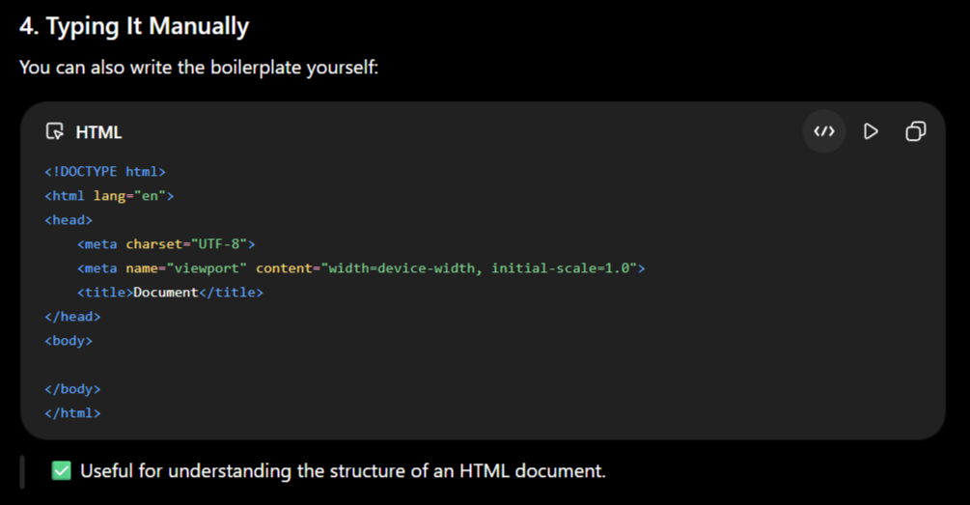

Why is it Called "Boilerplate" in HTML?
-The word boilerplate originally came from the printing industry in the 1800s.
- Large steel plates (called boiler plates) were used to print the same text repeatedly.
- Since the content didn't change, people started using the term boilerplate to describe any standard, reusable text or code.
-Later, programmers adopted the same term for code templates that are reused in many projects.
-Instead of writing this structure every time:
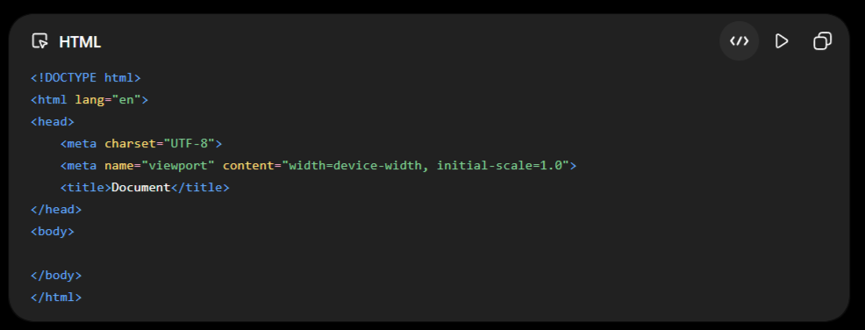
-We call it the HTML Boilerplate because it is the same starting template used for almost every HTML document.

TAGS

-A Tag is a predefined keyword enclosed within angle brackets (< >) that tells the browser how to display or structure the content of a webpage.
-Everything enclosed within < > is called an HTML Tag.
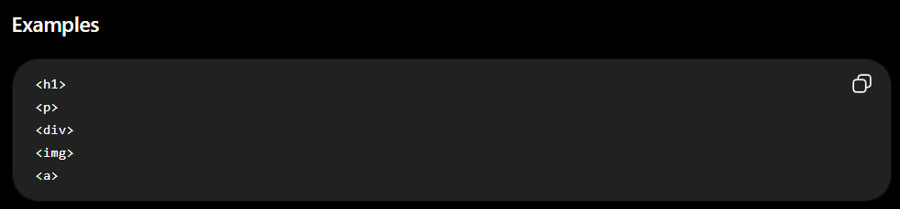
-HTML Tags are the building blocks of every HTML document. Without tags, a browser cannot understand the structure of a webpage.

Why Do We Need HTML Tags?
HTML Tags help the browser understand:
- What is a heading
- What is a paragraph
- Where an image should be displayed
- Which text is a hyperlink
- Where a table starts and ends
- How the webpage should be structured
Without HTML Tags, the browser treats everything as plain text.

Types of HTML Tags
HTML Tags are mainly classified into two types:
- Predefined Tags
- User-Defined Tags

- Predefined Tags

-The tags that are already defined by HTML and recognized by all web browsers are called Predefined Tags.
-These tags are part of the HTML language and are used to build webpages.
Examples
- <html>
- <head>
- <title>
- <body>
- <h1>
- <p>
- <div>
- <span>
- <img>
- <a>
- <table>
- <form>

Types of Predefined Tags
- Tags are divided into two categories:
- Paired Tags
- Unpaired Tags

1. Paired Tags (Container Tags)
-The tags that have both an opening tag and a closing tag are called Paired Tags or Container Tags.
-Everything written between the opening tag and closing tag is called content.
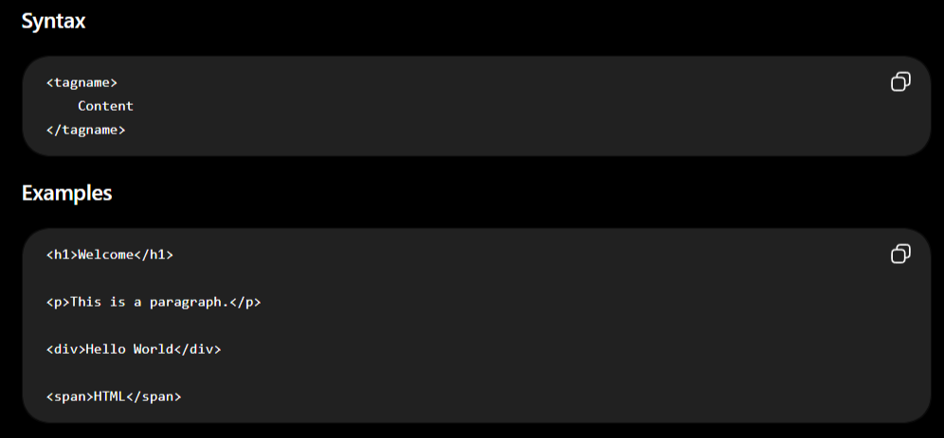
Characteristics
- Has an opening tag.
- Has a closing tag.
- Can contain text.
- Can contain images.
- Can contain other HTML elements.
- Used to create webpage structure.
Common Paired Tags
- <html></html>
- <head></head>
- <title></title>
- <body></body>
- <h1></h1>
- <p></p>
- <div></div>
- <span></span>
- <a></a>
- <table></table>
- <form></form>

2. Unpaired Tags (Empty Tags / Void Elements)
-The tags that do not have a closing tag are called Unpaired Tags, Empty Tags, or Void Elements.
-These tags do not contain any content.
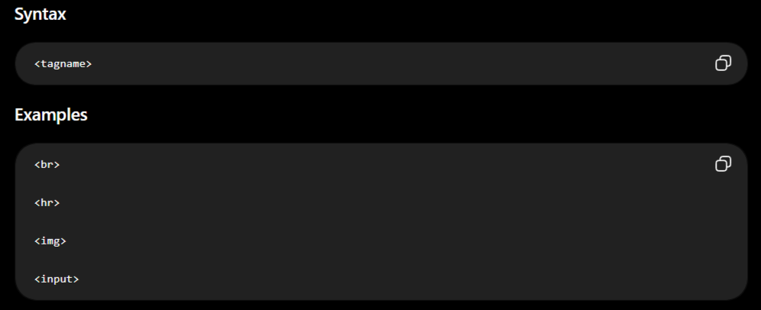
Characteristics
- Does not have a closing tag.
- Cannot contain any content.
- Performs only one specific task.
- Used for inserting elements like images, line breaks, metadata, etc.
Common Unpaired Tags
- <br>
- <hr>
- <img>
- <input>
- <meta>
- <link>
- <source>
- <track>
- <base>
- <col>
- <embed>
- <area>
- <wbr>

Difference Between Paired and Unpaired Tags
SrNo | Paired Tags | Unpaired Tags
 | Has opening and closing tag | Has only opening tag
 | Can contain content | Cannot contain content
 | Used to create structure | Used for a single operation
 | Example: <p>Hello</p> | Example: <br>

- User-Defined Tags

-Tags created by the developer that are not predefined in HTML are called User-Defined Tags.
-Browsers do not assign any special meaning to these tags by default. They are commonly used with Web Components (Custom Elements) or JavaScript frameworks.
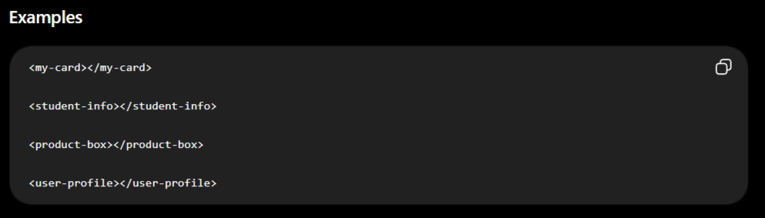

Characteristics
- Created by the developer.
- Not part of standard HTML.
- Browsers treat them as generic elements unless defined with JavaScript.
- Mainly used in modern frontend development.

HTML TAG STRUCTURE

-Most HTML tags have three parts:
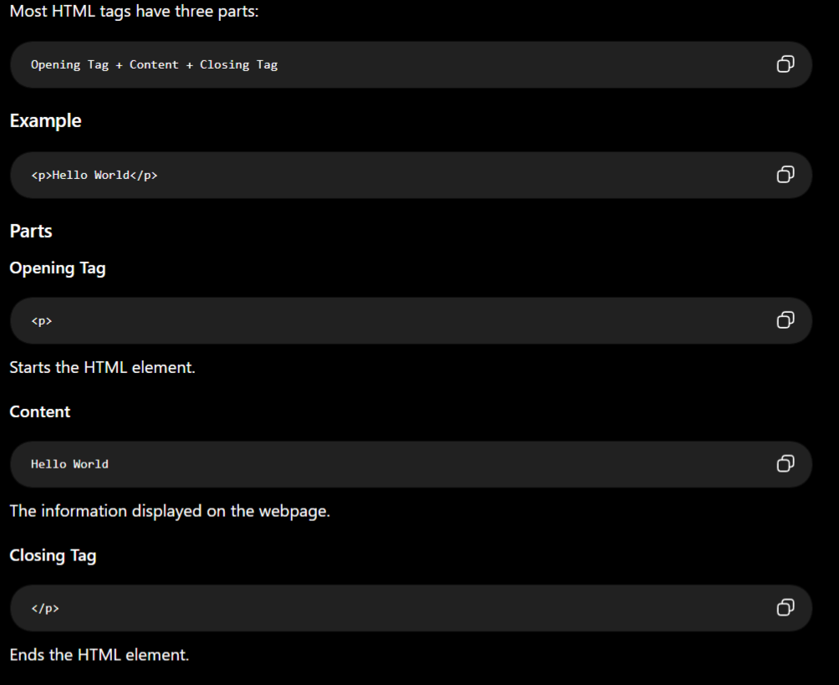

1.Opening Tag

-The opening tag marks the beginning of an HTML element.
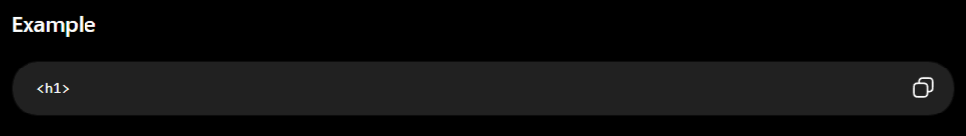

2.Opening Tag

-The closing tag marks the end of an HTML element.
-It always begins with a forward slash (/).
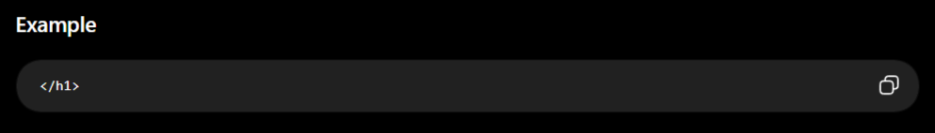

NESTED TAGS

-Placing one HTML element inside another HTML element is called Nesting.
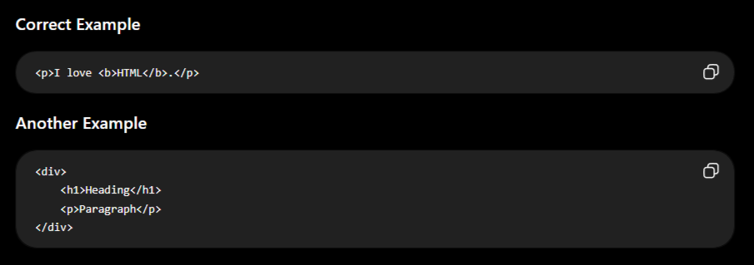
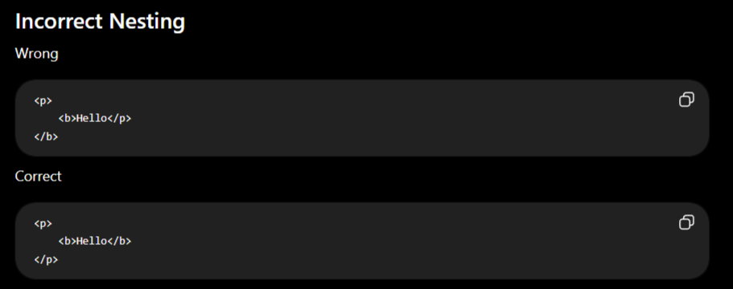
Rule: Always close the inner tag before closing the outer tag.

HTML TAGS – CATEGORY-WISE COMPLETE LIST

1. Document Structure Tags
- <html> → Root element of an HTML document
- <head> → Contains document metadata and resource information
- <body> → Contains the visible content of the document

2. Metadata Tags
- <title> → Defines the document title
- <base> → Defines the base URL for relative URLs
- <meta> → Defines document metadata
- <link> → Defines a relationship with an external resource
- <style> → Contains CSS styling rules

3. Heading Tags
- <h1> → Defines the highest-level heading
- <h2> → Defines a second-level heading
- <h3> → Defines a third-level heading
- <h4> → Defines a fourth-level heading
- <h5> → Defines a fifth-level heading
- <h6> → Defines a sixth-level heading
- <hgroup> → Groups a heading with related secondary content

4. Paragraph Tags
- <p> → Defines a paragraph

5. Container Tags
- <div> → Generic block-level container
- <span> → Generic inline container

6. Break / Separator Tags
- <br> → Creates a line break
- <hr> → Represents a thematic break
- <wbr> → Defines a possible word-breaking position

7. Text Formatting Tags
This is where <ins> and <del> should be placed along with the text-formatting elements.
- <b> → Draws attention to text without indicating extra importance
- <strong> → Indicates strong importance
- <i> → Represents text in an alternate voice or mood
- <em> → Indicates emphasis
- <u> → Represents text with a non-textual annotation
- <mark> → Highlights text for relevance
- <small> → Represents side comments or fine print
- <s> → Represents text that is no longer accurate or relevant
- <del> → Represents content that has been deleted
- <ins> → Represents content that has been inserted
- <sub> → Represents subscript text
- <sup> → Represents superscript text
✅ So yes: <ins> and <del> are included here.

8. Quotation Tags
- <blockquote> → Represents an extended quotation
- <q> → Represents a short inline quotation

9. Citation Tags
- <cite> → Represents the title of a creative work

10. Abbreviation Tags
- <abbr> → Represents an abbreviation or acronym

11. Definition Tags
- <dfn> → Represents the term being defined

12. Data Tags
- <data> → Associates content with a machine-readable value

13. Date / Time Tags
- <time> → Represents a date, time, or duration

14. Code / Computer Text Tags
- <code> → Represents a fragment of computer code
- <kbd> → Represents user input
- <samp> → Represents sample output from a computer program
- <var> → Represents a variable
- <pre> → Represents preformatted text

15. List Tags
- <ul> → Defines an unordered list
- <ol> → Defines an ordered list
- <li> → Defines a list item
- <dl> → Defines a description list
- <dt> → Defines a description-list term
- <dd> → Defines the description or value of a term
- <menu> → Defines a list of commands or menu items

16. Link / Anchor Tags
- <a> → Creates a hyperlink

17. Media Tags
All major media-related elements stay together here.
- <img> → Embeds an image
- <picture> → Provides alternative images for different conditions
- <audio> → Embeds audio content
- <video> → Embeds video content
- <source> → Defines an alternative media or image source
- <track> → Provides subtitles, captions, or other timed text
- <figure> → Represents self-contained media or illustrative content
- <figcaption> → Provides a caption for a <figure>
✅ <img>, <audio>, <video>, <figure>, <figcaption>, etc. are together under Media Tags.

18. Image Map Tags
- <map> → Defines an image map
- <area> → Defines a clickable area inside an image map

19. Embedded Content Tags
- <iframe> → Embeds another HTML document
- <embed> → Embeds external content
- <object> → Represents an external resource

20. Semantic Layout Tags
- <header> → Represents introductory content
- <nav> → Represents navigation links
- <main> → Represents the main content
- <section> → Represents a thematic section
- <article> → Represents independent self-contained content
- <aside> → Represents related secondary content
- <footer> → Represents footer content
- <address> → Represents contact information
- <search> → Represents a search or filtering section

21. Table Tags
- <table> → Defines a table
- <caption> → Defines a table caption
- <colgroup> → Groups table columns
- <col> → Defines properties for a table column
- <thead> → Defines the table header section
- <tbody> → Defines the table body section
- <tfoot> → Defines the table footer section
- <tr> → Defines a table row
- <th> → Defines a table header cell
- <td> → Defines a table data cell

22. Form Structure Tags
- <form> → Defines an HTML form
- <fieldset> → Groups related form controls
- <legend> → Defines a caption for a fieldset
- <label> → Defines a label for a form control

23. Form Control Tags
- <input> → Creates an input control
- <textarea> → Creates a multi-line text input
- <button> → Creates a clickable button
- <select> → Creates a selection control
- <option> → Defines an option in a selection list
- <optgroup> → Groups related options
- <datalist> → Provides predefined suggestions for an input
- <selectedcontent> → Displays the content of the selected option

24. Form Result / Measurement Tags
- <output> → Represents the result of a calculation or action
- <meter> → Represents a measurement within a known range
- <progress> → Represents the progress of a task

25. Interactive Tags
- <details> → Creates expandable/collapsible content
- <summary> → Defines the visible heading of <details>
- <dialog> → Represents a dialog or modal window

26. Bidirectional Text Tags
- <bdi> → Isolates bidirectional text from surrounding content
- <bdo> → Overrides the direction of text

27. Ruby Annotation Tags
- <ruby> → Defines ruby annotation content
- <rt> → Defines ruby annotation text
- <rp> → Provides fallback parentheses for ruby annotations

28. Scripting Tags
- <script> → Embeds or references executable code
- <noscript> → Provides fallback content when scripting is unavailable

29. Canvas / Drawing Tags
- <canvas> → Provides a script-controlled drawing surface

30. Web Component Tags
- <template> → Defines reusable inert HTML content
- <slot> → Defines an insertion point for Web Component content

31. SVG Tags
SVG Root
- <svg> → Defines an SVG graphics container
SVG Shapes
- <rect> → Creates a rectangle
- <circle> → Creates a circle
- <ellipse> → Creates an ellipse
- <line> → Creates a straight line
- <polyline> → Creates connected line segments
- <polygon> → Creates a closed polygon
- <path> → Creates a complex shape or path
SVG Grouping
- <g> → Groups SVG elements
- <defs> → Defines reusable SVG resources
- <use> → Reuses an existing SVG element
- <symbol> → Defines reusable graphical content
SVG Text
- <text> → Displays text inside SVG
- <tspan> → Defines a portion of SVG text
- <textPath> → Places text along a path
SVG Gradients
- <linearGradient> → Defines a linear gradient
- <radialGradient> → Defines a radial gradient
- <stop> → Defines a color stop
SVG Patterns / Masking
- <pattern> → Defines a reusable pattern
- <clipPath> → Defines a clipping region
- <mask> → Defines a masking region
SVG Markers
- <marker> → Defines reusable graphics along a path
SVG Filters
- <filter> → Defines a filter effect
- <feBlend> → Blends image inputs
- <feColorMatrix> → Applies color transformations
- <feComponentTransfer> → Performs component-wise color transformation
- <feComposite> → Combines image inputs
- <feConvolveMatrix> → Applies a convolution matrix
- <feDiffuseLighting> → Creates diffuse lighting
- <feDisplacementMap> → Displaces pixels
- <feDistantLight> → Defines a distant light source
- <feDropShadow> → Creates a drop-shadow effect
- <feFlood> → Fills an area with a color
- <feGaussianBlur> → Applies Gaussian blur
- <feImage> → Uses an image as filter input
- <feMerge> → Combines filter results
- <feMergeNode> → Provides an input to <feMerge>
- <feMorphology> → Performs dilation or erosion
- <feOffset> → Offsets graphical content
- <fePointLight> → Defines a point light
- <feSpecularLighting> → Creates specular lighting
- <feSpotLight> → Defines a spotlight
- <feTile> → Creates tiled output
- <feTurbulence> → Generates procedural noise
SVG Animation
- <animate> → Animates an SVG attribute
- <animateMotion> → Animates an element along a path
- <animateTransform> → Animates transformations
- <set> → Sets an attribute to a value

32. MathML Tags
Basic Math
- <math> → Root MathML element
- <mi> → Represents an identifier or variable
- <mn> → Represents a number
- <mo> → Represents a mathematical operator
- <mtext> → Represents ordinary text
- <ms> → Represents a string
- <mspace> → Creates mathematical spacing
Mathematical Structure
- <mrow> → Groups mathematical expressions
- <mfrac> → Creates a fraction
- <msqrt> → Creates a square root
- <mroot> → Creates a root with an index
- <mstyle> → Applies mathematical styling
- <merror> → Represents a mathematical error
- <mpadded> → Adjusts spacing around mathematical content
- <mphantom> → Creates invisible mathematical content
- <menclose> → Encloses mathematical content
Mathematical Scripts
- <msub> → Creates a subscript
- <msup> → Creates a superscript
- <msubsup> → Creates subscript and superscript
- <munder> → Places content underneath
- <mover> → Places content above
- <munderover> → Places content above and below
Mathematical Tables
- <mtable> → Creates a mathematical table
- <mtr> → Defines a mathematical table row
- <mtd> → Defines a mathematical table cell
Mathematical Semantics
- <semantics> → Adds semantic information to mathematical content
- <annotation> → Provides annotation information
- <annotation-xml> → Provides XML-based annotation information

33. Obsolete / Deprecated Tags
Do not use these in modern HTML.
- <acronym> → Use <abbr> instead
- <applet> → Old Java applet element
- <basefont> → Old default font element
- <big> → Old larger-text element
- <center> → Old centering element; use CSS
- <content> → Old Shadow DOM insertion element
- <dir> → Old directory-list element
- <font> → Old font-styling element; use CSS
- <frame> → Old individual frame
- <frameset> → Old frame container
- <image> → Old image element; use <img>
- <keygen> → Old cryptographic key-generation element
- <marquee> → Old scrolling-content element
- <menuitem> → Old menu-command element
- <nobr> → Old no-wrap element
- <noframes> → Old frame fallback
- <noembed> → Old embedded-content fallback
- <param> → Old parameter element for <object>
- <shadow> → Old Shadow DOM insertion element
- <spacer> → Old spacing element
- <strike> → Old strikethrough element
- <tt> → Old teletype text element
- <xmp> → Old raw HTML element

HTML ATTRIBUTES
-Attributes are simply properties of tags.
-An HTML attribute provides additional information about an HTML element.
-Attributes modify the behavior, appearance, or functionality of an element.
- Attributes are written inside the opening tag.
- They usually consist of a name and a value.
- The value is enclosed in double quotes (" ") (recommended).
- Attributes must be in the pattern of attribute = “value”
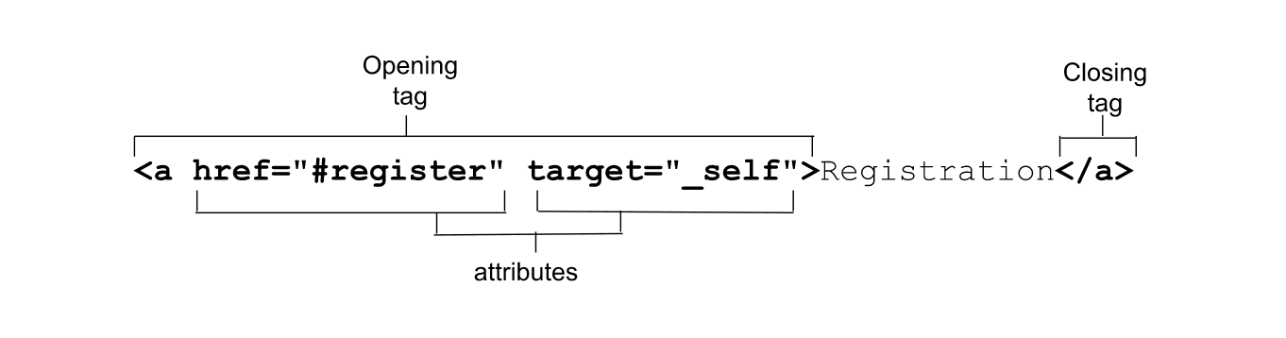
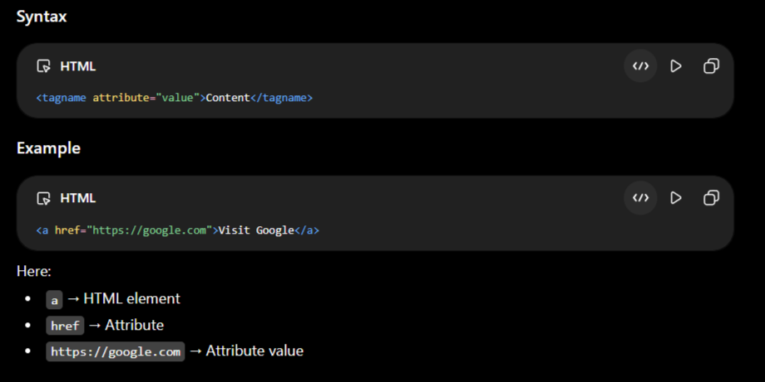
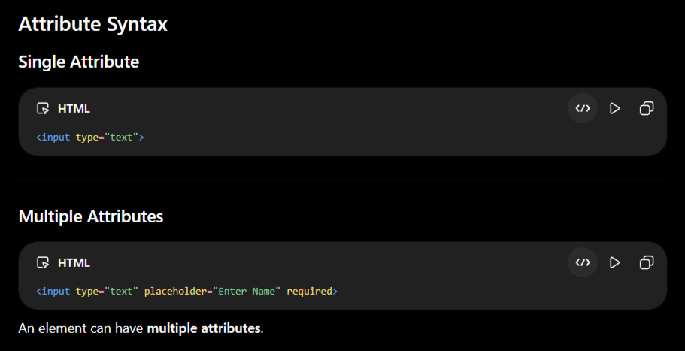

Rules and Characteristics
- Attributes are optional; you can use them to provide additional information about an HTML element.
- Attributes have name and value pairs, but some of the attributes do not require any value; those are known as Boolean attributes.
- An HTML element can have multiple attributes, and they should be separated by spaces.
- Attributes should always be written with the opening tag.
- All HTML elements can have attributes except a few like <head>, <title>, <script>, etc.

TYPES OF ATTRIBUTES

1. Global Attributes
-These can be used on almost every HTML element.
Examples:
- id
- class
- style
- title
- hidden
- tabindex
- draggable
- contenteditable
- lang
- dir
- data-*
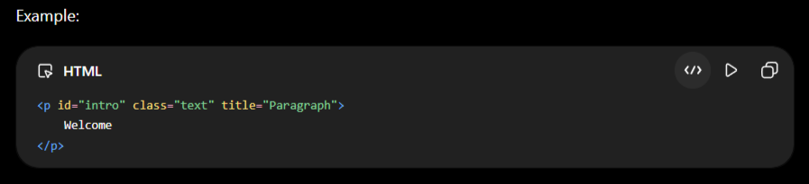

2. Element-Specific Attributes
-These work only with specific HTML elements.
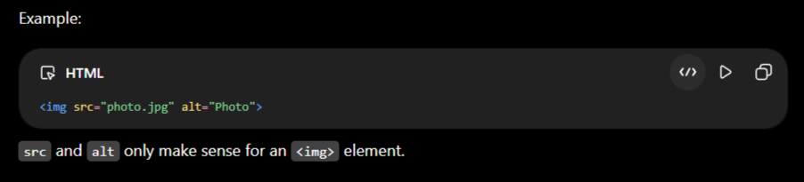
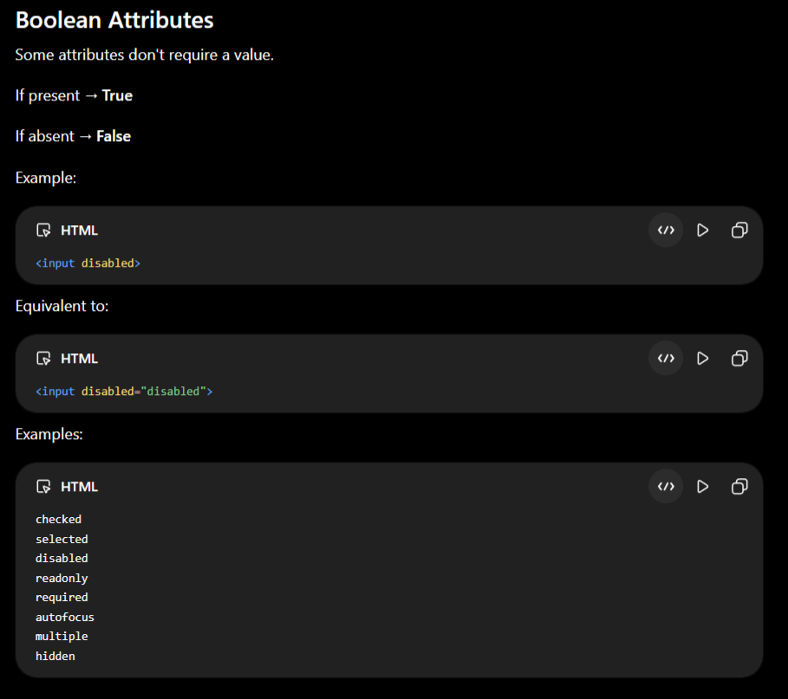

Common HTML Attributes
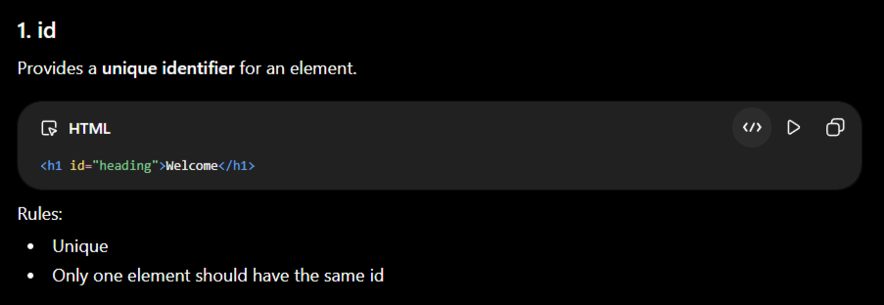
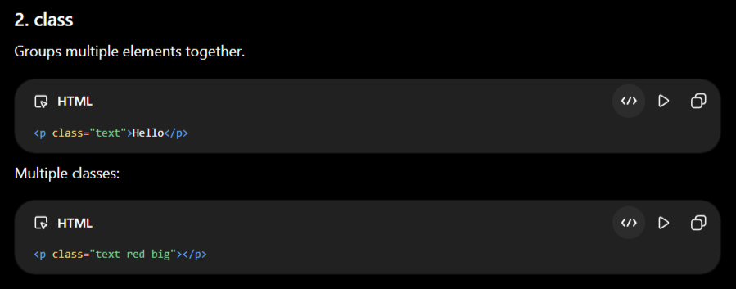
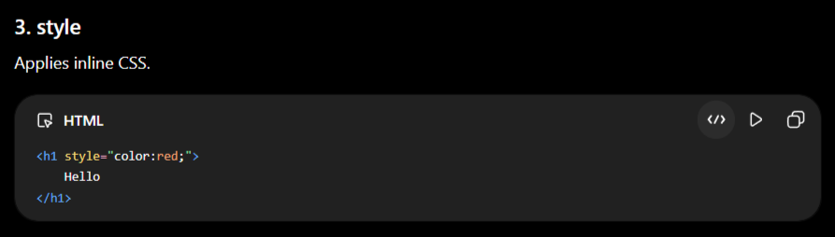
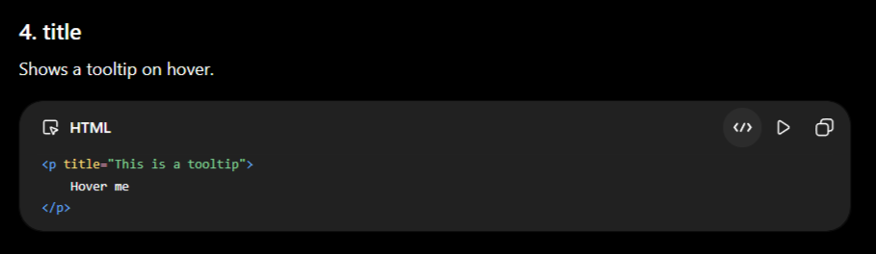
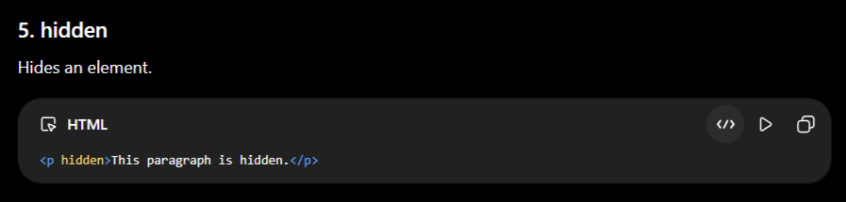
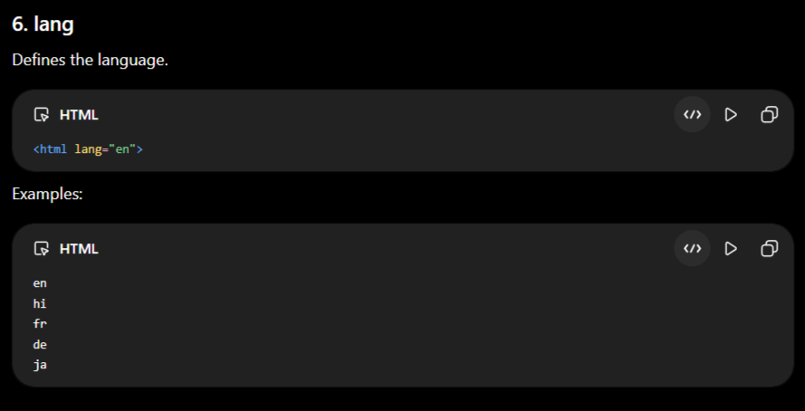
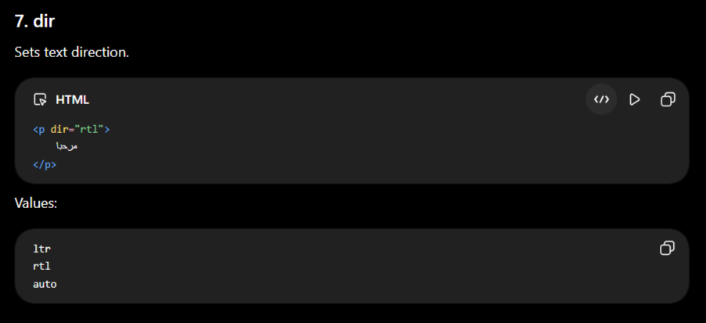
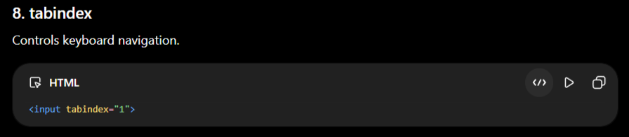
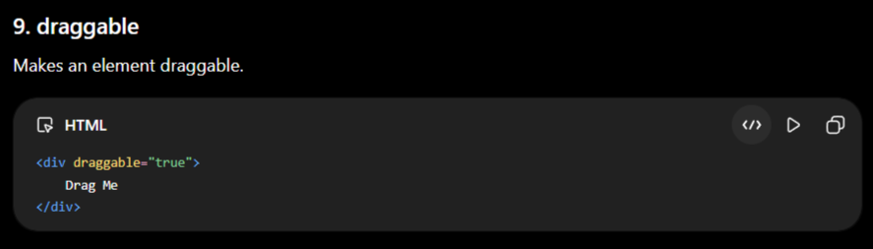
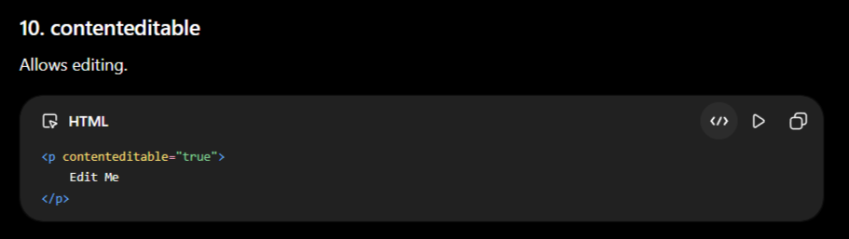
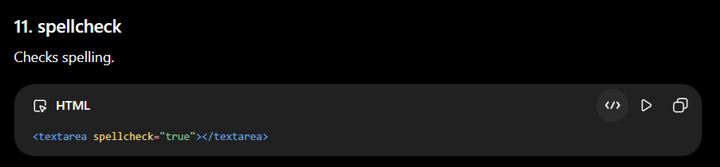

Anchor (<a>) Attributes
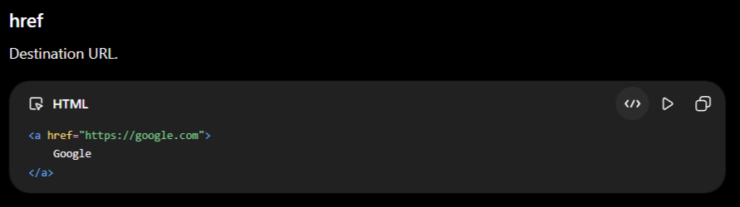
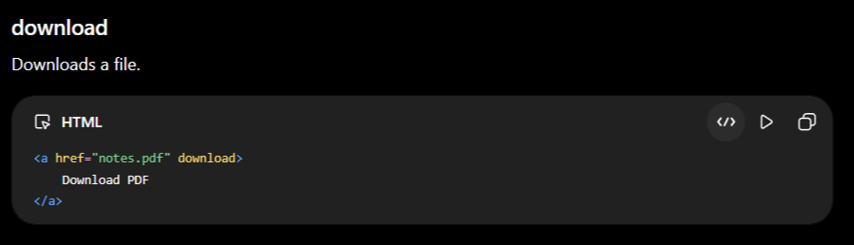
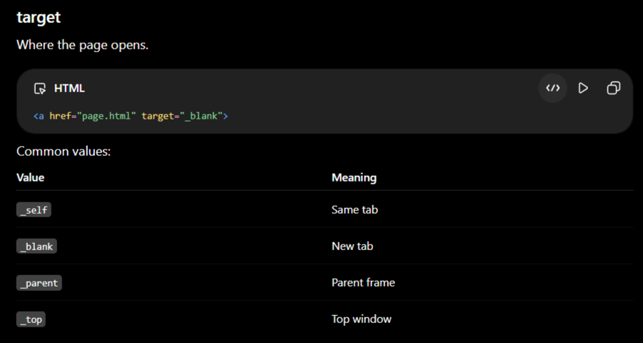

Image (<img>) Attributes
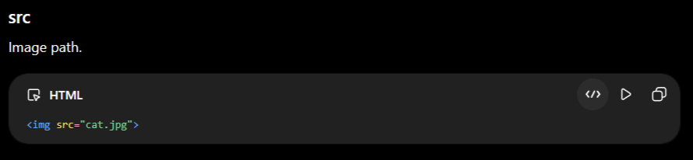
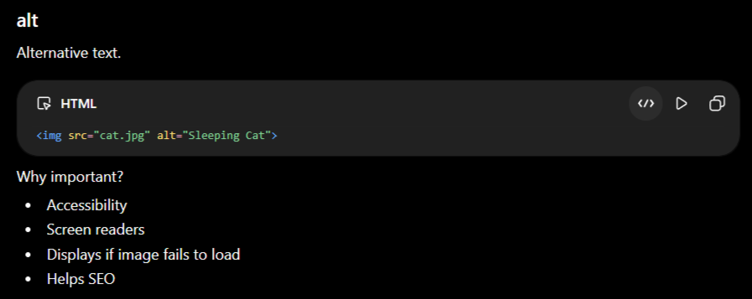
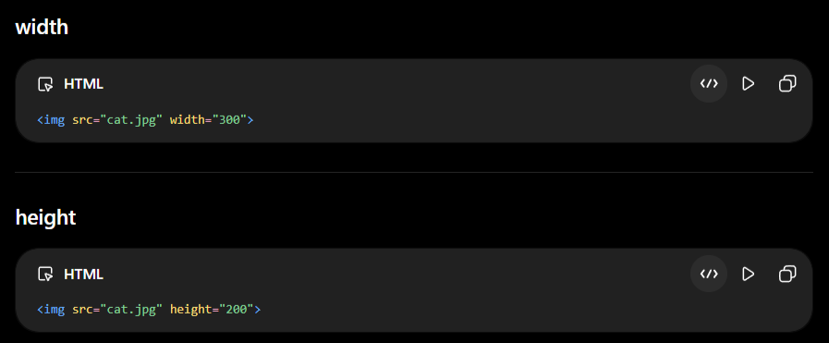
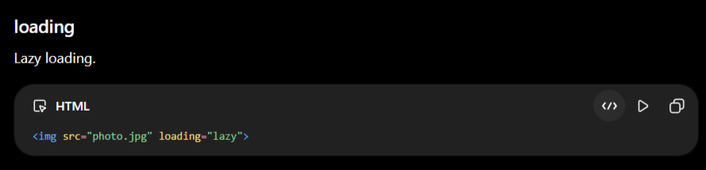

Input Attributes
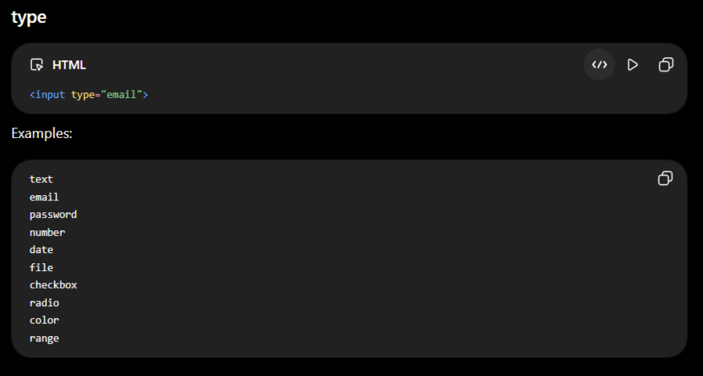
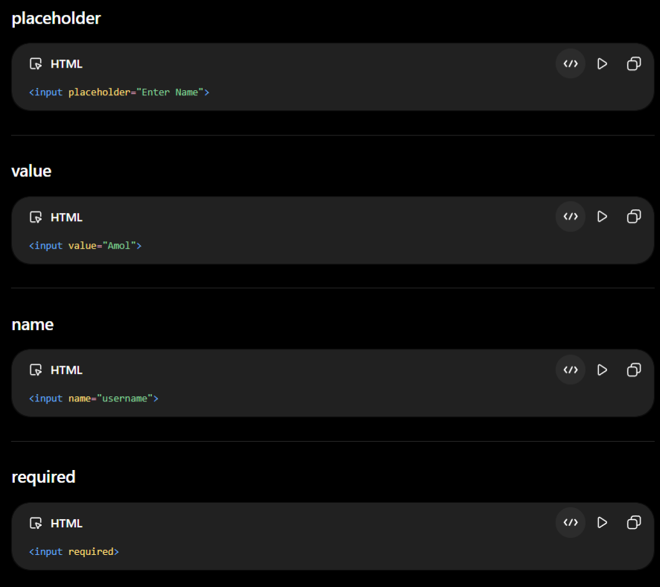
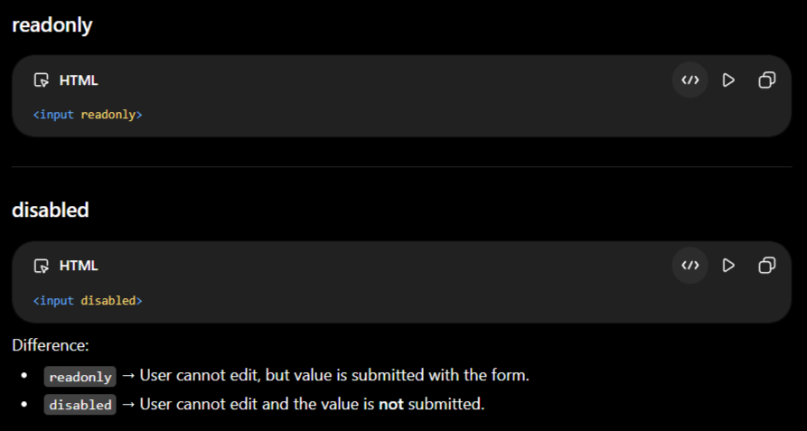

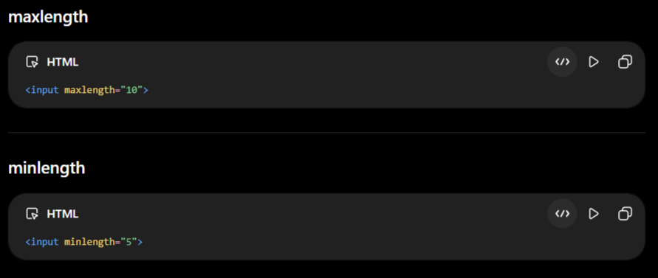
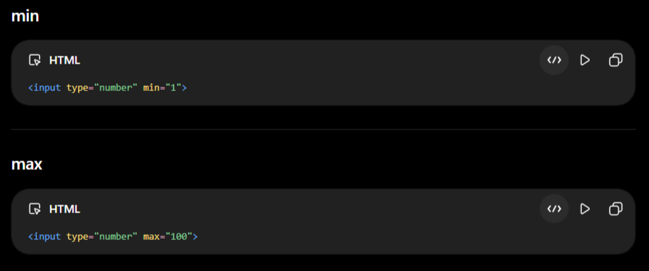
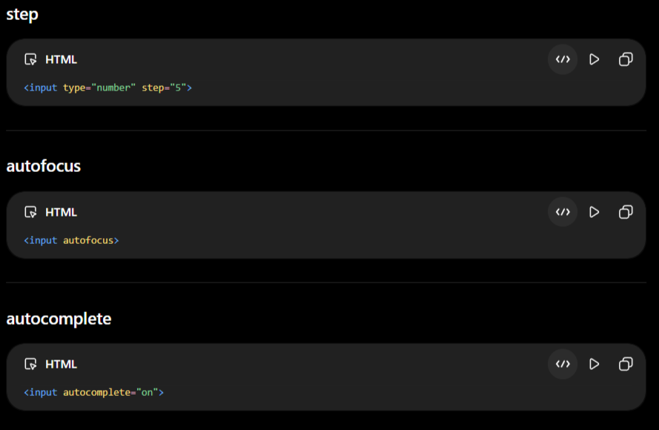
Form Attributes
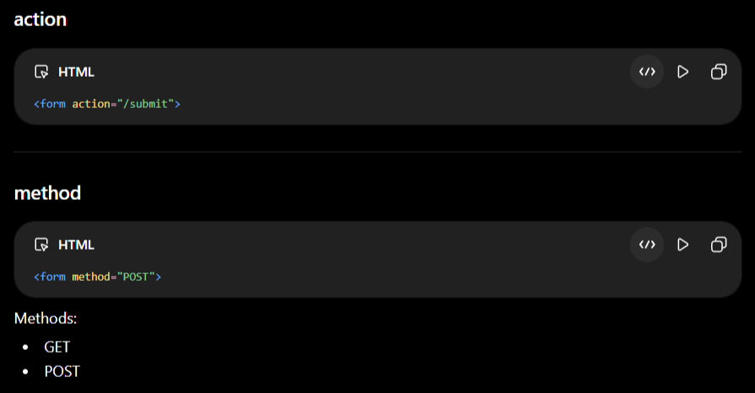
Table Attributes (Legacy)
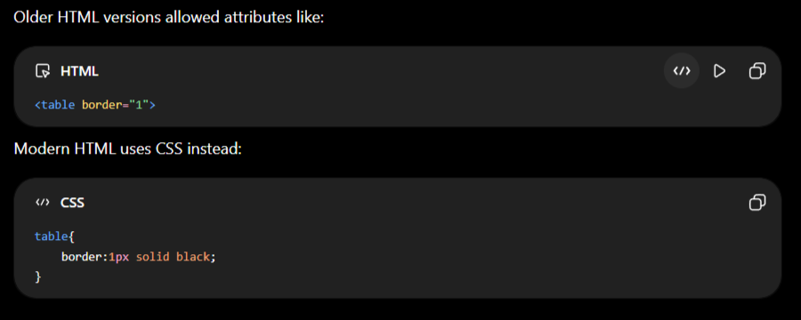
Custom Data Attributes
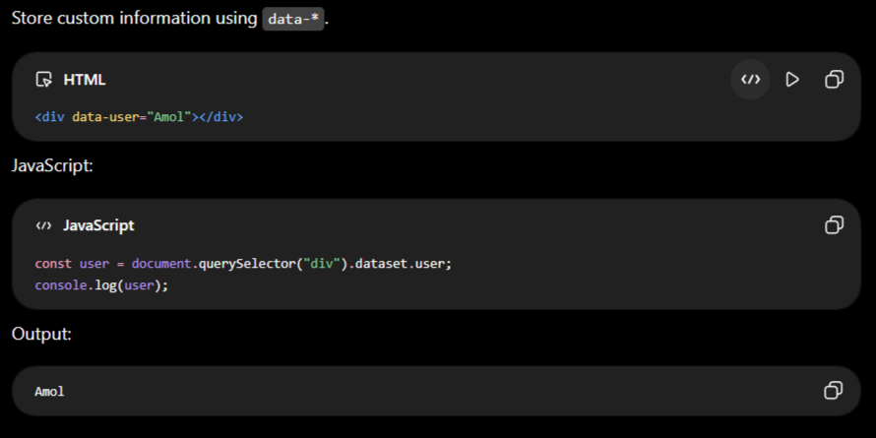

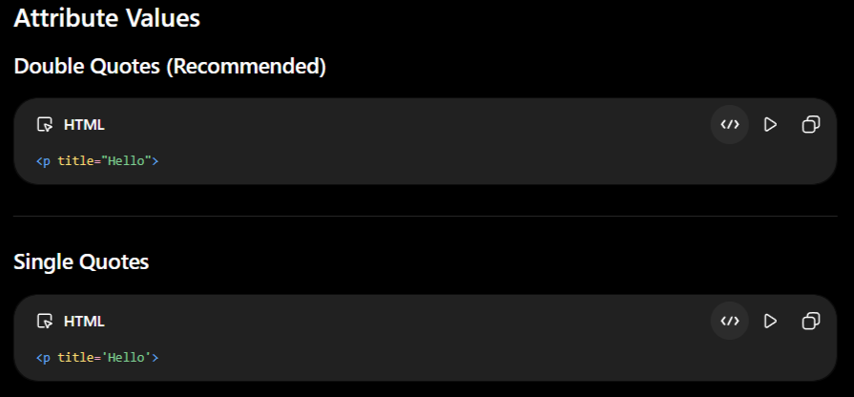
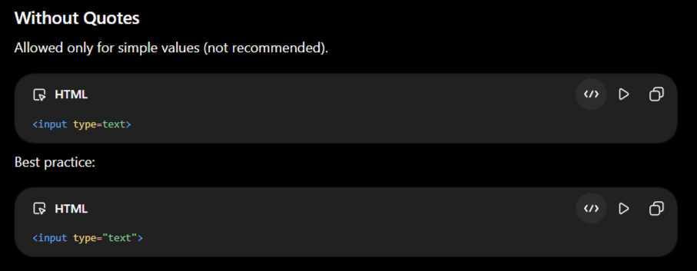
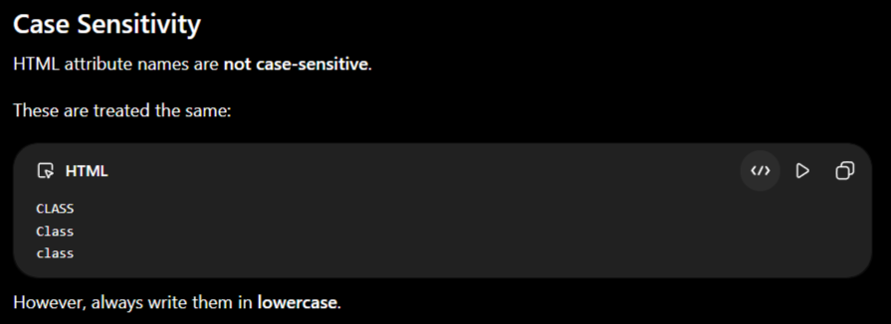

Why Do We Use Attributes?
-Attributes allow us to:
- Add links
- Display images
- Set IDs and classes
- Apply styles
- Add tooltips
- Disable inputs/buttons
- Specify input types
- Improve accessibility
- Store custom data
- Control element behavior
Without attributes, HTML elements would have very limited functionality.
1. Global Attributes (Can be used on almost every HTML element)
Attribute | Example
Id | <div id="header"></div>
class | <p class="text"></p>
style | <h1 style="color:red;">Hello</h1>
Title | <p title="Tooltip">Hover Me</p>
hidden | <div hidden></div>
Lang | <html lang="en">
Dir | <p dir="rtl">مرحبا</p>
tabindex | <input tabindex="1">
contenteditable | <div contenteditable="true">Edit Me</div>
draggable | <img draggable="true">
spellcheck | <textarea spellcheck="true"></textarea>
translate | <p translate="no">ChatGPT</p>
accesskey | <button accesskey="s">Save</button>
autocapitalize | <input autocapitalize="words">
autofocus | <input autofocus>
enterkeyhint | <input enterkeyhint="search">
inputmode | <input inputmode="numeric">
inert | <div inert></div>
Is | <button is="custom-button"></button>
nonce | <script nonce="abc123"></script>
Part | <div part="header"></div>
popover | <div popover></div>
Role | <nav role="navigation"></nav>
Slot | <span slot="title"></span>
data-* | <div data-id="10"></div>

2. Anchor (<a>)
Attribute | Example
Href | <a href="page.html">Home</a>
target | <a target="_blank">
download | <a download>
hreflang | <a hreflang="en">
Ping | <a ping="/track">
referrerpolicy | <a referrerpolicy="no-referrer">
Rel | <a rel="noopener">
Type | <a type="text/html">

3. Image (<img>)
Attribute | Example
Src | <img src="cat.jpg">
Alt | <img alt="Cat">
width | <img width="300">
height | <img height="200">
loading | <img loading="lazy">
decoding | <img decoding="async">
crossorigin | <img crossorigin="anonymous">
referrerpolicy | <img referrerpolicy="origin">
sizes | <img sizes="100vw">
srcset | <img srcset="small.jpg 500w">
usemap | <img usemap="#map">
ismap | <img ismap>
fetchpriority | <img fetchpriority="high">

4. Form (<form>)
Attribute | Example
action | <form action="/save">
method | <form method="POST">
autocomplete | <form autocomplete="off">
enctype | <form enctype="multipart/form-data">
name | <form name="login">
novalidate | <form novalidate>
target | <form target="_blank">
accept-charset | <form accept-charset="UTF-8">

5. Input (<input>)
Attribute | Example
Type | <input type="email">
name | <input name="email">
value | <input value="Amol">
placeholder | <input placeholder="Enter Name">
required | <input required>
readonly | <input readonly>
disabled | <input disabled>
checked | <input checked>
maxlength | <input maxlength="20">
minlength | <input minlength="5">
Min | <input min="1">
Max | <input max="100">
Step | <input step="5">
Size | <input size="40">
multiple | <input multiple>
pattern | <input pattern="[A-Z]{3}">
accept | <input accept=".jpg">
autocomplete | <input autocomplete="on">
autofocus | <input autofocus>
dirname | <input dirname="name.dir">
Form | <input form="loginForm">
formaction | <input formaction="/submit">
formenctype | <input formenctype="multipart/form-data">
formmethod | <input formmethod="POST">
formnovalidate | <input formnovalidate>
formtarget | <input formtarget="_blank">
List | <input list="cities">
Max | <input max="10">
Min | <input min="0">
Src | <input type="image" src="submit.png">

6. Textarea
Attribute | Example
rows | <textarea rows="5"></textarea>
Cols | <textarea cols="30"></textarea>
placeholder | <textarea placeholder="Message"></textarea>
maxlength | <textarea maxlength="100"></textarea>
minlength | <textarea minlength="10"></textarea>
readonly | <textarea readonly></textarea>
required | <textarea required></textarea>
wrap | <textarea wrap="hard"></textarea>

7. Button
Attribute | Example
Type | <button type="submit">
disabled | <button disabled>
name | <button name="save">
value | <button value="save">
Form | <button form="loginForm">
formaction | <button formaction="/save">
formmethod | <button formmethod="POST">

8. Select
Attribute | Example
multiple | <select multiple>
Size | <select size="5">
required | <select required>
disabled | <select disabled>
name | <select name="city">

9. Option
Attribute | Example
value | <option value="IN">India</option>
selected | <option selected>
disabled | <option disabled>
label | <option label="India">

10. Audio
Attribute | Example
Src | <audio src="song.mp3">
controls | <audio controls>
autoplay | <audio autoplay>
Loop | <audio loop>
muted | <audio muted>
preload | <audio preload="auto">
crossorigin | <audio crossorigin="anonymous">

11. Video
Attribute | Example
Src | <video src="movie.mp4">
controls | <video controls>
autoplay | <video autoplay>
Loop | <video loop>
muted | <video muted>
poster | <video poster="cover.jpg">
playsinline | <video playsinline>
width | <video width="500">
height | <video height="300">
preload | <video preload="metadata">

12. Script
Attribute | Example
Src | <script src="app.js"></script>
Type | <script type="module"></script>
async | <script async></script>
defer | <script defer></script>
crossorigin | <script crossorigin="anonymous"></script>
integrity | <script integrity="..."></script>
nomodule | <script nomodule></script>
referrerpolicy | <script referrerpolicy="origin"></script>

13. Link
Attribute | Example
Href | <link href="style.css">
Rel | <link rel="stylesheet">
Type | <link type="text/css">
media | <link media="screen">
sizes | <link sizes="32x32">
crossorigin | <link crossorigin>
hreflang | <link hreflang="en">
integrity | <link integrity="...">

14. Meta
Attribute | Example
charset | <meta charset="UTF-8">
name | <meta name="viewport">
content | <meta content="width=device-width">
http-equiv | <meta http-equiv="refresh">

15. Iframe
Attribute | Example
Src | <iframe src="page.html"></iframe>
width | <iframe width="500"></iframe>
height | <iframe height="300"></iframe>
loading | <iframe loading="lazy"></iframe>
allow | <iframe allow="fullscreen"></iframe>
allowfullscreen | <iframe allowfullscreen></iframe>
name | <iframe name="frame1"></iframe>
referrerpolicy | <iframe referrerpolicy="origin"></iframe>
sandbox | <iframe sandbox></iframe>

16. Table
Attribute | Example
colspan | <td colspan="2">
rowspan | <td rowspan="3">
headers | <td headers="h1">
scope | <th scope="col">

17. Details
Attribute | Example
open | <details open>

18. Dialog
Attribute | Example
open | <dialog open>

19. Ordered List
Attribute | Example
start | <ol start="5">
reversed | <ol reversed>
Type | <ol type="A">

20. Track
Attribute | Example
Kind | <track kind="subtitles">
Src | <track src="sub.vtt">
srclang | <track srclang="en">
label | <track label="English">
default | <track default>

HTML Boolean Attributes (Table Format)
# | Boolean Attribute | Used With | Purpose | Example
1 | allowfullscreen | <iframe> | Allows fullscreen mode | <iframe allowfullscreen></iframe>
2 | async | <script> | Loads and executes script asynchronously | <script async src="app.js"></script>
3 | autofocus | <input>, <textarea>, <button>, <select> | Automatically focuses the element | <input autofocus>
4 | autoplay | <audio>, <video> | Starts media automatically | <video autoplay></video>
5 | checked | <input type="checkbox">, <input type="radio"> | Selects checkbox/radio by default | <input type="checkbox" checked>
6 | controls | <audio>, <video> | Displays media controls | <audio controls></audio>
7 | default | <track> | Sets the default subtitle/track | <track default>
8 | defer | <script> | Executes script after HTML parsing | <script defer src="app.js"></script>
9 | disabled | Form elements | Disables the element | <button disabled>Save</button>
10 | formnovalidate | <button>, <input type="submit"> | Skips form validation | <button formnovalidate>Submit</button>
11 | hidden | Global | Hides the element | <div hidden></div>
12 | inert | Global | Prevents interaction with element | <section inert></section>
13 | ismap | <img> | Indicates server-side image map | <img src="map.jpg" ismap>
14 | itemscope | Any element | Defines a microdata item | <div itemscope></div>
15 | loop | <audio>, <video> | Repeats media continuously | <video loop></video>
16 | multiple | <input>, <select> | Allows multiple selections/files | <input type="file" multiple>
17 | muted | <audio>, <video> | Starts media muted | <video muted></video>
18 | nomodule | <script> | Runs script only in browsers without module support | <script nomodule src="legacy.js"></script>
19 | novalidate | <form> | Disables HTML form validation | <form novalidate></form>
20 | open | <details>, <dialog> | Opens the element by default | <details open></details>
21 | playsinline | <video> | Plays video inline on mobile | <video playsinline></video>
22 | readonly | <input>, <textarea> | Makes the field read-only | <input readonly>
23 | required | Form controls | Makes the field mandatory | <input required>
24 | reversed | <ol> | Displays list in reverse order | <ol reversed></ol>
25 | selected | <option> | Selects the option by default | <option selected>India</option>

HTML Enumerated (Commonly Confused) Attributes
-These attributes are not Boolean attributes because they require specific values. Their behavior depends on the value you provide.
# | Attribute | Allowed Values | Used With | Example
1 | contenteditable | true, false, plaintext-only | Global | <div contenteditable="true"></div>
2 | draggable | true, false, auto | Global | <img draggable="true">
3 | spellcheck | true, false | Global | <textarea spellcheck="true"></textarea>
4 | translate | yes, no | Global | <p translate="no">HTML</p>
5 | dir | ltr, rtl, auto | Global | <p dir="rtl"></p>
6 | popover | auto, manual | Global | <div popover="auto"></div>
7 | autocomplete | on, off (plus field-specific tokens for form controls) | <form>, <input>, <textarea> | <input autocomplete="on">
8 | crossorigin | anonymous, use-credentials | <img>, <script>, <link>, <audio>, <video> | <img crossorigin="anonymous">
9 | decoding | sync, async, auto | <img> | <img decoding="async">
10 | fetchpriority | high, low, auto | <img>, <link>, <script> | <img fetchpriority="high">
11 | loading | lazy, eager | <img>, <iframe> | <img loading="lazy">
12 | preload | none, metadata, auto | <audio>, <video> | <video preload="metadata">
13 | referrerpolicy | no-referrer, origin, same-origin, strict-origin, unsafe-url, etc. | <a>, <img>, <iframe>, <script>, <link> | <img referrerpolicy="origin">
14 | enterkeyhint | enter, done, go, next, previous, search, send | <input>, <textarea> | <input enterkeyhint="search">
15 | inputmode | none, text, decimal, numeric, tel, search, email, url | <input>, <textarea> | <input inputmode="numeric">
16 | autocapitalize | off, none, on, sentences, words, characters | Global/Form Controls | <input autocapitalize="words">
17 | wrap | soft, hard | <textarea> | <textarea wrap="hard"></textarea>
18 | formmethod | get, post, dialog | Submit buttons/Inputs | <button formmethod="post">
19 | formenctype | application/x-www-form-urlencoded, multipart/form-data, text/plain | Submit buttons/Inputs | <button formenctype="multipart/form-data">
20 | method | get, post, dialog | <form> | <form method="post">
21 | type | Depends on the element (text, email, submit, module, etc.) | <input>, <button>, <script>, <ol>, etc. | <input type="email">
22 | target | _self, _blank, _parent, _top | <a>, <form> | <a target="_blank">
23 | sandbox | Space-separated sandbox permissions | <iframe> | <iframe sandbox="allow-scripts"></iframe>

HTML ELEMENTS

-An HTML element is everything from the opening tag to the closing tag, including the content inside it.

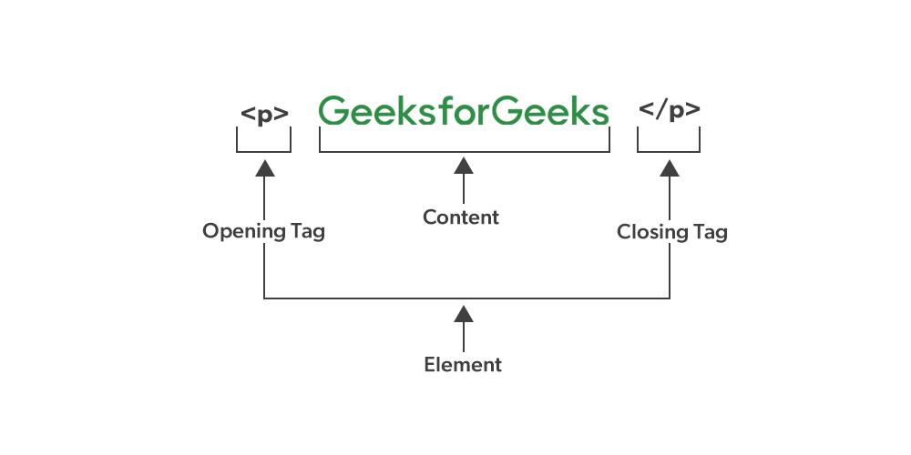
-An HTML element includes:
- Opening Tag: An opening tag specifies the beginning of the element and may include multiple attributes.
- Content: The content part includes the information to be displayed or processed within an element.
- Closing Tag: A closing tag marks the end of the element (A closing tag may be optional for some elements).

TYPES OF ELEMENTS
1.Normal/Paired Elements

-HTML elements can broadly be categorized based on whether they require a closing tag.
A. Normal/Paired Elements
These elements have:
- Opening tag
- Content
- Closing tag
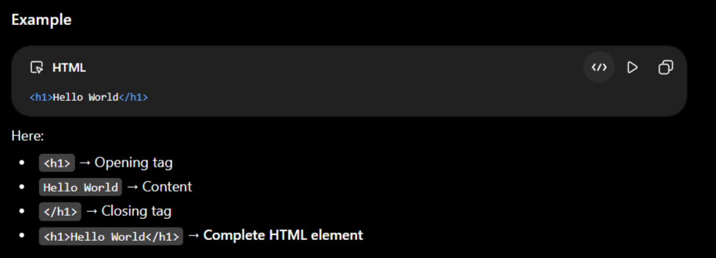

2.Void / Empty Elements

-Some HTML elements do not have closing tags and cannot contain child content.These are called void elements.
-HTML void elements are those elements that don't require closing tags.
-These tags don't have any content model and even don't allow nesting of elements.
-The void elements are also known as empty or self-closing elements.
-Some of the void elements are such as <img />, <hr />, and <br /> elements. The below table shows a list of void elements
S.No | Elements & Description
1 | <img>  Used for inserting images within HTML documents.
2 | <hr>  It displays a horizontal rule.
3 | <br>  It is used to provide a line break.
4 | <source>  It is used for embedding media resources like audio and video.
Common Void Elements
SrNo | Element | Purpose
 | <area> | Defines an area in an image map
 | <base> | Specifies base URL
 | <br> | Line break
 | <col> | Defines table column properties
 | <embed> | Embeds external content
 | <hr> | Horizontal thematic break
 | <img> | Displays an image
 | <input> | Creates an input control
 | <link> | Links external resources
 | <meta> | Provides metadata
 | <param> | Defines parameters for <object>
 | <source> | Specifies media resources
 | <track> | Provides text tracks
 | <wbr> | Possible line-break opportunity

Note: You might see these tags written with a / at the end, like <br />. This is an older syntax and is not needed in modern HTML5.
3.BLOCK LEVEL ELEMENTS

-Elements that normally begin on a new line and generally occupy the available width.
-The Block level Element it takes the all or entire Width of the Parent Container
-The Block Level Element it does not allow to other Element to Take his Own Space
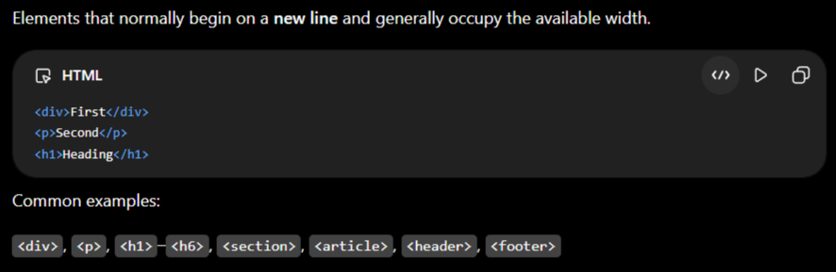
-We can Modify the Height and Width Of the Block Level Element
-This is mainly about an element's default CSS display behavior. CSS can change it.

4.INLINE LEVEL ELEMENTS

-Elements that normally remain within the current line and take only the space they need.
OR
- The Inline Level Element it only aquire the Exact Height & Width of the Content
-We cannot Modify the Inline Level Element
-The Inline Block Level Element we can Modify Easily using display CSS Properties.
-Multiple inline-level elements can appear side by side.

Default CSS Behavior
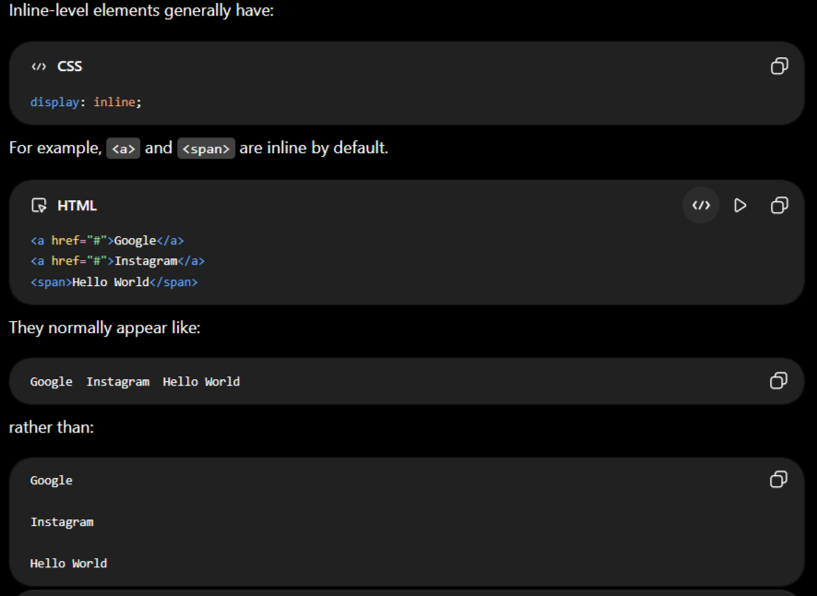

5.INLINE-BLOCK LEVEL ELEMENTS

-The Element which is acquire exact Height and Width of the Content along with we can Modify that it is Called as Inline Block Level Element
-Multiple inline-block elements can appear side by side.

6.SEMANTIC ELEMENTS

-Elements that clearly describe the meaning or purpose of their content is called as Semantic Elements.
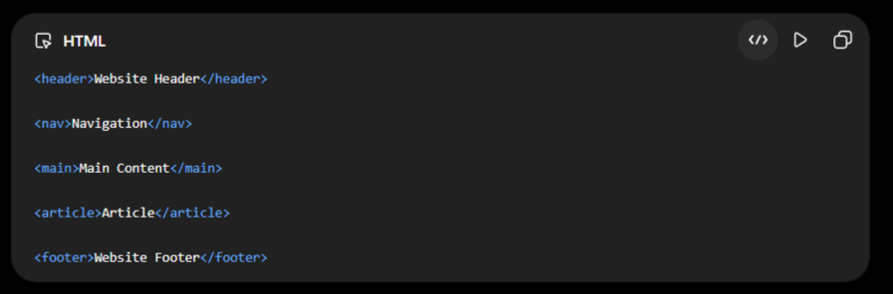
Examples:
<header>, <nav>, <main>, <section>, <article>, <aside>, <footer>
They improve:
- Accessibility
- SEO
- Code readability
- Document structure
7.NON-SEMANTIC ELEMENTS

-Elements that don't describe the specific meaning of their content.
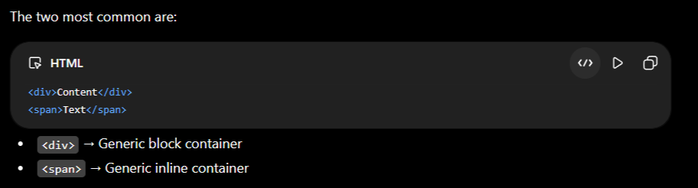

Elements Can Have Attributes
-An HTML element can contain attributes that provide additional information about the element.
Example:
<a href="https://example.com">Visit Website</a>
Here:
- <a> → Opening tag
- href="https://example.com" → Attribute
- Visit Website → Content
- </a> → Closing tag
- <a href="...">Visit Website</a> → Complete element

HTML Elements Can Contain Other Elements
-HTML elements can be nested inside other elements.
Example:
<div>
<h1>Welcome</h1>
<p>Hello World</p>
</div>
Here:
- <div>...</div> → Parent element
- <h1>Welcome</h1> → Child element
- <p>Hello World</p> → Child element

Are HTML Elements Case-sensitive?
-No, HTML elements are not case-sensitive, which means we can write HTML elements either in uppercase or lowercase.
-However, it is not a good practice, as W3C recommends and demands lowercase. Hence, always try to use lowercase for the tag names.
Inline vs Inline-Block vs Block
Feature | Inline | Inline-Block | Block
Same line | ✅ | ✅ | ❌
New line | ❌ | ❌ | ✅
Width | Normally ❌ | ✅ | ✅
Height | Normally ❌ | ✅ | ✅
Padding | ✅ | ✅ | ✅
Margin | Limited | ✅ | ✅
CSS value | inline | inline-block | block

HEADING TAGS
The 6 Heading Levels
- <h1>: Main Heading. Reserved for the primary title of the page.
- <h2>: Section Subheadings. Used to divide the document into major topics.
- <h3>: Subsection Headings. Used for finer details nested under an <h2>.
- <h4>: Minor Subsections. Provides further organizational depth inside an <h3>.
- <h5>: Deep Nesting. Seldom used, but helps categorize content within an <h4>.
- <h6>: Lowest Priority. The smallest subheading available

If the root/default font size is 16px, this approximately becomes:
Heading | Default Size | Approx. Pixel Size
<h1> | 2em | 32px
<h2> | 1.5em | 24px
<h3> | 1.17em | 18.72px
<h4> | 1em | 16px
<h5> | 0.83em | 13.28px
<h6> | 0.67em | 10.72px

1. H1 tag in HTML
h1 {
display: block;
font-size: 2em;
margin-top: 0.67em;
margin-bottom: 0.67em;
margin-left: 0;
margin-right: 0;
font-weight: bold;
}
2. H2 tag in HTML
h2 {
display: block;
font-size: 1.5em;
margin-top: 0.83em;
margin-bottom: 0.83em;
margin-left: 0;
margin-right: 0;
font-weight: bold;
}
3. H3 tag in HTML
h3 {
display: block;
font-size: 1.17em;
margin-top: 1em;
margin-bottom: 1em;
margin-left: 0;
margin-right: 0;
font-weight: bold;
}
4. H4 tag in HTML
h4 {
display: block;
font-size: 1em;
margin-top: 1.33em;
margin-bottom: 1.33em;
margin-left: 0;
margin-right: 0;
font-weight: bold;
}
5. H5 tag in HTML
h5 {
display: block;
font-size: .83em;
margin-top: 1.67em;
margin-bottom: 1.67em;
margin-left: 0;
margin-right: 0;
font-weight: bold;
}
6. H6 tag in HTML
h6 {
display: block;
font-size: .67em;
margin-top: 2.33em;
margin-bottom: 2.33em;
margin-left: 0;
margin-right: 0;
font-weight: bold;
}
-These default CSS attributes can be overwritten using the style attribute. Following is the code representing the six HTML headings:
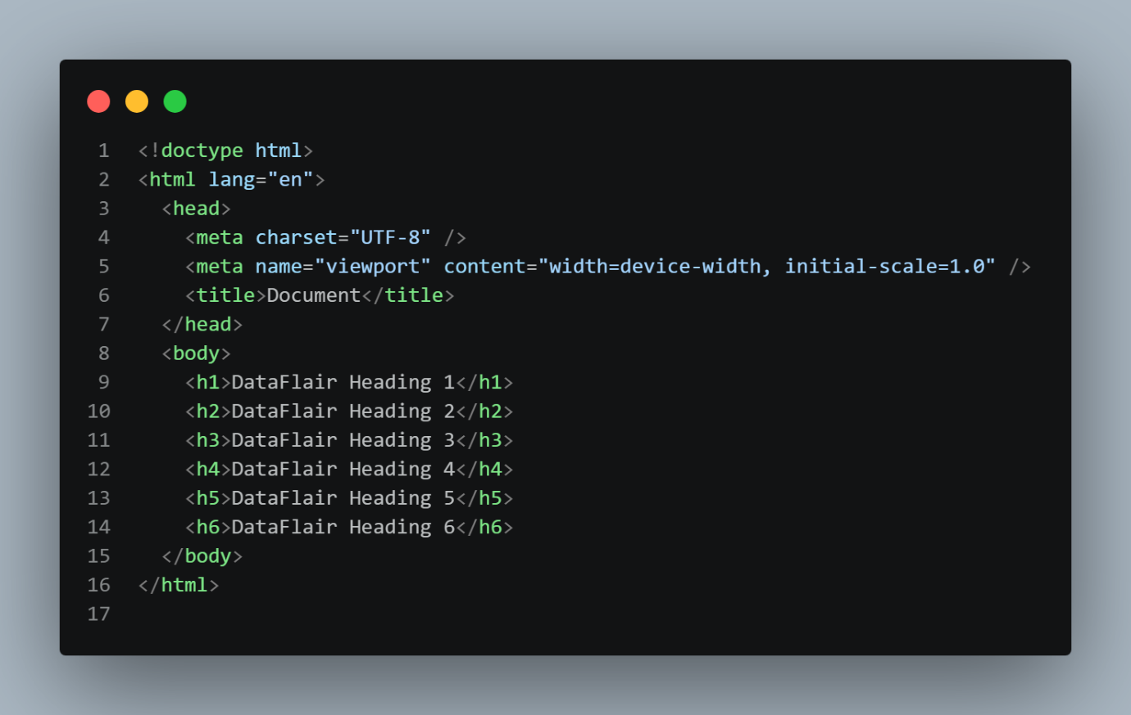
Output
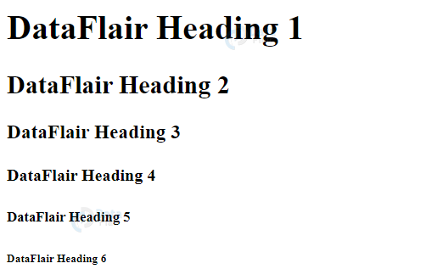

HTML PARAGRAPH TAG
-HTML paragraphs are block-level elements that are used to structure and format text content on a webpage. A paragraph is basically a collection of words and punctuation together.
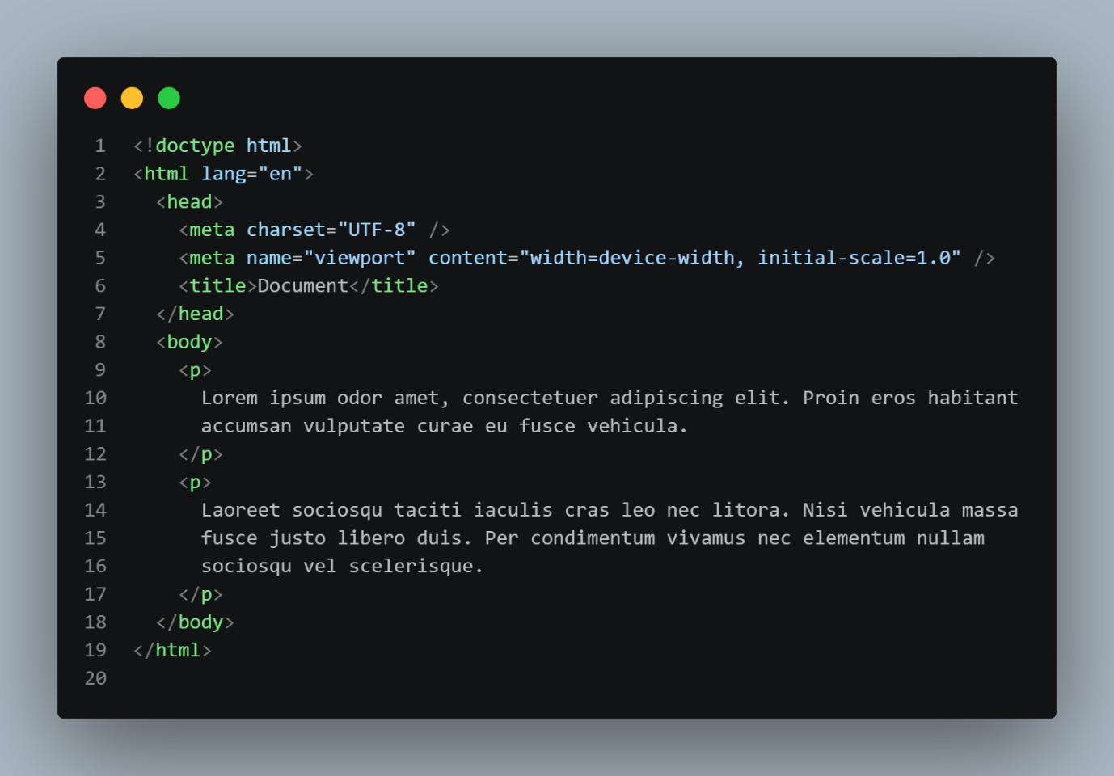
Properties of the paragraph Tag

- <p> stands for Paragraph.
- It is used to define a paragraph of text.
- Syntax:
<p>Paragraph content</p>
- Example:
<p>HTML is used to structure webpages.</p>
- <p> is a semantic HTML element.
- It is a block-level element by default.
- Each <p> normally starts on a new line.
- Browsers usually add margin above and below a paragraph by default.
- The default paragraph font size is generally 16px when the inherited/base font size is 16px.
- The default font weight is generally normal.
- <p> requires both opening and closing tags.
<p>Text</p>
- <p> is not a void element.
- A <p> element cannot contain another <p>.
- Multiple paragraphs can be used:
<p>First paragraph.</p>
<p>Second paragraph.</p>
- Use <br> when you need a line break inside a paragraph.
<p>Hello<br>World</p>

- <p> can contain inline elements such as:
- <strong>
- <em>
- <a>
- <span>
- <code>
- <br>

<br> Tag

-<br> stands for Line Break.
-It is used to break a line within text.
-Syntax:
<br>
Example:
<p>Hello<br>World</p>
Output:
Hello
World
-<br> is a void element.
-It does not have a closing tag.
-This is not required in HTML:
<br />

<hr> Tag
-<hr> stands for Horizontal Rule.
-It represents a thematic break between sections or topics of content.
-Syntax:
<hr>
-It does not have a closing tag.
<hr>
-<hr> does not mean simply "draw a horizontal line." Its semantic meaning is a thematic or section-level break.
-Browsers normally display <hr> as a horizontal line by default.
-The appearance of <hr> can be changed using CSS.

ANCHOR TAG
-The <a> (Anchor) tag is used to create hyperlinks in HTML. It allows users to navigate to webpages, websites, files, email addresses, phone numbers, or specific sections of a webpage.
Syntax
<a href="URL">Link Text</a>
Example
<a href="https://www.google.com">Visit Google</a>
Uses of <a> Tag
- Website Link
<a href="https://example.com">Visit Website</a>
- Page Link
<a href="about.html">About Us</a>
- Email Link using mailto:
<a href="mailto:example@gmail.com">Send Email</a>
- Phone Link using tel:
<a href="tel:+919876543210">Call Us</a>
- Page Section Link using #id
<a href="#about">About</a>
- File Download
<a href="notes.pdf" download>Download Notes</a>
- Open Link in New Tab using target="_blank"
<a href="https://example.com" target="_blank">Open Website</a>

Common <a> Attributes
Attribute | Purpose | Example
href | Specifies the destination of the link | <a href="about.html">About</a>
target | Specifies where to open the linked document | <a target="_blank">
download | Indicates that the linked resource is intended to be downloaded | <a download href="file.pdf">
rel | Specifies the relationship between the current page and linked resource | <a rel="noopener">
hreflang | Specifies the language of the linked document | <a hreflang="en">
type | Specifies the MIME type of the linked resource | <a type="application/pdf">
ping | Specifies URLs to notify when the link is followed | <a ping="/track">
referrerpolicy | Controls what referrer information is sent | <a referrerpolicy="no-referrer">
media | Specifies which media/device the linked resource is intended for | <a media="print">

Important Points
- <a> stands for Anchor.
- It is used to create hyperlinks.
- href is the main attribute used with <a>.
- <a> is not a void element.
- It requires an opening and closing tag.
- Text inside <a> is called link text or anchor text.
- mailto: is used for email links.
- tel: is used for phone links.
- #id is used for same-page navigation.

1. href
-The href attribute specifies the destination of the hyperlink.
<a href="https://example.com">Visit Website</a>
-It can contain:
<!-- External website -->
<a href="https://example.com">Website</a>

<!-- Another page -->
<a href="about.html">About</a>

<!-- Same-page section -->
<a href="#contact">Contact</a>

<!-- Email -->
<a href="mailto:example@gmail.com">Email</a>

<!-- Phone -->
<a href="tel:+919876543210">Call</a>
Most important attribute of <a>.

2. target
-Specifies where the linked document should open.
<a href="https://example.com" target="_blank">
Visit Website
</a>
Common values:
Value | Meaning
_self | Opens in the current browsing context
_blank | Opens in a new browsing context, commonly a new tab
_parent | Opens in the parent browsing context
_top | Opens in the top-level browsing context
Example:
<a href="about.html" target="_self">About</a>
<a href="about.html" target="_blank">About</a>

3. download
-Indicates that the linked resource is intended to be downloaded rather than simply navigated to.
<a href="notes.pdf" download>
Download Notes
</a>
-You can also suggest a filename:
<a href="notes.pdf" download="HTML-Notes.pdf">
Download Notes
</a>
Note: The browser/server may determine whether the download behavior is actually followed.

4. rel
-Defines the relationship between the current document and the linked resource.
<a href="https://example.com"
target="_blank"
rel="noopener noreferrer">
Visit Website
</a>
Common values include:
Value | Purpose
noopener | Prevents the new page from accessing the opener
noreferrer | Prevents sending the referrer
nofollow | Indicates that the link should not be treated as an endorsement for crawling purposes
external | Indicates an external link
sponsored | Identifies sponsored/advertising links
ugc | Identifies user-generated content links
Multiple values can be used:
<a href="https://example.com" rel="noopener noreferrer">
Website
</a>

5. hreflang
-Specifies the language of the linked document.
<a href="about-fr.html" hreflang="fr">
About Us - French
</a>
Example values:
en → English
fr → French
de → German
hi → Hindi
-It is mainly useful when linking to different language versions of content.

6. type
-Specifies the MIME type of the linked resource.
<a href="document.pdf" type="application/pdf">
Download PDF
</a>
-Another example:
<a href="video.mp4" type="video/mp4">
Watch Video
</a>
-The type attribute provides information about the expected resource type; it does not force the server to return that type.

7. ping
-Specifies one or more URLs that the browser can notify when the user follows the link.
<a href="https://example.com"
ping="https://example.com/track">
Visit Website
</a>
-It can be used for link tracking/analytics.
-Multiple URLs can be separated by spaces:
<a href="https://example.com"
ping="https://site1.com/track https://site2.com/track">
Visit
</a>

8. referrerpolicy
-Controls the referrer information sent when following the link.
<a href="https://example.com"
referrerpolicy="no-referrer">
Visit Website
</a>
Common values include:
Value | Purpose
no-referrer | Sends no referrer
origin | Sends only the origin
same-origin | Sends referrer for same-origin requests
strict-origin | Sends origin when appropriate
no-referrer-when-downgrade | Traditional default-style behavior

9. media
-Specifies the media/device type for which the linked resource is intended.
<a href="print-version.html" media="print">
Print Version
</a>
-It can be useful for links to resources intended for particular media conditions.
1. Hypertext

Definition
-Hypertext is text that contains links to other information or resources, allowing users to navigate from one document or location to another.
In simple words:
-Hypertext = Text that can connect to other information.
Example
<p>
Learn <a href="https://example.com">HTML</a>
</p>
Here, HTML is hypertext because it can be clicked to access another resource.

2. Hyperlink

Definition
-A hyperlink is a clickable link that connects one webpage, document, resource, or location to another.
In simple words:
-Hyperlink = A clickable connection to another resource.
Example
<a href="https://www.google.com">Visit Google</a>
Here, Visit Google is the clickable hyperlink.
HTML LIST

HTML Lists
- HTML Lists are used to display a group of related items in an organized and structured way.
- Lists are commonly used for menus, categories, instructions, rankings, features, and other grouped content.
- HTML provides three main types of lists.
Types of HTML Lists
- Ordered List — <ol>
- Unordered List — <ul>
- Description List — <dl>

1. Ordered List — <ol>
- The <ol> tag stands for Ordered List.
- It is used when the order or sequence of items is important.
- By default, items are displayed using numbers.
- Each item inside an ordered list is created using the <li> tag.
- <li> stands for List Item.
Basic Syntax
<ol>
<li>HTML</li>
<li>CSS</li>
<li>JavaScript</li>
</ol>
Output
1. HTML
2. CSS
3. JavaScript
- Ordered lists are useful for steps, rankings, instructions, procedures, recipes, etc.

Ordered List type Attribute
- The type attribute is used to change the numbering or marker style of an ordered list.
- HTML provides five standard values for the type attribute.
1. type="1" — Numbers
- This is the default type of an ordered list.
- Items are displayed using normal numbers.
- The sequence is 1, 2, 3, 4....
<ol type="1">
<li>HTML</li>
<li>CSS</li>
<li>JavaScript</li>
</ol>
Output
1. HTML
2. CSS
3. JavaScript

2. type="A" — Uppercase Alphabet
- Items are displayed using uppercase English letters.
- The sequence is A, B, C, D....
<ol type="A">
<li>HTML</li>
<li>CSS</li>
<li>JavaScript</li>
</ol>
Output
A. HTML
B. CSS
C. JavaScript

3. type="a" — Lowercase Alphabet
- Items are displayed using lowercase English letters.
- The sequence is a, b, c, d....
<ol type="a">
<li>HTML</li>
<li>CSS</li>
<li>JavaScript</li>
</ol>
Output
a. HTML
b. CSS
c. JavaScript

4. type="I" — Uppercase Roman Numerals
- Items are displayed using uppercase Roman numerals.
- The sequence is I, II, III, IV....
<ol type="I">
<li>HTML</li>
<li>CSS</li>
<li>JavaScript</li>
</ol>
Output
I. HTML
II. CSS
III. JavaScript

5. type="i" — Lowercase Roman Numerals
- Items are displayed using lowercase Roman numerals.
- The sequence is i, ii, iii, iv....
<ol type="i">
<li>HTML</li>
<li>CSS</li>
<li>JavaScript</li>
</ol>
Output
i. HTML
ii. CSS
iii. JavaScript

Ordered List start Attribute
- The start attribute is used to specify the starting value of an ordered list.
- By default, an ordered list starts from 1.
- You can change the starting value using start.
<ol start="5">
<li>HTML</li>
<li>CSS</li>
<li>JavaScript</li>
</ol>
Output
5. HTML
6. CSS
7. JavaScript
- start="5" means the first item starts from 5.

Using start with Alphabetical Lists
- The start attribute also works with alphabetic numbering.
<ol type="A" start="3">
<li>HTML</li>
<li>CSS</li>
<li>JavaScript</li>
</ol>
Output
C. HTML
D. CSS
E. JavaScript
- start="3" means the list starts from the third position, which is C for uppercase alphabet numbering.

Using start with Roman Numerals
<ol type="I" start="4">
<li>HTML</li>
<li>CSS</li>
<li>JavaScript</li>
</ol>
Output
IV. HTML
V. CSS
VI. JavaScript

Ordered List reversed Attribute
- The reversed attribute makes an ordered list count backward.
- It is a Boolean attribute.
- It does not require a value.
<ol reversed>
<li>HTML</li>
<li>CSS</li>
<li>JavaScript</li>
</ol>
Output
3. HTML
2. CSS
1. JavaScript

Ordered List start + reversed
- You can combine start and reversed.
<ol start="5" reversed>
<li>HTML</li>
<li>CSS</li>
<li>JavaScript</li>
</ol>
Output
5. HTML
4. CSS
3. JavaScript

<li> value Attribute
- The value attribute is used to specify the number of a particular list item in an ordered list.
- It can change the numbering from that item onward.
<ol>
<li>HTML</li>
<li value="5">CSS</li>
<li>JavaScript</li>
</ol>
Output
1. HTML
5. CSS
6. JavaScript

2. Unordered List — <ul>
- The <ul> tag stands for Unordered List.
- It is used when the order of items is not important.
- Items are normally displayed using bullet markers.
- Each item is created using the <li> tag.
- The appearance of bullets can be changed using CSS.
Basic Syntax
<ul>
<li>HTML</li>
<li>CSS</li>
<li>JavaScript</li>
</ul>
Output
• HTML
• CSS
• JavaScript
- Use <ul> when changing the order of items does not change their meaning.

Unordered List Marker Types
- Unlike <ol>, modern HTML does not use a type attribute to control <ul> bullet styles.
- Bullet styles should be controlled using CSS.
- The CSS property used is list-style-type.
disc
- Displays a filled circular bullet.
- This is the common default marker.
ul {
list-style-type: disc;
}
Output
● HTML
● CSS
● JavaScript

circle
- Displays a hollow circular bullet.
ul {
list-style-type: circle;
}
Output
○ HTML
○ CSS
○ JavaScript

square
- Displays a square bullet.
ul {
list-style-type: square;
}
Output
■ HTML
■ CSS
■ JavaScript

none
- Removes the bullet completely.
- This is commonly used when creating navigation menus.
ul {
list-style-type: none;
}
Output
HTML
CSS
JavaScript

3. Description List — <dl>
- The <dl> tag stands for Description List.
- It is used to display terms and their descriptions.
- A description list does not use normal numbered or bullet markers.
- It contains two important elements:
  - <dt> — Description Term
  - <dd> — Description Details
Basic Syntax
<dl>
<dt>HTML</dt>
<dd>HTML is used to structure web pages.</dd>

<dt>CSS</dt>
<dd>CSS is used to style web pages.</dd>
</dl>

<dt> — Description Term
- <dt> stands for Description Term.
- It represents the term, name, or item being described.
- It is normally placed inside <dl>.
<dl>
<dt>HTML</dt>
</dl>
- Here, HTML is the term.

<dd> — Description Details
- <dd> stands for Description Details.
- It contains the description or explanation of the corresponding <dt>.
- It is normally placed after a <dt>.
<dl>
<dt>HTML</dt>
<dd>HyperText Markup Language</dd>
</dl>
- HTML is the term.
- HyperText Markup Language is its description.

Multiple Terms and Descriptions
<dl>

<dt>HTML</dt>
<dd>Used to structure web pages.</dd>

<dt>CSS</dt>
<dd>Used to style web pages.</dd>

<dt>JavaScript</dt>
<dd>Used to add interactivity.</dd>

</dl>
- A <dl> can contain multiple <dt> and <dd> elements.

Multiple Descriptions for One Term
- One <dt> can have multiple <dd> elements.
<dl>
<dt>Frontend Development</dt>

<dd>HTML</dd>
<dd>CSS</dd>
<dd>JavaScript</dd>
</dl>
- Here, Frontend Development is one term.
- It has three related descriptions/items.

Nested Lists
- A list can contain another list.
- This is called a Nested List.
- Nested lists are useful for representing hierarchical information.
- The nested list should generally be placed inside an <li>.
Example
<ul>

<li>Frontend
<ul>
<li>HTML</li>
<li>CSS</li>
<li>JavaScript</li>
</ul>
</li>

<li>Backend
<ul>
<li>Node.js</li>
<li>Express.js</li>
</ul>
</li>

</ul>

Ordered List Inside Unordered List
<ul>

<li>Frontend
<ol>
<li>Learn HTML</li>
<li>Learn CSS</li>
<li>Learn JavaScript</li>
</ol>
</li>

</ul>
- The outer list is an unordered list.
- The inner list is an ordered list.

Unordered List Inside Ordered List
<ol>

<li>Frontend
<ul>
<li>HTML</li>
<li>CSS</li>
<li>JavaScript</li>
</ul>
</li>

<li>Backend
<ul>
<li>Node.js</li>
<li>Express.js</li>
</ul>
</li>

</ol>

CSS List Properties
- HTML provides the structure of a list.
- CSS is used to control the visual appearance of the list.
list-style-type
- Controls the type of list marker.
ul {
list-style-type: square;
}
list-style-position
- Controls whether the marker is positioned inside or outside the list item's content.
ul {
list-style-position: inside;
}
- outside is the default.
- inside places the marker within the content area.
list-style-image
- Allows an image to be used as the list marker.
ul {
list-style-image: url("arrow.png");
}
list-style
- This is the shorthand property for list styling.
ul {
list-style: square inside;
}

Removing Default List Styling
- Navigation menus commonly remove the default bullets and spacing.
ul {
list-style: none;
margin: 0;
padding: 0;
}
- list-style: none removes the marker.
- margin: 0 removes default margin.
- padding: 0 removes default padding.

HTML Lists — Important Tags
Tag | Purpose
<ol> | Creates an ordered list
<ul> | Creates an unordered list
<li> | Creates a list item
<dl> | Creates a description list
<dt> | Defines a description term
<dd> | Defines the description/details

HTML Lists — Important Attributes
<ol>
- type — Defines numbering style.
- start — Defines starting position.
- reversed — Reverses the numbering.
<li>
- value — Defines the item's ordinal value in an ordered list.

Ordered List type — Quick Revision
Type | Meaning | Example
1 | Numbers | 1, 2, 3
A | Uppercase Alphabet | A, B, C
a | Lowercase Alphabet | a, b, c
I | Uppercase Roman | I, II, III
i | Lowercase Roman | i, ii, iii

When to Use Which List?
Use <ol>
- When the order or sequence is important.
- Example: Steps to install software.
<ol>
<li>Download the software</li>
<li>Install the software</li>
<li>Run the software</li>
</ol>
Use <ul>
- When the order does not matter.
- Example: Programming skills.
<ul>
<li>HTML</li>
<li>CSS</li>
<li>JavaScript</li>
</ul>
Use <dl>
- When you have a term and its explanation.
- Example: Technical definitions.
<dl>
<dt>HTML</dt>
<dd>HyperText Markup Language</dd>
</dl>

Common Mistakes
Do not use <li> without a list container
❌ Incorrect:
<li>HTML</li>
<li>CSS</li>
✅ Correct:
<ul>
<li>HTML</li>
<li>CSS</li>
</ul>
Do not use <br> to create a list
❌ Avoid:
HTML<br>
CSS<br>
JavaScript
✅ Use:
<ul>
<li>HTML</li>
<li>CSS</li>
<li>JavaScript</li>
</ul>
For nested lists, place the nested list inside <li>
✅ Correct:
<ul>
<li>Frontend
<ul>
<li>HTML</li>
<li>CSS</li>
</ul>
</li>
</ul>

Final HTML List Structure
HTML LISTS
│
├── 1. Ordered List <ol>
│ ├── <li>
│ ├── type="1"
│ ├── type="A"
│ ├── type="a"
│ ├── type="I"
│ ├── type="i"
│ ├── start
│ ├── reversed
│ └── <li value="">
│
├── 2. Unordered List <ul>
│ ├── <li>
│ └── CSS list-style-type
│ ├── disc
│ ├── circle
│ ├── square
│ └── none
│
└── 3. Description List <dl>
├── <dt> → Term
└── <dd> → Description
Remember:
<ol> → Order Matters
<ul> → Order Doesn't Matter
<dl> → Term + Description

HTML LIST
HTML MEDIA TAGS
Introduction to HTML Media Tags
- HTML provides several tags to add and display media content such as images, audio, videos, captions, and responsive images on a web page.
- Media tags make it possible to include multimedia content directly in an HTML document.
- The most commonly used HTML media tags are <img>, <audio>, <video>, <source>, <track>, <picture>, <figure>, and <figcaption>.
Main HTML Media Tags
- <img> → Used to display images.
- <audio> → Used to embed and play audio.
- <video> → Used to embed and play videos.
- <source> → Specifies different media sources for audio and video.
- <track> → Adds subtitles, captions, chapters, or other timed text to video.
- <picture> → Provides different images for different screen sizes or image formats.
- <figure> → Groups media or other self-contained content.
- <figcaption> → Provides a caption for content inside <figure>.

1. <img> TAG
Definition
- The <img> tag is used to display an image on a web page.
- It is an empty element, which means it does not have a closing tag.
- The image file is specified using the src attribute.
- The alt attribute provides alternative text for the image.
- Common image formats include JPG, JPEG, PNG, GIF, SVG, and WebP.
Syntax
<img src="image.jpg" alt="Description of image">
Example
<img src="profile.jpg" alt="Profile Photo">
Important <img> Attributes
src Attribute
- Specifies the path or URL of the image.
<img src="logo.png" alt="Website Logo">
alt Attribute
- Specifies alternative text for the image.
- The alternative text is useful when the image cannot be displayed.
- It also improves accessibility for users who use screen readers.
<img src="logo.png" alt="Company Logo">
width Attribute
- Specifies the width of the image.
<img src="logo.png" alt="Logo" width="200">
height Attribute
- Specifies the height of the image.
<img src="logo.png" alt="Logo" height="100">
title Attribute
- Provides additional information about the image.
- Browsers may display the value as a tooltip when the user moves the mouse over the image.
<img src="logo.png" alt="Logo" title="Company Logo">
loading Attribute
- Specifies when the browser should load the image.
<img src="nature.jpg" alt="Nature" loading="lazy">
Common loading Values
- lazy → Loads the image when it is close to entering the viewport.
- eager → Loads the image immediately.
Important Point
- Always use a meaningful alt attribute for informative images.
- For purely decorative images, an empty alt="" can be used.

2. <audio> TAG
Definition
- The <audio> tag is used to embed and play audio content on a web page.
- It provides built-in audio playback support in modern browsers.
- Audio files can be provided directly using the src attribute or through the <source> tag.
- Common audio formats include MP3, WAV, and OGG.
Basic Syntax
<audio controls>
<source src="music.mp3" type="audio/mpeg">
</audio>
Example
<audio controls>
<source src="music.mp3" type="audio/mpeg">
</audio>
controls Attribute
- Displays the audio controls provided by the browser.
- These controls normally include Play, Pause, Volume, and a Progress Bar.
<audio controls>
<source src="music.mp3" type="audio/mpeg">
</audio>
autoplay Attribute
- Attempts to start the audio automatically when the page loads.
- Modern browsers may block autoplay, especially when audio has not been muted.
<audio controls autoplay>
<source src="music.mp3" type="audio/mpeg">
</audio>
loop Attribute
- Causes the audio to automatically start again after it finishes.
<audio controls loop>
<source src="music.mp3" type="audio/mpeg">
</audio>
muted Attribute
- Starts the audio in a muted state.
<audio controls muted>
<source src="music.mp3" type="audio/mpeg">
</audio>
preload Attribute
- Provides a hint to the browser about whether audio data should be loaded before the user starts playback.
<audio controls preload="metadata">
<source src="music.mp3" type="audio/mpeg">
</audio>
Common preload Values
- none → The audio should not be preloaded.
- metadata → Only metadata such as duration may be loaded.
- auto → The browser may preload the audio.
Audio with Multiple Sources
<audio controls>
<source src="music.mp3" type="audio/mpeg">
<source src="music.ogg" type="audio/ogg">
</audio>
- The browser checks the available sources and uses a supported format.

3. <video> TAG
Definition
- The <video> tag is used to embed and play video content on a web page.
- It provides built-in video playback support in modern browsers.
- Video files can be provided using the src attribute or through the <source> tag.
- Common video formats include MP4, WebM, and OGG.
Basic Syntax
<video controls>
<source src="video.mp4" type="video/mp4">
</video>
Example
<video width="600" controls>
<source src="movie.mp4" type="video/mp4">
</video>
controls Attribute
- Displays the browser's video controls.
- These controls normally include Play, Pause, Volume, Progress Bar, Fullscreen, and other playback options.
<video controls>
<source src="movie.mp4" type="video/mp4">
</video>
width Attribute
- Specifies the width of the video.
<video width="600" controls>
<source src="movie.mp4" type="video/mp4">
</video>
height Attribute
- Specifies the height of the video.
<video width="600" height="400" controls>
<source src="movie.mp4" type="video/mp4">
</video>
autoplay Attribute
- Attempts to start the video automatically when the page loads.
- Autoplay policies may prevent videos with sound from playing automatically.
<video controls autoplay muted>
<source src="movie.mp4" type="video/mp4">
</video>
loop Attribute
- Causes the video to replay automatically after it finishes.
<video controls loop>
<source src="movie.mp4" type="video/mp4">
</video>
muted Attribute
- Starts the video without sound.
<video controls muted>
<source src="movie.mp4" type="video/mp4">
</video>
poster Attribute
- Specifies an image displayed before the video starts playing.
- It is commonly used as a video thumbnail.
<video controls poster="thumbnail.jpg">
<source src="movie.mp4" type="video/mp4">
</video>
preload Attribute
- Provides a hint to the browser about how much video data should be loaded before playback.
<video controls preload="metadata">
<source src="movie.mp4" type="video/mp4">
</video>
Common preload Values
- none → The video should not be preloaded.
- metadata → Only metadata such as duration may be loaded.
- auto → The browser may preload the video.
Video with Multiple Sources
<video width="600" controls>
<source src="movie.mp4" type="video/mp4">
<source src="movie.webm" type="video/webm">
</video>
- Multiple sources can be provided so that the browser can choose a compatible format.

4. <source> TAG
Definition
- The <source> tag specifies an alternative media file for <audio> or <video>.
- It is useful when you want to provide multiple media formats.
- It is an empty element, so it does not have a closing tag.
- The browser checks the available sources and selects a format it can play.
Syntax
<source src="file.mp4" type="video/mp4">
Example with Audio
<audio controls>
<source src="music.mp3" type="audio/mpeg">
<source src="music.ogg" type="audio/ogg">
</audio>
Example with Video
<video controls>
<source src="movie.mp4" type="video/mp4">
<source src="movie.webm" type="video/webm">
</video>
Important <source> Attributes
src Attribute
- Specifies the location of the media file.
<source src="movie.mp4">
type Attribute
- Specifies the MIME type of the media.
<source src="movie.mp4" type="video/mp4">
Common Media MIME Types
- audio/mpeg → MP3 audio
- audio/wav → WAV audio
- audio/ogg → OGG audio
- video/mp4 → MP4 video
- video/webm → WebM video
- video/ogg → OGG video

5. <track> TAG
Definition
- The <track> tag is used to add timed text to a <video> element.
- It is commonly used for subtitles and captions.
- It uses WebVTT files, which normally have the .vtt extension.
- It is an empty element, so it does not have a closing tag.
Syntax
<track src="subtitles.vtt" kind="subtitles" srclang="en" label="English">
Example
<video controls>
<source src="movie.mp4" type="video/mp4">

<track
src="subtitles.vtt"
kind="subtitles"
srclang="en"
label="English"
>
</video>
Important <track> Attributes
src Attribute
- Specifies the location of the WebVTT file.
kind Attribute
- Specifies the type of text track.
srclang Attribute
- Specifies the language of the text track.
label Attribute
- Specifies the name of the track displayed to the user.
default Attribute
- Specifies that the track should be selected by default.
Common kind Values
- subtitles → Provides translated dialogue.
- captions → Provides dialogue and relevant sound information.
- descriptions → Provides descriptions of video content.
- chapters → Provides chapter titles.
- metadata → Provides metadata for scripts.

6. <picture> TAG
Definition
- The <picture> tag is used to provide different images based on screen size, resolution, or image format.
- It is mainly used for responsive images and art direction.
- It can contain one or more <source> elements.
- An <img> element is normally included as the fallback image.
Syntax
<picture>
<source media="condition" srcset="image.jpg">
<img src="default.jpg" alt="Description">
</picture>
Example
<picture>
<source media="(max-width: 600px)" srcset="mobile.jpg">
<source media="(max-width: 1200px)" srcset="tablet.jpg">
<img src="desktop.jpg" alt="Responsive Image">
</picture>
Important <picture> Elements
- <picture> → Container for different image sources.
- <source> → Defines an alternative image source.
- media → Specifies the condition under which the source can be selected.
- srcset → Specifies the image source.
- <img> → Provides the fallback image.
Important Point
- The <img> element should be included inside <picture> as the fallback.
- The browser chooses the most appropriate image source based on the available conditions.

7. <figure> TAG
Definition
- The <figure> tag represents self-contained content that is related to the main content.
- It is commonly used for images, diagrams, illustrations, charts, code examples, and other media.
- A <figure> can contain a <figcaption> to provide a caption.
Syntax
<figure>
Content
<figcaption>Caption</figcaption>
</figure>
Example
<figure>
<img src="nature.jpg" alt="Beautiful Nature">
<figcaption>Beautiful Nature</figcaption>
</figure>
Important Point
- <figure> groups the media and its related caption together.
- It improves the semantic structure of the HTML document.

8. <figcaption> TAG
Definition
- The <figcaption> tag defines a caption for the content inside a <figure> element.
- It is commonly used to describe images, diagrams, charts, or other media.
Example
<figure>
<img src="html-logo.png" alt="HTML Logo">
<figcaption>HTML5 Logo</figcaption>
</figure>
Important Point
- <figcaption> should be used inside <figure>.
- It can appear before or after the main content of the <figure>.

COMPLETE MEDIA EXAMPLE
<!DOCTYPE html>
<html lang="en">

<head>
<meta charset="UTF-8">
<meta name="viewport" content="width=device-width, initial-scale=1.0">
<title>HTML Media</title>
</head>

<body>

<h1>HTML Media Elements</h1>

<h2>Image</h2>

<img
src="image.jpg"
alt="Nature Image"
width="400"
>

<h2>Audio</h2>

<audio controls>
<source src="music.mp3" type="audio/mpeg">
<source src="music.ogg" type="audio/ogg">
</audio>

<h2>Video</h2>

<video
width="600"
controls
poster="thumbnail.jpg"
>
<source src="video.mp4" type="video/mp4">
<source src="video.webm" type="video/webm">

<track
src="subtitles.vtt"
kind="subtitles"
srclang="en"
label="English"
>
</video>

<h2>Responsive Image</h2>

<picture>
<source
media="(max-width: 600px)"
srcset="mobile.jpg"
>

<source
media="(max-width: 1200px)"
srcset="tablet.jpg"
>

<img
src="desktop.jpg"
alt="Responsive Image"
>
</picture>

<h2>Figure</h2>

<figure>
<img
src="html-logo.png"
alt="HTML Logo"
width="200"
>

<figcaption>
HTML5 Logo
</figcaption>
</figure>

</body>

</html>

IMPORTANT MEDIA ATTRIBUTES
Image Attributes
- src → Specifies the image location.
- alt → Specifies alternative text.
- width → Specifies image width.
- height → Specifies image height.
- loading → Controls image loading behavior.
- title → Provides additional information.
Audio Attributes
- controls → Displays audio controls.
- autoplay → Attempts automatic playback.
- loop → Repeats the audio.
- muted → Starts audio muted.
- preload → Specifies the preload behavior.
Video Attributes
- controls → Displays video controls.
- autoplay → Attempts automatic playback.
- loop → Repeats the video.
- muted → Starts video muted.
- poster → Specifies the preview image.
- width → Specifies video width.
- height → Specifies video height.
- preload → Specifies the preload behavior.
Source Attributes
- src → Specifies the media file.
- type → Specifies the MIME type.
Track Attributes
- src → Specifies the WebVTT file.
- kind → Specifies the type of track.
- srclang → Specifies the language.
- label → Specifies the track name.
- default → Selects the track by default.

HTML MEDIA TAGS – QUICK REVISION
Tag | Purpose
<img> | Displays an image
<audio> | Embeds audio
<video> | Embeds video
<source> | Provides alternative media sources
<track> | Adds subtitles and captions
<picture> | Provides responsive/alternative images
<figure> | Groups self-contained content
<figcaption> | Adds a caption to a figure
KEY POINTS
- <img> is used to display images.
- <audio> is used to play audio.
- <video> is used to play videos.
- <source> provides alternative media files.
- <track> provides subtitles, captions, and other timed text.
- <picture> is used for responsive images and alternative image sources.
- <figure> groups related self-contained content.
- <figcaption> provides a caption for <figure>.
- <img>, <source>, and <track> are empty elements.
- controls displays the browser's media controls.
- autoplay attempts to start media automatically.
- loop repeats the media.
- muted starts media without sound.
- poster specifies a preview image for a video.
- preload provides a hint about loading media before playback.
- Multiple <source> elements can be used to provide different media formats.
- Always provide meaningful alt text for informative images.
- Modern browsers may restrict autoplay, especially for media with sound.

HTML FORMATING TAGS

HTML FORMATTING TAGS
Introduction to HTML Formatting Tags
- HTML formatting tags are used to change the appearance, meaning, emphasis, or presentation of text on a web page.
- These tags can make text bold, italic, underlined, highlighted, smaller, deleted, inserted, or superscript/subscript.
- Some formatting tags are mainly visual, while others provide semantic meaning to the content.
- Semantic formatting is generally preferred because it gives meaning to the content and can improve accessibility and document structure.
Main HTML Formatting Tags
- <b> → Displays text in bold without adding importance.
- <strong> → Indicates that text has strong importance.
- <i> → Represents text in an alternate voice or mood, commonly displayed in italic.
- <em> → Indicates emphasized text.
- <u> → Represents text with a non-textual annotation, commonly displayed with an underline.
- <mark> → Highlights text.
- <small> → Represents smaller or side/commentary text.
- <del> → Represents deleted or removed text.
- <ins> → Represents inserted or added text.
- <s> → Represents text that is no longer accurate or relevant.
- <sub> → Displays subscript text.
- <sup> → Displays superscript text.
- <br> → Creates a line break.
- <hr> → Represents a thematic break between sections or content.

1. <b> TAG
Definition
- The <b> tag is used to draw attention to text without giving the text any special importance or emphasis.
- By default, browsers display <b> text in bold.
- It is mainly a presentational/attention-drawing element.
- If the text has semantic importance, <strong> is generally more appropriate.
Syntax
<b>Bold Text</b>
Example
<p>This is <b>important information</b>.</p>
Output
This is important information.
Important Point
- <b> makes text visually bold.
- <b> does not mean that the text is semantically important.
- Use <strong> when the text has strong importance.

2. <strong> TAG
Definition
- The <strong> tag indicates that the content has strong importance, seriousness, or urgency.
- Browsers normally display <strong> text in bold.
- It is a semantic HTML element.
Syntax
<strong>Important Text</strong>
Example
<p><strong>Warning:</strong> Save your work before closing the application.</p>
Output
Warning: Save your work before closing the application.
Important Point
- <strong> provides meaning as well as the default bold appearance.
- Screen readers may give emphasis to strongly important content.
- Use <strong> instead of <b> when the text is genuinely important.

3. <i> TAG
Definition
- The <i> tag represents text in an alternate voice or mood.
- It is commonly displayed in italic by browsers.
- It can be used for terms, foreign words, technical terms, thoughts, or other text that is conventionally italicized.
Syntax
<i>Italic Text</i>
Example
<p>The word <i>HTML</i> is commonly used in web development.</p>
Important Point
- <i> does not simply mean "make text italic."
- It represents text that is set apart from the surrounding content.
- If the text needs emphasis, use <em> instead.

4. <em> TAG
Definition
- The <em> tag represents emphasized text.
- Browsers normally display emphasized text in italic.
- It is a semantic HTML element.
- The emphasis can change the meaning or stress of a sentence.
Syntax
<em>Emphasized Text</em>
Example
<p>You <em>must</em> complete the assignment.</p>
Important Point
- <em> gives semantic emphasis to text.
- <em> is generally preferred over <i> when the purpose is emphasis.
- <em> can be nested to represent stronger levels of emphasis.

5. <u> TAG
Definition
- The <u> tag represents text with a non-textual annotation.
- Browsers normally display the text with an underline.
- It should not be used simply to underline text for decoration.
- CSS is generally better when you only want visual underlining.
Syntax
<u>Underlined Text</u>
Example
<p>This is <u>underlined text</u>.</p>
Important Point
- <u> has semantic meaning related to an annotation.
- For purely decorative underlining, CSS can be used instead.

6. <mark> TAG
Definition
- The <mark> tag represents text that is highlighted or marked because it is relevant in the current context.
- Browsers normally display <mark> with a highlighted background.
Syntax
<mark>Highlighted Text</mark>
Example
<p>HTML is a <mark>markup language</mark>.</p>
Output
HTML is a highlighted markup language.
Important Point
- <mark> is useful for highlighting search results or important portions of text.
- It provides semantic meaning rather than only applying a background color.

7. <small> TAG
Definition
- The <small> tag represents smaller side comments, fine print, or other text that is less prominent.
- Browsers normally display it in a smaller font size.
Syntax
<small>Small Text</small>
Example
<p>Copyright © 2026 <small>All rights reserved.</small></p>
Important Point
- <small> has semantic meaning.
- It should not be used simply as a replacement for CSS font-size styling.

8. <del> TAG
Definition
- The <del> tag represents text that has been deleted or removed from a document.
- Browsers normally display deleted text with a strikethrough.
Syntax
<del>Deleted Text</del>
Example
<p>Old Price: <del>₹999</del></p>
Important Point
- <del> indicates that the text has been removed from the document.
- It is useful when showing changes, revisions, or old prices.

9. <ins> TAG
Definition
- The <ins> tag represents text that has been inserted or added to a document.
- Browsers normally display inserted text with an underline.
Syntax
<ins>Inserted Text</ins>
Example
<p>New Price: <ins>₹799</ins></p>
Important Point
- <ins> indicates that content has been added.
- It is often used together with <del> to show changes.
Example with <del> and <ins>
<p>
Price:
<del>₹999</del>
<ins>₹799</ins>
</p>

10. <s> TAG
Definition
- The <s> tag represents text that is no longer accurate, relevant, or applicable.
- Browsers normally display it with a strikethrough.
- It should not be used to indicate that content was deleted from a document.
Syntax
<s>Old Information</s>
Example
<p><s>Available Seats: 50</s></p>
<p>Available Seats: 0</p>
Important Point
- <s> means the information is no longer accurate or relevant.
- <del> means the content was deleted from the document.

11. <sub> TAG
Definition
- The <sub> tag is used to display subscript text.
- Subscript text appears below the normal text baseline.
- It is commonly used in mathematical formulas and chemical formulas.
Syntax
<sub>Subscript Text</sub>
Example
<p>Water formula: H<sub>2</sub>O</p>
Output
H₂O
More Examples
<p>CO<sub>2</sub></p>
<p>H<sub>2</sub>SO<sub>4</sub></p>

12. <sup> TAG
Definition
- The <sup> tag is used to display superscript text.
- Superscript text appears above the normal text baseline.
- It is commonly used for mathematical expressions, powers, and references.
Syntax
<sup>Superscript Text</sup>
Example
<p>2<sup>2</sup> = 4</p>
Output
2² = 4
More Examples
<p>x<sup>2</sup> + y<sup>2</sup></p>
<p>10<sup>th</sup></p>

13. <br> TAG
Definition
- The <br> tag creates a line break in the text.
- The content after <br> starts on a new line.
- It is an empty element, so it does not have a closing tag.
Syntax
<br>
Example
<p>
Hello<br>
Welcome to HTML
</p>
Output
Hello
Welcome to HTML
Important Point
- <br> should be used when a line break is actually part of the content.
- It should not be used repeatedly to create spacing between elements.
- CSS should be used for layout and spacing.

14. <hr> TAG
Definition
- The <hr> tag represents a thematic break between sections or topics.
- Browsers normally display it as a horizontal line.
- It is an empty element.
Syntax
<hr>
Example
<h2>HTML</h2>

<p>HTML is used to structure web pages.</p>

<hr>

<h2>CSS</h2>

<p>CSS is used to style web pages.</p>
Important Point
- <hr> represents a change or break in the topic.
- It should not be used only to create a decorative horizontal line.
- CSS can be used to customize its appearance.

BOLD TAGS: <b> vs <strong>
<b> | <strong>
Makes text visually bold | Indicates strong importance
Mainly draws attention | Provides semantic meaning
No inherent importance | Has semantic importance
Presentational/attention purpose | Semantic purpose
Example
<p>This is <b>bold text</b>.</p>

<p>This is <strong>important text</strong>.</p>

ITALIC TAGS: <i> vs <em>
<i> | <em>
Represents alternate voice or mood | Represents emphasis
Usually displayed in italic | Usually displayed in italic
Does not necessarily indicate emphasis | Provides semantic emphasis
Used for terms, foreign words, etc. | Used when emphasis is intended
Example
<p>This is <i>italic-style text</i>.</p>

<p>You <em>must</em> read this chapter.</p>

<del> vs <s>
<del> | <s>
Represents deleted content | Represents inaccurate or outdated content
Indicates removal from a document | Indicates content is no longer relevant
Useful for document revisions | Useful for outdated information or offers
Example
<p><del>Old paragraph removed</del></p>

<p><s>Sale ends tomorrow</s></p>

<sub> vs <sup>
<sub> | <sup>
Displays text below the baseline | Displays text above the baseline
Used for chemical formulas | Used for powers and mathematical expressions
Example: H₂O | Example: X²
Example
<p>H<sub>2</sub>O</p>

<p>x<sup>2</sup></p>

SEMANTIC vs PRESENTATIONAL FORMATTING
Semantic Formatting
- Semantic tags provide meaning to the content.
- They help browsers, search engines, and assistive technologies understand the purpose of the text.
- Examples include:
  - <strong>
  - <em>
  - <mark>
  - <del>
  - <ins>
  - <s>
Presentational Formatting
- Presentational formatting mainly focuses on how content visually appears.
- CSS is generally preferred for controlling visual appearance.
- Examples include using CSS to:
  - Make text bold
  - Make text italic
  - Change text color
  - Add underline
  - Change font size

COMBINING FORMATTING TAGS
- Multiple formatting tags can be used together when their meanings are appropriate.
Example
<p>
This is
<strong>
<em>very important</em>
</strong>
information.
</p>
- <strong> indicates strong importance.
- <em> indicates emphasis.

COMPLETE FORMATTING TAG EXAMPLE
<!DOCTYPE html>
<html lang="en">

<head>
<meta charset="UTF-8">
<title>HTML Formatting Tags</title>
</head>

<body>

<h1>HTML Formatting Tags</h1>

<p>This is <b>bold text</b>.</p>

<p>This is <strong>important text</strong>.</p>

<p>This is <i>italic text</i>.</p>

<p>This is <em>emphasized text</em>.</p>

<p>This is <u>underlined text</u>.</p>

<p>This is <mark>highlighted text</mark>.</p>

<p>This is <small>small text</small>.</p>

<p>This is <del>deleted text</del>.</p>

<p>This is <ins>inserted text</ins>.</p>

<p><s>Old information</s></p>

<p>Water: H<sub>2</sub>O</p>

<p>Square: x<sup>2</sup></p>

<p>
Hello<br>
Welcome to HTML
</p>

<hr>

<p>New Section</p>

</body>

</html>

HTML FORMATTING TAGS – QUICK REVISION
Tag | Purpose
<b> | Draws attention to text, usually bold
<strong> | Indicates strong importance
<i> | Represents alternate voice/mood, usually italic
<em> | Indicates emphasis
<u> | Represents a non-textual annotation, usually underlined
<mark> | Highlights relevant text
<small> | Represents smaller side/fine-print text
<del> | Represents deleted content
<ins> | Represents inserted content
<s> | Represents inaccurate/outdated content
<sub> | Displays subscript
<sup> | Displays superscript
<br> | Creates a line break
<hr> | Represents a thematic break
KEY POINTS TO REMEMBER
- <b> → Bold/attention, without semantic importance.
- <strong> → Strong importance.
- <i> → Alternate voice or mood, commonly italic.
- <em> → Emphasis.
- <u> → Non-textual annotation, commonly underlined.
- <mark> → Highlighted text.
- <small> → Smaller side or fine-print text.
- <del> → Deleted content.
- <ins> → Inserted content.
- <s> → No longer accurate or relevant content.
- <sub> → Subscript.
- <sup> → Superscript.
- <br> → Line break.
- <hr> → Thematic break.
- Use semantic tags when you want to communicate the meaning of content.
- Use CSS when you only need to control the visual appearance of text.
- <br> and <hr> are empty elements and do not require closing tags.
HTML QUOATATION TAGS

