HTML

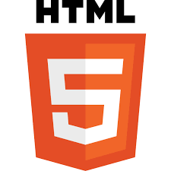
-HTML was created by Sir Tim Berners-Lee in late 1991 but was not officially released. It was published in 1995 as HTML 2.0. HTML 4.01 was published in late 1999 and was a major version of HTML.
In 1980, physicist Tim Berners-Lee, a contractor at CERN, proposed and prototyped ENQUIRE, a system for CERN researchers to use and share documents. In 1989, Berners-Lee wrote a memo proposing an Internet-based hypertext system.^{[3]} Berners-Lee specified HTML and wrote the browser and server software in late 1990. That year, Berners-Lee and CERN data systems engineer Robert Cailliau collaborated on a joint request for funding, but the project was not formally adopted by CERN. In his personal notes of 1990, Berners-Lee listed "some of the many areas in which hypertext is used"; an encyclopedia is the first entry.^{[4]}
The first publicly available description of HTML was a document called "HTML Tags",^{[5]} first mentioned on the Internet by Tim Berners-Lee in late 1991.

HTML

Official logo of HTML5^{[1]}
Filename extension | - .html  - .htm
Internet media type | text/html
Type code | TEXT
Uniform Type Identifier (UTI) | public.html
Developed by | - WHATWG  - World Wide Web Consortium (W3C; formerly)
Initial release | 1993; 31 years ago
Latest release | Living Standard
Type of format | Document file format
Container for | HTML elements
Contained by | Web browser
Extended from | SGML
Extended to | XHTML
Open format? | Yes
Website | html.spec.whatwg.org
ABOUT
HyperText Markup Language (HTML) was initially developed by Sir Tim Berners-Lee in late 1991. It was designed as a standard language for creating and formatting documents on the World Wide Web. All the web pages on the internet are made from HTML.
From 1990 to 1995, HTML underwent changes and extensions, initially at CERN and then at the IETF. The World Wide Web Consortium (W3C) became the new home for HTML development.
HyperText
We must first examine the idea of hypertext in order to comprehend the origins of HTML. Early 20th-century pioneers like Vannevar Bush proposed the concept of tying information together through hypertext, envisioning a "memex" machine that could organize enormous volumes of information using linked microfilm.
However, Ted Nelson, an American philosopher and sociologist, first used the word "hypertext" in the 1960s. Nelson's idea of hypertext was to develop a network of connected text and multimedia that permitted non-linear information navigation.

HISTORY
-The history of HTML, or Hypertext Markup Language, includes the following milestones:
- 1980: Tim Berners-Lee, a physicist at CERN, proposed a system for CERN researchers to share documents.
- 1989: Berners-Lee wrote a memo proposing an Internet-based hypertext system.
- 1991: Berners-Lee invented HTML 1.0 and first publicly described it in a document called "HTML Tags".
- 1993: The first version of HTML was released.
- 1995: HTML 2.0 was published, which included new features in addition to those of HTML 1.0.
- 1997: HTML 3.0 was invented, which improved existing features and gave webmasters more tools for designing websites.
- 1999: HTML 4.0 was released and became widely used.
- 2000: XHTML, an XML version of HTML, became an official standard.
- 2014: HTML 5.0 was released and used worldwide.
HTML was originally developed to help CERN researchers organize scientific information. However, it quickly became clear that HTML could be used to change how information is presented online.

History and Evolution
Here you will see the evolution of HTML over the past couple of decades. The major upgrade was done in HTML5 in 2012.
Year | Progress
1991 | Tim Berners-Lee created HyperText Markup Language but it was not officially released.
1993 | Tim Berners-Lee created the first version of HTML that was published and available to the public.
1995 | HTML 2.0 was released with a few additional features along with the existing features.
1997 | There was an attempt to extend HTML with HTML 3.0, but it was replaced by the more practical HTML 3.2.
1998 | The W3C (World Wide Web Consortium) decided to shift focus to an XML-based HTML equivalent called XHTML.
1999 | HTML 4.01, which became an official standard in December 1999, was the most widely used version in the early 2000s.
2000 | XHTML 1.0, completed in 2000, was a combination of HTML4 in XML.
2003 | The introduction of XForms reignited interest in evolving HTML itself rather than replacing it with new technologies. This new theory recognized that XML was better suited for new technologies like RSS and Atom, while HTML remained the cornerstone of the web.
2004 | A W3C workshop took place to explore reopening HTML's evolution. Mozilla and Opera jointly presented the principles that later influenced HTML5.
2006 | The W3C expressed interest in HTML5 development and formed a working group to collaborate with the WHATWG. The W3C aimed to publish a "finished" HTML5 version, whereas the WHATWG focused on a Living Standard, continuously evolving HTML.
2012 | HTML5 can be seen as an extended version of HTML 4.01, which was officially published in 2012.
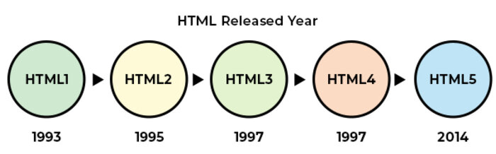
Evolution of HTML Features: From HTML 1.2 to HTML 5
With the introduction of new versions of HTML, support for additional features was added, and the user experience was enhanced. The following table shows the features introduced in later versions of HTML:
Type of Content | HTML 1.2 | HTML 4.01 | HTML 5 | Description
Image | Yes | Yes | Yes | The img tag allows to add images to HTML document
Paragraph | Yes | Yes | Yes | Paragraph element in HTML is used to represent a paragraph of text on a webpage.
Heading | Yes | Yes | Yes | Heading are used in HTML to define variable length headings. (h1 to h6)
Address | Yes | Yes | Yes | Address element in HTML is used to contain contact information of user.
Anchor | Yes | Yes | Yes | Anchor tag is used to define hyperlink in webpage.
List | Yes | Yes | Yes | List is used in HTML to display list of related items.
Table | No | Yes | Yes | Table is used to organize data into rows and columns
Style | No | Yes | Yes | Style is used to add CSS styling to webpage
Script | No | Yes | Yes | Script is used to add JavaScript to HTML.
Audio | No | No | Yes | Enables introduction of audio to webpage
Video | No | No | Yes | Enables introduction of video to webpage.
Canvas | No | No | Yes | Enables introduction of graphics elements to webpage.

HTML editors are used to create, edit, and manage HTML code. In this tutorial, you will learn about the popular HTML editors that can be used to manage your HTML documents. Here, we are explaning the steps to create and run HTML code in the specific editors.
What are HTML Editors?
HTML editors are tools/software to create, edit, manage, and run (in some cases) HTML documents. HTML editors provide many features, such as auto-indenting, syntax highlighting, autocompletion, etc.
You can use any of the HTML editors mentioned below to write and manage your HTML codes. You need to save the file with an extension .htm or .html.

Popular HTML Editors
-There are several HTML editors available to the user (paid and unpaid, both). The following is the list of some popular editors:
- Notepad
- TextEdit
- Notepad++
- Sublime
- Visual Studio Code
- Atom
- Brackets
- Adobe Dreamweaver CC
- CoffeeCup

1. Notepad
Notepad is a basic free text editor which is preinstalled in Windows systems. Notepad can be used as an HTML Editor.
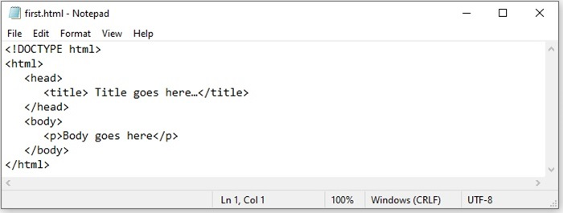
Steps to Create and Run HTML Code in Notepad
The following are the steps to create and run an HTML document in Notepad:
- Open notepad application.
- Write your HTML code.
- Save the file with an extension ".htm" or ".html" and set the encoding to UTF-8.
- Now, you can open this HTML document in any web browser.
2. TextEdit
TextEdit is a default text editor and an open-source word processor that comes with MacOS. You can use TextEdit as an HTML editor to create, edit, and manage your HTML code. You can also use it to display HTML documents like you see them in a browser or in code-editing mode.
The only limitation in TextEdit is that it doesn't display images when you use it to browse webpages.
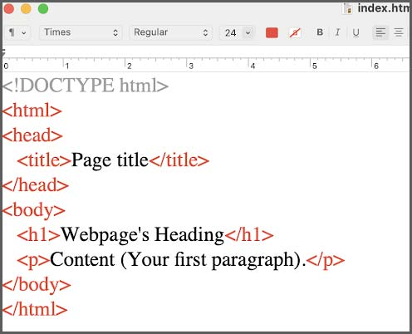
Steps to Create and Run HTML Code in TextEdit
The following are the steps to create and run an HTML document in TextEdit:
- Open TextEdit
- Create a new file
- Go to the "format" then Make Plain Text
- Write your HTML code
- Save the with an extension ".htm" or ".html"
3. Notepad++
Notepad++ is a free source code editor. It is written in C++ and supports features like, syntax highlighting, limited auto completion for programming, scripting, etc. Notepad++ is one of the best HTML code editors where you can create and manage HTML documents.
Notepad++ does not come with preinstallation, you need to download it manually from the different devices from its official website: notepad-plus-plus.org
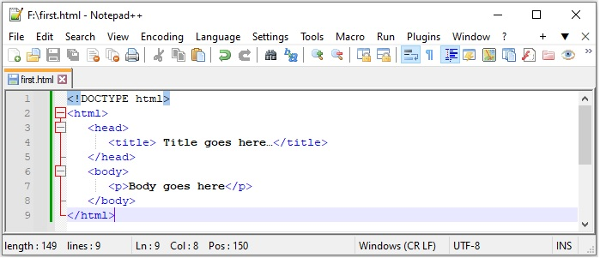
Steps to Create and Run HTML Code in Notepad++
To create an HTML document in Notepad++:
- Open Notepad++
- Open a new file, write your HTML code, and save the file as ".html"or ".htm"
- Click on the file and select the browser in which you want to view the results.
4. Sublime Editor
Subline editor is a cross-platform source code editor. It is used to write Codes, markup, and prose. It is written in C++ and Python.
Sublime editor provides features like quick navigation to files, symbols, or lines. It allows you to simultaneously edit multiple selected area.
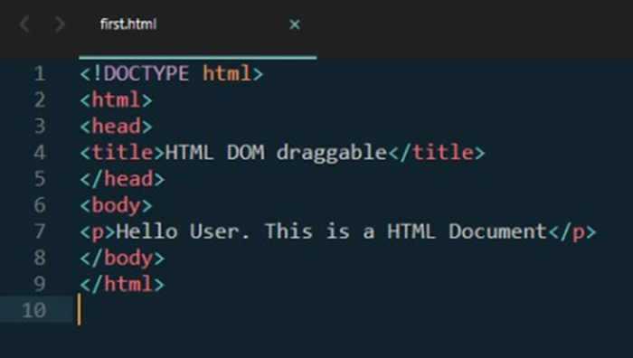
Sublime editor can be downloaded from this link: Sublime Text
5. Visual Studio Code
Visual Studio Code (VS Code) is also a source-code editor developed by Microsoft. It supports Windows, Linux, and macOS. VS code is widely used for creating and managing HTML documents due to its amazing features like debugging support, syntax highlighting, code refactoring, intelligent code completion, etc.
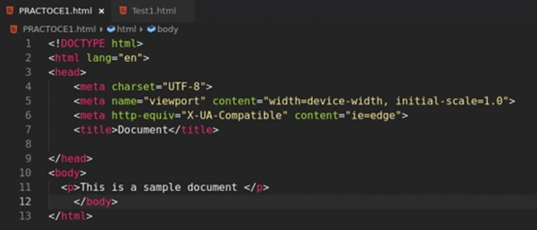
VS Code is not preinstalled software; you need to download it from code.visualstudio.com/download
6. Atom Editor
Atom is an open-source text and source code editor for MacOS. Atom can also be used in Windows systems after downloading and installing. Atom is also a free editor and can be used as an HTML editor where you can create and manage HTML documents. It provides various features such as syntax highlighting, code completion, find and replace, auto detect indentation, and different themes.
The steps to write and run HTML in the Atom editor are:
Steps to Create and Run HTML Code in Atom
- Create/open a file
- Write or paste HTML code.
- Save file with ".htm" or ".html" extension.
- And, press "CTRL + Shift + B" (in Windows) to run and see the preview.
7. Brackets Editor
Brackets is a source code editor that can be used for creating and managing HTML documents. Brackets is created by Adobe, and it is useful for web development. Brackets features include auto saving, code beautification, live preview, and many more.
Steps to Create and Run HTML Code in Brackets
The steps to create an HTML document in brackets editors are:
- Download & Install Bracket Editor
- Create a new file.
- Write HTML code and save the files with the extension ".htm" or ".html".
8. Adobe Dreamweaver CC
Adobe Dreamweaver CC is a premium IDE application for web development and source code editing, like HTML editors. It offers toolkits for designing and creating websites that combine a visual design interface with a code editor.
It supports many programming languages like Python and HTML, enabling efficient coding for both beginners and advanced users, and also provides Git support. It is a subscription-based model as it ensures access to regular updates and customer support for assistance.
9. CoffeeCup
CoffeeCup is a paid HTML editor software known for its user-friendly interface and powerful features. It offers a range of tools for web development, including code editing, site management, and responsive design support.
With CoffeeCup, users can create and edit HTML, CSS, and JavaScript code efficiently. It provides live previews, code validation, and an integrated FTP client for seamless website management.
Advantages of Using HTML Editors
There are several advantages to using HTML editors to write and manage your HTML codes. Some of the main advantages are as follows:
- Error Reduction: HTML editors are useful to identify and correct the syntax errors during writing the HTML codes.
- Syntax Highlighting: Most of the HTML editors come with the syntax highlighting features that enable color-coding to distinguish HTML tags, attributes, and content that makes the code clear and readable.
- Code Autocompletion: Most of the HTML editors autocomplete the tags or attributes while writing the code. For example, if you start writing a paragraph and type <p>, editors will automatically insert a closing tag </p>. The editors also suggest the syntax of the elements.
- Code Validation: Most of the HTML editors have code validating features; you don't need any other tool to validate your code. This feature helps to validate the errors.
- Collaboration Tools: Some of the HTML editors come with version control systems that make it easier for teams to collaborate and track changes.
THE FIRST WEBBROWSER

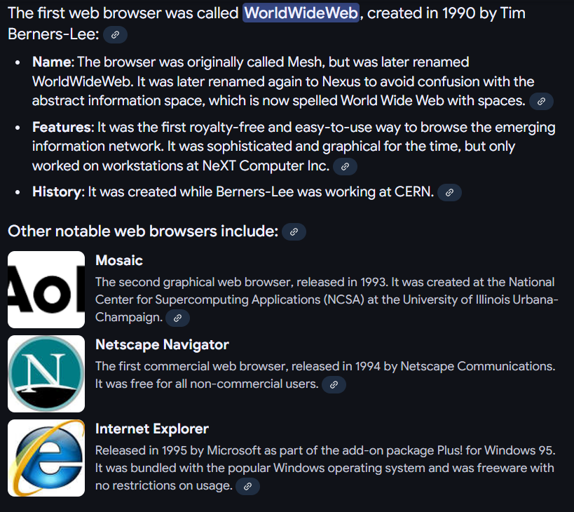
Year | Web browsers
1990 | WorldWideWeb (Nexus)
1991 | Line Mode Browser
1992 | Erwise, MacWWW (Samba), MidasWWW, ViolaWWW
1993 | AMosaic 1.0, Arena, Cello,^{[46]} Lynx 2.0, Mosaic
1994 | Agora (Argo), IBM WebExplorer, IBrowse, MacWeb, Minuet, Netscape Navigator, SlipKnot 1.0
1995 | Grail, Internet Explorer 1, Internet Explorer 2, Netscape Navigator 2.0, OmniWeb, UdiWWW,^{[47]}
1996 | Amaya 0.9,^{[48]} Arachne 1.0, AWeb, Cyberdog, Internet Explorer 3.0, Netscape Navigator 3.0, Opera 2.0, PowerBrowser 1.5,^{[49]} Voyager
1997 | Amaya 1.0, ^{[48]} Internet Explorer 4.0, Netscape Navigator 4.0, Netscape Communicator 4.0, Opera 3.0^{[50]}
1998 | iCab, Mozilla
1999 | Amaya 2.0,^{[48]} Mozilla M3, Internet Explorer 5.0
2000 | Amaya 3.0^{[48]}, Amaya 4.0,^{[48]} K-Meleon 0.2, Konqueror, Netscape 6, Opera 4,^{[51]} Opera 5,^{[52]}
2001 | Amaya 5.0,^{[48]} Internet Explorer 6, Galeon 1.0, Opera 6,^{[53]}
2002 | Amaya 6.0,^{[48]} Amaya 7.0,^{[48]}Phoenix 0.1, Netscape 7, Mozilla 1.0, Links 2.0
2003 | Amaya 8.0,^{[48]} Epiphany 1.0, Opera 7,^{[54]} Apple Safari 1.0,
2004 | Firefox 1.0, Netscape Browser, OmniWeb 5.0
2005 | Amaya 9.0,^{[48]} AOL Explorer 1.0, Epiphany 1.8, Maxthon 1.0, Netscape Browser 8.0, Opera 8,^{[55]} Apple Safari 2.0, Shiira 1.0
2006 | Camino 1.0, Galeon 2.0, iCab 3, K-Meleon 1.0, Mozilla Firefox 2.0, Internet Explorer 7, Opera 9,^{[56]}, SeaMonkey 1.0
2007 | Conkeror, Flock 1.0, Apple Safari 3.0, Netscape Navigator 9, NetSurf 1.0
2008 | Google Chrome 1, Maxthon 2.0, Mozilla Firefox 3, Opera 9.5,^{[57]}, Apple Safari 3.1, Konqueror 4, Amaya 10.0^{[48]}, Flock 2, Amaya 11.0^{[48]}
2009 | Google Chrome 2–3, Mozilla Firefox 3.5, Internet Explorer 8, Opera 10,^{[58]}, Apple Safari 4, SeaMonkey 2, Camino 2, surf, Pale Moon 3.0^{[59]}
2010 | Google Chrome 4–8, Mozilla Firefox 3.6, Opera 10.50,^{[60]}, Opera 11, Apple Safari 5, K-Meleon 1.5.4, xxxterm
2011 | Google Chrome 9–16, Mozilla Firefox 4–9, Internet Explorer 9, Opera 11.50, Apple Safari 5.1, Maxthon 3.0, SeaMonkey 2.1–2.6
2012 | Google Chrome 17–23, Mozilla Firefox 10–17, Internet Explorer 10, Opera 12, Apple Safari 6, Maxthon 4.0, SeaMonkey 2.7–2.14
2013 | Google Chrome 24–31, Mozilla Firefox 18–26, Internet Explorer 11, Opera 15–18, Pale Moon 15.4–24.2.2^{[61]}, Apple Safari 7, SeaMonkey 2.15–2.23
2014 | Google Chrome 32–39, Mozilla Firefox 27–34, Opera 19–26, Pale Moon 24.3.0–25.1.0^{[61]}, Apple Safari 8, SeaMonkey 2.24–2.30
2015 | Google Chrome 40–47, Microsoft Edge, Mozilla Firefox 35–43, Opera 27–34, Pale Moon 25.2.0–25.8.1^{[61]}, Vivaldi
2016 | Google Chrome 48–55, Mozilla Firefox 44–50, Microsoft Edge 14, Opera 35–42, Pale Moon 26.0.0–27.0.3, Apple Safari 9–10, SeaMonkey 2.24–2.30
2017 | Google Chrome 56–60, Microsoft Edge 15, Mozilla Firefox 51–55.0.2, Opera 43–45, Opera Neon, Pale Moon 27.1.0–27.6.2, Safari 10–11
2018 | Chrome 64–71, Firefox 58–64, Microsoft Edge 42–44, Opera 50–57, Pale Moon 27.7.0–28.2.2, Safari 11–12, Vivaldi 1.14–2.2
2019 | Chrome 72–79, Firefox 65–71, Microsoft Edge, Opera 58–65, Pale Moon 28.3.0–28.8.0, Safari 12–13, SeaMonkey, Vivaldi 2.2–2.10, Yandex.browser
2020 | Chrome 80–87, Firefox 72–84, Microsoft Edge, Opera 66–73, Pale Moon 28.8.1–28.17.0, Safari 13–14, SeaMonkey, Vivaldi 2.10–3.5, Yandex.browser
2021 | Chrome 88–96, Firefox 85–95, Microsoft Edge 88–96, Opera 74–82, Pale Moon 29.0.0–29.4.3, Safari 15, Vivaldi 3.6–5.0
2022 | Chrome 97–107, Firefox 96–107, Microsoft Edge 97–107, Opera 83–93, Pale Moon 29.4.4-31.4.2, Safari 15.4–16.2, Vivaldi 5.1–5.6
2023 | Chrome 108–120.0.6099.129, Firefox 108–121.0, Microsoft Edge 108–120.0.2210.61, Opera 94–106.0.4998.19, Pale Moon 31.4.3-32.5.2, Safari 16.3–17.2, Vivaldi 5.7–6.5, Arc 1.10-1.21.0
2024 | Chrome 120–Current, Firefox 122–Current, Microsoft Edge 121–Current, Opera 106-Current, Pale Moon 33-Current, Safari 17.3–Current, Vivaldi 6.6-Current, Arc 1.21.1-Current, Ecosia Browser 1.0.0.31–Current

SERVER
-A server is a computer, device, or program that provides data, services, or resources to other computers (called clients) over a network
-Computer Servers
- Web Server: Stores and sends web pages to your browser.
- File Server: Holds shared files for a network.
- Mail Server: Manages and delivers email.
- Client-Server Model: Clients make requests, and the server replies with the needed info

-Can Be Hardware or Software:
1.Hardware Server: A powerful physical machine designed to handle multiple client requests.
2.Software Server: A program that performs server functions (e.g., a web server like Apache or Nginx).

ZEN CODING

1]h${title$}*5
Gives Five Heading With Text

