JAVASCRIPT
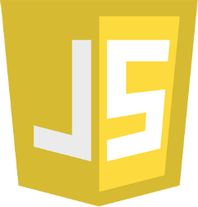
JavaScript is the Programming Language for the Web.
JavaScript can update and change both HTML and CSS.
JavaScript can calculate, manipulate and validate data.

Born | 4 July 1961 (age 63)  Pittsburgh, Pennsylvania, US
Alma mater | University of Illinois Urbana-Champaign  Santa Clara University
Known for | Creation of JavaScript and co-founder of Mozilla project, Mozilla Foundation, and Mozilla Corporation
Website | brendaneich.com

Brendan Eich

Brendan Eich (/ˈaɪk/; born July 4, 1961)^{[1]} is an American computer programmer and technology executive. He created the JavaScript programming language and co-founded the Mozilla project, the Mozilla Foundation, and the Mozilla Corporation. He served as the Mozilla Corporation's chief technical officer before he was appointed chief executive officer, but resigned shortly after his appointment due to pressure over his firm opposition to same-sex marriage. He subsequently became the CEO of Brave Software.

JAVASCRIPT ECMASCRIPT HISTORY

-JavaScript was invented by Brendan Eich in 1995.
-It was developed for Netscape 2, and became the ECMA-262 standa-rd in 1997.
-After Netscape handed JavaScript over to ECMA, the Mozilla foundation continued to develop JavaScript for the Firefox browser. Mozilla's latest version was 1.8.5. (Identical to ES5).
-Internet Explorer (IE4) was the first browser to support ECMA-262 Edition 1 (ES1).
Year | ECMA | Browser
1995 |  | JavaScript was invented by Brendan Eich
1996 |  | Netscape 2 was released with JavaScript 1.0
1997 |  | JavaScript became an ECMA standard (ECMA-262)
1997 | ES1 | ECMAScript 1 was released
1997 | ES1 | IE 4 was the first browser to support ES1
1998 | ES2 | ECMAScript 2 was released
1998 |  | Netscape 42 was released with JavaScript 1.3
1999 | ES2 | IE 5 was the first browser to support ES2
1999 | ES3 | ECMAScript 3 was released
2000 | ES3 | IE 5.5 was the first browser to support ES3
2000 |  | Netscape 62 was released with JavaScript 1.5
2000 |  | Firefox 1 was released with JavaScript 1.5
2008 | ES4 | ECMAScript 4 was abandoned
2009 | ES5 | ECMAScript 5 was released
2011 | ES5 | IE 9 was the first browser to support ES5 *
2011 | ES5 | Firefox 4 was released with JavaScript 1.8.5
2012 | ES5 | Full support for ES5 in Safari 6
2012 | ES5 | Full support for ES5 in IE 10
2012 | ES5 | Full support for ES5 in Chrome 23
2013 | ES5 | Full support for ES5 in Firefox 21
2013 | ES5 | Full support for ES5 in Opera 15
2014 | ES5 | Full support for ES5 in all browsers
2015 | ES6 | ECMAScript 6 was released
2016 | ES6 | Full support for ES6 in Chrome 51
2016 | ES6 | Full support for ES6 in Opera 38
2016 | ES6 | Full support for ES6 in Safari 10
2017 | ES6 | Full support for ES6 in Firefox 54
2017 | ES6 | Full support for ES6 in Edge 15
2018 | ES6 | Full support for ES6 in all browsers **

The ECMA Technical Committee 39
-In 1996, Netscape and Brendan Eich took JavaScript to the ECMA international standards organization, and a technical committee (TC39) was created to develop the language.
ECMA-262 Edition 1 was released in June 1997.

From ES4 to ES6
-When the TC39 committee got together in Oslo in 2008, to agree on ECMAScript 4, they were divided into 2 very different camps:
-The ECMAScript 3.1 Camp:
Microsoft and Yahoo who wanted an incremental upgrade from ES3.
-The ECMAScript 4 Camp:
Adobe, Mozilla, Opera, and Google who wanted a massive ES4 upgrade.
-August 13 2008, Brendan Eich wrote an email:
-It's no secret that the JavaScript standards body, Ecma's Technical Committee 39, has been split for over a year, with some members favoring ES4, a major fourth edition to ECMA-262, and others advocating ES3.1 based on the existing ECMA-262 Edition 3 (ES3) specification. Now, I'm happy to report, the split is over.
-The solution was to work together:
- ECMAScript 4 was renamed to ES5
- ES5 should be an incremental upgrade of ECMAScript 3.
- Features of ECMAScript 4 should be picked up in later versions.
- TC39 should develop a new major release, bigger in scope than ES5.
-The planned new release (ES6) was codenamed "Harmony" (Because of the split it created?).
-ES5 was a huge success. It was released in 2009, and all major browsers (including Internet Explorer) were fully compliant by July 2013:
 |  |  |  | 
Chrome 23 | IE10 / Edge | Firefox 21 | Safari 6 | Opera 15
Nov 2012 | Sep 2012 | May 2013 | Jul 2012 | Jul 2013
ES6 was also a huge success. It was released in 2015, and all major browsers were fully compliant by March 2017:
 |  |  |  | 
Chrome 51 | Edge 14 | Firefox 52 | Safari 10 | Opera 38
May 2016 | Aug 2016 | Mar 2017 | Sep 2016 | Jun 2016

What is Website?
-Website is the collection of web pages, different multimedia content such as text, images, and videos which can be accessed by the URL which you can see in the address bar of the browser. For example: https://www.geeksforgeeks.org .

How to access Websites?
-When we type a certain URL in a browser search bar, the browser requests the page from the Web server and the Web server returns the required web page and its content to the browser.
Types of Website:
- Static Website
- Dynamic Website
Static Website:
-These websites are made up of individual HTML files and display fixed content that doesn't change. They don't interact with users or change in real time. Static websites are built using HTML, CSS, and JavaScript.
-In Static Websites, Web pages are returned by the server which are prebuilt source code files built using simple languages such as HTML, CSS, or JavaScript. There is no processing of content on the server (according to the user) in Static Websites. Web pages are returned by the server with no change therefore, static Websites are fast. There is no interaction with databases. Also, they are less costly as the host does not need to support server-side processing with different languages.

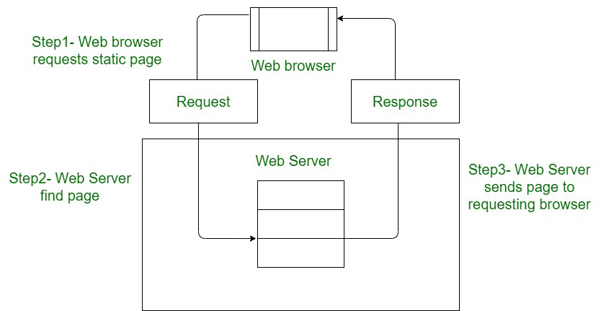

Dynamic Website:
-These websites use back-end code to build each web page on the fly, allowing them to change based on the user, time, or other factors. They can adjust to the viewer's screen size, change language automatically, and provide custom recommendations. Dynamic websites use server-side languages like PHP, Ruby, Python, and server-side JavaScript.
-In Dynamic Websites, Web pages are returned by the server which are processed during runtime means they are not prebuilt web pages but they are built during runtime according to the user’s demand with the help of server-side scripting languages such as PHP, Node.js, ASP.NET and many more supported by the server. So, they are slower than static websites but updates and interaction with databases are possible.
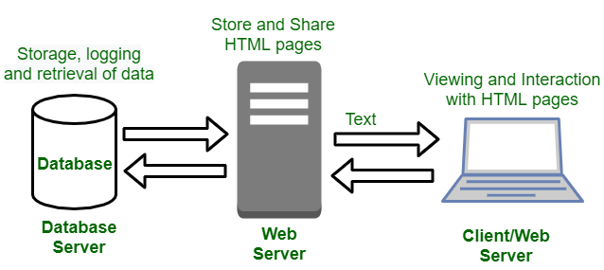

Difference Between Static Website and Dynamic Website

-The main difference between static and dynamic websites is that static websites display the same content to all users, while dynamic websites can change based on the user or other factors:
SrNo | Static Website | Dynamic Website
 | Content of Web pages can not be change at runtime. | Content of Web pages can be changed.
 | No interaction with database possible. | Interaction with database is possible
 | It is faster to load as compared to dynamic website. | It is slower than static website.
 | Cheaper Development costs. | More Development costs.
 | No feature of Content Management. | Feature of Content Management System.
 | HTML, CSS, Javascript is used for developing the website. | Server side languages such as PHP, Node.js are used.
 | Same content is delivered everytime the page is loaded. | Content may change everytime the page is loaded.

Differences Between Web Application And Website:

SrNo | Web Application | Website
 | Web application is designed for interaction with end users. | Website basically contains static content.
 | The user of web application can read the content of web application and also manipulate the data. | The user of website only can read the content of website but not manipulate .
 | The web application site should be precompiled before deployment. | The website does not need to be precompiled .
 | The function of a web application is quite complex. | The function of website is simple.
 | Web application is interactive for users. | Web site is not interactive for users.
 | The browser capabilities involved with a web application is high. | The browser capabilities involved with web site is high.
 | Integration is complex for web application because of its complex functionality. | Integration is simpler for web site.
 | Web application mostly requires authentication | In web site authentication is not necessary.
 | EXAMPLE :- Amazon, Facebook, etc. | EXAMPLE :- Breaking News, Aktu website, etc.

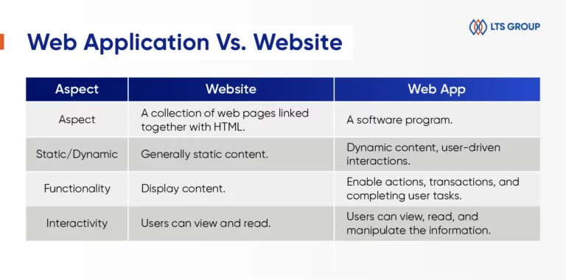
Difference Between Web App And Android App
-The main difference between a web app and an app is that web apps are accessible through a browser and don't need to be installed on a device, while apps are built for a specific platform and need to be installed on a device

Other differences include:
- Platform
Web apps work on any platform, device, and version of the system, while apps are built for a specific platform or device type.
- Development
Web apps are built using technologies like JavaScript, CSS, HTML, and Python, while apps are built using platform-specific technologies.
- Features
Apps may have more complex features and functionalities than web apps, and may have access to system resources like GPS and the camera.
- Offline use
Apps may work offline, while web apps do not.
- Testing
Web app testing ensures quality, functionality, and usability, while app testing refers to testing application software for controlling and handling mobile devices.
SrNo | Mobile Apps[Native] Apps | Web Apps
 | Mobile apps are developed for a specific platform, such as iOS for the Apple iPhone or Android | On the other hand, Web Apps are accessed via the internet browser and will function according to the device you’re viewing them on
 | They are downloaded and installed via an app store such as Google Play Store and Apple Store and have access to system resources, such as GPS and the camera of the device. | Web apps are not native to a particular system and there is no need to be downloaded or installed.
 | Mobile apps may work offline. | In order to run web apps need an active internet connection.
 | Native Apps are comparatively faster. | Web Apps are comparatively slower.
 | It is difficult to have a native mobile app approved by the App Store. | In Web Apps App store approval is not required, so web apps can be launched easily.
 | Native apps have more safety and security. | Web apps have comparatively low security.
 | Maintaining and consistently update of native apps cause more cost. | These apps can be set to update themselves or automatically.

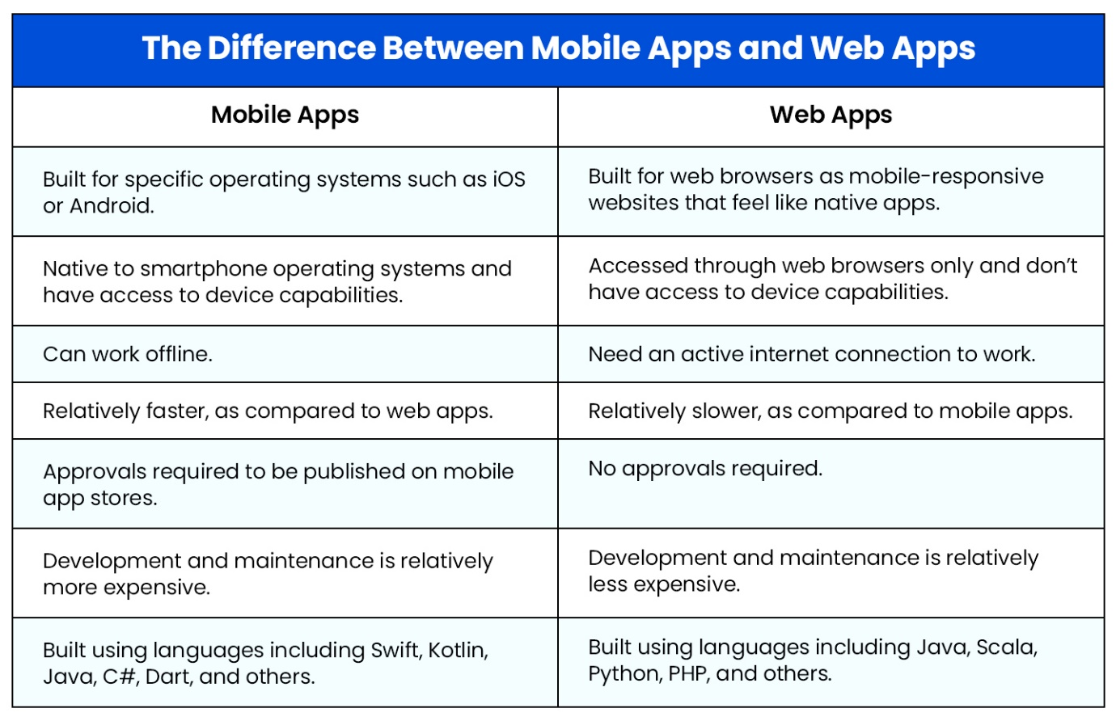

SCRIPT

-In programming, a script is a set of instructions that a computer or programming language can execute to perform a task.
-a script is a program or sequence of instructions that is interpreted or carried out by another program rather than by the computer processor (as a compiled program is).
-According to your instruction the components or objects perform the tasks.
Advantages of scripts
- Allows users to view and edit the script if needed.
- Does not require the file to be compiled, but it may be when necessary.
- Easy to learn and write.
- Easy to port between different operating systems.
- Much faster to develop than an actual program - some individuals and companies write scripts as a prototype for actual programs.

What Is JavaScript?

-JavaScript is a scripting language for creating dynamic web page content.
OR
- JavaScript (JS) is a programming language used to make web pages interactive and dynamic.

- 👉 In simple words:
JavaScript adds life to a website.

-It creates elements for improving site visitors’ interaction with web pages, such as dropdown menus, animated graphics, and dynamic background colors.

-JavaScript (often shortened to JS) is a lightweight, interpreted, or just-in-time compiled programming language commonly used for adding interactivity and dynamic features to websites.
-There are a few key points about JavaScript:
- Purpose:
-JavaScript is primarily used for front-end web development, meaning it runs directly in the user's web browser. It allows developers to create dynamic content, handle user interactions, update web pages without reloading, and build interactive web applications.
- Relationship with HTML and CSS:
-JavaScript works alongside HTML (structure) and CSS (styling) to create the complete user interface of a website. HTML provides the basic structure, CSS styles the elements, and JavaScript adds behavior and interactivity.
- Syntax:
-JavaScript's syntax is similar to other C-style languages like Java and C++. It's known for being relatively beginner-friendly, although it has its complexities as you dive deeper.
In simple words, JavaScript is the language that makes websites interactive and dynamic.

🔹 What JavaScript Can Do
JavaScript can:
- Show alerts and messages
- Validate forms
- Handle button clicks
- Change HTML & CSS
- Create animations
- Fetch data from servers (API)
- Build web apps (React, Angular, etc.)
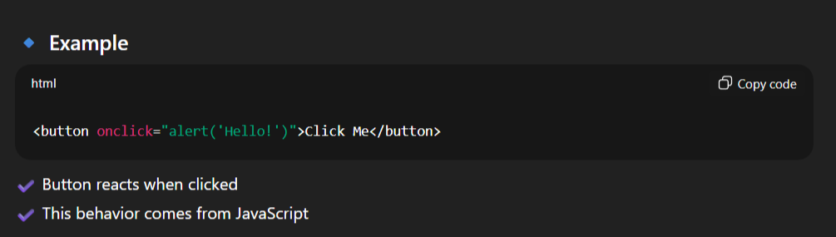
Why JavaScript is Important
- Works in all browsers
- Easy to learn
- Fast execution
- Used for frontend + backend
- Huge community & libraries

🔹 Where JavaScript Runs
1]Browser (Chrome, Firefox, Edge)
2️]Server (Node.js)
3️]Mobile Apps (React Native)

1.Scripting Language
2.Interpreted Language
3.Ligth-Weight language
4.WeaklyTyped Language
5.Object Based Language
7. Client-Side Validation
8.Versatility
9. DOM Manipulation
10.Event Handling

FEATURES OF JAVASCRIPT

1.Light-Weight Scripting Language

👉 Lightweight means JavaScript needs very little memory, setup, and resources to run.
It runs directly inside the browser without heavy installations.
- JavaScript is a lightweight scripting language because it is made for data handling in the browser or the client side.
- Because JavaScript is meant for client-side execution for web applications, hence the lightweight nature of JavaScript is a great feature.
JavaScript — Why Is It Called Lightweight?
1. What does "Lightweight" mean?
- Lightweight means JavaScript is relatively simple and easy to execute.
- It does not require a lot of code for performing common tasks.
- JavaScript was designed to work efficiently, especially inside web browsers.

2. Simple Syntax
-JavaScript has a simple and easy-to-understand syntax.
let name = "Amol";
console.log(name);
- Less code is required.
- No complicated syntax is needed for basic operations.

3. Dynamically Typed
-In JavaScript, you don't need to specify the data type of a variable.
let value = 10;
value = "Hello";
-The same variable can hold different types of values.
let age = 25;
let name = "Amol";
let isDeveloper = true;
So, JavaScript requires less boilerplate code.

4. Automatic Memory Management
-JavaScript has Garbage Collection.You don't manually have to free memory.
let user = {
name: "Amol"
};

user = null;
-When an object is no longer needed or reachable, JavaScript's Garbage Collector can remove it from memory.

5. JIT Compilation
-Modern JavaScript engines use JIT (Just-In-Time) compilation.
For example:
JavaScript Code
↓
JavaScript Engine
↓
Optimization / JIT
↓
Machine Code
↓
Execution
This allows JavaScript to execute code efficiently.

6. Runs Directly in the Browser
-JavaScript engines are already built into modern browsers.
Examples:
- Chrome → V8
- Firefox → SpiderMonkey
- Safari → JavaScriptCore
- Edge → V8
-Therefore, users normally don't need to install a separate JavaScript runtime to execute JavaScript in a browser.

7. Asynchronous Programming
-JavaScript can perform tasks asynchronously.
For example:
fetch("/api/users");
console.log("Hello");
-The browser can start the network request and continue executing other JavaScript instead of waiting for the request to finish.
-This helps JavaScript build responsive web applications.

8. Event-Driven
-JavaScript works heavily with events.
Examples:
- Click
- Keyboard input
- Mouse movement
- Form submission
- API response
button.addEventListener("click", () => {
console.log("Button clicked");
});
-This makes JavaScript suitable for interactive websites.

9. Less Boilerplate Code
-JavaScript can accomplish many things with relatively little code.
For example:
const numbers = [1, 2, 3, 4];

const doubled = numbers.map(num => num * 2);
-You don't need to write a large amount of code for this operation.

10. Important: Lightweight ≠ Low Memory Usage
This is very important.
Lightweight does NOT mean JavaScript always uses very little RAM.
For example:
- A small JavaScript program may use little memory.
- A large React/Next.js application can use significant memory.
- Node.js applications can also consume considerable RAM.

2.Weakly Typed Language
- JavaScript supports dynamic typing which means types of the variable are defined based on the stored value.
- For example, if you declare a variable x then you can store either a string or a Number type value in JavaScript or an array or an object. This is known as dynamic typing.
- JavaScript allows you to declare variables without specifying their type. The type is determined at runtime, providing flexibility in coding.

<!--! ======= WEAKLY TYPED LANGUAGE =========-->
<! --* 1.We can directly declare the variable without variable type. -->
<script>
a=5;
</script>
<! --* 2. In below example Semicolon Is Not Mandatory -->
<! --* For better Code Indentation or to main company standard We can write semicolon -->
<! --* So, JS cannot give errors -->
<script>
a=10
</script>
<! --* 3. In JavaScript, a variable can be declared and assigned a value of any type, including objects, arrays, and functions. -->
<script>
var a=5;
console.log(typeof(a));

a="Amol";
console.log(typeof(a));

a=["Amol",24,2000];
console.log(typeof(a));

a=true;
console.log(typeof(a));

a=null;
console.log(typeof(a));
</script>

3. Object-Oriented Programming support
- Starting from ES6, the concept of class and OOP is better defined.
- Also, in JavaScript, two important principles with OOP in JavaScript are:
  - Object Creation Patterns (Encapsulation)
  - Code Reuse patterns (Inheritance)
- Although JavaScript developers rarely use these features, it's there for everyone to explore.

4. Functional Style

- This implies that JavaScript uses a functional approach, even objects can be created using constructor functions and each constructor function represents a unique object type.
- Also, functions in JavaScript can be used as objects and can be passed to other functions too.
- Many important JavaScript concepts and features like callbacks, closures, etc. are implementations of functions only.

5.Platform Independent

- This implies that JavaScript is platform-independent or we can say it is portable.
- This simply means that you can simply write the script once and run it anywhere and anytime.
- In general, you can write your JavaScript applications and run them on any platform or any browser without affecting the output of the Script.

6.Prototype-bassed Language

- JavaScript is a prototype-based scripting Language.
- This means JavaScript uses prototypes instead of classes or inheritance.
- In languages like Java, we create a class and then we create objects for those classes.
- But in JavaScript, we define an object prototype, and then more objects can be created using this object prototype.

7.Interpreted Language

- JavaScript is an interpreted language which means the script written inside JavaScript is processed line by line.
- The JS code is interpreted by JavaScript interpreter which is a built-in component of the Web browser.
- But these days many JavaScript engines in browsers like the V8 engine in Chrome use just-in-time compilation for JavaScript code.
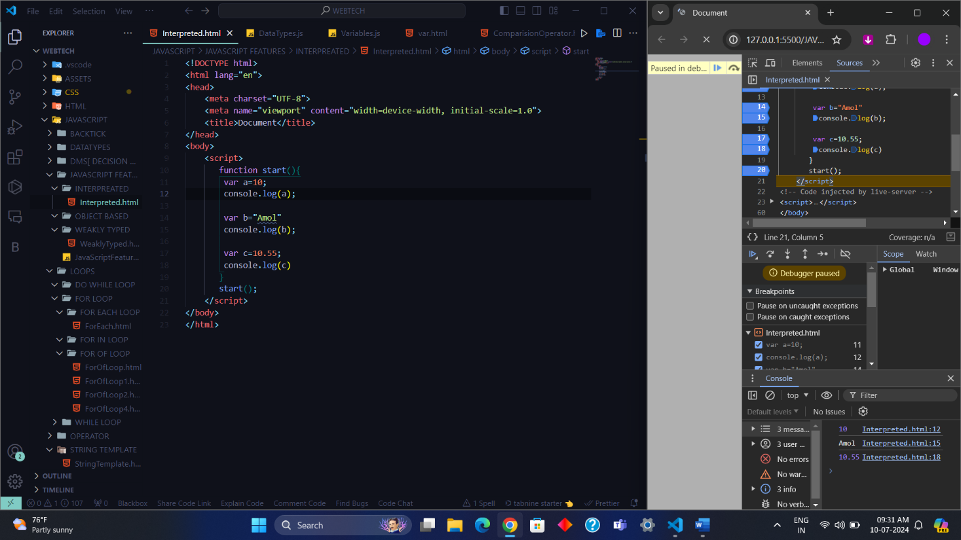
8.Single Threaded

- JavaScript doesn't support multi-threading, by default it is single-threaded, which means it can execute only a single task at a time.
- But JavaScript provides some features using which you can implement parallel execution. They are:
  - Async processing
  - Web workers
9.Asynch Processing

- JavaScript supports Promise which enables asynchronous requests wherein a request is initiated and JavaScript doesn't have to wait for the response if a request takes time and may block the request processing.
- Also starting from ES8, Async functions are also supported in JavaScript, these functions don't execute one by one, rather they are processed parallelly which has a positive effect on the processing time, reducing it to a great extent.
10.Web Workers

- Using Web workers you can run processes in background threads so that you can have parallel execution.
- If you have any task that performs some heavy-duty work, then you can use a Web worker to run it in the background.

11.Client Side Validation

- This is a feature that has been available in JavaScript since the beginning and is still widely used because every website has a form in which users enter values, and to make sure that users enter the correct value, we must put proper validations in place, both on the client side and on the server-side.
- JavaScript is used for implementing client-side validations.
12.More Control On Browser

-JavaScript being a client-side language provides many features that help developers to divide processing between browser and server hence reducing the load on servers by having basic processing, validations, temporary data saving using cookies, etc. on the browser itself.
Along with all these features, JavaScript provides the following useful features too:
- Detecting browser type, name OS version, etc information of the client for analysis.
- Extensive in-built library with many useful functions for validation, data type conversion, string operations, etc.
- It is an object-centered language with Window Object being the most important object in JavaScript and it also supports Polymorphism.
- Support for commonly used complex data types like arrays, Maps, lists, etc. with support of in-built functions to operate on them.

13.Backend Development

-With NodeJS, backend development can also be done using JavaScript. MERN stack is one of the most popular stacks based on JavaScript for Fullstack Development using JavaScript. ExpressJS can be used for API or REST service development. NodeJS brings in npm which is a package manager for JavaScript modules, hence you can use 3rd party packages too, making the backend development even more fun and easy in JavaScript.

COMPILER

-A language processor that converts a program written in high-level language into machine language, entire program at once, is called a compiler. Thus, the input of a compiler is a high-level language code (called source code), while its output is a machine language code (called object code).
-A compiler scans whole program and then check it for syntactic and semantic error, once the code is checked for errors, it is converted into an object code. Then, it can be processed by the machine to perform the corresponding task. The common programming languages that use compiler are C, C++, C#, etc.
Role of a Compiler

For Converting the code written in a high-level language into machine-level language so that computers can easily understand, we use a compiler. Converts basically convert high-level language

Advantages of Compiler
There are various advantages of the compiler which are as follows −
- A compiler translates a program in a single run.
- It consumes less time.
- CPU utilization is more.
- Both syntactic and semantic errors can be checked concurrently.
- It is easily supported by many high-level languages like C, C++, JAVA, etc.

Disadvantages of Compiler
- The compiler can catch only syntax errors and some semantic errors.
- Compilation can take more time in the case of bulky code.

INTERPRETER

-A language translator that converts a high-level language program into a machine language program, one line at a time, is referred to as an interpreter. Interpreters converts the codes slower than compiler. This is because the interpreter can scan and translate only one statement of the program at a time. Therefore, interpreters convert the source code into machine code during the execution of the program.
-Interpreters do not generate an object code corresponding to the source code. However, these are relatively easy to use and execute the code. The programming languages that use interpreters are Perl, Ruby, Python, METLAB, etc.

Advantages of Interpreter
-There are various advantages of the interpreter which are as follows.
- An interpreter translates the program line by line.
- The interpreter is smaller in size.
- It is flexible.
- Error localization is easier.
- The interpreter facilitates the implementation of computer programming language constructs.

Disadvantages of Interpreter
- The interpreter can run only the corresponding Interpreted program.
- Interpreted code runs slower in comparison to Compiled code.

Working of Compiler and Interpreter

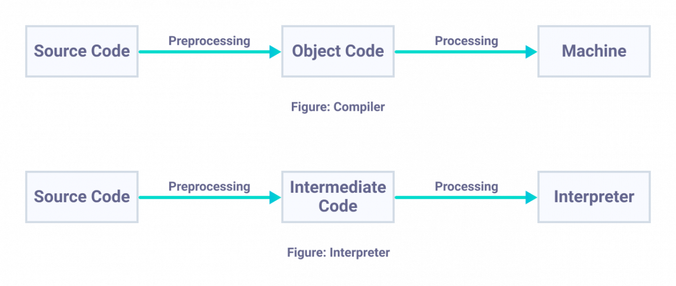
-Both compilers and interpreters are the language processors used to convert software codes written in high-level language into machine language codes.

Difference between Compiler and Interpreter
-The following table highlights all the significant differences between a Compiler and an Interpreter −
Parameter | Compiler | Interpreter
Program scanning | Compilers scan the entire program in one go. | The program is interpreted/translated one line at a time.
Error detection | As and when scanning is performed, all the errors are shown in the end together, not line by line. | One line of code is scanned, and errors encountered are shown.
Object code | Compilers convert the source code to object code. | Interpreters do not convert the source code into object code.
Execution time | The execution time of compiler is less, hence it is preferred. | It is not preferred due to its slow speed. Usually, interpreter is slow, and hence takes more time to execute the object code.
Need of source code | Compiler doesn’t require the source code for execution later. | It requires the source code for execution later.
Programming languages | Programming languages that use compilers include C, C++, C#, etc.. | Programming languages that uses interpreter include Python, Ruby, Perl, MATLAB, etc.
Types of errors detected | Compiler can check syntactic and semantic errors in the program simultaneously. | Interpreter checks the syntactic errors only.
Size | Compiler are larger in size. | Interpreters are smaller in size.
Flexibility | Compilers are not flexible. | Interpreters are relatively flexible.
Efficiency | Compilers are more efficient. | Interpreters are less efficient.

Types of Interpreters

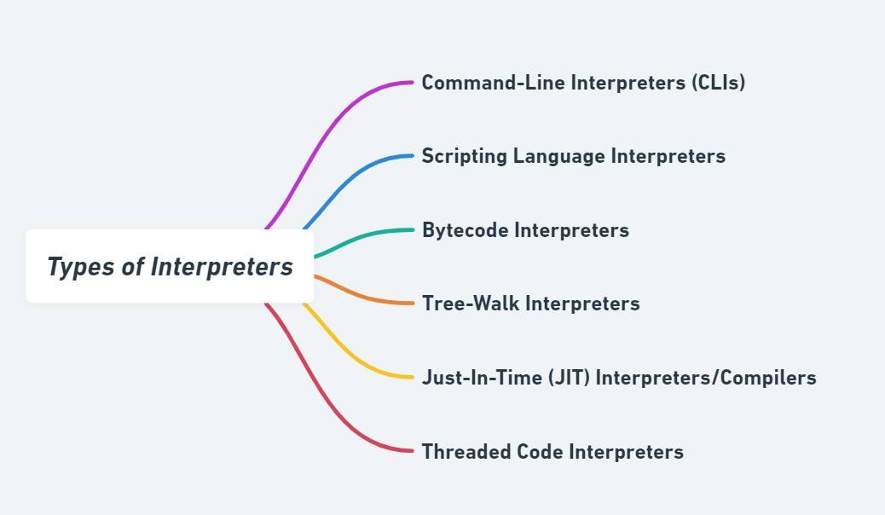

-Let's read about each one in detail below!
Type | Description | Examples
Command-Line Interpreters (CLIs) | Execute user commands one at a time. | Unix shells like Bash.
Scripting Language Interpreters | Used for scripting languages to automate tasks. | Python, Ruby, Perl.
Bytecode Interpreters | Interpret an intermediate bytecode, not the high-level source code directly. | Java Virtual Machine (JVM).
Tree-Walk Interpreters | Parse code into an abstract syntax tree and traverse it to interpret the program. | Simple language interpreters in educational tools.
Just-In-Time (JIT) Interpreters/Compilers | Compile source code or bytecode to machine code just in time for execution. | Modern JavaScript engines like V8 (in Chrome) or SpiderMonkey (in Firefox).
Threaded Code Interpreters | Execute sequences of simpler instructions for better performance. | Forth, some implementations of Python.
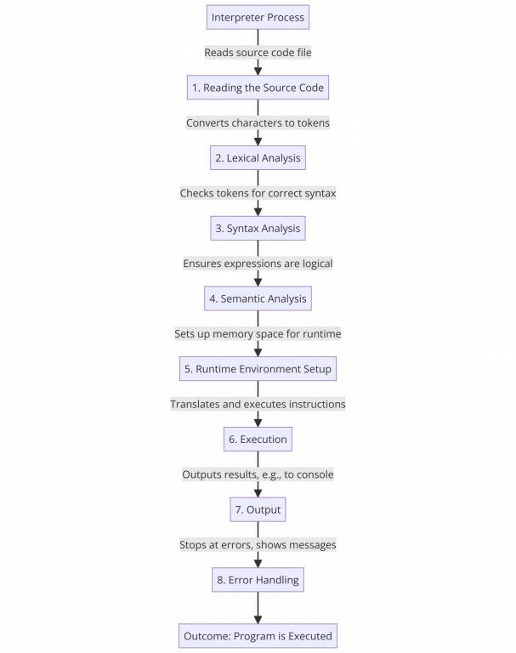

Advantages of Using an Interpreter
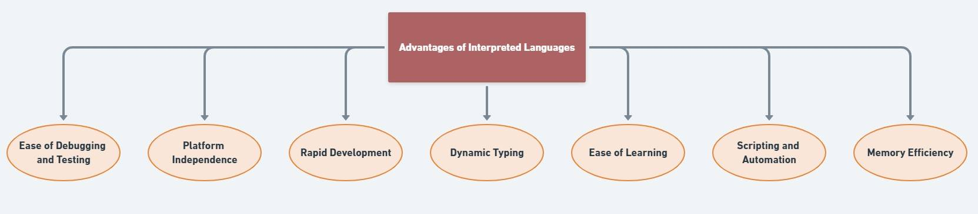
Let's read about each one in detail below!
Advantages | Explanation
Ease of Debugging and Testing | Errors can be detected and fixed as the code is executed line by line.
Platform Independence | Code can run on multiple platforms without modification as long as the interpreter is available.
Rapid Development | Immediate execution allows for quick testing and iteration without the compile-link-execute cycle.
Dynamic Typing | Supports on-the-fly typing, which can lead to faster development times and less code verbosity.
Ease of Learning | Simplifies the learning process for beginners by allowing immediate execution of code snippets.
Scripting and Automation | Ideal for writing scripts that automate tasks due to their ease of use and execution.
Memory Efficiency | No need for executable binaries, which conserves memory space on the system.

Note :- We cannot perform the Function Overloading in JavaScript because JavaScript has Default Datatype called as "Undefined"
Note :- In JavaScript Entire Memory Management is doing the JsEngine we do not worry about the Memory Management
-A JavaScript engine is a computer program that executes JavaScript code and converts it into computer understandable language.

List of JavaScript Engines:
Browser | Name of Javascript Engine
Google Chrome | V8
Edge (Internet Explorer) | Chakra
Mozilla Firefox | Spider Monkey
Safari | Javascript Core Webkit
Let’s understand each of them.
1. V8: V8 is a JavaScript engine developed by the Chromium Project for Google Chrome and Chromium web browsers.
-It is a JavaScript engine that can run standalone, or be embedded into any C++ application. Using its own parser, it generates an abstract syntax tree. Then, Ignition generates bytecode from this syntax tree using the internal V8 bytecode format. Bytecode is compiled into machine code by TurboFan.
-It also handles memory allocation for objects, and garbage collects objects it no longer needs. Optimization techniques such as elision of expensive runtime properties, and inline caching. The garbage collector is a generational incremental collector.
-V8 provides an edge as it allows JavaScript to run much faster, which improves users’ experience of the web, paves the way for the development of web applications, and spurs rapid growth of server-side JavaScript through projects like Node.js.

2. Chakra: Chakra is a JScript engine developed by Microsoft. It is proprietary software. It is used in the Internet Explorer web browser. A distinctive feature of the engine is that it JIT compiles scripts on a separate CPU core, parallel to the web browser.
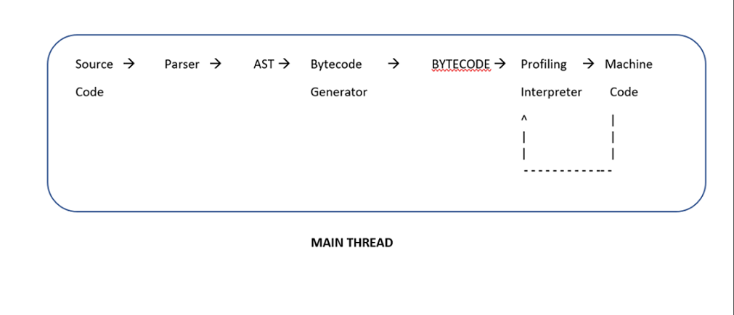
3. Spider Monkey: SpiderMonkey is the first JavaScript engine, written by Brendan Eich at Netscape Communications, later released as open-source and currently maintained by the Mozilla Foundation. It is still used in the Firefox web browser.
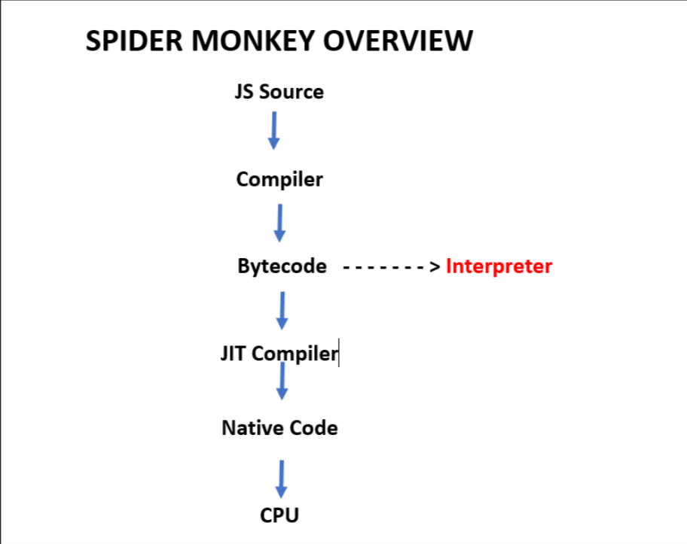

4. Webkit: WebKit is developed by Apple and used in its Safari web browser, as well as all iOS web browsers. It is used by the BlackBerry Browser, PlayStation consoles beginning from the PS3, the Tizen mobile operating systems, and a browser included with the Amazon Kindle e-book reader. WebKit’s C++ Application Programming Interface (API) provides a set of classes to display Web content in windows and implements browser features such as following links when clicked by the user, managing a back-forward list, and managing a history of pages recently visited.
JavaScript is one of the 3 languages all web developers must learn:
1. HTML to define the content of web pages
2. CSS to specify the layout of web pages
HOW TO ADD JAVASCRIPT TO HTML

-We can write or add a script in two ways
1]Internal

-You can add JavaScript code in an HTML document by employing the dedicated HTML tag <script> that wraps around JavaScript code.

-The <script> tag can be placed in the <head> section of your HTML or in the <body> section, depending on when you want the JavaScript to load.

A]Inside Head Section
-Generally, JavaScript code can go inside the document <head> section in order to keep it contained and out of the main content of your HTML document.
-We can write multiple scripts mean there can be multiple <script> tags.
-But the order of the execution is line-by-line in Top-To-Bottom order.
<!DOCTYPE html>
<html lang="en-US">
<head>
<meta charset="UTF-8">
<meta name="viewport" content="width=device-width, initial-scale=1">
<title>In Body JavaScript</title>
<!--! 1.First Script -->
<script>
function myFunction() {
document.getElementById("demo").innerHTML = "Paragraph changed.";
}
</script>
<!--! 2.Second Script -->
<script>
let d = new Date();
document.write("Today's date is " + d);
</script>
</head>
<body>
<h2>JavaScript in Head</h2>
<p id="demo"></p>
<button type="button" onclick="myFunction()">Try it</button><br>
</body>
</html>

B]Inside Body Section
-We can write a script inside the body section also for that we have add <script> </script> tag In body section as show below.

-We can write multiple scripts mean there can be multiple <script> tags.

-But the order of the execution is line-by-line in Top-To-Bottom order.
<!DOCTYPE html>
<html lang="en-US">
<head>
<meta charset="UTF-8">
<meta name="viewport" content="width=device-width, initial-scale=1">
<title>In Body JavaScript</title>
</head>
<body>
<h2>JavaScript in Head</h2>
<p id="demo"></p>
<button type="button" onclick="myFunction()">Try it</button><br>
<!--! 1.First Script -->
<script>
function myFunction() {
document.getElementById("demo").innerHTML = "Paragraph changed.";
}
</script>
<!--! 2.Second Script -->
<script>
let d = new Date();
document.write("Today's date is " + d);
</script>

</body>
</html>

2]EXTERNAL

-For That you have create a new file with .js extension then inside that JavaScript file you have directly write the JavaScript code. There is no <script></script> tag is required.
-After Writing Script then you have link the script to HTML document.
-For that you have to use <script src=”./”> tag. Where src means Source or Location of that file.
NOTE : - You can link JavaScript file in Head Section also.
External.html
<!DOCTYPE html>
<html lang="en">
<head>
<meta charset="UTF-8">
<meta name="viewport" content="width=device-width, initial-scale=1.0">
<title>Document</title>
<script src="./External.js"></script>
</head>
<body>
<h2>JavaScript in Head</h2>
<p id="demo"></p>
<button type="button" onclick="myFunction()">Try it</button><br>
</body>
</html>

External.js
//! 1.First Script -->
function myFunction() {
document.getElementById("demo").innerHTML = "Paragraph changed.";
}
//! 2.Second Script-->

let d = new Date();
document.write("Today's date is " + d);

NOTE : - You can link Javascript File in Body Section also.
<!DOCTYPE html>
<html lang="en">
<head>
<meta charset="UTF-8">
<meta name="viewport" content="width=device-width, initial-scale=1.0">
<title>Document</title>
</head>
<body>
<script src="./External.js"></script>
</body>
</html>

External JavaScript Advantages
Using external JavaScript files offers several advantages:
1. Improved Code Organization and Readability:
- Separates HTML structure from JavaScript behaviour, making both files cleaner and easier to understand and maintain.
- Improves code reusability as the same JavaScript file can be linked to multiple HTML pages.
2. Faster Page Loading:
- Browsers can cache external JavaScript files. This means that once a user visits a page, the browser can store the file locally, so it doesn't need to be downloaded again on subsequent visits, resulting in faster loading times.
3. Easier Maintenance and Update:
- Updating JavaScript code becomes simpler when it's in a separate file. You can make changes to the script without touching the HTML structure or other parts of the website, and these changes will be reflected across all pages that use the script. reducing the risk of introducing errors.
4. Separation of Concerns (SoC):
- Promotes a better development workflow by allowing designers and developers to focus on their respective areas without interfering with each other's work.
- Improves overall code quality and maintainability.

5.Code Reusability:
External JavaScript files can be reused across multiple web pages within the same site or even across different sites. This promotes consistency and reduces duplication of code.
6.Accessibility: Separating JavaScript into an external file makes it easier for developers to collaborate. Multiple developers can work on different parts of the codebase simultaneously without conflicts.
7.Reduced HTML Size: Placing JavaScript code externally reduces the size of the HTML file itself. This is especially beneficial for larger scripts, helping to keep your HTML code clean and more readable.
8.Compatibility: External JavaScript files are compatible with various development tools, version control systems, and content management systems (CMS). This flexibility makes them suitable for a wide range of web development projects.

JAVASCRIPT CODING CONVENTIONS
-Coding conventions secure quality:
- Improve code readability
- Make code maintenance easier
Naming Conventions

-Always use the same naming convention for all your code. For example:
- Variable and function names written as camelCase
- Global variables written in UPPERCASE (We don't, but it's quite common)
- Constants (like PI) written in UPPERCASE
var name = 'Robin Wieruch';
var Name = 'Dennis Wieruch';
var NAME = 'Thomas Wieruch';
console.log(name);
// "Robin Wieruch"
console.log(Name);
// "Dennis Wieruch"
console.log(NAME);
// "Thomas Wieruch"

-A JavaScript variable should be self-descriptive. It shouldn't be necessary to add a comment for additional documentation to the variable:
// bad
var value = 'Robin';
// bad
var val = 'Robin';
// good
var firstName = 'Robin';

// bad
var firstname = 'Robin';

// bad
var first_name = 'Robin';

// bad
var FIRSTNAME = 'Robin';

// bad
var FIRST_NAME = 'Robin';

// good
var firstName = 'Robin';

JAVASCRIPT NAMING CONVENTIONS: BOOLEAN
-A prefix like is, are, or has helps every JavaScript developer to distinguish a boolean from another variable by just looking at it:
/ bad
var visible = true;
// good
var isVisible = true;
// bad
var equal = false;
// good
var areEqual = false;
// bad
var encryption = true;

// good
var hasEncryption = true;

JAVASCRIPT NAMING CONVENTIONS: FUNCTION
-JavaScript functions are written in camel case too. In addition, it's a best practice to actually tell what the function is doing by giving the function name a verb as prefix.
// bad
function name(firstName, lastName) {
return `${firstName} ${lastName}`;
}
// good
function getName(firstName, lastName) {
return `${firstName} ${lastName}`;
}

JAVASCRIPT NAMING CONVENTIONS: CLASS
-A JavaScript class is declared with a PascalCase in contrast to other JavaScript data structures:
class SoftwareDeveloper {
constructor(firstName, lastName) {
this.firstName = firstName;
this.lastName = lastName;
}
}

var me = new SoftwareDeveloper('Robin', 'Wieruch');

JAVASCRIPT NAMING CONVENTIONS: COMPONENT
-Components are not everywhere in JavaScript, but commonly found in frontend frameworks like React. Since a component is kinda instantiated -- but appended to the DOM instead -- like a JavaScript class, they are widely declared with Pascal Case too.
/ bad
function userProfile(user) {
return (
<div>
<span>First Name: {user.firstName}</span>
<span>Last Name: {user.lastName}</span>
</div>
);
}
// good
function UserProfile(user) {
return (
<div>
<span>First Name: {user.firstName}</span>
<span>Last Name: {user.lastName}</span>
</div>
);
}

-When a component gets used, it distinguishes itself from native HTML and web components, because its first letter is always written in uppercase
<div>
<UserProfile
user={{ firstName: 'Robin', lastName: 'Wieruch' }}
/>
</div>

JAVASCRIPT NAMING CONVENTIONS: METHODS
-Identical to JavaScript functions, a method on a JavaScript class is declared with camelCase:
class SoftwareDeveloper {
constructor(firstName, lastName) {
this.firstName = firstName;
this.lastName = lastName;
}
getName() {
return `${this.firstName} ${this.lastName}`;
}
}
var me = new SoftwareDeveloper('Robin', 'Wieruch');
console.log(me.getName());
// "Robin Wieruch"

JAVASCRIPT NAMING CONVENTIONS: CONSTANT
Last but not least, there are constants -- intended to be non-changing variables -- in JavaScript which are written in capital letters (UPPERCASE):
var SECONDS = 60;
var MINUTES = 60;
var HOURS = 24;

var DAY = SECONDS * MINUTES * HOURS;

If a variable has more than one word in its variable declaration name, it makes use of an underscore (_):
var DAYS_UNTIL_TOMORROW = 1;

JAVASCRIPT NAMING CONVENTIONS: PRIVATE
-Rarely you will find an underscore (_) in front of a variable/function/method in JavaScript. If you see one, it is intended to be private.
class SoftwareDeveloper {
constructor(firstName, lastName) {
this.firstName = firstName;
this.lastName = lastName;
this.name = _getName(firstName, lastName);
}

_getName(firstName, lastName) {
return `${firstName} ${lastName}`;
}
}

var me = new SoftwareDeveloper('Robin', 'Wieruch');

// good
var name = me.name;
console.log(name);
// "Robin Wieruch"

// bad
name = me._getName(me.firstName, me.lastName);
console.log(name);
// "Robin Wieruch"

-A private variable/function can occur in a JavaScript file as well. -This could mean that the variable/function shouldn't be used outside of this file

JAVASCRIPT NAMING CONVENTIONS: GLOBAL VARIABLE
-A JavaScript variable is globally defined, if all its context has access to it. Often the context is defined by the JavaScript file where the variable is declared/defined in, but in smaller JavaScript projects it may be the entire project. There are no special naming conventions for global JavaScript variables.
- A global JavaScript variable is declared at the top of a project/file.
- A global JavaScript variable is written in camelCase if it is mutable.
- A global JavaScript variable is written in UPPERCASE if it is immutable.
JAVASCRIPT NAMING CONVENTIONS: FILES
-HTML files should have a .html extension (.htm is allowed).
-CSS files should have a .css extension.
-JavaScript files should have a .js extension.
-There are two strategies of naming files in JavaScript: PascalCase and kebab-case. In JavaScript frontend applications, you will often see PascalCase for naming components (e.g. React components).
- components/
--- user/
----- UserProfile.js
----- UserList.js
----- UserItem.js
--- ui/
----- Dialog.js
----- Dropdown.js
----- Table.js

-In contrast, in JavaScript backend application, kebab-case is the common sense:
- routing/
--- user-route.js
--- messages-route.js

Spaces Around Operators
-Always put spaces around operators ( = + - * / ), and after commas:
Examples:
let x = y + z;
const myArray = ["Volvo", "Saab", "Fiat"];

Statement Rules
-General rules for simple statements:
- Always end a simple statement with a semicolon.
Examples:
const cars = ["Volvo", "Saab", "Fiat"];
const person = {
firstName: "John",
lastName: "Doe",
age: 50,
eyeColor: "blue"
};

Object Rules
General rules for object definitions:
- Place the opening bracket on the same line as the object name.
- Use colon plus one space between each property and its value.
- Use quotes around string values, not around numeric values.
- Do not add a comma after the last property-value pair.
- Place the closing bracket on a new line, without leading spaces.
- Always end an object definition with a semicolon.
Examples:
const person = {
firstName: "John",
lastName: "Doe",
age: 50,
eyeColor: "blue"
};

JavaScript Best Practices
-Avoid global variables, avoid new, avoid ==, avoid eval()

Avoid Global Variables
-Minimize the use of global variables.
-This includes all data types, objects, and functions.
-Global variables and functions can be overwritten by other scripts.
-Use local variables instead, and learn how to use closures.

Always Declare Local Variables
-All variables used in a function should be declared as local variables.
-Local variables must be declared with the var, the let, or the const keyword, otherwise they will become global variables.
Declarations on Top
-It is a good coding practice to put all declarations at the top of each script or function.
This will:
- Give cleaner code
- Provide a single place to look for local variables
- Make it easier to avoid unwanted (implied) global variables
- Reduce the possibility of unwanted re-declarations

// Declare at the beginning
let firstName, lastName, price, discount, fullPrice;
// Use later
firstName = "John";
lastName = "Doe";
price = 19.90;
discount = 0.10;
fullPrice = price - discount;

Initialize Variables
-It is a good coding practice to initialize variables when you declare them.
-This will:
- Give cleaner code
- Provide a single place to initialize variables
- Avoid undefined values
// Declare and initiate at the beginning
let firstName = "";
let lastName = "";
let price = 0;
let discount = 0;
let fullPrice = 0,
const myArray = [];
const myObject = {};

Declare Objects with const
-Declaring objects with const will prevent any accidental change of type:

Example
let car = {type:"Fiat", model:"500", color:"white"};
car = "Fiat"; // Changes object to string

Example
const car = {type:"Fiat", model:"500", color:"white"};
car = "Fiat"; // Not possible

Declare Arrays with const
-Declaring arrays with const will prevent any accidential change of type:

Example
let cars = ["Saab", "Volvo", "BMW"];
cars = 3; // Changes array to number

Example
const cars = ["Saab", "Volvo", "BMW"];
cars = 3; // Not possible

Don't Use new Object()
- Use "" instead of new String()
- Use 0 instead of new Number()
- Use false instead of new Boolean()
- Use {} instead of new Object()
- Use [] instead of new Array()
- Use /()/ instead of new RegExp()
- Use function (){} instead of new Function()

Example
let x1 = ""; // new primitive string
let x2 = 0; // new primitive number
let x3 = false; // new primitive boolean
const x4 = {}; // new object
const x5 = []; // new array object
const x6 = /()/; // new regexp object
const x7 = function(){}; // new function object

Beware of Automatic Type Conversions
JavaScript is loosely typed.
A variable can contain all data types.
A variable can change its data type:

Example
let x = "Hello"; // typeof x is a string
x = 5; // changes typeof x to a number
-Beware that numbers can accidentally be converted to strings or NaN (Not a Number).
-When doing mathematical operations, JavaScript can convert numbers to strings:

Example
let x = 5 + 7; // x.valueOf() is 12, typeof x is a number
let x = 5 + "7"; // x.valueOf() is 57, typeof x is a string
let x = "5" + 7; // x.valueOf() is 57, typeof x is a string
let x = 5 - 7; // x.valueOf() is -2, typeof x is a number
let x = 5 - "7"; // x.valueOf() is -2, typeof x is a number
let x = "5" - 7; // x.valueOf() is -2, typeof x is a number
let x = 5 - "x"; // x.valueOf() is NaN, typeof x is a number

-Subtracting a string from a string, does not generate an error but returns NaN (Not a Number):

Example
"Hello" - "Dolly" // returns NaN

Use === Comparison
-The == comparison operator always converts (to matching types) before comparison.
-The === operator forces comparison of values and type:

Example
0 == ""; // true
1 == "1"; // true
1 == true; // true
0 === ""; // false
1 === "1"; // false
1 === true; // false

End Your Switches with Defaults
-Always end your switch statements with a default. Even if you think there is no need for it.

Example
switch (new Date().getDay()) {
case 0:
day = "Sunday";
break;
case 1:
day = "Monday";
break;
case 2:
day = "Tuesday";
break;
case 3:
day = "Wednesday";
break;
case 4:
day = "Thursday";
break;
case 5:
day = "Friday";
break;
case 6:
day = "Saturday";
break;
default:
day = "Unknown";
}
-This a common mistake to forget that switch statements use strict comparison:
This case switch will display an alert:
let x = 10;
switch(x) {
case 10: alert("Hello");
}
Try it Yourself »
This case switch will not display an alert:
let x = 10;
switch(x) {
case "10": alert("Hello");
}
Try it Yourself »

JavaScript Common Mistakes

Expecting Loose Comparison
-In regular comparison, data type does not matter. This if statement returns true:
let x = 10;
let y = "10";
if (x == y)
Try it Yourself »
-In strict comparison, data type does matter. This if statement returns false:
let x = 10;
let y = "10";
if (x === y)
Try it Yourself »

Confusing Addition & Concatenation
-Addition is about adding numbers.
-Concatenation is about adding strings.
-In JavaScript both operations use the same + operator.
let x = 10;
x = 10 + 5; // Now x is 15
let y = 10;
y += "5"; // Now y is "105"
Try it Yourself »
When adding two variables, it can be difficult to anticipate the result:
let x = 10;
let y = 5;
let z = x + y; // Now z is 15
let x = 10;
let y = "5";
let z = x + y; // Now z is "105"
Try it Yourself »

Breaking a JavaScript String
-JavaScript will allow you to break a statement into two lines:

Example 1
let x =
"Hello World!";
Try it Yourself »
-But, breaking a statement in the middle of a string will not work:

Example 2
let x = "Hello
World!";
Try it Yourself »
-You must use a "backslash" if you must break a statement in a string:

Example 3
let x = "Hello \
World!";
Try it Yourself »

Breaking a Return Statement
-It is a default JavaScript behavior to close a statement automatically at the end of a line.
-Because of this, these two examples will return the same result:

Example 1
function myFunction(a) {
let power = 10
return a * power
}
Try it Yourself »

Example 2
function myFunction(a) {
let power = 10;
return a * power;
}
Try it Yourself »
-JavaScript will also allow you to break a statement into two lines.
-Because of this, example 3 will also return the same result:

Example 3
function myFunction(a) {
let
power = 10;
return a * power;
}
Try it Yourself »
-But, what will happen if you break the return statement in two lines like this:

Example 4
function myFunction(a) {
let
power = 10;
return
a * power;
}
Try it Yourself »
-The function will return undefined!
-Why? Because JavaScript thought you meant:

Example 5
function myFunction(a) {
let
power = 10;
return;
a * power;
}
Try it Yourself »

Explanation
-If a statement is incomplete like:
let
-JavaScript will try to complete the statement by reading the next line:
power = 10;
-But since this statement is complete:
return
-JavaScript will automatically close it like this:
return;
-This happens because closing (ending) statements with semicolon is optional in JavaScript.
-JavaScript will close the return statement at the end of the line, because it is a complete statement.
Never break a return statement.

Undefined is Not Null
-JavaScript objects, variables, properties, and methods can be undefined.
-In addition, empty JavaScript objects can have the value null.
-This can make it a little bit difficult to test if an object is empty.
-You can test if an object exists by testing if the type is undefined:

Example:
if (typeof myObj === "undefined")

The Lifetime of JavaScript Variables
-The lifetime of a JavaScript variable starts when it is declared.
-Function (local) variables are deleted when the function is completed.
-In a web browser, global variables are deleted when you close the browser -window (or tab).

JavaScript Display Possibilities

-JavaScript can "display" data in different ways:
- Writing into an HTML element, using innerHTML.
- Writing into the HTML output using document.write().
- Writing into the HTML output using document.writeln().
- Writing into an alert box, using window.alert().
- Writing into the browser console, using console.log().
1]innerHTML
-We can write Text From JavaScript also for that we have take help of geElementId() Method for to access HTML Element.
-Then after write .innerHTML=”HELLO THIS INNERHTML”
document.getElementById().innerHTML=”HELLO THIS INNERHTML”

<body>
<h1 id="Demo"></h1>
<script>
document.getElementById("Demo").innerHTML="HELLO THIS IS WRITING BY USING INNER HTML"
</script>
</body>

2]innerText
-Using innerText we can write or fetch the text inside in the HTML elements.
document.getElementById().innerText=”HELLO THIS INNERHTML”

<body>
<h1 id="Head1"></h1>
<script>
document.getElementById("Head1").innerText = "This is innerText";
</script>
</body>

3]textContent
document.getElementById().textContent=”HELLO THIS INNERHTML”

<body>
<h1 id="Head1"></h1>
<script>
document.getElementById("Head1").textContent = "This is innerText";
</script>
</body>

4]Document.write(“”)
-In JavaScript, the document object represents the entire HTML document loaded in the browser window. It serves as the root node of the DOM (Document Object Model) and provides access to all elements, attributes, and content within the page.
-For that we write document object and call write(“ ”) method.
document.write("Hello This Text is Rendering By using Write Method")

<script>
document.write("Hello This Text is Rendering By using Write Method")
</script>

5]Document.writeln(“”)
-Writeln(“ “) method only increase the readability of the code.
-It adds the Space between word.
-For that we write document object and call writeln(“ ”) method.
<script>
document.writeln("Hello This Text is Rendering By using WriteIn Method")
</script>

DIFFERENCE BETWEEN WRITE() and WRITElN()
document.write():
-Writes a string of text to the document without adding any newline characters.
document.writeln():
-Writes a string of text to the document and appends a newline character (\n) after it.
-When writing to an HTML document, this nearly never makes a difference. Writeln only increases the readability of the code.
<script>
document.write("Hello");
document.write("World!");
document.writeln("This")
document.write("<br>")
document.writeln("Hello");
document.writeln("World!");
document.writeln("This")
</script>

NOTE : -because of windows.document.write(), windows.document. writeln() methods are the problem...if we want to break the line we have to use br, \n, or pre tag or you can use the para tag in the script.
-We have no option with writeln() method to break the line.
6] Using console.log()
-For debugging purposes, you can call the console.log() method in the browser to display data.
-It displays only on Console Tab Of the Browser.
<script>
console.log("This Text is rendered By From Console Log ()")
</script>

Note:-There are also More Ways To Print.(alert(),confirm());

JAVASCRIPT VARIABLES

-In JavaScript, objects and functions are also variables.
-Scope determines the accessibility of variables, objects, and functions from different parts of the code.
VARIABLES
-Variables are containers for storing information.
-Variable is a Block of Container used to store the value.
-Variable is a Block of Memory used to store the value.
-Variable are Case – Sensitive.
1.Variable Declaration

-Creating a variable syntax: -
VariableType VariableName
//var/let/const carName
e.g.: -var carName

1.Variable Declaration
-Creating a variable in JavaScript is called "declaring" a variable:
var carName;

2. Variable Initialization
-After the declaration, the variable is empty (it has no value).
-To assign a value to the variable, use the equal sign:
var carName; //Declaration
carName = "Volvo";//Initailization

3.Variable Declaration with Initialization.
-You can also assign a value to the variable when you declare it:
var carName = "Volvo";//Declaration with Initialization

4.Re-Initialization
var carName = "Volvo";//Declaration with Initialization
carName = “BMW”;//Re-Initialization

5.Re-Declaration

5.Re-Declaration
var carName = "Volvo";//Declaration with Initialization
var carName = “BMW”;//Re-Declaration

TYPES OF VARAIBLES

-There are Three types of Variables in JavaScript.
1]var 2] let 3] const

1]var
-In Var Declaration of Variable is Possible.
-In Var Declaration with Initialization is also Possible.
-In Var Re-Declaration is also Possible.
-In Var Re-Initialization is also Possible.
-In Var Hoisting is also Possible.
-var has a Global/Function Scope Variable

2]let
-In let Declaration of Variable is Possible.
-In let Declaration with Initialization is also Possible.
-In let Re-Declaration of Variable is Not Possible.
-In let Re-Initialization of Variable is also Possible.
-In let Hoisting is Not Possible
-let has a Block Scope Variable.

3]const
-In const Declaration of variable is Not Possible.
-In const Declaration with Initialization is Possible.
-In const Re-Declaration of Variable is Not Possible.
-in const Re-Initialization of Variable is Not Possible.
-In Const Hoisting is Not Possible.
-const has a Block / Local Variable.

Difference Between Var, Let, Const
Sr.No | Parameters | var | let | const
1. | Scope | Global | Block / Local | Block
2. | Declaration |  |  | 
3. | Declaration-Initailization |  |  | 
4. | Re-Declaration |  |  | 
5. | Re-Initialization |  |  | 
6. | Hoisting |  |  | 

JAVASCRIPT SCOPE

-Scope determines the accessibility (visibility) of variables.
JavaScript variables have mainly 3 types of scope:
- Block scope
- Function scope
- Global scope
- Local Scope
- Lexical Scope
1.Global Scope

-Any variable declared outside of a function is said to have Global Scope.
-Global variables can be accessed from anywhere in a JavaScript program.
-Globally scoped variables can be defined using any of the three keywords: let, const, and var.
-A global variable has Global Scope:
-All scripts and functions on a web page can access it.
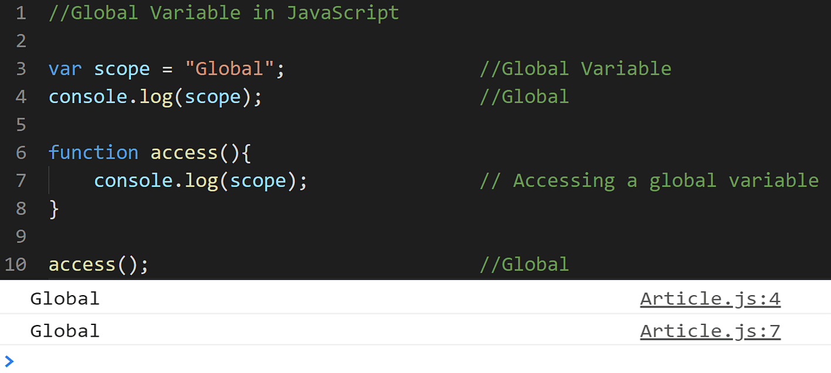
-Variables declared with var, let and const are quite similar when declared outside a block.
They all have Global Scope:
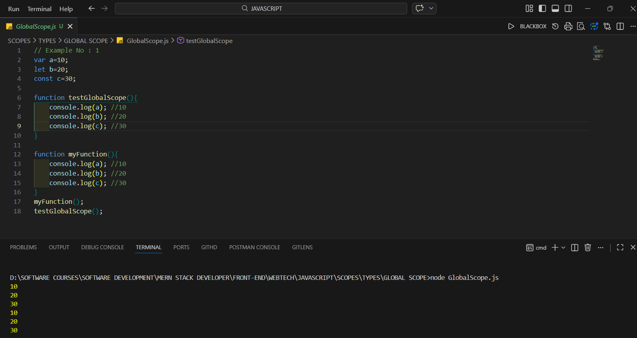
- Variable declared with the var are belonging to the window.
<!DOCTYPE html>
<html lang="en">
<head>
<meta charset="UTF-8">
<meta name="viewport" content="width=device-width, initial-scale=1.0">
<title>Document</title>
</head>
<body>
<!--! Global variables defined with the let,Const keyword do not belong to the window object: -->
<script>
var car="Fortuner";
let Mobile="Iphone15";
const Bike="NS400";
function Global(params) {
console.log(window.car);
console.log(window.Mobile);
console.log(window.Bike);
}
Global();
</script>
</body>
</html>

-You want to know why only car works with window.
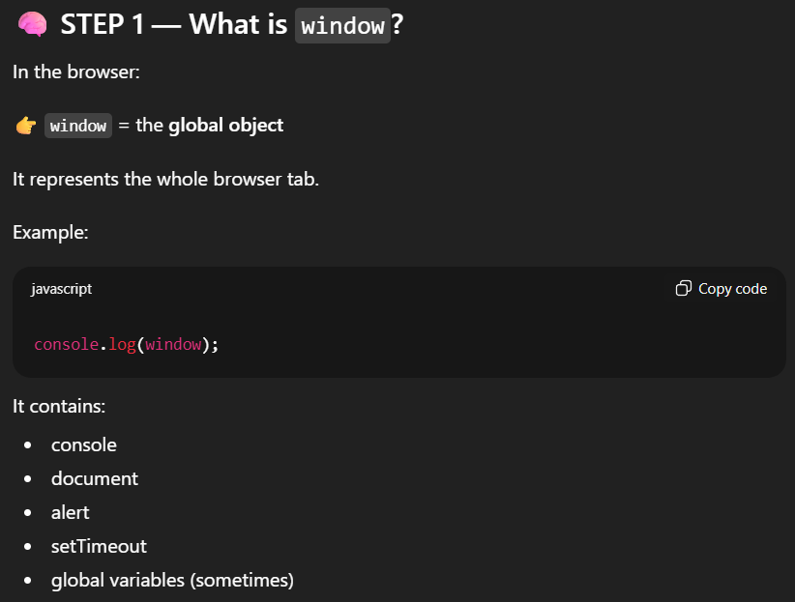
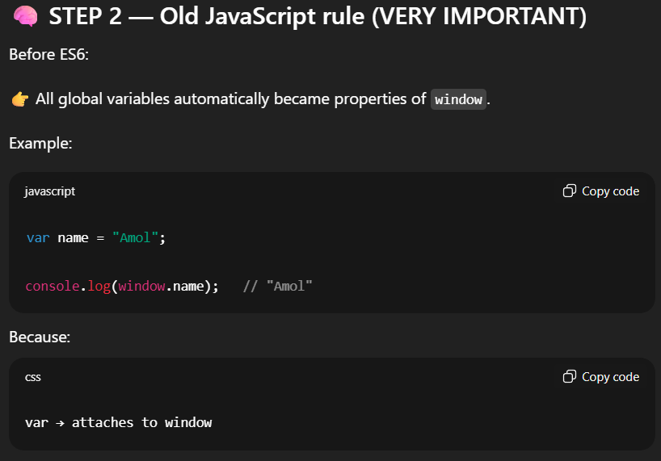
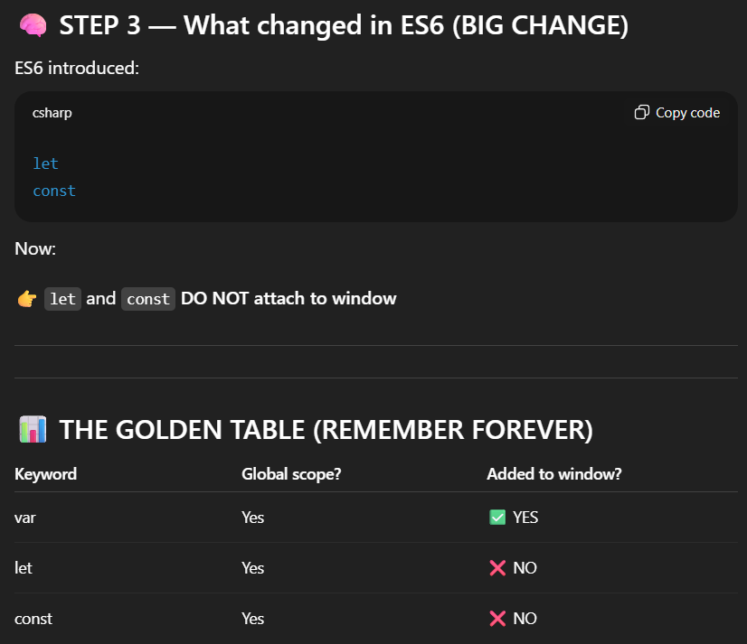

2.Local Scope
-Any variable that you declare inside a function is said to have Local Scope. You can access a local variable can within a function. If you try to access any variable defined inside a function from outside or another function, it throws an error.
-Local variables have Function Scope:
-They can only be accessed from within the function.
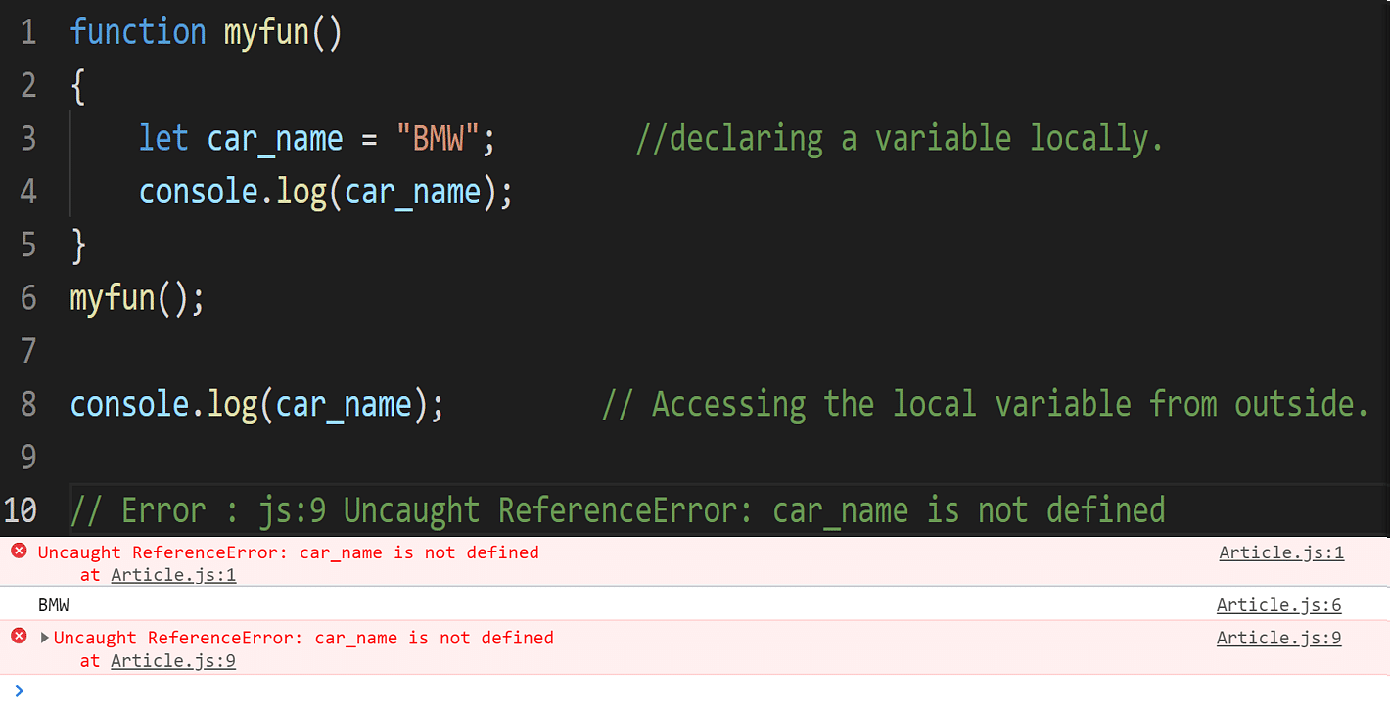
-Since you cannot access a local variable from outside the function, you can have a variable of the same name in another function as well.
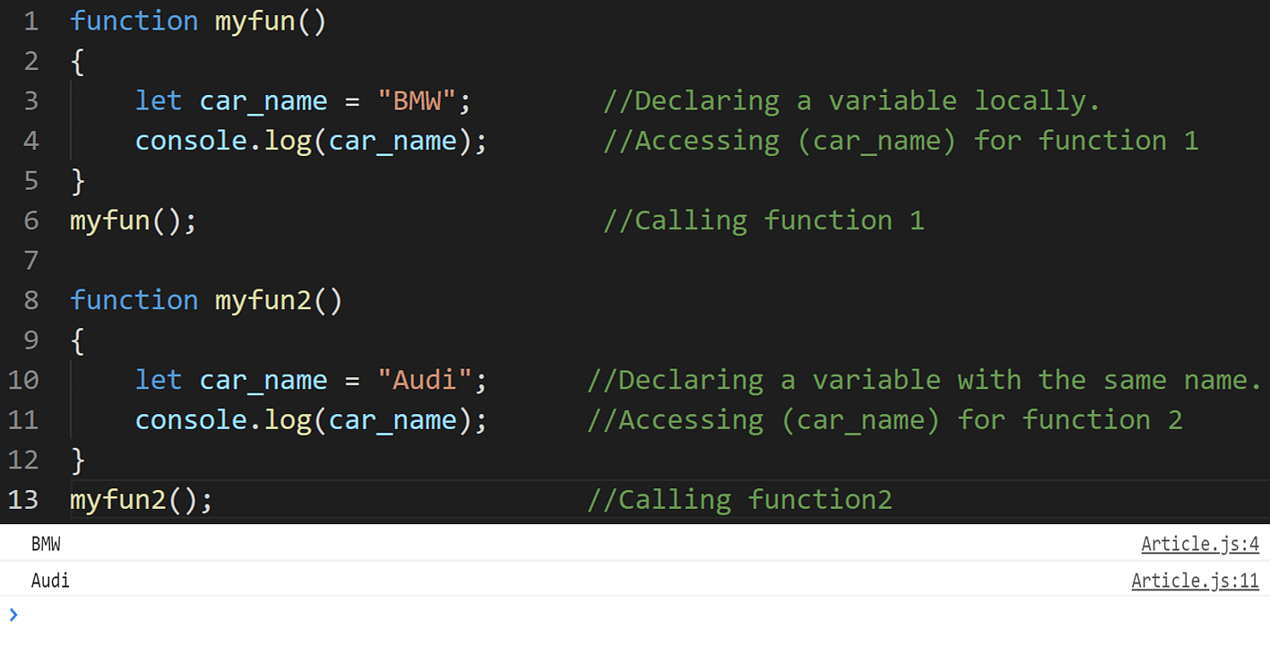

3.Block Scope
-Before ES6 (2015), JavaScript variables had only Global Scope and Function Scope.
-ES6 introduced two important new JavaScript keywords: let and const.
-These two keywords provide Block Scope in JavaScript.
-Variables declared inside a { } block cannot be accessed from outside the block:
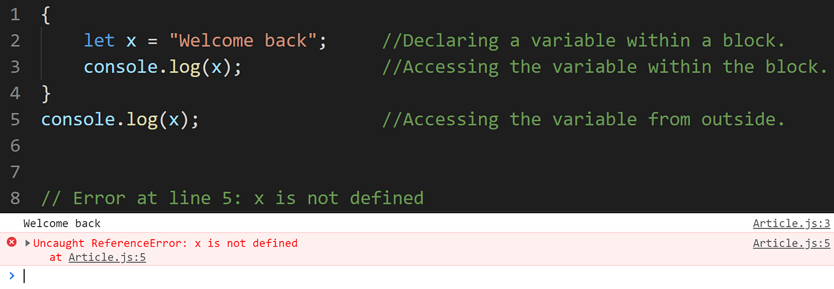
-The block scope does not work with the var keyword. You can either use let or const keywords for that.
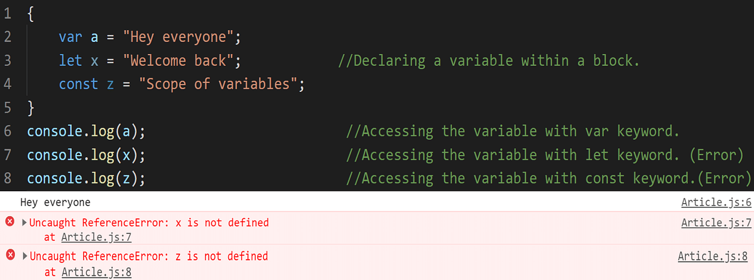
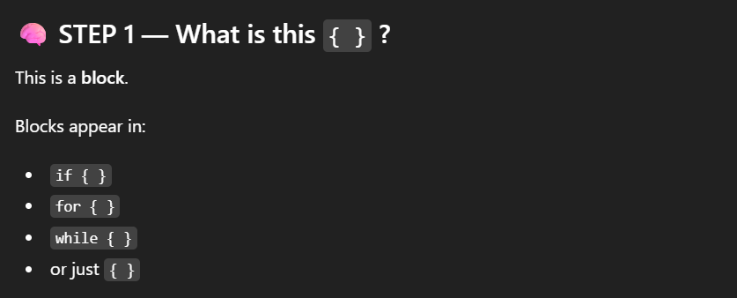
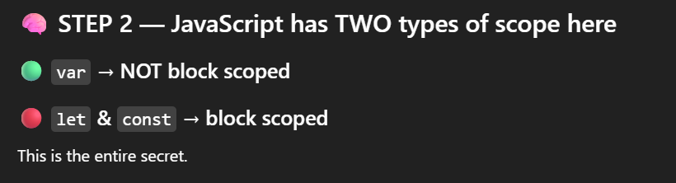
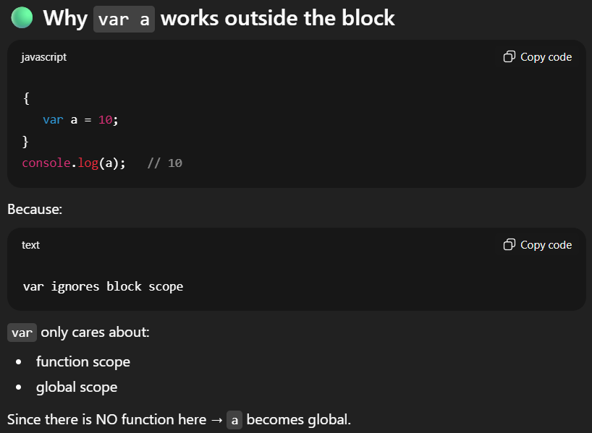

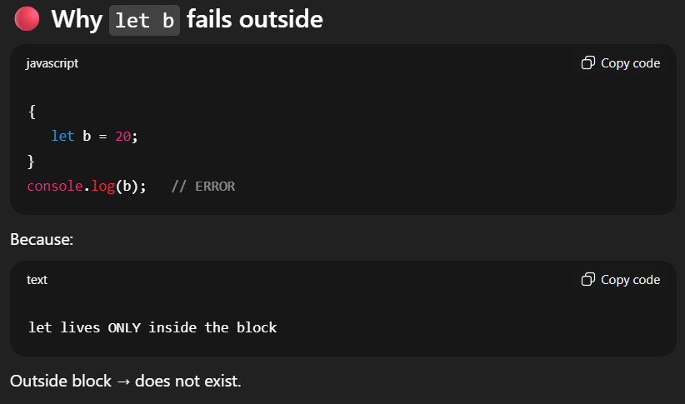
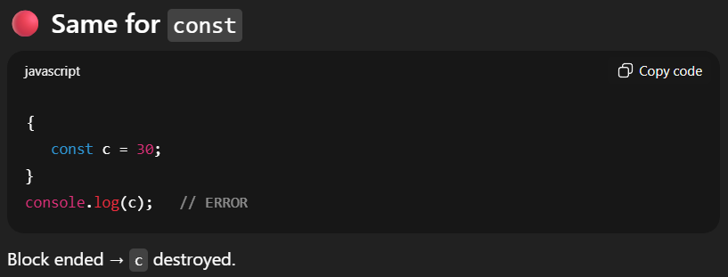

4.Function Scope

-With the creation of each new function, it creates a new scope in JavaScript. You cannot access variables defined inside a function from outside the function or from another function. Var, let, and const work similarly when used inside a function.
-JavaScript has function scope: Each function creates a new scope.
They all have Function Scope:
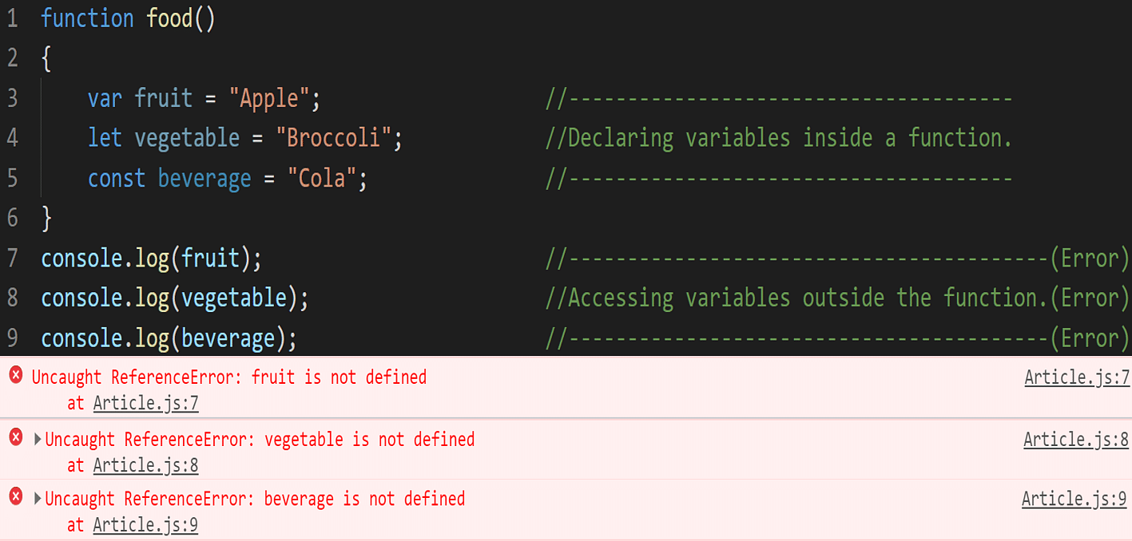

5.Lexical Scope
-Lexical scope means a function can access variables from its parent scope based on where it is defined in the code.
- Lexical: Refers to the structure of the code.
- How it works: In JavaScript, the scope of a variable is determined by where it is declared within the nested structure of your code. A variable declared inside a function is only accessible within that function and any nested functions within it.
- 👉 “Lexical” = based on code position / structure
function outer() {
let x = 10;
function inner() {
console.log(x); // Can access 'x' from the outer function
}
inner();
}
outer();
console.log(x); // Error: 'x' is not defined

✔ Function reads variable from its outer environment.
Key Points:
- Inner functions can access variables from their outer functions.
- Variables declared outside any function are global.
- let and const introduce block scope, meaning variables declared with these keywords are only accessible within the block they are defined (e.g., inside an if statement or for loop).
- Closures: are a powerful feature of JavaScript that rely on lexical scoping. A closure is a function that retains access to its outer function's scope even after the outer function has finished executing.
Closure
-In JavaScript, a closure is a function that "remembers" its outer scope even after that outer function has finished executing
-Closures work because of lexical scope.
-Lexical scope means a function can access variables from its parent scope based on where it is defined in the code.
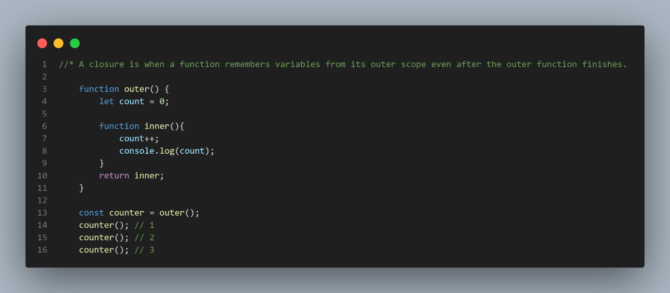
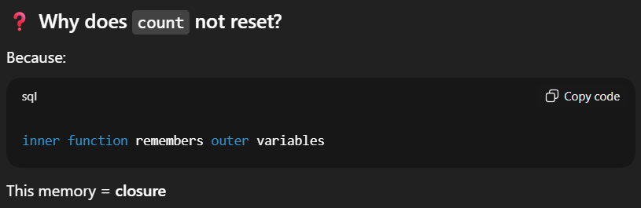
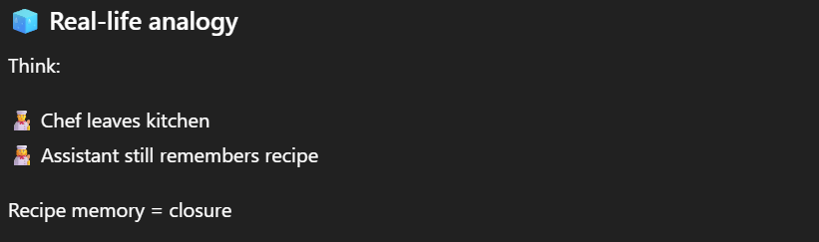
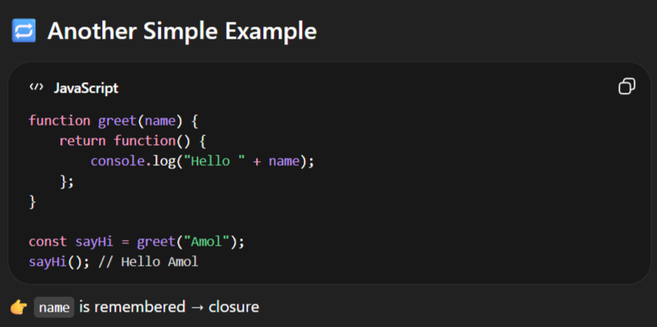

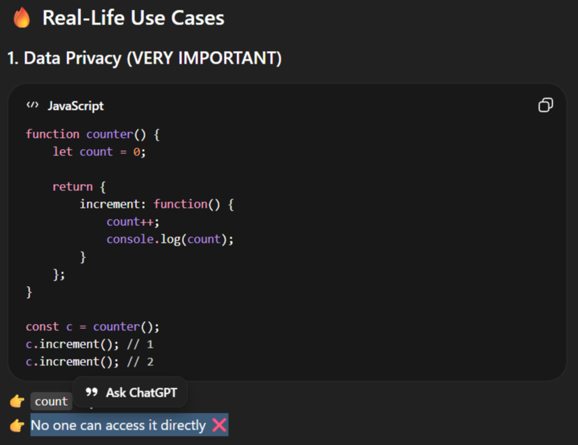

Scope Best Practices

-Scope best practices are essential guidelines for writing clean, efficient, and maintainable code in JavaScript. Below are some key scope best practices to consider:
Use Local Scope Whenever Possible
- Limit the use of global variables.
- Encapsulate variables within functions whenever feasible, as local variables are only accessible within the function where they are declared, reducing the risk of unintended side effects and conflicts.
Avoid Global Variables
- Minimize the use of global variables to prevent variable pollution and potential conflicts with other parts of the codebase.
Use Block Scope with let and const
- Embrace block scope introduced in ES6 using let and const keywords for variable declaration within block statements (e.g., if, for, while).
- Unlike var, let and const have block scope, meaning they are only accessible within the block where they are defined, reducing the risk of unintentional variable hoisting and improving code predictability.
Avoid Variable Hoisting Pitfalls
- Be aware of variable hoisting, a behavior in JavaScript where variable declarations are moved to the top of their containing scope during the compilation phase.
- To avoid confusion and potential bugs, declare variables at the beginning of their scope and assign values later in the code.

HOW TO CHECK SCOPE OF VARIABLE
-In JavaScript, you "check" the scope of a variable by identifying its declaration keyword (var, let, or const) and its physical location within the code. JavaScript uses lexical scoping, meaning the scope is determined by where the variable is written, not where it is called.
1. Identify the Declaration Keyword
The keyword used to declare a variable defines its scoping rules:
- const and let: These are block-scoped. They are only accessible within the nearest set of curly braces {} (e.g., inside an if statement, for loop, or function).
- var: This is function-scoped. It ignores block boundaries (like if or for) and is accessible anywhere within the function it was declared in. If declared outside any function, it is globally scoped.
2. Locate the Variable in the Code
Check where the variable is physically placed to determine its specific scope type:
- Global Scope: Declared outside of any function or block. It is accessible from anywhere in your script.
- Function Scope: Declared inside a function. It is accessible only within that function.
- Block Scope: Declared inside {} braces using let or const. It is only accessible within those braces.
- Module Scope: Declared in a JavaScript Module (type="module"). It is only accessible within that specific file unless explicitly exported.
3. Practical Testing Methods
You can verify a variable's scope using these techniques:
- Intentional ReferenceError: Try accessing the variable outside its suspected block or function. If the console throws a ReferenceError: [variable] is not defined, you have confirmed its scope is restricted to that inner block.
- Browser Developer Tools:
  - Open your browser's console (F12).
  - Set a breakpoint inside a function using the Chrome DevTools Sources panel.
  - Look at the Scope pane in the debugger; it will explicitly list which variables are currently in the Local, Block, Closure, or Global scopes.
- window Object Check: If you use var in the global scope, it becomes a property of the global window object (e.g., window.myVar). Variables declared with let or const do not attach to window.
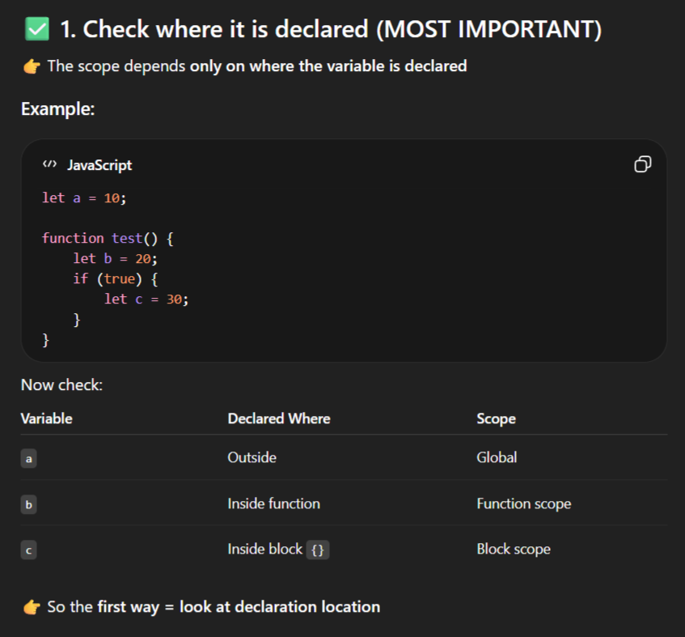
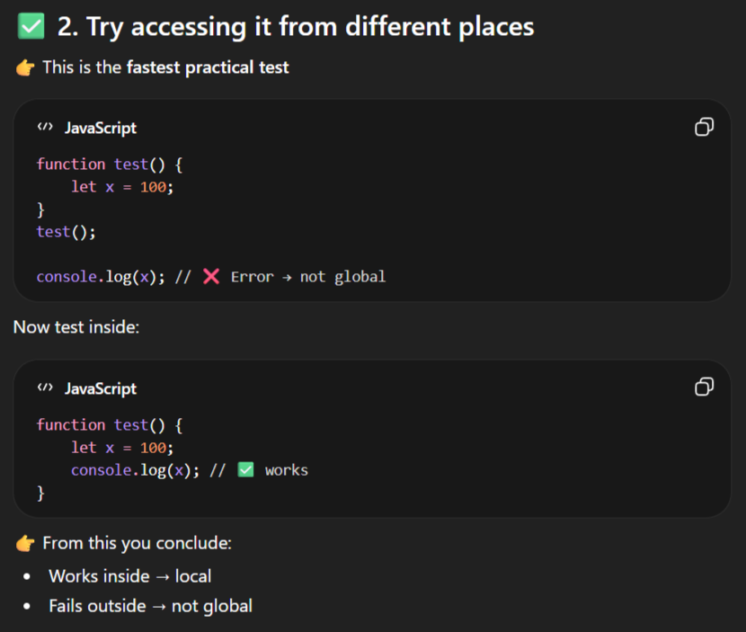
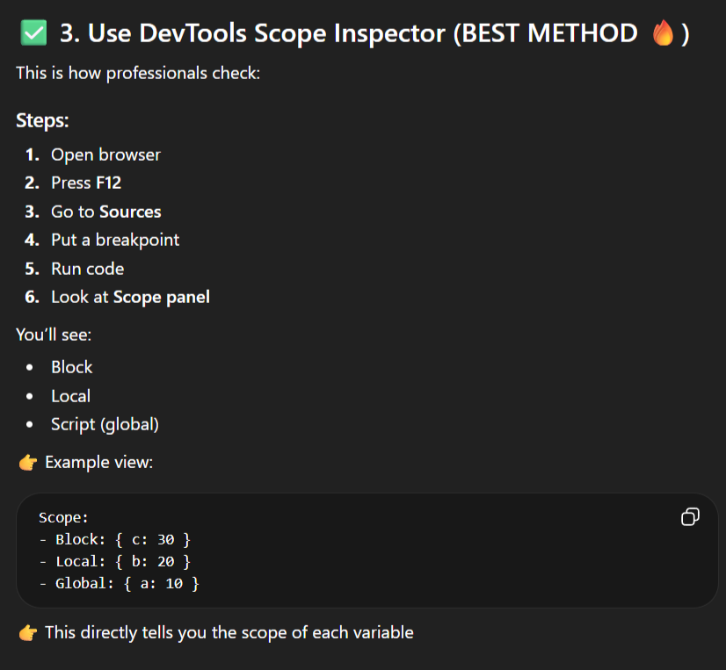
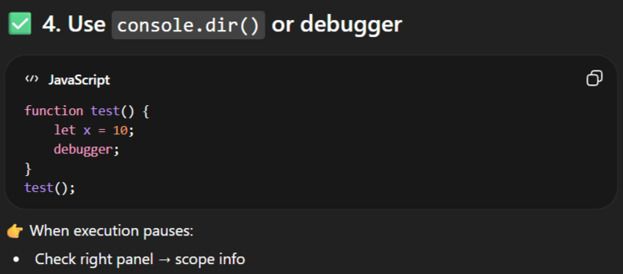
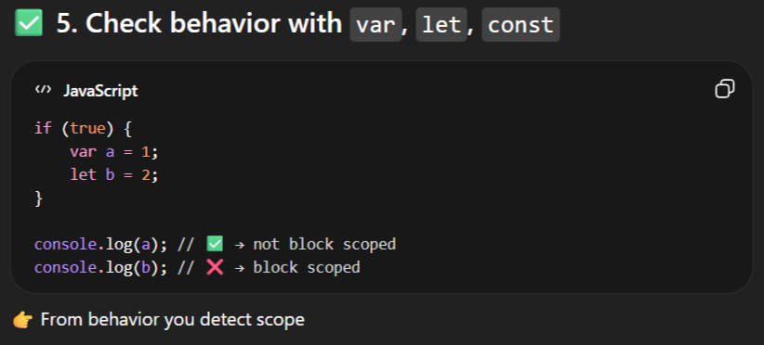
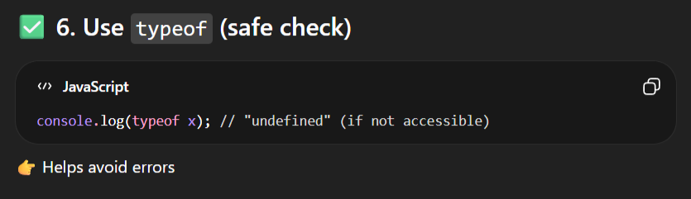

When to Use Different Types of Scope

-Understanding when to use different types of scope in JavaScript is crucial for writing efficient and maintainable code.
-JavaScript offers various types of scope, including global scope, function scope, and block scope, each serving distinct purposes. Here's a guide on when to use each type of scope:
1.Global Scope

-Global scope is the outermost scope in javascript where variables and functions are accessible from anywhere in the program
-When to Use: Use global scope for variables and functions that need to be accessible from anywhere within the codebase.
-If a variable is not inside any function or block, it belongs to the global scope.
🔹 Where Does Global Scope Exist?
- Browser → window object
- Node.js → global object

ExampleNo1 :
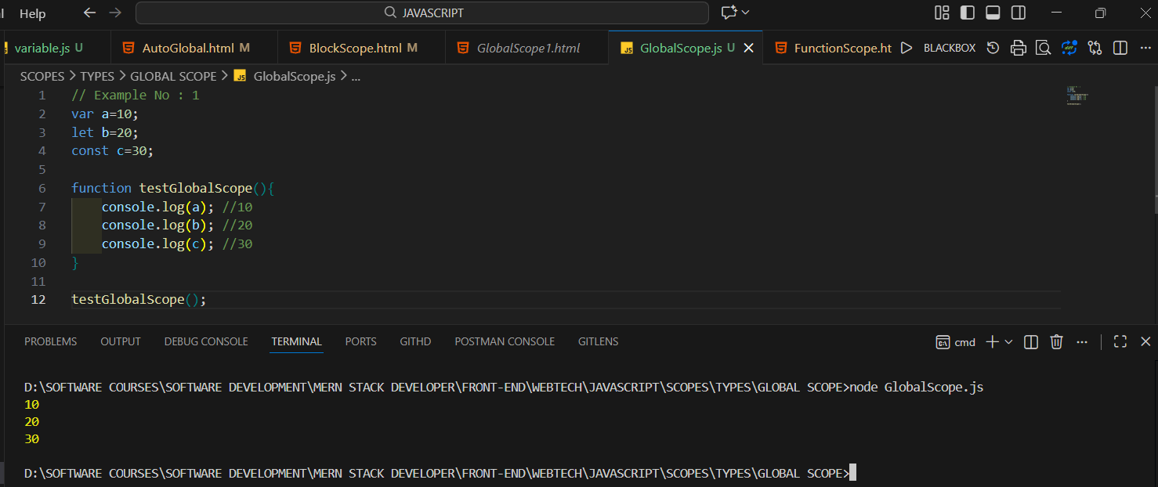

ExampleNo2:
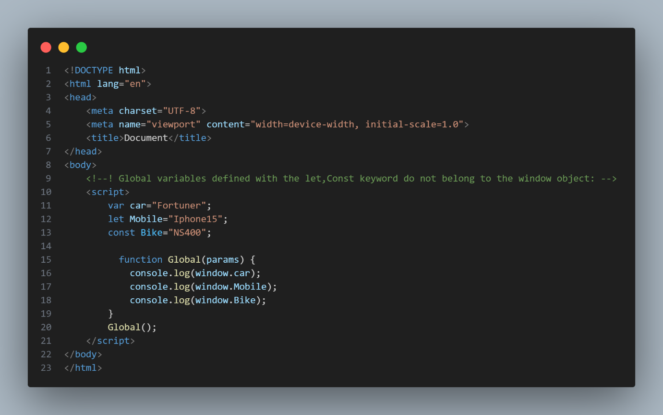
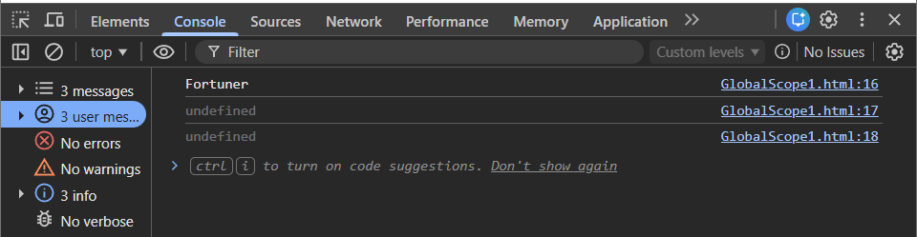

🔹 Global Scope & var, let, const
Keyword | Global Scope | Added to window
var | Yes | Yes
let | Yes | No
const | Yes | No

Example Use Cases:
  - Constants or configuration variables that are used throughout the application.
  - Utility functions or libraries that provide standard functionality across different modules or components.
Considerations: Be cautious when using global scope to avoid polluting the global namespace and potential conflicts with other parts of the codebase.

🔹 Problems with Global Scope
❌ Name conflicts
❌ Security issues
❌ Hard to maintain
❌ Memory stays till program ends
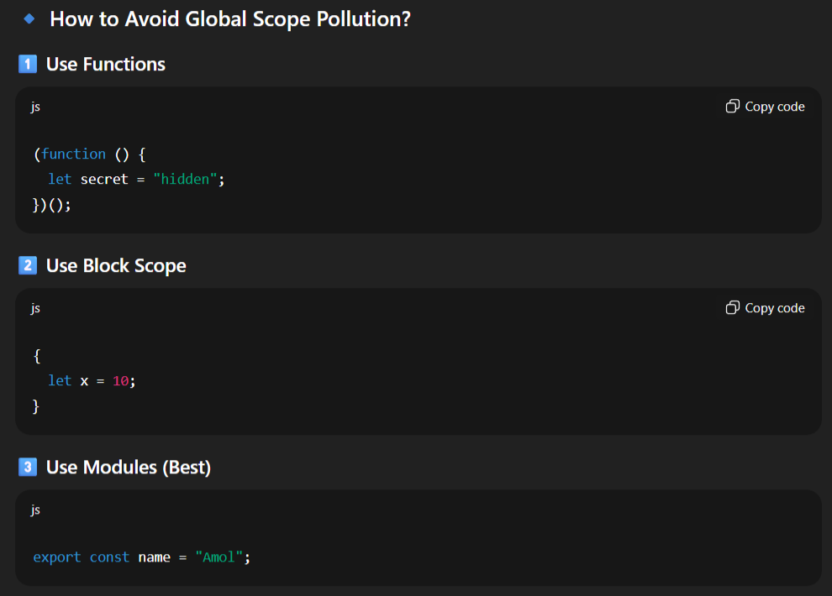

2.Function Scope

👉 Function Scope means variables declared inside a function are accessible only within that function.
They cannot be accessed from outside the function.
📌 var, let, and const declared inside a function are function-scoped.
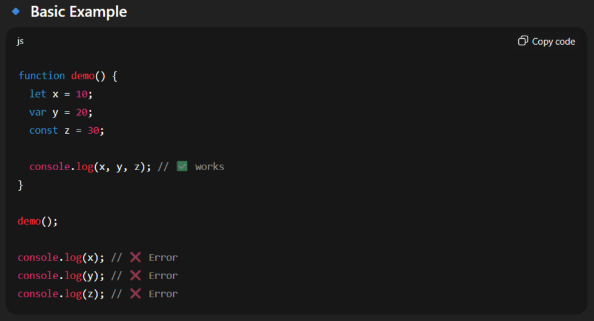
🔹 Why Function Scope is Needed
✔ Prevents variable conflicts
✔ Protects data (encapsulation)
✔ Improves readability
✔ Avoids global pollution

Example No 2:
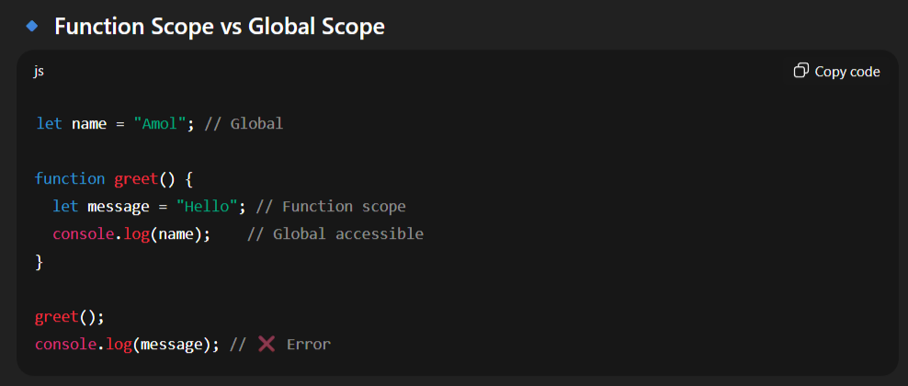
-In above program the message variable declared with the let also inside the function that why when you try to access to outside then you got Error.

Example No 3 :
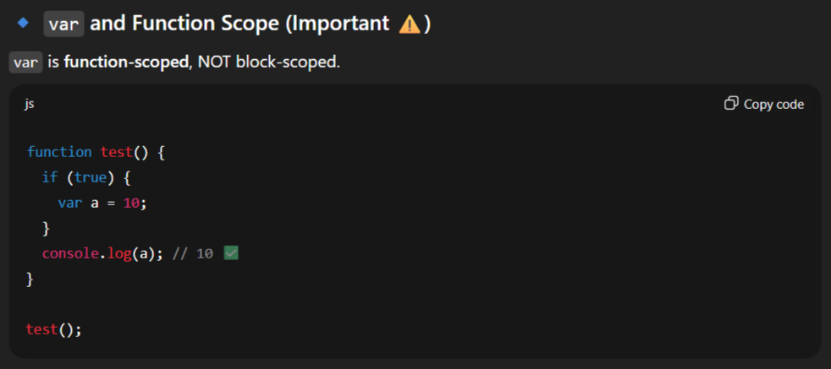
-The variable is accessible the variable type is var which is Global scope.

Example No 4 :
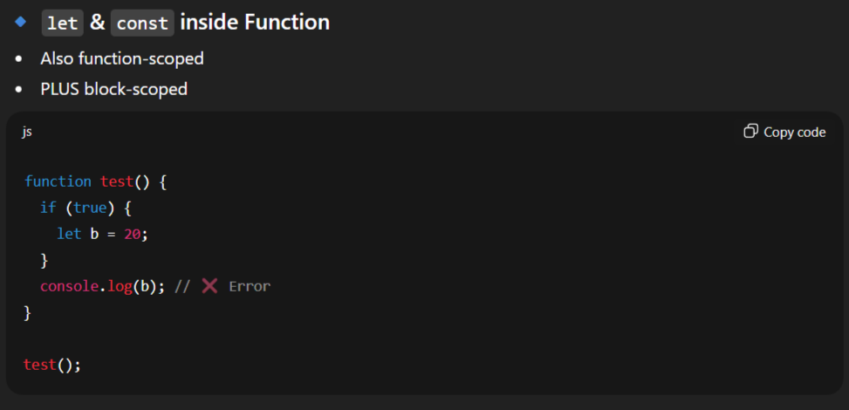
-Here we got error called console.log(b); // ReferenceError: b is not defined cause the let and const are the block scope error.

Example No 5:
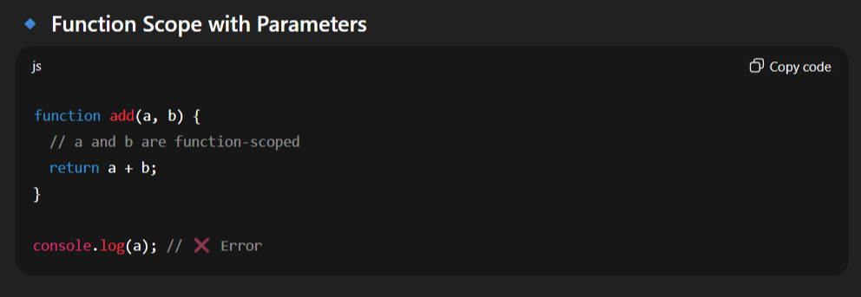
-The variable a & b are the function scoped so it not accessible to the outside.

Example No 6 :
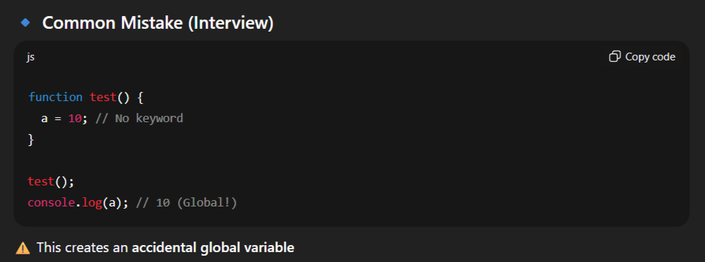

When to Use: Use function scope for variables and functions only needed within a specific function.
Example Use Cases:
  - Temporary variables used for calculations or intermediate results within a function.
  - Helper functions or callbacks that are only relevant to a particular function's execution context.
- Considerations: Variables declared within a function are not accessible outside that function, promoting encapsulation and preventing unintended side effects.

Block Scope (Introduced with let and const)
- When to Use: Use block scope for variables that are limited in scope to a specific block of code, such as if statements, for loops, or while loops.
- Example Use Cases:
  - Loop counters or iterators that are only relevant within a loop.
  - Temporary variables are used for conditionally executing code blocks.
- Considerations: Block-scoped variables are only accessible within the block where they are declared, providing tighter control over variable visibility and lifetime.
Lexical Scope
- When to Use: Lexical scope is inherent in JavaScript and is automatically applied based on the physical placement of code within the source file.
- Example Use Cases:
  - Variables declared in outer scopes are accessible to nested functions, allowing for closures and maintaining access to variables even after the outer function has returned.
- Considerations: Lexical scope enables powerful programming patterns such as closures, which can encapsulate state and create modular and reusable code.

Use Strict Mode

-Enable strict mode (“use strict”) at the beginning of JavaScript files or functions to enforce stricter parsing and error handling. This will help catch common programming mistakes and promote cleaner code practices.
JavaScript Strict Mode for Defining Scope of a Variable
-In JavaScript, if you forget to declare a variable with a keyword: var, let, and const, JavaScript automatically takes it as a global variable, and you can access it anywhere in the program.
<!DOCTYPE html>
<html lang="en">
<head>
<meta charset="UTF-8">
<meta name="viewport" content="width=device-width, initial-scale=1.0">
<title>Document</title>
</head>
<body>
<!--! AUTOMATICALLY GLOBAL -->
<! --* If you assign a value to a variable that has not been declared, it will automatically become a GLOBAL variable: -->
<p id="demo"></p>
<script>
myFunction ();
// code here can use carName as a global variable
document. getElementById("demo").innerHTML = "I can display " + carName;
function myFunction() {
carName = "Volvo";
}
console.log(carName);
</script>
</body>
</html>

Strict Mode
All modern browsers support running JavaScript in "Strict Mode".
In "Strict Mode", undeclared variables are not automatically global.
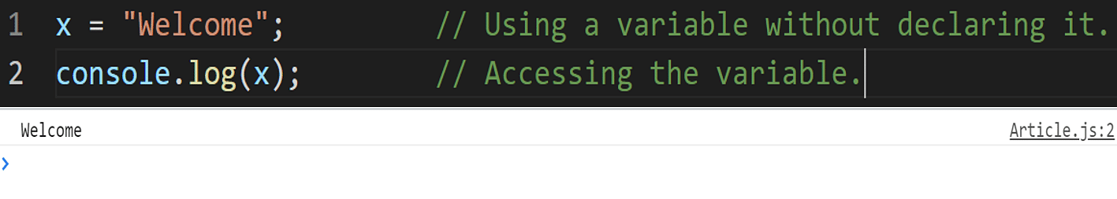
-To avoid such mistakes and confusion, the strict mode was introduced in JavaScript with ES5 (ECMAScript 5) in the year 2009.
- Strict mode will throw an error if you try to use the same syntax after including "strict mode" in your program. It will help you in writing cleaner and more secure code.
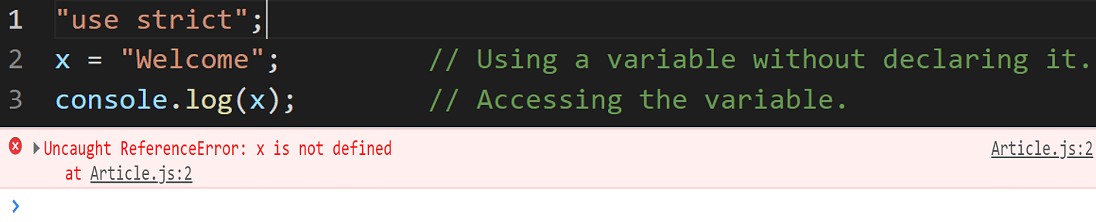
- Just like variables, strict mode too can be used either globally or locally. If you write "use strict" at the program's start, it will be used globally. Otherwise, you can also use strict mode locally inside a function.
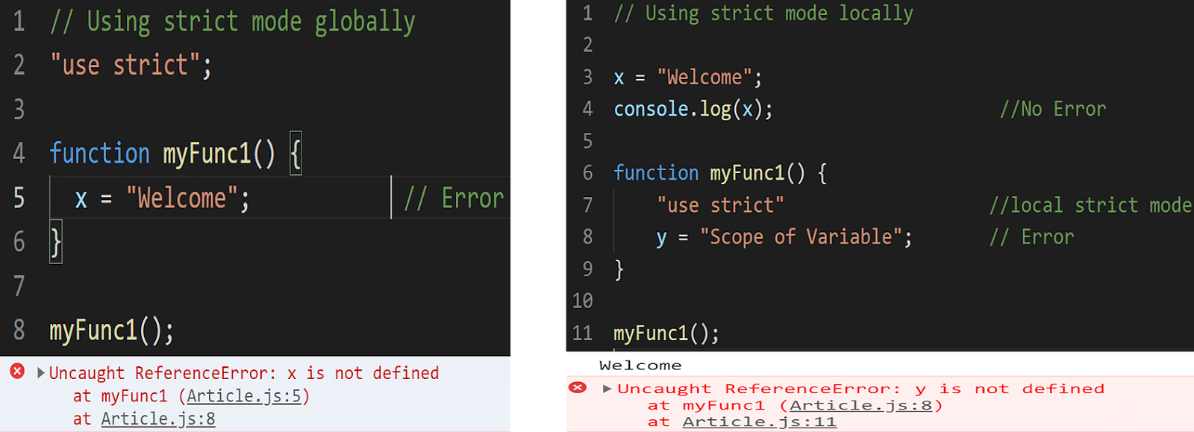
Warning
-Do NOT create global variables unless you intend to.
-Your global variables (or functions) can overwrite window variables (or functions).
-Any function, including the window object, can overwrite your global variables and functions.
HOISTING

- Hoisting is JavaScript's default behavior of moving declarations to the top.
-It is the process of before Declaration Variable we can Initialize it.
-In JavaScript, a variable can be declared after it has been used.
-In other words; a variable can be used before it has been declared
- Hoisting is works with Variables(var,let,const).
-When there no type of variables are not declared
-JavaScript Hoisting refers to the process whereby the interpreter appears to move the declaration of functions, variables, classes, or imports to the top of their scope, prior to execution of the code.
console.log(x); // undefined
var x = 5;

-JavaScript actually does:
-This code behaves as if it were interpreted like this:
var x; // Declaration is hoisted
console.log(x); // undefined
x = 5; // Initialization remains here

Function Hoisting:
-Function declarations are also hoisted similarly, meaning the entire function declaration is moved to the top of the scope. For example:
foo(); // "Hello, world!"
function foo() {
console.log("Hello, world!");
}

-Here, foo() can be called before its declaration in the code because the function declaration itself is hoisted to the top of its scope.

Hoisting Doesn't Move Code:
-It's important to note that hoisting doesn't physically move any code in your script. It's a concept that helps explain the behavior of variable and function declarations during the compilation phase of JavaScript code execution. The actual code you write remains in the same order you wrote it; only the declarations are conceptually moved to the top.
- Hoisting means JavaScript prepares variables and functions in memory before running code — it does NOT move code.
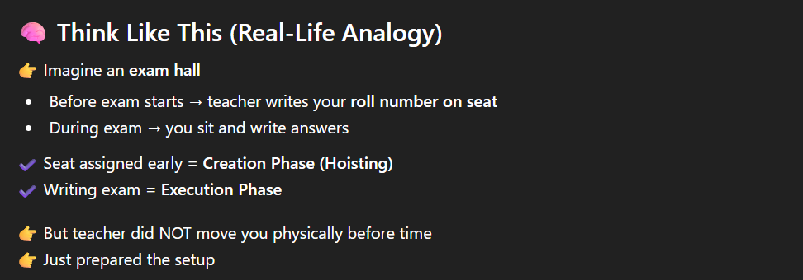
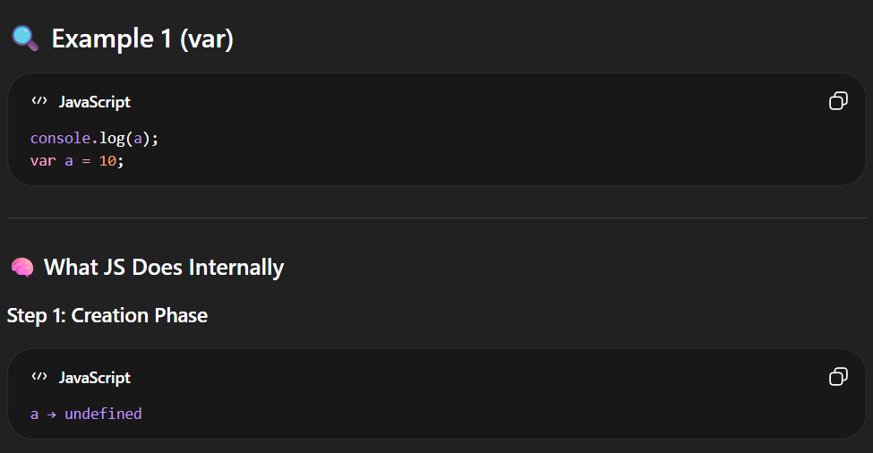
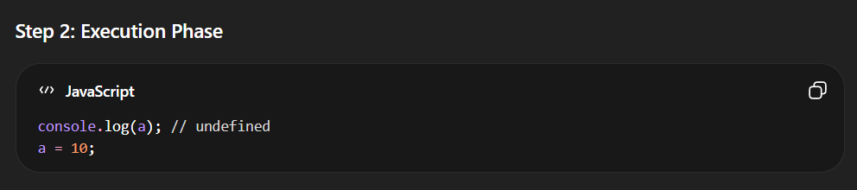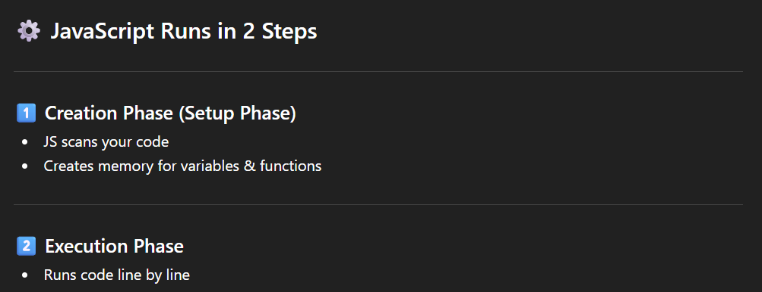
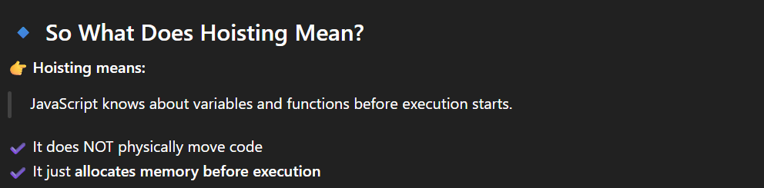
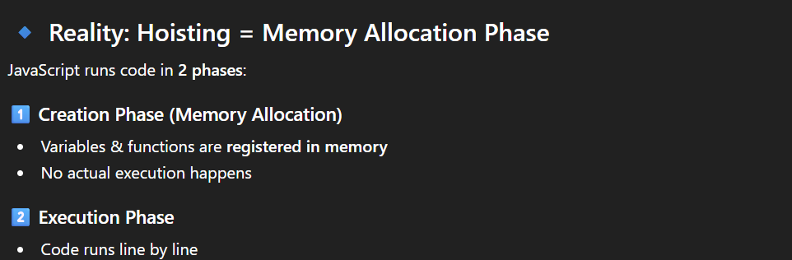
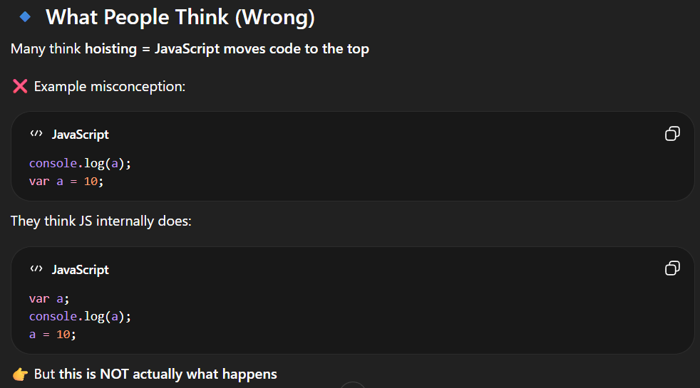
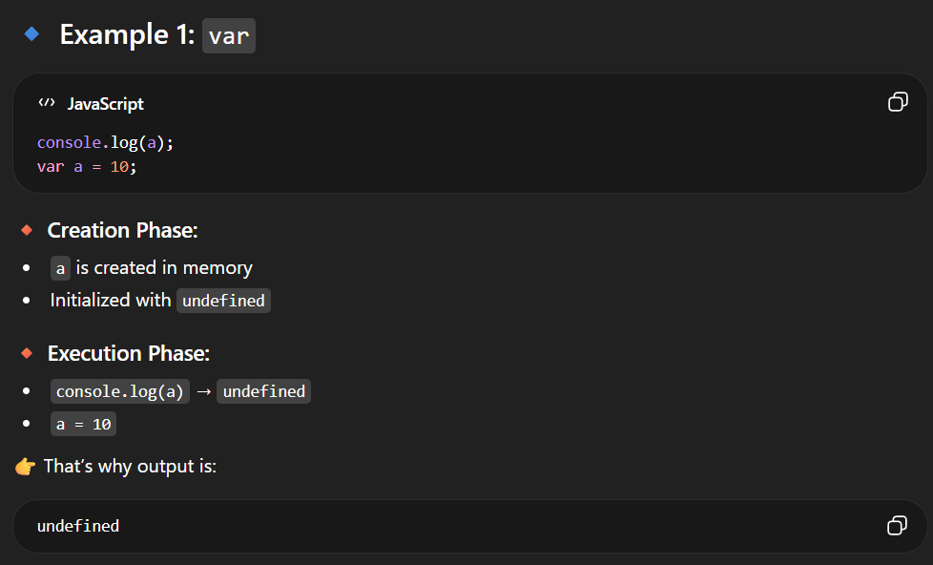

Function Declarations vs. Function Expressions:
Function declarations are fully hoisted, meaning the entire function body is moved to the top of its containing scope. This allows functions to be called before they are declared in the code.
foo(); // "Hello, world!"

function foo() {
console.log("Hello, world!");
}

-However, function expressions (where a function is assigned to a variable) are not hoisted in the same way:
bar(); // TypeError: bar is not a function
var bar = function() {//Here bar is declared with var
console.log("This won't work!");
};

-In this case, bar is hoisted as a variable declaration (var bar;), but its assignment to a function expression remains where it is in the code, resulting in a TypeError when trying to call bar() before it's assigned.
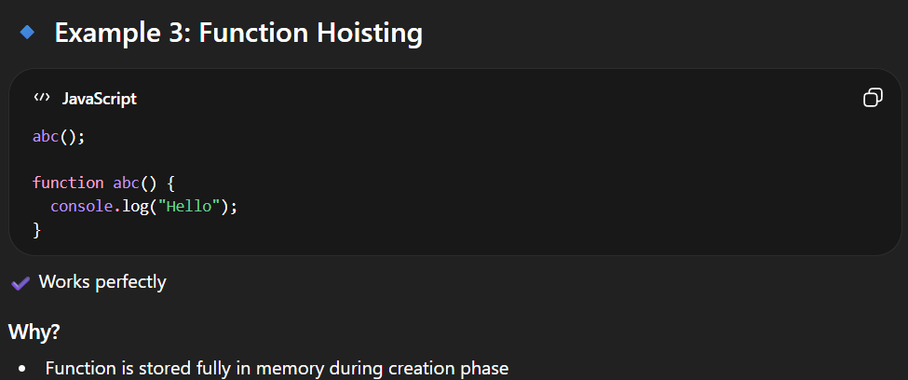
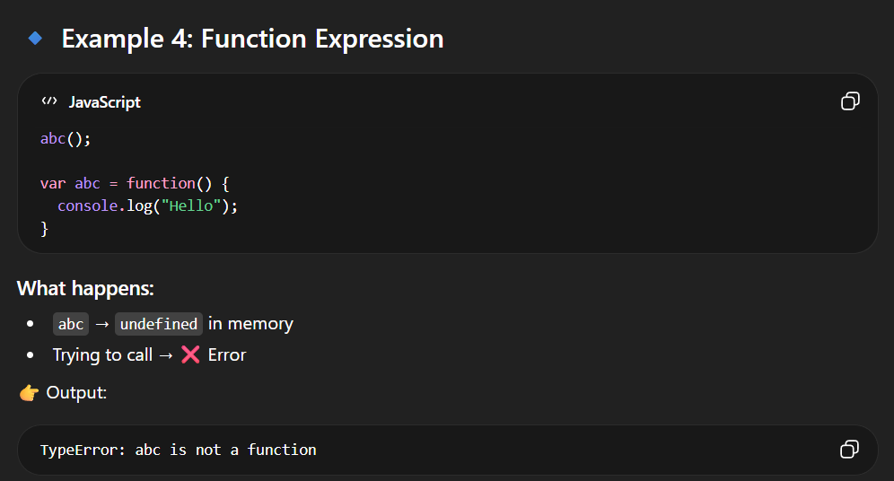

Hoisting Behaviour of let and const:
Temporal Dead Zone (TDZ):
-Variables declared with let and const are hoisted to the top of their block scope (just like var), but they are not initialized.
-Accessing these variables before their declaration (initialization) results in a ReferenceError. This period between the hoisting and the actual initialization is called the Temporal Dead Zone (TDZ).
Example:
console.log(x); // ReferenceError: Cannot access 'x' before initialization
let x = 10;

-In this example, x is hoisted to the top of its scope (global or function scope), but it's not initialized. Trying to access x before the initialization (let x = 5;) results in a ReferenceError due to the TDZ.
Benefits:
-Hoisting let and const declarations allows you to understand the scope where they are available, similar to var.
-The Temporal Dead Zone (TDZ) behavior ensures that variables are properly declared and initialized before being used, helping to catch potential issues early.
Correct Usage:
-To avoid TDZ errors, ensure that you only access let and const variables after they have been properly declared and initialized.
Additional Example Showing TDZ in a Conditional Block:
let y = 20;
if (true) {
console.log(y); // Throws ReferenceError
let y = 30;
}

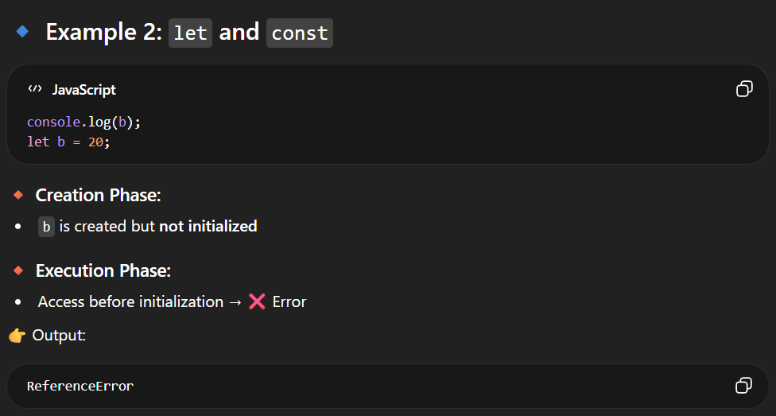
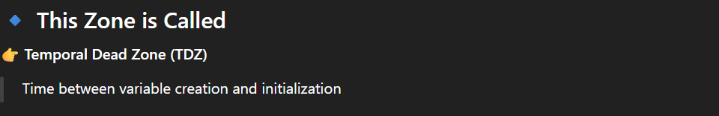

DATATYPES
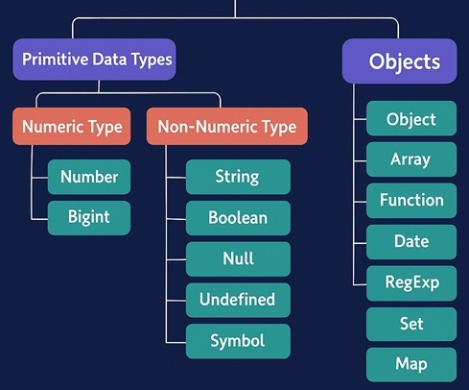
- Data types in JavaScript refers to the types of the values that we are storing or working with.
-Datatype is the Type of the data.
-Datatype is the data storage format that contains specific type of data.
-Datatype contains different types of values we used in programming.
-Data Types or Types are attributes that are predefined or can be created by the user so that the program can easily detect the different types of information.
Dynamic and weak typing
-JavaScript is a dynamic language with dynamic types. Variables in JavaScript are not directly associated with any particular value type, and any variable can be assigned (and re-assigned) values of all types:
let foo = 42; // foo is now a number
foo = "bar"; // foo is now a string
foo = true; // foo is now a boolean
foo= null; // foo is now a null

There are altogether 8 basic data types in JavaScript.
Data Type | Description | Example
String | Textual data. | 'hello', "hello world!", etc.
Number | An integer or a floating-point number. | 3, 3.234, 3e-2, etc.
BigInt | An integer with arbitrary precision. | 900719925124740999n, 1n, etc.
Boolean | Any of two values: true or false. | true and false
undefined | A data type whose variable is not initialized. | let a;
null | Denotes a null value. | let a = null;
Symbol | A data type whose instances are unique and immutable. | let value = Symbol('hello');
Object | Key-value pairs of collection of data. | let student = {name: "John"};

-In JavaScript there are two types of Datatypes:-
1]Primitive Datatype
2]Non-Primitive Datatype

Note: JavaScript data types are divided into primitive and non-primitive types.
- Primitive Data Types:- They can hold a single simple value. String, Number, BigInt, Boolean, undefined, null and Symbol are primitive data types.
- Non-Primitive Data Types:- They can hold multiple values. Objects are non-primitive data types.

Difference Between Primitive vs Non-Primitive
SrNo | Primitive | Non-Primitive
 | Primitive Data types are predefined. | Non-Primitive data types are created by the programmer
 | Primitive Data types will have certain values. | Non-Primitive data types can be NULL.
 | Size depends on the type of data structure. | Size is not fixed
 | Examples are numbers and strings. | Examples are Array and Linked List.
 | It can start with a lowercase. | It can start with uppercase.

1]PRIMITIVE DATATYPE

-Primitive data types are the built-in data types provided by JavaScript. They represent single values and are not mutable.
-Primitive = Simple Single value
-Primitive values are immutable(cannot be changed the original value)
-Primitive values compared by value.
-Stored directly in the memory
Type | typeof return value | Object wrapper
Null | "object" | N/A
Undefined | "undefined" | N/A
Boolean | "boolean" | Boolean
Number | "number" | Number
BigInt | "bigint" | BigInt
String | "string" | String
Symbol | "symbol" | Symbol
-All primitive types, except null, can be tested by the typeof operator. typeof null returns "object", so one has to use === null to test for null.
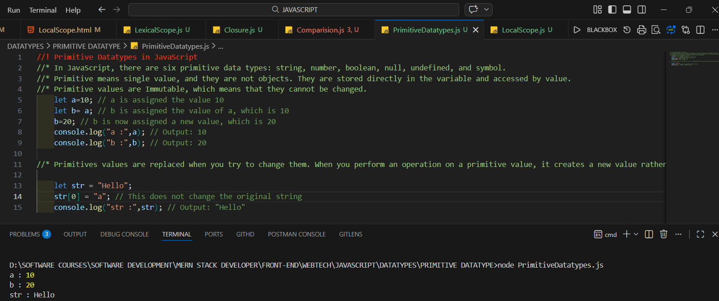

✔ Copy created
✔ Original unchanged
-This proves primitives store value, not reference.

1.STRING

-String Are Immutable In Nature.
-String Is Primitive Datatype in JavaScript.
-The sequence of character is called as String.
-Strings are for storing text
-Strings are written with quotes ( “ “ )
-We write String in following ways: -
1." String "
2.' String '
3.` String `
e.g.: -
Single Quotes | 'Hello'
Double Quotes | "Hello"
Backticks | `Hello`

-We Can Write Also
1." ' String ' "
2." ` String ` "
-Not Allowed To String in Following Ways: -
1. " " " " It is Not Allowed because same Sign is Dominated to each other
2. ` ` ` ` It is Not Allowed because same Sign is Dominated to each other
3. ' ' ' ' It is Not Allowed because same Sign is Dominated to each other
e.g.: -" " String " " it is not allowed
-We can create the String using Two Ways
1.Using Literals
2.Using New Keyword

1.Using Literals

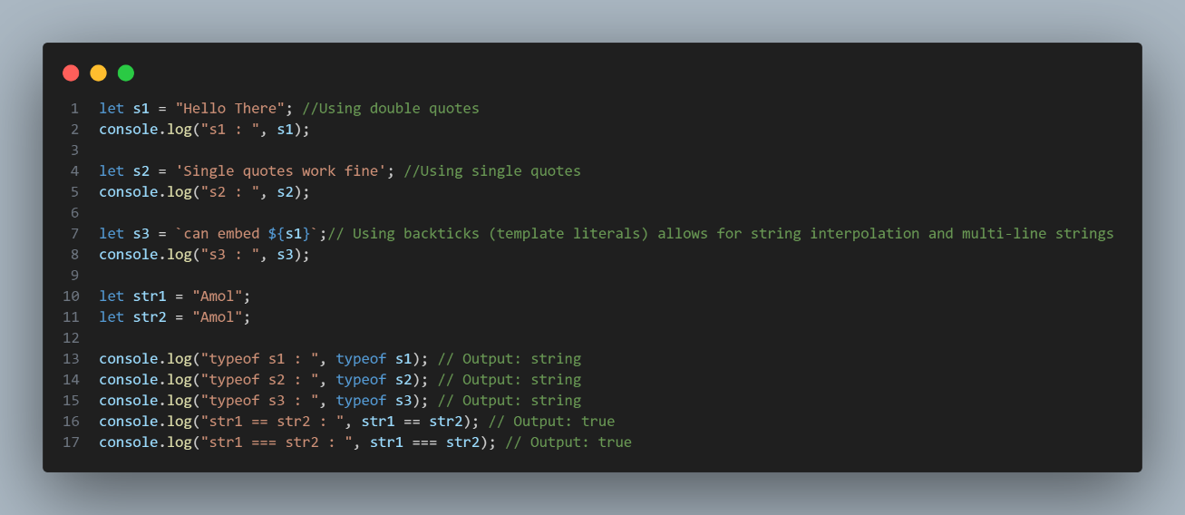
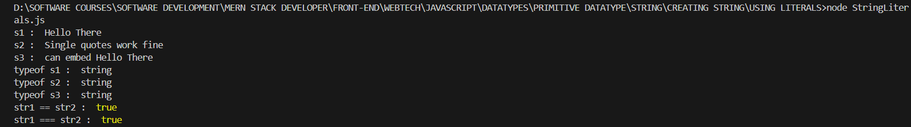
-In this we have create variable and directly pass the Values.
-We can pass in three ways as shown in above example.
2.By Using New Keyword

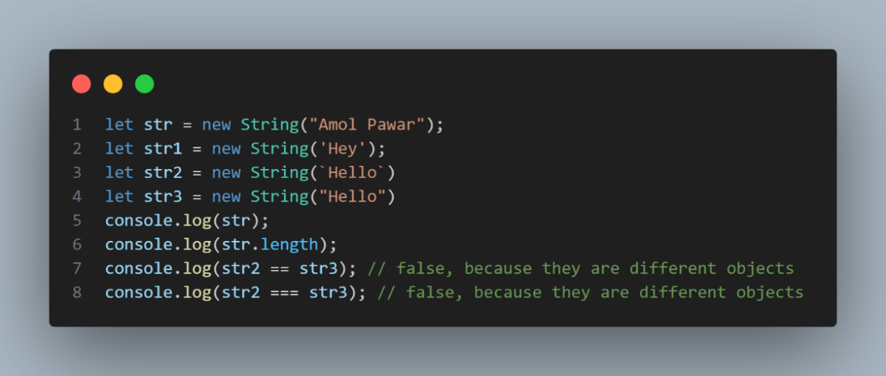
-In this case we have to create the variable.
-Then we have write the New Keyword.
-After that call the String Constructor.
-Then pass the String value in the String Class Constructor.
Length Property
- To find the length of a string, use the built-in length property:
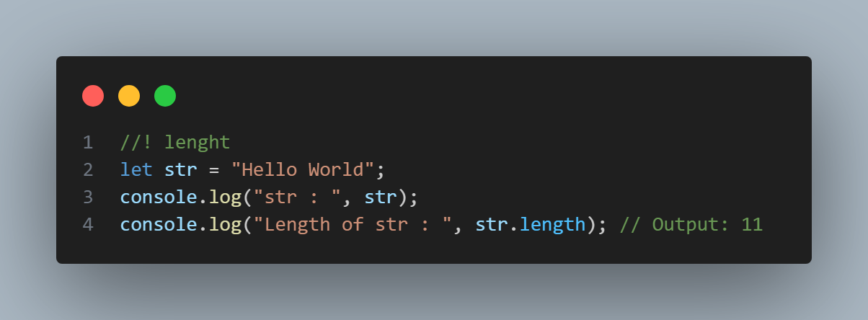

Escape Characters
-The backslash escape character (\) turns special characters into string characters:
Code | Result | Description
\' | ' | Single quote
\" | " | Double quote
\\ | \ | Backslash

1.Insert A Single Coat.
<script>
let text= 'It\'s alright.';
document.write(text);
</script>

O/P:- It's alright.

2.Insert Double Coat in String
<script>
let text = "We are the So called \"Vikings\" From the North.";
document.write(text);
</script>

O/P:-We are the So called "Vikings" From the North.

3.Insert BackSlash in String
<script>
let text = "The character \\ is called backslash.";
document.write(text);
</script>

O/P:- The character \ is called backslash.

Six other escape sequences are valid in JavaScript:
Code | Result
\b | Backspace
\f | Form Feed
\n | New Line
\r | Carriage Return
\t | Horizontal Tabulator
\v | Vertical Tabulator
-These other Escape Sequence character works only Browsers Console.
Access String Characters
-One way is to treat strings as an array and access the character at the specified index. For example,
<script>
let message = "hello";
// use index 1 to access
// 2nd character of message
console.log(message[1]); // e
</script>

Features of JavaScript Strings

1. JavaScript Strings are Immutable
<!--! String are immutable in Nature -->
<script>
let message = "hello";
message[0] = "H";
console.log(message); // hello
</script>

-You cannot change the String because it is Immutable in Nature.
-But you achieve that output by assigning new Value.
<!--* you cannot change value of String But you can assign new Value in String -->
<script>
let message = "hello";
message = "Hello";
console.log(message); // Hello
</script>

2. JavaScript Strings are Case-Sensitive
In JavaScript., the lowercase and uppercase letters are treated as different values. For example,
<script>
let value1 = "a";
let value2 = "A"
console.log(value1 == value2); // false
</script>

-Javascript strings are primitive and immutable: All string methods produce a new string without altering the original string.
STRING BASIC METHODS
String length  String charAt()  String charCodeAt()  String codePointAt()  String concat()  String at()  String [ ]  String slice()  String substring()  String substr()  String toUpperCase()  String toLowerCase() | String isWellFormed()  String toWellFormed()  String trim()  String trimStart()  String trimEnd()  String padStart()  String padEnd()  String repeat()  String replace()  String replaceAll()  String split()

There are 4 methods for extracting string characters:
- The at(position) Method
- The charAt(position) Method
- The charCodeAt(position) Method
- Using property access [] like in arrays.

-The at() method returns the character at a specified index (position) in a string.
1.at()

-It accepts Negative Values.
-ES2022 introduced the string method at():
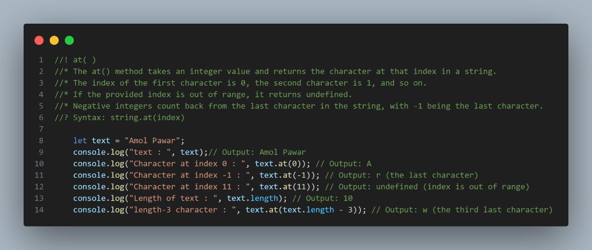
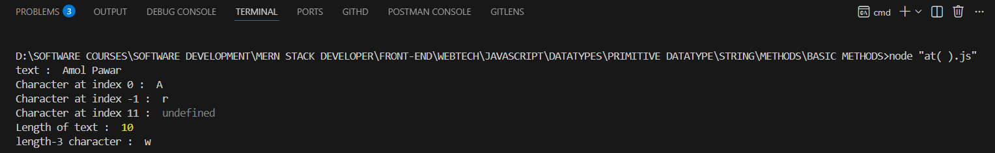

-The charAt() method returns the character at a specified index (position) in a string
2.charAt()
-It cannot accepts the Negative values.
-It cannot accepts the values greater than length of string.
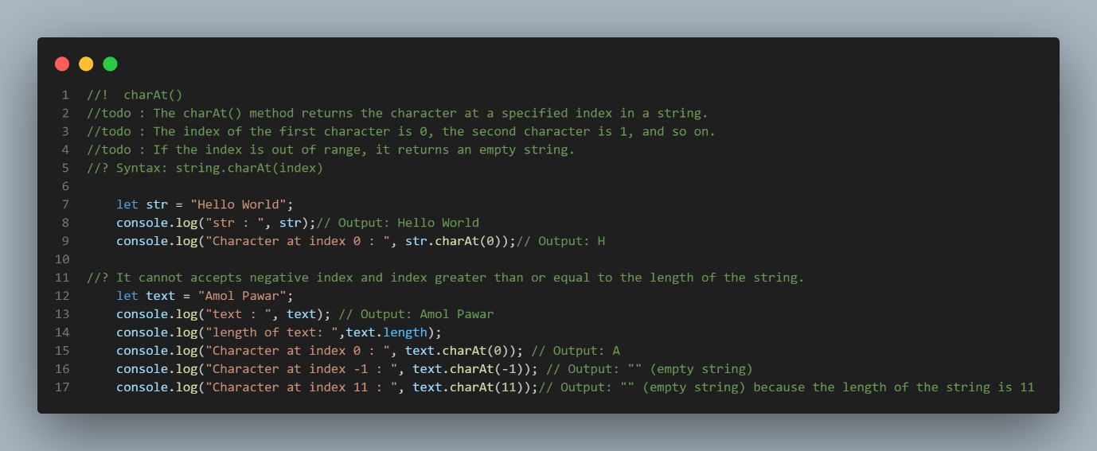
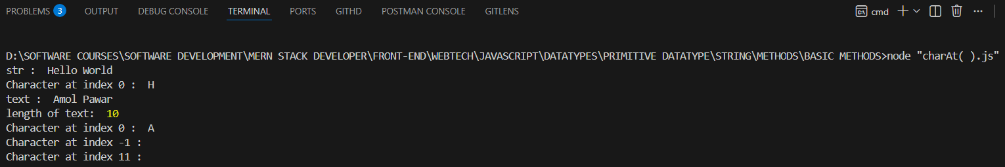
3.charCodeAt()

-The charCodeAt() method returns the code of the character at a specified index in a string:
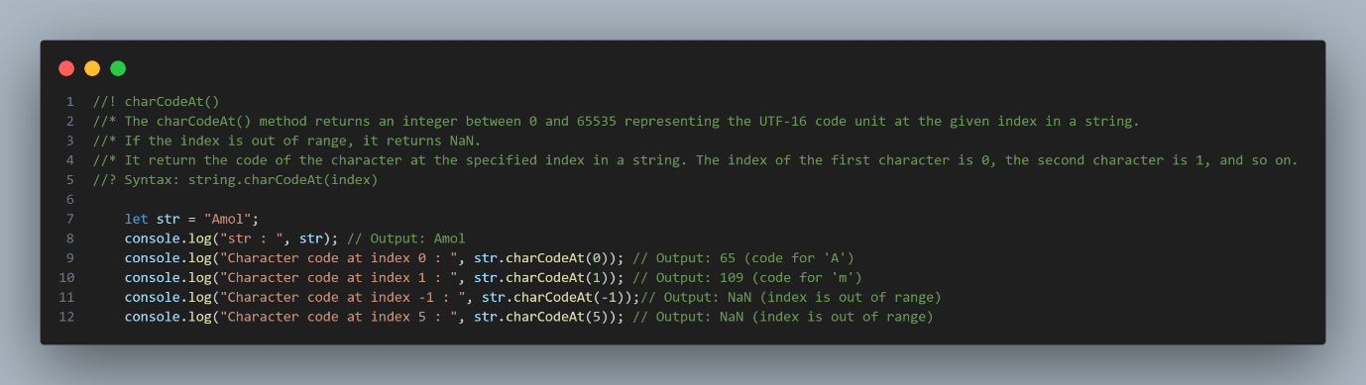
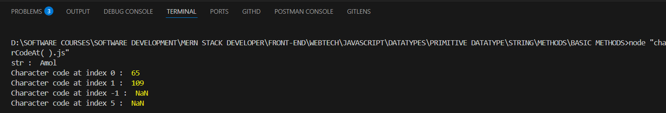
-If the string index is out of range then it will return the NaN
-It cannot accepts Negative value it return returns the NaN.

4.[0]

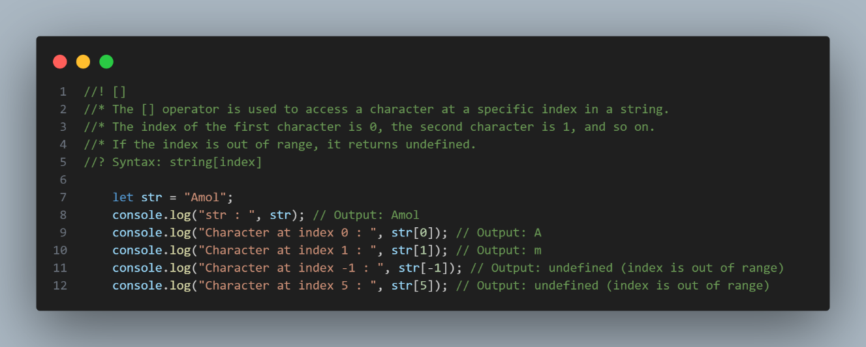
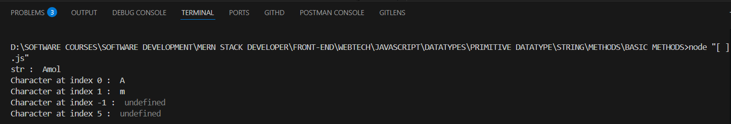
- -It makes strings look like arrays (but they are not)
- If no character is found, [ ] returns undefined, while charAt() returns an empty string.
- It is read only. str[0] = "A" gives no error (but does not work!)

5.toUpperCase

-The toUpperCase() method returns the string converted to uppercase.
-toUpperCase() method does not change Original String.
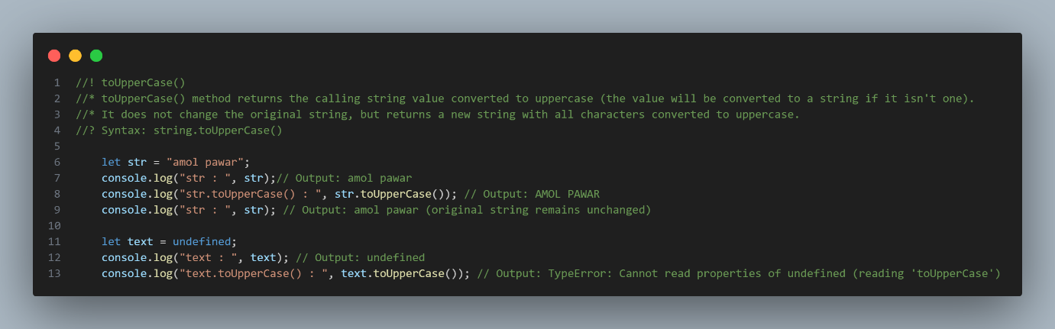
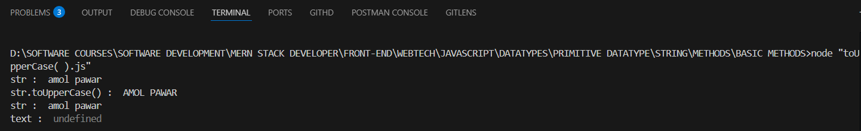

Notes:
- The toUpperCase() method raises TypeError when called on null or undefined.
- The toUpperCase() method does not change the original string.

6.toLowerCase()

-toLowerCase() method converts the Uppercase string into LowerCase string.
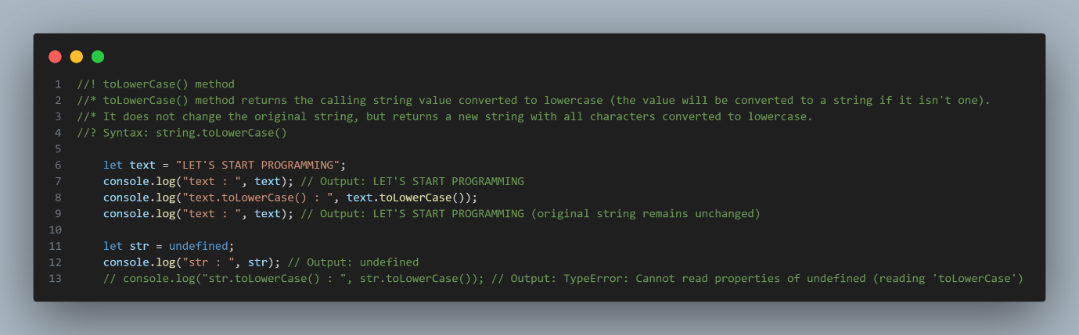
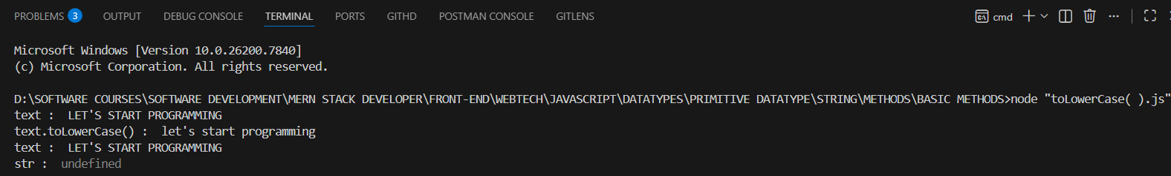
Note
- The toLowerCase() method raises TypeError when called on null or undefined.
- The toLowerCase() method does not change the original string.

7.concat()

-concat() joins two or more strings:
-It takes two parameter:
concat(“ “,stringAsAnArgument)
- First(optinal):-Inside this if you want space or any sign to be for string separation you can pass as an First Argument.
- String:-inside this pass the String Variable as an argument want to be concatenated.
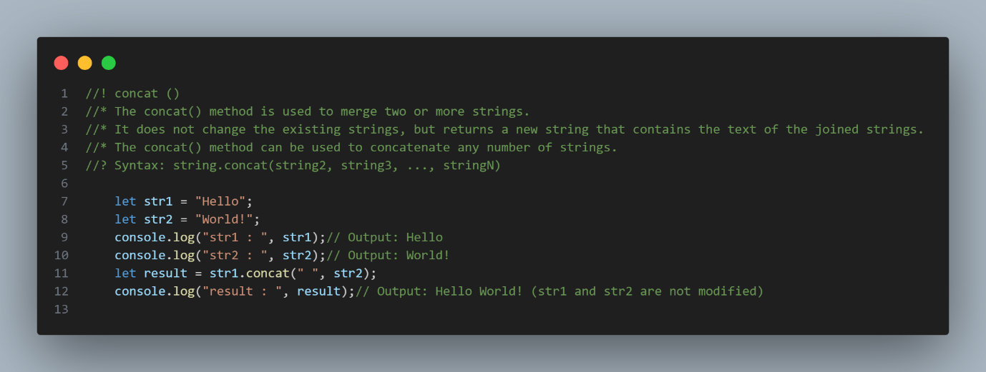
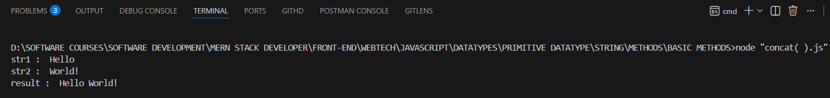
8.trim()

- The trim() method removes whitespace from both ends of a string.
- The trim() method does not take in any parameters.
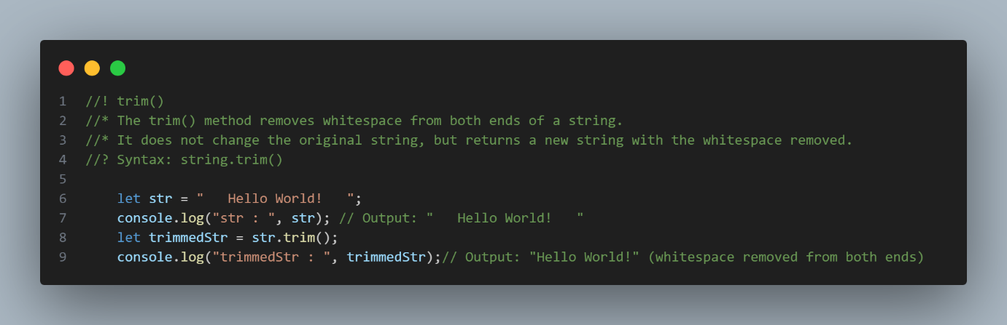
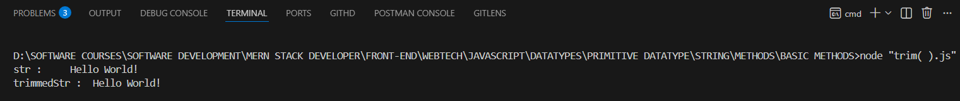

9.trimStart()

-ECMAScript 2019 added the String method trimStart() to JavaScript.
-The trimStart() method works like trim(), but removes whitespace only from the start of a string.
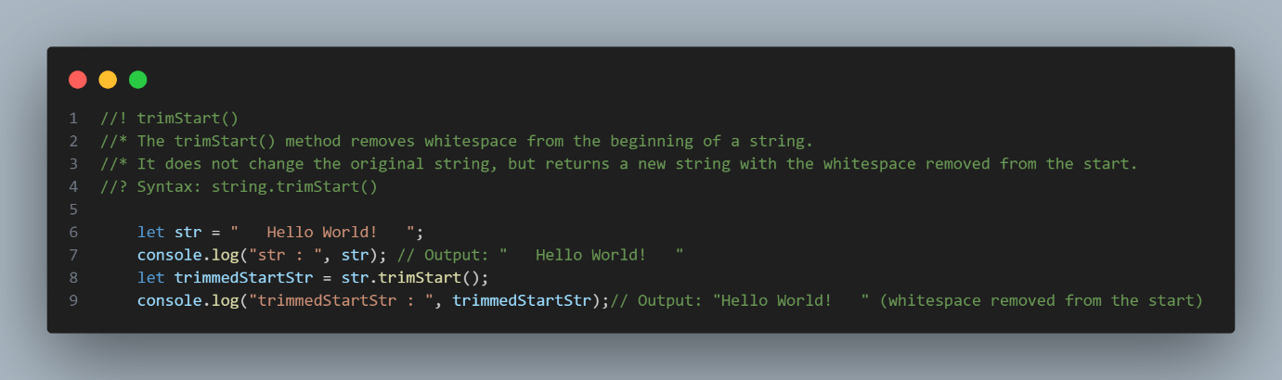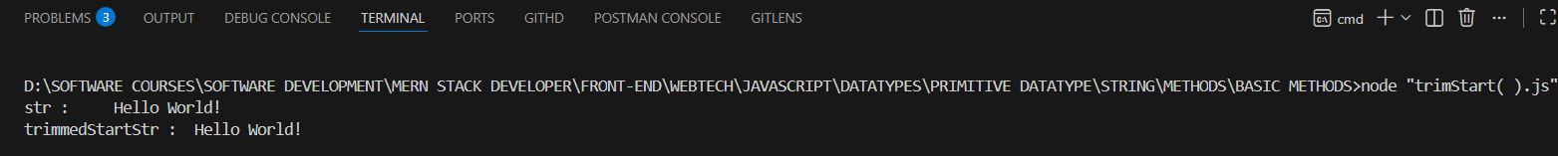
10.trimEnd()

-ECMAScript 2019 added the string method trimEnd() to JavaScript.
-The trimEnd() method works like trim(), but removes whitespace only from the end of a string.
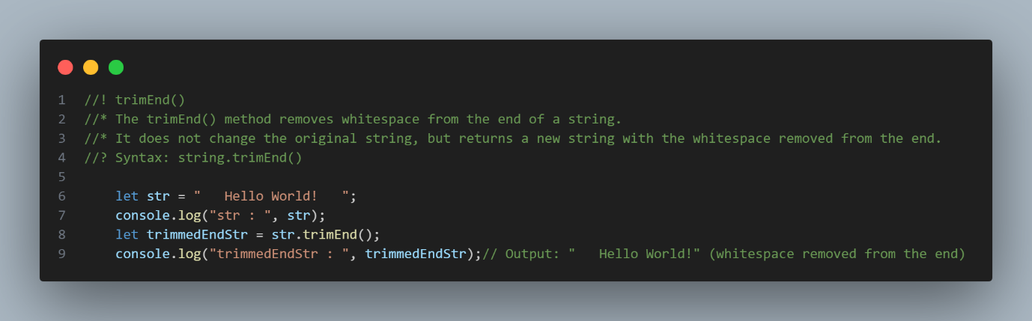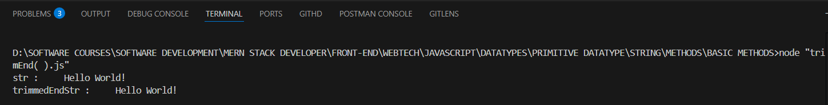

-The repeat() method returns a string with a number of copies of a string.
11.repeat()

-The repeat() method returns a new string.
-The repeat() method does not change the original string.
-The repeat() method creates a new string by repeating the given string a specified number of times and returns it.
The repeat() method takes in :
- count - An integer between 0 and +Infinity, indicating the number of times to repeat the string.
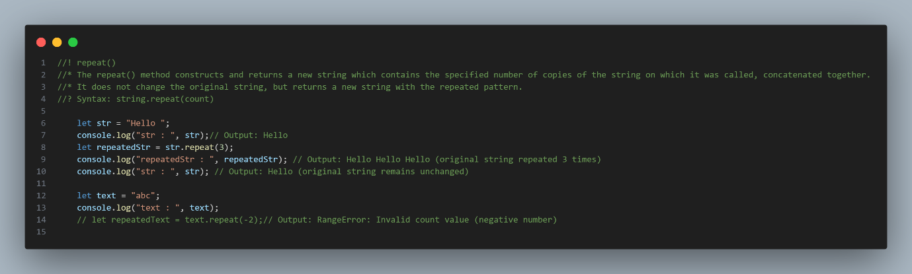
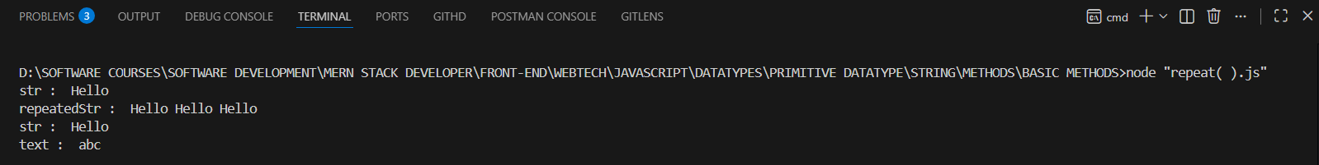
Note: repeat() raises RangeError if repeat count is negative, infinity, or overflows maximum string size.
12.replace()

-The replace() method replaces a specified value with another value in a string:
-The replace() method does not change the string it is called on.
-The replace() method returns a new string.
-The replace() method replaces only the first match
-If you want to replace all matches, use a regular expression with the /g flag set.
The syntax of replace() is:
str.replace(pattern, replacement)
The replace() method takes in:
- pattern - either a string or a regex that is to be replaced
- replacement - the pattern is replaced with this replacement (can be either a string or a function)
1.It will replace first caught string after that i will not replace.
<script>
const text = "Java is awesome. Java is fun."
console.log(text.replace("Java","JavaScript"));//JavaScript is awesome. Java is fun.
console.log()
</script>

2.By default, the replace() method is case sensitive. Writing MICROSOFT (with upper-case) will not work:
<script>
let message = "Please visit Microsoft!";
let newText = message.replace("MICROSOFT", "W3Schools");
console.log(newText);
</script>

3.To replace case insensitive, use a regular expression with an /i flag (insensitive):
<script>
let message1 = "Please visit Microsoft!";
let newText1 = message.replace(/MICROSOFT/i, "W3Schools");
console.log(newText1);
</script>

4.To replace all matches, use a regular expression with a /g flag (global match)

<script>
const text2 = "Java is awesome. Java is fun."
console.log(text2.replace("/Java/g","JavaScript"));//JavaScript is awesome. Java is fun.
console.log()
</script>

13.replaceAll()

-The replaceAll() method returns a new string with all matches of a pattern replaced by a replacement.
The syntax of replaceAll() is:
str.replaceAll(pattern, replacement)
replaceAll() Parameter
- pattern - either a substring or a regex that is to be replaced
- replacement - the pattern is replaced with this replacement (can be either a string or a function)
1.The replaceAll() method returns a new string with all matches of a pattern replaced by a replacement.
<script>
const message = "ball bat";
console.log(message.replaceAll("b","c"));
</script>

2.The replaceAll() method is case sensitive
<script>
const text = "Java is awesome. Java is fun.";
console.log(text.replaceAll("JAVA","JavaScript"))
console.log(text.replaceAll(/JAVA/gi,"JavaScript"))
</script>

Note: A RegExp without the global ("g") flag will throw a TypeError
14.padStart()

-The padStart() method pads a string from the start.
It pads a string with another string (multiple times) until it reaches a given length.
The syntax of the padStart() method is:
str.padStart(targetLength, padString)
- targetLength - The length of the final string after the current string has been padded.
- padString (optional) - The string to pad the current string with. Its default value is " ".
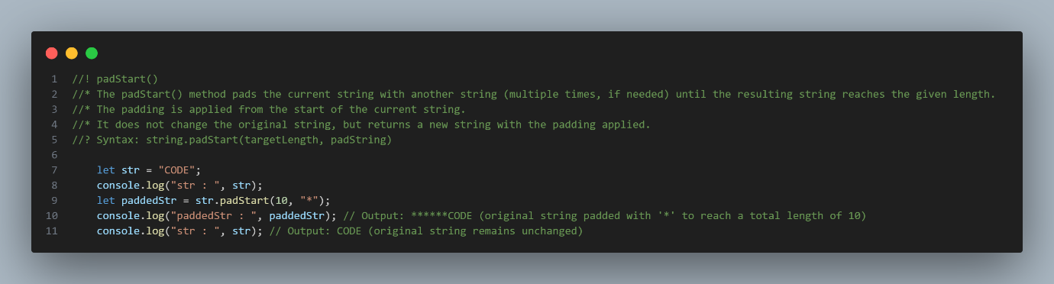
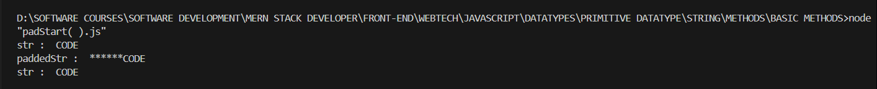

15.padEnd()

-The padEnd() method pads the current string with another string to the end.
The syntax of the padEnd() method is:
str.padEnd(targetLength, padString)
The padEnd() method takes two parameters:
- targetLength - The length of the final string after the current string has been padded.
- padString (optional) - The string to pad the current string with. Its default value is " ".

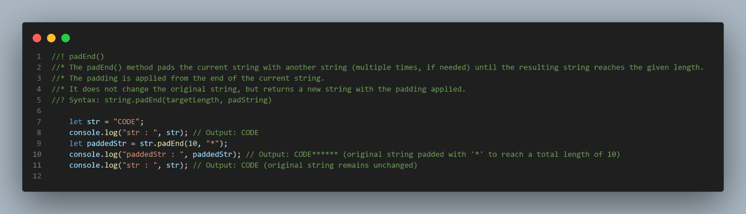

16.spilt()

-A string can be converted to an array with the split() method:
-If you want to work with a string as an array, you can convert it to an array.
Note: The split() method does not change the original string.
split() Parameter
The split() method takes in:
- separator (optional) - The pattern (string or regular expression) describing where each split should occur.
- limit (optional) - A non-negative integer limiting the number of pieces to split the given string into.
-If the separator is "", the returned array will be an array of single characters as an Array.

Example
1.text.split(",") // Split on commas
2.text.split(" ") // Split on spaces
3.text.split("|") // Split on pipe
4.text.split(“”) // Split on pipe

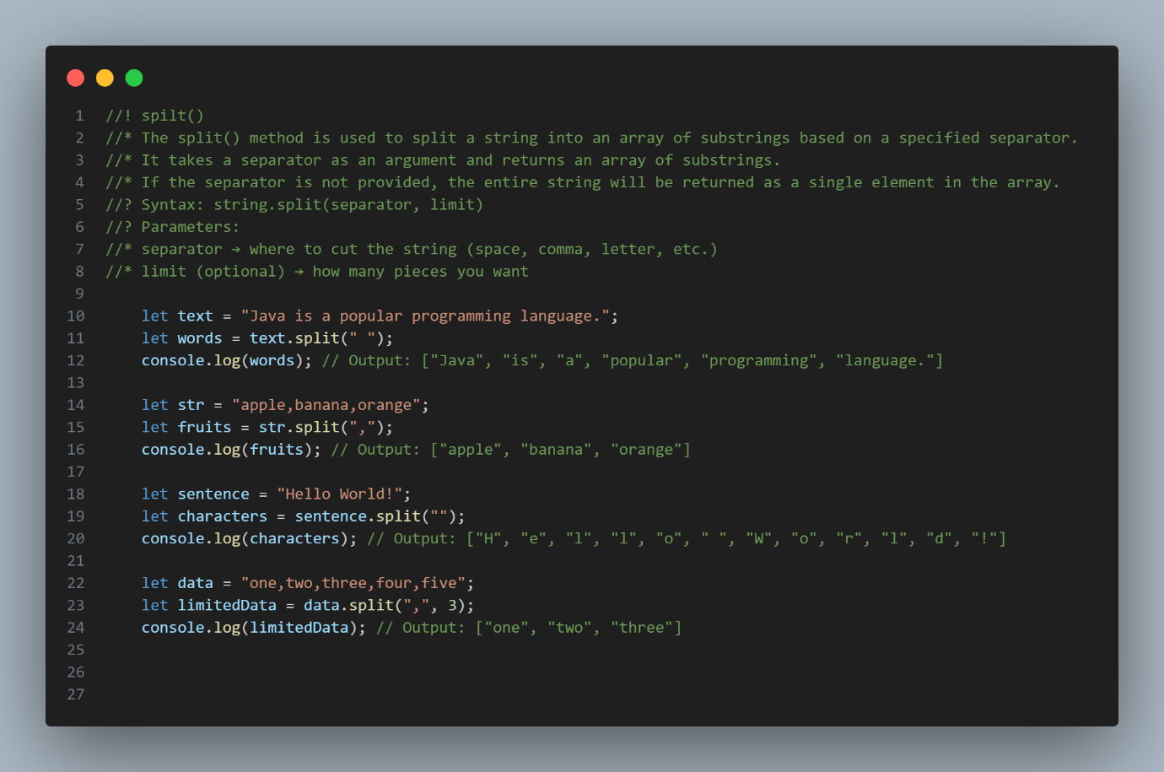
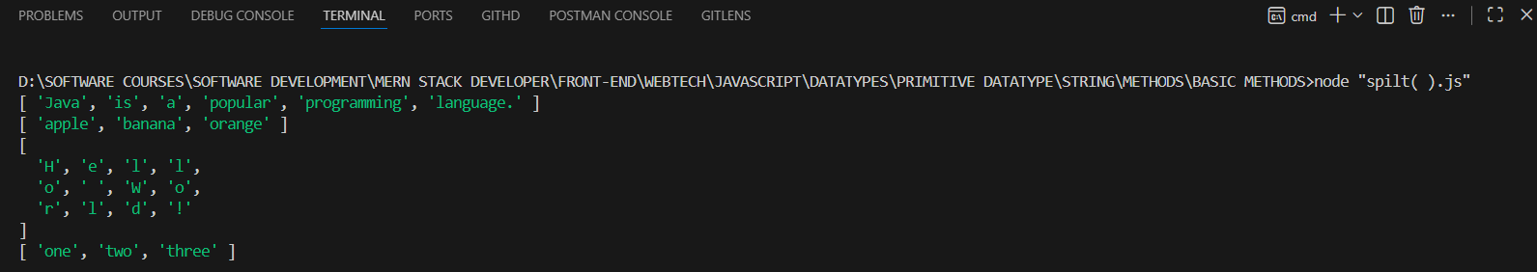

Extracting String Parts
There are 3 methods for extracting a part of a string:
- slice(start, end)
- substring(start, end)
- substr(start, length)
1.slice(start, end)

-slice() extracts a part of a string and returns the extracted part in a new string.
-The method takes 2 parameters:
- start → index where extraction begins
- end → index where extraction stops (not included)
- If end is missing → goes till last
-It accepts the Negative Values As well.
Note: The slice() method does not change the original string.
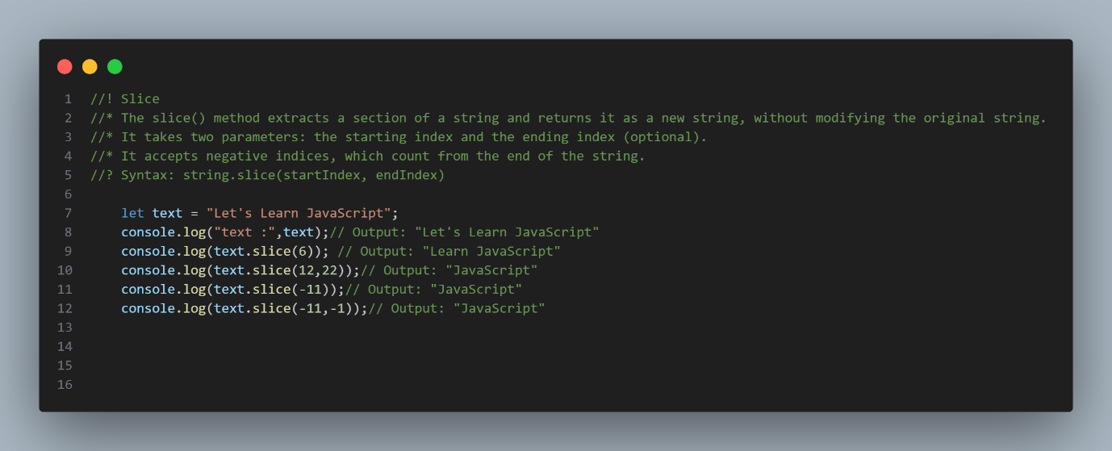
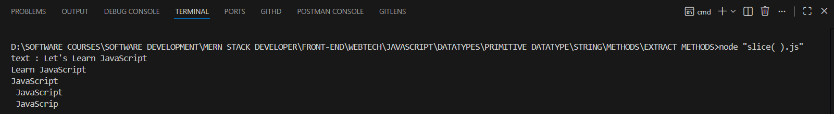

2.subStr(start index, length)

-substr() is similar to slice().
-The substr() method is removed (deprecated) in the latest JavaScript standard.
-The difference is that the second parameter specifies the length of the extracted part.
Syntax:
subStr(start-index, define-length)
- start-index:-Define the Start index when you start.
- Define-length:-After define the length of string that from starting point you want to extracted.
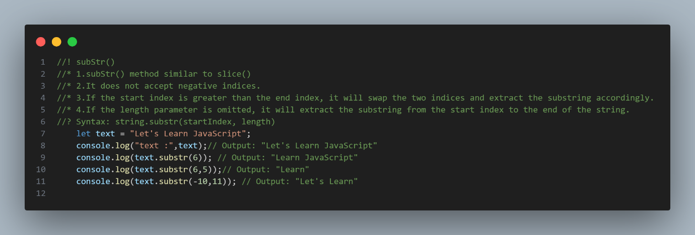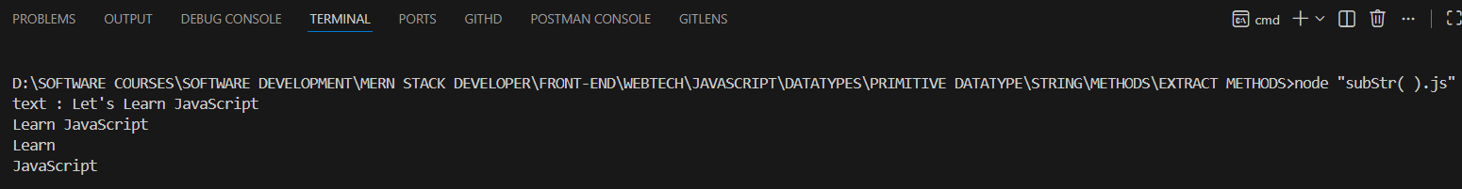

3.subString(startIndex, endIndex)

-The substr() method is removed (deprecated) in the latest JavaScript standard.
-substring() is used to extract part of a string between two indexes.
-It does not accept negative indices. If a negative index is provided, it will be treated as 0.
Notes:
- Any argument value < 0 is treated as 0.
- Any argument value > str.length is treated as str.length.
- Any NaN argument value is treated as 0.
- If indexStart is greater than indexEnd, the two arguments are swapped, i.e. str.substring(a, b) will be str.substring(b, a).
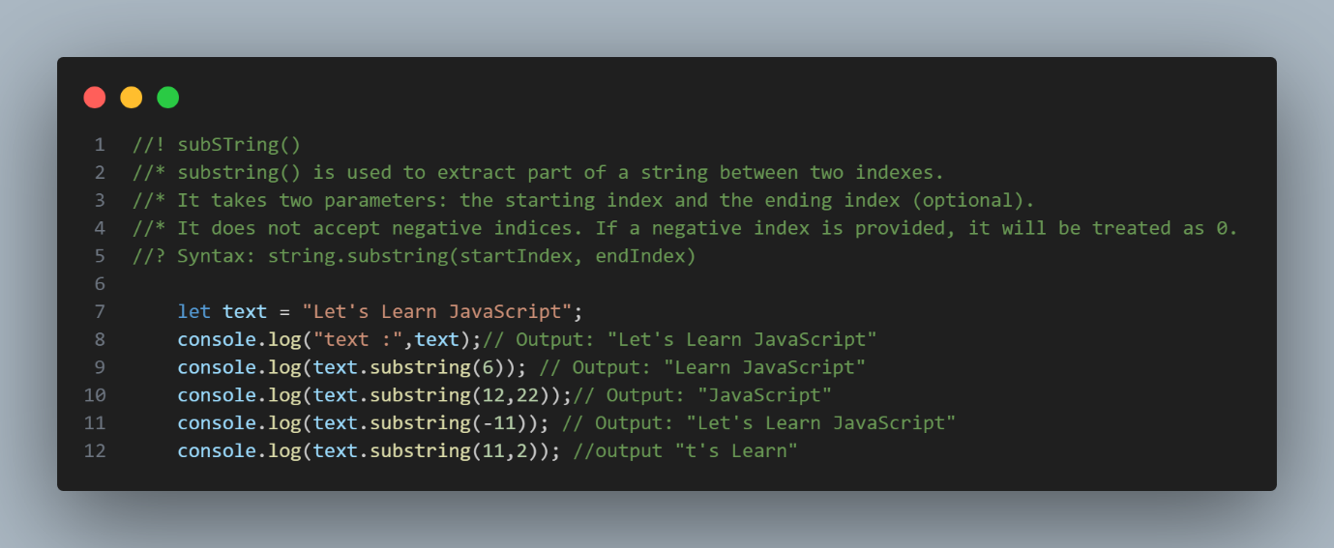
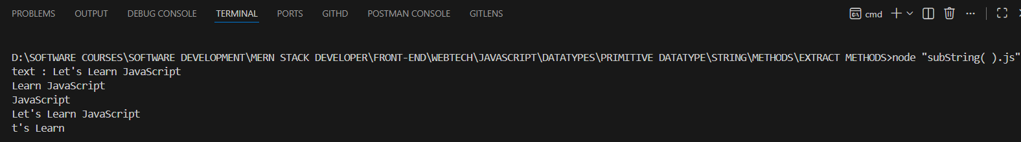

1.indexOf(searchValue, startPosition)

STRING SEARCH METHODS

-The indexOf() method returns the index (position) of the first occurrence of a string in a string,
-If not found → returns -1
The indexOf() method takes in:
- searchValue - The value to search for in the string. If no string is provided explicitly, "undefined" will be searched.
- startPosition (optional) - The index to start the search at. By default it is 0. If fromIndex < 0, the search starts at index 0.

1.Returns the first index of the value in the string if it is present at least once.
<script>
let text = "Please locate where 'locate' occurs!";
console.log(text.indexOf("a"));//3
console.log(text.indexOf("locate"));//7
</script>

2. Returns -1 if the value is not found in the string.
<script>
let str = "Apple, Banana, Kiwi";
console.log(str.indexOf("orange"));//-1
</script>

3. The indexOf() method is case sensitive
<script>
let str1 = "Apple, Banana, Kiwi";
console.log(str.indexOf("apple"));//-1
</script>

4. For empty string searchValue and fromIndex less than the string's length, indexOf returns the value the same as fromIndex.
<script>
let str2 = "Apple, Banana, Kiwi";
console.log(str2.indexOf("", 10));//10
</script>

5. Similarly, for empty string searchValue and fromIndex greater than the string's length, indexOf returns the string's length.
<script>
let str3 = "Apple, Banana, Kiwi";
console.log(str3.indexOf("", 55));//19
</script>

2.lastIndexOf(searchValue, startPosition)

-The lastIndexOf() method returns the index of the last occurrence of a specified text in a string.
👉 It searches backwards
👉 Returns the last occurrence index
👉 If not found → returns -1

lastIndexOf() Parameters
The lastIndexOf() method takes in:
- substr- The value to search for in the given string.
- fromIndex (optional) - The index to start searching the string backwards. By default it is +Infinity.
<script>
let str = "I love Java.The Best language is Java.";
console.log(str.lastIndexOf("Java"));
</script>

2.Both indexOf(), and lastIndexOf() return -1 if the text is not found:
<script>
let string = "Hey..."
console.log(string.lastIndexOf("P"))
</script>

3.search(value)
-The search() method searches a string for a string (or a regular expression) and returns the position of the match.
👉 It returns the index of the first match
👉 If not found → returns -1

The search() method takes a single parameter:
- value- A regular expression object (Argument is implicitly converted to regExp if it is a non-regExp object)
-The two methods are NOT equal. These are the differences:
- The search() method cannot take a second start position argument.
- The indexOf() method cannot take powerful search values (regular expressions).
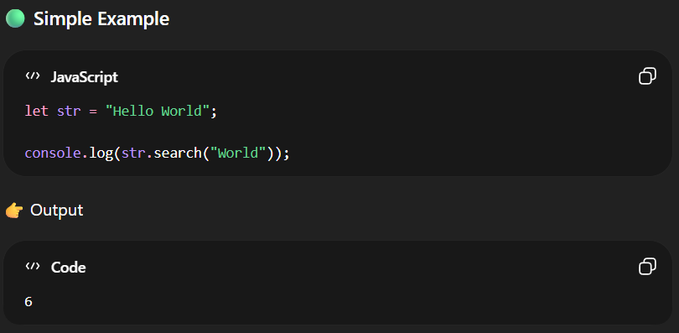
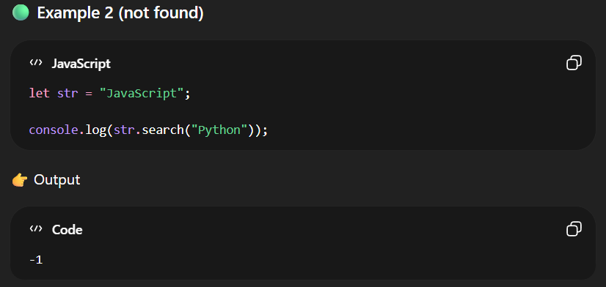
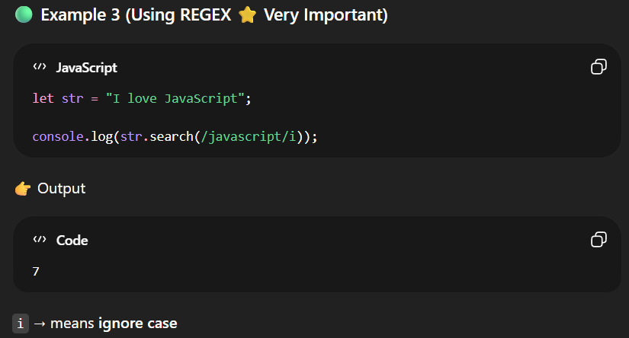

4.match(regex)

-match() is used to search a string using a Regular Expression (regex) and return the matched result.
👉 If match found → returns an array
👉 If not found → returns null
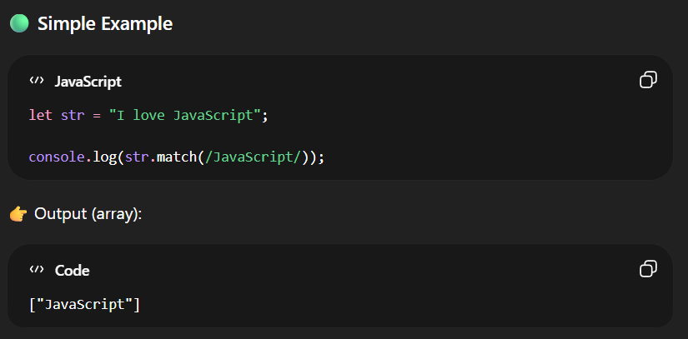
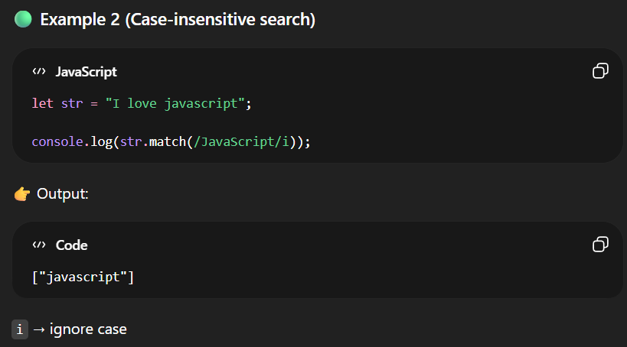
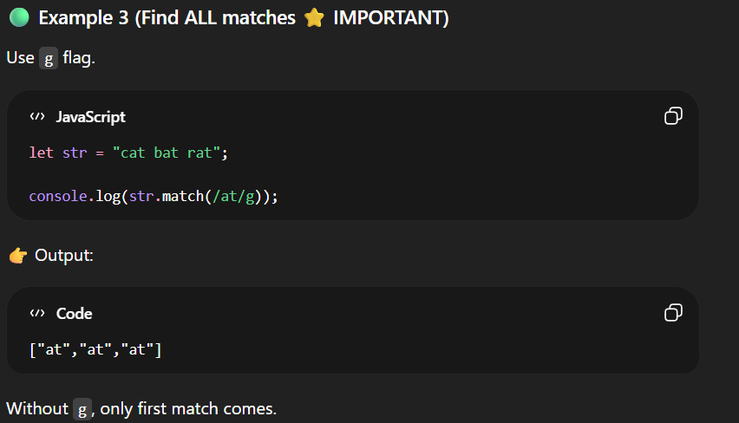
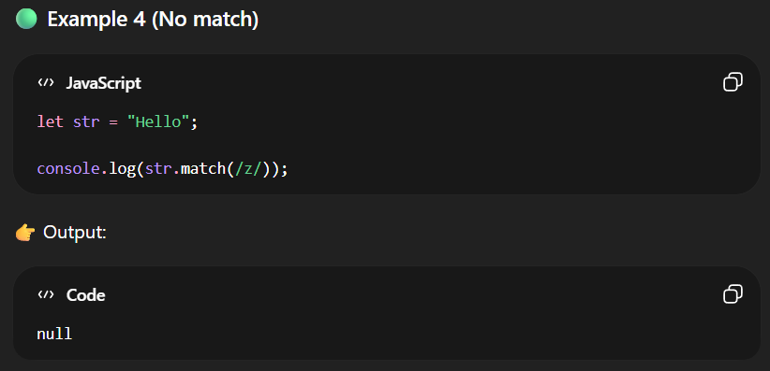
6.includes()
-The includes() method returns true if a string contains a specified value.
Otherwise it returns false.
-includes() is case sensitive.
<script>
let text = "Hello world, welcome to the universe.";
console.log(text.includes("world"));//true
</script>

The includes() method takes in:
- searchString - A string to be searched for within str.
- position (optional) - The position within str to begin searching for searchString. By default, it is 0.
<script>
let text1 = "Hello world, welcome to the universe.";
console.log(text1.includes("world",13));//false
</script>

- Returns true if searchString is found anywhere within str.
- Returns false if searchString is not found anywhere within str.

7.startsWith()
-The startsWith() method returns true if a string begins with a specified value.Otherwise it returns false:
-The startsWith() method is case sensitive.
The syntax of the startsWith() method is:
str.startsWith(searchString, position)
<script>
let text1 = "Hello world, welcome to the universe.";
console.log(text1.includes("world",13));//false
</script>

<script>
let text1 = "Hello world, welcome to the universe.";
console.log(text1.startsWith("Hello"));
</script>

-Here, str is a string.
The startsWith() method takes in :
- searchString - The characters to be searched for at the beginning of str.
- position (optional) - The position in str to start searching for searchString. Default value is 0.
<script>
let sentence = "Java is to JavaScript what Car is to Carpet.";
let check3 = sentence.startsWith("JavaScript", 11);
console.log(check3); // true
</script>

8.endsWith()
-The endsWith() method returns true if a string ends with a specified value.Otherwise it returns false:
<script>
let text = "John Doe";
console.log(text.endsWith("Doe"));
</script>

The endsWith() method takes two parameters:
- searchString - The characters to be searched for at the end of str.
- length (optional) - It is used as the length of str where searchString is searched. Default value is str.length.

<script>
let text1 = "Hello world, welcome to the universe.";
console.log(text1.endsWith("world", 11));
</script>

9.String()

Description
The String() method converts a value to a string.

Note
The String() method returns the same as the toString() method for any value.

Syntax
String(value)

Parameters
Parameter | Description
value | Required.  A JavaScript value.

Return Value
Type | Description
A string. | The value converted to a string.

2.Number

-In JavaScript, the number type represents numeric values (both integers and floating-point numbers).Integers - Numeric values without any decimal parts.
- Integers - Numeric values without any decimal parts. Example: 3, -74, etc.
- Floating-Point - Numeric values with decimal parts. Example: 3.15, -1.3, etc.

<!--! Number -->
<!--? Example1 -->
<script>
let num1 = 10; // Integer
let num2 = 10.22; // Floating point number
document.write("The value of num1 is " + num1 + "<br/>");
document.write("The value of num2 is " + num2 + "<br/>");
console.log(typeof num1);
console.log(typeof num2);
</script>
<!--? Example2 -->
<script>
let num3 = 98e4; // 980000
let num4 = 98e-4; // 0.0098
document.write("The value of num3 is: " + num3 + "<br/>");
document.write("The value of num4 is: " + num4);
console.log(typeof num3);
console.log(typeof num4);
</script>

255; // two-hundred and fifty-five
255.0; // same number
255 === 255.0; // true
255 === 0xff; // true (hexadecimal notation)
255 === 0b11111111; // true (binary notation)
255 === 0.255e3; // true (decimal exponential notation)

JavaScript Number Methods and Properties
Name | Description
constructor | Returns the function that created JavaScript's Number prototype
EPSILON | Returns the difference between 1 and the smallest number greater than 1
isFinite() | Checks whether a value is a finite number
isInteger() | Checks whether a value is an integer
isNaN() | Checks whether a value is Number.NaN
isSafeInteger() | Checks whether a value is a safe integer
MAX_SAFE_INTEGER | Returns the maximum safe integer in JavaScript.
MIN_SAFE_INTEGER | Returns the minimum safe integer in JavaScript
MAX_VALUE | Returns the largest number possible in JavaScript
MIN_VALUE | Returns the smallest number possible in JavaScript
NaN | Represents a "Not-a-Number" value
NEGATIVE_INFINITY | Represents negative infinity (returned on overflow)
POSITIVE_INFINITY | Represents infinity (returned on overflow)
parseFloat() | Parses a string an returns a number
parseInt() | Parses a string an returns a whole number
prototype | Allows you to add properties and methods to an object
toExponential(x) | Converts a number into an exponential notation
toFixed(x) | Formats a number with x numbers of digits after the decimal point
toLocaleString() | Converts a number into a string, based on the locale settings
toPrecision(x) | Formats a number to x length
toString() | Converts a number to a string
valueOf() | Returns the primitive value of a number

Note
-Most programming languages have many number types:
-Whole numbers (integers):
byte (8-bit), short (16-bit), int (32-bit), long (64-bit)
-Real numbers (floating-point):
float (32-bit), double (64-bit).
-Javascript numbers are always one type:
double (64-bit floating point).
JAVASCRIPT NUMBER CONSTRUCTOR
-The constructor property returns the function that created the Number prototype.
-For JavaScript numbers the constructor property returns:
function Number() { [native code] }
<script>
let num1 = new Number(123);
console.log(num1);
console.log(typeof num1);//Object

let num2 = 123;
console.log(num1 == num2);//true
console.log(num1 === num2);//false
</script>

1.Number()
-The Number() method converts a value to a number.
-If the value cannot be converted, NaN is returned.

<script>
let num1 = new Number(123);
console.log(num1);
console.log(typeof num1);//Object

let num2 = 123;
console.log(num1 == num2);//true
console.log(num1 === num2);//false
</script>

Syntax
Number(value)

Parameters
Parameter | Description
value | Optional.  A JavaScript value (variable).

Return Value
Type | Description
A number | Returns the value as a number.  If the value cannot be converted to a number, NaN is returned.  If no value is provided, 0 is returned.

Notes
-For booleans, Number() returns 0 or 1.
-For dates, Number() returns milliseconds since January 1, 1970 00:00:00.
-For strings, Number() returns a number or NaN.
2.Number.isFinite()

Syntax
Number.isFinite(value)

Return Value
Type | Description
A boolean | true if the value is a finite Number, otherwise false.
<script>
let num1 = 123;
console.log(Number.isFinite(num1))//true
console.log(Number.isFinite(5-5));//true
console.log(Number.isFinite("123"));//false
console.log(Number.isFinite(undefined));//false
console.log(Number.isFinite(true));;//false
</script>

3.isInteger()
-The Number.isInteger() method returns true if a value is an integer of the datatype Number.
-Otherwise it returns false.

<script>
let num = 10;
console.log(Number.isInteger(num)); // true

let decimal = 10.5;
console.log(Number.isInteger(decimal)); // false
</script>

4.isNaN()
-In JavaScript, NaN is short for "Not-a-Number".
-In JavaScript, NaN is a number that is not a legal number.
-The Number.isNaN() method returns true if the value is NaN, and the type is a Number.
Syntax:-
Number.isNan(value);

Return Value
Type | Description
A boolean. | true if the value is Number.NaN, otherwise false.
<script>
let num1 = "Hello";
console.log(Number.isNaN(num1));//false

let num2 = 12;
console.log(Number.isNaN(num2));//false
</script>

5.toFixed()
The toFixed() method rounds the string to a specified number of decimals.

Syntax
number.toFixed(x)
<script>
let num1 = 4554554.33443;
console.log(num1.toFixed(0));

let num2 = 2332;
console.log(num2.toFixed(4));

</script>

Return Value
Type | Description
A string | The representation of a number with (or without) decimals.

6.parseInt()
-The Number.parseInt method parses a value as a string and returns the first integer.
-A radix parameter specifies the number system to use:
-2 = binary, 8 = octal, 10 = decimal, 16 = hexadecimal.
-If radix is omitted, JavaScript assumes radix 10. If the value begins with "0x", JavaScript assumes radix 16.
Syntax
Number.parseInt(string, radix)

Return Value
Type | Description
Number | NaN if no integer is found.
<script>
console.log(Number.parseInt("10"));
console.log(Number.parseInt("10"));
console.log(Number.parseInt("10.00"));
console.log(Number.parseInt("10.33"));
console.log(Number.parseInt("34 45 66"));
console.log(Number.parseInt(" 60 "));
console.log(Number.parseInt("40 years"));
console.log(Number.parseInt("He was 40"));
</script>

7.parseFloat()
-The Number.parseFloat() method parses a value as a string and returns the first number.

Syntax
Number.parseFloat(value)

Parameters
Parameter | Description
value | Required.  The value to parse.

Return Value
Type | Description
Number | NaN if no number is found.
<script>
console.log(Number.parseFloat(10));
console.log(Number.parseFloat("10") );
console.log(Number.parseFloat("10.33"));
console.log(Number.parseFloat("34 45 66"));
console.log(Number.parseFloat("He was 40"));
</script>

Notes
-If the first character cannot be converted, NaN is returned.

8.toLocalString()
-The toLocaleString() returns a number as a string, using local language format.
-The language format depends on the locale setup on your computer.
<script>
let num = 1000000;
let text = num.toLocaleString();
console.log(text);
</script>

Syntax
number.toLocaleString(locales, options)

-NaN means Not a Number.
3.NaN

-NaN is not separate datatype in JavaScript
-It appears when a numeric calculation fails.
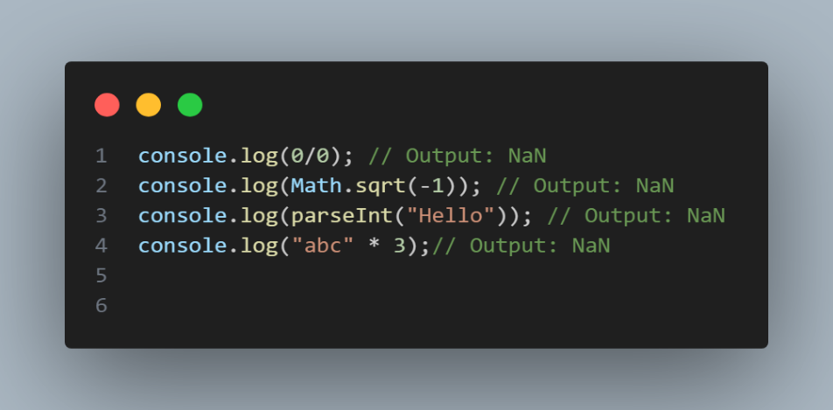
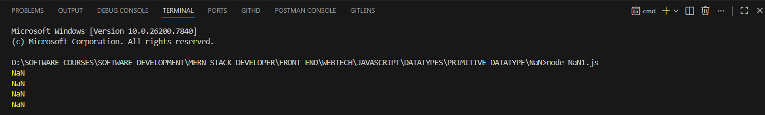
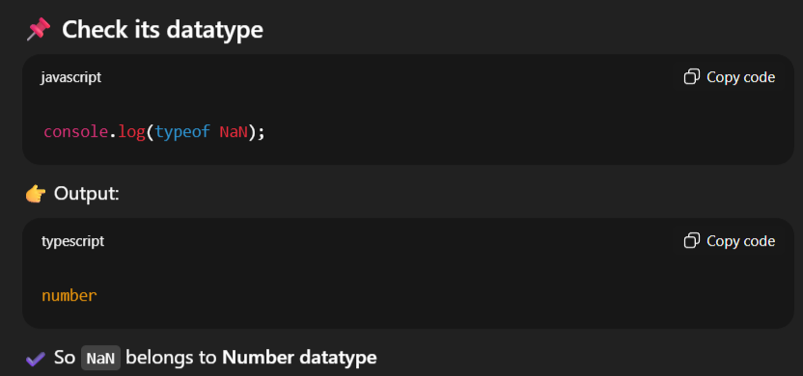
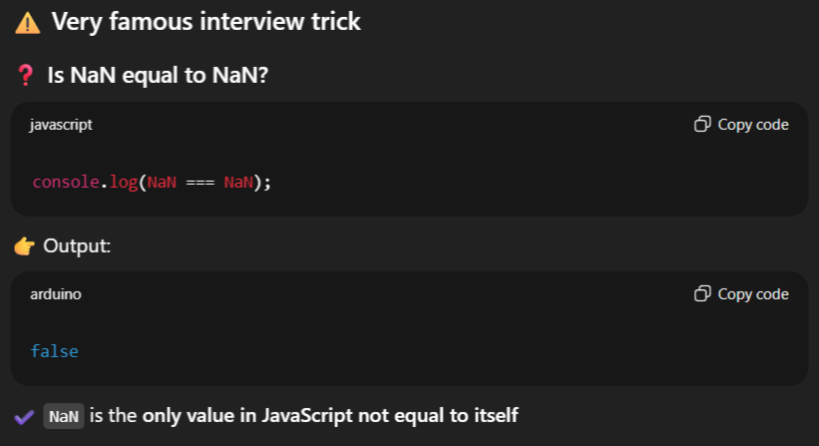
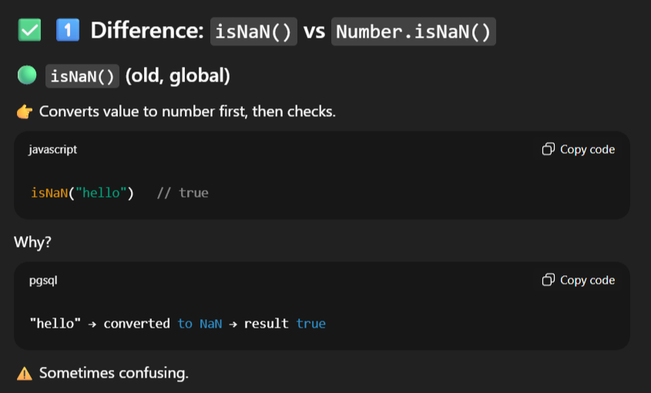
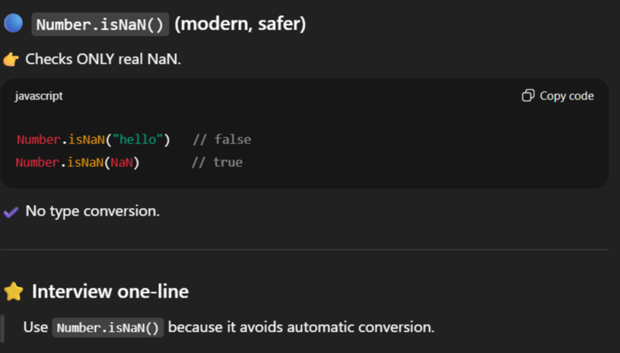
3.JavaScript BigInt

-BigInt is a type of number that can represent very large or very small integers beyond the range of the regular number data type.
-Note: The regular number data type can handle values less than (2^53 - 1) and greater than -(2^53 - 1).
-A BigInt number is created by appending n to the end of an integer.
<script>
let largeNum = 1245646564515635412348923448234842842343546576876789n;
document.write("The value of the largeNum is " + largeNum + "<br/>");
</script>

-A Boolean data can only have one of two values: true or false. For
4.Boolean

example,
<!DOCTYPE html>
<html lang="en">
<head>
<meta charset="UTF-8">
<meta name="viewport" content="width=device-width, initial-scale=1.0">
<title>Document</title>
</head>
<body>
<!--! Boolean -->
<!--? In JavaScript true and false has values -->
<!--* 1.true = 1 -->
<!--* 2.false = 0 -->
<script>
let bool1 = true;
let bool2 = false;
document.write("The value of the bool1 is " + bool1 + "<br/>");
document.write("The value of the bool2 is " + bool2 + "<br/>");
</script>
</body>
</html>

JavaScript Boolean constructor
<script>
let bool = false;
let text = bool.constructor;
consol.log(text)
</script>

Description
The constructor property returns the function that created the Boolean prototype.

Syntax
boolean.constructor

Return Value
function Boolean() { [native code] }

5.Symbol

-The Symbol data type is introduced in the ES6 version of JavaScript. It is used to create unique primitive, and immutable values.
-The Symbol() constructor can be used to create a unique symbol, and you may pass the string as a parameter of the Symbol() constructor.

Example
-In the example below, we created the sym1 and sym2 symbols for the same string. After that, we compared the value of sym1 and sym2, and it gave a false output. It means both symbols are unique.
<!--! Symbol -->
<script>
let sym1 = Symbol("123");
let sym2 = Symbol("123");

let res = sym1 == sym2;

console.log("Is sym1 is Equal To sym2 : "+ res);
// Output: Is sym1 is Equal To sym2 : false
</script>

6.Undefined

-The undefined type is a primitive type that has only one value undefined. By default, when a variable is declared but not initialized, it defaults to undefined.
<script>
let x;
console.log(x);
</script>

<script>
let counter;
console.log(counter); // undefined
console.log(typeof counter); // undefined
</script>

7.Null

-The null type is the second primitive data type that also has only one value null. For example:
<script>
let obj = null;
console.log(typeof obj); // object
</script>

-The typeof null returns object is a known bug in JavaScript. A proposal to fix was rejected due to the potential to break many existing sites.

JavaScript defines that null is equal to undefined as follows:
<script>
console.log(a == b);
</script>

2]Non-Primitive Datatype

-The data types that are derived from primitive data types of the JavaScript language are known as non-primitive data types. It is also known as derived data types or reference data types.
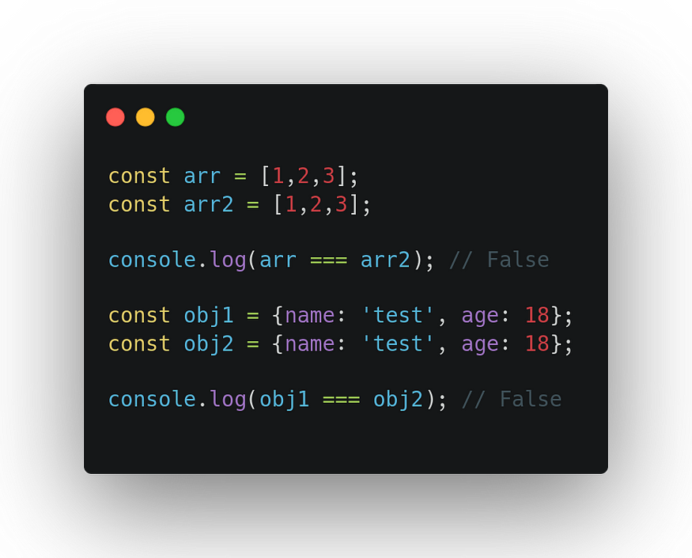
-Non-primitive values are mutable
-Non-primitive compare by reference not value

Example :-
Object , Array, Functions, Date ,Regex

1.Object

-Object is the Realtime entity
-Anything which has the Existence in the World is called Object
-Object some have Properties And Behaviour.
-Object does not remember the order of properties.
-In JavaScript, an object is a collection of properties, where each property is defined as a key-value pair,where the keys are strings (or symbols) and the values can be any data type (including other objects).
-Objects are one of the fundamental building blocks of JavaScript, allowing you to represent real-world entities and organize data in a structured way.
Key Concepts:
- Properties:-
-The key-value pairs within an object are called properties. The key represents the name of the property, and the value represents its associated data.
- Methods:-
-Functions that are stored as properties of an object are called methods. They allow objects to perform actions or operations.

Here is a car object example:
Car Object | Properties | Methods
 | car.name = Fiat  car.model = 500  car.weight = 850kg  car.color = white | car.start()  car.drive()  car.brake()  car.stop()

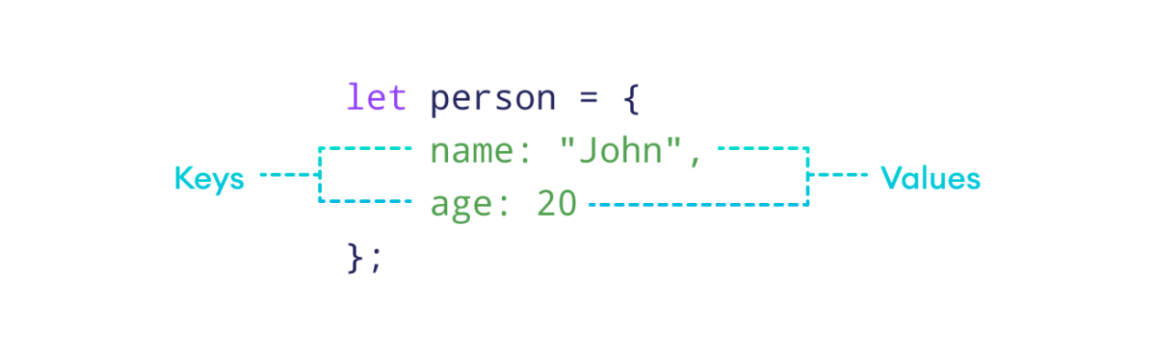

There are several ways to create objects in JavaScript:
1]BY USING LITERALS
2]BY USING NEW KEYWORD
3]BY USING FUNCTION CONSTRUCTOR
4]BY USING SINGLTON PATTERN
5]BY USING ES6 CLASSES
6]BY USING CREATE() METHOD

1.Object Literals

-This is the most common way to create objects. You use curly braces {} to define the object, with each property separated by a comma.
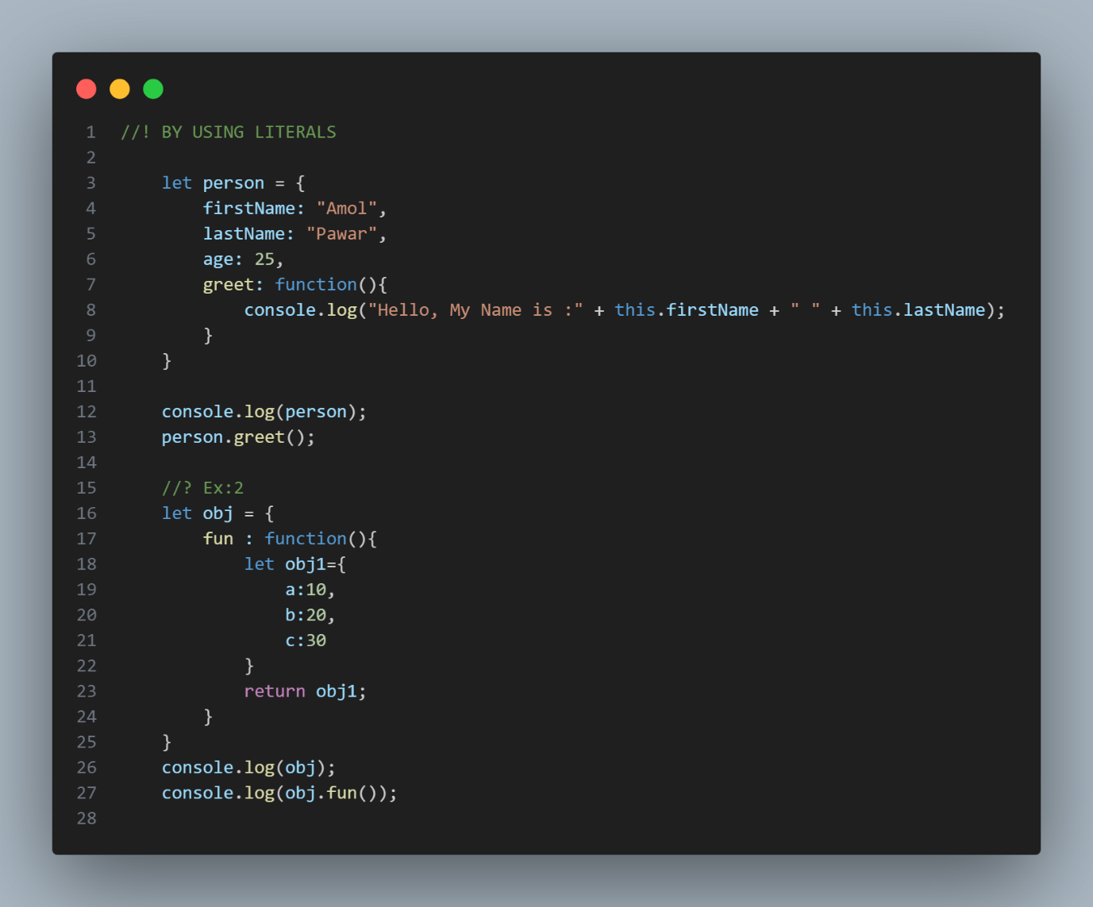
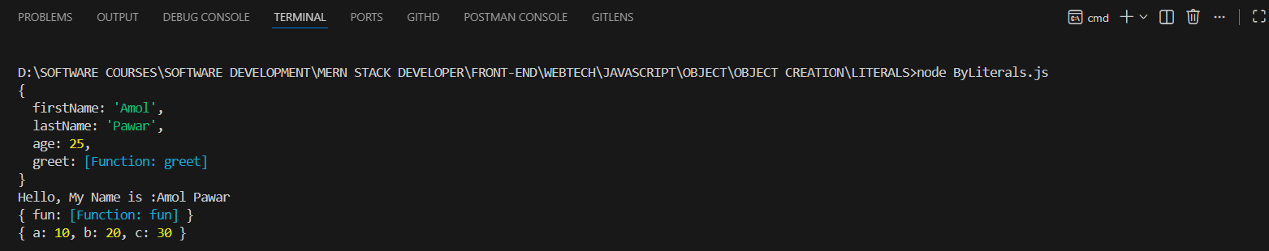
-In JavaScript, an Object is a non-primitive data type used to store multiple values in one variable.
-An object literal is a list of property names:values inside curly braces {}.

-The syntax of JavaScript object is:
const objectName = {
key1: value1,
key2: value2,
...,
keyN: valueN
};
Here,
- objectName - Name of the object.
- key1: value1 - The first key-value pair.
- key2: value2 - The second key-value pair.
- keyN: valueN - The Nth key-value pair.
-Each key-value pair has a colon : between them and is separated by a comma ,.

Note:
An object literal is also called an object initializer.

2.Using New Keyword

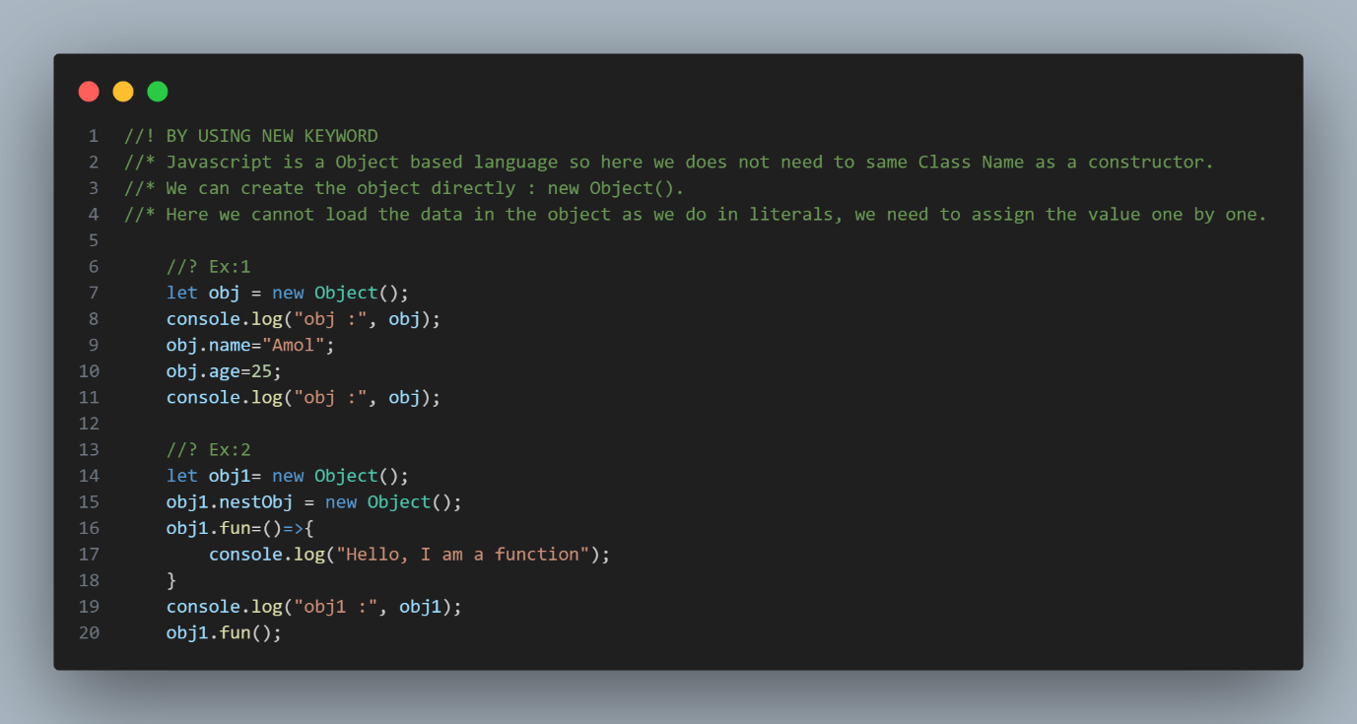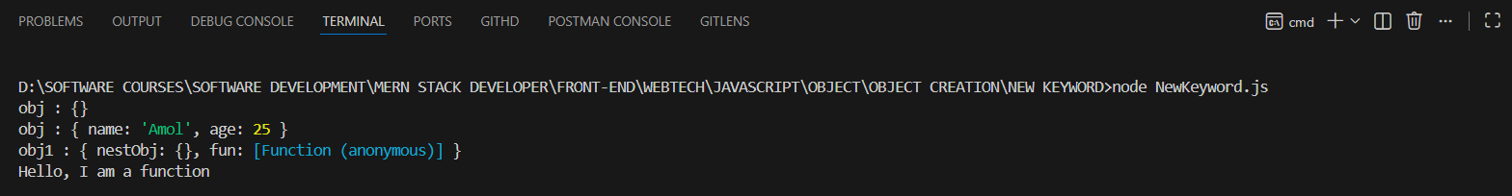

-Here, the new keyword is used with the Object() instance to create an object.
-After that the instance is created then you have to manually add the Properties inside the Object Using assigning.

3.Using Function Constructor

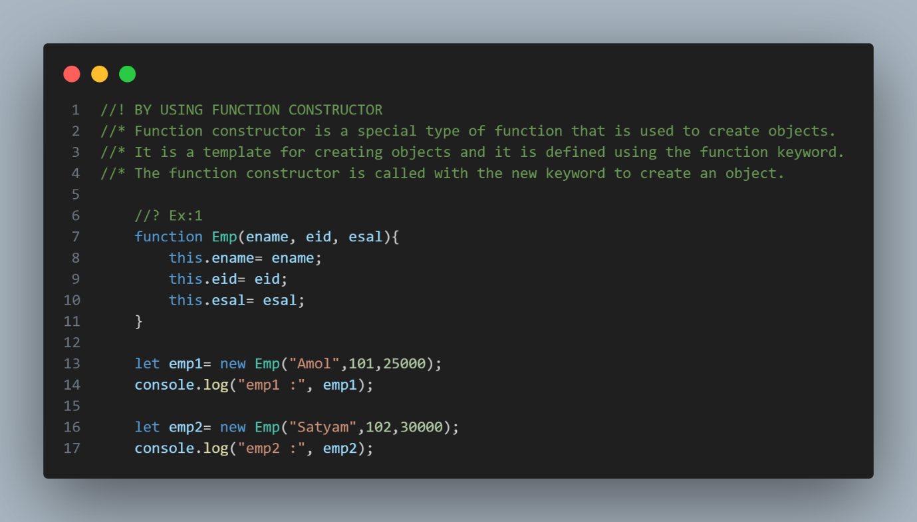
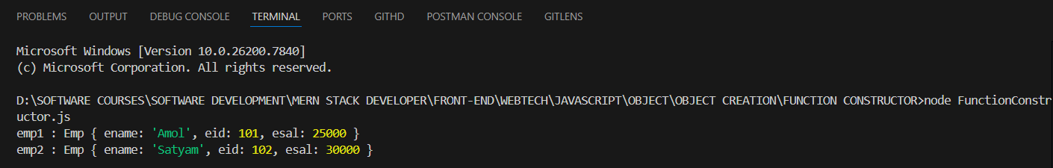

-In this example we have to take the help to assigning value odf properties.
-In the constructor function, this has no value.
-The value of this will become the new object when a new object is created.

4.BY USING OBJECT CREATE () METHOD

-Object.create() is a method in JavaScript that creates a new object and allows you to set another object as its prototype.
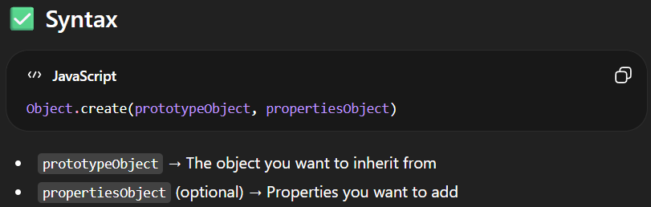
<!--! USING OBJECT CREATE() METHOD -->
<!--todo : - For that you have Create one Variable and assign to Object.create( ). -->
<!--todo : - Inside that you have pass the null is mandatory -->
<script>
let obj = Object.create(null);
obj.name = "Amol"
console.log(obj);
</script>

-In this example we have to use create method with null datatype.
It will create the Object but it will null mandatory neither the browser will throw the error.
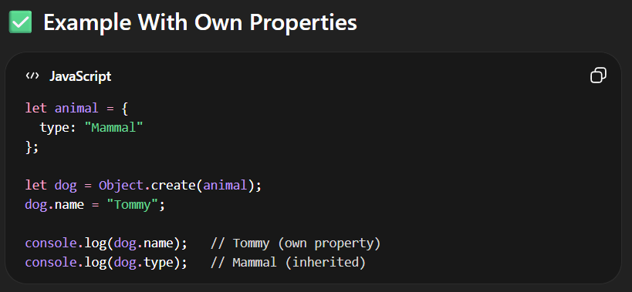

5.BY USING ES6 CLASS

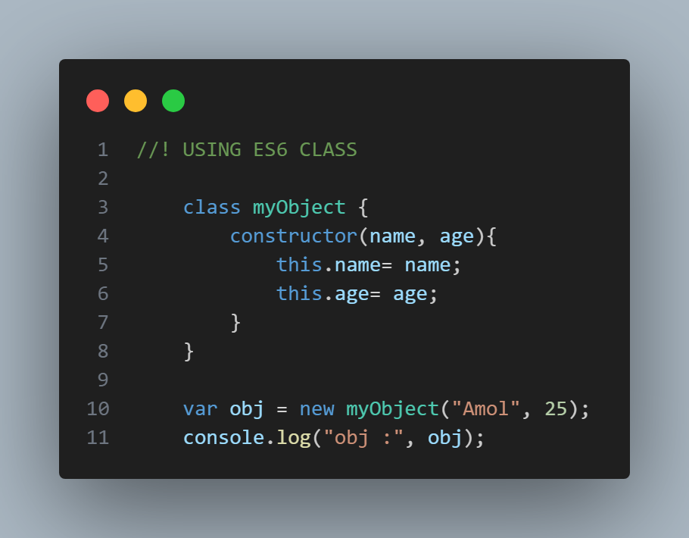

6.BY USING SINGLTON PATTERN

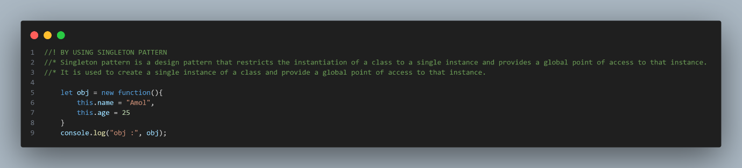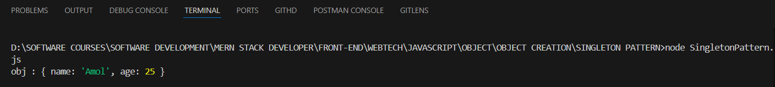

Access Object Properties
-You can access the value of a property by using its key.
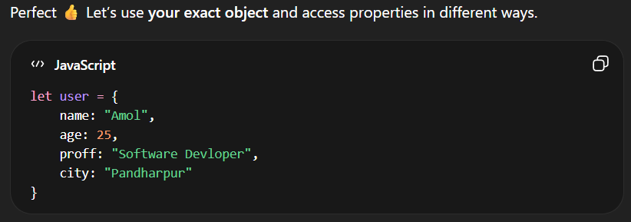
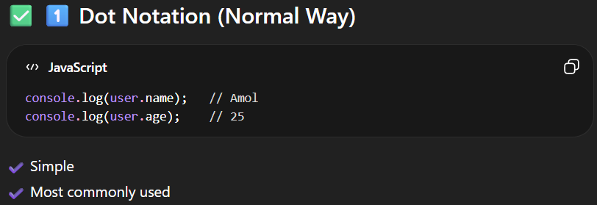
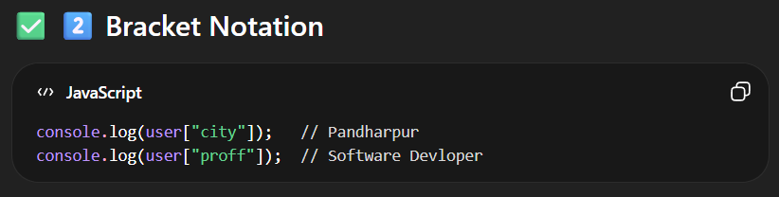
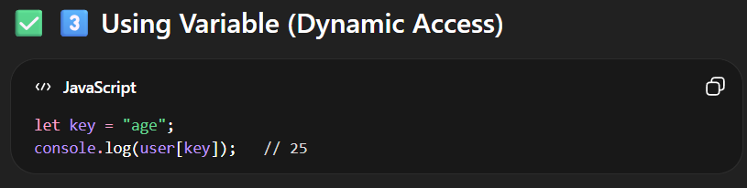
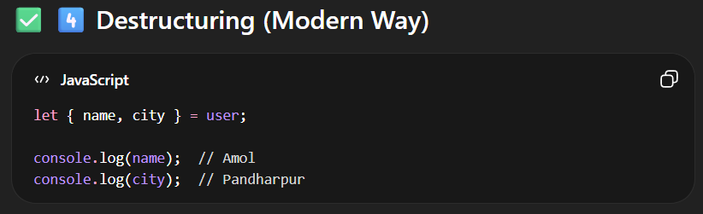
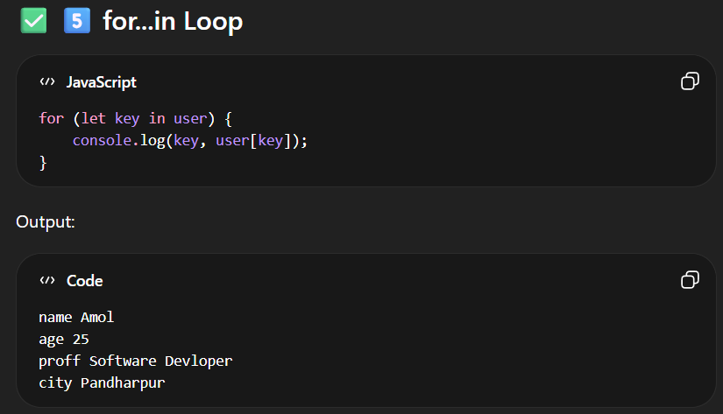
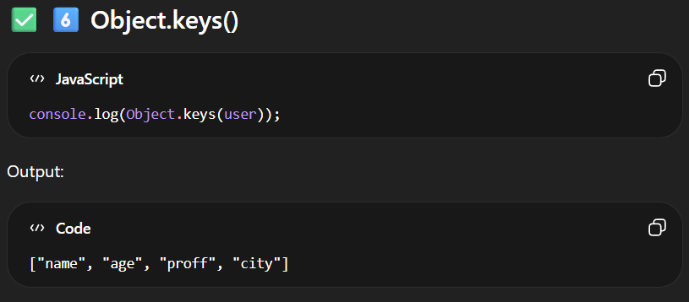
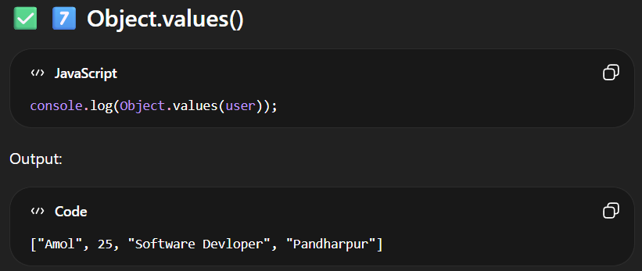

OBJECT DESTRUCTURING
-Taking properties from an object and storing them into variables in a short and clean way.
OR
-The destructuring syntax is a JavaScript syntax that makes it possible to unpack values from arrays, or properties from objects, into distinct variables.
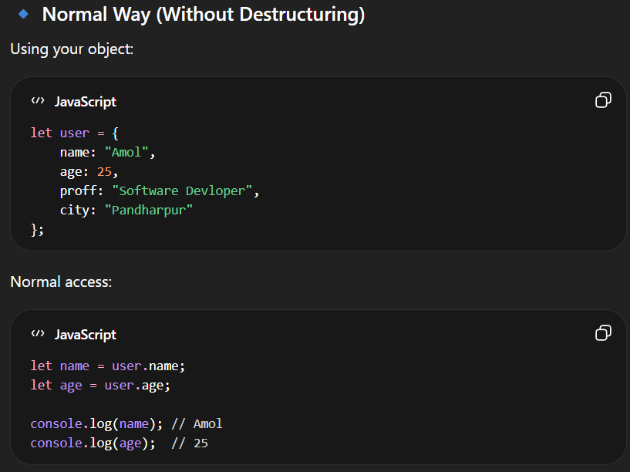
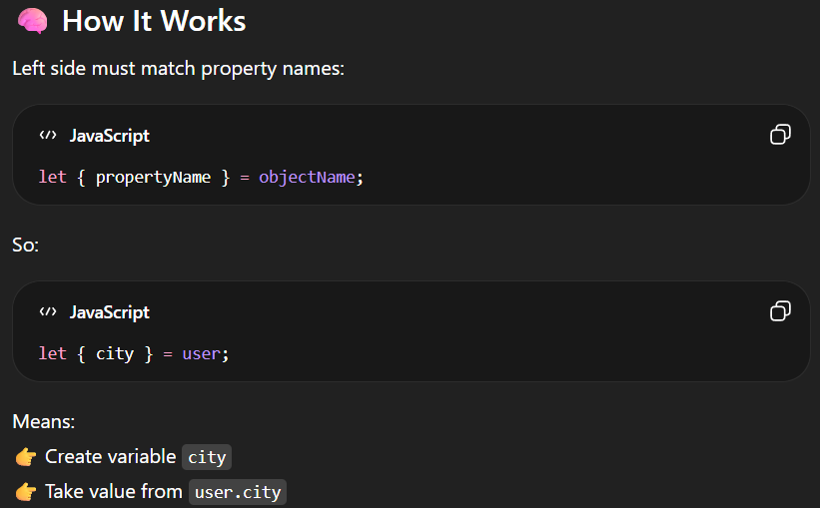
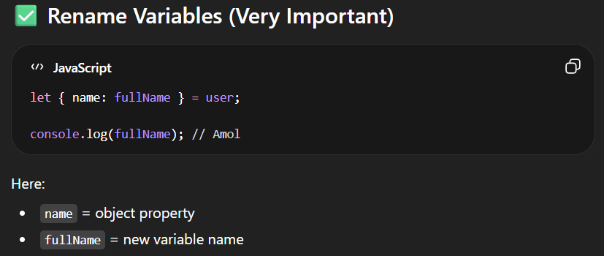
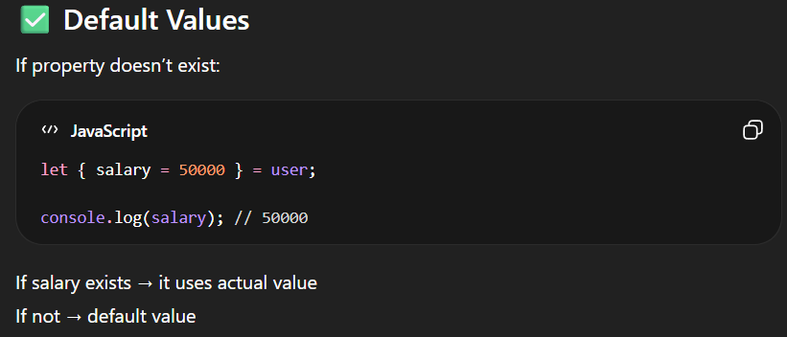
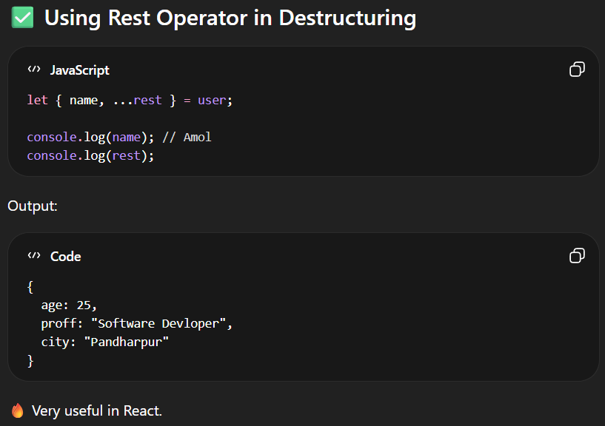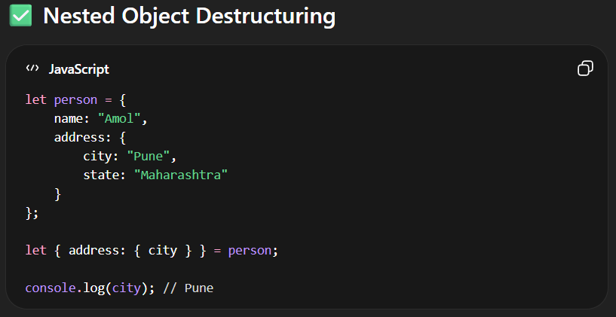

OBJECT METHODS

-In JavaScript, Object methods are mainly divided into:
- 🔹 Static Methods (used with Object.methodName())
- 🔹 Prototype Methods (used on object instances)

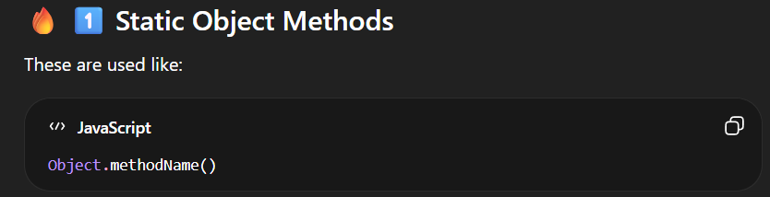

STATIC METHODS
-static method is a method that belongs directly to a constructor function (class), not to the objects created from it.
-It is called using the constructor name, not an instance.
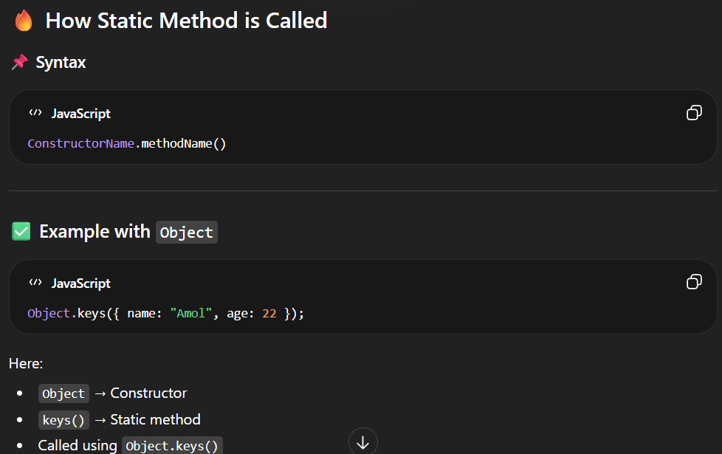
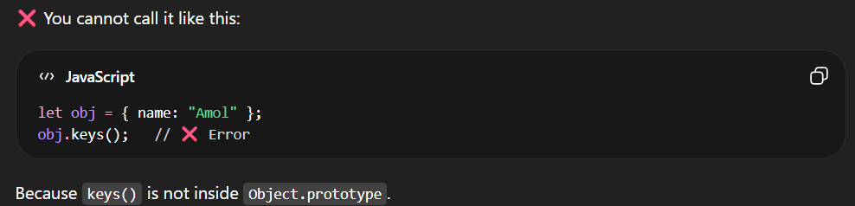

🔥 All Static Methods of Object in JavaScript
Here is the complete list 👇
- Object.assign()
- Object.create()
- Object.defineProperty()
- Object.defineProperties()
- Object.entries()
- Object.freeze()
- Object.fromEntries()
- Object.getOwnPropertyDescriptor()
- Object.getOwnPropertyDescriptors()
- Object.getOwnPropertyNames()
- Object.getOwnPropertySymbols()
- Object.getPrototypeOf()
- Object.groupBy() ✅ (ES2024)
- Object.hasOwn()
- Object.is()
- Object.isExtensible()
- Object.isFrozen()
- Object.isSealed()
- Object.keys()
- Object.preventExtensions()
- Object.seal()
- Object.setPrototypeOf()
- Object.values()

1.Object.keys(Object)
-Object.keys() is a static method that returns an array of an object’s own properties names.
Object.keys() returns:
✔ Only own properties (not inherited ones)
✔ Only enumerable properties
✔ Result is always an array.
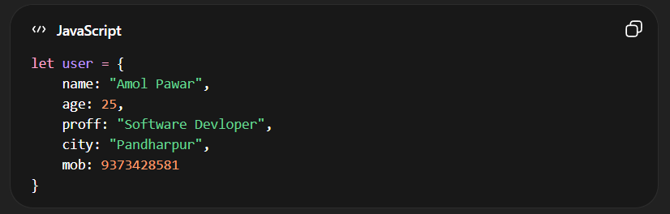
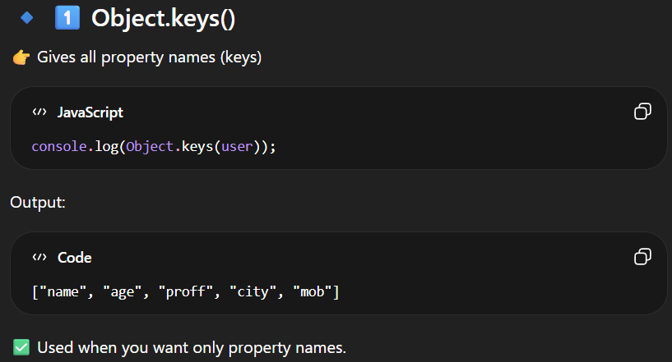

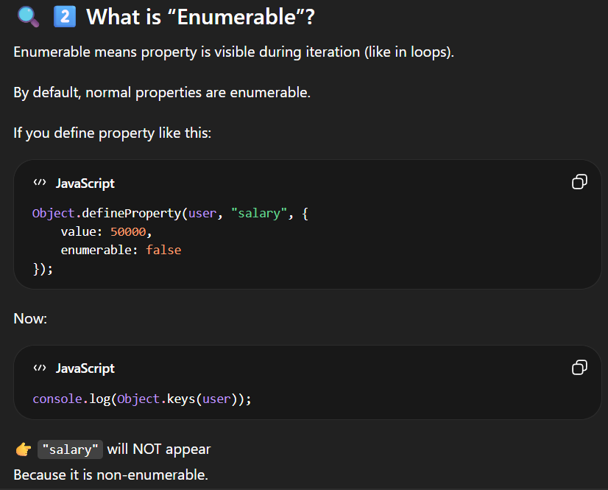

2.Object.values()
-Object.values() is a static method that returns an array of an object’s own enumerable property values.
Object.values returns :
✔ Only own properties
✔ Only enumerable properties
✔ Returns an array of values only
✔ Order is same as property insertion order
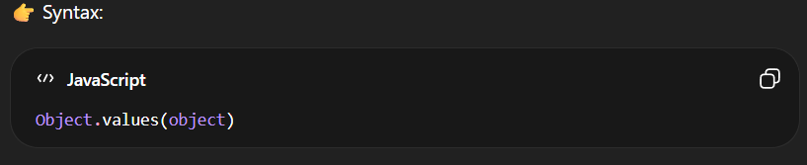
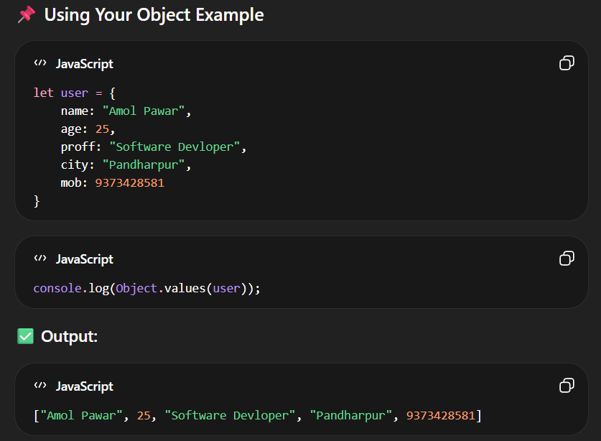

3.Object.entries()
-Object.entries() is a static method that returns an array of an object’s own enumerable key–value pairs.
Object.entries() returns:
✔ Only own properties
✔ Only enumerable properties
✔ Returns array of [key, value] pairs
✔ Order = insertion order
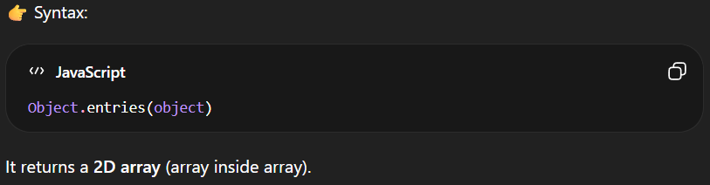
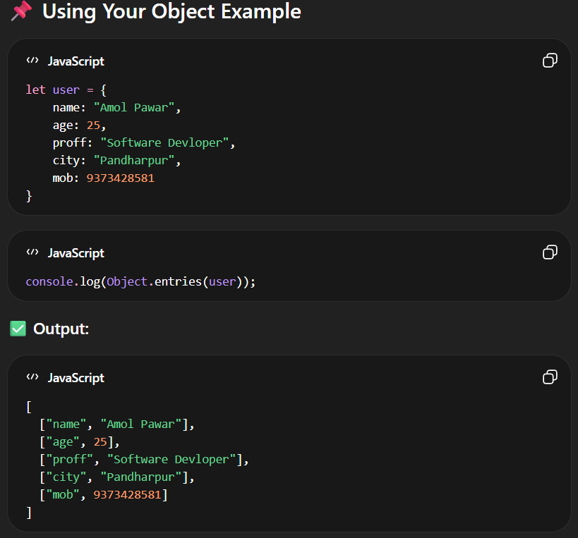
4.Object.assign()
-Object.assign() is a static method used to copy properties from one or more source objects into a target object.
-✔ Copies only own properties
✔ Copies only enumerable properties
✔ Performs shallow copy
✔ Returns the modified target object
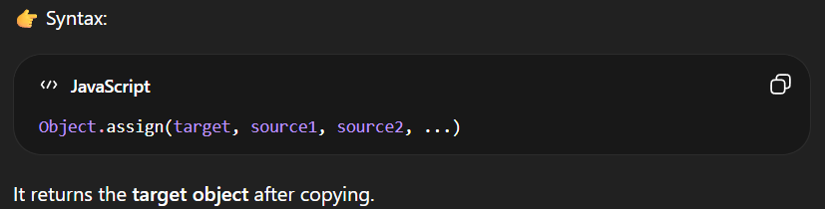
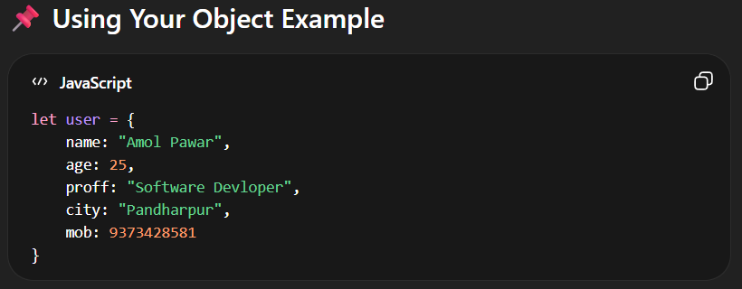
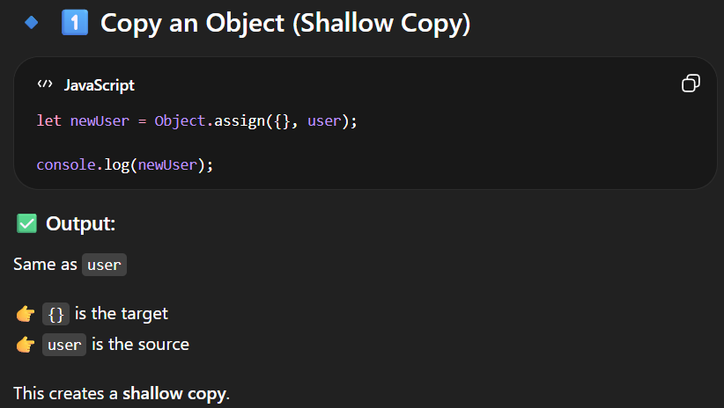
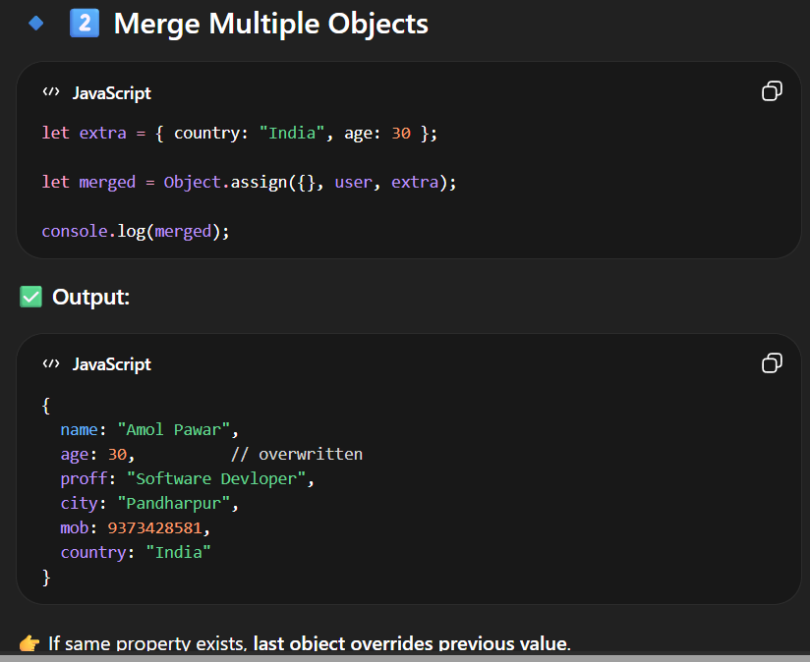

5.Object.freeze()
-Object.freeze() is a static method that makes an object completely immutable (cannot be changed).

🔥 What Freeze Prevents
After freezing:
❌ Cannot add new property
❌ Cannot delete property
❌ Cannot modify existing property
❌ Cannot change property descriptors.
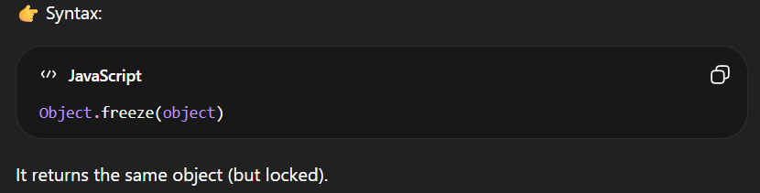
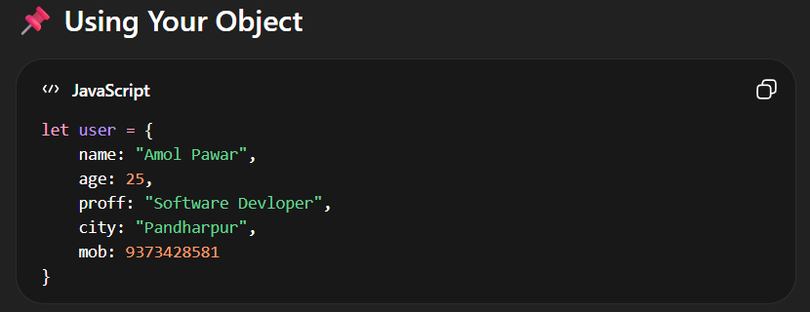
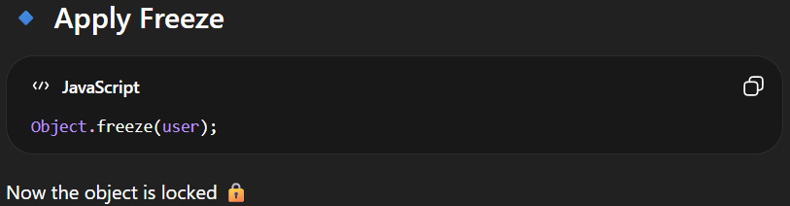
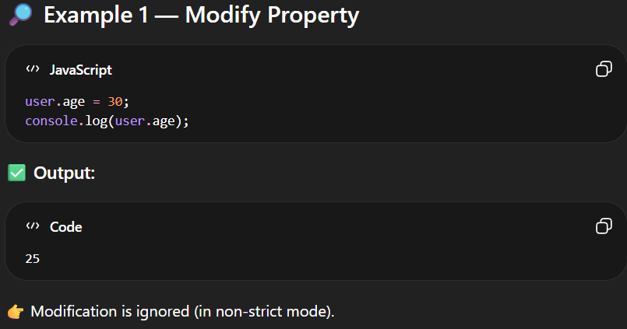
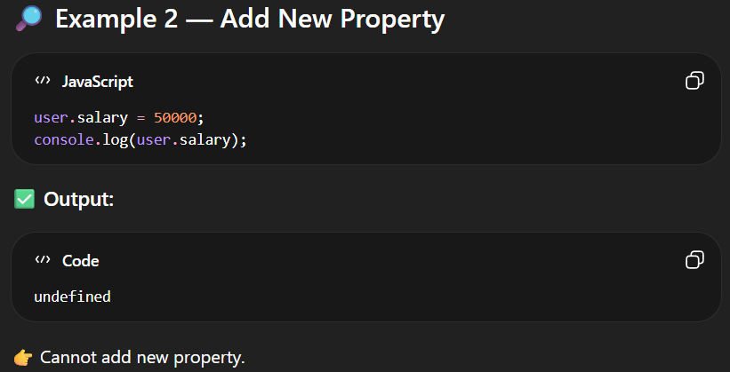
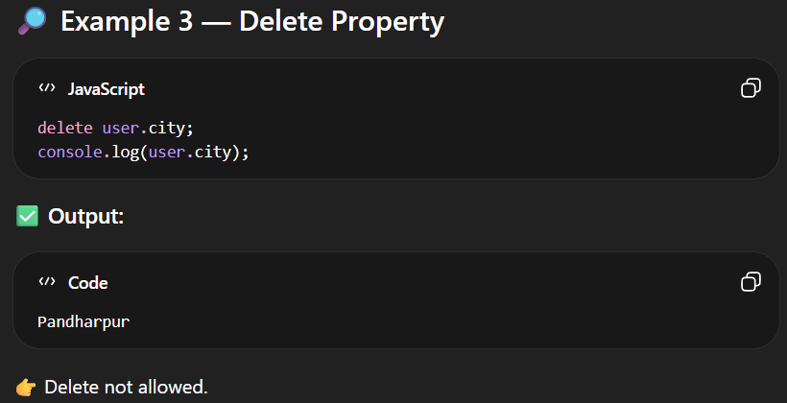

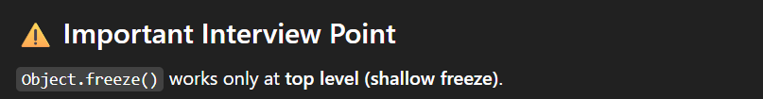
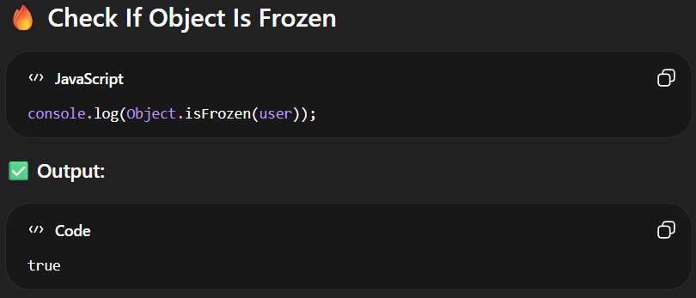

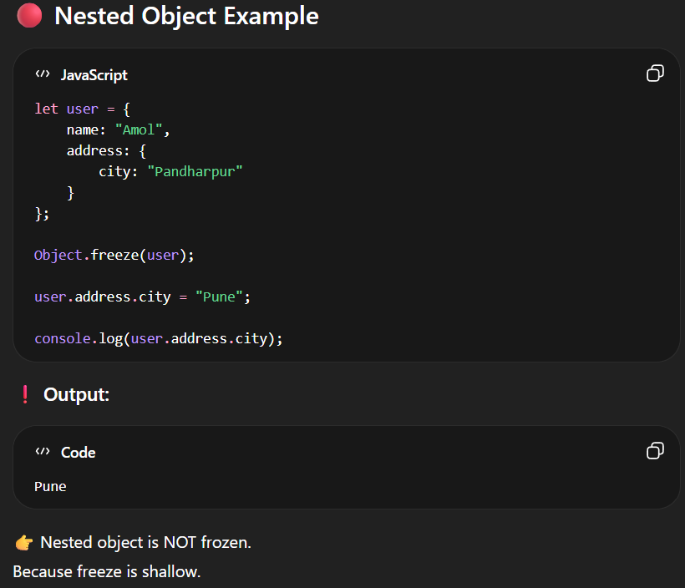

6.Object.seal()

-Object.seal() is a static method that locks the structure of an object.
- Seal means locks the Object.
👉 After sealing:
- ❌ You cannot add new properties
- ❌ You cannot delete properties
- ✅ You CAN modify existing properties
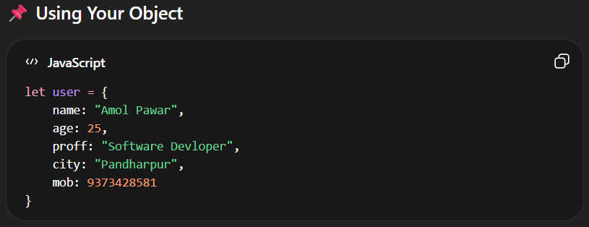
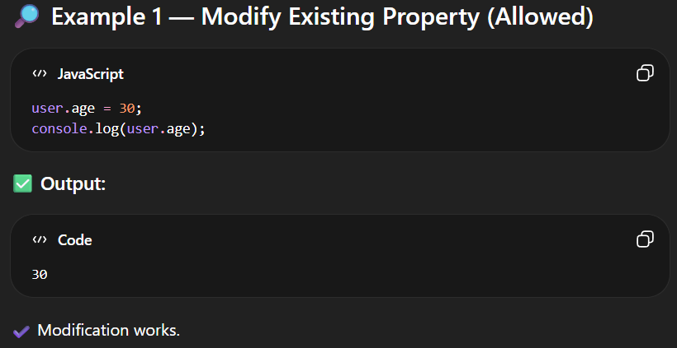

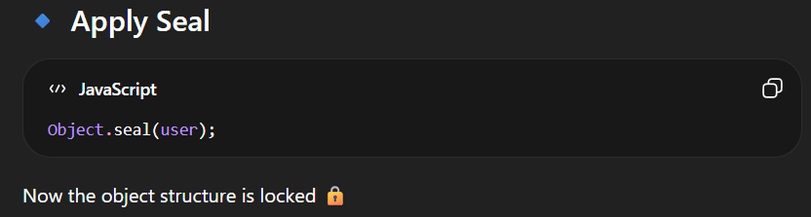
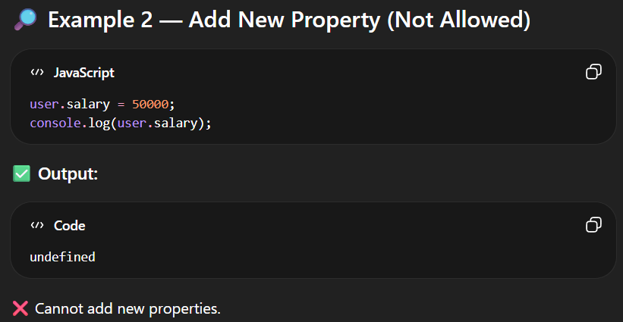
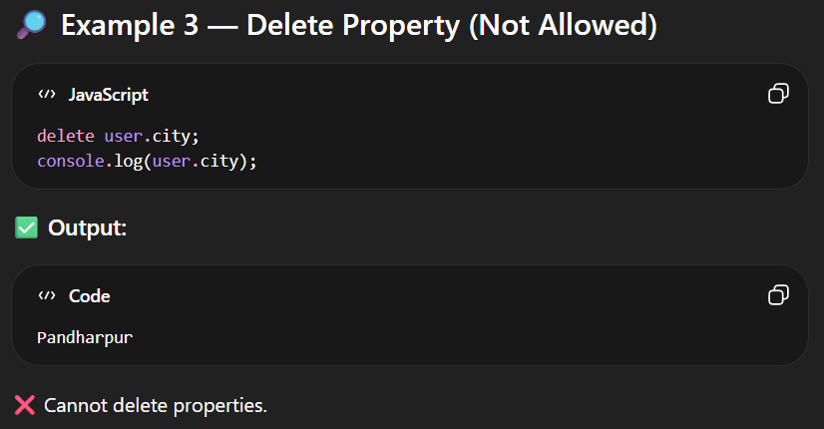
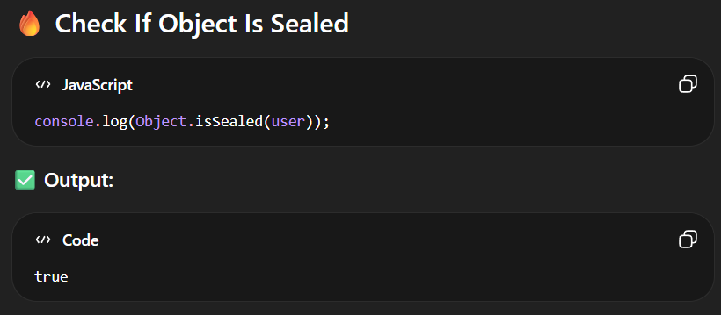

7.Object.hasOwn()
-Object.hasOwn() is a static method used to check whether a property exists directly on the object (own property).
-👉 It does NOT check properties from the prototype chain.
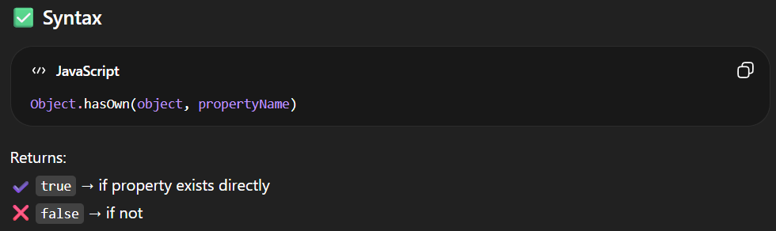
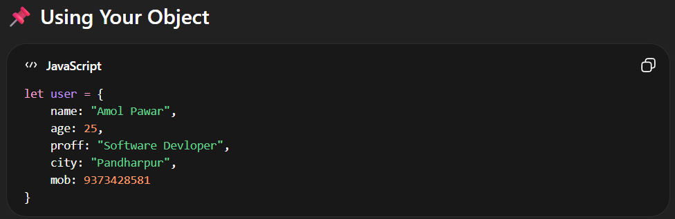
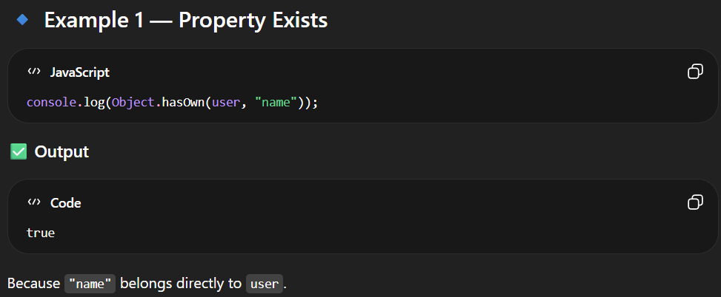
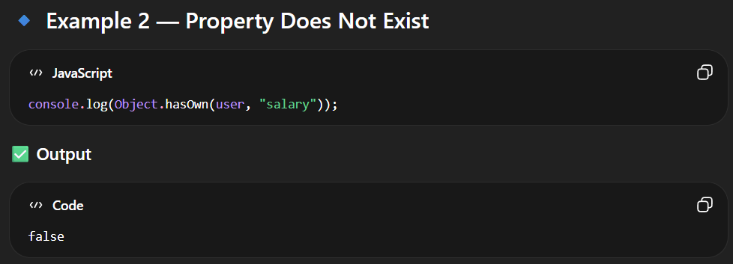
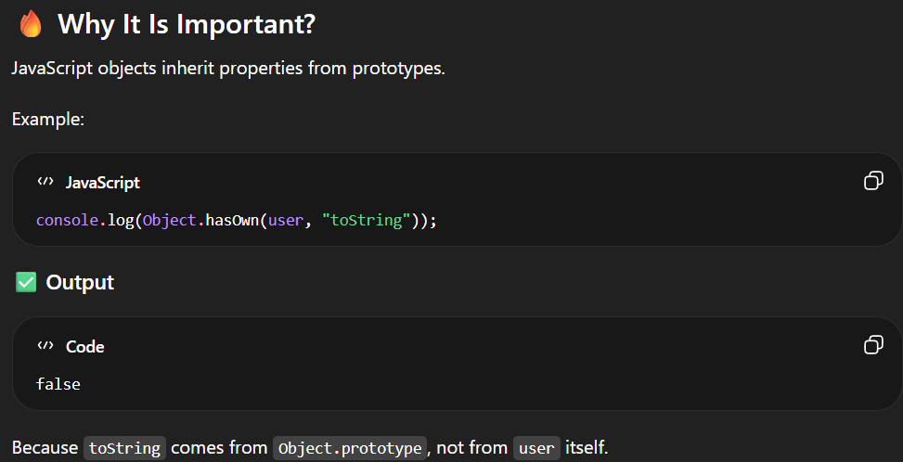
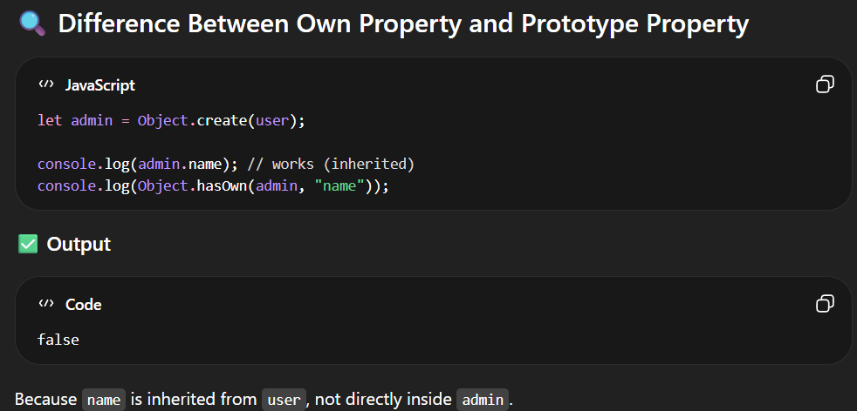

8.Object.create()

-Object.create() is a static method of Object that creates a new object and sets its prototype to the object you pass.
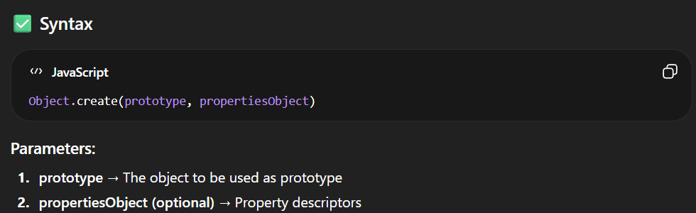
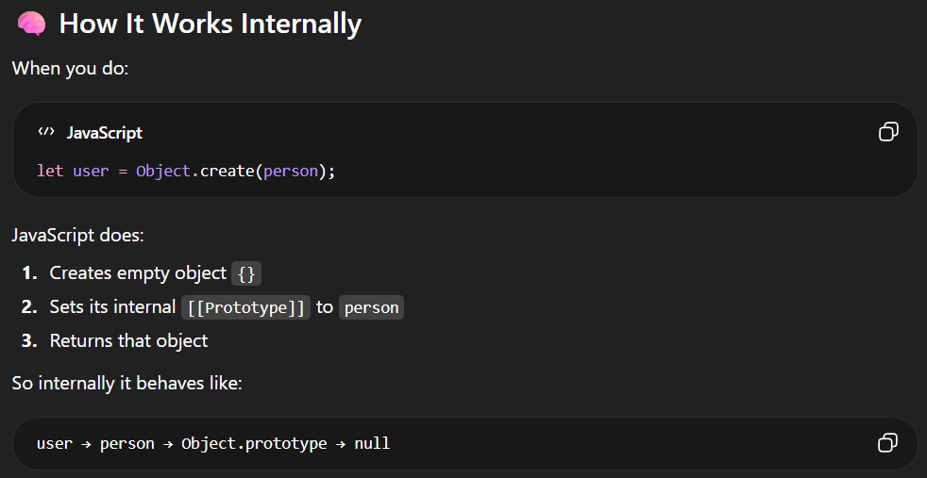
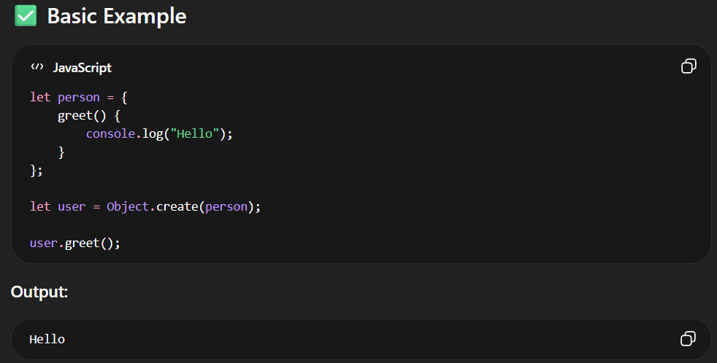
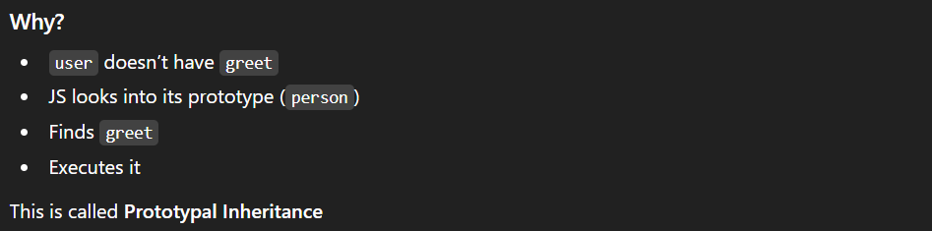
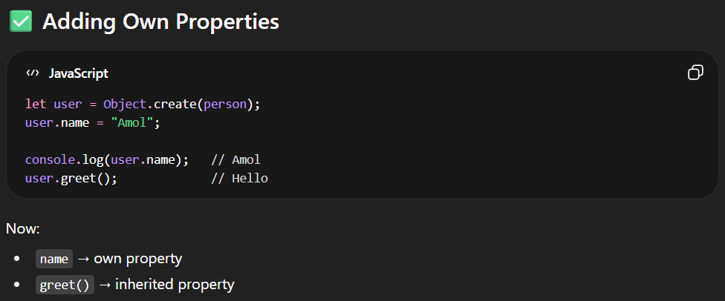
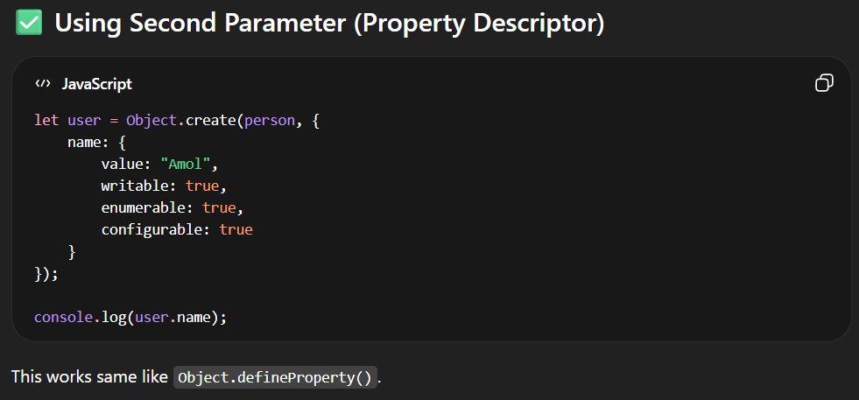

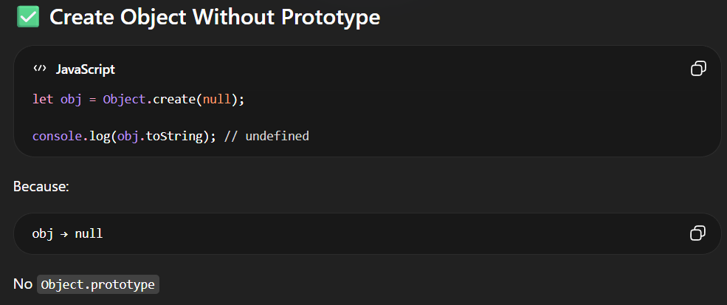

PROTOTYPE METHODS

🔥 What is Prototype Chain?
-In JavaScript, every object has a hidden link to another object called its prototype.
-This linking continues until it reaches null.
-That chain is called the Prototype Chain

-The following are the prototype method
- hasOwnProperty()
- isPrototypeOf()
- propertyIsEnumerable()
- toString()
- valueOf()
- toLocaleString()
- __proto__ (legacy accessor property)

1.Object.hasOwnProperty()

-hasOwnProperty() is a method that checks whether a property exists directly inside the object (own property).
👉 It does NOT check properties from the prototype chain.

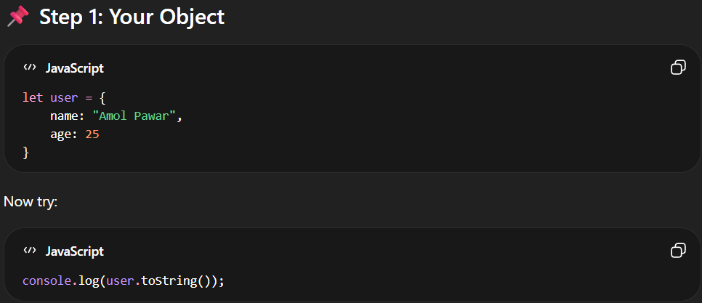
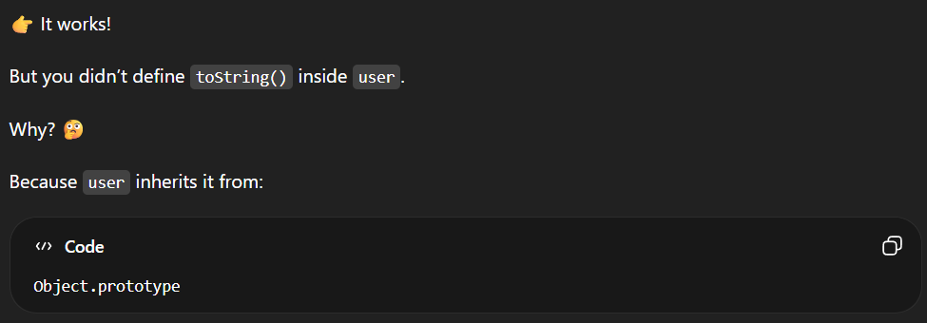
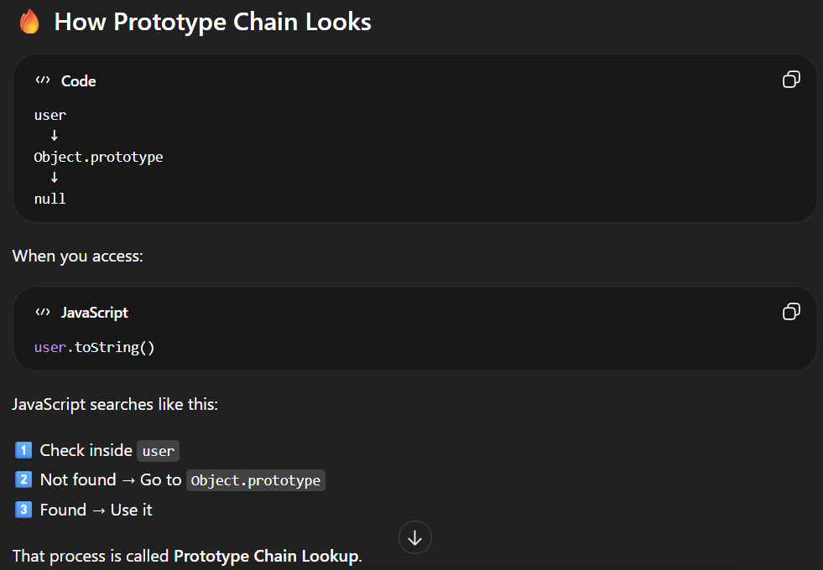
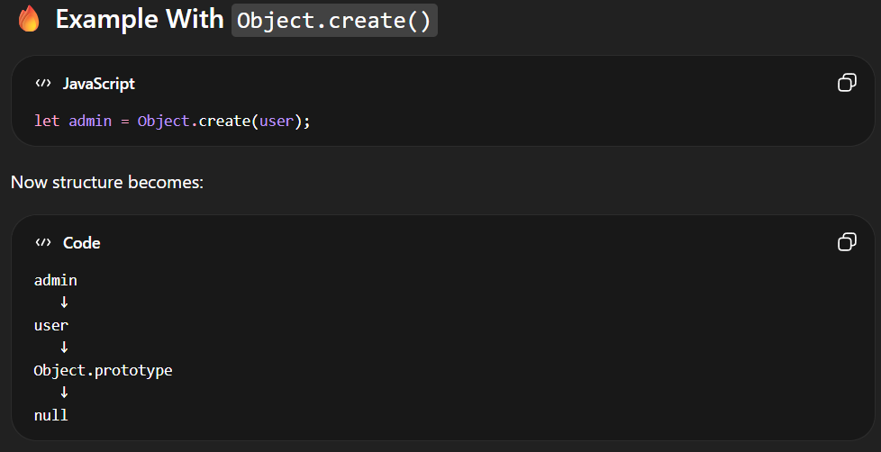
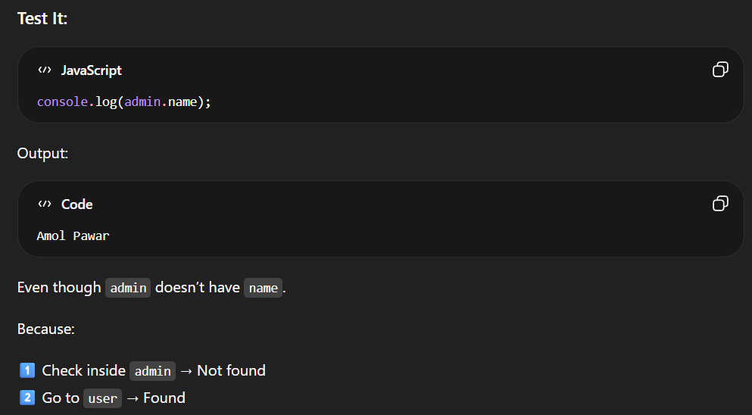
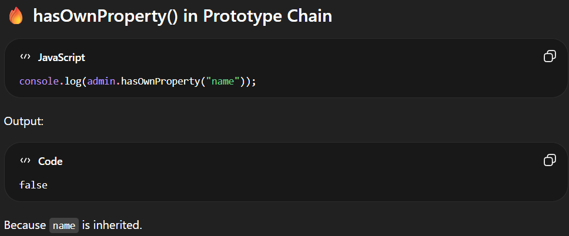
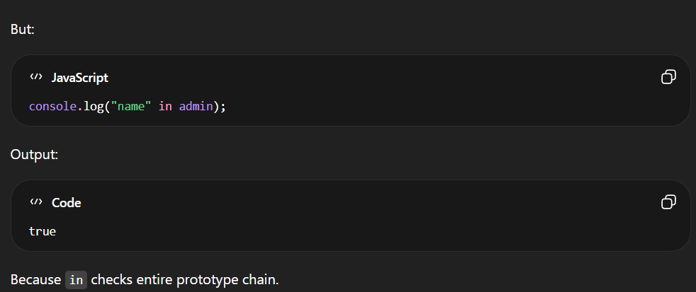
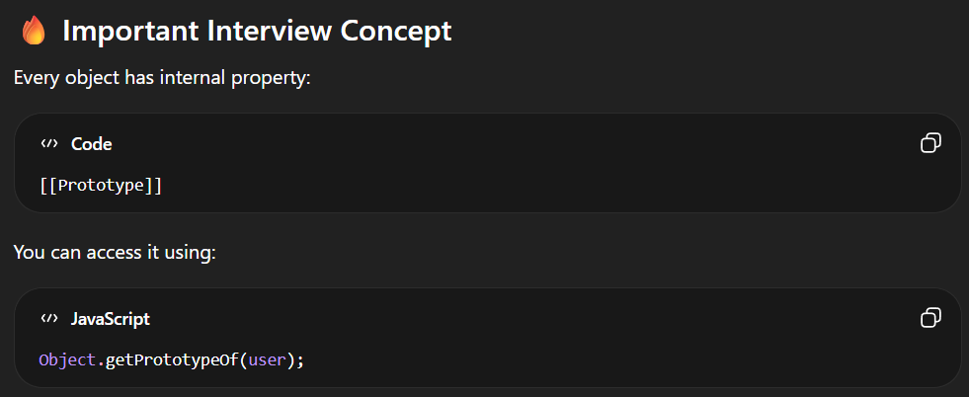

JAVASCRIPT OBJECT OPERATIONS
C = CREATE

R = RETRIVE
U = UPADATE

D = DELETE

CRUD OPERATION
-In JavaScript, we can perform various operations on object properties like modifying, adding, deleting, and so on.
1. Modify Object Properties

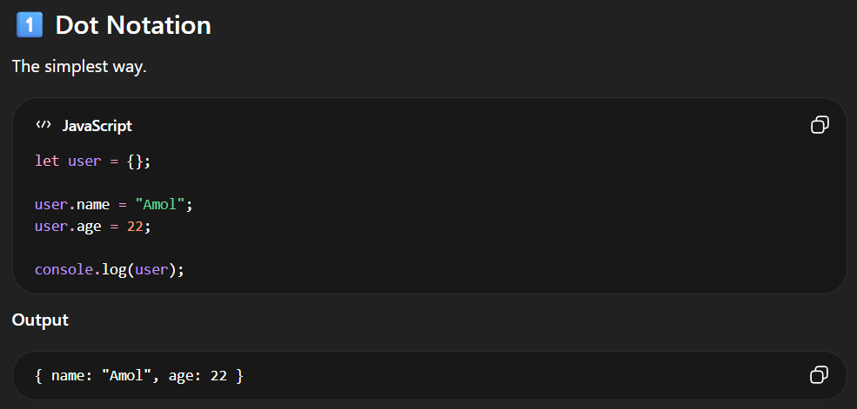
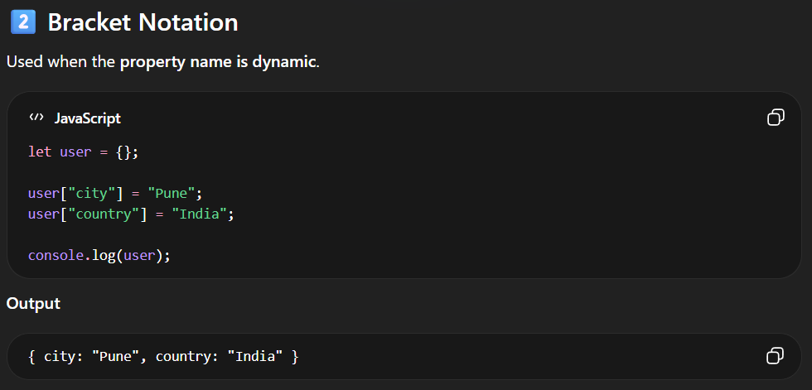
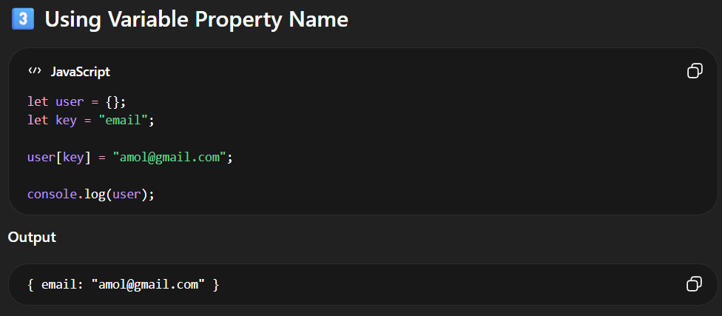
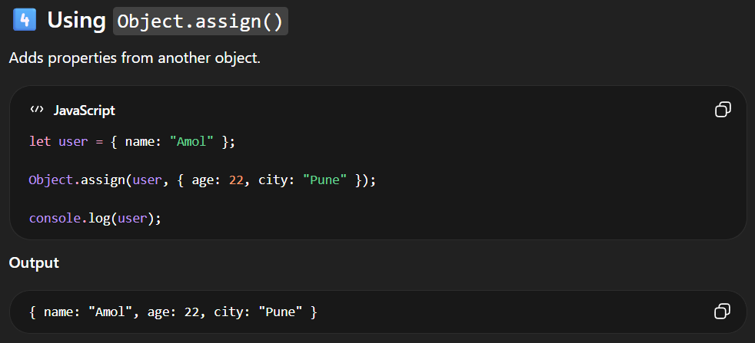
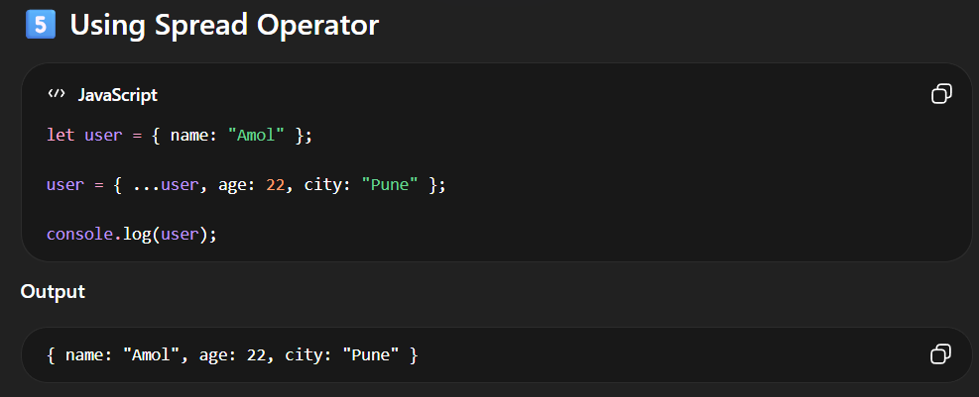
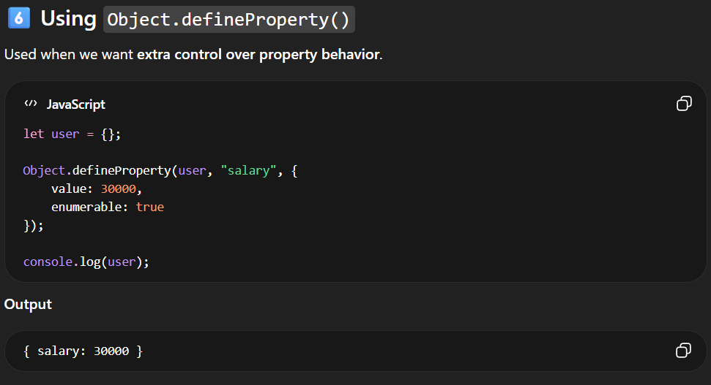
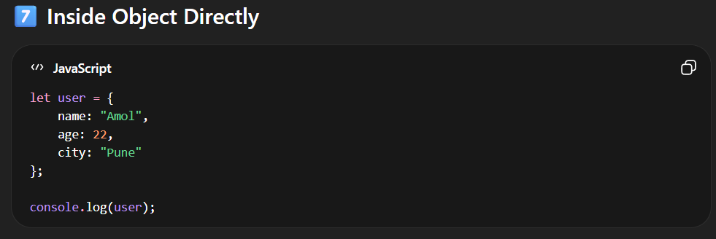

2. Read Object Properties

-Reading means getting the value of a property from an object.
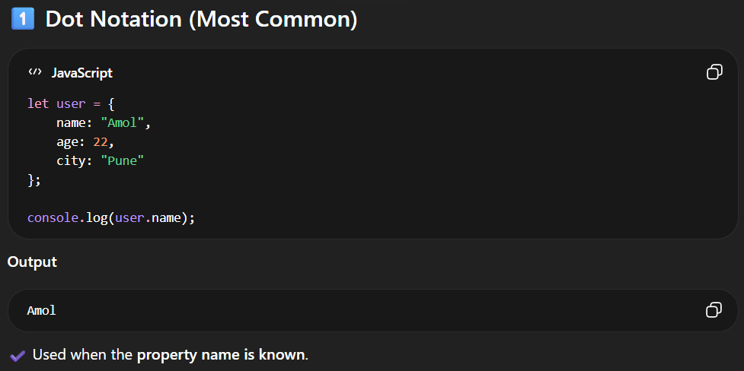
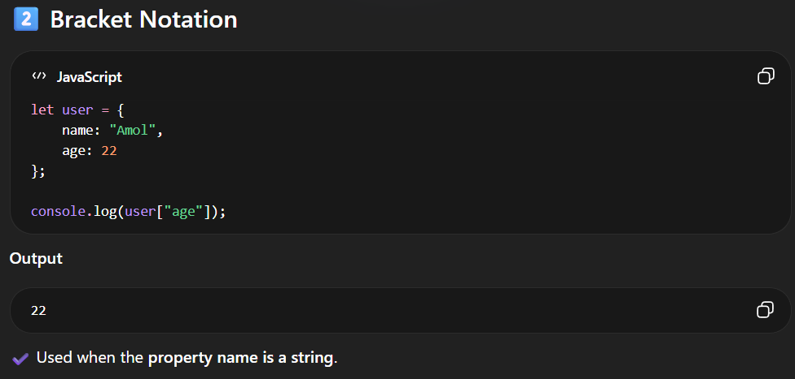
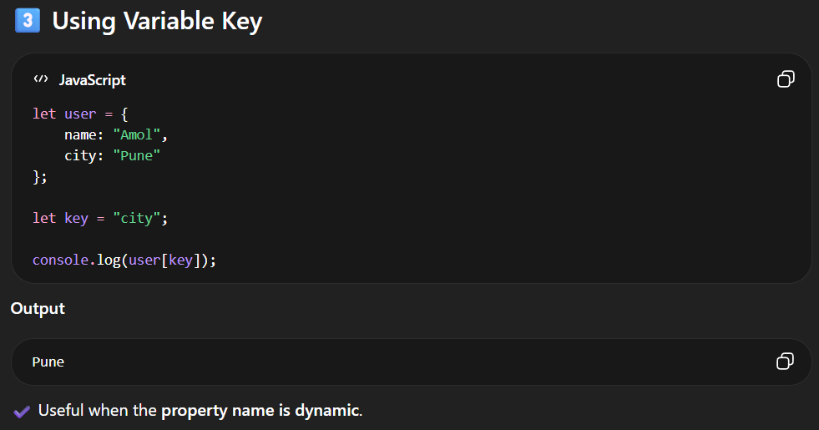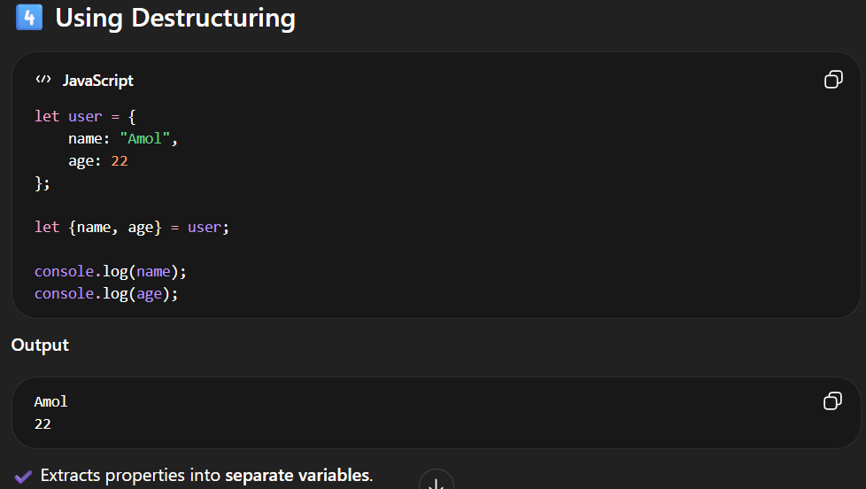
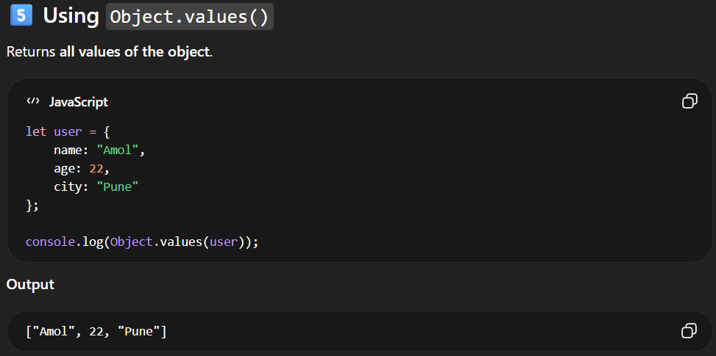
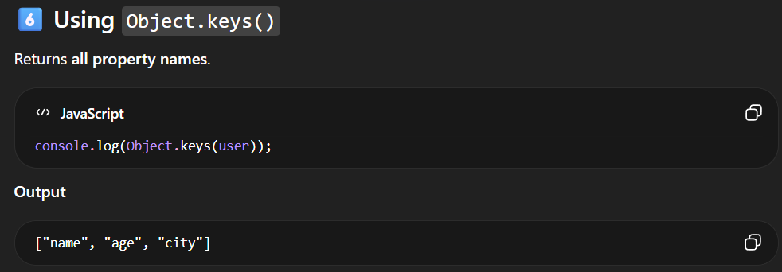
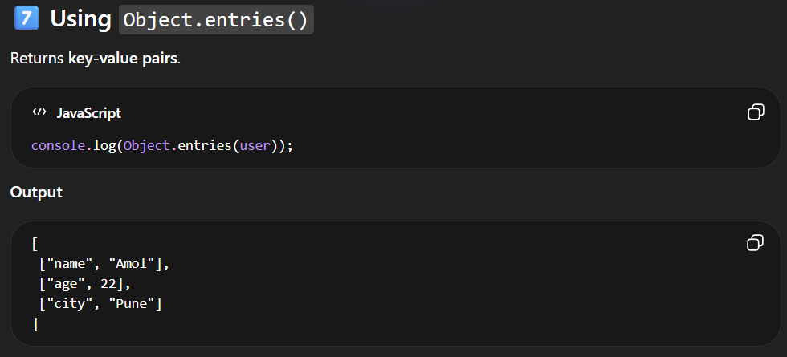
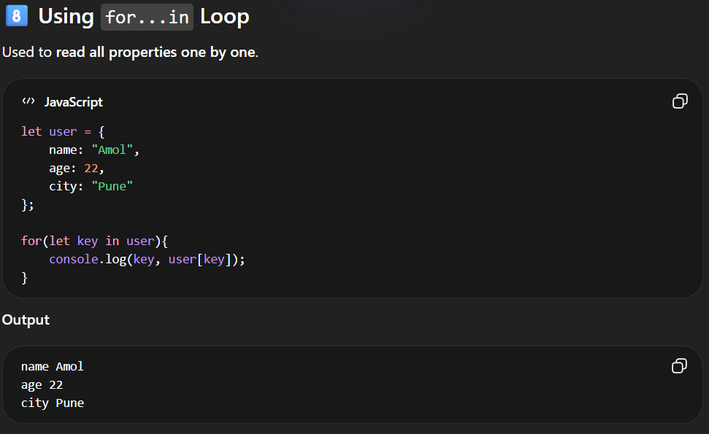

3. Update Object Properties

-Update means changing the value of an existing property in an object.
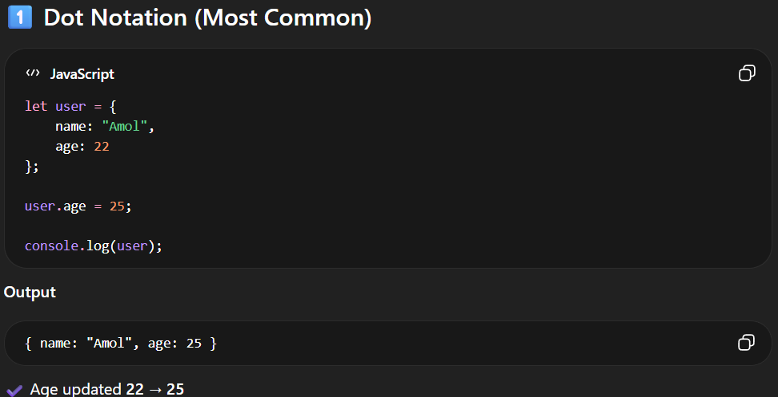
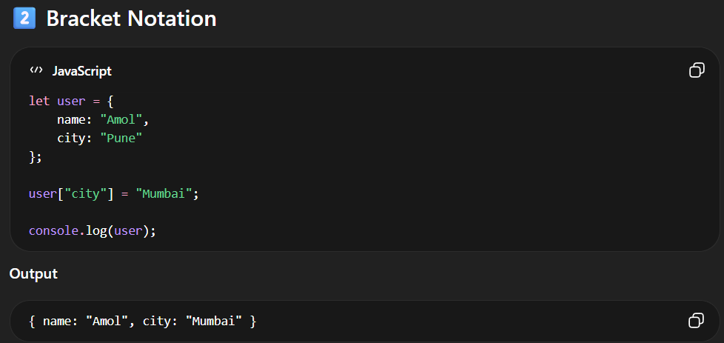
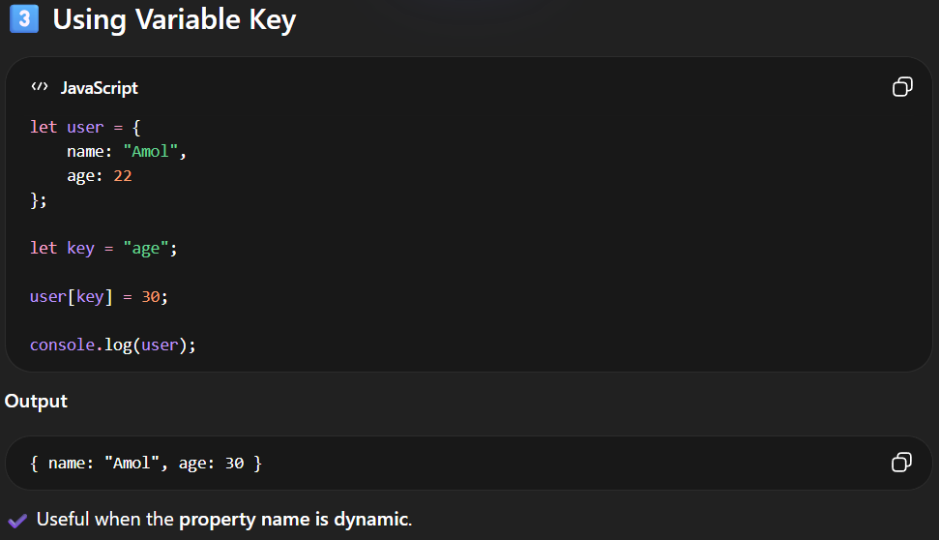
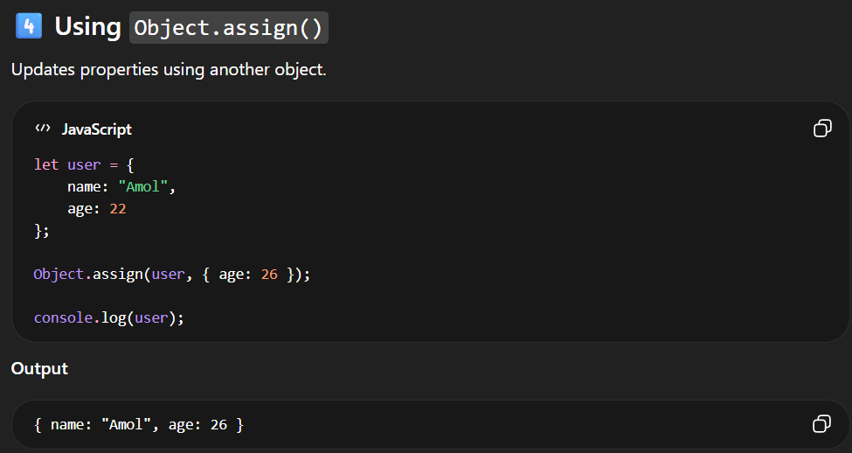
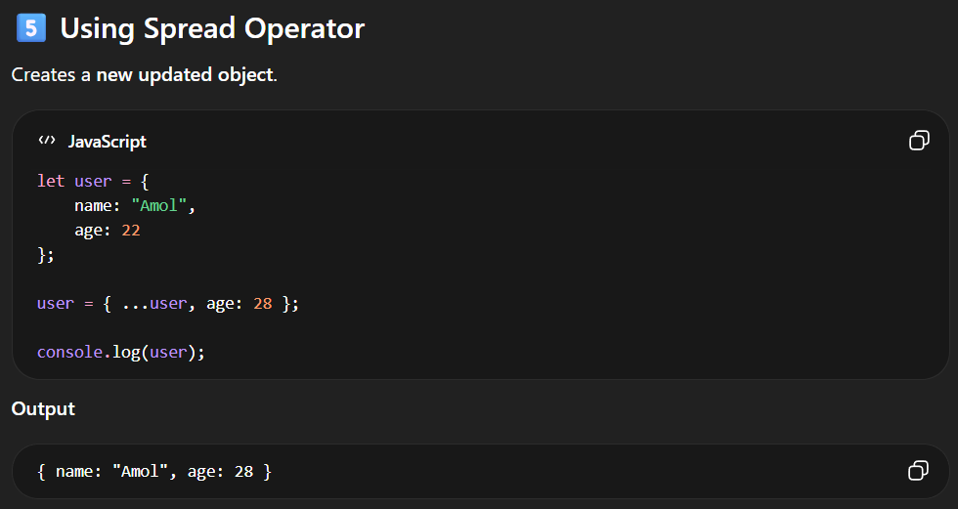
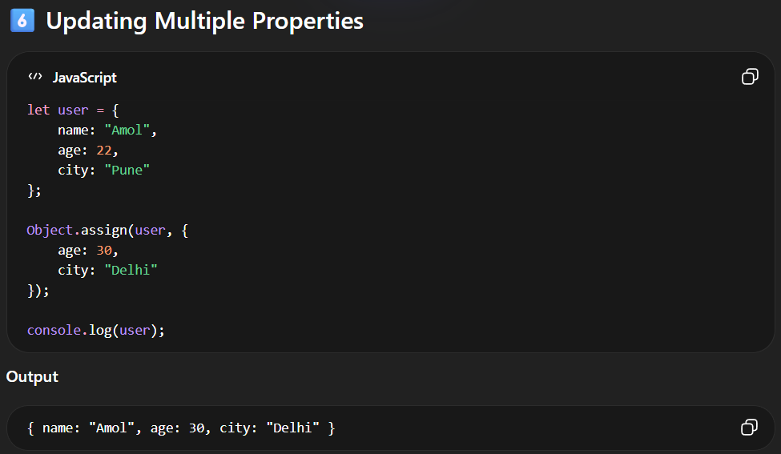

4. Delete Object Properties

-Delete means removing a property from an object.
-JavaScript provides different ways to delete properties.
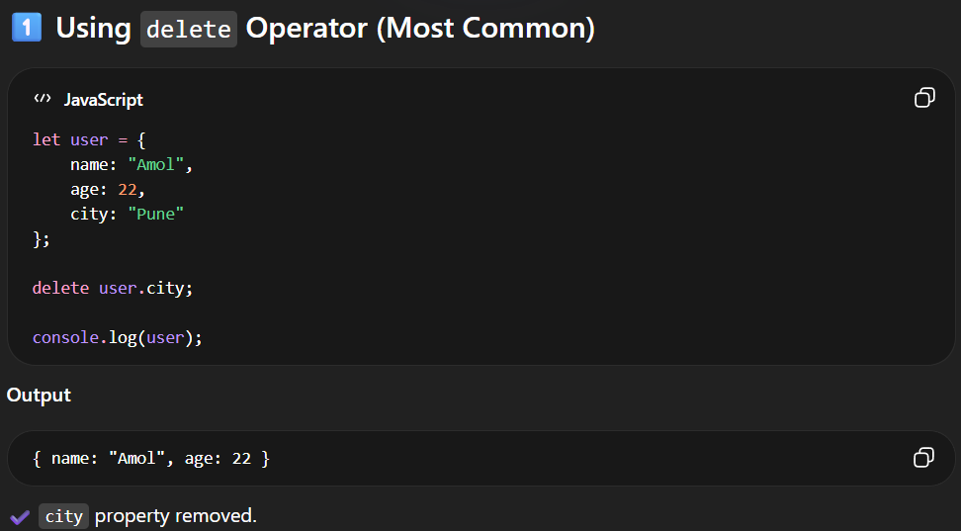

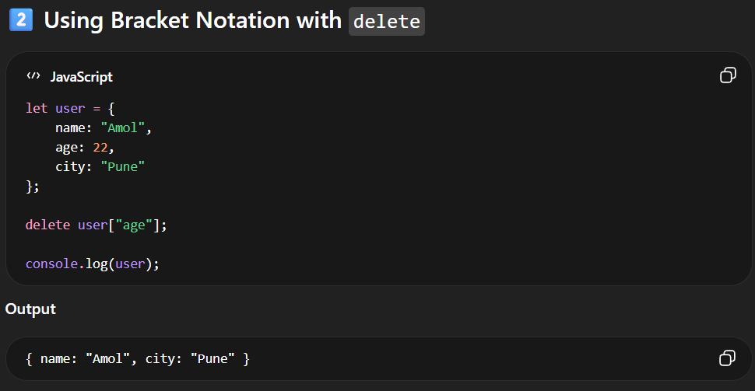
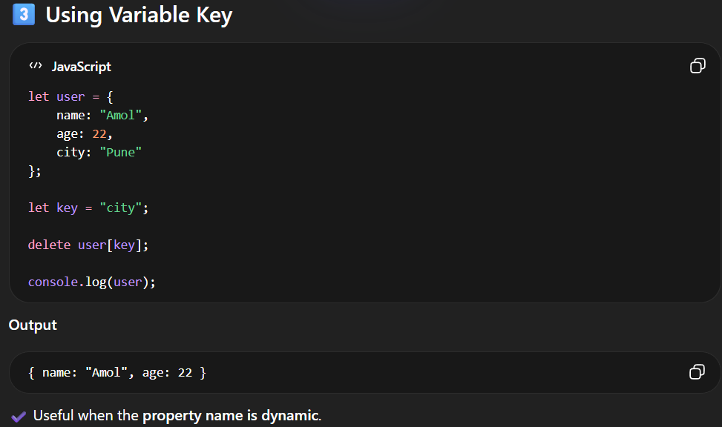
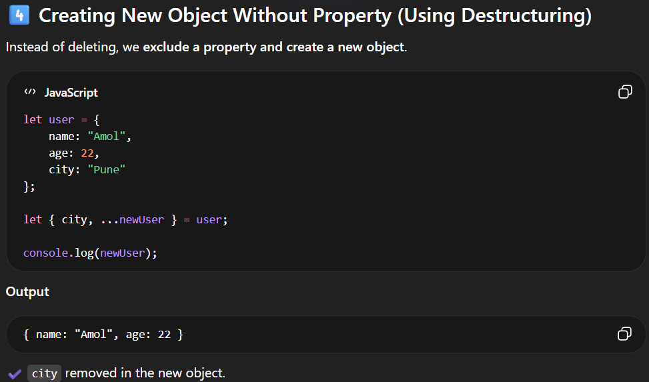
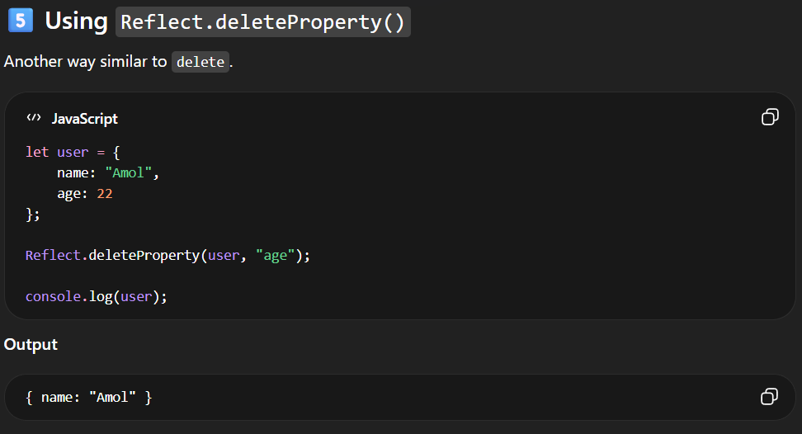

JavaScript Nested Objects
A nested object contains another object as a property. For example,
// outer object student
const student = {
name: "John",
age: 20,
// contains another object marks
marks: {
science: 70,
math: 75
}
};
// display student
console.log(student);

// Output: { name: 'John', age: 20, marks: { science: 70, math: 75 } }

Access Properties of Nested Objects
const student = {
name: "John",
age: 20,
marks: {
science: 70,
math: 75
}
};
// use dot notation
console.log(student.marks.science); // 70
// use bracket notation
console.log(student["marks"]["math"]); // 75

2.ARRAY

-Array is continuous Block of Memory which is used to store the Heterogeneous (Different Type) Type of data in JavaScript
-In JavaScript Array is used to store the Heterogeneous (Different Types Of Values.) Type of data.
-An array is an object that can store multiple values at once.
-An array is a special variable, which can hold more than one value.
-Array is type of object.

Why Use Arrays?
-Arrays allow us to organize related data by grouping them within a single variable.
-Suppose you want to store a list of fruits. Using only variables, this process might look like this:
let fruit1 = "Apple";
let fruit2 = "Banana";
let fruit3 = "Orange";
Here, we've only listed a few fruits. But what if we need to store 100 fruits?
For such a case, the easiest solution is to store them in an array.
let fruits = ["Apple", "Banana", "Orange", ...];

Basic Terminologies of JavaScript Array
- Array: A data structure in JavaScript that allows you to store multiple values in a single variable.
- Array Reference variable: - In the array the Array reference Variable is created which holds the Address of the Array
- Array Element: Each value within an array is called an element. Elements are accessed by their index.
- Array Index value: Array index value is always start with 0 [Zero] with the help of Array Index value we store or manipulate the data.
- Array Length: The number of elements in an array. It can be retrieved using the length property. The Length of the Array is always starts with 1.
The length Property
-The length property of an array returns the length of an array (the number of array elements).
-The length always starts with 1.
Example : -
const fruits = ["Banana", "Orange", "Apple", "Mango"];
let length = fruits.length;
-The length property is always one more than the highest array index.

Create an Array
Using an array literal is the easiest way to create a JavaScript Array.
Syntax: -
const array_name = [item1, item2, ...];

It is a common practice to declare arrays with the const keyword.
For Example : -
const array1 = [“Amol”,”Ganesh”,”Onkar”,”Rohit”, true,24,null,undefined]

LENGTH
array1
INDEX VALUE

1
0

Amol

8
7
6
5
3
2
4
1
Ganesh

2
Onkar
3
Rohit

4
true
5
24

6
null
7
undefined

-In JavaScript, you cannot directly print the memory address of an array (or any object) like in languages like C/C++. JavaScript abstracts memory management from the developer.
However, if you need a way to uniquely identify an array, you can use its object reference:
const arr = [1, 2, 3];
console.log(arr); // This prints the array content, not the address
-In JavaScript we can create an array in three ways:
1.By Using Literals
2.By Using Array Of Object
3.By Using New Keyword /Array Constructor
4.By Using Array.of() Method
5.By Using Array.from() Method

1.By Using Literals

-'We can create an array by placing elements inside an array literal [], separated by commas( , ). For example,
const numbers = [10, 30, 40, 60, 80];
Here,
- numbers - Name of the array.
- [10, 30, 40, 60, 80] - Elements of the array.

Access Elements of an Array
-Each element of an array is associated with a number called an index, which specifies its position inside the array.
Consider the following array:
let numbers = [10, 30, 40, 60, 80];
Here is the indexing of each element:s
-We can use an array index to access the elements of the array.
Code | Description
numbers[0] | Accesses the first element 10.
numbers[1] | Accesses the second element 30.
numbers[2] | Accesses the third element 40.
numbers[3] | Accesses the fourth element 60.
numbers[4] | Accesses the fifth element 80.
// Example 1: Empty Array
let emptyArray = [];
// Example 2: Array with elements
let numbers = [1, 2, 3, 4, 5]; let fruits = ["apple", "banana", "cherry"];

2.By Using Array Of Object

<!--! ARRAY USING OBJECT -->
<script>
let obj={
name:"Amol",
Age:24,
Proff:"Software Developer",
array:[10,20,30,40,50]
}

console.log(obj);
console.log(obj.name);
console.log(obj.array);
console.log(obj.array[0]);
</script>

-By Using Object you can create the Array.
-For that you have define one Object. Inside that you have define Name of the array as key and Values in the Pair.
<script>
// Create an array of objects
const students = [
{ name: "Alice", age: 20 },
{ name: "Bob", age: 21 },
{ name: "Charlie", age: 19 }
];

// Access properties of an object in the array
console.log(students[1]); // Output: "Bob"
</script>

3.By Using New Keyword / Array Constructor

<script>
let array = new Array();
console.log(array);
console.log(array[0]);
array[0]=10;
array[1]="Amol";
array[2]=true;
array[3]=null;
console.log(array)
console.log(array.length)
</script>

-In this we have to use the new keyword.
You can use the Array constructor to create an array. This method is particularly useful if you want to create an array of a specific length.

// Example 1: Empty Array
let emptyArray = new Array();

// Example 2: Array with specified length
let tenElementsArray = new Array(10);

// Example 3: Array with elements
let numbers = new Array(1, 2, 3, 4, 5);

4.By Using New Keyword / Array Constructor

-The Array.of() method creates a new Array instance with a variable number of arguments, regardless of the number or type of the arguments.
Example : -
let numbers = Array.of(1, 2, 3, 4, 5);
let fruits = Array.of("apple", "banana", "cherry");

5. Using the Array.from( ) Method

-The Array.from() method creates a new, shallow-copied Array instance from an array-like or iterable object.
<script>
// Array.from Method
let arrayFromString = Array.from("hello");
console.log(arrayFromString); // Output: ["h", "e", "l", "l", "o"]
</script>

ARRAY BASIC METHODS

1.Array.toString()
-The JavaScript method toString() converts an array to a string of (comma separated) array values.
<script>
const fruits = ["Banana", "Orange", "Apple", "Mango"];
console.log(fruits);
console.log(fruits.toString()); // Outputs: Banana,Orange,Apple,Mango
</script>

2.Array.at()
-The at() method returns an indexed element from an array that mentioned inside the Parenthesis( ).
-It is a Parameterized method it accepts the Parameter.
<script>
let numbers = [10,20,30,40,50];
console.log(numbers);
console.log(numbers.at(2));
</script>

3. Array.join()
-The join method in JavaScript is used to combine all the elements of an array into a single string. The elements are separated by a specified separator string. If no separator is provided, a comma is used by default.
let fruits = ["apple", "banana", "cherry"];
let result = fruits.join();
console.log(result); // Output: "apple,banana,cherry"

let fruits = ["apple", "banana", "cherry"];
let result = fruits.join(" - ");
console.log(result); // Output: "apple - banana - cherry"

4. Array.pop()
- The pop() method removes the last element from an array.
-The pop() method returns the value that was "popped out":
<script>
let arr = ["Amol",24,null,true,10,20,30];
console.log(arr.pop());
</script>

<script>
const fruits = ["Banana", "Orange", "Apple", "Mango"];
console.log(fruits.pop())
</script>

5.Array.push()
-It is Parameterized method accepts the arguments.
-You can add Multiple elements in the Array.
-The push() adds the elements from Last Index.
Syntax:-
array.push(element1, ..., elementN)

-Adding single elements in the array
let fruits = ["apple", "banana"];
fruits.push("cherry");
console.log(fruits); // Output: ["apple", "banana", "cherry"]

-Adding Multiple Elements.
let fruits = ["apple", "banana"];
let newLength = fruits.push("cherry", "date", "fig");
console.log(fruits); // Output: ["apple", "banana", "cherry", "date", "fig"]
console.log(newLength); // Output: 5

6.Array.shift()
-The shift() method removes the first array element and "shifts" all other elements to a lower index.
-It is Non-Parameterized method
<script>
let arr = [1,2,3,4,5,6,7,8,9]
console.log(arr.shift());//1
console.log(arr);//2,3,4,5,6,7,8,9
</script>

7.Array.unshift()
-The unshift() method adds a new element to an array (at the beginning), and "unshifts" older elements
-The unshift() method returns the new array length:
<script>
const fruits = ["Banana", "Orange", "Apple", "Mango"];
fruits.unshift("Lemon");
console.log(fruits)
</script>

Note:We cannot use the shift() and unshift() more because it changes the array index value

8.Array.splice()
-The splice() method can be used to add new items to an array
<script>
const fruits = ["Banana", "Orange", "Apple", "Mango"];
console.log(fruits)
fruits.splice(2, 0, "Lemon", "Kiwi");
console.log(fruits);// Banana,Orange,Lemon,Kiwi,Apple,Mango
</script>

-The first parameter (2) defines the position where new elements should be added (spliced in).
-The second parameter (0) defines how many elements should be removed.
-The rest of the parameters ("Lemon" , "Kiwi") define the new elements to be added.

Example NO2:-
<script>
const fruits1 = ["Banana", "Orange", "Apple", "Mango"];
console.log(fruits1);
fruits1.splice(2, 2, "Lemon", "Kiwi");
console.log(fruits1)
</script>

Original Array:
Banana,Orange,Apple,Mango
New Array:
Banana,Orange,Lemon,Kiwi
Removed Items:
Apple,Mango

Note : Splice method changes the original array

9.Array.slice()
-The slice() method slices out a piece of an array into a new array
-The slice() method creates a new array.
-The slice() method does not remove any elements from the source array.
-The slice() method can take two arguments like slice(1, 3).
-The method then selects elements from the start argument, and up to (but not including) the end argument.
Syntax
array.slice(start, end)
Parameters
Parameter | Description
start | Optional.  Start position. Default is 0.  Negative numbers select from the end of the array.
end | Optional.  End position. Default is last element.  Negative numbers select from the end of the array.
<script>
const fruits = ["Banana", "Orange", "Lemon", "Apple", "Mango"];
const citrus = fruits.slice(1);
console.log(citrus)
</script>

Examples

<script>
const fruits = ["Banana", "Orange", "Lemon", "Apple", "Mango"];
const citrus = fruits.slice(1, 3);
</script>

-slice() returns selected array elements as a new array:
Orange,Lemon.

<script>
const fruits = ["Banana", "Orange", "Lemon", "Apple", "Mango"];
const myBest = fruits.slice(-3, -1);
</script>

slice() returns selected array elements as a new array:
Lemon,Apple.

ARRAY ITERATIONS METHODS

1.map()

-Map is array method in Javascript.
-Map method used to perform the operation on the array.
-map() loops through every element of an array and creates a new array using the returned values from the callback function.
-When we applied map on the array the size of the array is same like original array.
-map() creates a new array from calling a function for every array element.
-map() does not execute the function for empty elements.
-map() does not change the original array.
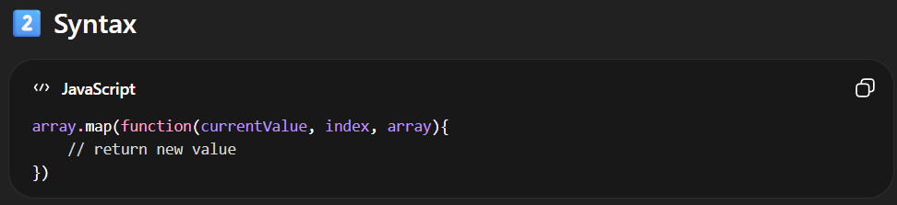
Parameters
Parameter | Description
function() | Required.  A function to be run for each array element.
currentValue | Required.  The value of the current element.
index | Optional.  The index of the current element.
arr | Optional.  The array of the current element.
thisValue | Optional.  Default value undefined.  A value passed to the function to be used as its this value.

Return Value
Type | Description
An array | The results of a function for each array element.

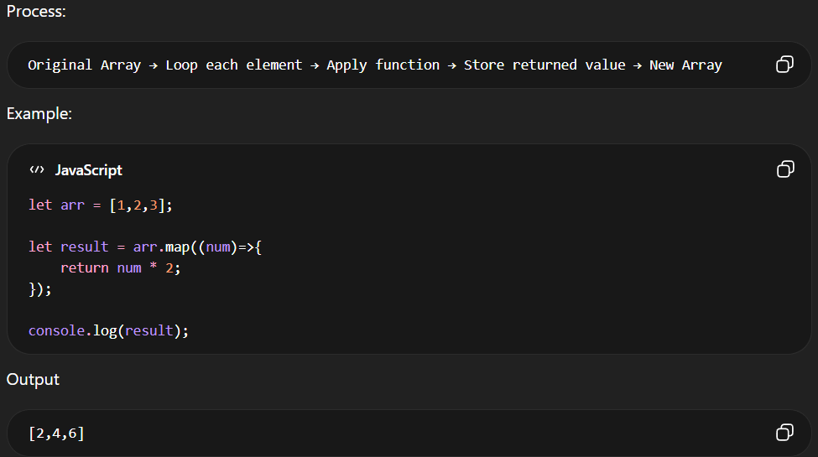
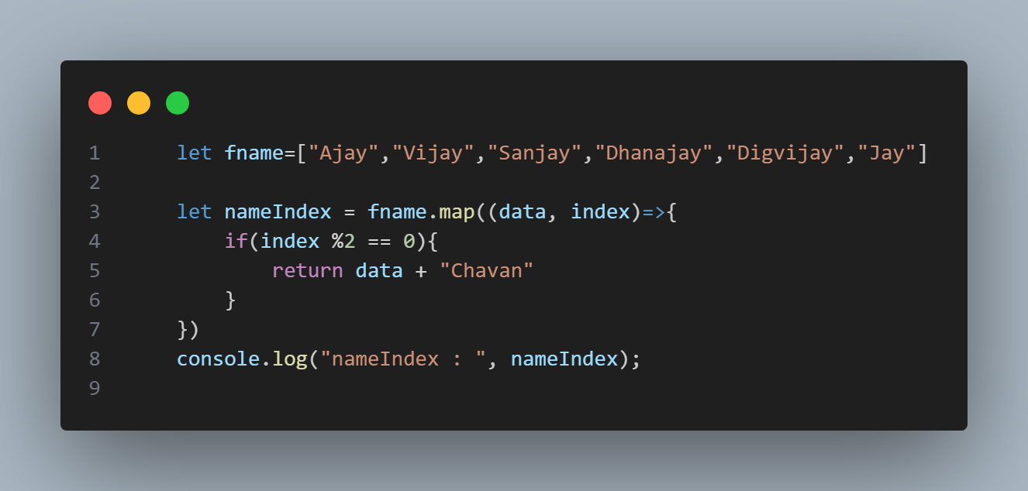
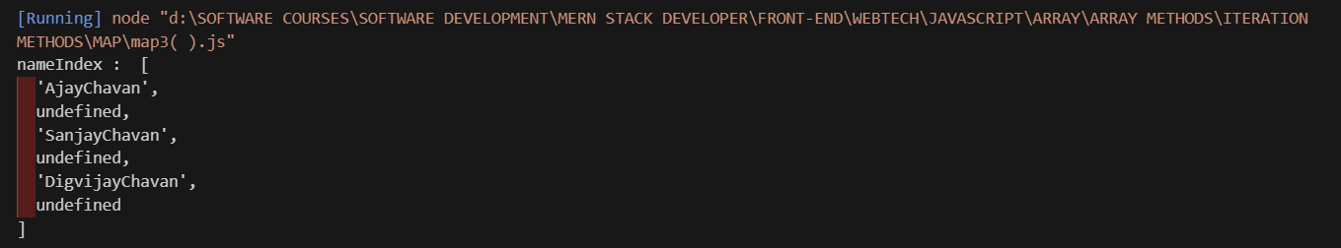
-Yes, map() can return undefined, but only when your callback function does not return a value.
Important point:
👉 map() itself does not return undefined.
👉 It always returns a new array.
👉 But each element inside the array can be undefined if you don’t return anything for that iteration.

2.filter()

-It is used to select elements from an array based on a condition.
-The filter() method creates a new array containing only the elements that pass a test (condition).
-If the condition is true → element is included
-If the condition is false → element is removed
Parameters: This method accepts five parameters as mentioned above and described below:
SrNo | Parameter | Description
 | callback | The function is to be called for each element of the array.
 | element | The value of the element currently being processed.
 | index | (Optional) The index of the current element in the array, starting from 0.
 | arr | (Optional) The complete array on which Array.every is called.
 | thisValue | (Optional) The context to be passed as this to be used while executing the callback function. If not provided, undefined is used as the default context.
Return value: It returns an array of elements that pass the test and an empty array if no elements pass the test.

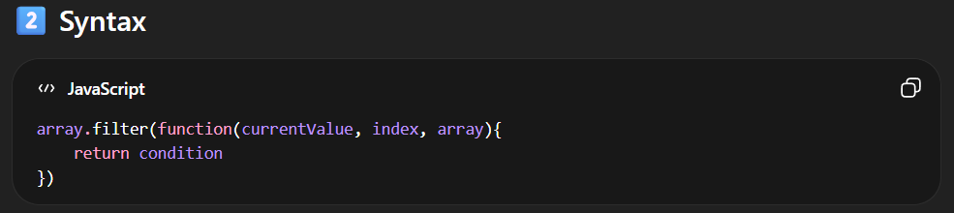
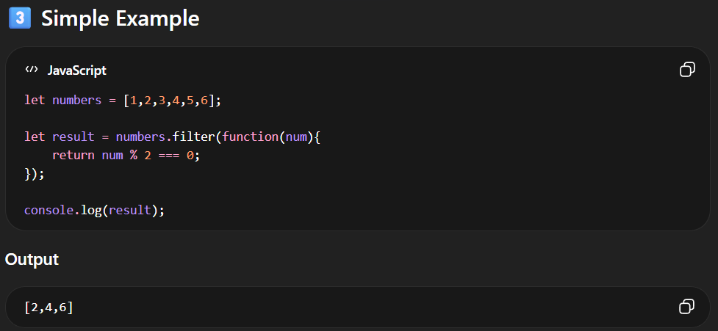
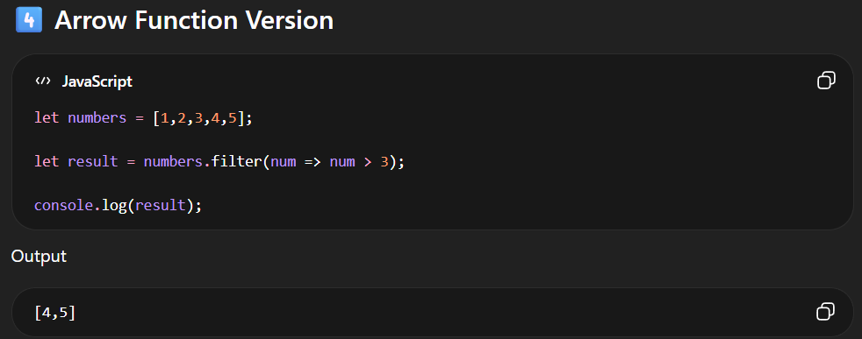

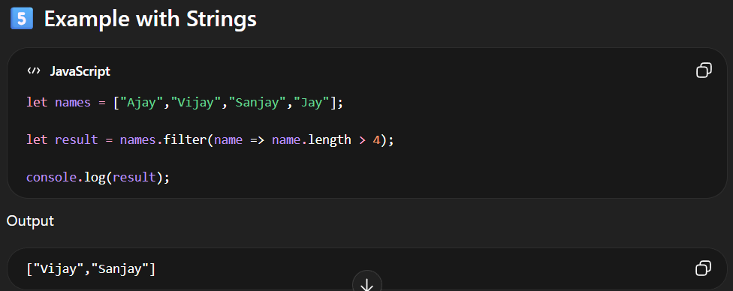
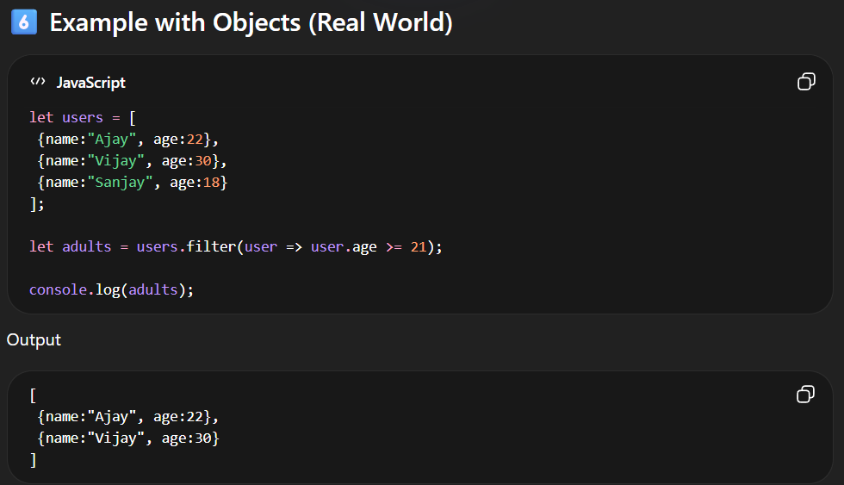

3.reduce()
-The reduce() method runs a function on each array element to produce (reduce it to) a single value.
-The reduce() method works from left-to-right in the array. See also reduceRight().
-The reduce() method does not reduce the original array.
-Note that the function takes 4 arguments:
Parameters:
1.callback: A function to execute on each element in the array, taking four arguments:
- Total /Accumulator: It is a required parameter, also called accumulator, that holds the initialValue in the beginning and then the last returned value of the function.
- curValue: This is a required argument that holds the value of the current element being executed.
- curIndex: It is an optional parameter holding the index of the current value.
- Array: This is also an optional parameter that holds the complete array object on which the operation is performed.
2. initialValue (optional):
-This is an optional parameter and holds the initial value passed to the function.
<script>
let num = [10,20,30,40,50];
let sum = num.reduce((accu,cValue)=>{
return accu + cValue;
})
console.log(sum)
</script>

When to Use the reduce() Method
-As shown above, the reduce() method is recommended when you need to have a single value returned from iterating over your array.

Difference Between forEach, Map(), filter(), reduce() Methods
SrNo | forEach | Map | Filter | Reduce
1 | .forEach(), is used to execute the same code on every element in an array but does not change the array and it returns undefined. | The map method is used to create a new array with the result of a callback function called on each element in the original array | The name itself conveys what this method can do. It just filters the array and returns only the needed elements out of it. | The reduce method is used to reduce an array to a single value. The reduce method takes a callback function as its argument, which is called on each element in the array.
2 | The For Each also accepts Function as an argument and that Function also take array as argument as an variable. | The callback function takes one argument, the current element, and returns the new value for that element. | The filter method takes a callback function as its argument, which is called on each element in the array | The callback function takes two arguments, the accumulator and the current element, and returns the new value for the accumulator.
3 | It does not return new array | It Also Return New Array | It Also Return New Array | It Does Not Return Array
4 | The Array Size is Similar | The Array Size is Similar | Array Size is not Similar | It does not return array
5 | It return Modified Elements | It return Modified Elements | It return Filtered Elements | It return Only Single Element
6 | The return values is always undefined | return value is not undefined | return value is not undefined | return value is not undefined

4.Array.keys()
-The Array.keys() method returns an Array Iterator object with the keys of an array.
-keys() method only return the Index value not value inside the index.

5.Array.entries()
-Create an Array Iterator, and then iterate over the key/value pairs
-The entries() method returns an Array Iterator object with key/value pairs.
-The entries() method does not change the original array.

FUNCTIONS

-Function is a set of instruction to perform the set of instructions
-A JavaScript function is a block of code designed to perform a particular task.
-Function have some functionality to perform some Action
-Function have some instruction according to that instruction it performs some Action.
-Function have their own scope.
-A JavaScript function is executed when "something" invokes it (calls it).
-The () operator invokes (calls) the function:
-There are Five Types of Functions in JavaScript.
1]Function Declaration
2]Function with Expression
3]Anonymous Function(No Name)
4]Arrow Function ES06 Function
5]IIFE Function (IMMEDIATE INVOKING FUNCTION)ES Function

-Functions are categorized into Two Types JavaScript
1]Parametrized Functions.
2]Non-Parameterized Functions.

Function contains the following parts:

1.Function Keyword
- The function keyword is used to create the function.
2.Function Name
– We have to give the Function Name to identified, followed by parentheses ().
3.Function Body
-Inside the Function body we can write the instruction.
-Instruction means to required steps to perform that action.
4.Function Call Statement
-Function call statement is used to call the Function.
-For Execution of that function calling is mandatory.
-So we have that as an Function Call Statement.
<!DOCTYPE html>
<html lang="en">
<head>
<meta charset="UTF-8">
<meta name="viewport" content="width=device-width, initial-scale=1.0">
<title>Document</title>
</head>
<body>
<script>
// Keyword FunctionName
function myFunction() {
//Function Body

console.log("Hello This Is Function Block")
}
myFunction() // Function Call Statement
</script>
</body>
</html>

Syntax: -
Keyword FunctionName
function functionName(){
//Function Body
-----------------------------
INSTRUCTIONS
----------------------------
-----------------------------
}
functionName();//FunctionCall Statement
Why Functions?
-With functions you can reuse code
-You can write code that can be used many times.
-You can use the same code with different arguments, to produce different results.

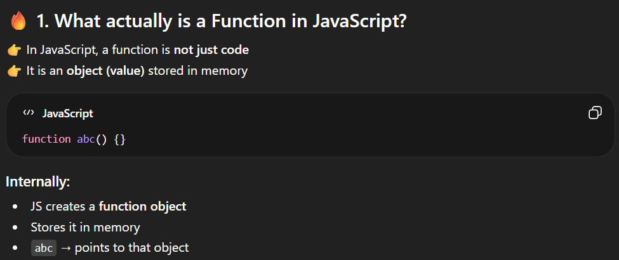
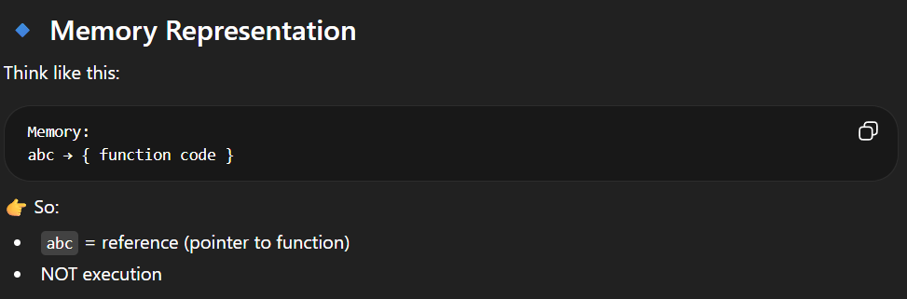

FUNCTIONS REFERENCE

-A Function Reference refers to the function object itself without executing it. It acts as an alias or a pointer to the block of code

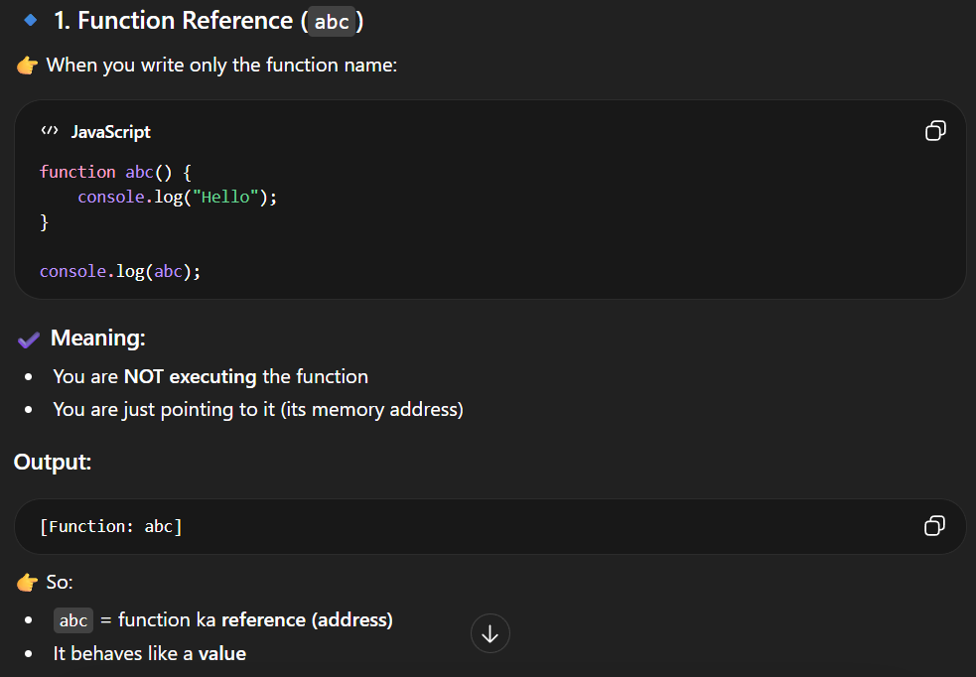
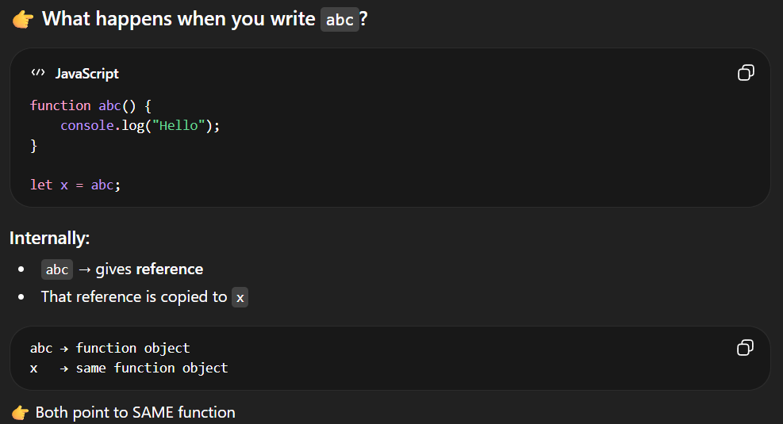
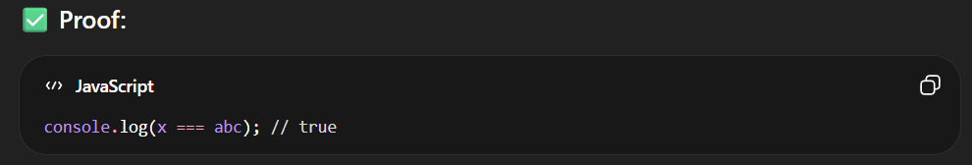

🔥 Key Point
👉 Function reference =
just pointing to function, not executing

FUNCTIONS CALL

-A Function Call (or invocation) instructs the program to execute the code inside the function immediately
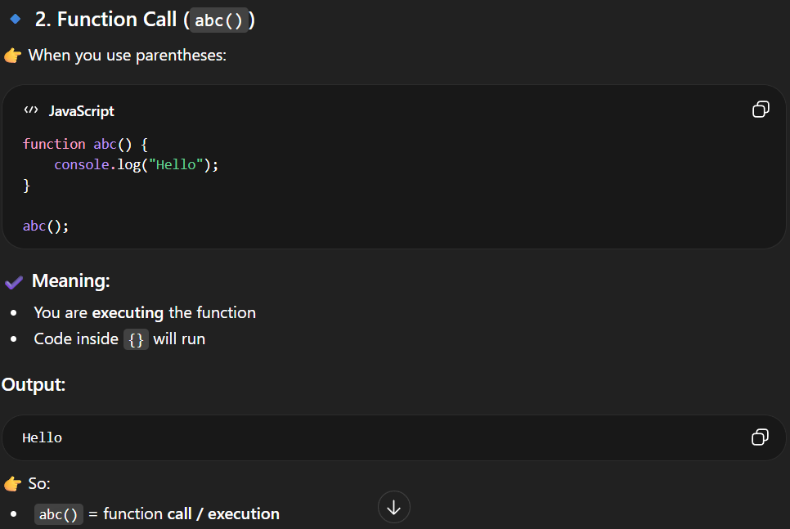
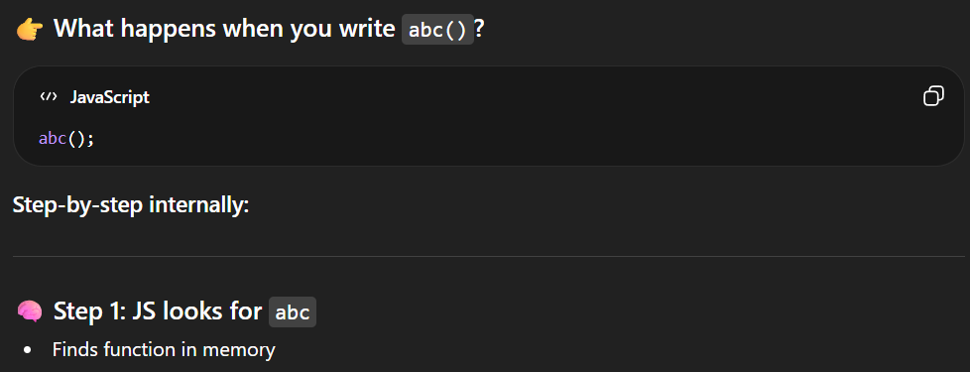
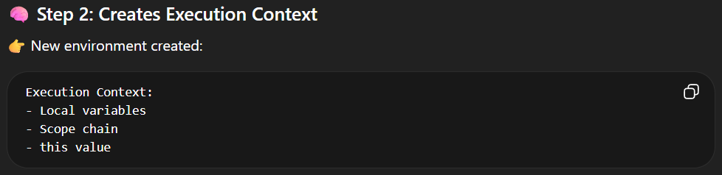
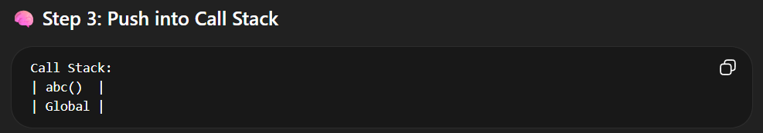
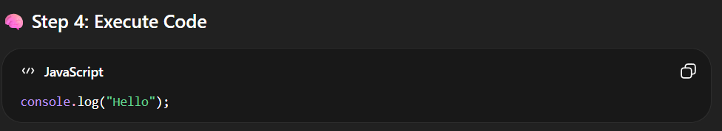
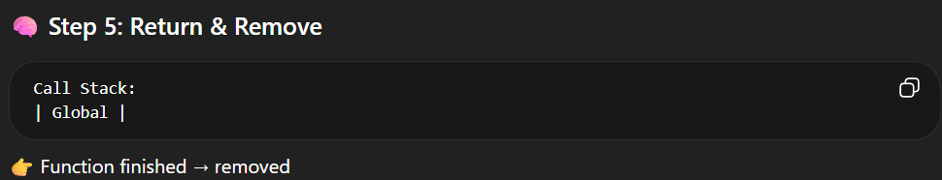
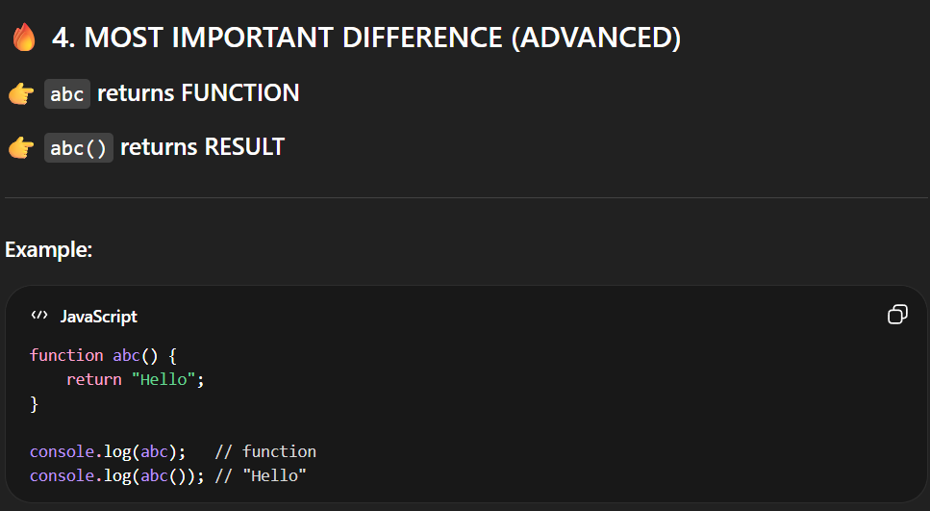


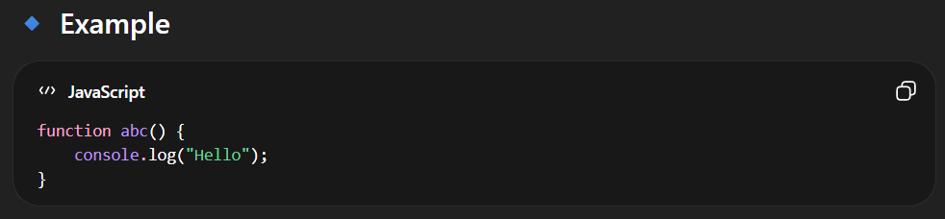
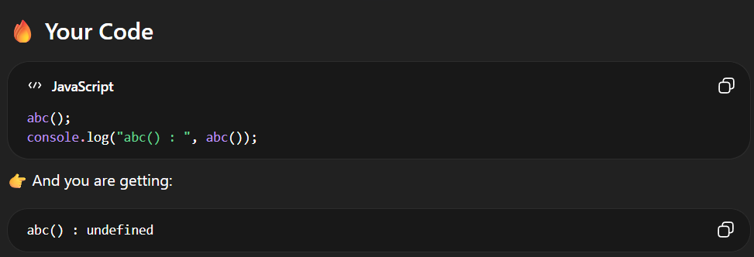
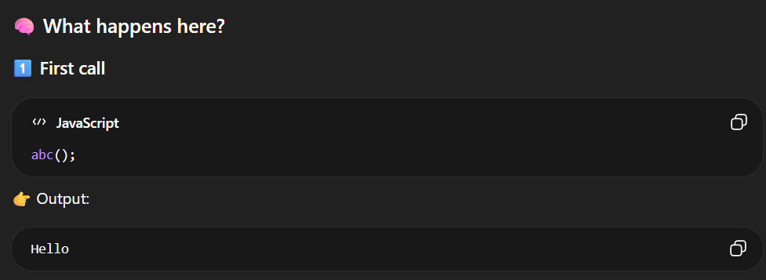
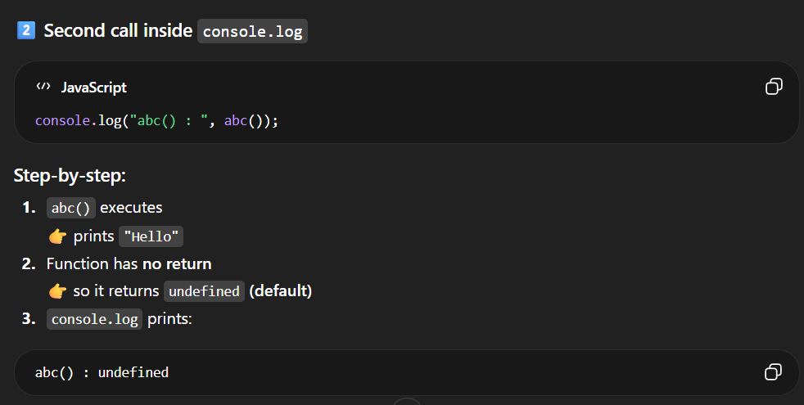
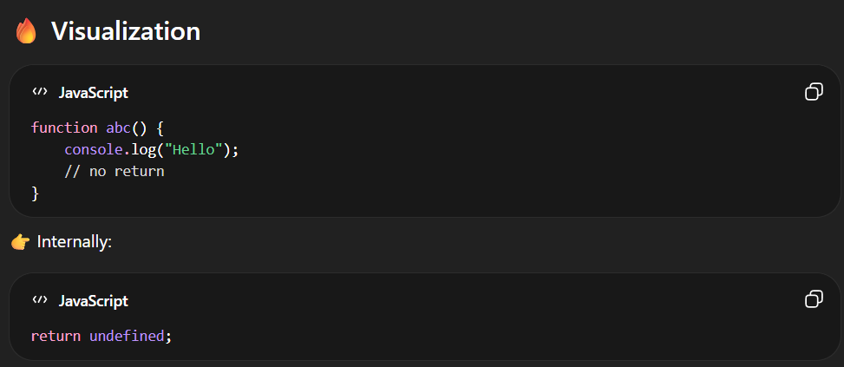

DATE OBJECT

-Date objects are static. The "clock" is not "running".
-The computer clock is ticking, date objects are not.

JavaScript Date Output
By default, JavaScript will use the browser's time zone and display a date as a full text string:
Thu Jul 18 2024 16:27:41 GMT+0530 (India Standard Time)
-Creating Date Objects
-Date objects are created with the new Date() constructor.
-There are 9 ways to create a new date object:
new Date()
new Date(date string)
new Date(year,month)
new Date(year,month,day)
new Date(year,month,day,hours)
new Date(year,month,day,hours,minutes)
new Date(year,month,day,hours,minutes,seconds)
new Date(year,month,day,hours,minutes,seconds,ms)
new Date(milliseconds)

1.JavaScript new Date()
-new Date() creates a date object with the current date and time:

1. new Date()
Example
const d = new Date();
console.log(d);

2.new Date(date string)
-new Date(date string) creates a date object from a date string:
Example1:-
const d = new Date("October 13, 2014 11:13:00");
console.log(d);

Example2:-
const d = new Date("2022-03-25");
console.log(d);

3.new Date(year, month,day,hour,minute,second,millisecond)
-new Date(year, month, day, hour, minute, second, millisecond) creates a date object with a specified date and time.
-7 numbers specify year, month, day, hour, minute, second, and millisecond (in that order):
Example:-
const d = new Date(2018, 11, 24, 10, 33, 30, 0);
console.log(d);

-Specifying a month higher than 11, will not result in an error but add the overflow to the next year:

Note
JavaScript counts months from 0 to 11:
January = 0.
December = 11.

Example:-
const d = new Date(2018, 15, 24, 10, 33, 30);
console.log(d);

Using 6, 4, 3, or 2 Numbers
6 numbers specify year, month, day, hour, minute, second:

Example
const d = new Date(2018, 11, 24, 10, 33, 30);
console.log(d);
5 numbers specify year, month, day, hour, and minute:

Example
const d = new Date(2018, 11, 24, 10, 33);
console.log(d);
4 numbers specify year, month, day, and hour:

Example
const d = new Date(2018, 11, 24, 10);
console.log(d);
3 numbers specify year, month, and day:

Example
const d = new Date(2018, 11, 24);
console.log(d);
2 numbers specify year and month:

Example
const d = new Date(2018, 11);
console.log(d);
You cannot omit month. If you supply only one parameter it will be treated as milliseconds.

Example
const d = new Date(2018);
console.log(d);

Previous Century
One and two digit years will be interpreted as 19xx:

Example
const d = new Date(99, 11, 24);
console.log(d);

Example
const d = new Date(9, 11, 24);
console.log(d);

new Date(milliseconds)
new Date(milliseconds) creates a new date object as milliseconds plus zero time:

Examples
01 January 1970 plus 100 000 000 000 milliseconds is:
const d = new Date(100000000000);
console.log(d);

Date Methods
When a date object is created, a number of methods allow you to operate on it.
Date methods allow you to get and set the year, month, day, hour, minute, second, and millisecond of date objects, using either local time or UTC (universal, or GMT) time.

Displaying Dates
JavaScript will (by default) output dates using the toString() method. This is a string representation of the date, including the time zone. The format is specified in the ECMAScript specification:

Example
Thu Jul 18 2024 17:15:53 GMT+0530 (India Standard Time)
-When you display a date object in HTML, it is automatically converted to a string, with the toString() method.

Example
const d = new Date();
d.toString();
-The toDateString() method converts a date to a more readable format:

Example
const d = new Date();
d.toDateString();
-The toUTCString() method converts a date to a string using the UTC standard:

Example
const d = new Date();
d.toUTCString();
The toISOString() method converts a date to a string using the ISO standard:

Example
const d = new Date();
d.toISOString();

JavaScript Date Input
-There are generally 3 types of JavaScript date input formats:
Type | Example
ISO Date | "2015-03-25" (The International Standard)
Short Date | "03/25/2015"
Long Date | "Mar 25 2015" or "25 Mar 2015"
The ISO format follows a strict standard in JavaScript.
The other formats are not so well defined and might be browser specific.

Date Get Methods
Method | Description
getFullYear() | Get year as a four digit number (yyyy)
getMonth() | Get month as a number (0-11)
getDate() | Get day as a number (1-31)
getDay() | Get weekday as a number (0-6)
getHours() | Get hour (0-23)
getMinutes() | Get minute (0-59)
getSeconds() | Get second (0-59)
getMilliseconds() | Get millisecond (0-999)
getTime() | Get time (milliseconds since January 1, 1970)

Note 1
The get methods above return Local time.
<script>
let a = new Date();
console.log(a);

console.log(a.getMilliseconds());
console.log(a.getSeconds());
console.log(a.getMinutes());
console.log(a.getHours());
console.log(a.getDay())
console.log(a.getDate());
console.log(a.getMonth());
console.log(a.getFullYear());
console.log(a.getTimezoneOffset());
console.log(a.getUTCSeconds());
console.log(a.getUTCMinutes());
console.log(a.getUTCHours());
console.log(a.getUTCDate());
console.log(a.getUTCDay());
console.log(a.getUTCMonth());
console.log(a.getUTCFullYear());
</script>

<!DOCTYPE html>
<html lang="en">
<head>
<meta charset="UTF-8">
<meta name="viewport" content="width=device-width, initial-scale=1.0">
<title>Document</title>
</head>
<body>
<script>
const months = ["January", "February", "March", "April", "May", "June", "July", "August", "September", "October", "November", "December"];

const d = new Date("2021-03-25");
let month = months[d.getMonth()];

document.write(month)

</script>
</body>
</html>

JavaScript Set Date Methods
-Set Date methods let you set date values (years, months, days, hours, minutes, seconds, milliseconds) for a Date Object.

Set Date Methods
Set Date methods are used for setting a part of a date:
Method | Description
setDate() | Set the day as a number (1-31)
setFullYear() | Set the year (optionally month and day)
setHours() | Set the hour (0-23)
setMilliseconds() | Set the milliseconds (0-999)
setMinutes() | Set the minutes (0-59)
setMonth() | Set the month (0-11)
setSeconds() | Set the seconds (0-59)
setTime() | Set the time (milliseconds since January 1, 1970)

The setFullYear() Method
-The setFullYear() method sets the year of a date object. In this example to 2020:

Example
const d = new Date();
d.setFullYear(2020);
The setFullYear() method can optionally set month and day:

Example
const d = new Date();
d.setFullYear(2020, 11, 3);

The setMonth() Method
The setMonth() method sets the month of a date object (0-11):

Example
const d = new Date();
d.setMonth(11);

The setDate() Method
The setDate() method sets the day of a date object (1-31):

Example
const d = new Date();
d.setDate(15);
The setDate() method can also be used to add days to a date:

Example
const d = new Date();
d.setDate(d.getDate() + 50);
If adding days shifts the month or year, the changes are handled automatically by the Date object.

The setHours() Method
The setHours() method sets the hours of a date object (0-23):

Example
const d = new Date();
d.setHours(22);

The setMinutes() Method
The setMinutes() method sets the minutes of a date object (0-59):

Example
const d = new Date();
d.setMinutes(30);

The setSeconds() Method
The setSeconds() method sets the seconds of a date object (0-59):

Example
const d = new Date();
d.setSeconds(30);

SPREAD OPERATOR…

-The JavaScript spread operator (...) allows us to quickly copy all or part of an existing array or object into another array or object.
-Basically It is used to spread(uncompress/unpack) the values.
const numbersOne = [1, 2, 3];
const numbersTwo = [4, 5, 6];
const numbersCombined = [...numbersOne, ...numbersTwo];

-We can use the More Than Spread Operator
syntax : ...variableName

-The spread operator in JavaScript, represented by three dots (...), allows you to expand iterable objects, such as arrays, strings, and objects, into their individual elements.
const arr1 = [1, 2, 3];
const arr2 = [4, 5, 6];
const mergedArr = [...arr1, ...arr2];
console.log(mergedArr); // Output: [1, 2, 3, 4, 5, 6]

function sum(a, b, c) {
return a + b + c;
}
const numbers = [1, 2, 3];
const result = sum(...numbers);
console.log(result); // Output: 6

REST OPERATOR

-In JavaScript, the rest operator, represented by three dots (...), allows a function to accept an indefinite number of arguments as an array.
-Rest mean remaining values pack in one parameter.
function sum(...numbers) {
let total = 0;
for (let number of numbers) {
total += number;
}
return total;
}
console.log(sum(1, 2, 3, 4)); // Output: 10

const numbers = [1, 2, 3, 4, 5];
const [first, second, ...rest] = numbers;

console.log(first); // Output: 1
console.log(second); // Output: 2
console.log(rest); // Output: [3, 4, 5]

OOPS IN JAVASCRIPT

Synchronous JavaScript

-JavaScript is, by default, single-threaded and synchronous. This means it executes code line by line, one operation at a time.
-Functions running in parallel with other functions are called asynchronous
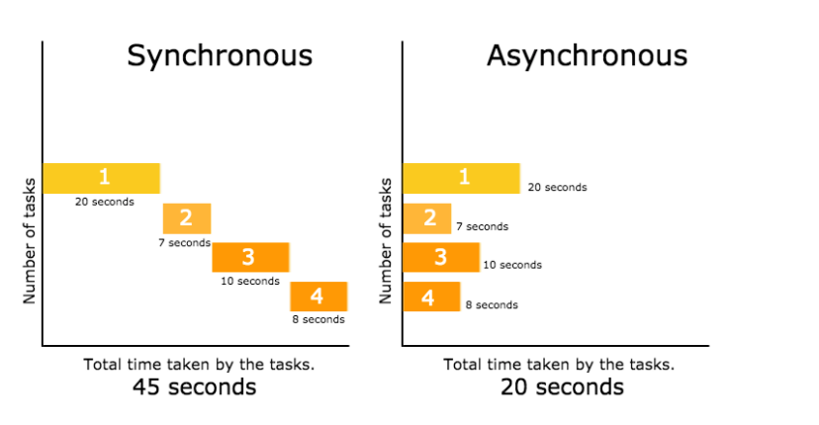
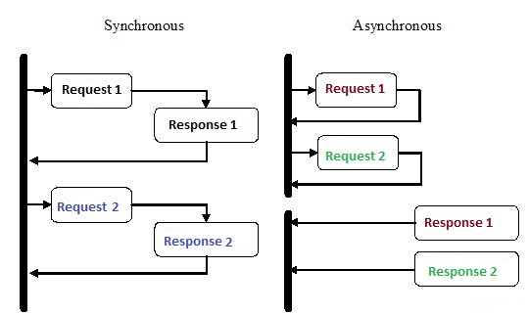

-In a synchronous way the first operation is start first and complete its execution then the next operation is start after complete the first one. Next operation is blocked by the previous operation until complete it.
-But in asynchronous programming one task never wait for another task for execute. The task execute first which completed first. It never block one task input or output for another task.
What is Synchronous Programming?

-Synchronous programming is a way for computers to do things one step at a time, in the order they are given the instructions.
-Imagine you're cooking dinner and have a list of tasks, like boiling water for pasta, frying chicken, and making a salad.
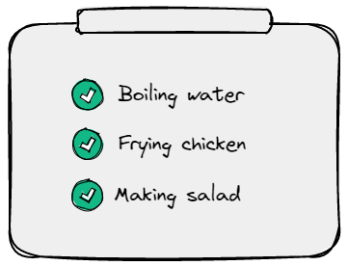
-You would do these tasks one at a time and wait for each one to finish before moving to the next.
console.log("Start");
console.log("Middle");
console.log("End");

Synchronous JavaScript:
- Code executes in a predictable order, one line after the other.
- If a long-running operation is encountered, the entire program is blocked until it completes.

-Here's an example of synchronous code in JavaScript:
// Define three functions
function firstTask() {
console.log("Task 1");
}
function secondTask() {
console.log("Task 2");
}
function thirdTask() {
console.log("Task 3");
}
// Execute the functions
firstTask();
secondTask();
thirdTask();

-The code will execute the tasks in the order you see them and wait for each task to be completed before moving on to the next one.
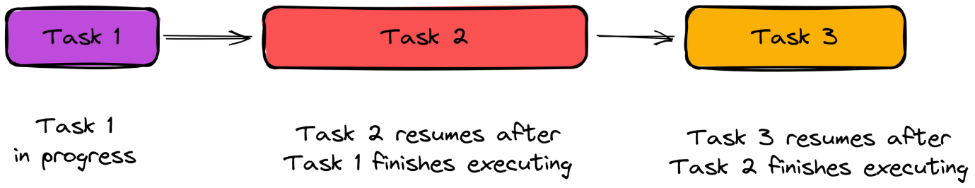

WHAT IS ASYNCHRONOUS PROGRAMMING?
-Asynchronous programming is a way for a computer program to handle multiple tasks simultaneously rather than executing them one after the other.
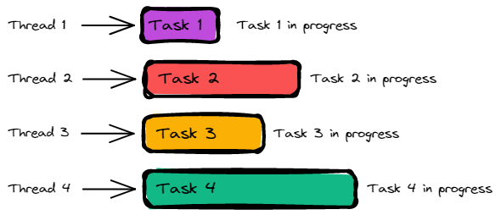-Diagram showing how asynchronous programming works.
-Here's an example of an asynchronous program using the setTimeout method:
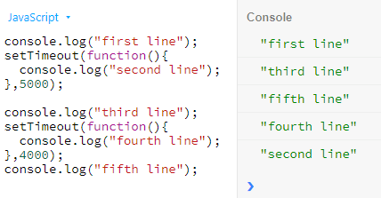
-JavaScript is, by default, single-threaded and synchronous. This means it executes code line by line, one operation at a time.

Example 1: Synchronous programming java
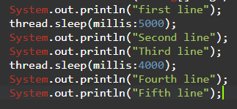
-In this example after execute first line it will wait for 5 sec, then second and third line will be executed. Also wait 4 second after third line and execute fourth and fifth line.
Example 2: Asynchronous programming JavaScript.
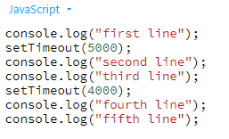
-In this example using JavaScript no line wait for another line. Here second line does not wait for first line and forth line does not wait after third line. These all lines are execute at run time. No line blocked another line. That is non-blocking of asynchronous programming.

-There are different way to implement Asynchronous in JavaScript.
- Callback function
- Promise
- Generators
- Async & Await.

1.Callback Function

"I will call back later!"
-A callback is a function passed as an argument to another function
This technique allows a function to call another function
A callback function can run after another function has finished.
// function
function greet(name, callback) {
console.log('Hi' + ' ' + name);
callback();
}
// callback function
function callMe() {
console.log('I am callback function');
}
// passing function as an argument
greet('Peter', callMe);

Output
Hi Peter
I am callback function
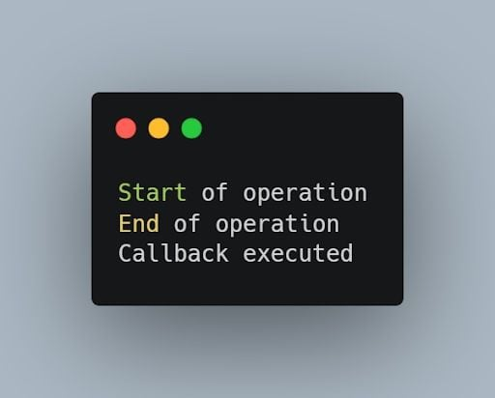
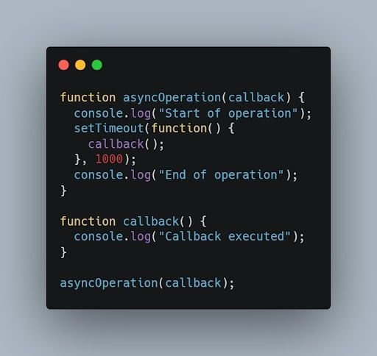

-Calling Multiple Functions using Set Timeout Function
<script>
function person1(name,person2,person3,person4,person5,person6,person7,person8, person9,person10) {
console.log("Person 1 is Busy with "+name);
setTimeout(person2,4000)
setTimeout(person3,6000)
setTimeout(person4,7000)
setTimeout(person5,5000)
setTimeout(person6,5000)
setTimeout(person7,5000)
setTimeout(person8,5000)
setTimeout(person9,5000)
setTimeout(person10,5000)
}
function person2() {
console.log("person 2 is Called");
}
function person3() {
console.log("person 3 is Called" );
}
function person4() {
console.log("person 4 is Called" );

}
function person5() {
console.log("person 5 is Called" );
}
function person6() {
console.log("person 6 is Called" );
}
function person7() {
console.log("person 7 is Called" );
}
function person8() {
console.log("person 8 is Called" );
}
function person9() {
console.log("person 9 is Called" );
}
function person10() {
console.log("person 10 is Called" );

}
person1("Amol",person2,person3,person4,person5,person6,person7,person8,person9,person10);
</script>

2.PROMISES

- In JavaScript, a Promise is a built-in object that represents the eventual completion (or failure) of an asynchronous operation and its resulting value. Promises are used to handle asynchronous operations more effectively compared to traditional callback-based approaches.
Key Concepts of Promises:
- States:
  - Pending: The initial state of a promise. The operation has not yet completed.
  - Fulfilled/Resolve/Successful: The state when the operation completes successfully, and the promise has a resolved value.
  - Rejected/NotFulfilled: The state when the operation fails, and the promise has a reason for the failure (an error).
  - Settled:A promise is said to be settled if it is either fulfilled or rejected, but not pending.
- Promise Creation: A promise is created using the Promise constructor,which takes an executor function with two arguments: resolve and reject.
let myPromise = new Promise((resolve, reject) => {
// Asynchronous operation
let success = true;
if (success) {
resolve("Operation successful");
} else {
reject("Operation failed");
}
});

- Handling Promises: You handle the results of a promise using .then() for successful completions and .catch() for errors.
myPromise.then(result => {
console.log(result); // "Operation successful"
}).catch(error => {
console.error(error); // "Operation failed"
});

- Chaining Promises: Promises can be chained, allowing for multiple asynchronous operations to be performed in sequence.
myPromise
.then(result => {
console.log(result); // "Operation successful"
return anotherAsyncOperation(); // Returns a new promise
})
.then(nextResult => {
console.log(nextResult); // Result of the next async operation
})
.catch(error => {
console.error(error); // Error handling for any of the promises
});

- Promise.all(): You can run multiple promises in parallel and wait for all of them to complete.
Promise.all([promise1, promise2, promise3])
.then(results => {
console.log(results); // Array of results
})
.catch(error => {
console.error(error); // If any of the promises fail
});

- Promise.race(): You can run multiple promises in parallel and get the result of the first one that completes.
Promise.race([promise1, promise2, promise3])
.then(result => {
console.log(result); // Result of the first promise to resolve or reject
})
.catch(error => {
console.error(error); // Error from the first promise to reject
});

-Promises provide a cleaner, more manageable way to handle asynchronous operations compared to nested callbacks, making code more readable and easier to maintain.
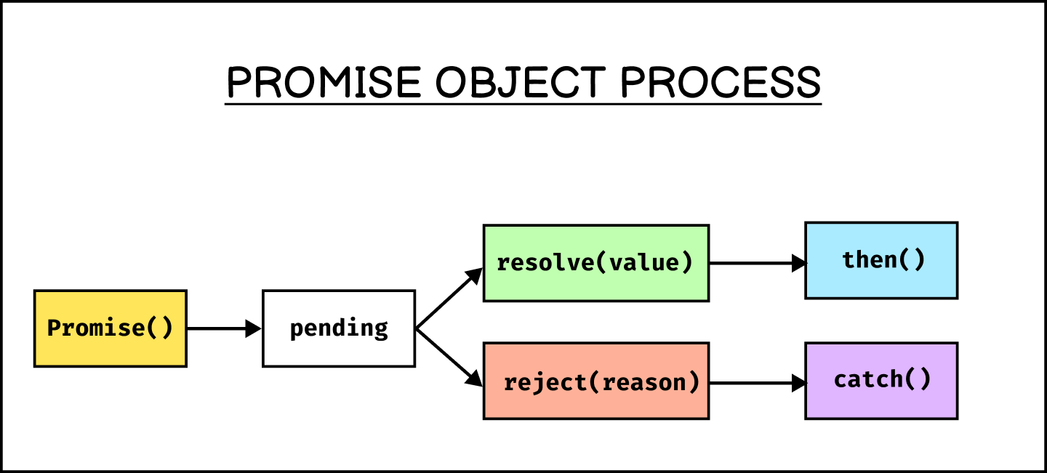

Promise()
-The Promise() constructor creates Promise objects. It is primarily used to wrap callback-based APIs that do not already support promises.
<script>
let promises = new Promise(function(resolve,reject){
resolve();
reject();
})
promises.then(
function(value){
console.log("Promise Resolved");
}
)
promises.catch(()=>{
console.log("Promise Rejected")
})
</script>

Note: Promise() can only be constructed with new. Attempting to call it without new throws a TypeError.

JavaScript Promise Methods and Properties
Name | Description
Promise.all() | Returns a single Promise from a list of promises  When all promises fulfill
Promise.allSettled() | Returns a single Promise from a list of promises  When all promises sette
Promise.any() | Returns a single Promise from a list of promises  When any promise fulfills
Promise.race() | Returns a single Promise from a list of promises  When the faster promise settles
Promise.reject() | Returns a Promise object rejected with a value
Promise.resolve() | Returns a Promise object resolved with a value
catch() | Provides a function to be called when a promise is rejected
finally() | Provides a function to be called when a promise is fulfilled or rejected
then() | Provide two functions to be called when a promise is fulfilled or rejected

Promise.all()
Syntax:-
Promise.all(iterable)

<script>
const recordVideoOne = new Promise((resolve,reject) =>{
// resolve("Video 1 Recorded")
reject("Video 1 is Not Recorded");
})

const recordVideoTwo = new Promise((resolve,reject) =>{
// resolve("Video 2 Recorded")
reject("Video 3 is Not Recorded");

})

const recordVideoThree = new Promise((resolve,reject) =>{
// resolve("Video 3 Recorded")
reject("Video 3 is Not Recorded");

})

Promise.all([
recordVideoOne,
recordVideoTwo,
recordVideoThree
]).then((message) =>{
console.log(message)
}).catch((error) =>{
console.log(error)
})
</script>

Parameters
iterable
An iterable (such as an Array) of promises.
Return value
A Promise that is:
- Already fulfilled, if the iterable passed is empty.

JavaScript async/await
"async and await make promises easier to write"
async makes a function return a Promise
await makes a function wait for a Promise
-We use the async keyword with a function to represent that the function is an asynchronous function. The async function returns a promise.
async function name(parameter1, parameter2, ...paramaterN) {
// statements
}
Here,
- name - name of the function
- parameters - parameters that are passed to the function

JavaScript await Keyword
The await keyword is used inside the async function to wait for the asynchronous operation.

DOM [Document Object Model] in JavaScript

Section 1. Getting started
What is Document Object Model (DOM)
-The Document Object Model (DOM) is an application programming interface (API) for manipulating HTML documents.
-The DOM represents an HTML document as a tree of nodes. The DOM provides functions that allow you to add, remove, and modify parts of the document effectively.
-A document as a hierarchy of nodes
-The DOM represents an HTML document as a hierarchy of nodes. Consider the following HTML document:
-With the object model, JavaScript gets all the power it needs to create dynamic HTML:
- JavaScript can change all the HTML attributes in the page
- JavaScript can change all the CSS styles in the page
- JavaScript can remove existing HTML elements and attributes
- JavaScript can add new HTML elements and attributes
- JavaScript can react to all existing HTML events in the page
- JavaScript can create new HTML events in the page

Why is DOM required?
- Access HTML elements
- Replace HTML elements
- Add New HTML elements
- Delete HTML elements
- Change CSS of HTML elements
- Change attributes of HTML elements
- Add animation to HTML elements
- Add events to HTML elements

The HTML DOM Tree of Objects
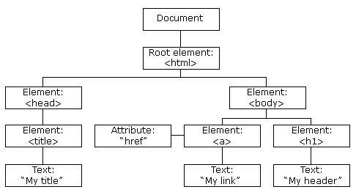
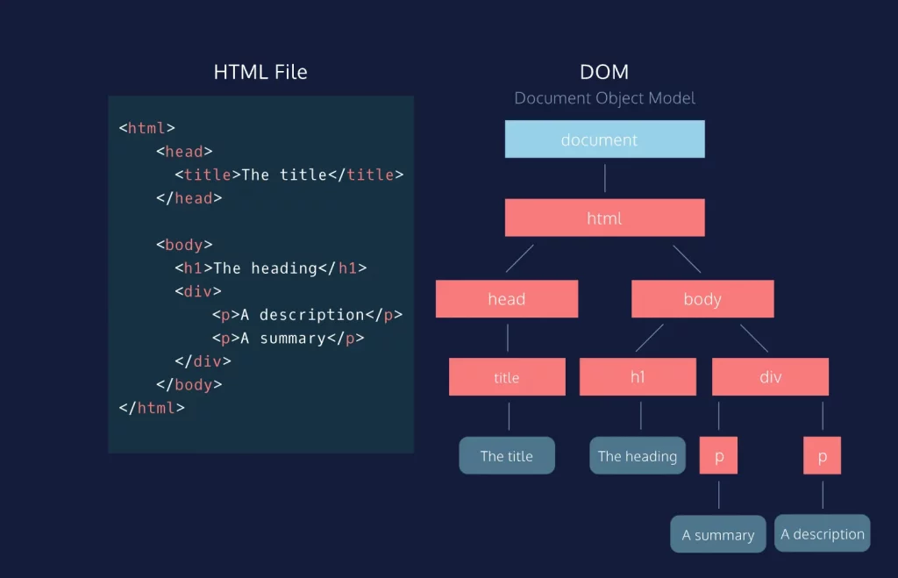
-In this DOM tree, the document is the root node. The root node has one child node which is the <html> element. The <html> element is called the document element.
-Each document can have only one document element. In an HTML document, the document element is the <html> element. Each markup can be represented by a node in the tree.

Document Object Properties and Methods
The following properties and methods can be used on HTML documents:
Property / Method | Description
activeElement | Returns the currently focused element in the document
addEventListener() | Attaches an event handler to the document
adoptNode() | Adopts a node from another document
anchors | Deprecated
applets | Deprecated
baseURI | Returns the absolute base URI of a document
body | Sets or returns the document's body (the <body> element)
charset | Deprecated
characterSet | Returns the character encoding for the document
close() | Closes the output stream previously opened with document.open()
cookie | Returns all name/value pairs of cookies in the document
createAttribute() | Creates an attribute node
createComment() | Creates a Comment node with the specified text
createDocumentFragment() | Creates an empty DocumentFragment node
createElement() | Creates an Element node
createEvent() | Creates a new event
createTextNode() | Creates a Text node
defaultView | Returns the window object associated with a document, or null if none is available.
designMode | Controls whether the entire document should be editable or not.
doctype | Returns the Document Type Declaration associated with the document
documentElement | Returns the Document Element of the document (the <html> element)
documentMode | Deprecated
documentURI | Sets or returns the location of the document
domain | Returns the domain name of the server that loaded the document
domConfig | Deprecated
embeds | Returns a collection of all <embed> elements the document
execCommand() | Deprecated
forms | Returns a collection of all <form> elements in the document
getElementById() | Returns the element that has the ID attribute with the specified value
getElementsByClassName() | Returns an HTMLCollection containing all elements with the specified class name
getElementsByName() | Returns an live NodeList containing all elements with the specified name
getElementsByTagName() | Returns an HTMLCollection containing all elements with the specified tag name
hasFocus() | Returns a Boolean value indicating whether the document has focus
head | Returns the <head> element of the document
images | Returns a collection of all <img> elements in the document
implementation | Returns the DOMImplementation object that handles this document
importNode() | Imports a node from another document
inputEncoding | Deprecated
lastModified | Returns the date and time the document was last modified
links | Returns a collection of all <a> and <area> elements in the document that have a href attribute
normalize() | Removes empty Text nodes, and joins adjacent nodes
normalizeDocument() | Deprecated
open() | Opens an HTML output stream to collect output from document.write()
querySelector() | Returns the first element that matches a specified CSS selector(s) in the document
querySelectorAll() | Returns a static NodeList containing all elements that matches a specified CSS selector(s) in the document
readyState | Returns the (loading) status of the document
referrer | Returns the URL of the document that loaded the current document
removeEventListener() | Removes an event handler from the document (that has been attached with the addEventListener() method)
renameNode() | Deprecated
scripts | Returns a collection of <script> elements in the document
strictErrorChecking | Deprecated
title | Sets or returns the title of the document
URL | Returns the full URL of the HTML document
write() | Writes HTML expressions or JavaScript code to a document
writeln() | Same as write(), but adds a newline character after each statement

Properties and Methods
The following properties and methods can be used on all HTML elements:
Property / Method | Description
accessKey | Sets or returns the accesskey attribute of an element
addEventListener() | Attaches an event handler to an element
appendChild() | Adds (appends) a new child node to an element
attributes | Returns a NamedNodeMap of an element's attributes
blur() | Removes focus from an element
childElementCount | Returns an elements's number of child elements
childNodes | Returns a NodeList of an element's child nodes
children | Returns an HTMLCollection of an element's child elements
classList | Returns the class name(s) of an element
className | Sets or returns the value of the class attribute of an element
click() | Simulates a mouse-click on an element
clientHeight | Returns the height of an element, including padding
clientLeft | Returns the width of the left border of an element
clientTop | Returns the width of the top border of an element
clientWidth | Returns the width of an element, including padding
cloneNode() | Clones an element
closest() | Searches the DOM tree for the closest element that matches a CSS selector
compareDocumentPosition() | Compares the document position of two elements
contains() | Returns true if a node is a descendant of a node
contentEditable | Sets or returns whether the content of an element is editable or not
dir | Sets or returns the value of the dir attribute of an element
firstChild | Returns the first child node of an element
firstElementChild | Returns the first child element of an element
focus() | Gives focus to an element
getAttribute() | Returns the value of an element's attribute
getAttributeNode() | Returns an attribute node
getBoundingClientRect() | Returns the size of an element and its position relative to the viewport
getElementsByClassName() | Returns a collection of child elements with a given class name
getElementsByTagName() | Returns a collection of child elements with a given tag name
hasAttribute() | Returns true if an element has a given attribute
hasAttributes() | Returns true if an element has any attributes
hasChildNodes() | Returns true if an element has any child nodes
id | Sets or returns the value of the id attribute of an element
innerHTML | Sets or returns the content of an element
innerText | Sets or returns the text content of a node and its descendants
insertAdjacentElement() | Inserts a new HTML element at a position relative to an element
insertAdjacentHTML() | Inserts an HTML formatted text at a position relative to an element
insertAdjacentText() | Inserts text into a position relative to an element
insertBefore() | Inserts a new child node before an existing child node
isContentEditable | Returns true if an element's content is editable
isDefaultNamespace() | Returns true if a given namespaceURI is the default
isEqualNode() | Checks if two elements are equal
isSameNode() | Checks if two elements are the same node
isSupported() | Deprecated
lang | Sets or returns the value of the lang attribute of an element
lastChild | Returns the last child node of an element
lastElementChild | Returns the last child element of an element
matches() | Returns true if an element is matched by a given CSS selector
namespaceURI | Returns the namespace URI of an element
nextSibling | Returns the next node at the same node tree level
nextElementSibling | Returns the next element at the same node tree level
nodeName | Returns the name of a node
nodeType | Returns the node type of a node
nodeValue | Sets or returns the value of a node
normalize() | Joins adjacent text nodes and removes empty text nodes in an element
offsetHeight | Returns the height of an element, including padding, border and scrollbar
offsetWidth | Returns the width of an element, including padding, border and scrollbar
offsetLeft | Returns the horizontal offset position of an element
offsetParent | Returns the offset container of an element
offsetTop | Returns the vertical offset position of an element
outerHTML | Sets or returns the content of an element (including the start tag and the end tag)
outerText | Sets or returns the outer text content of a node and its descendants
ownerDocument | Returns the root element (document object) for an element
parentNode | Returns the parent node of an element
parentElement | Returns the parent element node of an element
previousSibling | Returns the previous node at the same node tree level
previousElementSibling | Returns the previous element at the same node tree level
querySelector() | Returns the first child element that matches a CSS selector(s)
querySelectorAll() | Returns all child elements that matches a CSS selector(s)
remove() | Removes an element from the DOM
removeAttribute() | Removes an attribute from an element
removeAttributeNode() | Removes an attribute node, and returns the removed node
removeChild() | Removes a child node from an element
removeEventListener() | Removes an event handler that has been attached with the addEventListener() method
replaceChild() | Replaces a child node in an element
scrollHeight | Returns the entire height of an element, including padding
scrollIntoView() | Scrolls the an element into the visible area of the browser window
scrollLeft | Sets or returns the number of pixels an element's content is scrolled horizontally
scrollTop | Sets or returns the number of pixels an element's content is scrolled vertically
scrollWidth | Returns the entire width of an element, including padding
setAttribute() | Sets or changes an attribute's value
setAttributeNode() | Sets or changes an attribute node
style | Sets or returns the value of the style attribute of an element
tabIndex | Sets or returns the value of the tabindex attribute of an element
tagName | Returns the tag name of an element
textContent | Sets or returns the textual content of a node and its descendants
title | Sets or returns the value of the title attribute of an element
toString() | Converts an element to a string

DOM DOCUMENT PROPERTIES
1.activeElement

-The activeElement property returns the HTML element that have focus.
-The activeElement property is read-only.
Return Value
Type | Description
Element | The HTML element that has focus
Syntax: -
document.activeElement

<!DOCTYPE html>
<html lang="en">
<head>
<meta charset="UTF-8">
<meta name="viewport" content="width=device-width, initial-scale=1.0">
<title>Document</title>
</head>
<body onclick="myFunction()">

<form action="">
<input type="text" placeholder="input text">
</form>

<button>BUTTON</button>

<h4 id="Head4"></h4>
<script>
function myFunction(){
const element = document.activeElement.tagName;

document.getElementById("Head4").innerHTML=element;
}
</script>
</body>
</html>

2.baseURI

-The baseURI property returns the base URI of the document.
-The baseURI property is read-only.
Return Value
Type | Description
String | The Base URI of the document.
Syntax: -
document.baseURI

<!DOCTYPE html>
<html lang="en">
<head>
<meta charset="UTF-8">
<meta name="viewport" content="width=device-width, initial-scale=1.0">
<title>Document</title>
</head>
<body>
<!--! baseURI -->

<h3 id="demo"></h3>

<script>
// Get the base URL of the document
var baseURL = document.baseURI;

// Display the base URL
document.getElementById('demo').textContent = baseURL;
</script>
</body>
</html>

3.body

-The body property sets or returns a document's <body> element.Return Value.
Return Value
Type | Description
Object | The body element of the document.
Syntax: -
document.body

<!DOCTYPE html>
<html lang="en">
<head>
<meta charset="UTF-8">
<meta name="viewport" content="width=device-width, initial-scale=1.0">
<title>Document</title>
</head>
<body>
<!--! body -->
<script>
document.body.style.backgroundColor="black";
document.body.style.color="white";
document.body.innerHTML="Hello This Welcome To Javascript"
</script>
</body>
</html>

DOM DOCUMENT METHODS

1. addEventListener

-The addEventListener() method attaches an event handler to a document.
Syntax: -
document.addEventListener(event, function, Capture)

Parameters
Parameter | Description
event | Required.  The event name.  Do not use the "on" prefix.  Use "click" instead of "onclick".  All HTML DOM events are listed in the:  HTML DOM Event Object Reference.
function | Required.  The function to run when the event occurs.  When the event occurs, an event object is passed to the function as the first parameter. The type of the event object depends on the specified event. For example, the "click" event belongs to the MouseEvent object.
capture | Optional (default = false).  true - The handler is executed in the capturing phase.  false - The handler is executed in the bubbling phase.

<!DOCTYPE html>
<html lang="en">
<head>
<meta charset="UTF-8">
<meta name="viewport" content="width=device-width, initial-scale=1.0">
<title>Document</title>
</head>
<body>
<h1>The Document Object</h1>
<h2>The addEventListener() Method</h2>
<p>Click anywhere in the document to display "Hello World!".</p>
<p id="demo"></p>
<div id="Circle">
</div>
<script>
document.addEventListener("click",myFunction)

function myFunction(){
document.getElementById("demo").innerHTML = "Hello World!";
}
</script>
<script>
document.addEventListener("click",myFunction2)

function myFunction2(){
let Circle = document.getElementById("Circle");
Circle.style.backgroundColor = "red";
Circle.style.height = "200px";
Circle.style.width = "200px";
Circle.style.border = "1px solid";
Circle.style.borderRadius = "50%";
}
</script>
</body>
</html>

2.open()

-The open() method opens a document for writing.
-All existing document content will be cleared.
Syntax: -
document.open();

<!DOCTYPE html>
<html lang="en">
<head>
<meta charset="UTF-8" />
<meta name="viewport" content="width=device-width, initial-scale=1.0" />
<title>Document</title>
</head>
<body>
<p>Lorem ipsum, dolor sit amet consectetur adipisicing elit. Aperiam sed ex quis odio ducimus atque necessitatibus, officiis aliquam. Mollitia rem quidem velit dolore expedita!
</p>

<button onclick="myFunction()">OPEN</button>
<script>
function myFunction(){
document.open();
document.write("<h1>Hello This Is Heading<h1>");
}
</script>
</body>
</html>

3.close()

-The close() method closes a window previously opened with the open() method.
Syntax: -
document.close();

<!DOCTYPE html>
<html lang="en">
<head>
<meta charset="UTF-8" />
<meta name="viewport" content="width=device-width, initial-scale=1.0" />
<title>Document</title>
</head>
<body>
<p>Lorem ipsum, dolor sit amet consectetur adipisicing elit. Aperiam sed ex quis odio ducimus atque necessitatibus, officiis aliquam. Mollitia rem uidem velit dolore expedita!
</p>

<button onclick="myFunction()">OPEN</button>
<script>
function myFunction(){
document.open();
document.write("<h1>Hello This Is Heading<h1>");
document.close();
}
</script>
</body>
</html>

4.createAttribute(name)

-The createAttribute() method creates an attribute and returns the attribute as an Attr object.
Syntax: -
document.createAttribute(name);

Parameters
Parameter | Description
name | Required.  The name of the attribute to create.
<!DOCTYPE html>
<html lang="en">
<head>
<meta charset="UTF-8">
<meta name="viewport" content="width=device-width, initial-scale=1.0">
<title>Document</title>
<style>
.demo{
color: red;
}
</style>
</head>
<body>
<h1>The Document Object</h1>
<h2>The createAttribute() and setAttributeNode() Methods</h2>
<p>Click "Add" to create a class attribute and add it to first h1 element.</p>
<button onclick="myFunction()">Add</button>
<script>
function myFunction(params) {
// Create a class attribute:
let att = document.createAttribute("class");
// Set a value of the class attribute
att.value = "demo";
// Add the class attribute to the first h1;
let h1 = document.getElementsByTagName("h1")[0];
h1.setAttributeNode(att);
}
</script>
</body>
</html>

5.createElement(name)

-The createElement() method creates an element node.
Syntax: -
document.createElement(type);

Parameters
Parameter | Description
type | Required.  The type of element to create.
<!DOCTYPE html>
<html lang="en">
<head>
<meta charset="UTF-8">
<meta name="viewport" content="width=device-width, initial-scale=1.0">
<title>Document</title>
</head>
<body>
<!--! createElement() -->
<script>
var a = document.createElement("h1");
console.log(a);
a.innerHTML = "Hello, World!";
// Append to body:
document.body.appendChild(a);
</script>
</body>
</html>

6.createComment(text)

-The createComment() method creates a comment and returns the comment node.
Syntax: -
document.createComment(text);

Parameter | Description
text | Optional.  The comment text.
<!DOCTYPE html>
<html lang="en">
<head>
<meta charset="UTF-8">
<meta name="viewport" content="width=device-width, initial-scale=1.0">
<title>Document</title>
</head>
<body>
<!--! createComments() -->
<!--? The createComment() method creates a comment and returns the comment node. -->
<script>
var a = document.createComment("This Is Comments");
console.log(a);
</script>
</body>
</html>

7.createComment(text)

-The createComment() method creates a comment and returns the comment node.
Syntax: -
document.createComment(text);

Parameter | Description
text | Optional.  The comment text.
<!DOCTYPE html>
<html lang="en">
<head>
<meta charset="UTF-8">
<meta name="viewport" content="width=device-width, initial-scale=1.0">
<title>Document</title>
</head>
<body>
<!--! createComments() -->
<!--? The createComment() method creates a comment and returns the comment node. -->
<script>
var a = document.createComment("This Is Comments");
console.log(a);
</script>
</body>
</html>

8.contains()

The contains() method returns true if a node is a descendant of a node.
The contains() method returns false if not.
Syntax: -
node.contains(node)

Parameters
Parameter | Description
node | Required.  The node that may be a descendant of the node.
Return Value
Type |  | Description
Boolean |  | true - The node is a descendant  false - The node is NOT a descendant
<!DOCTYPE html>
<html lang="en">
<head>
<meta charset="UTF-8">
<meta name="viewport" content="width=device-width, initial-scale=1.0">
<title>Document</title>
</head>
<body>
<div id="myDIV">
<p>I am a p element inside "myDIV", and I have a <span id="mySPAN"> <b>span</b></span> element inside of me.</p>
</div>
<h3 id="demo"></h3>
<script>
const span = document.getElementById("mySPAN");
let answer = document.getElementById("myDIV").contains(span);
document.getElementById("demo").innerHTML = answer;
</script>
</body>
</html>

HTML Nodes vs Elements
-In the HTML DOM (Document Object Model), an HTML document is a collection of nodes with (or without) child nodes.
-Nodes are element nodes, text nodes, and comment nodes.
-Whitespace between elements are also text nodes.
-Elements are only element nodes.

childNodes vs children
-childNodes returns child nodes (element nodes, text nodes, and comment nodes).
-children returns child elements (not text and comment nodes).

Siblings vs Element Siblings
-Siblings are "brothers" and "sisters".
-Siblings are nodes with the same parent (in the same childNodes list).
-Element Siblings are elements with the same parent (in the same children list).

Section 2. Selecting elements
- getElementById() – select an element by id.
- getElementsByName() – select elements by name.
- getElementsByTagName() – select elements by a tag name.
- getElementsByClassName() – select elements by one or more class names.
- querySelector() – select elements by CSS selectors.

HTML DOM EVENTS

- HTML events are "things" that happen to HTML elements.
-When JavaScript is used in HTML pages, JavaScript can "react" on these events.
-In JavaScript, an event is an occurrence such as a user clicking a button, hovering over an element, or a page finishing loading. These events trigger JavaScript code to execute, allowing developers to create interactive and dynamic web applications.
Key points about JavaScript events:
- Trigger:
An event is triggered by an action, like a user interaction or a system occurrence.
- Event Object:
When an event occurs, JavaScript creates an event object containing information about the event, such as the type of event, the element that triggered it, and other relevant details.
- Event Listener:
To respond to an event, you attach an event listener to an element. This listener is a function that gets executed when the specified event happens on that element.
- Event Handling:
The process of responding to an event is called event handling.
Common examples of JavaScript events:
- Mouse events: click, dblclick, mouseover, mouseout, mousemove
- Keyboard events: keydown, keyup, keypress
- Form events: submit, change, focus, blur
- Window events: load, resize, scroll

JavaScript Event Handlers
Event handlers can be used to handle and verify user input, user actions, and browser actions:
- Things that should be done every time a page loads
- Things that should be done when the page is closed
- Action that should be performed when a user clicks a button
- Content that should be verified when a user inputs data
- And more ...
Many different methods can be used to let JavaScript work with events:
- HTML event attributes can execute JavaScript code directly
- HTML event attributes can call JavaScript functions
- You can assign your own event handler functions to HTML elements
- You can prevent events from being sent or being handled
- And more ...

JavaScript Event Listeners
-In JavaScript, an event listener is a function that "listens" for a specific event to occur on a particular HTML element or the document itself. When the event happens, the associated function is executed.
How it works:
- Attaching an event listener: You use the addEventListener() method to attach an event listener to an element.
JavaScript
element.addEventListener(eventName, functionToExecute);
- eventName: The name of the event you want to listen for (e.g., click, mouseover, keydown).
- functionToExecute: The function that will be called when the event occurs.
Event triggering: When the specified event happens on the element, the browser triggers the event listener and executes the associated function.
Example:
JavaScript

const button = document.querySelector('button');

button.addEventListener('click', function() {
console.log('Button clicked!');
});

Event Bulbling
-Bottom To Top
-When we want to stop propagation child to parent then we have write the Stoppropagation child.
-When we write false.

Event Capturing
-Top to Bottom
-When we write true.
-When we want to stop propagation parent to child then we have write stopPropagation in Parent.

Event | Occurs When | Belongs To
abort | The loading of a media is aborted | UiEvent, Event
afterprint | A page has started printing | Event
animationend | A CSS animation has completed | AnimationEvent
animationiteration | A CSS animation is repeated | AnimationEvent
animationstart | A CSS animation has started | AnimationEvent
beforeprint | A page is about to be printed | Event
beforeunload | Before a document is about to be unloaded | UiEvent, Event
blur | An element loses focus | FocusEvent
canplay | The browser can start playing a media (has buffered enough to begin) | Event
canplaythrough | The browser can play through a media without stopping for buffering | Event
change | The content of a form element has changed | Event
click | An element is clicked on | MouseEvent
contextmenu | An element is right-clicked to open a context menu | MouseEvent
copy | The content of an element is copied | ClipboardEvent
cut | The content of an element is cut | ClipboardEvent
dblclick | An element is double-clicked | MouseEvent
drag | An element is being dragged | DragEvent
dragend | Dragging of an element has ended | DragEvent
dragenter | A dragged element enters the drop target | DragEvent
dragleave | A dragged element leaves the drop target | DragEvent
dragover | A dragged element is over the drop target | DragEvent
dragstart | Dragging of an element has started | DragEvent
drop | A dragged element is dropped on the target | DragEvent
durationchange | The duration of a media is changed | Event
ended | A media has reach the end ("thanks for listening") | Event
error | An error has occurred while loading a file | ProgressEvent, UiEvent, Event
focus | An element gets focus | FocusEvent
focusin | An element is about to get focus | FocusEvent
focusout | An element is about to lose focus | FocusEvent
fullscreenchange | An element is displayed in fullscreen mode | Event
fullscreenerror | An element can not be displayed in fullscreen mode | Event
hashchange | There has been changes to the anchor part of a URL | HashChangeEvent
input | An element gets user input | InputEvent, Event
invalid | An element is invalid | Event
keydown | A key is down | KeyboardEvent
keypress | A key is pressed | KeyboardEvent
keyup | A key is released | KeyboardEvent
load | An object has loaded | UiEvent, Event
loadeddata | Media data is loaded | Event
loadedmetadata | Meta data (like dimensions and duration) are loaded | Event
loadstart | The browser starts looking for the specified media | ProgressEvent
message | A message is received through the event source | Event
mousedown | The mouse button is pressed over an element | MouseEvent
mouseenter | The pointer is moved onto an element | MouseEvent
mouseleave | The pointer is moved out of an element | MouseEvent
mousemove | The pointer is moved over an element | MouseEvent
mouseover | The pointer is moved onto an element | MouseEvent
mouseout | The pointer is moved out of an element | MouseEvent
mouseup | A user releases a mouse button over an element | MouseEvent
mousewheel | Deprecated. Use the wheel event instead | WheelEvent
offline | The browser starts working offline | Event
online | The browser starts working online | Event
open | A connection with the event source is opened | Event
pagehide | User navigates away from a webpage | PageTransitionEvent
pageshow | User navigates to a webpage | PageTransitionEvent
paste | Some content is pasted in an element | ClipboardEvent
pause | A media is paused | Event
play | The media has started or is no longer paused | Event
playing | The media is playing after being paused or buffered | Event
popstate | The window's history changes | PopStateEvent
progress | The browser is downloading media data | Event
ratechange | The playing speed of a media is changed | Event
resize | The document view is resized | UiEvent, Event
reset | A form is reset | Event
scroll | An scrollbar is being scrolled | UiEvent, Event
search | Something is written in a search field | Event
seeked | Skipping to a media position is finished | Event
seeking | Skipping to a media position is started | Event
select | User selects some text | UiEvent, Event
show | A <menu> element is shown as a context menu | Event
stalled | The browser is trying to get unavailable media data | Event
storage | A Web Storage area is updated | StorageEvent
submit | A form is submitted | Event
suspend | The browser is intentionally not getting media data | Event
timeupdate | The playing position has changed (the user moves to a different point in the media) | Event
toggle | The user opens or closes the <details> element | Event
touchcancel | The touch is interrupted | TouchEvent
touchend | A finger is removed from a touch screen | TouchEvent
touchmove | A finger is dragged across the screen | TouchEvent
touchstart | A finger is placed on a touch screen | TouchEvent
transitionend | A CSS transition has completed | TransitionEvent
unload | A page has unloaded | UiEvent, Event
volumechange | The volume of a media is changed (includes muting) | Event
waiting | A media is paused but is expected to resume (e.g. buffering) | Event
wheel | The mouse wheel rolls up or down over an element | WheelEvent

JavaScript Window Event Attributes
JavaScript Window events triggered for a window object and apply in <body> tag
Attributes | Value | Description | In HTML5?
onafterprint | js_script | Script is run after the document is printed | NEW
onbeforeprint | js_script | Script is run before the document is printed | NEW
onbeforeunload | js_script | Script is run before the document is unloaded | NEW
onerror | js_script | Script is run when any error occur | NEW
onhaschange | js_script | Script is run when document has changed | NEW
onload | js_script | Event fires after the page loading finished
onmessage | js_script | Script is run when document goes in offline | NEW
onoffline | js_script | Script is run when document comes in online | NEW
onpagehide | js_script | Script is run when document window is hidden | NEW
onpageshow | js_script | Script is run when document window become visible | NEW
onpopstate | js_script | Script is run when document window history changes | NEW
onredo | js_script | Script is run when document perform redo | NEW
onresize | js_script | Event fires when browser window is resized | NEW
onstorage | js_script | Script is run when web storage area is updated | NEW
onundo | js_script | Script is run when document performs undo | NEW
onunload | js_script | Event fires when browser window has been closed

JavaScript Form Events
JavaScript Form events triggered by perform some action inside HTML form elements.
Attributes | Value | Description | In HTML5?
onblur | js_script | Event fire when element loses focus
onchange | js_script | Event fire when element value is changed
oncontextmenu | js_script | Event fire when context menu is triggered | NEW
onfocus | js_script | Event fire when element gets focus
onformchange | js_script | Event fire when form changes | NEW
onforminput | js_script | Event fire when form get input field
oninput | js_script | Event fire when element get input field | NEW
oninvalid | js_script | Event fire when element is invalid | NEW
onreset | js_script | Event fire when clicked on form reset button | REMOVE
onselect | js_script | Event fire after allow to select text in an element
onsubmit | js_script | Event fire when form is submitted

JavaScript Keyboard Events
Attributes | Value | Description | In HTML5?
onkeydown | js_script | Event fire when pressing a key
onkeypress | js_script | Event fire when press a key
onkeyup | js_script | Event fire when releases a key
JavaScript Mouse Events
JavaScript Mouse events triggered by mouse action.
Attributes | Value | Description | In HTML5?
onclick | js_script | Event fire when mouse click on element
ondblclick | js_script | Event fire when mouse double click on element
ondrag | js_script | Script is run when element is dragged | NEW
ondragend | js_script | Script is run at end of drag operation | NEW
ondragenter | js_script | Script is run when element has dragged to a valid drop target | NEW
ondragleave | js_script | Script is run when element leaves valid drop target | NEW
ondragover | js_script | Script is run when element is dragged over on valid drop target | NEW
ondragstart | js_script | Script is run at start of drag operation | NEW
ondrop | js_script | Script is run when dragged element is dropped | NEW
onmousedown | js_script | Event fire when mouse button is pressed down on element
onmousemove | js_script | Event fire when mouse pointer moves over an element
onmouseout | js_script | Event fire when mouse pointer moves out an element
onmouseover | js_script | Event fire when mouse pointer moves over on element
onmouseup | js_script | Event fire when mouse button is released over an element
onmousewheel | js_script | Event fire when mouse wheel being rotated | NEW
onscroll | js_script | Event fire when element scrollbar being scrolled | NEW

JavaScript Media Events
JavaScript Media events triggered by common media elements like <img>, <audio>, <embed>, <object>, and <video>.
Attributes | Value | Description | In HTML5?
onabort | js_script | Script is run when element is abort
oncanplay | js_script | Script is run when file is ready for start playing | NEW
oncanplaythrough | js_script | Script is run when file is played all way without pausing for buffering | NEW
ondurationchange | js_script | Script is run when media length changes | NEW
onemptied | js_script | Script is run when something unavailable/disconnects | NEW
onended | js_script | Script is run when media has reach to end position | NEW
onerror | js_script | Script is run when error occurs file loaded time | NEW
onloadeddata | js_script | Script is run when media is loaded | NEW
onloadedmetadata | js_script | Script is run when meta data are loaded | NEW
onloadstart | js_script | Script is run when file being loaded | NEW
onpause | js_script | Script is run when media is paused | NEW
onplay | js_script | Script is run when media is ready to start playing | NEW
onplaying | js_script | Script is run when media is actually start for playing | NEW
onprogress | js_script | Script is run when browser is process of getting media data | NEW
onratechange | js_script | Script is run when playback rate changes | NEW
onreadystatechange | js_script | Script is run when ready state changes for each time | NEW
onseeked | js_script | Script is run when seeking attribute value set to false, that indicate seeking has ended | NEW
onseeking | js_script | Script is run when seeking attribute value set to true, that indicate seeking has active | NEW
onstalled | js_script | Script is run when browser is unable to fetch media data for any reason | NEW
onsuspend | js_script | Script is run when fetching media data is stopped before it is completely loaded for any reason | NEW
ontimeupdate | js_script | Script is run when playing position has changed | NEW
onvolumechange | js_script | Script is run each time volume is changed | NEW
onwaiting | js_script | Script is run when media has paused(for buffer more data) | NEW

JSON[JAVASCRIPT OBJECT NOTATION]


JSON
JSON stands for JavaScript Object Notation
JSON is a text format for storing and transporting data
JSON is "self-describing" and easy to understand

What is JSON?
- JSON stands for JavaScript Object Notation
- JSON is a lightweight data-interchange format
- JSON is plain text written in JavaScript object notation
- JSON is used to send data between computers
- JSON is language independent *
-The JSON syntax is derived from JavaScript object notation, but the JSON format is text only.
Why Use JSON?
-The JSON format is syntactically similar to the code for creating JavaScript objects. Because of this, a JavaScript program can easily convert JSON data into JavaScript objects.
-Since the format is text only, JSON data can easily be sent between computers, and used by any programming language.
JSON.parse()
-JavaScript has a built in function for converting JSON strings into JavaScript objects
JSON.stringify()
-JavaScript also has a built in function for converting an object into a JSON string
-JSON makes it possible to store JavaScript objects as text.

JSON Syntax Rules
JSON syntax is derived from JavaScript object notation syntax:
- Data is in name/value pairs
- Data is separated by commas
- Curly braces hold objects
- Square brackets hold arrays

JSON Data - A Name and a Value
-JSON data is written as name/value pairs (aka key/value pairs).
-A name/value pair consists of a field name (in double quotes), followed by a colon, followed by a value:

Example
"name":"John"
<!--! NORMAL OBJECT -->
<script>
let obj1 = {
name : "Amol",
age : 24,
proff : "Software Engineer"
}
console.log(obj1);

</script>

<!--! JSON OBJECT -->
<script>
let obj2 = {
"Key1" : "Value1",
"Key2" : "Value2",
"Key3" : "Value3"
}
console.log(obj2)
</script>

// JSON syntax
{
"name": "John",
"age": 22,
"gender": "male",

}

-Below is a simple example −
{
"book": [

{
"id": "01",
"language": "Java",
"edition": "third",
"author": "Herbert Schildt"
},

{
"id": "07",
"language": "C++",
"edition": "second",
"author": "E.Balagurusamy"
}

]
}

-We have to create the JSON file with filename extension .json.
-In JSON File comments are not permitted(We cannot write the comments in JSON file).

JSON format supports the following data types −
Sr.No. | Type & Description
1 | Number  double- precision floating-point format in JavaScript
2 | String  double-quoted Unicode with backslash escaping
3 | Boolean  true or false
4 | Array  an ordered sequence of values
5 | Value  it can be a string, a number, true or false, null etc
6 | Object  an unordered collection of key:value pairs
7 | Whitespace  can be used between any pair of tokens
8 | null  empty

Try to find all the data types in this JSON example:
{
"student": {
"name": "Rumaisa Mahoney",
"age": 30,
"fullTime": true,
"languages": [ "JavaScript", "HTML", "CSS" ],
"GPA": 3.9,
"favoriteSubject": null
}
}

JSON Strings
Strings in JSON must be written in double quotes.

Example
{"name":"John"}

JSON Numbers
Numbers in JSON must be an integer or a floating point.

Example
{"age":30}

JSON Objects
Values in JSON can be objects.

Example
{
"employee":{"name":"John", "age":30, "city":"New York"}
}
Objects as values in JSON must follow the JSON syntax.

JSON Arrays
Values in JSON can be arrays.

Example
{
"employees":["John", "Anna", "Peter"]
}

JSON Booleans
Values in JSON can be true/false.

Example
{"sale":true}

JSON null
Values in JSON can be null.

Example
{"middlename":null}

JSON Data
JSON data consists of key/value pairs similar to JavaScript object properties. The key and values are written in double quotes separated by a colon :. For example,
// JSON data
"name": "John"
Note: JSON data requires double quotes for the key.

JSON Object
The JSON object is written inside curly braces { }. JSON objects can contain multiple key/value pairs. For example,
// JSON object
{ "name": "John", "age": 22 }

JSON Array
JSON array is written inside square brackets [ ]. For example,
// JSON array
[ "apple", "mango", "banana"]

// JSON array containing objects
[
{ "name": "John", "age": 22 },
{ "name": "Peter", "age": 20 }.
{ "name": "Mark", "age": 23 }
]
Note: JSON data can contain objects and arrays. However, unlike JavaScript objects, JSON data cannot contain functions as values.

Accessing JSON Data
You can access JSON data using the dot notation. For example,
// JSON object
const data = {
"name": "John",
"age": 22,
"hobby": {
"reading" : true,
"gaming" : false,
"sport" : "football"
},
"class" : ["JavaScript", "HTML", "CSS"]
}

// accessing JSON object
console.log(data.name); // John
console.log(data.hobby); // { gaming: false, reading: true, sport: "football"}

console.log(data.hobby.sport); // football
console.log(data.class[1]); // HTML
Run Code
We use the . notation to access JSON data. Its syntax is: variableName.key
You can also use square bracket syntax [] to access JSON data. For example,
// JSON object
const data = {
"name": "John",
"age": 22
}

// accessing JSON object
console.log(data["name"]); // John
Run Code

JSON METHODS
- JSON.parse() turns JSON into JavaScript
- JSON.stringify() turns JavaScript into JSON
1.stringify(Normal ObjectName)
-It is used to convert the normal object into the JSON object.
-It is the parameterized method it will accept the Normal object.
-Syntax:-
JSON.stringify(Normal ObjectName);

-For calling we write like JSON.stringify(Normal ObjectName);

Converting JavaScript Object to JSON
You can also convert JavaScript objects to JSON format using the JavaScript built-in JSON.stringify() function. For example,
// JavaScript object
const jsonData = { "name": "John", "age": 22 };

// converting to JSON
const obj = JSON.stringify(jsonData);

// accessing the data
console.log(obj); // "{"name":"John","age":22}"

2.parse(JSON ObjectName)
-It is used to convert the JSON object into the Normal object.
-It is the parameterized method it will accept the JSON object.
-Syntax:-
JSON.stringify(Normal ObjectName);

-For calling we write like JSON.parse(JSON ObjectName);

Converting JSON to JavaScript Object
You can convert JSON data to a JavaScript object using the built-in JSON.parse() function. For example,
// json object
const jsonData = '{ "name": "John", "age": 22 }';

// converting to JavaScript object
const obj = JSON.parse(jsonData);

// accessing the data
console.log(obj.name); // John
1. Check if what you are passing to JSON.parse() is a string
// ❌ ERROR!
const result = { name: "my object" };
console.log(typeof result);
// "object" ❌
const obj = JSON.parse(result);
// Error: "[object Object]" is not valid JSON

// ✅ WORKS!
const result = `{ "name": "my object" }`;
console.log(typeof result);
// "string" ✅
const obj = JSON.parse(result);

JavaScript Objects VS JSON
Though the syntax of JSON is similar to the JavaScript object, JSON is different from JavaScript objects.
JSON | JavaScript Object
The key in key/value pair should be in double quotes. | The key in key/value pair can be without double quotes.
JSON cannot contain functions. | JavaScript objects can contain functions.
JSON can be created and used by other programming languages. | JavaScript objects can only be used in JavaScript.

JAVSCRIPT WINDOW – BROWSERS OBJECT MODEL

-The Browser Object Model (BOM) is used to interact with the browser.
-The default object of browser is window means you can call all the functions of window by specifying window or directly.

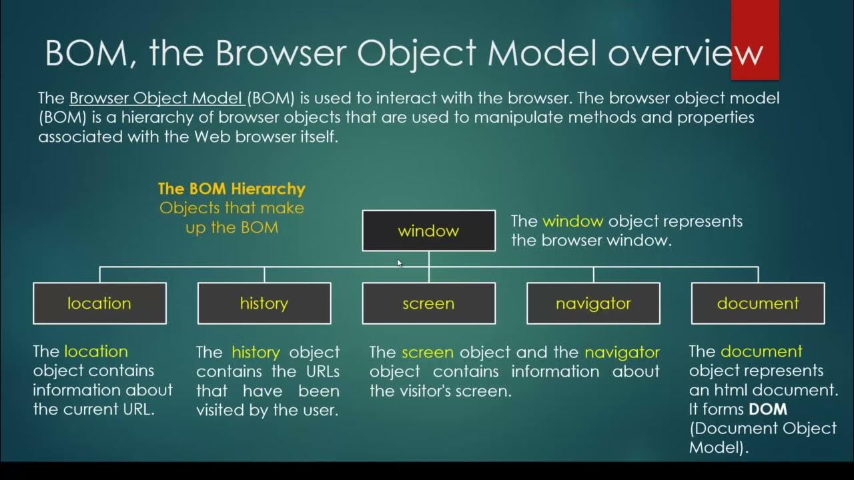

-The Browser Object Model (BOM) in JavaScript refers to the objects provided by the browsers to interact with them. By using these objects, you can manipulate the browser's functionality. For example, you can get the browser history and window size, navigate to different URLs, etc.
-The Browser Object Model (BOM) is the core of JavaScript on the web. The BOM provides you with objects that expose the web browser’s functionality.
-The BOM includes objects such as Window, Navigator, Location, History, and Screen. The Window object serves as the entry point to the BOM and provides access to the other objects within it.

Here, we have listed all objects of the Browser Object Model with descriptions −
- Window − The 'window' object represents the current browser window. You can use it to manipulate the browser window.
- Document − The 'document' object represents the currently opened web page in the browser window. You can use it to customize the property of the document.
- Screen − It provides information about the user's device's screen.
- History − It provides the browser's session history.
- Navigator − It is used to get the browser's information like default language, etc.
- Location − The Location object is used to get the URL information, such as the hostname of the current web page.
- Console − The console object allows developers to access the browser's console.

1.JavaScript Window

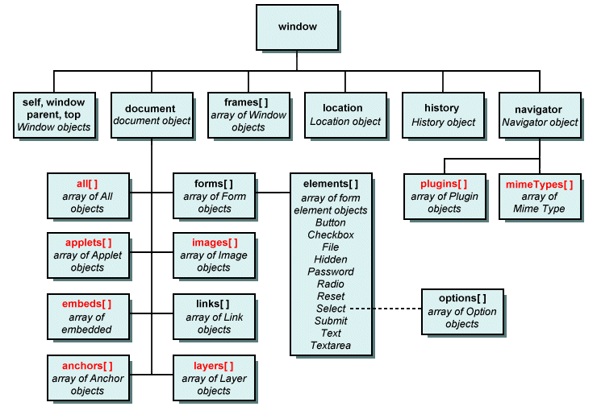
-The window object is global.The window object is supported by all browsers. It represents the browser's window.
The Window object serves as the entry point to the BOM and provides access to the other objects within it.
-All global JavaScript objects, functions, and variables automatically become members of the window object.
-Global variables are properties of the window object.
-Global functions are methods of the window object.
-Even the document object (of the HTML DOM) is a property of the window object.
-The global object of JavaScript in the web browser is the window object.

The window object is global
-The global object of JavaScript in the web browser is the window object. It means that all variables and functions declared globally with the var keyword become the properties and methods of the window object. For example:
<script>
var counter = 1;
var showCounter = () => console.log("counter "+counter);

console.log(window.counter);
window.showCounter();
</script>

1
counter 1

-Because the counter variable and the showCounter() function are declared globally with the var keyword, they are automatically added to the window object.
-If you don’t want to pollute the window object, you can use the let keyword to declare variables and functions.

Window Object Properties
Below, we have covered all properties of the 'window' object with a description. You may use the 'window' as a reference to access these properties.
Property Name | Property Description
closed | When the particular window is closed, it returns true.
console | It returns the window's console object.
customElements | It is used to define and access the custom elements in the browser window.
devicePixelRatio | It returns the physical pixel ratio of the device divided by CSS pixel ratio.
document | It is used to access the HTML document opened in the current window.
frames | It is used to get the window items like iframes, which are opened in the current window.
frameElement | It returns the current frame of the window.
history | It is used to get the history object of the window.
innerHeight | It returns the inner height of the window without including the scroll bar, toolbar, etc.
innerWidth | It returns the inner width of the window without including the scroll bar, toolbar, etc.
length | It returns the total number of iframes in the current window.
localStorage | It is used to access the local storage of the current window.
location | It is used to access the location object of the current window.
name | It is used to get or set the name of the window.
navigator | It is used to get the Navigator object of the browser.
opener | It returns a reference to the window from where the current window is opened.
outerHeight | It returns the total height of the window.
outerWidth | It returns the total width of the window.
pageXOffset | It returns the number of pixels you have scrolled the web page horizontally.
pageYOffset | It returns the number of pixels you have scrolled the web page vertically.
parent | It contains the reference to the parent window of the current window.
scheduler | It is entry point for using the prioritized task scheduling.
screen | It returns the 'screen' object of the current window.
screenLeft | It returns the position of the x-coordinate of the current window relative to the screen in pixels.
screenTop | It returns the position of the y-coordinate of the current window relative to the screen in pixels.
screenX | It is similar to the screenLeft property.
screenY | It is similar to the screenTop property.
scrollX | It is similar to the pageXOffset.
scrollY | It is similar to the pageYOffset.
self | It is used to get the current state of the window.
sessionStorage | It lets you access the 'sessionStorage' object of the current window.
speechSynthesis | It allows you to use the web speech API.
visualViewPort | It returns the object containing the viewport of the current window.
top | It contains a reference to the topmost window.

Window Object Methods
-The 'window' object also contains methods like properties to manipulate the current browser window.

Method Name | Method Description
alert() | It is used to show the alert message to the visitors.
atob() | It converts the string into the base-64 string.
blur() | It removes the focus from the window.
btoa() | It decodes the base-64 string in the normal string.
cancelAnimationFrame() | It cancels the animation frame scheduled using the requestAnimationFrame() method.
cancelIdleCallback() | It cancels a callback scheduled with the requestIdCallback() method.
clearImmediate() | It is used to clear actions specified using the setImmediate() method.
clearInterval() | It resets the timer you have set using the setInterval() method.
clearTimeout() | It stops the timeout you have set using the setTimeOut() method.
close() | It is used to close the current window.
confirm() | It shows the confirm box to get the confirmation from users.
focus() | It focuses on the current active window.
getComputedStyle() | It returns the current window's computed CSS style.
getSelection() | It returns the selection object based on the selected text range.
matchMedia() | It returns a new MediaQueryList object, which you can use to check whether the document matches the media queries.
moveBy() | It changes the position of the window relative to the current position.
moveTo() | It changes the position of the window absolutely.
open() | It opens a new window.
postMessage() | It is used to send a message to a window.
print() | It lets you print the window.
prompt() | It allows you to show a prompt box to get user input.
requestAnimationFrame() | It helps you to tell the browser that you want to perform an animation so the browser can update the animation before the next repaint.
requestIdleCallback() | It sets the callback functions to be called when the browser is Idle.
resizeBy() | It resizes the window by a particular number of pixels.
resizeTo() | It changes the size of the window.
scrollTo() | It scrolls the window to the absolute position.
scrollBy() | It scrolls the window relative to the current position.
setImmediate() | It breaks up long-running operations and runs the callback function instantly when the browser completes other operations.
setInterval() | It is used to execute a particular action after every interval.
setTimeout() | It is used to execute a particular action after a particular time.
stop() | It stops the loading of window.

ES6 FEATURES
ECMAScript 2015 was the second major revision to JavaScript.
ECMAScript 2015 is also known as ES6 and ECMAScript 6.

New Features in ES6
- The let keyword
- The const keyword
- Arrow Functions
- The {a,b} = Operator
- The [a,b] = Operator
- The ... Operator[Spread]
- For/of
- Map Objects
- Set Objects
- Classes
- Template String
- Promises
- Symbol
- Default Parameters
- Function Rest Parameter
- String.includes()
- String.startsWith()
- String.endsWith()
- Array entries()
- Array.from()
- Array keys()
- Array find()
- Array findIndex()
- Math.trunc
- Math.sign
- Math.cbrt
- Math.log2
- Math.log10
- Number.EPSILON
- Number.MIN_SAFE_INTEGER
- Number.MAX_SAFE_INTEGER
- Number.isInteger()
- Number.isSafeInteger()
- New Global Methods
- JavaScript Modules
CLOSURE IN JAVSCRIPT

What is Closure?
-The concept of closures in JavaScript allows nested functions to access variables defined in the scope of the parent function, even if the execution of the parent function is finished.
OR
-In JavaScript, closure provides access to the outer scope of a function from inside the inner function, even after the outer function has closed
-A JavaScript closure is basically a combination of the function and its lexical environment. This allows an inner function to access the outer function scope. A closure is created every time a function is -created at the function creation time.
The closure has three scope chains listed as follows:
- Access to its own scope.
- Access to the variables of the outer function.
- Access to the global variables.
Example
<script>
// javascript closure example
// outer function
function greet() {
// variable defined outside the inner function
let name = 'John';
// inner function
function displayName() {

// accessing name variable
return 'Hi' + ' ' + name;
}

return displayName;
}
const g1 = greet();
console.log(g1); // returns the function definition
console.log(g1()); // returns the value
</script>

Output
function displayName() {
// accessing name variable
return 'Hi' + ' ' + name;
}
Hi John

-In the above example, when greet() function is called, it returns the function definition of displayName.
-Here, g1 is a reference to the displayName() function.
-When g1() is called, it still has access to the greet() function.
-When we run console.log(g1), it returns the function definition.

COERCION IN JAVSCRIPT

-In JavaScript, coercion refers to the automatic or implicit conversion of a value from one data type to another. This happens when you perform operations on values of different types, and JavaScript attempts to make them compatible.
-There are two types of coercion in Javascript.
1]Implicit Coercion
2]Explicit Coercion.

1]Implicit Coercion
-Implicit Coercion: This is when JavaScript automatically converts a value without you explicitly asking for it.
-Interpreter automatically Converts.
<script>
let x = 5 + "10"; // Output: "510" (number coerced to string)
</script>

2]Explicit Coercion.
-Explicit Coercion: This is when you intentionally convert a value to a different type using built-in functions.
-This conversion you have do it by own to taking help of methods or operartors.
<script>
let y = Number("10"); // Output: 10 (string coerced to number)
</script>

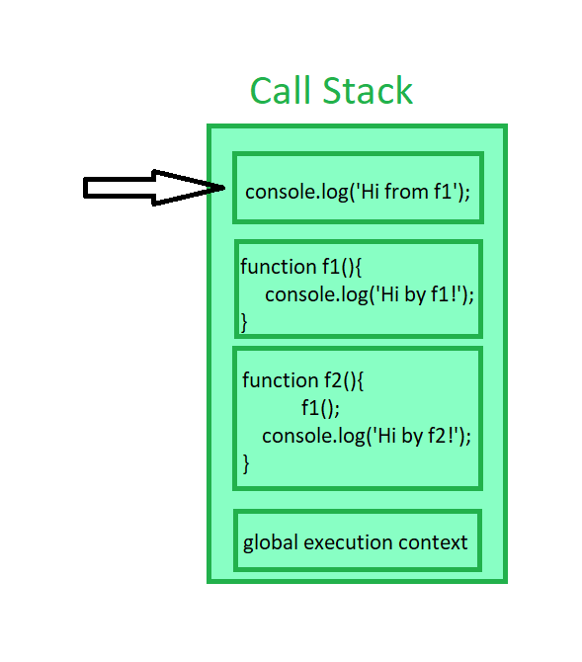
CALL STACK
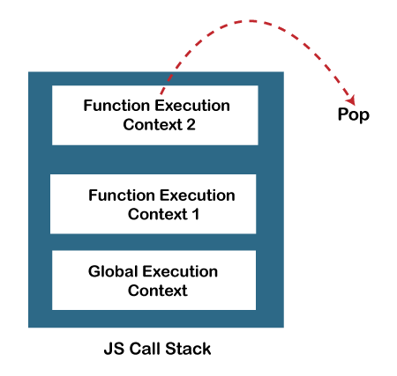

-In JavaScript, the call stack is a data structure that keeps track of the execution context of functions. It operates on a Last-In-First-Out (LIFO) principle, meaning the last function called is the first one to finish executing.

<script>
function foo() {
console.log("Inside foo");
bar();
}

function bar() {
console.log("Inside bar");
}

foo();
</script>

Call Stack Progression:
- foo() is called, and its execution context is pushed onto the call stack.
- console.log("Inside foo") executes.
- bar() is called, and its execution context is pushed onto the stack.
- console.log("Inside bar") executes.
- bar() completes, its context is popped off the stack.
- foo() completes, its context is popped off the stack.
-Why it's important:
-Function Execution Order: The call stack ensures that functions are executed in the correct order.
-Error Tracking: When an error occurs, the call stack provides a trace of the function calls leading to the error, making debugging easier.
-Recursion: The call stack enables recursive function calls, where a function calls itself.
Stack Overflow:
-If the call stack grows too large, it can lead to a "stack overflow" error. This often happens when a recursive function calls itself indefinitely without a proper base case to stop the recursion.

Role of JavaScript Call Stack
There are the following points where the call stack is being used by the JS engine:
-When any script is executed by the user, the JS engine creates a Global execution context and then adds it on the call stack and at the top of the stack so that it may get executed.
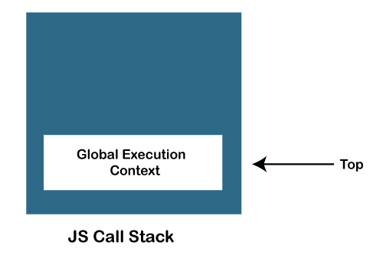
-When any function is invoked, the JS engine creates a Function execution context and adds it on the stack and at the top of the stack so that the invoked function may get executed.
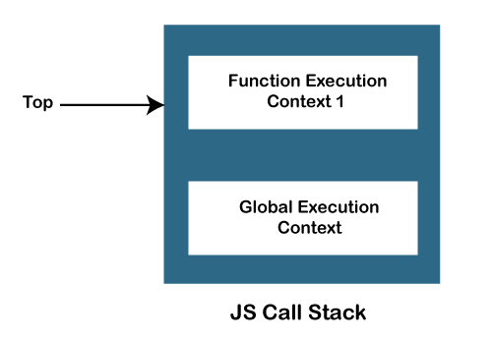
-In case a function invokes another function, the JS engine creates a Function execution context for the invoked function, adds it to the top of the stack, and begins the execution.
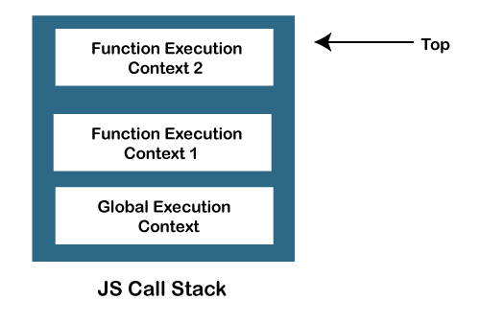
When any function execution gets completed, the JS engine pops it out of the stack and continues the execution of the other functions stored in the stack.

If no space is left in the stack and we try to push more functions, it throws a "stack overflow" error, and if no further execution context is present in the call stack, it throws a "Stack Underflow" error.

JavaScript call stack example
Let’s start with the following example:
function add(a, b) {
return a + b;
}

function average(a, b) {
return add(a, b) / 2;
}

let x = average(10, 20);
Code language: JavaScript (javascript)
When the JavaScript engine executes this script, it places the global execution context (denoted by main() or global() function on the call stack.
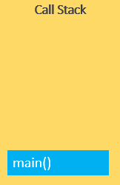
The global execution context enters the creation phase and moves to the execution phase.
-The JavaScript engine executes the call to the average(10, 20) function and creates a function execution context for the average() function and pushes it on top of the call stack:
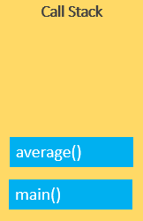
-The JavaScript engine starts executing the average() since because the average() function is on the top of the call stack.
-The average() function calls add() function. At this point, the JavaScript engine creates another function execution context for the add() function and places it on the top of the call stack:
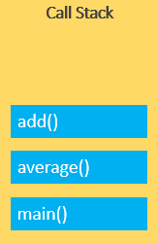
-JavaScript engine executes the add() function and pops it off the call stack:
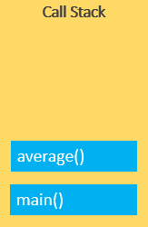
-At this point, the average() function is on the top of the call stack, the JavaScript engine executes and pops it off the call stack.
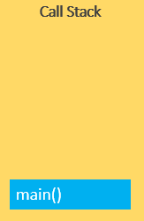
-Now, the call stack is empty so the script stops executing:


-The following picture illustrates the overall status of the Call Stack in all steps:
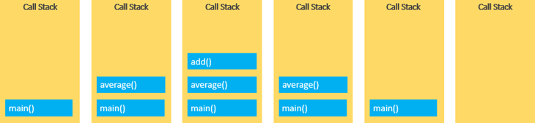

JAVSCRIPT MODULES
-JavaScript modules allow you to break up your code into separate files.
-This makes it easier to maintain a code-base.
-Modules are imported from external files with the import statement.
-Modules also rely on type="module" in the <script> tag.
-Before importing the module we have take care of it the module first exported.

Export

-Modules with functions or variables can be stored in any external file.
-There are two types of exports: Named Exports and Default Exports.
Named Exports
-Let us create a file named person.js, and fill it with the things we want to export.
-You can create named exports two ways. In-line individually, or all at once at the bottom.
In-line individually:
person.js

export const name = "Amol";
export const age = 24;

All at once at the bottom:
person1.js

const name = "Jesse";
const age = 40;

export {name, age};

Default Export
-Let us create another file, named message.js, and use it for demonstrating default export.
-You can only have one default export in a file.
message.js

const message = () => {
const name = "Amol";
const age = 24;
return name + ' is ' + age + 'years old.';
};

export default message;

Import

-You can import modules into a file in two ways, based on if they are named exports or default exports.
-Named exports are constructed using curly braces. Default exports are not.
Import from named exports
Import named exports from the file person.js:
person.html

<!DOCTYPE html>
<html lang="en">
<head>
<meta charset="UTF-8">
<meta name="viewport" content="width=device-width, initial-scale=1.0">
<title>Document</title>
</head>
<body>
<h1 id="demo"></h1>
<script type="module">
import { name, age } from "../EXPORTS/person.js";
let text = "My name is " + name + ", I am " + age + ".";
document.getElementById("demo").innerHTML = text;
</script>
</body>
</html>

Import from default exports
Import a default export from the file message.js:

meassge.html

<!DOCTYPE html>
<html lang="en">
<head>
<meta charset="UTF-8">
<meta name="viewport" content="width=device-width, initial-scale=1.0">
<title>Document</title>
</head>
<body>
<h1>JavaScript Modules</h1>

<p id="demo"></p>

<script type="module">
import message from "../EXPORTS/message.js";
document.getElementById("demo").innerHTML = message();
</script>
</body>
</html>

Note
Modules only work with the HTTP(s) protocol.
A web-page opened via the file:// protocol cannot use import / export.

IMPORTANT QUESTIONS

QNO1:- is JavaScript and ECMAScript same?
Ans:-
-Yes, ECMAScript and JavaScript are often used interchangeably, but they are technically different things:
- ECMAScript
-The standard for the core language of JavaScript. It's a programming language that defines syntax, operators, types, and more. ECMAScript also serves as a standard for other scripting languages, like JScript and ActionScript.
- JavaScript
-A scripting language that conforms to the ECMAScript specifications. JavaScript was created by Brendan Eich in 1995, and it was originally named Mocha and then LiveScript.
-ECMAScript is intended to ensure that web pages are compatible across different browsers. It's also used in non-browser environments, like Node.js.
-ECMAScript versions are often abbreviated as ES1, ES2, ES3, ES5, and ES6. Since 2016, versions have been named by year, like ECMAScript 2016, 2017, 2018, 2019, and 2020.
-JavaScript was invented by Brendan Eich in 1995, and became an ECMA standard in 1997.
-ECMAScript is the official name of the language.
-ECMAScript versions have been abbreviated to ES1, ES2, ES3, ES5, and ES6.
-Since 2016, versions are named by year (ECMAScript 2016, 2017, 2018, 2019, 2020).

Differences Between JavaScript and ECMAScript
1. Definition
- JavaScript - High-level languages and interpreted programming languages like JavaScript are frequently employed in designing websites. JavaScript executions, such as those in web browsers, adhere to the ECMAScript requirements while including environment-specific functionality.
- ECMAScript - A standardized programming language specification is called ECMAScript. It acts as a model for languages of scripting and establishes criteria for their implementation.
2. Execution
- JavaScript - This term describes the language used in browsers and other settings. It has environment-specific functionality in addition to ECMAScript features.
- ECMAScript - ECMAScript is the abbreviation for the standardized scripting language, which is not dependent on any specific environment.
3. Browser Compatibility
- JavaScript - Browsers use ECMAScript guidelines to execute JavaScript; nevertheless, browsers may differ in availability for the most recent ECMAScript features.
- ECMAScript - By offering a uniform collection of rules and norms, ECMAScript serves as a standard that ensures compatibility across distinct implementations.
4. Usage Scope
- JavaScript - Web developers utilize JavaScript, a programming language, for client-side and web-server scripting.
- ECMAScript - This is the name of the fundamental principle specification that outlines the fundamental characteristics of this programming language.

Top 50 JavaScript Interview Questions With Example Answers

JavaScript Fundamentals

1. What is JavaScript?
A high-level, interpreted programming language called JavaScript makes it possible to create interactive web pages and online apps with dynamic functionality. Commonly referred to as the universal language, Javascript is primarily used by developers for front-end and back-end work.

2. What are the different data types in JavaScript?
JavaScript has six primitive data types:
- Number
- String
- Boolean
- Null
- Undefined
- Symbol
It also has two compound data types:
- Object
- Array

3. What is hoisting in JavaScript?
Hoisting is a JavaScript concept that refers to the process of moving declarations to the top of their scope. This means that variables and functions can be used before they are declared, as long as they are declared before they are used in a function.
For example, the following code will print "Hello, world!" even though the greeting variable is not declared until after the console.log() statement.
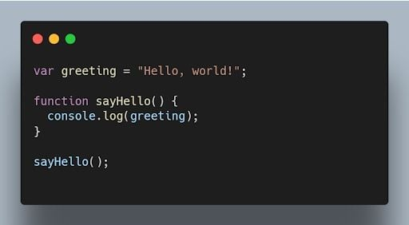JavaScript code printing "Hello World" using hoisting. | Image: Akshay Kumar

4. What is the difference between null and undefined?
null is an assignment value that represents no value or an empty value, while undefined is a variable that has been declared but not assigned a value.
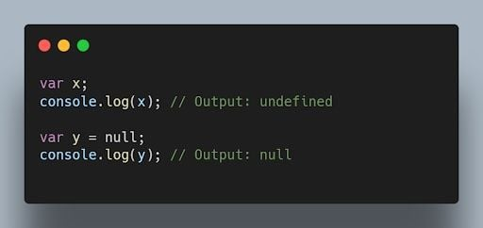JavaScript code outputting null and undefined values. | Image: Akshay Kumar

5. Why do we use the word “debugger” in JavaScript?
The word “debugger” is used in JavaScript to refer to a tool that can be used to step through JavaScript code line by line. This can be helpful for debugging JavaScript code, which is the process of finding and fixing errors in JavaScript code. To use the debugger, you need to open the JavaScript console in your browser. Then, you can use debugger commands to comb through your code line by line.
It's essential to know debugging techniques as well as the more general ideas behind code optimization and speed improvement. In addition to operating smoothly, efficient code significantly enhances the user experience.
For example, the following code will print the value of the x variable at each step of the debugger.
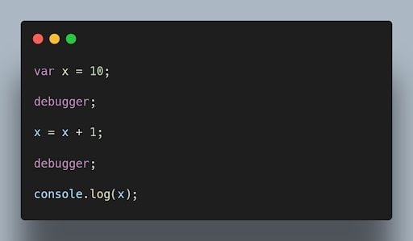JavaScript debugger code printing the value of x at each step. | Image: Akshay Kumar

6. What is the purpose of the “this” keyword in JavaScript?
The this keyword refers to the object that is executing the current function or method. It allows access to object properties and methods within the context of that object.
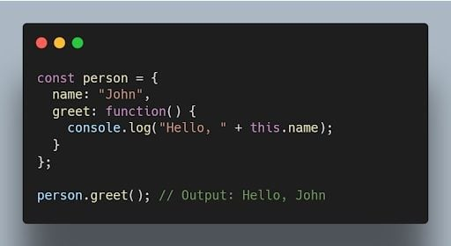JavaScript code using the this keyword to output person name. | Image: Akshay Kumar

7. What is the difference between == and === operators in JavaScript?
The equality == operator is a comparison operator that compares two values and returns true if they are equal. The strict equality === operator is also a comparison operator, but it compares two values and returns true only if they are equal and of the same type.
For example, the following code will return true, because the values of the x and y variables are equal.
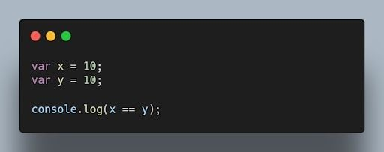JavaScript equality operator code comparing x and y variables. | Image: Akshay Kumar

8. What is the difference between “var” and “let” keywords in JavaScript?
The var and let keywords are both used to declare variables in JavaScript. However, there are some key differences between the two keywords.
The var keyword declares a global variable, which means that the variable can be accessed from anywhere in the code. The let keyword declares a local variable, which means that the variable can only be accessed within the block of code where it is declared.
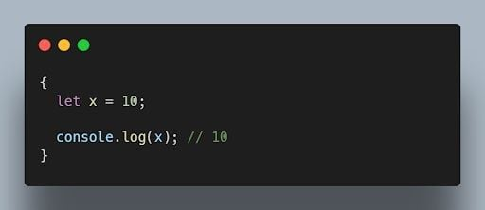JavaScript let keyword example. | Image: Akshay Kumar

9. What are closures in JavaScript?
Closures (closureFn) are functions that have access to variables from an outer function even after the outer function has finished executing. They “remember” the environment in which they were created.
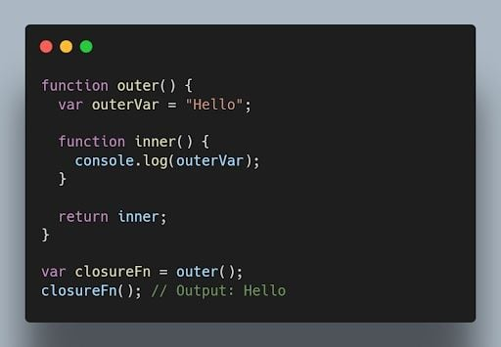JavaScript closure code. | Image: Akshay Kumar

10. What is event delegation in JavaScript?
Event delegation is a technique where you attach a single event listener to a parent element, and that event listener handles events occurring on its child elements. It helps optimize performance and reduce memory consumption.
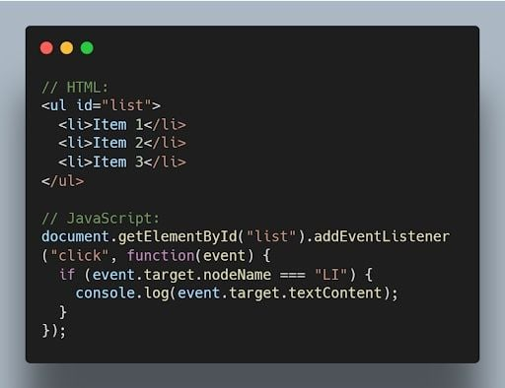JavaScript event delegation code example. | Image: Akshay Kumar

11. What is the difference between “let”, “const”, and “var”?
let and const were introduced in ES6 and have block scope. let is reassignable, and const is non-reassignable. var is function-scoped and can be redeclared and reassigned throughout the function.
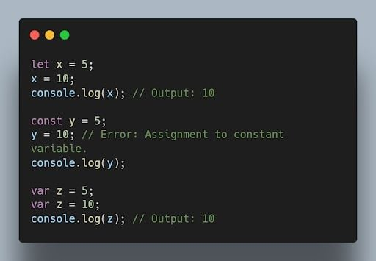JavaScript let, const and var keywords with outputs. | Image: Akshay Kumar

12. What is implicit type coercion in JavaScript?
Implicit type coercion is a JavaScript concept that refers to the automatic conversion of a value from one type to another. In JavaScript, this conversion follows a priority order that typically begins with strings, then numbers, and finally booleans. If you try to add a string to a number, JavaScript will implicitly coerce the number to a string before performing the addition operation because strings have the highest priority in type coercion.
For example, when you combine the number 5 with the string '10' using the addition operator, the result is the string '510'. This occurs because JavaScript will implicitly convert the number 5 to a string following the priority of coercion, and then concatenate it to the string '10'.
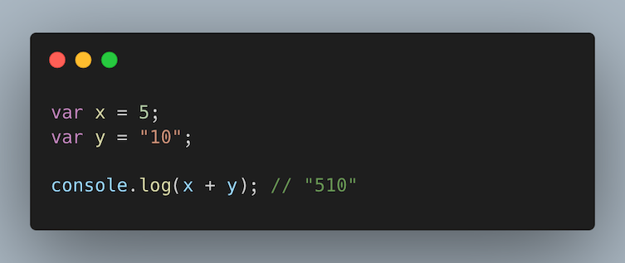Implicit type coercion code example in JavaScript adding x and y variables. | Image: Raymond Van Hoecke

13. Explain the concept of prototypes in JavaScript.
Prototypes are a mechanism used by JavaScript objects for inheritance. Every JavaScript object has a prototype, which provides properties and methods that can be accessed by that object.
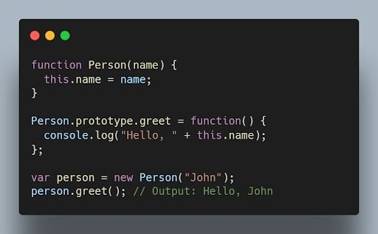JavaScript prototype code example. | Image: Akshay Kumar

14. What is the output of the following code?
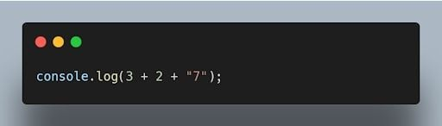JavaScript console.log code. | Image: Akshay Kumar
The output will be "57". The addition operation is performed from left to right, and when a string is encountered, it performs concatenation.

15. How can you clone an object in JavaScript?
There are multiple ways to clone an object in JavaScript. One common method is using the Object.assign() method or the spread operator (...).
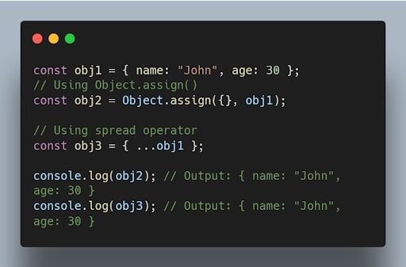JavaScript code for cloning an object using object.assign() and ... operators. | Image: Akshay Kumar
More on JavaScriptJavaScript Question Mark (?) Operator Explained

Intermediate Concepts

16. What are higher-order functions in JavaScript?
Higher order functions are functions that can accept other functions as arguments or return functions as their results. They enable powerful functional programming patterns in JavaScript.
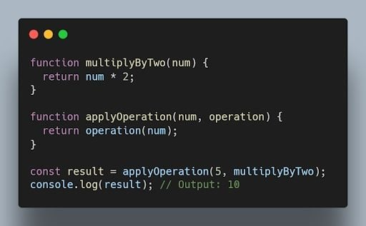JavaScript higher order functions code. | Image: Akshay Kumar

17. What is the purpose of the bind() method in JavaScript?
The bind() method is used to create a new function with a specified this value and an initial set of arguments. It allows you to set the context of a function permanently.
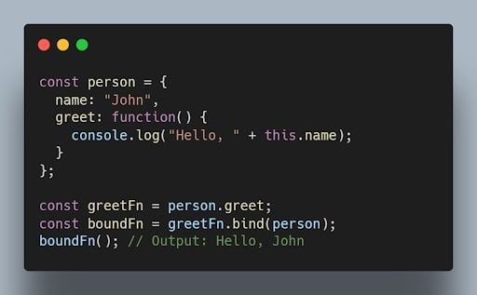JavaScript bound() method code example. | Image: Akshay Kumar

18. What is the difference between function declarations and function expressions?
Function declarations are defined using the function keyword, while function expressions are defined by assigning a function to a variable. Function declarations are hoisted, while function expressions are not.
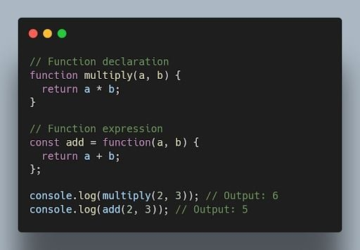JavaScript code showing differences between declaration and expression. | Image: Akshay Kumar

19. What are the different types of errors in JavaScript?
JavaScript can throw a variety of errors, including:
- Syntax errors: These errors occur when the JavaScript code is not syntactically correct.
- Runtime errors: These errors occur when the JavaScript code is executed and there is a problem.
- Logical errors: These errors occur when the JavaScript code does not do what it is supposed to do.

20. What is memoization in JavaScript?
Memoization is a technique that can be used to improve the performance of JavaScript code. Memoization works by storing the results of expensive calculations in a cache. This allows the JavaScript code to avoid re-performing the expensive calculations if the same input is provided again.
For example, the following code calculates the factorial of a number. The factorial of a number is the product of all the positive integers from one to the number.
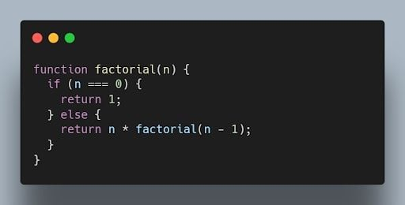JavaScript code to calculate the factorial of all positive integers from one to a number. | Image: Akshay Kumar
This code can be memoized as follows:
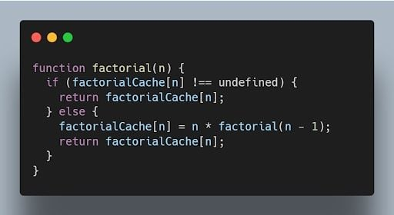Memoized code for JavaScript factorial. | Image: Akshay Kumar

21. What is recursion in JavaScript?
Recursion is a programming technique that allows a function to call itself. Recursion can be used to solve a variety of problems, such as finding the factorial of a number or calculating the Fibonacci sequence.
The following code shows how to use recursion to calculate the factorial of a number:
JavaScript recursion code to solve for factorial of a number. | Image: Akshay Kumar

22. What is the use of a constructor function in JavaScript?
A constructor function is a special type of function that is used to create objects. Constructor functions are used to define the properties and methods of an object.
The following code shows how to create a constructor function:
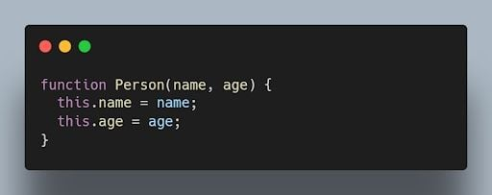Constructor function in JavaScript. | Image: Akshay Kumar

23. What is the difference between a function declaration and a function expression in JavaScript?
A function declaration is a statement that defines a function. A function expression is an expression that evaluates to a function.
The following code shows an example of a function declaration. This code defines a function named factorial. The factorial function calculates the factorial of a number.
JavaScript function declaration code for a factorial function. | Image: Akshay Kumar
The following code shows an example of a function expression:
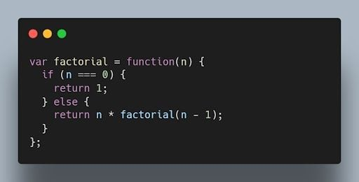JavaScript function expression for factorial code. | Image: Akshay Kumar

24. What is a callback function in JavaScript?
A callback function is a function passed as an argument to another function, which is then invoked inside the outer function. It allows asynchronous or event-driven programming.
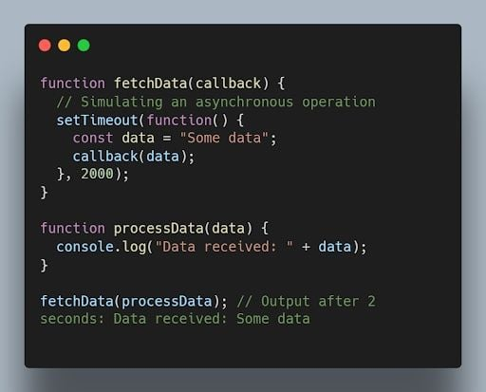JavaScript code for the callback function. | Image: Akshay Kumar

25. What are promises in JavaScript?
Promises are objects used for asynchronous operations. They represent the eventual completion or failure of an asynchronous operation and allow chaining and handling of success or error cases.
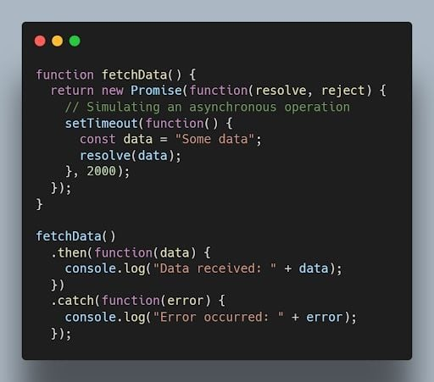JavaScript promises code example. | Image: Akshay Kumar

26. What is the difference between synchronous and asynchronous programming?
In synchronous programming, the program execution occurs sequentially, and each statement blocks the execution until it is completed. In asynchronous programming, multiple tasks can be executed concurrently, and the program doesn’t wait for a task to finish before moving to the next one.
Synchronous coding example:
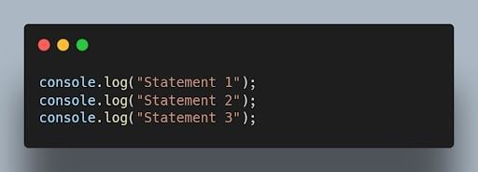JavaScript synchronous code example. | Image: Akshay Kumar
Asynchronous code example:
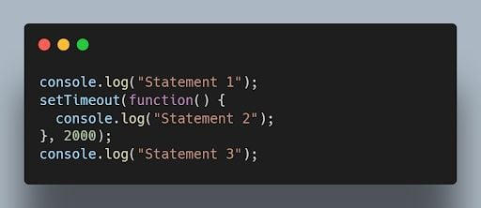Asynchronous JavaScript code example. | Image: Akshay Kumar

27. How do you handle errors in JavaScript?
Errors in JavaScript can be handled using try-catch blocks. The try block contains the code that may throw an error, and the catch block handles the error and provides an alternative execution path.
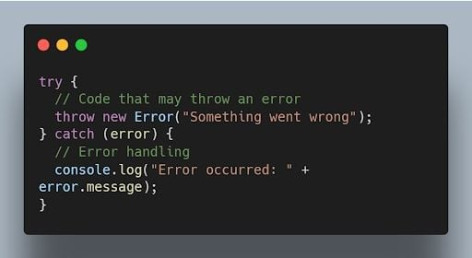JavaScript try-catch blocks of code. | Image: Akshay Kumar

28. Explain the concept of event bubbling in JavaScript.
Event bubbling is the process where an event triggers on a nested element, and then the same event is propagated to its parent elements in the document object model (DOM) tree. It starts from the innermost element and goes up to the document root.
Example:
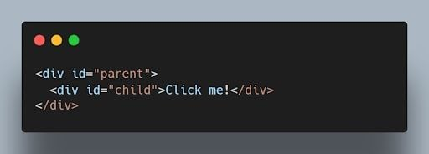JavaScript code using event bubbling. | Image: Akshay Kumar
When you click on the child element, both the child and parent event handlers will be triggered, and the output will be:
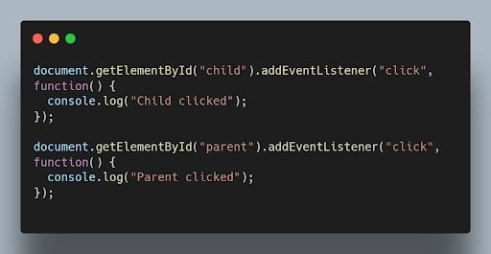JavaScript code output after clicking on the child element with event bubbling. | Image: Akshay Kumar

29. What are arrow functions in JavaScript?
Arrow functions are a concise syntax for writing JavaScript functions. They have a more compact syntax compared to traditional function expressions and inherit the this value from their surrounding scope.
For example:
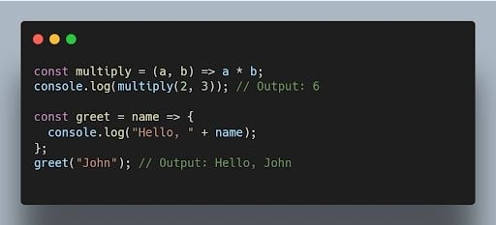JavaScript arrow functions code example. | Image: Akshay Kumar

30. What is the difference between querySelector and getElementById?
querySelector is a more versatile method that allows you to select elements using CSS-like selectors, while getElementById specifically selects an element with the specified ID.
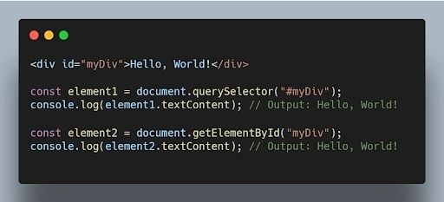JavaScript code comparing querySelector and getElementByID methods. | Image: Akshay Kumar

31. What is the purpose of the setTimeout() function in JavaScript?
The setTimeout() function is used to delay the execution of a function or the evaluation of an expression after a specified amount of time in milliseconds.
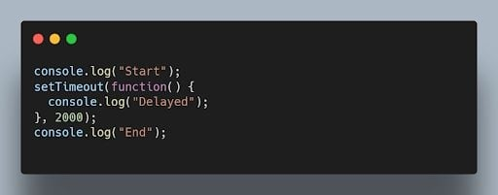JavaScript setTimeout() function code. | Image: Akshay Kumar
Output after two seconds:
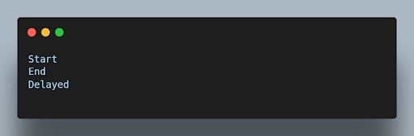JavaScript setTimeout code output after two seconds. | Image: Akshay Kumar

32. What is event delegation and why is it useful?
Event delegation is a technique where you attach a single event listener to a parent element to handle events occurring on its child elements. It’s useful for dynamically created elements or when you have a large number of elements.
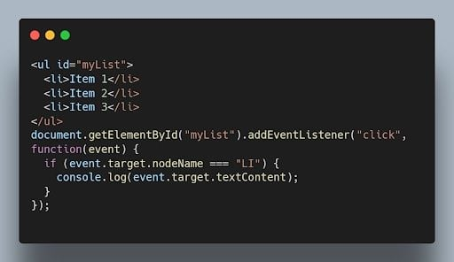JavaScript event delegation code example. | Image: Akshay Kumar

33. How can you prevent the default behavior of an event in JavaScript?
You can use the preventDefault() method on the event object within an event handler to prevent the default behavior associated with that event.
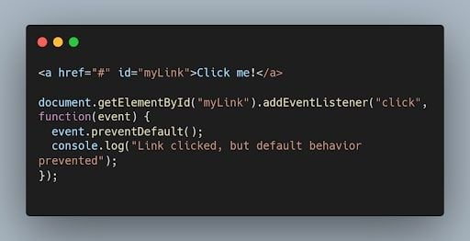JavaScript preventDefault() method code example. | Image: Akshay Kumar

34. What is the difference between localStorage and sessionStorage in JavaScript?
Both localStorage and sessionStorage are web storage objects in JavaScript, but they have different scopes and lifetimes.
- localStorage persists data even after the browser window is closed and is accessible across different browser tabs/windows of the same origin.
- sessionStorage stores data for a single browser session and is accessible only within the same tab or window.
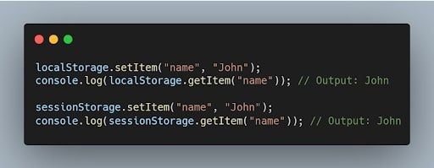JavaScript localStorage and sessionStorage code comparisons. | Image: Akshay Kumar

35. How can you convert a string to lowercase in JavaScript?
You can use the toLowerCase() method to convert a string to lowercase in JavaScript.
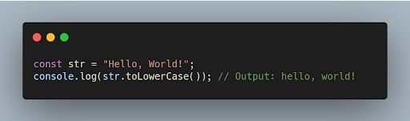JavaScript toLowerCase() code example. | Image: Akshay Kumar

Advanced Concepts
36. What is the purpose of the map() function in JavaScript?
The map() function is used to iterate over an array and apply a transformation or computation on each element. It returns a new array with the results of the transformation.
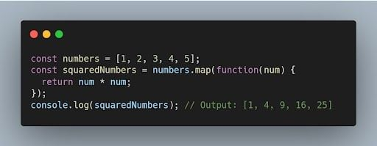JavaScript map() function code example. | Image: Akshay Kumar

37. What is the difference between splice() and slice()?
- splice() is used to modify an array by adding, removing, or replacing elements at a specific position.
- slice() is used to create a new array that contains a portion of an existing array, specified by the starting and ending indices.
Example of splice():
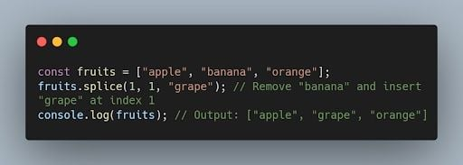JavaScript splice() function code example. | Image: Akshay Kumar
Example of slice():
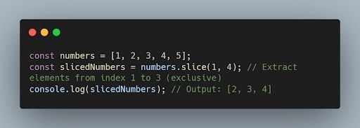JavaScript slice() code example. | Image: Akshay Kumar

38. What is the purpose of the reduce() function in JavaScript?
The reduce() function is used to reduce an array to a single value by applying a function to each element and accumulating the result.
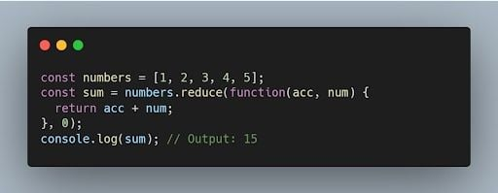JavaScript reduce() function example. | Image: Akshay Kumar

39. How can you check if an array includes a certain value in JavaScript?
You can use the includes() method to check if an array includes a specific value. It returns true if the value is found, and false otherwise.
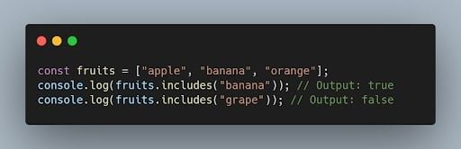JavaScript includes() method code on an array. | Image: Akshay Kumar

40. What is the difference between prototype and instance properties in JavaScript?
A prototype property is a property that is defined on the prototype object of a constructor function. Instance properties are properties that are defined on individual objects that are created by a constructor function.
Prototype properties are shared by all objects that are created by a constructor function. Instance properties are not shared by other objects.

41. What is the difference between an array and an object in JavaScript?
An array is a data structure that can store a collection of values. An object is a data structure that can store a collection of properties.
Arrays are indexed by numbers. Objects are indexed by strings. Arrays can only store primitive data types and objects. Objects can store primitive data types, objects and arrays.
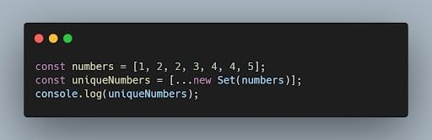JavaScript differences between array and object code example. | Image: Akshay Kumar

42. How can you remove duplicates from an array in JavaScript?
One way to remove duplicates from an array is by using the Set object or by using the filter() method with the indexOf() method.
Example:
JavaScript code example removing duplicates using the filter() method. | Image: Akshay Kumar

43. What is the purpose of the fetch() function in JavaScript?
The fetch() function is used to make asynchronous HTTP requests in JavaScript. It returns a Promise that resolves to the response from the server.
Example:
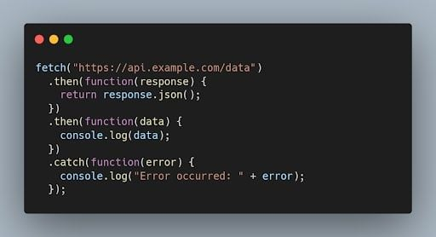JavaScript fetch() code function example. | Image: Akshay Kumar

44. What is a generator function in JavaScript?
A generator function is a special type of function that can be paused and resumed during its execution. It allows generating a sequence of values over time, using the yield keyword.
Example:
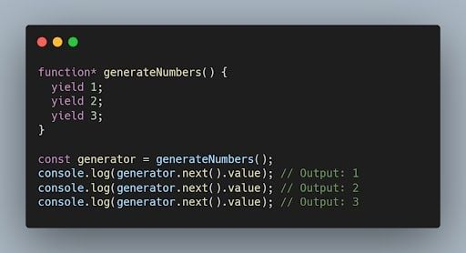JavaScript generator function code example. | Image: Akshay Kumar

45. What are the different events in JavaScript?
There are many different events in JavaScript, but some of the most common events include:
- Click: The click event occurs when a user clicks on an HTML element.
- Mouseover: The mouseover event occurs when a user's mouse pointer moves over an HTML element.
- Keydown: The keydown event occurs when a user presses a key on the keyboard.
- Keyup: The keyup event occurs when a user releases a key on the keyboard.
- Change: The change event occurs when a user changes the value of an HTML input element.

46. What are the different ways to access an HTML element in JavaScript?
There are three main ways to access an HTML element in JavaScript:
- Using the getElementById() method: The getElementById() method takes a string as an argument and returns the HTML element with the specified ID.
- Using the getElementsByTagName() method: The getElementsByTagName() method takes a string as an argument and returns an array of all the HTML elements with the specified tag name.
- Using the querySelector() method: The querySelector() method takes a CSS selector as an argument and returns the first HTML element that matches the selector.

47. What is the scope of a variable in JavaScript?
The scope of a variable in JavaScript is the part of the code where the variable can be accessed. Variables declared with the var keyword have a local scope, which means that they can only be accessed within the block of code where they are declared. Variables declared with the let keyword have a block scope, which means that they can only be accessed within the block of code where they are declared and any nested blocks. Variables declared with the const keyword have a global scope, which means that they can be accessed from anywhere in the code.

48. What are the different ways to create objects in JavaScript?
There are multiple ways to create objects in JavaScript, including object literals, constructor functions, the Object.create() method and the class syntax introduced in ECMAScript 2015 (ES6).
Example using object literals:
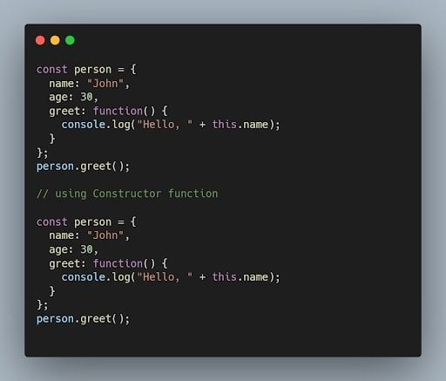JavaScript object literals code example. | Image: Akshay Kumar

49. What is the purpose of the window object in JavaScript?
The window object represents the browser window. The window object can be used to access the browser’s features, such as the location bar, the status bar and the bookmarks bar.

50. What is the purpose of the async and await keywords in JavaScript?
The async and await keywords are used for handling asynchronous operations in a more synchronous-like manner. The async keyword is used to define an asynchronous function, and the await keyword is used to pause the execution of an async function until a promise is fulfilled or rejected.
Example:
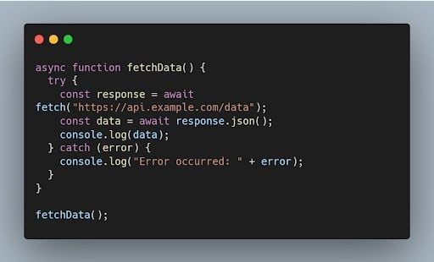

51. What are the different data types present in javascript?
To know the type of a JavaScript variable, we can use the typeof operator.
1. Primitive types
String - It represents a series of characters and is written with quotes. A string can be represented using a single or a double quote.
Example :
var str = "Vivek Singh Bisht"; //using double quotes
var str2 = 'John Doe'; //using single quotes

- Number - It represents a number and can be written with or without decimals.
Example :
var x = 3; //without decimal
var y = 3.6; //with decimal

- BigInt - This data type is used to store numbers which are above the limitation of the Number data type. It can store large integers and is represented by adding “n” to an integer literal.
Example :
var bigInteger = 234567890123456789012345678901234567890;

- Boolean - It represents a logical entity and can have only two values : true or false. Booleans are generally used for conditional testing.

Example :
var a = 2;
var b = 3;
var c = 2;
(a == b) // returns false
(a == c) //returns true

- Undefined - When a variable is declared but not assigned, it has the value of undefined and it’s type is also undefined.
Example :
var x; // value of x is undefined
var y = undefined; // we can also set the value of a variable as undefined

- Null - It represents a non-existent or a invalid value.
Example :
var z = null;

- Symbol - It is a new data type introduced in the ES6 version of javascript. It is used to store an anonymous and unique value.
Example :
var symbol1 = Symbol('symbol');
- typeof of primitive types :
typeof "John Doe" // Returns "string"
typeof 3.14 // Returns "number"
typeof true // Returns "boolean"
typeof 234567890123456789012345678901234567890n // Returns bigint
typeof undefined // Returns "undefined"
typeof null // Returns "object" (kind of a bug in JavaScript)
typeof Symbol('symbol') // Returns Symbol

2. Non-primitive types
- Primitive data types can store only a single value. To store multiple and complex values, non-primitive data types are used.
- Object - Used to store collection of data.
- Example:
// Collection of data in key-value pairs
var obj1 = {
x: 43,
y: "Hello world!",
z: function(){
return this.x;
}
}

// Collection of data as an ordered list

var array1 = [5, "Hello", true, 4.1];
Note- It is important to remember that any data type that is not a primitive data type, is of Object type in javascript.

52. Explain Hoisting in javascript.
Hoisting is the default behaviour of javascript where all the variable and function declarations are moved on top.
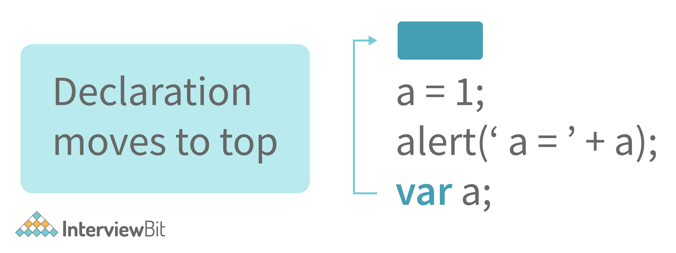
This means that irrespective of where the variables and functions are declared, they are moved on top of the scope. The scope can be both local and global.
Example 1:
hoistedVariable = 3;
console.log(hoistedVariable); // outputs 3 even when the variable is declared after it is initialized
var hoistedVariable;
Example 2:
hoistedFunction(); // Outputs " Hello world! " even when the function is declared after calling

function hoistedFunction(){
console.log(" Hello world! ");
}
Example 3:
// Hoisting takes place in the local scope as well
function doSomething(){
x = 33;
console.log(x);
var x;
}
doSomething(); // Outputs 33 since the local variable “x” is hoisted inside the local scope
Note - Variable initializations are not hoisted, only variable declarations are hoisted:
var x;
console.log(x); // Outputs "undefined" since the initialization of "x" is not hoisted
x = 23;
Note - To avoid hoisting, you can run javascript in strict mode by using “use strict” on top of the code:
"use strict";
x = 23; // Gives an error since 'x' is not declared
var x;
53. Why do we use the word “debugger” in javascript?
The debugger for the browser must be activated in order to debug the code. Built-in debuggers may be switched on and off, requiring the user to report faults. The remaining section of the code should stop execution before moving on to the next line while debugging.

54. Difference between “ == “ and “ === “ operators.
Both are comparison operators. The difference between both the operators is that “==” is used to compare values whereas, “ === “ is used to compare both values and types.
Example:
var x = 2;
var y = "2";
(x == y) // Returns true since the value of both x and y is the same
(x === y) // Returns false since the typeof x is "number" and typeof y is "string"
55. Difference between var and let keyword in javascript.
Some differences are
- From the very beginning, the 'var' keyword was used in JavaScript programming whereas the keyword 'let' was just added in 2015.
- The keyword 'Var' has a function scope. Anywhere in the function, the variable specified using var is accessible but in ‘let’ the scope of a variable declared with the 'let' keyword is limited to the block in which it is declared. Let's start with a Block Scope.
- In ECMAScript 2015, let and const are hoisted but not initialized. Referencing the variable in the block before the variable declaration results in a ReferenceError because the variable is in a "temporal dead zone" from the start of the block until the declaration is processed.
Explore InterviewBit’s Exclusive Live Events
By

56. Explain Implicit Type Coercion in javascript.
Implicit type coercion in javascript is the automatic conversion of value from one data type to another. It takes place when the operands of an expression are of different data types.
- String coercion
String coercion takes place while using the ‘ + ‘ operator. When a number is added to a string, the number type is always converted to the string type.
Example 1:
var x = 3;
var y = "3";
x + y // Returns "33"
Example 2:
var x = 24;
var y = "Hello";
x + y // Returns "24Hello";
Note - ‘ + ‘ operator when used to add two numbers, outputs a number. The same ‘ + ‘ operator when used to add two strings, outputs the concatenated string:
var name = "Vivek";
var surname = " Bisht";
name + surname // Returns "Vivek Bisht"
Let’s understand both the examples where we have added a number to a string,
When JavaScript sees that the operands of the expression x + y are of different types ( one being a number type and the other being a string type ), it converts the number type to the string type and then performs the operation. Since after conversion, both the variables are of string type, the ‘ + ‘ operator outputs the concatenated string “33” in the first example and “24Hello” in the second example.
Note - Type coercion also takes place when using the ‘ - ‘ operator, but the difference while using ‘ - ‘ operator is that, a string is converted to a number and then subtraction takes place.
var x = 3;
Var y = "3";
x - y //Returns 0 since the variable y (string type) is converted to a number type
- Boolean Coercion
Boolean coercion takes place when using logical operators, ternary operators, if statements, and loop checks. To understand boolean coercion in if statements and operators, we need to understand truthy and falsy values.
Truthy values are those which will be converted (coerced) to true. Falsy values are those which will be converted to false.
All values except false, 0, 0n, -0, “”, null, undefined, and NaN are truthy values.
If statements:
Example:
var x = 0;
var y = 23;

if(x) { console.log(x) } // The code inside this block will not run since the value of x is 0(Falsy)

if(y) { console.log(y) } // The code inside this block will run since the value of y is 23 (Truthy)
- Logical operators:
Logical operators in javascript, unlike operators in other programming languages, do not return true or false. They always return one of the operands.
OR ( | | ) operator - If the first value is truthy, then the first value is returned. Otherwise, always the second value gets returned.
AND ( && ) operator - If both the values are truthy, always the second value is returned. If the first value is falsy then the first value is returned or if the second value is falsy then the second value is returned.
Example:
var x = 220;
var y = "Hello";
var z = undefined;

x | | y // Returns 220 since the first value is truthy

x | | z // Returns 220 since the first value is truthy

x && y // Returns "Hello" since both the values are truthy

y && z // Returns undefined since the second value is falsy

if( x && y ){
console.log("Code runs" ); // This block runs because x && y returns "Hello" (Truthy)
}

if( x || z ){
console.log("Code runs"); // This block runs because x || y returns 220(Truthy)
}
- Equality Coercion
Equality coercion takes place when using ‘ == ‘ operator. As we have stated before
The ‘ == ‘ operator compares values and not types.
While the above statement is a simple way to explain == operator, it’s not completely true
The reality is that while using the ‘==’ operator, coercion takes place.
The ‘==’ operator, converts both the operands to the same type and then compares them.
Example:
var a = 12;
var b = "12";
a == b // Returns true because both 'a' and 'b' are converted to the same type and then compared. Hence the operands are equal.
Coercion does not take place when using the ‘===’ operator. Both operands are not converted to the same type in the case of ‘===’ operator.
Example:
var a = 226;
var b = "226";

a === b // Returns false because coercion does not take place and the operands are of different types. Hence they are not equal.
7. Is javascript a statically typed or a dynamically typed language?
JavaScript is a dynamically typed language. In a dynamically typed language, the type of a variable is checked during run-time in contrast to a statically typed language, where the type of a variable is checked during compile-time.
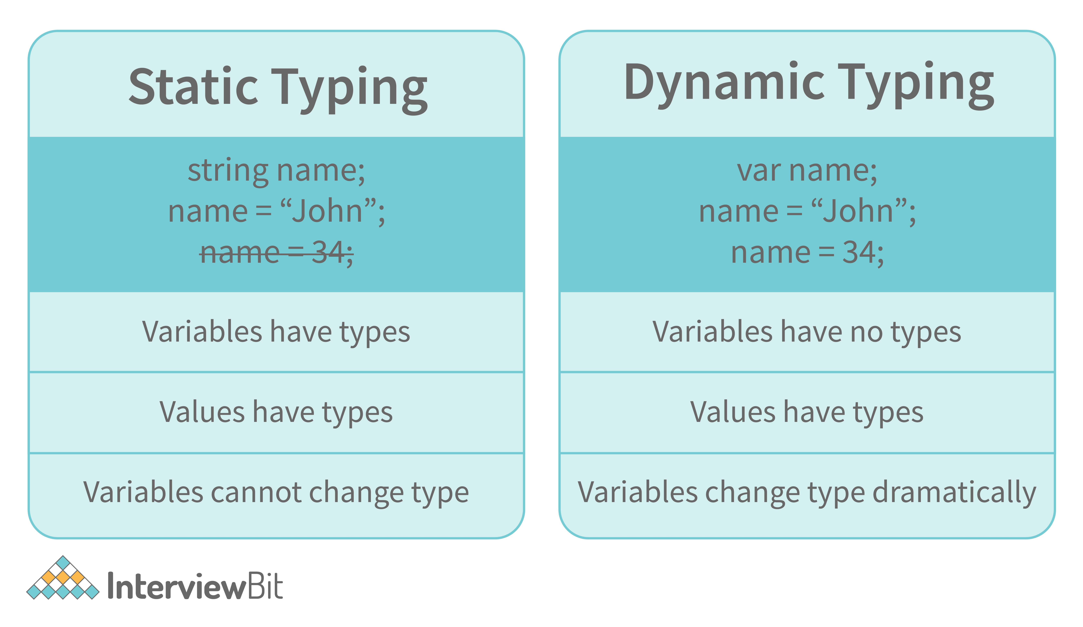
Since javascript is a loosely(dynamically) typed language, variables in JS are not associated with any type. A variable can hold the value of any data type.
For example, a variable that is assigned a number type can be converted to a string type:
var a = 23;
var a = "Hello World!";

58. What is NaN property in JavaScript?
NaN property represents the “Not-a-Number” value. It indicates a value that is not a legal number.
typeof of NaN will return a Number.
To check if a value is NaN, we use the isNaN() function,
Note- isNaN() function converts the given value to a Number type, and then equates to NaN.
isNaN("Hello") // Returns true
isNaN(345) // Returns false
isNaN('1') // Returns false, since '1' is converted to Number type which results in 0 ( a number)
isNaN(true) // Returns false, since true converted to Number type results in 1 ( a number)
isNaN(false) // Returns false
isNaN(undefined) // Returns true
59. Explain passed by value and passed by reference.
In JavaScript, primitive data types are passed by value and non-primitive data types are passed by reference.
For understanding passed by value and passed by reference, we need to understand what happens when we create a variable and assign a value to it,
var x = 2;
In the above example, we created a variable x and assigned it a value of “2”. In the background, the “=” (assign operator) allocates some space in the memory, stores the value “2” and returns the location of the allocated memory space. Therefore, the variable x in the above code points to the location of the memory space instead of pointing to the value 2 directly.
Assign operator behaves differently when dealing with primitive and non-primitive data types,
Assign operator dealing with primitive types:
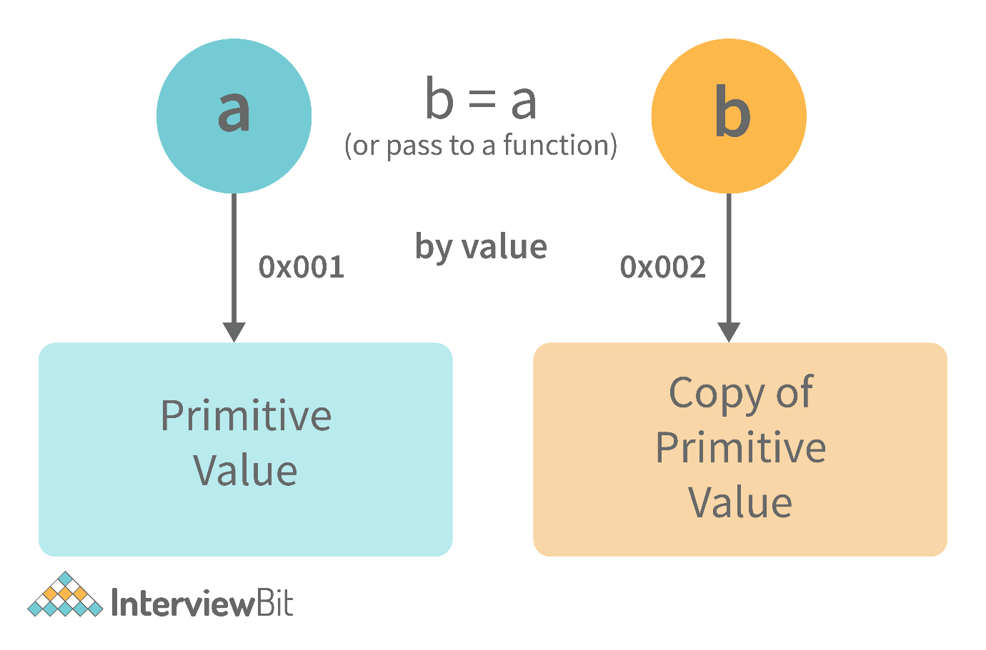
var y = 234;
var z = y;
In the above example, the assign operator knows that the value assigned to y is a primitive type (number type in this case), so when the second line code executes, where the value of y is assigned to z, the assign operator takes the value of y (234) and allocates a new space in the memory and returns the address. Therefore, variable z is not pointing to the location of variable y, instead, it is pointing to a new location in the memory.
var y = #8454; // y pointing to address of the value 234

var z = y;

var z = #5411; // z pointing to a completely new address of the value 234

// Changing the value of y
y = 23;
console.log(z); // Returns 234, since z points to a new address in the memory so changes in y will not effect z
From the above example, we can see that primitive data types when passed to another variable, are passed by value. Instead of just assigning the same address to another variable, the value is passed and new space of memory is created.
Assign operator dealing with non-primitive types:
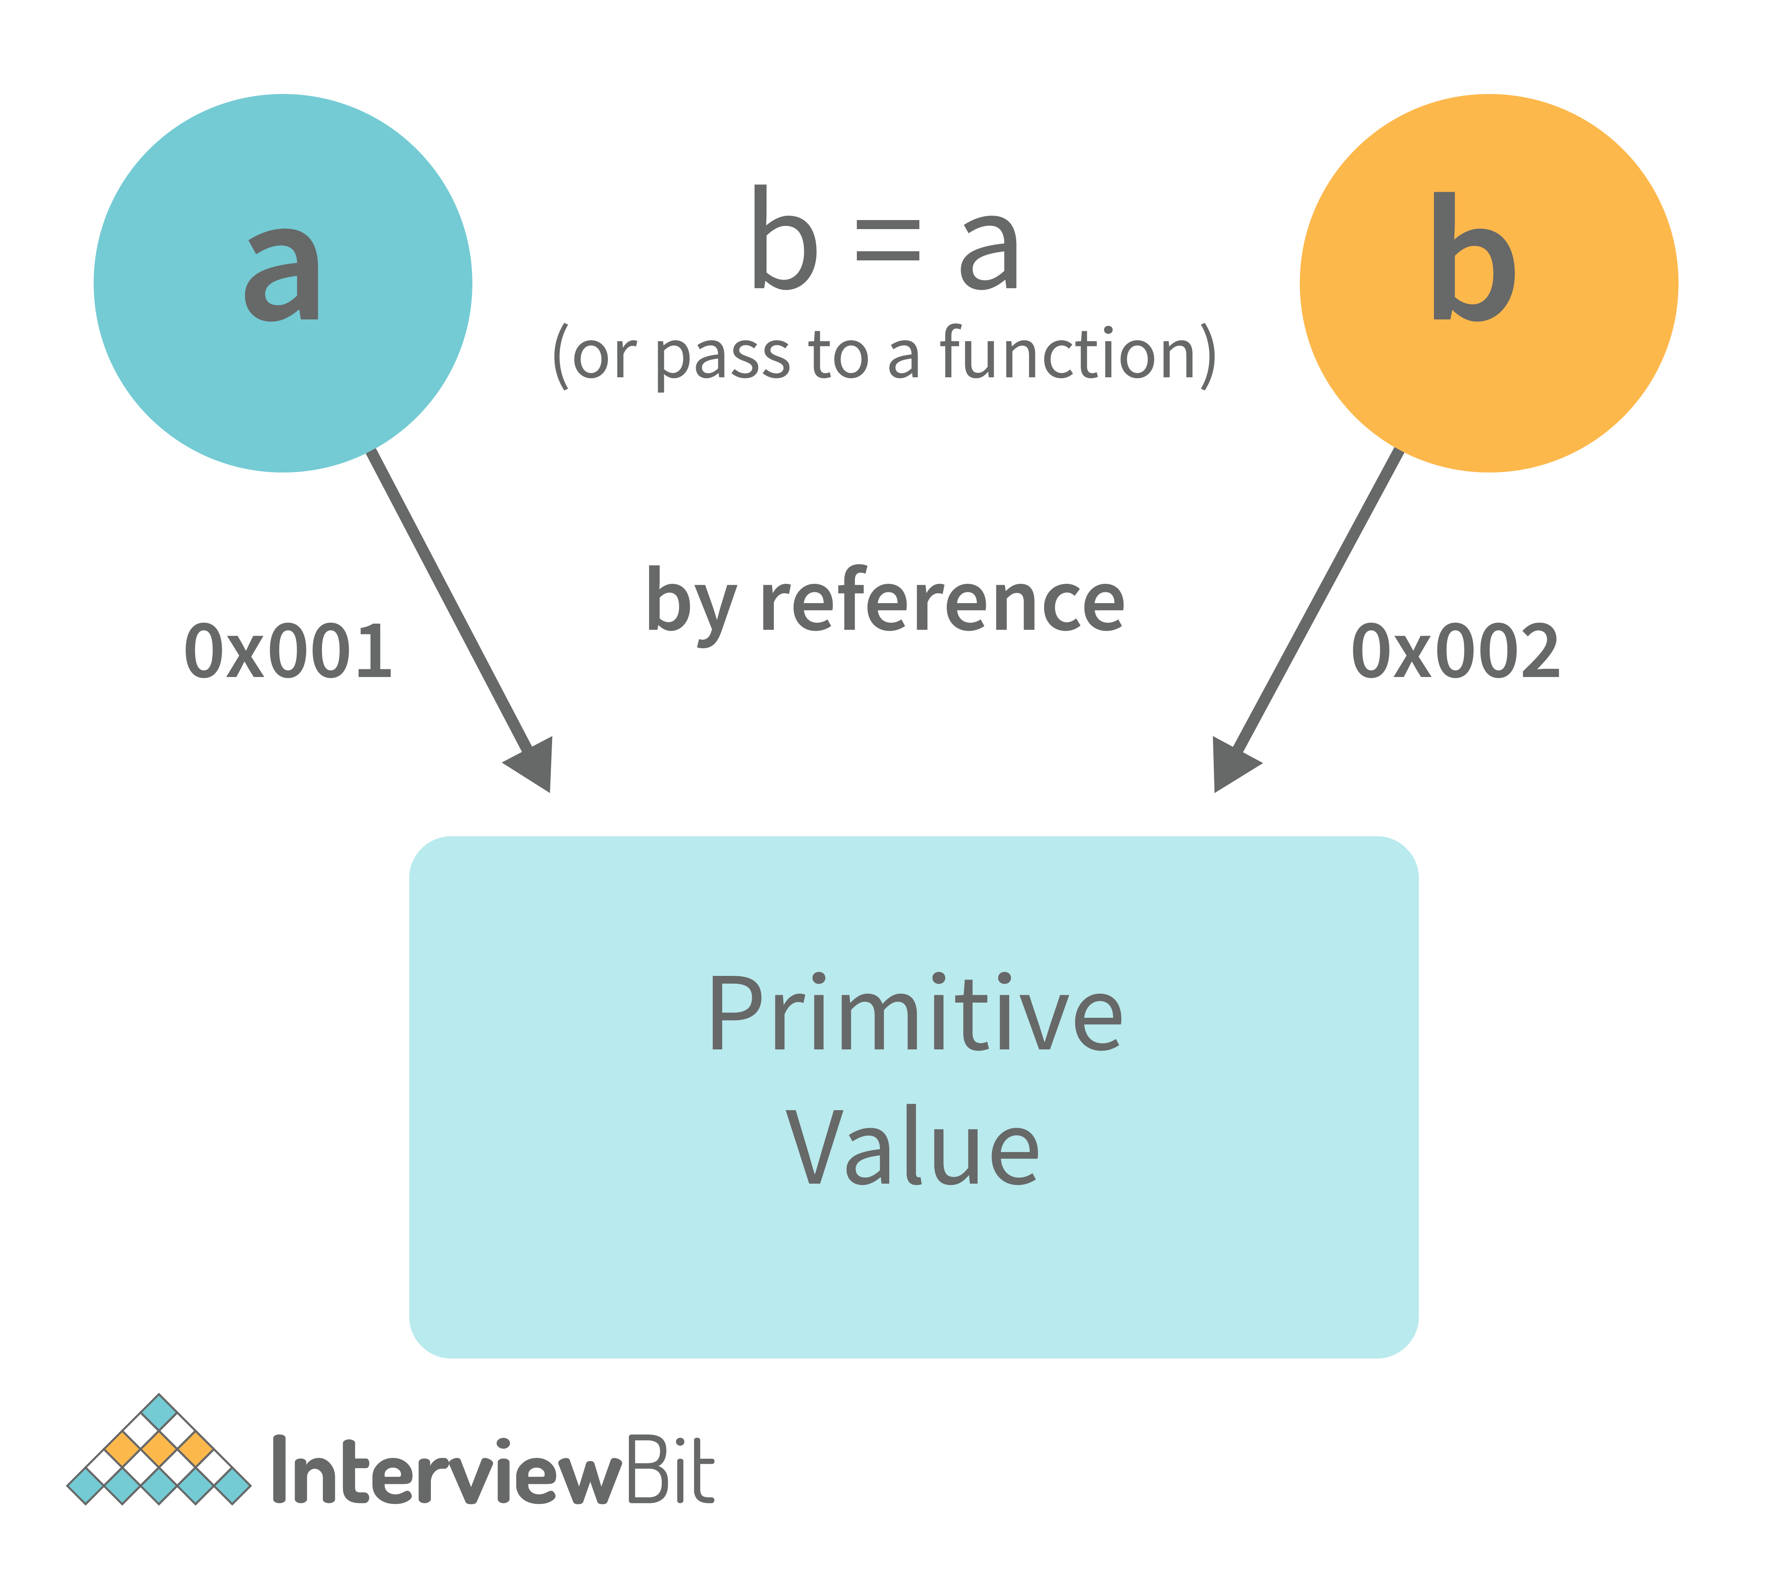
var obj = { name: "Vivek", surname: "Bisht" };
var obj2 = obj;
In the above example, the assign operator directly passes the location of the variable obj to the variable obj2. In other words, the reference of the variable obj is passed to the variable obj2.
var obj = #8711; // obj pointing to address of { name: "Vivek", surname: "Bisht" }
var obj2 = obj;

var obj2 = #8711; // obj2 pointing to the same address

// changing the value of obj1

obj.name = "Akki";
console.log(obj2);

// Returns {name:"Akki", surname:"Bisht"} since both the variables are pointing to the same address.
From the above example, we can see that while passing non-primitive data types, the assigned operator directly passes the address (reference).
Therefore, non-primitive data types are always passed by reference.
60. What is an Immediately Invoked Function in JavaScript?
An Immediately Invoked Function ( known as IIFE and pronounced as IIFY) is a function that runs as soon as it is defined.
Syntax of IIFE :
(function(){
// Do something;
})();
To understand IIFE, we need to understand the two sets of parentheses that are added while creating an IIFE :
The first set of parenthesis:
(function (){
//Do something;
})
While executing javascript code, whenever the compiler sees the word “function”, it assumes that we are declaring a function in the code. Therefore, if we do not use the first set of parentheses, the compiler throws an error because it thinks we are declaring a function, and by the syntax of declaring a function, a function should always have a name.
function() {
//Do something;
}
// Compiler gives an error since the syntax of declaring a function is wrong in the code above.
To remove this error, we add the first set of parenthesis that tells the compiler that the function is not a function declaration, instead, it’s a function expression.
The second set of parenthesis:
(function (){
//Do something;
})();
From the definition of an IIFE, we know that our code should run as soon as it is defined. A function runs only when it is invoked. If we do not invoke the function, the function declaration is returned:
(function (){
// Do something;
})

// Returns the function declaration
Therefore to invoke the function, we use the second set of parenthesis.
61. What do you mean by strict mode in javascript and characteristics of javascript strict-mode?
In ECMAScript 5, a new feature called JavaScript Strict Mode allows you to write a code or a function in a "strict" operational environment. In most cases, this language is 'not particularly severe' when it comes to throwing errors. In 'Strict mode,' however, all forms of errors, including silent errors, will be thrown. As a result, debugging becomes a lot simpler. Thus programmer's chances of making an error are lowered.
Characteristics of strict mode in javascript
- Duplicate arguments are not allowed by developers.
- In strict mode, you won't be able to use the JavaScript keyword as a parameter or function name.
- The 'use strict' keyword is used to define strict mode at the start of the script. Strict mode is supported by all browsers.
- Engineers will not be allowed to create global variables in 'Strict Mode.
62. Explain Higher Order Functions in javascript.
Functions that operate on other functions, either by taking them as arguments or by returning them, are called higher-order functions.
Higher-order functions are a result of functions being first-class citizens in javascript.
Examples of higher-order functions:
function higherOrder(fn) {
fn();
}

higherOrder(function() { console.log("Hello world") });
function higherOrder2() {
return function() {
return "Do something";
}
}
var x = higherOrder2();
x() // Returns "Do something"

63. Explain “this” keyword.
The “this” keyword refers to the object that the function is a property of.
The value of the “this” keyword will always depend on the object that is invoking the function.\
Confused? Let’s understand the above statements by examples:
function doSomething() {
console.log(this);
}

doSomething();
What do you think the output of the above code will be?
Note - Observe the line where we are invoking the function.
Check the definition again:
The “this” keyword refers to the object that the function is a property of.
In the above code, the function is a property of which object?
Since the function is invoked in the global context, the function is a property of the global object.
Therefore, the output of the above code will be the global object. Since we ran the above code inside the browser, the global object is the window object.
Example 2:
var obj = {
name: "vivek",
getName: function(){
console.log(this.name);
}
}

obj.getName();
In the above code, at the time of invocation, the getName function is a property of the object obj , therefore, this keyword will refer to the object obj, and hence the output will be “vivek”.
Example 3:
var obj = {
name: "vivek",
getName: function(){
console.log(this.name);
}

}

var getName = obj.getName;

var obj2 = {name:"akshay", getName };
obj2.getName();
Can you guess the output here?
The output will be “akshay”.
Although the getName function is declared inside the object obj, at the time of invocation, getName() is a property of obj2, therefore the “this” keyword will refer to obj2.
The silly way to understand the “this” keyword is, whenever the function is invoked, check the object before the dot. The value of this . keyword will always be the object before the dot.
If there is no object before the dot-like in example1, the value of this keyword will be the global object.
Example 4:
var obj1 = {
address : "Mumbai,India",
getAddress: function(){
console.log(this.address);
}
}

var getAddress = obj1.getAddress;
var obj2 = {name:"akshay"};
obj2.getAddress();
Can you guess the output?
The output will be an error.
Although in the code above, this keyword refers to the object obj2, obj2 does not have the property “address”‘, hence the getAddress function throws an error.
64. What do you mean by Self Invoking Functions?
Without being requested, a self-invoking expression is automatically invoked (initiated). If a function expression is followed by (), it will execute automatically. A function declaration cannot be invoked by itself.
Normally, we declare a function and call it, however, anonymous functions may be used to run a function automatically when it is described and will not be called again. And there is no name for these kinds of functions.
65. Explain call(), apply() and, bind() methods.
1. call():
- It’s a predefined method in javascript.
- This method invokes a method (function) by specifying the owner object.
- Example 1:
function sayHello(){
return "Hello " + this.name;
}

var obj = {name: "Sandy"};

sayHello.call(obj);

// Returns "Hello Sandy"
- call() method allows an object to use the method (function) of another object.
- Example 2:
var person = {
age: 23,
getAge: function(){
return this.age;
}
}
var person2 = {age: 54};
person.getAge.call(person2);
// Returns 54
- call() accepts arguments:
function saySomething(message){
return this.name + " is " + message;
}
var person4 = {name: "John"};
saySomething.call(person4, "awesome");
// Returns "John is awesome"
apply()
The apply method is similar to the call() method. The only difference is that,
call() method takes arguments separately whereas, apply() method takes arguments as an array.
function saySomething(message){
return this.name + " is " + message;
}
var person4 = {name: "John"};
saySomething.apply(person4, ["awesome"]);
2. bind():
- This method returns a new function, where the value of “this” keyword will be bound to the owner object, which is provided as a parameter.
- Example with arguments:
var bikeDetails = {
displayDetails: function(registrationNumber,brandName){
return this.name+ " , "+ "bike details: "+ registrationNumber + " , " + brandName;
}
}

var person1 = {name: "Vivek"};

var detailsOfPerson1 = bikeDetails.displayDetails.bind(person1, "TS0122", "Bullet");

// Binds the displayDetails function to the person1 object

detailsOfPerson1();
//Returns Vivek, bike details: TS0122, Bullet
66. What is the difference between exec () and test () methods in javascript?
- test () and exec () are RegExp expression methods used in javascript.
- We'll use exec () to search a string for a specific pattern, and if it finds it, it'll return the pattern directly; else, it'll return an 'empty' result.
- We will use a test () to find a string for a specific pattern. It will return the Boolean value 'true' on finding the given text otherwise, it will return 'false'.
67. What is currying in JavaScript?
Currying is an advanced technique to transform a function of arguments n, to n functions of one or fewer arguments.
Example of a curried function:
function add (a) {
return function(b){
return a + b;
}
}

add(3)(4)
For Example, if we have a function f(a,b), then the function after currying, will be transformed to f(a)(b).
By using the currying technique, we do not change the functionality of a function, we just change the way it is invoked.
Let’s see currying in action:
function multiply(a,b){
return a*b;
}

function currying(fn){
return function(a){
return function(b){
return fn(a,b);
}
}
}

var curriedMultiply = currying(multiply);

multiply(4, 3); // Returns 12

curriedMultiply(4)(3); // Also returns 12
As one can see in the code above, we have transformed the function multiply(a,b) to a function curriedMultiply , which takes in one parameter at a time.
68. What are some advantages of using External JavaScript?
External JavaScript is the JavaScript Code (script) written in a separate file with the extension.js, and then we link that file inside the <head> or <body> element of the HTML file where the code is to be placed.
Some advantages of external javascript are
- It allows web designers and developers to collaborate on HTML and javascript files.
- We can reuse the code.
- Code readability is simple in external javascript.
69. Explain Scope and Scope Chain in javascript.
Scope in JS determines the accessibility of variables and functions at various parts of one’s code.
In general terms, the scope will let us know at a given part of code, what are variables and functions we can or cannot access.
There are three types of scopes in JS:
- Global Scope
- Local or Function Scope
- Block Scope
Global Scope: Variables or functions declared in the global namespace have global scope, which means all the variables and functions having global scope can be accessed from anywhere inside the code.
var globalVariable = "Hello world";

function sendMessage(){
return globalVariable; // can access globalVariable since it's written in global space
}
function sendMessage2(){
return sendMessage(); // Can access sendMessage function since it's written in global space
}
sendMessage2(); // Returns “Hello world”
Function Scope: Any variables or functions declared inside a function have local/function scope, which means that all the variables and functions declared inside a function, can be accessed from within the function and not outside of it.
function awesomeFunction(){
var a = 2;

var multiplyBy2 = function(){
console.log(a*2); // Can access variable "a" since a and multiplyBy2 both are written inside the same function
}
}
console.log(a); // Throws reference error since a is written in local scope and cannot be accessed outside

multiplyBy2(); // Throws reference error since multiplyBy2 is written in local scope
Block Scope: Block scope is related to the variables declared using let and const. Variables declared with var do not have block scope. Block scope tells us that any variable declared inside a block { }, can be accessed only inside that block and cannot be accessed outside of it.
{
let x = 45;
}

console.log(x); // Gives reference error since x cannot be accessed outside of the block

for(let i=0; i<2; i++){
// do something
}

console.log(i); // Gives reference error since i cannot be accessed outside of the for loop block
Scope Chain: JavaScript engine also uses Scope to find variables. Let’s understand that using an example:
var y = 24;

function favFunction(){
var x = 667;
var anotherFavFunction = function(){
console.log(x); // Does not find x inside anotherFavFunction, so looks for variable inside favFunction, outputs 667
}

var yetAnotherFavFunction = function(){
console.log(y); // Does not find y inside yetAnotherFavFunction, so looks for variable inside favFunction and does not find it, so looks for variable in global scope, finds it and outputs 24
}

anotherFavFunction();
yetAnotherFavFunction();
}
favFunction();
As you can see in the code above, if the javascript engine does not find the variable in local scope, it tries to check for the variable in the outer scope. If the variable does not exist in the outer scope, it tries to find the variable in the global scope.
If the variable is not found in the global space as well, a reference error is thrown.
70. Explain Closures in JavaScript.
Closures are an ability of a function to remember the variables and functions that are declared in its outer scope.
var Person = function(pName){
var name = pName;

this.getName = function(){
return name;
}
}

var person = new Person("Neelesh");
console.log(person.getName());
Let’s understand closures by example:
function randomFunc(){
var obj1 = {name:"Vivian", age:45};

return function(){
console.log(obj1.name + " is "+ "awesome"); // Has access to obj1 even when the randomFunc function is executed

}
}

var initialiseClosure = randomFunc(); // Returns a function

initialiseClosure();
Let’s understand the code above,
The function randomFunc() gets executed and returns a function when we assign it to a variable:
var initialiseClosure = randomFunc();
-The returned function is then executed when we invoke initialiseClosure:
initialiseClosure();
The line of code above outputs “Vivian is awesome” and this is possible because of closure.
console.log(obj1.name + " is "+ "awesome");
-When the function randomFunc() runs, it seems that the returning function is using the variable obj1 inside it:
-Therefore randomFunc(), instead of destroying the value of obj1 after execution, saves the value in the memory for further reference. This is the reason why the returning function is able to use the variable declared in the outer scope even after the function is already executed.
This ability of a function to store a variable for further reference even after it is executed is called Closure.

71. Mention some advantages of javascript.
There are many advantages of javascript. Some of them are
- Javascript is executed on the client-side as well as server-side also. There are a variety of Frontend Frameworks that you may study and utilize. However, if you want to use JavaScript on the backend, you'll need to learn NodeJS. It is currently the only JavaScript framework that may be used on the backend.
- Javascript is a simple language to learn.
- Web pages now have more functionality because of Javascript.
- To the end-user, Javascript is quite quick.
72. What are object prototypes?
All javascript objects inherit properties from a prototype. For example,
- Date objects inherit properties from the Date prototype
- Math objects inherit properties from the Math prototype
- Array objects inherit properties from the Array prototype.
- On top of the chain is Object.prototype. Every prototype inherits properties and methods from the Object.prototype.
- A prototype is a blueprint of an object. The prototype allows us to use properties and methods on an object even if the properties and methods do not exist on the current object.
Let’s see prototypes help us use methods and properties:
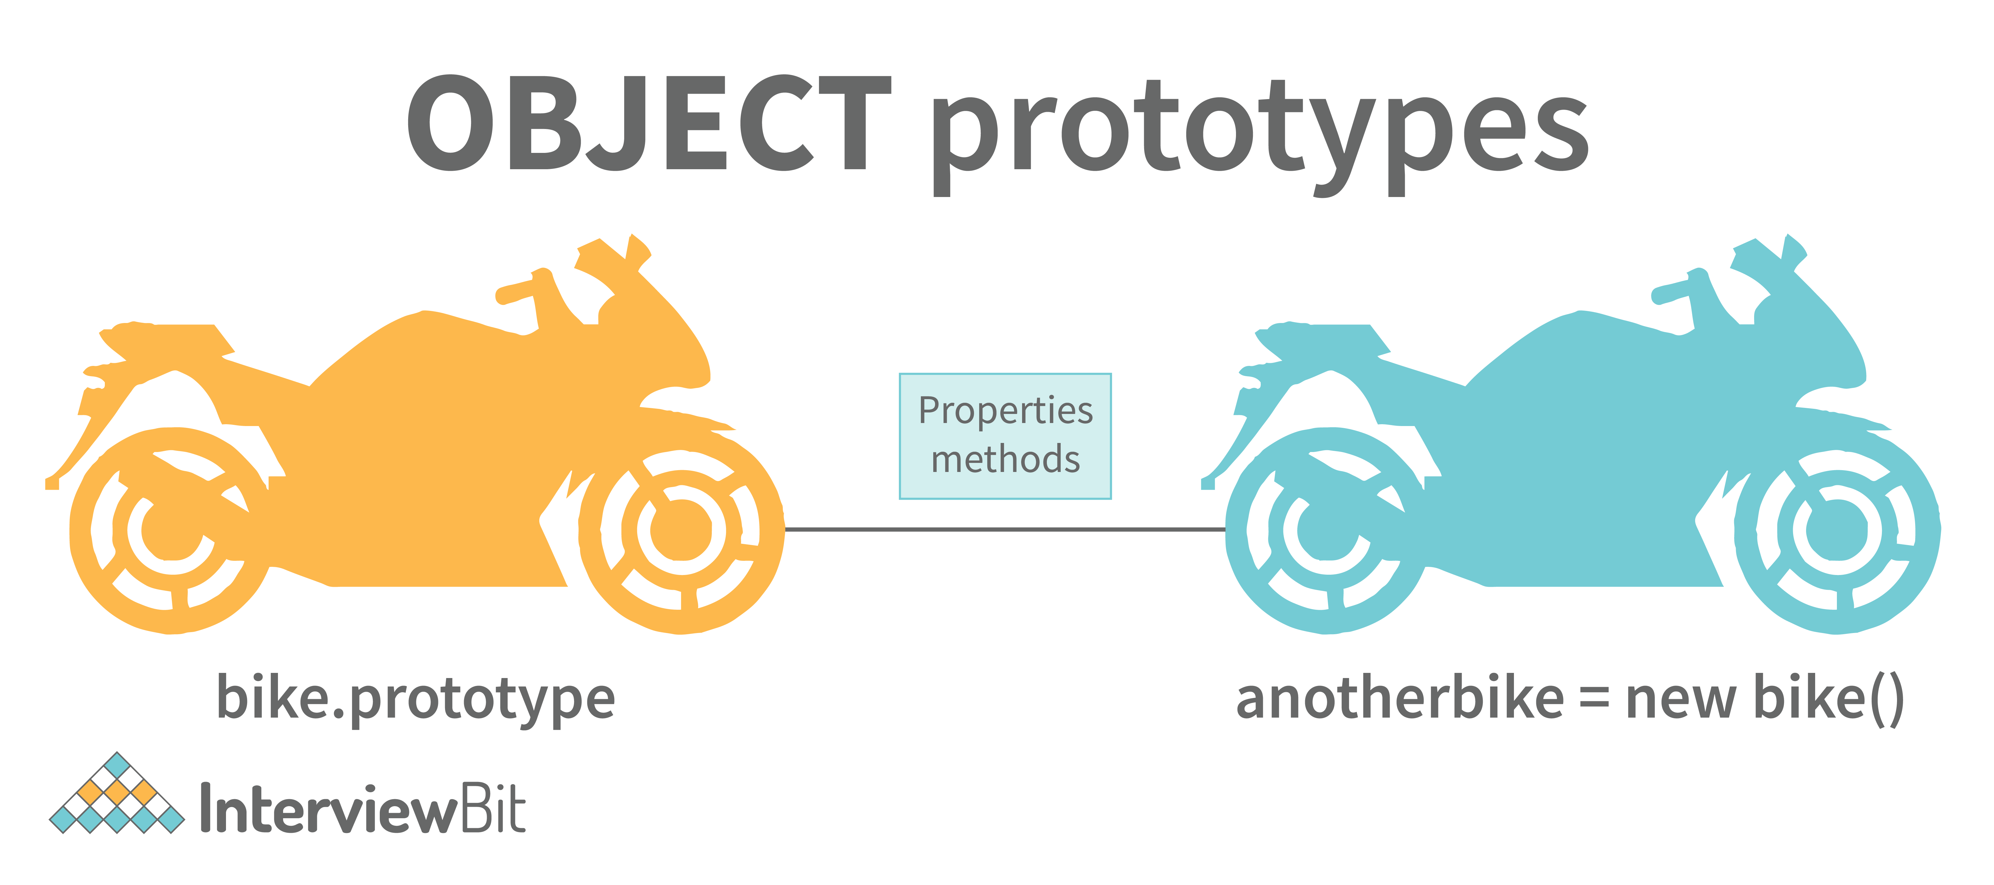
var arr = [];
arr.push(2);

console.log(arr); // Outputs [2]
In the code above, as one can see, we have not defined any property or method called push on the array “arr” but the javascript engine does not throw an error.
The reason is the use of prototypes. As we discussed before, Array objects inherit properties from the Array prototype.
The javascript engine sees that the method push does not exist on the current array object and therefore, looks for the method push inside the Array prototype and it finds the method.
Whenever the property or method is not found on the current object, the javascript engine will always try to look in its prototype and if it still does not exist, it looks inside the prototype's prototype and so on.
73. What are callbacks?
A callback is a function that will be executed after another function gets executed. In javascript, functions are treated as first-class citizens, they can be used as an argument of another function, can be returned by another function, and can be used as a property of an object.
Functions that are used as an argument to another function are called callback functions. Example:
function divideByHalf(sum){
console.log(Math.floor(sum / 2));
}

function multiplyBy2(sum){
console.log(sum * 2);
}

function operationOnSum(num1,num2,operation){
var sum = num1 + num2;
operation(sum);
}

operationOnSum(3, 3, divideByHalf); // Outputs 3

operationOnSum(5, 5, multiplyBy2); // Outputs 20
- In the code above, we are performing mathematical operations on the sum of two numbers. The operationOnSum function takes 3 arguments, the first number, the second number, and the operation that is to be performed on their sum (callback).
- Both divideByHalf and multiplyBy2 functions are used as callback functions in the code above.
- These callback functions will be executed only after the function operationOnSum is executed.
- Therefore, a callback is a function that will be executed after another function gets executed.
74. What are the types of errors in javascript?
There are two types of errors in javascript.
- Syntax error: Syntax errors are mistakes or spelling problems in the code that cause the program to not execute at all or to stop running halfway through. Error messages are usually supplied as well.
- Logical error: Reasoning mistakes occur when the syntax is proper but the logic or program is incorrect. The application executes without problems in this case. However, the output findings are inaccurate. These are sometimes more difficult to correct than syntax issues since these applications do not display error signals for logic faults.
75. What is memoization?
Memoization is a form of caching where the return value of a function is cached based on its parameters. If the parameter of that function is not changed, the cached version of the function is returned.
Let’s understand memoization, by converting a simple function to a memoized function:
Note- Memoization is used for expensive function calls but in the following example, we are considering a simple function for understanding the concept of memoization better.
Consider the following function:
function addTo256(num){
return num + 256;
}
addTo256(20); // Returns 276
addTo256(40); // Returns 296
addTo256(20); // Returns 276
In the code above, we have written a function that adds the parameter to 256 and returns it.
When we are calling the function addTo256 again with the same parameter (“20” in the case above), we are computing the result again for the same parameter.
Computing the result with the same parameter, again and again, is not a big deal in the above case, but imagine if the function does some heavy-duty work, then, computing the result again and again with the same parameter will lead to wastage of time.
This is where memoization comes in, by using memoization we can store(cache) the computed results based on the parameters. If the same parameter is used again while invoking the function, instead of computing the result, we directly return the stored (cached) value.
Let’s convert the above function addTo256, to a memoized function:
function memoizedAddTo256(){
var cache = {};

return function(num){
if(num in cache){
console.log("cached value");
return cache[num]
}
else{
cache[num] = num + 256;
return cache[num];
}
}
}
var memoizedFunc = memoizedAddTo256();

memoizedFunc(20); // Normal return
memoizedFunc(20); // Cached return
In the code above, if we run the memoizedFunc function with the same parameter, instead of computing the result again, it returns the cached result.
Note- Although using memoization saves time, it results in larger consumption of memory since we are storing all the computed results.
76. What is recursion in a programming language?
Recursion is a technique to iterate over an operation by having a function call itself repeatedly until it arrives at a result.
function add(number) {
if (number <= 0) {
return 0;
} else {
return number + add(number - 1);
}
}
add(3) => 3 + add(2)
3 + 2 + add(1)
3 + 2 + 1 + add(0)
3 + 2 + 1 + 0 = 6
Example of a recursive function:
The following function calculates the sum of all the elements in an array by using recursion:
function computeSum(arr){
if(arr.length === 1){
return arr[0];
}
else{
return arr.pop() + computeSum(arr);
}
}
computeSum([7, 8, 9, 99]); // Returns 123
77. What is the use of a constructor function in javascript?
Constructor functions are used to create objects in javascript.
When do we use constructor functions?
If we want to create multiple objects having similar properties and methods, constructor functions are used.
Note- The name of a constructor function should always be written in Pascal Notation: every word should start with a capital letter.
Example:
function Person(name,age,gender){
this.name = name;
this.age = age;
this.gender = gender;
}

var person1 = new Person("Vivek", 76, "male");
console.log(person1);

var person2 = new Person("Courtney", 34, "female");
console.log(person2);
In the code above, we have created a constructor function named Person. Whenever we want to create a new object of the type Person, We need to create it using the new keyword:
var person3 = new Person("Lilly", 17, "female");
The above line of code will create a new object of the type Person. Constructor functions allow us to group similar objects.
78. What is DOM?
- DOM stands for Document Object Model. DOM is a programming interface for HTML and XML documents.
- When the browser tries to render an HTML document, it creates an object based on the HTML document called DOM. Using this DOM, we can manipulate or change various elements inside the HTML document.
- Example of how HTML code gets converted to DOM:
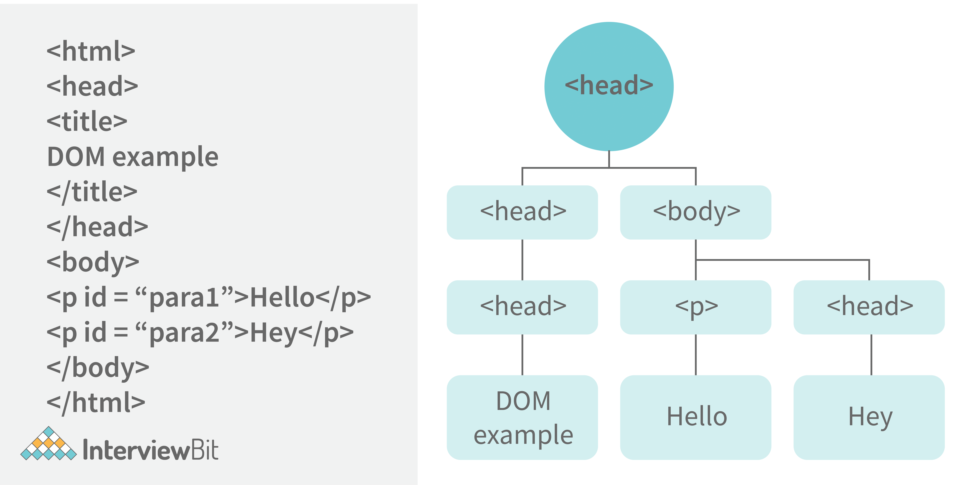
79. Which method is used to retrieve a character from a certain index?
The charAt() function of the JavaScript string finds a char element at the supplied index. The index number begins at 0 and continues up to n-1, Here n is the string length. The index value must be positive, higher than, or the same as the string length.
80. What do you mean by BOM?
Browser Object Model is known as BOM. It allows users to interact with the browser. A browser's initial object is a window. As a result, you may call all of the window's functions directly or by referencing the window. The document, history, screen, navigator, location, and other attributes are available in the window object.
81. What is the distinction between client-side and server-side JavaScript?
Client-side JavaScript is made up of two parts, a fundamental language and predefined objects for performing JavaScript in a browser. JavaScript for the client is automatically included in the HTML pages. At runtime, the browser understands this script.
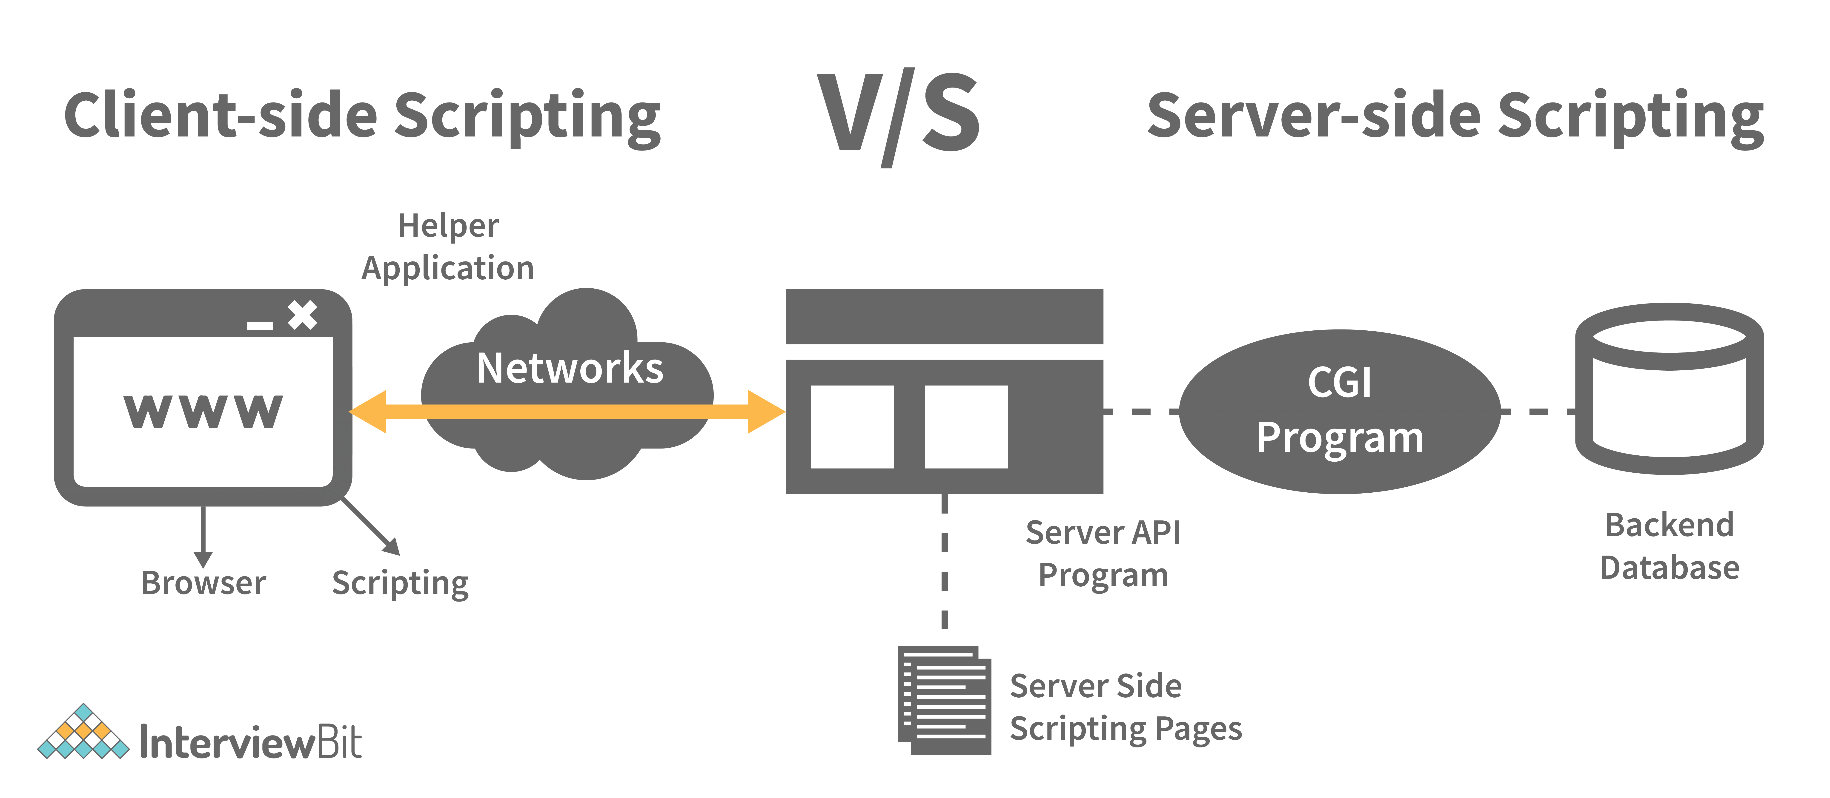
Server-side JavaScript, involves the execution of JavaScript code on a server in response to client requests. It handles these requests and delivers the relevant response to the client, which may include client-side JavaScript for subsequent execution within the browser

82. What are arrow functions?
Arrow functions were introduced in the ES6 version of javascript. They provide us with a new and shorter syntax for declaring functions. Arrow functions can only be used as a function expression.
Let’s compare the normal function declaration and the arrow function declaration in detail:
// Traditional Function Expression
var add = function(a,b){
return a + b;
}

// Arrow Function Expression
var arrowAdd = (a,b) => a + b;
Arrow functions are declared without the function keyword. If there is only one returning expression then we don’t need to use the return keyword as well in an arrow function as shown in the example above. Also, for functions having just one line of code, curly braces { } can be omitted.
// Traditional function expression
var multiplyBy2 = function(num){
return num * 2;
}
// Arrow function expression
var arrowMultiplyBy2 = num => num * 2;
If the function takes in only one argument, then the parenthesis () around the parameter can be omitted as shown in the code above.
var obj1 = {
valueOfThis: function(){
return this;
}
}
var obj2 = {
valueOfThis: ()=>{
return this;
}
}

obj1.valueOfThis(); // Will return the object obj1
obj2.valueOfThis(); // Will return window/global object
The biggest difference between the traditional function expression and the arrow function is the handling of this keyword. By general definition, this keyword always refers to the object that is calling the function. As you can see in the code above, obj1.valueOfThis() returns obj1 since this keyword refers to the object calling the function.
In the arrow functions, there is no binding of this keyword. This keyword inside an arrow function does not refer to the object calling it. It rather inherits its value from the parent scope which is the window object in this case. Therefore, in the code above, obj2.valueOfThis() returns the window object.
83. What do mean by prototype design pattern?
The Prototype Pattern produces different objects, but instead of returning uninitialized objects, it produces objects that have values replicated from a template – or sample – object. Also known as the Properties pattern, the Prototype pattern is used to create prototypes.
The introduction of business objects with parameters that match the database's default settings is a good example of where the Prototype pattern comes in handy. The default settings for a newly generated business object are stored in the prototype object.
The Prototype pattern is hardly used in traditional languages, however, it is used in the development of new objects and templates in JavaScript, which is a prototypal language.
84. Differences between declaring variables using var, let and const.
Before the ES6 version of javascript, only the keyword var was used to declare variables. With the ES6 Version, keywords let and const were introduced to declare variables.
keyword | const | let | var
global scope | no | no | yes
function scope | yes | yes | yes
block scope | yes | yes | no
can be reassigned | no | yes | yes
Let’s understand the differences with examples:
var variable1 = 23;

let variable2 = 89;

function catchValues(){
console.log(variable1);
console.log(variable2);

// Both the variables can be accessed anywhere since they are declared in the global scope
}

window.variable1; // Returns the value 23

window.variable2; // Returns undefined
- The variables declared with the let keyword in the global scope behave just like the variable declared with the var keyword in the global scope.
- Variables declared in the global scope with var and let keywords can be accessed from anywhere in the code.
- But, there is one difference! Variables that are declared with the var keyword in the global scope are added to the window/global object. Therefore, they can be accessed using window.variableName.
Whereas, the variables declared with the let keyword are not added to the global object, therefore, trying to access such variables using window.variableName results in an error.
var vs let in functional scope
function varVsLetFunction(){
let awesomeCar1 = "Audi";
var awesomeCar2 = "Mercedes";
}

console.log(awesomeCar1); // Throws an error
console.log(awesomeCar2); // Throws an error
Variables are declared in a functional/local scope using var and let keywords behave exactly the same, meaning, they cannot be accessed from outside of the scope.
{
var variable3 = [1, 2, 3, 4];
}

console.log(variable3); // Outputs [1,2,3,4]

{
let variable4 = [6, 55, -1, 2];
}

console.log(variable4); // Throws error

for(let i = 0; i < 2; i++){
//Do something
}

console.log(i); // Throws error

for(var j = 0; j < 2; i++){
// Do something
}

console.log(j) // Outputs 2
- In javascript, a block means the code written inside the curly braces {}.
- Variables declared with var keyword do not have block scope. It means a variable declared in block scope {} with the var keyword is the same as declaring the variable in the global scope.
- Variables declared with let keyword inside the block scope cannot be accessed from outside of the block.
Const keyword
- Variables with the const keyword behave exactly like a variable declared with the let keyword with only one difference, any variable declared with the const keyword cannot be reassigned.
- Example:
const x = {name:"Vivek"};

x = {address: "India"}; // Throws an error

x.name = "Nikhil"; // No error is thrown

const y = 23;

y = 44; // Throws an error
In the code above, although we can change the value of a property inside the variable declared with const keyword, we cannot completely reassign the variable itself.
85. What is the rest parameter and spread operator?
Both rest parameter and spread operator were introduced in the ES6 version of javascript.
Rest parameter ( … ):
- It provides an improved way of handling the parameters of a function.
- Using the rest parameter syntax, we can create functions that can take a variable number of arguments.
- Any number of arguments will be converted into an array using the rest parameter.
- It also helps in extracting all or some parts of the arguments.
- Rest parameters can be used by applying three dots (...) before the parameters.
function extractingArgs(...args){
return args[1];
}

// extractingArgs(8,9,1); // Returns 9

function addAllArgs(...args){
let sumOfArgs = 0;
let i = 0;
while(i < args.length){
sumOfArgs += args[i];
i++;
}
return sumOfArgs;
}

addAllArgs(6, 5, 7, 99); // Returns 117
addAllArgs(1, 3, 4); // Returns 8
**Note- Rest parameter should always be used at the last parameter of a function:
// Incorrect way to use rest parameter
function randomFunc(a,...args,c){
//Do something
}

// Correct way to use rest parameter
function randomFunc2(a,b,...args){
//Do something
}
- Spread operator (…): Although the syntax of the spread operator is exactly the same as the rest parameter, the spread operator is used to spreading an array, and object literals. We also use spread operators where one or more arguments are expected in a function call.
function addFourNumbers(num1,num2,num3,num4){
return num1 + num2 + num3 + num4;
}

let fourNumbers = [5, 6, 7, 8];

addFourNumbers(...fourNumbers);
// Spreads [5,6,7,8] as 5,6,7,8

let array1 = [3, 4, 5, 6];
let clonedArray1 = [...array1];
// Spreads the array into 3,4,5,6
console.log(clonedArray1); // Outputs [3,4,5,6]

let obj1 = {x:'Hello', y:'Bye'};
let clonedObj1 = {...obj1}; // Spreads and clones obj1
console.log(obj1);

let obj2 = {z:'Yes', a:'No'};
let mergedObj = {...obj1, ...obj2}; // Spreads both the objects and merges it
console.log(mergedObj);
// Outputs {x:'Hello', y:'Bye',z:'Yes',a:'No'};
***Note- Key differences between rest parameter and spread operator:
- Rest parameter is used to take a variable number of arguments and turns them into an array while the spread operator takes an array or an object and spreads it
- Rest parameter is used in function declaration whereas the spread operator is used in function calls.
86. In JavaScript, how many different methods can you make an object?
In JavaScript, there are several ways to declare or construct an object.
- Object.
- using Class.
- create Method.
- Object Literals.
- using Function.
- Object Constructor.
87. What is the use of promises in javascript?
Promises are used to handle asynchronous operations in javascript.
Before promises, callbacks were used to handle asynchronous operations. But due to the limited functionality of callbacks, using multiple callbacks to handle asynchronous code can lead to unmanageable code.
Promise object has four states -
- Pending - Initial state of promise. This state represents that the promise has neither been fulfilled nor been rejected, it is in the pending state.
- Fulfilled - This state represents that the promise has been fulfilled, meaning the async operation is completed.
- Rejected - This state represents that the promise has been rejected for some reason, meaning the async operation has failed.
- Settled - This state represents that the promise has been either rejected or fulfilled.
A promise is created using the Promise constructor which takes in a callback function with two parameters, resolve and reject respectively.
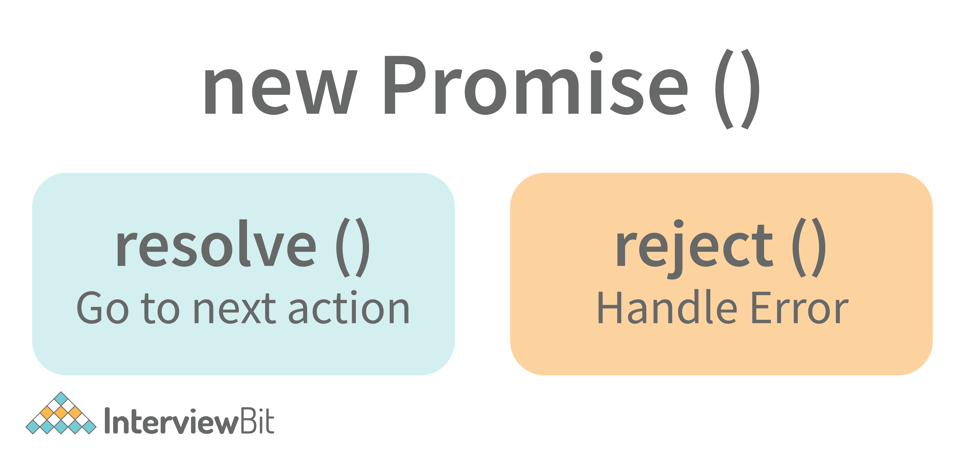
resolve is a function that will be called when the async operation has been successfully completed.
reject is a function that will be called, when the async operation fails or if some error occurs.
Example of a promise:
Promises are used to handle asynchronous operations like server requests, for ease of understanding, we are using an operation to calculate the sum of three elements.
In the function below, we are returning a promise inside a function:
function sumOfThreeElements(...elements){
return new Promise((resolve,reject)=>{
if(elements.length > 3 ){
reject("Only three elements or less are allowed");
}
else{
let sum = 0;
let i = 0;
while(i < elements.length){
sum += elements[i];
i++;
}
resolve("Sum has been calculated: "+sum);
}
})
}
In the code above, we are calculating the sum of three elements, if the length of the elements array is more than 3, a promise is rejected, or else the promise is resolved and the sum is returned.
We can consume any promise by attaching then() and catch() methods to the consumer.
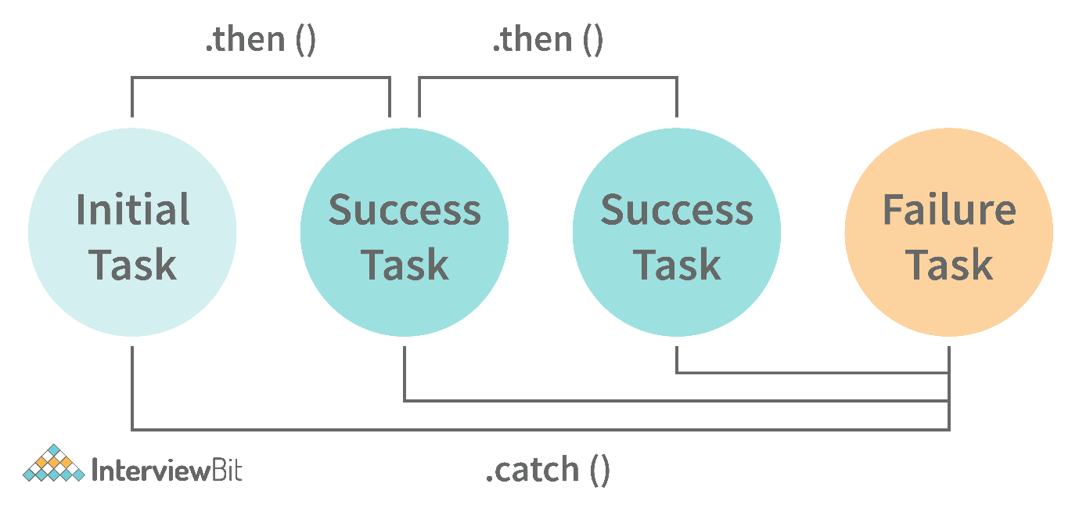
then() method is used to access the result when the promise is fulfilled.
catch() method is used to access the result/error when the promise is rejected. In the code below, we are consuming the promise:
sumOfThreeElements(4, 5, 6)
.then(result=> console.log(result))
.catch(error=> console.log(error));
// In the code above, the promise is fulfilled so the then() method gets executed

sumOfThreeElements(7, 0, 33, 41)
.then(result => console.log(result))
.catch(error=> console.log(error));
// In the code above, the promise is rejected hence the catch() method gets executed
88. What are classes in javascript?
Introduced in the ES6 version, classes are nothing but syntactic sugars for constructor functions. They provide a new way of declaring constructor functions in javascript. Below are the examples of how classes are declared and used:
// Before ES6 version, using constructor functions
function Student(name,rollNumber,grade,section){
this.name = name;
this.rollNumber = rollNumber;
this.grade = grade;
this.section = section;
}

// Way to add methods to a constructor function
Student.prototype.getDetails = function(){
return 'Name: ${this.name}, Roll no: ${this.rollNumber}, Grade: ${this.grade}, Section:${this.section}';
}

let student1 = new Student("Vivek", 354, "6th", "A");
student1.getDetails();
// Returns Name: Vivek, Roll no:354, Grade: 6th, Section:A

// ES6 version classes
class Student{
constructor(name,rollNumber,grade,section){
this.name = name;
this.rollNumber = rollNumber;
this.grade = grade;
this.section = section;
}

// Methods can be directly added inside the class
getDetails(){
return 'Name: ${this.name}, Roll no: ${this.rollNumber}, Grade:${this.grade}, Section:${this.section}';
}
}

let student2 = new Student("Garry", 673, "7th", "C");
student2.getDetails();
// Returns Name: Garry, Roll no:673, Grade: 7th, Section:C
Key points to remember about classes:
- Unlike functions, classes are not hoisted. A class cannot be used before it is declared.
- A class can inherit properties and methods from other classes by using the extend keyword.
- All the syntaxes inside the class must follow the strict mode(‘use strict’) of javascript. An error will be thrown if the strict mode rules are not followed.
89. What are generator functions?
Introduced in the ES6 version, generator functions are a special class of functions.
They can be stopped midway and then continue from where they had stopped.
Generator functions are declared with the function* keyword instead of the normal function keyword:
function* genFunc(){
// Perform operation
}
In normal functions, we use the return keyword to return a value and as soon as the return statement gets executed, the function execution stops:
function normalFunc(){
return 22;
console.log(2); // This line of code does not get executed
}
In the case of generator functions, when called, they do not execute the code, instead, they return a generator object. This generator object handles the execution.
function* genFunc(){
yield 3;
yield 4;
}
genFunc(); // Returns Object [Generator] {}
The generator object consists of a method called next(), this method when called, executes the code until the nearest yield statement, and returns the yield value.
For example, if we run the next() method on the above code:
genFunc().next(); // Returns {value: 3, done:false}
As one can see the next method returns an object consisting of a value and done properties. Value property represents the yielded value. Done property tells us whether the function code is finished or not. (Returns true if finished).
Generator functions are used to return iterators. Let’s see an example where an iterator is returned:
function* iteratorFunc() {
let count = 0;
for (let i = 0; i < 2; i++) {
count++;
yield i;
}
return count;
}

let iterator = iteratorFunc();
console.log(iterator.next()); // {value:0,done:false}
console.log(iterator.next()); // {value:1,done:false}
console.log(iterator.next()); // {value:2,done:true}
As you can see in the code above, the last line returns done:true, since the code reaches the return statement.
90. Explain WeakSet in javascript.
In javascript, a Set is a collection of unique and ordered elements. Just like Set, WeakSet is also a collection of unique and ordered elements with some key differences:
- Weakset contains only objects and no other type.
- An object inside the weakset is referenced weakly. This means, that if the object inside the weakset does not have a reference, it will be garbage collected.
- Unlike Set, WeakSet only has three methods, add() , delete() and has() .
const newSet = new Set([4, 5, 6, 7]);
console.log(newSet);// Outputs Set {4,5,6,7}

const newSet2 = new WeakSet([3, 4, 5]); //Throws an error

let obj1 = {message:"Hello world"};
const newSet3 = new WeakSet([obj1]);
console.log(newSet3.has(obj1)); // true
91. Why do we use callbacks?
A callback function is a method that is sent as an input to another function (now let us name this other function "thisFunction"), and it is performed inside the thisFunction after the function has completed execution.
JavaScript is a scripting language that is based on events. Instead of waiting for a reply before continuing, JavaScript will continue to run while monitoring for additional events. Callbacks are a technique of ensuring that a particular code does not run until another code has completed its execution.
92. Explain WeakMap in javascript.
In javascript, Map is used to store key-value pairs. The key-value pairs can be of both primitive and non-primitive types. WeakMap is similar to Map with key differences:
- The keys and values in weakmap should always be an object.
- If there are no references to the object, the object will be garbage collected.
const map1 = new Map();
map1.set('Value', 1);

const map2 = new WeakMap();
map2.set('Value', 2.3); // Throws an error

let obj = {name:"Vivek"};
const map3 = new WeakMap();
map3.set(obj, {age:23});
93. What is Object Destructuring?
Object destructuring is a new way to extract elements from an object or an array.
- Object destructuring: Before ES6 version:
const classDetails = {
strength: 78,
benches: 39,
blackBoard:1
}

const classStrength = classDetails.strength;
const classBenches = classDetails.benches;
const classBlackBoard = classDetails.blackBoard;
The same example using object destructuring:
const classDetails = {
strength: 78,
benches: 39,
blackBoard:1
}

const {strength:classStrength, benches:classBenches,blackBoard:classBlackBoard} = classDetails;

console.log(classStrength); // Outputs 78
console.log(classBenches); // Outputs 39
console.log(classBlackBoard); // Outputs 1
As one can see, using object destructuring we have extracted all the elements inside an object in one line of code. If we want our new variable to have the same name as the property of an object we can remove the colon:
const {strength:strength} = classDetails;
// The above line of code can be written as:
const {strength} = classDetails;
- Array destructuring: Before ES6 version:
const arr = [1, 2, 3, 4];
const first = arr[0];
const second = arr[1];
const third = arr[2];
const fourth = arr[3];
The same example using object destructuring:
const arr = [1, 2, 3, 4];
const [first,second,third,fourth] = arr;
console.log(first); // Outputs 1
console.log(second); // Outputs 2
console.log(third); // Outputs 3
console.log(fourth); // Outputs 4
94. Difference between prototypal and classical inheritance
Programers build objects, which are representations of real-time entities, in traditional OO programming. Classes and objects are the two sorts of abstractions. A class is a generalization of an object, whereas an object is an abstraction of an actual thing. A Vehicle, for example, is a specialization of a Car. As a result, automobiles (class) are descended from vehicles (object).
Classical inheritance differs from prototypal inheritance in that classical inheritance is confined to classes that inherit from those remaining classes, but prototypal inheritance allows any object to be cloned via an object linking method. Despite going into too many specifics, a prototype essentially serves as a template for those other objects, whether they extend the parent object or not.
95. What is a Temporal Dead Zone?
Temporal Dead Zone is a behaviour that occurs with variables declared using let and const keywords. It is a behaviour where we try to access a variable before it is initialized. Examples of temporal dead zone:
x = 23; // Gives reference error

let x;

function anotherRandomFunc(){
message = "Hello"; // Throws a reference error

let message;
}
anotherRandomFunc();
In the code above, both in the global scope and functional scope, we are trying to access variables that have not been declared yet. This is called the Temporal Dead Zone.

96. What do you mean by JavaScript Design Patterns?
JavaScript design patterns are repeatable approaches for errors that arise sometimes when building JavaScript browser applications. They truly assist us in making our code more stable.
They are divided mainly into 3 categories
- Creational Design Pattern
- Structural Design Pattern
- Behavioral Design Pattern.
- Creational Design Pattern: The object generation mechanism is addressed by the JavaScript Creational Design Pattern. They aim to make items that are appropriate for a certain scenario.
- Structural Design Pattern: The JavaScript Structural Design Pattern explains how the classes and objects we've generated so far can be combined to construct bigger frameworks. This pattern makes it easier to create relationships between items by defining a straightforward way to do so.
- Behavioral Design Pattern: This design pattern highlights typical patterns of communication between objects in JavaScript. As a result, the communication may be carried out with greater freedom.
97. Is JavaScript a pass-by-reference or pass-by-value language?
The variable's data is always a reference for objects, hence it's always pass by value. As a result, if you supply an object and alter its members inside the method, the changes continue outside of it. It appears to be pass by reference in this case. However, if you modify the values of the object variable, the change will not last, demonstrating that it is indeed passed by value.
98. Difference between Async/Await and Generators usage to achieve the same functionality.
- Generator functions are run by their generator yield by yield which means one output at a time, whereas Async-await functions are executed sequentially one after another.
- Async/await provides a certain use case for Generators easier to execute.
- The output result of the Generator function is always value: X, done: Boolean, but the return value of the Async function is always an assurance or throws an error.
99. What are the primitive data types in JavaScript?
A primitive is a data type that isn't composed of other data types. It's only capable of displaying one value at a time. By definition, every primitive is a built-in data type (the compiler must be knowledgeable of them) nevertheless, not all built-in datasets are primitives. In JavaScript, there are 5 different forms of basic data. The following values are available:
- Boolean
- Undefined
- Null
- Number
- String
100. What is the role of deferred scripts in JavaScript?
The processing of HTML code while the page loads are disabled by nature till the script hasn't halted. Your page will be affected if your network is a bit slow, or if the script is very hefty. When you use Deferred, the script waits for the HTML parser to finish before executing it. This reduces the time it takes for web pages to load, allowing them to appear more quickly.
101. What has to be done in order to put Lexical Scoping into practice?
To support lexical scoping, a JavaScript function object's internal state must include not just the function's code but also a reference to the current scope chain.
102. What is the purpose of the following JavaScript code?
var scope = "global scope";
function check()
{
var scope = "local scope";
function f()
{
return scope;
}
return f;
}
Every executing function, code block, and script as a whole in JavaScript has a related object known as the Lexical Environment. The preceding code line returns the value in scope.

Interesting Facts About Javascript!

- A semicolon is commonly used to conclude a statement in computer languages. Although JavaScript already accomplishes this, statements can also start with a semicolon.
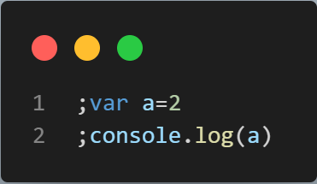
The above bit of code will display 2 in the console without raising an error!
- You can combine a number with a string in JavaScript. A string without any errors will be the outcome.
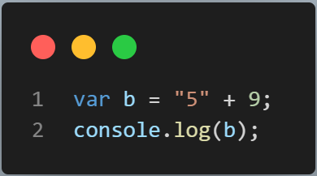
In the console, the code snippet will show "59"!
- When used in JavaScript, comparison operators frequently behave strangely. Observe a few instances.
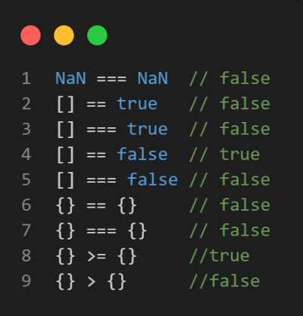
- A useful feature of JavaScript is called Immediately Invoked Function Expression, which enables a function to be called automatically after it has been defined.
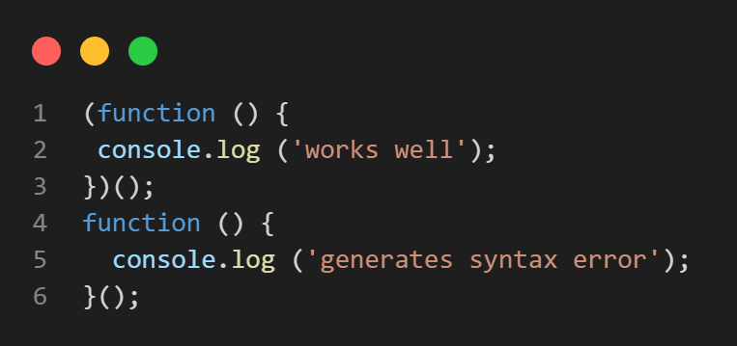
Here, the first function, which is an IIFE, operates without issue, while the second function produces a syntax error.
- Two functions in JavaScript can be distinguished from one another by the placement of the parenthesis.
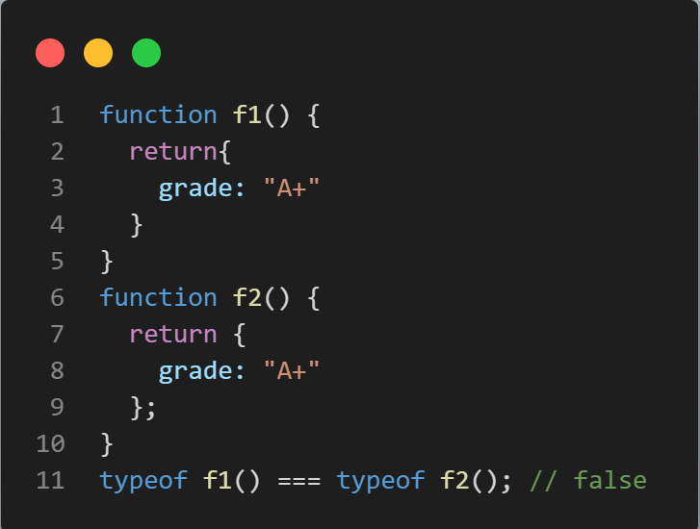
- Undefined is not a reserved word in JavaScript despite having a specific meaning. Although the following code snippet appears strange, this is the only way to tell if a variable is undefined.
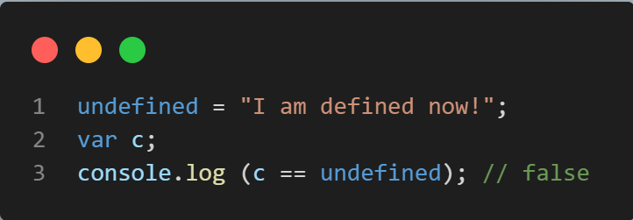
- You cannot use src and the codes in a single <script> tags like below:​​​​​​​
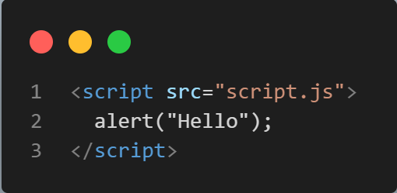
- Delete A Value from Array
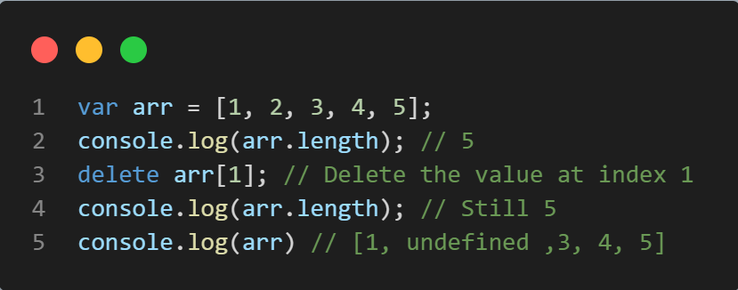
Never fall victim to the delete keyword trap. The value of the array will be deleted, but the value will still be there. The value will be deleted if the keyword delete is used, but the array will not actually be re-indexed. It will merely leave the slot vacant. The slot at index 1 in the aforementioned example will be empty, which is why the log entry for that slot reads "undefined." Therefore, even deleting all of the values from an array with the delete keyword will not alter the array's length. Use array.splice(1,1) instead to remove the value from the first to the first number of values.​​​​​​​

- Why type of null Is Object?​​​​​​​
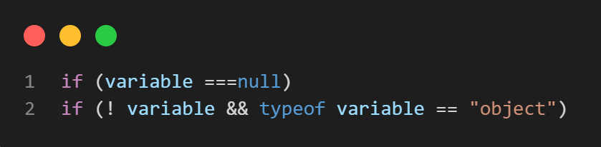
Nothing here should surprise anyone. It is a JavaScript BUG that is 20 years old. Yes, that is an issue that was impossible to remedy because a significant amount of online code relies on the typeof null === "object" phrase. If not, we anticipate the browser to return "null" as the string value when typeof null is used. Use the following methods to see if a variable has a null value type. The only value that is false yet still an object is Null, which is false

