PYTHON
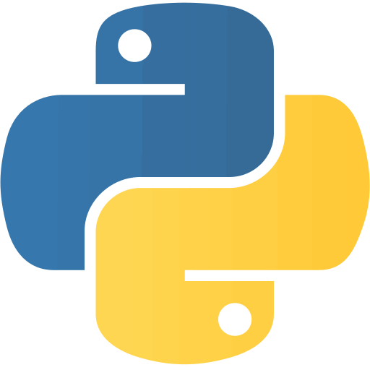
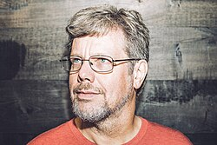
Guido van Rossum in 2014
Python was invented by a Dutch Programmer Guido Van Rossum in the late 1980s. He began working on Python in December 1989 as a hobby project while working at the Centrum Wiskunde & Informatica (CWI) in the Netherlands. Python's first version (0.9.0) was released in 1991.
Python
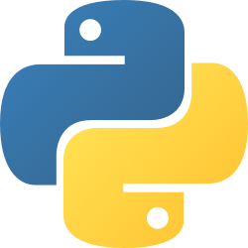
Paradigm | Multi-paradigm: object-oriented,^{[1]} procedural (imperative), functional, structured, reflective
Designed by | Guido van Rossum
Developer | Python Software Foundation
First appeared | 20 February 1991; 35 years ago^{[2]}
Stable release | 3.14.7^{[3]} / 5 August 2026; 52 days ago
Typing discipline | Duck, dynamic, strong;^{[4]} optional type annotations^{[a]}
Memory management | Garbage-collected
OS | Cross-platform^{[b]}
License | Python Software Foundation License
Filename extensions | .py,^{[11]} .pyc,^{[12]} .pyd,^{[13]} .pyi,^{[14]} .pyw,^{[15]} .pyz^{[16]}
Website | python.org
Major implementations
CPython, PyPy, MicroPython, CircuitPython, IronPython, Jython, Stackless Python
Dialects
Cython, RPython, Starlark^{[17]}
Influenced by
ABC,^{[18]} Ada,^{[19][failed verification]} ALGOL 68,^{[20]} APL,^{[21]} C,^{[22]} C++,^{[23]} CLU,^{[24]} Dylan,^{[25]} Haskell,^{[26][21]} Icon,^{[27]} Lisp,^{[28]} Modula-3,^{[20][23]} Perl,^{[29]} Standard ML^{[21]}
Influenced
Apache Groovy, Boo, Cobra, CoffeeScript,^{[30]} D, F#, GDScript, Go, JavaScript,^{[31][32]} Julia,^{[33]} Mojo,^{[34]} Nim, Ruby,^{[35]} Swift,^{[36]} V^{[37]}
- Python Programming at Wikibooks

HISTORY OF PYTHON

Python was developed by Guido van Rossum (a Dutch programmer) in the late 1980s and early nineties at the National Research Institute for Mathematics and Computer Science in the Netherlands.
Python is derived from many other languages, including ABC, Modula-3, C, C++, Algol-68, SmallTalk, and Unix shell and other scripting languages. Guido van Rossum wanted Python to be a high-level language that was powerful yet readable and easy to use.
Python is copyrighted. Like Perl, Python source code is now available under the GNU General Public License (GPL).
For many uninitiated people, the word Python is related to a species of snake. Rossum though attributes the choice of the name Python to a popular comedy series Monty Python's Flying Circus on BBC.
Being the principal architect of Python, the developer community conferred upon him the title of Benevolent Dictator for Life (BDFL). However, in 2018, Rossum relinquished the title. Thereafter, the development and distribution of the reference implementation of Python is handled by a nonprofit organization Python Software Foundation.

EVOLUTION OF PYTHON

-Following are the important stages in the history of Python −
Python 0.9.0
-Python's first published version is 0.9. It was released in February 1991. It consisted of features such as classes with inheritance, exception handling, and core data types like lists and dictionaries..
Python 1.0
-In January 1994, version 1.0 was released, armed with functional programming tools, features like support for complex numbers etc and module system which allows a better code organization and reuse.
Python 2.0
Next major version − Python 2.0 was launched in October 2000. Many new features such as list comprehension, garbage collection and Unicode support were included with it. Throughout the 2000s, Python 2.x became the dominant version, gaining traction in industries ranging from web development to scientific research. Various useful libraries like like NumPy, SciPy, and Django were also developed.
Python 3.0
Python 3.0, a completely revamped version of Python was released in December 2008. The primary objective of this revamp was to remove a lot of discrepancies that had crept in Python 2.x versions. Python 3 was backported to Python 2.6. It also included a utility named as python2to3 to facilitate automatic translation of Python 2 code to Python 3. Python 3 provided new syntax, unicode support and Improved integer division.
EOL for Python 2.x
Even after the release of Python 3, Python Software Foundation continued to support the Python 2 branch with incremental micro versions till 2019. However, it decided to discontinue the support by the end of year 2020, at which time Python 2.7.17 was the last version in the branch.

FEATURES OF PYTHON

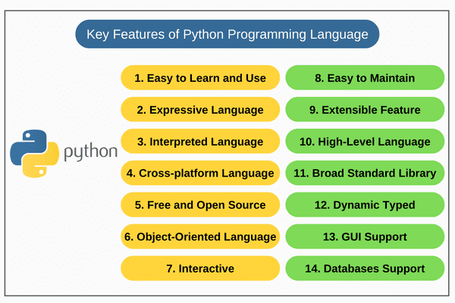
1. Free and Open Source/
Python language is available free of cost at the official website. Since it is open-source, this means that source code is also available to the public. So you can download it, use it as well as share it.
2. Easy to code
Python has a simple and readable syntax, making it easier to learn and write than many other programming languages. Its concise code structure enables faster development and makes it a highly developer-friendly language.
3. Easy to Read
Python has a clean and straightforward syntax that makes code easy to read and understand. It uses indentation to define code blocks instead of semicolons or braces, resulting in more organized and readable programs.
4. Object-Oriented Language
One of the key features of Python is Object-Oriented programming as it supports concepts of classes, object encapsulation, etc.
5. GUI Programming Support
Graphical User interfaces can be made using a module such as PyQt5, PyQt4, wxPython, or Tk in Python. PyQt5 is the most popular option for creating graphical apps with Python.
6. High-Level Language
Python is a high-level language that abstracts low-level system details. It automatically manages memory, allowing developers to focus on solving problems rather than handling hardware-specific operations.
7. Large Community Support
Python has a large and active community that provides extensive support through forums, tutorials, and discussion platforms such as Stack Overflow. This strong community ecosystem makes it easier to find solutions, learn best practices, and resolve issues quickly.
8. Easy to Debug
Python provides clear and informative error messages, making it easier to identify and fix issues. Its readable syntax also helps developers quickly understand and debug code.
9. Python is an Integrated language
Python is also an Integrated language because we can easily integrate Python with other languages like C, C++, etc.
10. Interpreted Language:
Python is an Interpreted Language because code is executed line by line at a time, like other languages C, C++, Java, etc. there is no need to compile Python code this makes it easier to debug our code. The source code of Python is converted into an immediate form called bytecode.
11. Large Standard Library
Python has a large standard library that provides a rich set of modules and functions so you do not have to write your own code for every single thing. There are many libraries present in Python such as regular expressions, unit-testing, web browsers, etc.
12. Dynamically Typed Language
Python is a dynamically-typed language. That means the type (for example-int, float, or str) for a variable is decided at run time not in advance because of this feature we don't need to specify the type of variable.
13. Frontend and backend development
With a new project py script, you can run and write Python codes in HTML with the help of some simple tags <py-script>, <py-env>, etc. This will help you do frontend development work in Python like javascript. Backend is the strong forte of Python it's extensively used for this work cause of its frameworks like Django and Flask.
14. Allocating Memory Dynamically
In Python, the variable data type does not need to be specified. The memory is automatically allocated to a variable at runtime when it is given a value. Developers do not need to write int y = 18 if the integer value 15 is set to y. You may just type y=18.

PYTHON SETUP

Install Python for Windows
Installing Python on Windows will take some important steps :
Step 1): Go to the python official website at https://www.python.org/downloads/windows/.
Step 2): Choose the latest version of Python releases for Windows.

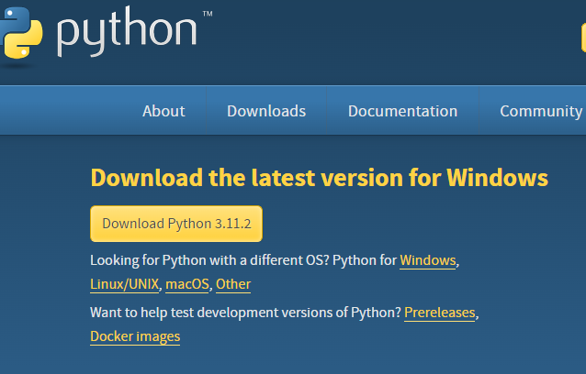Official Python Page

Step 3): After choosing the correct released version, Click on the download Python.
Step 4): Click on Install now, and you can add python.exe path.

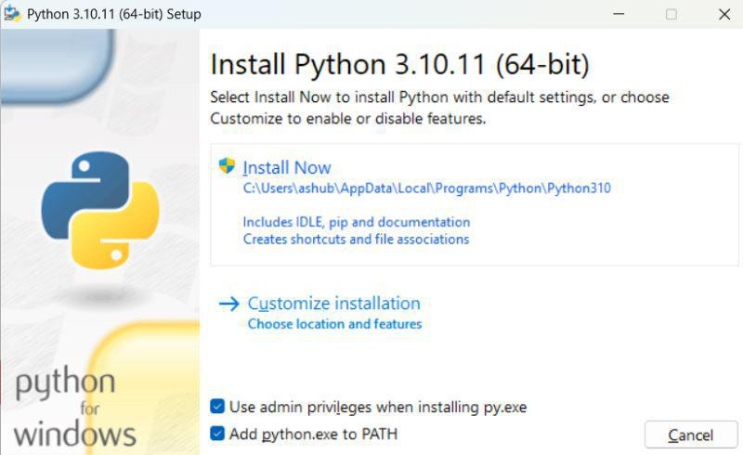Click on Install

Step 5) : After the installation completed , You will find python is installed in your system .

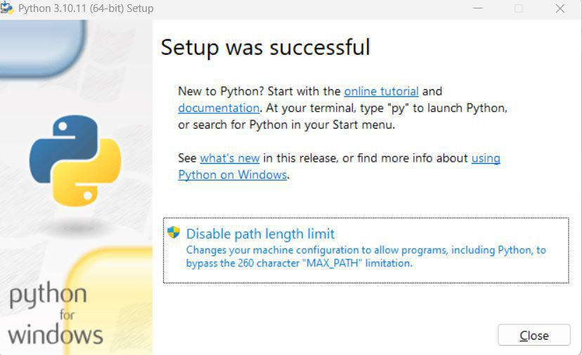Python Installed in system

After a successful installation of Python, IDLE(Integrated Development and Learning Environment) will also be installed on our local computer alongside some of the packages. For simple programs, we can use IDLE.
Python programs can also be written in a notepad and run from the command prompt. For this, follow the steps:
- Open the notepad.
- Write the code in it.
- Save the file with the .py extension.
- Open the terminal/command prompt.
- For type in the following command >> py filename.py.
- The output will be displayed.
Example: We have created a file named hello.py with the content print("Hello world").
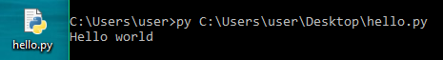
For large and complex programs, it is more convenient to use a smart IDE. To set-up Python properly in your system You can prefer to any IDLE mentioned below.
Different IDLE and Python Programming Environment
1. Atom : Atom is a free and open-source text and source code editor for macOS, Linux, and Microsoft Windows with support for plug-ins written in Node.js, and embedded Git Control, developed by GitHub. Atom is a desktop application built using web technologies. [link - https://sourceforge.net/projects/atom.mirror/]
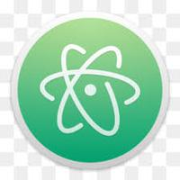Atom Logo
2. PyCharm : PyCharm is an integrated development environment used in computer programming, specifically for the Python language. It is developed by the Czech company JetBrains. [link - https://www.jetbrains.com/pycharm/]
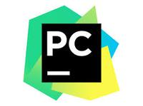PyCharm logo
3. Visual Studio Code : Visual Studio Code is a free source-code editor made by Microsoft for Windows, Linux and macOS. Features include support for debugging, syntax highlighting, intelligent code completion, snippets, code refactoring, and embedded Git. [link - https://code.visualstudio.com/]
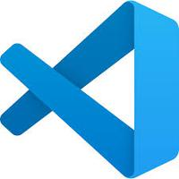Visual Studio Code
4. Spyder : Spyder is an open-source cross-platform integrated development environment for scientific programming in the Python language. [link - https://www.spyder-ide.org/]
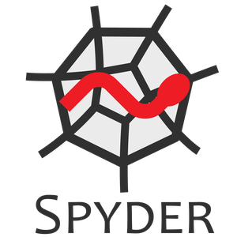Spyder
5. Wing IDE : The Wing Python IDE family of integrated development environments from Wingware was created specifically for the Python programming language. [ link - https://wingware.com/]
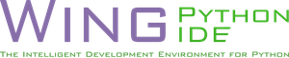WinG IDE
6. Thonny : Thonny is an integrated development environment for Python that is designed for beginners. It supports different ways of stepping through the code, step-by-step expression evaluation, detailed visualization of the call stack and a mode for explaining the concepts of references and heap. [ link -https://thonny.org/ ]
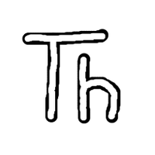Thonny

