SQL[ Oracle Plus]
3 Tier Architecture

Web-Technologies

Middleware
Database
Sql, MySql, MangoDB
-Data Of the Application.

Core Java, Advanced Java
-Logic Of the Application.

Html, Css, JavaScript ReactJS
-Look & Feel

FRONT-END
BACK-END
DATABASE

Language: -
-It is Predefined set of rules and regulations that must be followed in order to established the communication between two different entities.
-Language are categorized into two types.
1]Verbal Language
2]Programming Language.

1]Verbal Language
-The type of language which we can read, write and speak that can be categorized as verbal language.
e.g. :- English,Hindi,Marathi,Spannish.
2]Programming Language
-Programming language it is set of instruction to perform a particular task by the machine which is given by the programmer is called as Programming language.
OR
-The type of language we can read, write but cannot speak that can be categorized as Programming language.
-It is generally used to communicate the machine.
-Based on its application programming language are further categorized into two types: -
1]General Purpose Language
2]Domain Specific Language.

1]General Purpose Language
-The Programming Language which can be used for all the purposes is called as General-Purpose Programming language.
-With the help of General-Purpose Language, we can build entire application.
e.g. :- Java, Python, C, C++, Ruby, Dot Net.
-General purpose Programming Language are further more classified into three types.
i]High Level Language
ii]Low Level Language
iii]Middle Level Language.
i]High Level Language
-The Programming Language which is writeable, Readable, Understandable & Executable by the programmer such language are called as High Level Programming Language.
e.g.: - Java, Javascript, Python, C, C++, Ruby, Dot Net.

ii]Low Level Language
-The Language which is Understandable & Executable by the machine is called as Low-Level Programming Language.
e.g.: - Binary language, Assembly Language.

iii]Middle Level Language
-The Programming Language with having features of both Low Level & High Level Programming Language such languages are called as Middle Level programming Language.
e.g.: - Java, Python, C, C++, Ruby, Dot Net.
2]Domain Specific Language.
-The Programming language which help to build only specific part of application that language can be called as Domain Specific Programming Language.
e.g.: -Sql, MySql

Note:- Sql belong to Domain Specific Programming Language.
Programming Language
DATABASE
SQL

DOMAIN

Data
-Data is a raw fact that has no context by itself.
-Data is a piece of or part of information that complete information and adds meaning to it.
-Data can be classified into two types.
1]Quantitative Data
-The Data which contain only numeric values is considers as Quantitative Data.
e.g. Ip Address, Pin Code

1]Qualitative Data
-The Data which can contain Alphanumeric values (Alphabet + Numbers) as well as Special Characters is considered as Qualitative Data..
e.g. Batch Code, PAN No
Database
-Database is the place where data of application can be stored and manipulating.
-Data Manipulating means Performs Operation on it.

SQL
Data
Communicate or Interact
Database
Representation Of Database

-Sql is used to communicate or interact with database.
-Operation Perform of an database. C R U D

C : CREATE
R : RETRIVE
U : UPADATE
D : DELETE

Database Model
-Based on its characteristics and working Nature database is classified into DBMS & RDBMS.

#DBMS
1]DBMS is stands for Database Management System.
2]In DBMS model data is store in form of that file
e.g.-CSV
-CSV stands for Comma Separated Values.
3]In DBMS Model Identifying duplicate record is highly impossible.
4]As data repeated (redundant) cannot be identified hence it is also impossible to remove it.
5]In DBMS model “Normalization” which is a process of removing duplicate redundant data form entire database is also not achievable.
Note :- As the above characteristics of DBMS Module were considered as its drawbacks to overcome of DBMS Model drawback the RDMS Model is developed.

#RDBMS
1]RDBMS stands for Relational Database Management System.
2]In RDBMS Model data is store in the form of Table.
3]As Data stored in the Table format it becomes easy to identify duplicate and redundant data.
4]As redundant data can be identify easily so it also can be removed easily.
5]In RDMS model process of “Normalization” is achievable.

Note:- Data can be related to other data only if it is something in common such data is called as relational data.
-Sql works on Relational Model.

Difference Between DBMS and RDBMS
DBMS | RDBMS
DBMS stores data as file. | RDBMS stores data in tabular form.
Data elements need to access individually. | Multiple data elements can be accessed at the same time.
No relationship between data. | Data is stored in the form of tables which are related to each other.
Normalization is not present. | Normalization is present.
DBMS does not support distributed database. | RDBMS supports distributed database.
It stores data in either a navigational or hierarchical form. | It uses a tabular structure where the headers are the column names, and the rows contain corresponding values.
It deals with small quantity of data. | It deals with large amount of data.
Data redundancy is common in this model. | Keys and indexes do not allow Data redundancy.
It is used for small organization and deal with small data. | It is used to handle large amount of data.
Not all Codd rules are satisfied. | All 12 Codd rules are satisfied.
Security is less | More security measures provided.
It supports single user. | It supports multiple users.
Data fetching is slower for the large amount of data. | Data fetching is fast because of relational approach.
The data in a DBMS is subject to low security levels with regards to data manipulation. | There exists multiple levels of data security in a RDBMS.
Low software and hardware necessities. | Higher software and hardware necessities.
Examples: XML, Window Registry, Forxpro, dbaseIIIplus etc. | Examples: MySQL, PostgreSQL, SQL Server, Oracle, Microsoft Access etc.

Table
Column

Row
.

Cell

1] A Table can be consider as combination of rows and column.
2]Horizontal set of block of Table are considered as Row.
3]Vertical ser of block of Table are considered as Column.
4]Smallest unit of a Table Is called as Cell.
5]Cell can be located as Intersection Point of row and column.

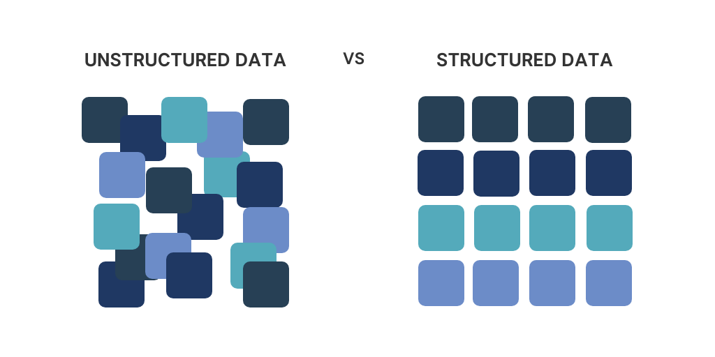
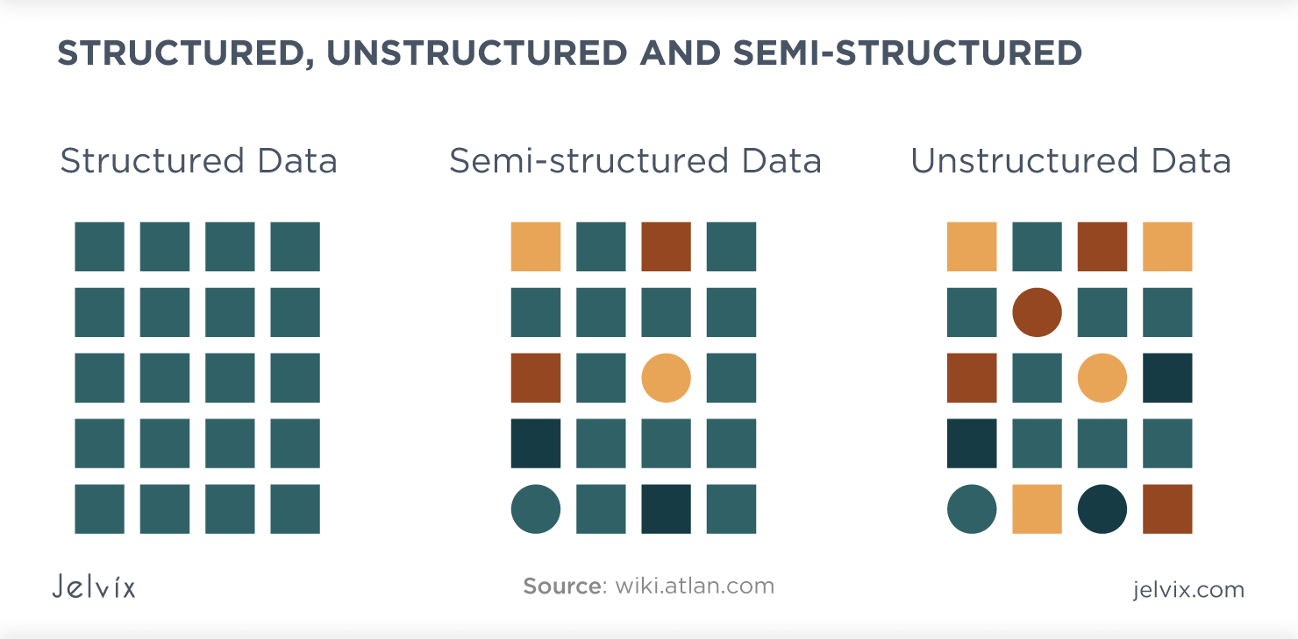
-When rows and columns of tables are not proportional then tbale is consider as on Unstructured Table.
-Where as when rows and columns of table are proportional then table are considered as Structured Table.
Note :- Sql does not allow Unstructured table it is capable of operation on Structured Table only.

-Table in sql
Stud ID | Name | Email | Mobile
1 | Amol | amol@gmail.com | 9373428583
2 | Om | om@gmail.com | 9288725253
3 | Dev | dev@gmail.com | 9370049100
4 | Kiran | kiran@gmail.com | 9881678965
5 | Soham | soham@gmail.com | 9968673742

-In Sql
1]Table is considered as Logical representation of an entity.
2]Column are considered as Attribute.
3]Rows considered as Records/Tuples of entity.

1]Employee :-
Attribute:-i]EmpId
Ii]Name
Iii]Salary
Iv]MobileNo
V]EmailId
Logical Representation :-
StudId | Name | Salary | Email | Mobile
1 | Amol | 35000 | amol@gmail.com | 9373428583
2 | Om | 22000 | om@gmail.com | 9288725253
3 | Dev | 15000 | dev@gmail.com | 9370049100
4 | Kiran | 18000 | kiran@gmail.com | 9881678965
5 | Soham | 17000 | soham@gmail.com | 9968673742

History Of SQL:-
1]The Formal Name of sql was SEQUEL.

S : Simple
E : English
Q
U Query
E
L : Language

2] The name had to be changed to sql due to trademark conflicts.
3]In Late 1960_{s} Mathematician E.F.Codd proposed a mathematical model based on fact that the data can be stored.
4]In the year 1970_{s} two researchers form IBM Raymond Boyce & Donald Chamberlin implemented the mathematical model proposed by E.F.Codd & developed a technology called as DBMS.
5]This technology was not made to available to everyone it was given only to the to the American Navy ,CIA & few other government organization.
6]In the year 1973 oracle corporation develop there own DBMS technology and named it as SQL.
7]Sql got his global acceptance in the year 1986.
8]Since the sql has received multiple update and in the year 2016 is the last update for sql was released.

Note : -There are 50+ Query Language are available in the market and few more under development.

#E.F CODD RULES
1]Rule 0 : - The rule 0 stated that the data stored in the database should be in the form of Table.
2]Rule 1 :- The Rule 1 stated that there can be multiple tables in the database but not with the Same Name.
3]Rule 2 :- The Rule 2 Stated that each cell of the table should be Atomic / Singular i.e each cell can hold only one data at a time.
4]Rule 3 :- The Rule 3 Stated that each data stored in the tables should have some relationship among itslf.

Note : - For a DBMS to be called as RDBMS it must follow all the above mentioned E.F Codd Rules.

Codd’s Rules in DBMS

Rule 1: The Information Rule
All information, whether it is user information or metadata, that is stored in a database must be entered as a value in a cell of a table. It is said that everything within the database is organized in a table layout.

Rule 2: The Guaranteed Access Rule
Each data element is guaranteed to be accessible logically with a combination of the table name, primary key (row value), and attribute name (column value).

Rule 3: Systematic Treatment of NULL Values
Every Null value in a database must be given a systematic and uniform treatment.

Rule 4: Active Online Catalog Rule
The database catalog, which contains metadata about the database, must be stored and accessed using the same relational database management system.

Rule 5: The Comprehensive Data Sublanguage Rule
A crucial component of any efficient database system is its ability to offer an easily understandable data manipulation language (DML) that facilitates defining, querying, and modifying information within the database.

Rule 6: The View Updating Rule
All views that are theoretically updatable must also be updatable by the system.

Rule 7: High-level Insert, Update, and Delete
A successful database system must possess the feature of facilitating high-level insertions, updates, and deletions that can grant users the ability to conduct these operations with ease through a single query.

Rule 8: Physical Data Independence
Application programs and activities should remain unaffected when changes are made to the physical storage structures or methods.

Rule 9: Logical Data Independence
Application programs and activities should remain unaffected when changes are made to the logical structure of the data, such as adding or modifying tables.

Rule 10: Integrity Independence
Integrity constraints should be specified separately from application programs and stored in the catalog. They should be automatically enforced by the database system.

Rule 11: Distribution Independence
The distribution of data across multiple locations should be invisible to users, and the database system should handle the distribution transparently.

Rule 12: Non-Subversion Rule
If the interface of the system is providing access to low-level records, then the interface must not be able to damage the system and bypass security and integrity constraints.

#SQL ACCOUNTS
-As we know SQL follows the RDBMS model hence the data will be store in the form of table.
-The table are not directly store in the database instead they are stored in the Accounts.
-The accounts are present in the database.

DATABASE

ACCOUNTS

TABLE

DATA

-There can be multiple accounts by default present in the database but with not same name.
DATABASE

Root
SYSTEM
HR
HR
SYS
HR
SCOTT
Account

-A database can have predefined as well as User Created Account.
-Every database will have predefined Root Account.
-In SQL Plus Root Account is “SYSTEM”.
#ROOT ACCOUNT
-Every database has a predefined account that has all permission to perform only operation to entire database such account is called as Root Account.
-Although the root account have the permission to perform operations on database but it does not access data with data another account.
Note : -All the tables in the database are limited it own account.

#
Basic Commands

SQL Case Insensitive.
DATA Case Sensitive.

1]Display Current User:-
Syntax: -
show user;
-This command is used to display that we are currently connected

2]Connected to user Account
Syntax: -
1)connect username;
2)conn username;
For e.g., 1) connect system;
2)conn Scott;
-This command is used to connect to different user account without having restart the application.

.

3]Display all users from the database
Syntax:-
Select * from all_users;
-This command is used to display all the entire existing user accounts from the entire database.
-This included predefined accounts (default accounts) as well as user created account.

4]Changing the page size
Syntax:-
Set pages PageSize;
e.g: - set pages 1000;
-This command is used to set the pages size if the default page size is not sufficient to display all the records once.

5]Display all the Tables from the Accounts
Syntax:-
Select * from tabs;
e.g:- Select * from tabs;
-This command is used to display all the tables present in the specific user account.

6]Changing the line size
Syntax:-
Set lines lineSize;
e.g:- Set lines 1000;
-This command is used to change the size of the line in the SQL console.
-If the Predefined line size is not sufficient to display structure in the proper content.

7]Changing the Structure
Syntax:-
1)Set lines lineSize Pages PageSize;
2)Set Pages PageSize lines lineSize;
e.g:- 1)Set lines 1000 Page 1000;
2)Set Pages 1000 lines 1000;
-This command is used to change the SQL console i.e the page size and the line_size together in one command.

8]Describing the Table
Syntax:-
1)describe TableName;
2)desc tableName;
e.g:- 1)describe emp;
2)desc emp;
-This command is used to display the details about the columns of the table.
-It is used to described tables.

9]Display all table content
Syntax:-
Select * from TableName;
e.g:- select * from emp;
-This command is used to display all the records from all the columns from table.

10]Re-Executing The Last Query
Syntax:-
/
e.g.:- /
-With the help of this command we can re-executing the last query.
-we cannot execute any query before the last one.

12]Clearing the sql console screen
Syntax:-
1)Clear Screen
2)cl scr
e.g:- 1)Clear Screen
2)cl scr
-This command is used to clear the console screen.
11]Editing the last query
Syntax:-
1)edit
2)ed
e.g:- 1)edit
2)Ed
-This command is used to edit the last executed query.
-The query is written to a temporary text file.
-we can make the changes in the text file then save it and then close the file.
-The edited query automatically appears in the SQL console which can be executed by entirely ‘ / ’ “ Forward Slash“.

13]User Creation
Step 1: - We need to login “SYSTEM” account as Root account in the database and has the permission to perform all operation on the database.
-Hence we will use the system account to create a user account.
=======================================================
SQL> conn system
Enter password: *****
Connected.
=======================================================
Step 2: -We need to execute a command to create a new user.
-The command is as mention below.
Syntax:-
Create user username
Identified by password;
e.g:- Create user Amol
Identified by amol123;
=======================================================
SQL> create user Amol
identified by Amol123;
User created.
=======================================================

Step 3: -
=======================================================
SQL> conn Amol
Enter password: *******
ERROR:
ORA-01045: user AMOL lacks CREATE SESSION privilege; logon denied
=======================================================
-After created the accont we cannot login to immediately because the newely created account will not have permission [ Previlege ] to login.
-Hence we need to give this permission to the Newley created account.
=======================================================
Step 4: -The System account has to grant the “ CREATE SESSION “ Previlage with the help of command mentioned below.
Syntax:-
Grant privilegeName to username;
e.g:- grant create session to Amol;
;
=======================================================
SQL> grant create session to amol;

Grant succeeded.
=======================================================
-After receiving the permission to login the newly created account will ready to use.
=======================================================
SQL> conn amol
Enter password: *******
Connected.
=======================================================

14]Locking user Account
-To lock user account we first need to login a system account.
-In order to do so we need to execute the command mentioned below.
Syntax:-
Alter user username
Account lock;
e.g:- alter user Amol
account lock;

=======================================================
SQL> conn amol
Enter password: *******
ERROR:
ORA-28000: the account is locked
=======================================================
-Once a user account is lock we can no longer login to that account.

15]Unlocking user Account
-To unlock a locked account we need to first unlock it from the system account.
-In order to do so we first need to login to the system account and execute the command mentioned below.
Syntax:-
Alter user username
Account unlock;
e.g:- alter user Amol
account unlock;
=======================================================
SQL> alter user amol
account unlock;
User altered.
=======================================================
-After unlocking the account once again we can login the account.

16]Deleting User Account
-A user can be removed from the database with the help of “ SYSTEM “ account (drop).
Syntax:-
Drop user username;
e.g:- drop user amol;
=======================================================
SQL> drop user amol;
User dropped.
=======================================================
Note : - The newely created user account will not have any permission by default
-In order to perform any kind of operation the required permission for that operation has to be granted first.
-All the permission granted to a user define account from the root account itself.

#DATATYPES
-Datatypes are used to restrict to a user from entering any invalid data in the column.
-It mandatory to assign a datatypes to a column at the time of table creation.
-There are Predefined datatypes in sql are as following:-
1]char
2]varchar
3]varchar2
4]number
5]date
6]large object

1]char
Syntax:
Char(size);
-The char size datatype accepts:-
1]Alphabet (A to Z)
2]alphabet (a to z)
3]digit (0 to 9)
4]Special Character (@,#,$)
-char has fixed Memory Allocation.
-char has size 2000.
-The char datatype accepts size an argument. If a column is assigned with char datatype then the column can accept.
-For each new data the char datatype takes memory block from the main memory equal to the defined size.
-The char datatype has Fixed-Length Memory Allocation it it means that the used block of memory are not returned back to the main memory.
-Hence unused block of memory are wasted.
e.g:-
char(8)
I | N | D | I | A

USED BLOCK
UNUSED BLOCK

2]varchar
Syntax:
varchar(size);
-If varchar given to the column then column will accepts:-
1]Alphabet (A to Z)
2]alphabet (a to z)
3]digit (0 to 9)
4]Special Character (@,#,$)
-varchar means Variable Character.
-varchar datatype will accepts 2000 size.
-varchar datatype is a variable length Memory Allocation.
-It means the unused memory blocks are returned to the main memory.
-As the unused block returned to the main memory they can be utilized for the data.
-Hence the unused block of memory are not wasted in varchar.
e.g: -
char(8)
I | N | D | I | A

UNUSED BLOCK
USED BLOCK
MAIN MEMORY

Note:- When a character exceeds 2000 character both char, varchar cannot be used for such data.
-Hence we need to used varchar2 datatype.

