1. Read the case file
2. Define UDFs (Define->User-Defined->Functions->Compiled)
3. Press Add, choose the \*.c file with UDFs.
4. Build, then load. Read the messages, if any errors, fix errors.
5. Hooking heat/mass transfer for discrete phase: (Discrete phase->Injections->UDFs…)  
   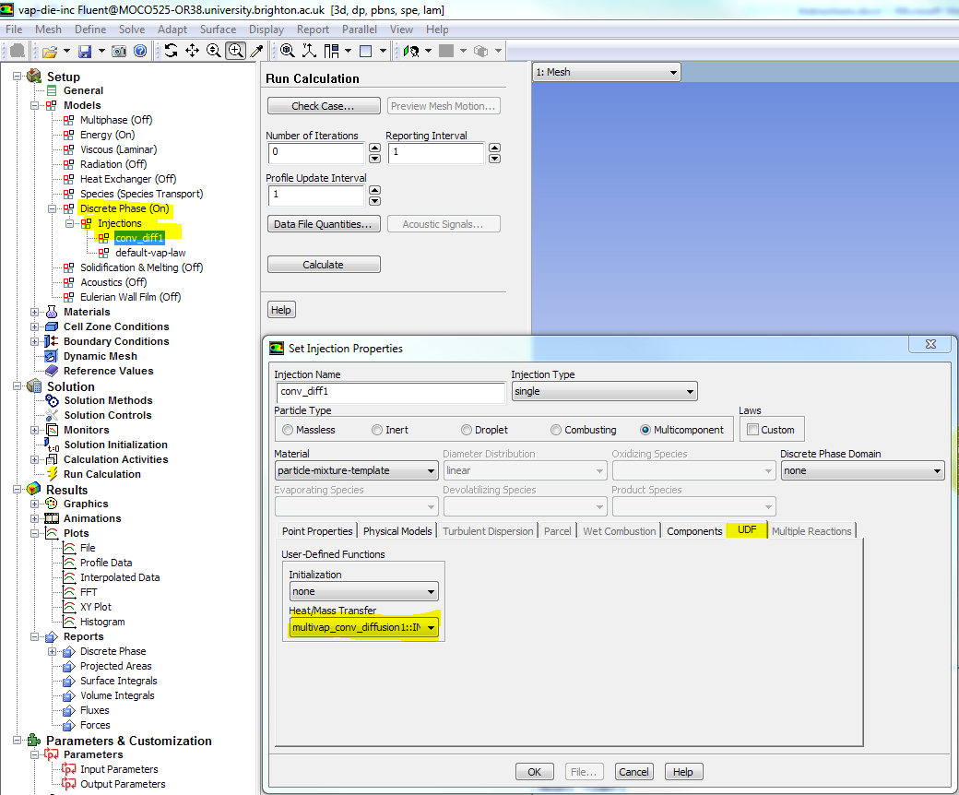
6. Specify the number of User Variables (this number may vary, see the UDF for details):  
   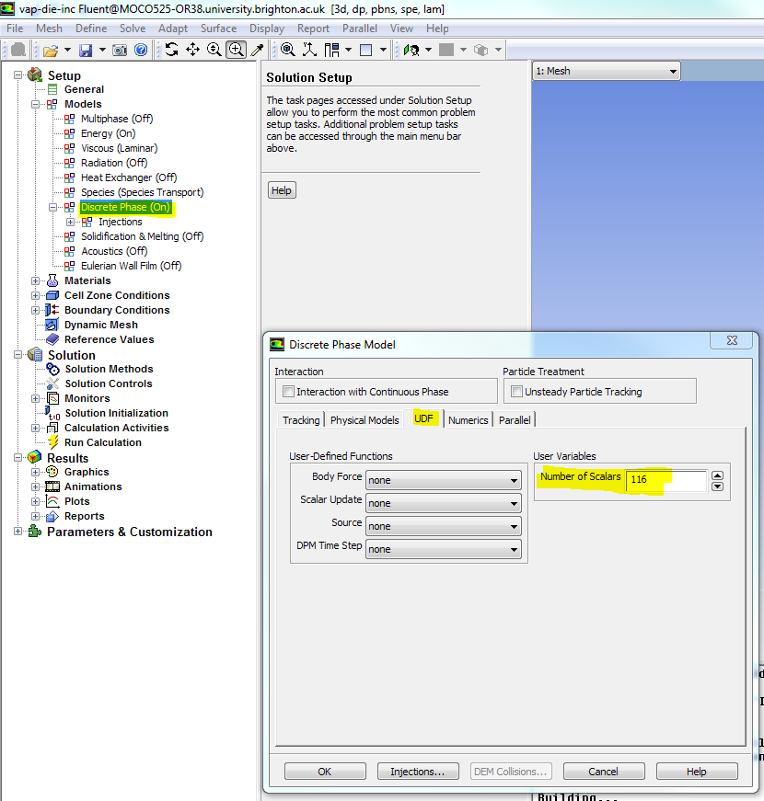
7. For the performance report go to Report ->System ->Time Usage
8. For the report on droplets go to Results-> Graphics -> Particle Tracks. Choose injector, Step by Step, you can also choose Reporting Variables, then choose write and specify the file.  
   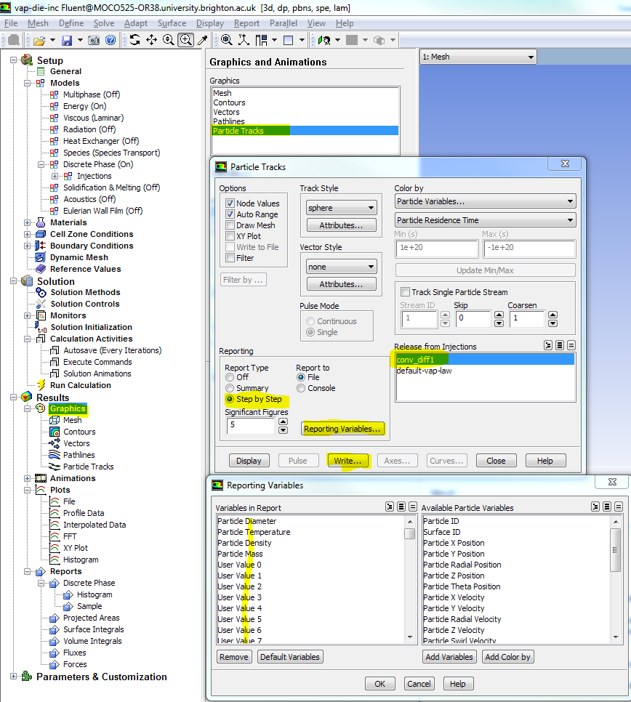

Note: You can also save a case file with hooked UDF, no need to compile and load the library, hook UDFs every time.