ASSIGNMENT No:1

Q1. Explore the following commands with various options, refer man pages for

further help a) date b) cal c) bc d) echo e) who f) whoami g) logname g) uname h)

seq i) clear

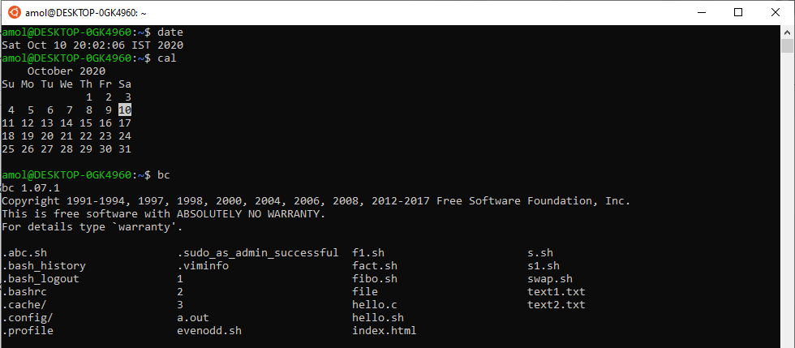

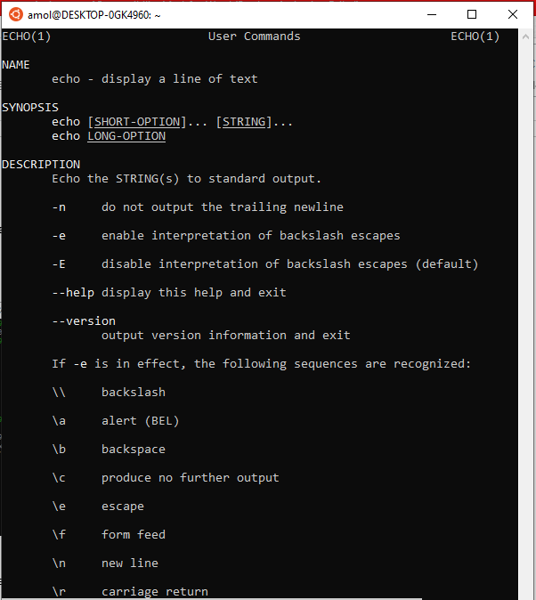

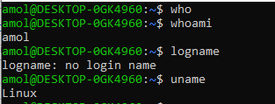

1. date – Display date on shell screen
2. cal – Display calendar of running month
3. bc - Display all files in directory
4. echo - Display a line of text
5. who – display user name Id
6. whoami - Display user name
7. logname - Display login name of user
8. uname - Display OS name
9. clear- clear screen

Q2. A) Create three directory a b and c and create a.txt,b.txt and c.txt

in each directory respectively and then copy c directory into the a.

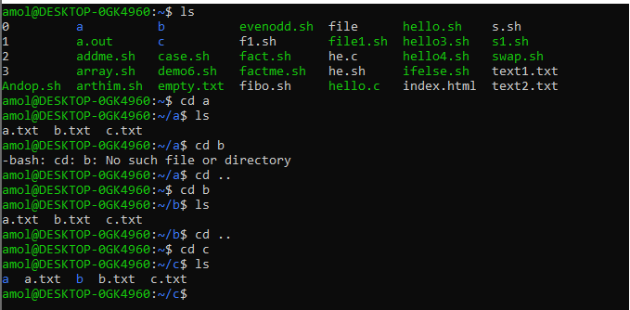

B)Move Directory b to c.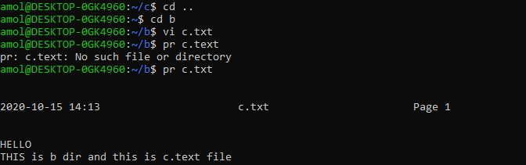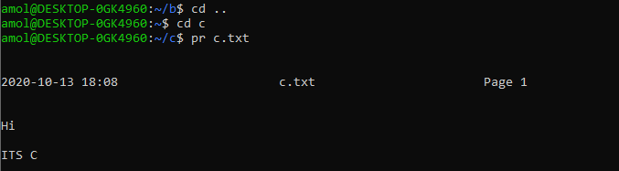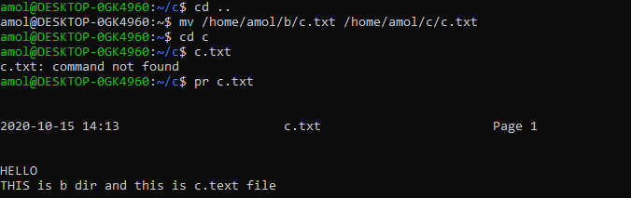

C) Create alias of ls -lh command to your name.

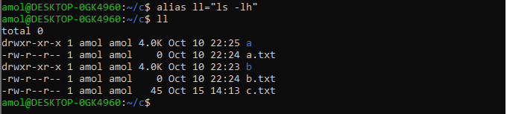

D) Change Directory name a to cdac.

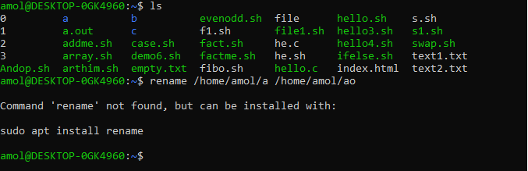

Q3. A) Create five files file1.txt , file2.txt ,file3.txt file4.txt and

file5.txt with some text inside it. Search for 's' character

inside all the files using grep command.

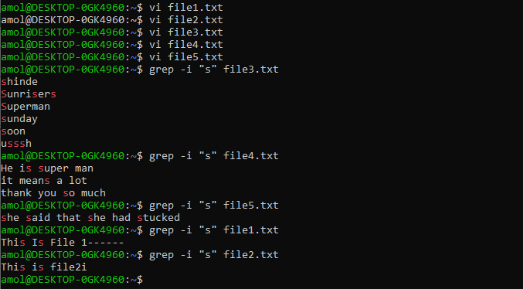

Also Use cat to view all file content together.

B)Create file.txt using cat and edit that using nano editor.

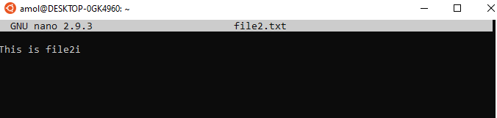

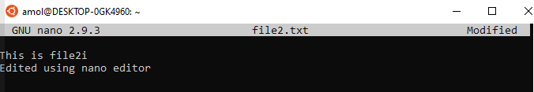



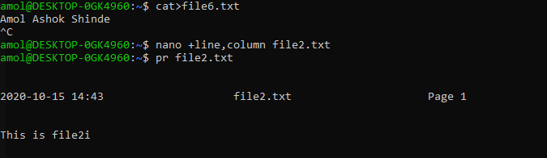

c)Create 5 empty files using touch command

touch a.txt b.txt c.txt d.txt e.txt

D)Remove previously created directory a , b and c.

rm -r a

rm -r b c

Q4. Create a file with some content using vi editor

1. Display the file using cat command

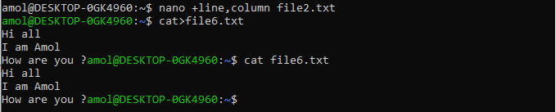

1. Display line numbers along with content

cat -b file.txt

tac file.txt

c) Display the file in reverse order using tac

d) Combine multiple files using cat command

Q5. Create Random some files and sub directories.

1. display files row wise, column wise, 1 per row

sort file1.txt

1. sort the files in ascending, descending order

ls -a ls -A

c) Create some hidden files and sub directories and display them using “ls -a”

1. ls -r ls -t ls-rt

d) Change time stamp of some files and directories using touch command and display the files using ls -t ls -rt

e) Recursive display contents of your home directory.

f) display all attributes of files and directories using ls -l

g) display attributes of a directory using ls -ld

==================================================================================

Q1. Create directory of your name and then create 4 files inside it named

a.txt, b.txt, c.txt and d.sh. And change the directory permission to

Ans : only user and also files permission to only user such that

mkdir Amol

touch a.txt b.txt c.txt d.txt

chmod +x d.sh

a)user can read and write the file a.txt and b.txt

chmod +rw a.txt b.txt

b)user can write the file c.txt

chmod +w c.txt

c)user can exectuable the file d.sh. Make

Contents of file d.sh:

#/bin/sh

ls –lh

cat>d.hs #/bin/sh

chmod +x d.sh

Q2. Change the permission of the previous directory to executable only.

Analyze the output.

chmod +x vipul

Q3. Change the permission of the previous directory to read only.

Analyze the output

chmod -x amol.txt

chmod –ramol.txt

Q4. Use echo to list the all files of your home directory.

echo $(file.txt

Q5. Use echo to list the all files of /etc/ directory

echo>>"Hi there is message " >> file.txt

Q6. Use echo to list the all files of /etc/ directory with extension name .conf

Q7. Use echo to append your name to a.txt

==================================================================================

Note:Many operation might not work.Analyze them

1. Create Three level nested directory a,b and c

mkdir a

cd a

mkdir b

cd b

mkdir c

a)Create at least one hidden file in each directory

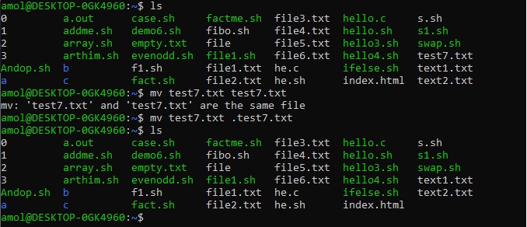

b)Create at least one normal text file in each directory

touch file.txt

c)Copy c into a

cp c a

d)Copy file inside a into b

cp c a

1. Change the third level directory c permission to read only

chmod +r c cp a c

cd b mkdir data

chmod +rw b

cd b touch data.txt

1. Try copying third level c directory to outside of a

mv c copied_dir

1. Create the directory “data“ inside b



5. Change the permission of b to read and write only

6. Create directory “data2” inside b



7. Create data.txt file inside b

