<https://dustinstansbury.github.io/theclevermachine/derivation-common-neural-network-activation-functions>

# The Identity Activation Function

glinear(z)=z

g′linear(z)=1

The Logistic Sigmoid Activation Function



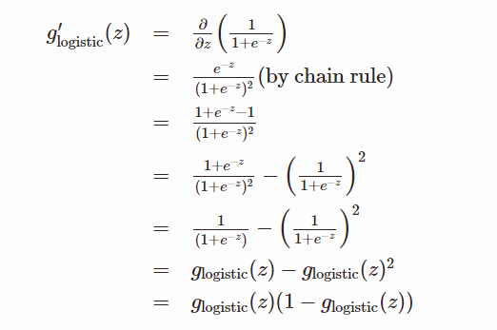

# The Hyperbolic Tangent Activation Function

# 

