**Pik search**

* First give the name pik vibhag.
* Add images of farmer and trader. On left and right side of the page.
* Add a map(Maharashtra or Bharat) also add logo (pik setu logo).
* Reference link: <https://bhulekh.mahabhumi.gov.in/>
* Content:
* Select crop:

(e.g; Wheat , Onion, Bajara ,…)

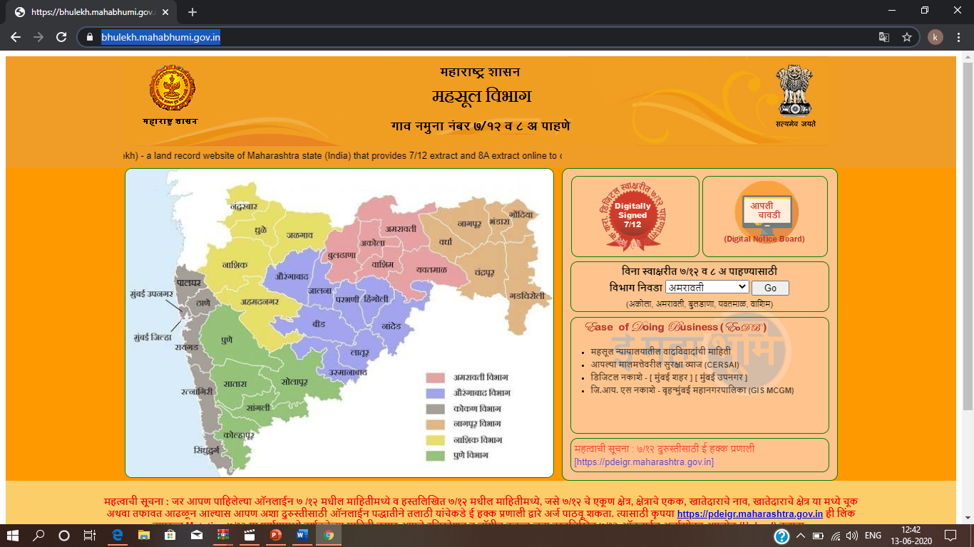

* Next click on go or search
* Select state/ district:

( Maharashtra , Karnataka,….)

(Pune , satara , Solapur,….)

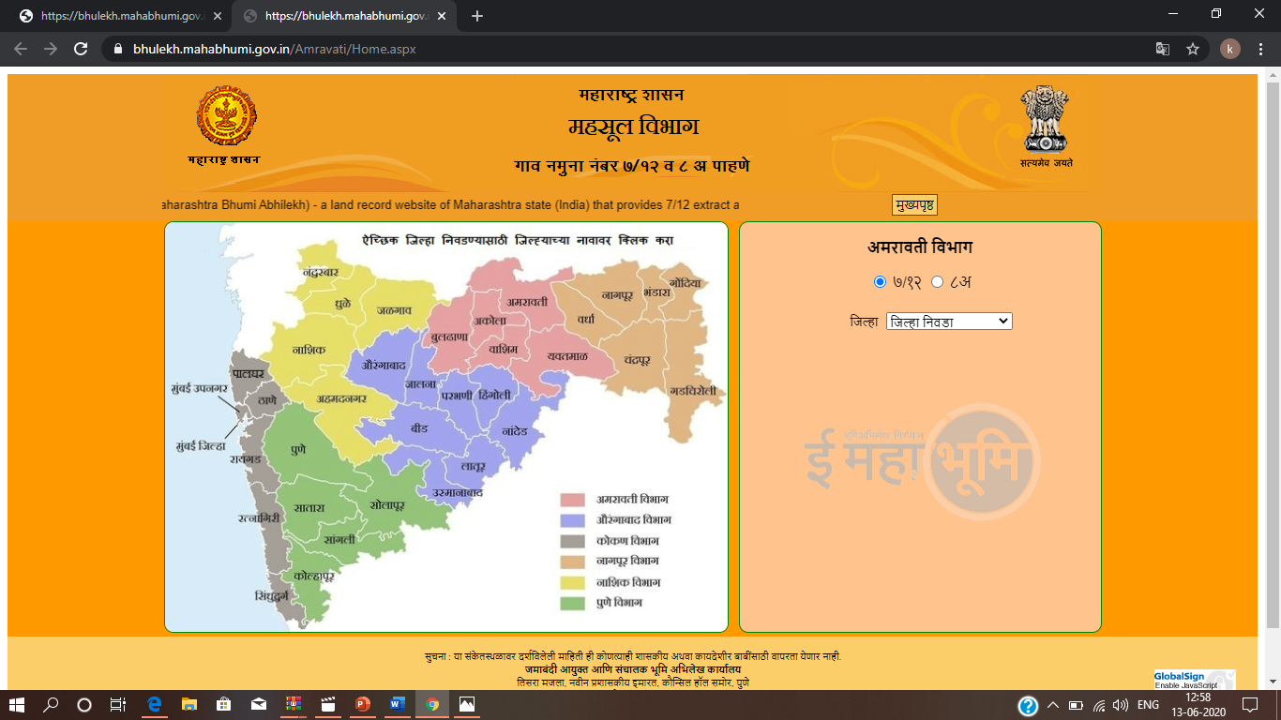

* Select taluka:
* Select village:
* Then it will show the pictures and videos of that crop