**home Page**

Home page is about pik-setu which is the bridge between the farmers and the traders .In this pi-setu website there are 3 people are going to attached with website:

1. farmers
2. traders
3. pik setu center members

At the header of home page ,

* about the pik-setu
* farmers registration
* pik registration
* traders registration
* services
* awards
* recruitment
* piksearch panel
* account signup

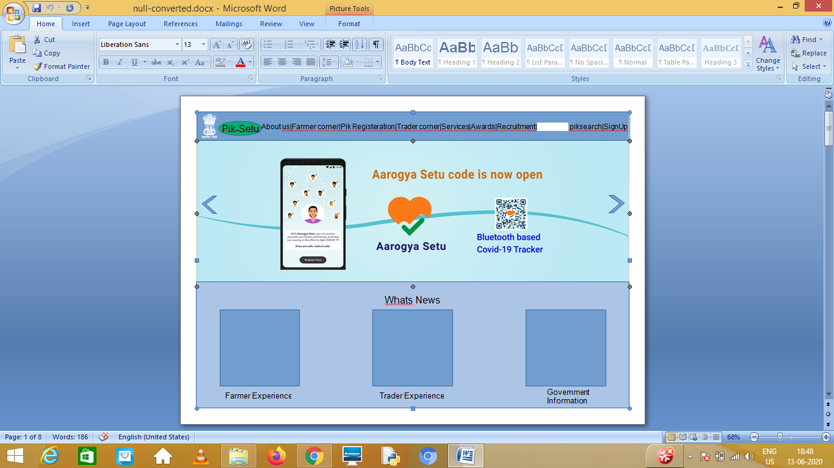

we add content in section which

* contains latest news about the pik setu,
* government steps about the farmers , experience about the benefits gets from pik-setu website ,
* latest trends ,etc.

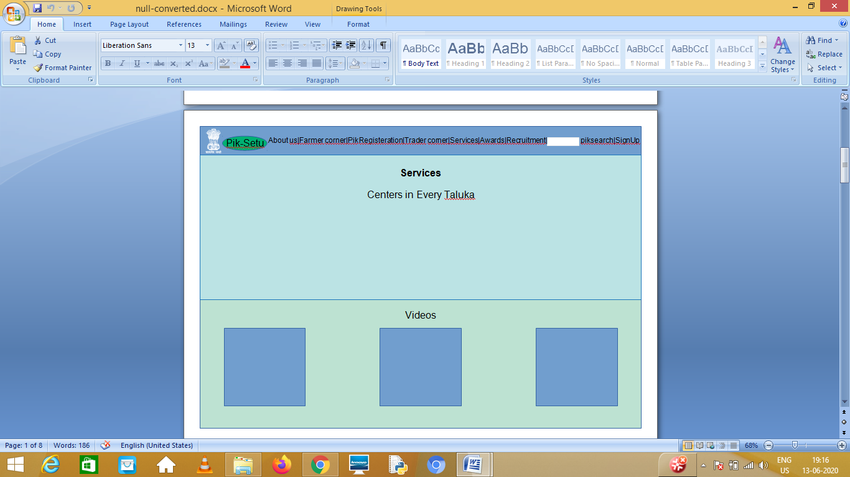

* services (about centers of pik-setu in every taluka.)
* video (getting awards ,news ,etc )
* testimonials ( thoughts of the politician about the pik-setu website)

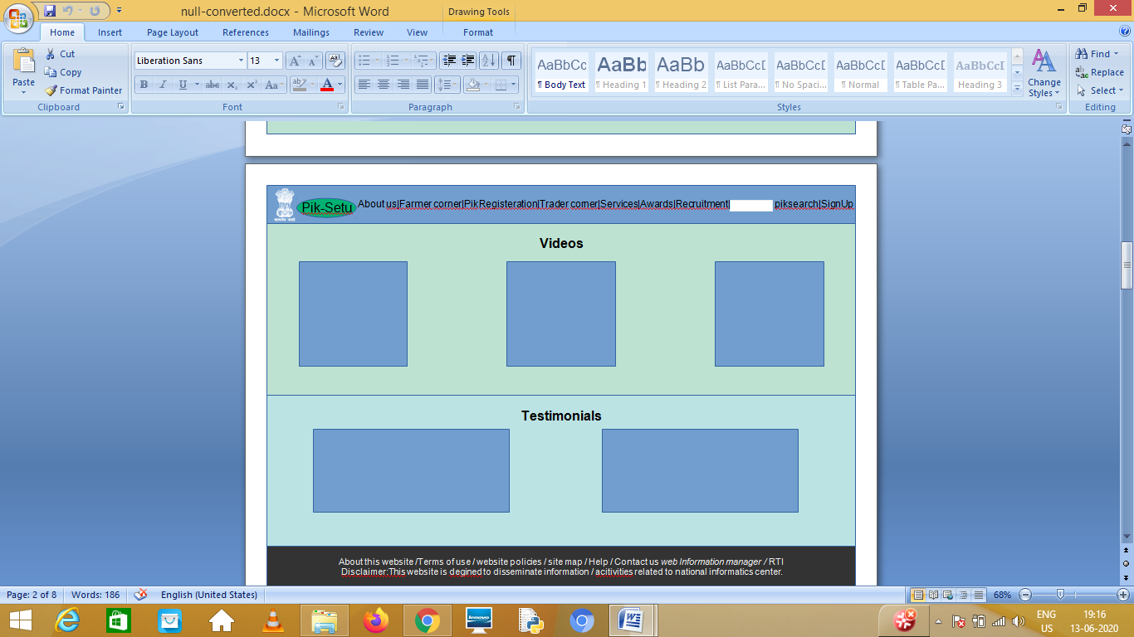

For overall layout of web page : <https://www.nic.in/>