**CS6301.0U1- Web Programming Languages**

**(By Amol Vaze – Net-id: - asv130130@utdallas.edu)**

**Assignment- No-1 Readme Documentation**

* **Assignment No-1** focuses on design & implementation of GUI for degree planner.
* My degree planner GUI web page design consists of following files which I have created under a new directory called **www21** under WAMP server (localhost).
* Link to access my local system:- **http://localhost/www21/index.php**
* Being I am into Data Science track, I am implementing degree planner for the same.
* I have created following files/web pages for my design which has **HTML** code:-
  + - 1. Index.php(Login- Form)
      2. Mainform.php (Login- Form with Track Options)
      3. Login.php (UTD Planner Form)
      4. Degree-plan.php
      5. Degree-req.php
      6. Courses.php
      7. Form.php(Ack_Form)

**Detailed Description of each above as follows:-**

* **Index.php** homepage allows student’s registration into the system. Login page does all the needed validation part (Client side using JavaScript.) After successful login, student user will be taken to Mainform.php page.

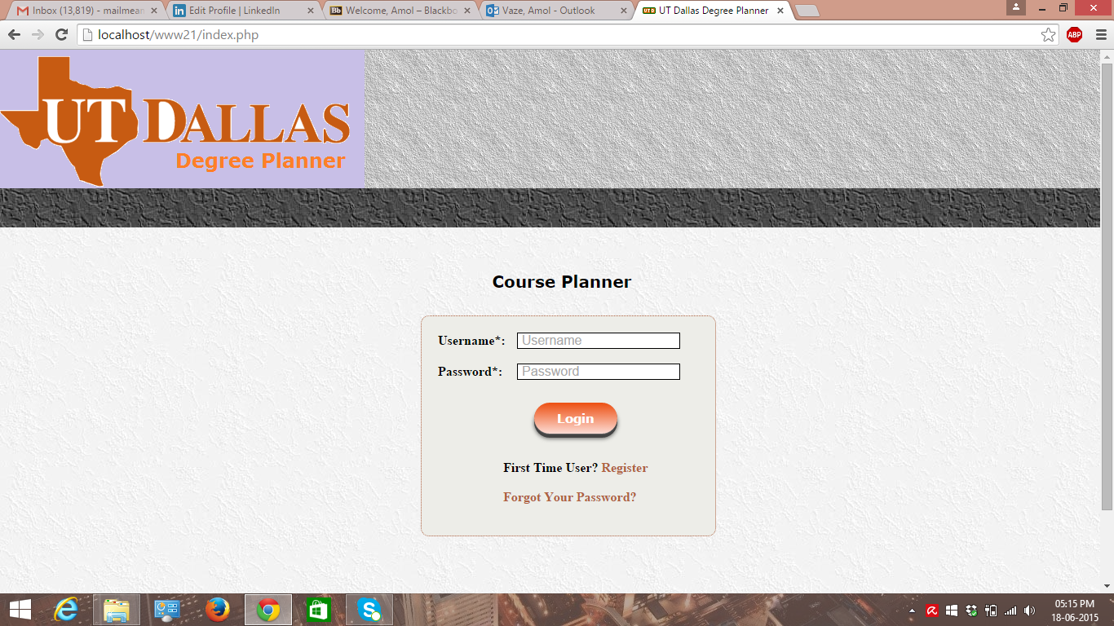

* **Mainform.**php allows to choose a particular track & then proceed with login. It also does client side validation. After successful login, student user will be taken to Login.php page.

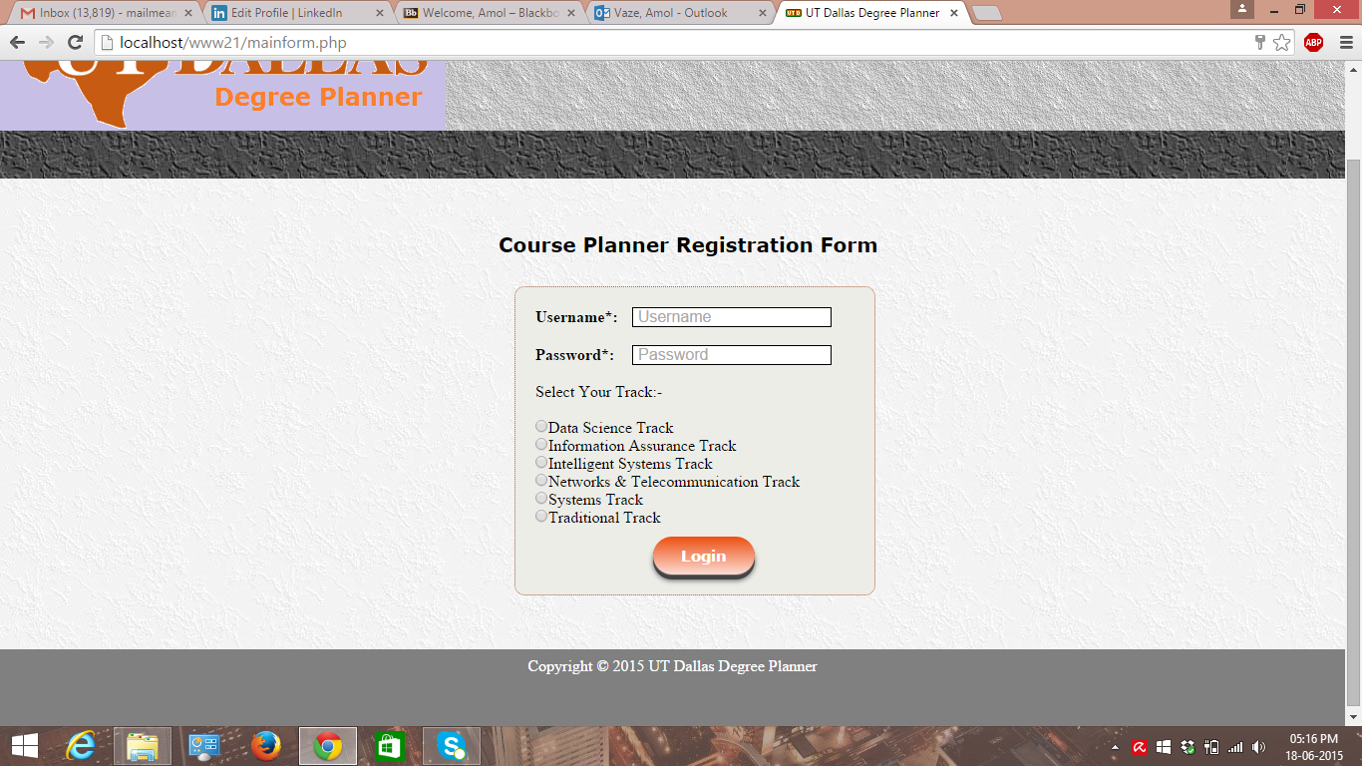

* **Login.php** has a UTD degree planner form & student user will have to fill all the needed details to get updated GPA record. It also does required validation of fields.

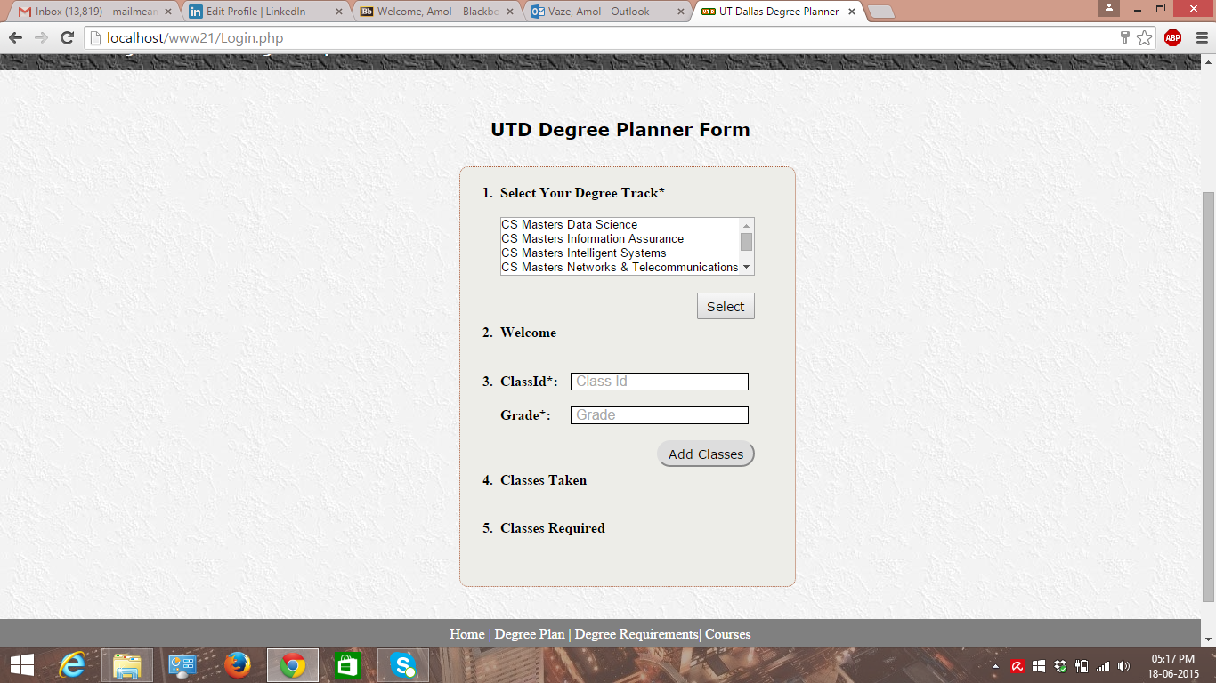

* **Degree-plan.php** page will be visible once student has logged in into system & it has the degree plan for Data Science track.

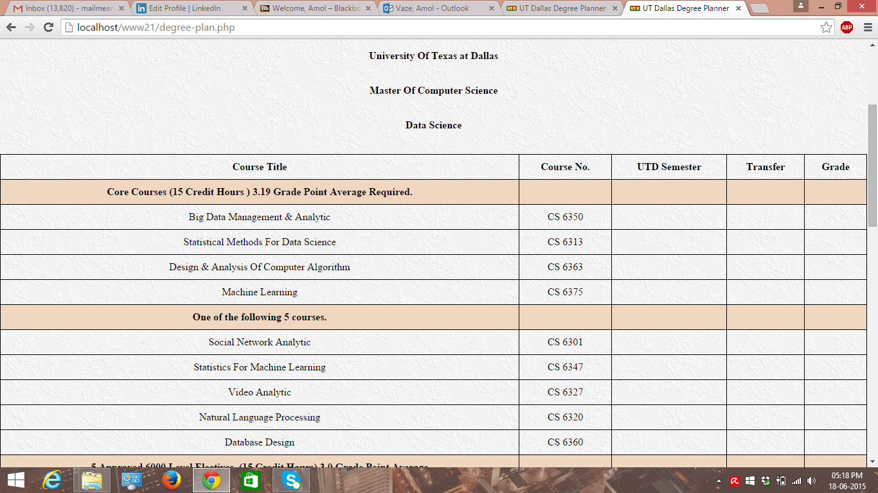

* **Degree-Req.php** page will be visible once student has logged in into system & it describes the degree requirement for all CS track with their respective core and elective courses requirement for M.S.

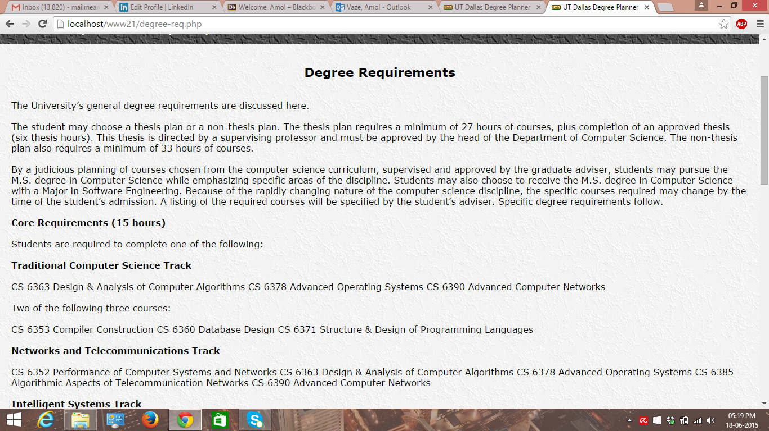

* **Courses.php** page will be visible once student has logged in into system & it has a list of 5000 & 6000 level courses.

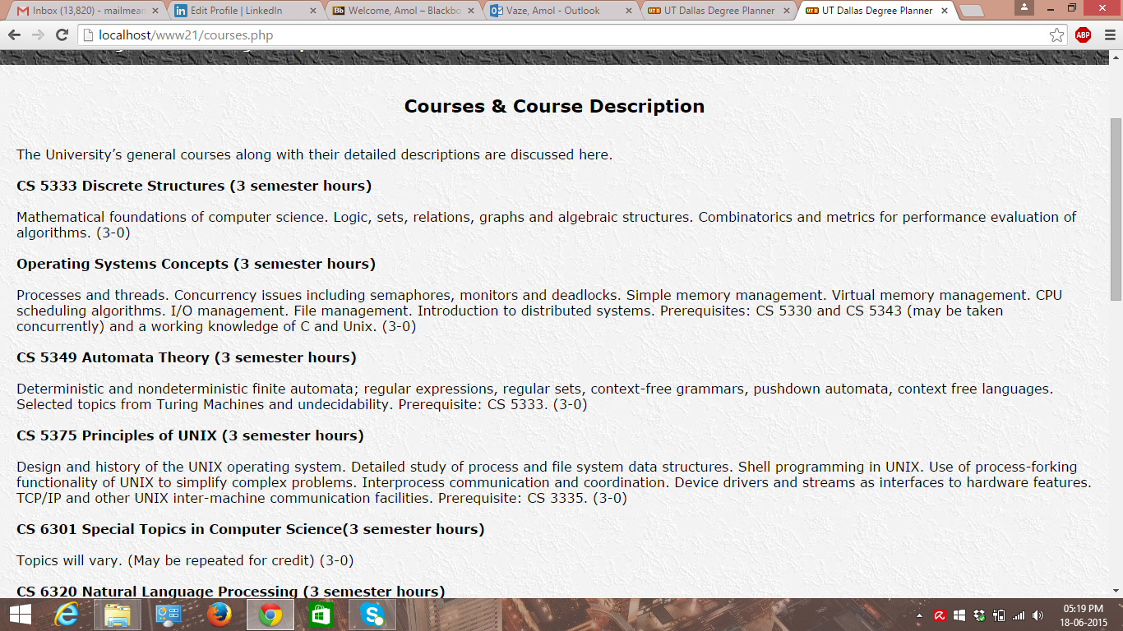

* **Acknowledgement Form.php** is aseparate web page which has Master’s acknowledgement form & **degree-req** web page has the **link** to this form at bottom of the page.

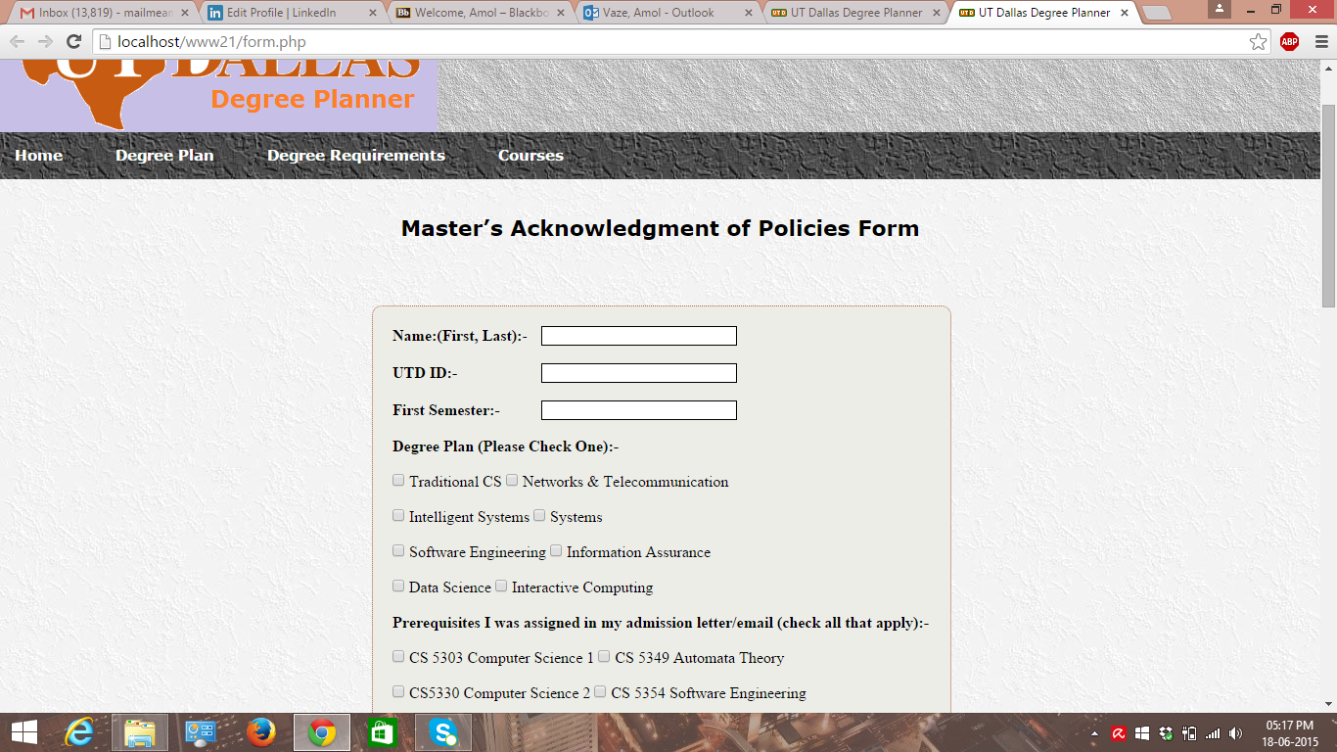

* Web design includes UTD logo & UTD favicon.
* For header & navigation-menu, gradient images have been used.
* Finally, a footer has all web pages links for the purpose of navigation.

**P.S:-**

1. The important point here is that for client side JavaScript validation, it is working with any valid email-address & for any password because, server side validation using database & PHP is not a part of this homework.
2. The functionality part of the system will be done in future homework assignments. This is only related to the GUI part of the system.

Validation Part Screenshots are as follows:-

This is validation part for home page.

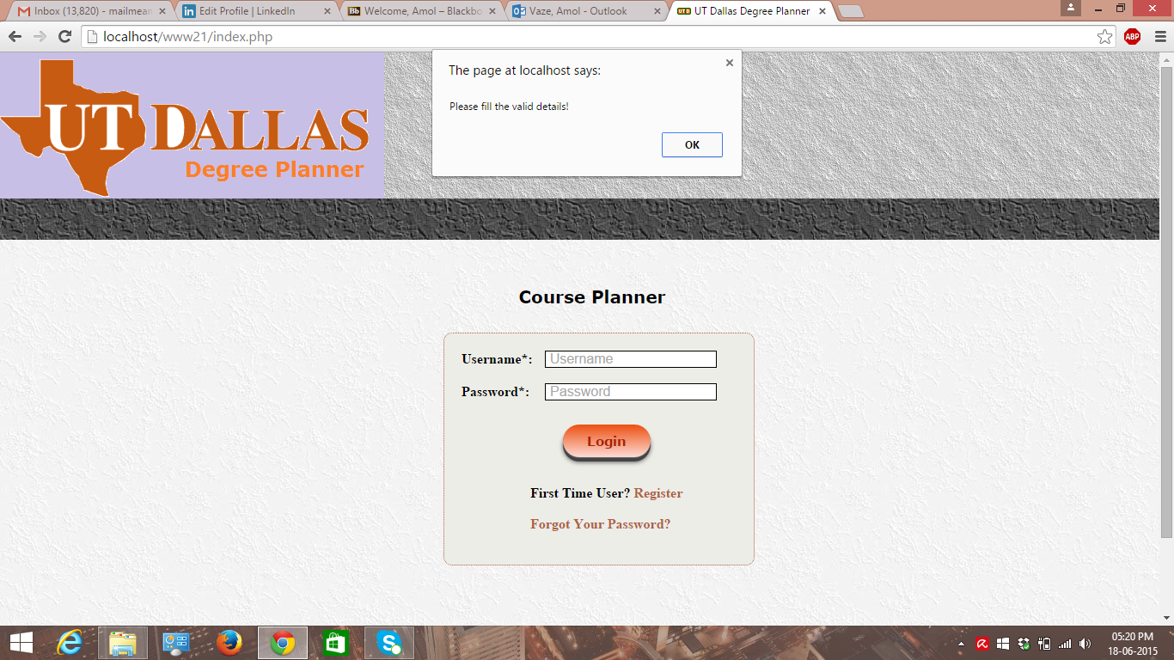

This is validation for radio button checking!

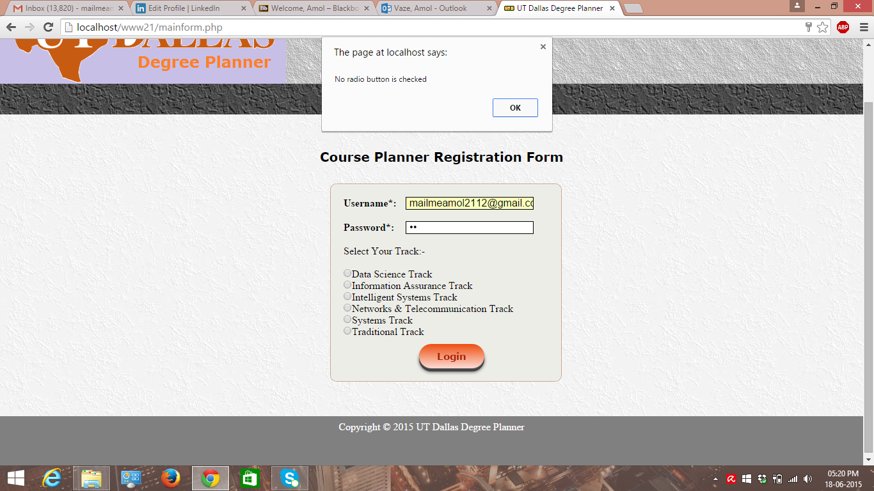

This is validation part for all fields entered.

