**CS6301.0U1- Web Programming Languages**

**(By Amol Vaze – Net-id: - asv130130@utdallas.edu)**

**Assignment- No-3 Design Documentation**

* **Assignment No-3** focuses on design & implementation of fully functional UTD degree course planner system for all tracks given.
* My degree planner GUI web page design consists of following files which I have created under a new directory called **www21** under WAMP server (localhost).
* Link to access my local system:- **http://localhost/www21/index.php**
* User should be able to select multiple tracks in this system.

Design documentation for my degree planner system with requirement specification and use cases can be as follows:-

* **Requirement Specification (SRS Documentation)**
* The main purpose of the system design is to give user a facility to view degree plan for CS Masters courses once completed upon successful login.
* System should be able to provide the user with navigation in order to make its use easy for user.
* System gives the user privileges to view grades, add classes, updated, delete classes & update grades via GUI.
* System does have facility for core course requirement, prerequisites courses, transfer/waived courses check.
* System prompts the user about the graduation status when core and overall GPA is computed.
* System does compute no of credit hours that the user has completed and no of pending credit hours for them.
* System does check for duplicate courses if user tries to register for class which has already been enrolled.
* System does the needed client side validation using Javascript.
* **Use Case Diagrams for design[various use cases for system’s flow]**:-

1. **Login-Use Case**: - This use case defines the login flow of the system. It has student as actor & it includes forgot password & Register use case which takes care of the new user that is being enrolled into the system.

A screen shot of the same is attached for reference.

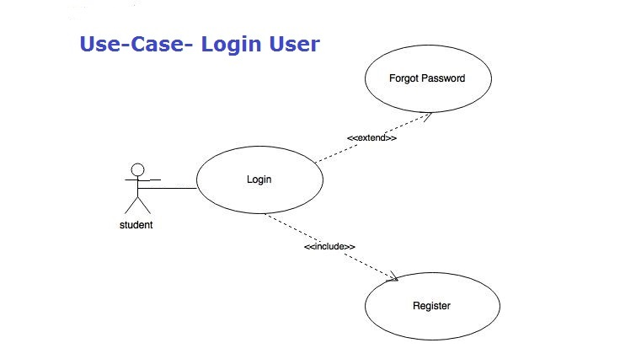

1. **Main- form Page Use Case**:-

This use case has a student as an actor of the system & once student has logged in with valid credentials, student has to select one of the degree tracks. Hence main-login form use case has a set of use cases which has various degree tracks.

A screen shot for the same is shown below.

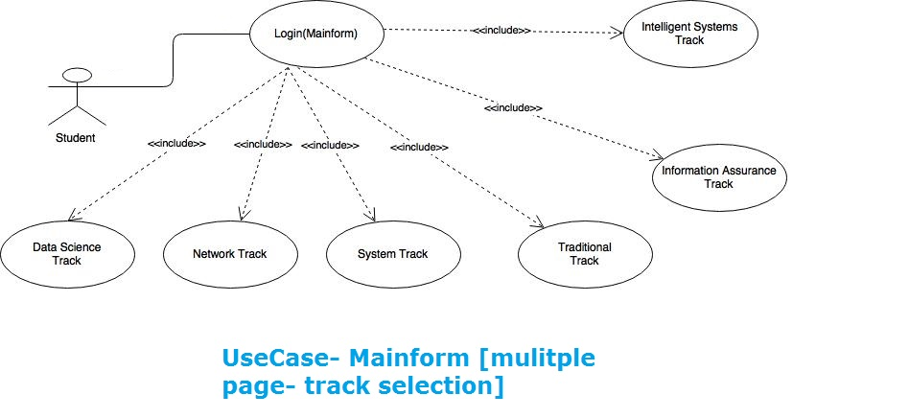

1. **Profile Page Use Case**:-

A profile page is a main web page of the system from where student should be able to navigate to check out degree plan for the particular track. Track selection use case describes it & it has a set of tracks. A user can have more than one degree track to choose from for the degree plan. A user should be able to manage (add/drop/update) classes with the help of add-classes use case.

Finally, use should be able to log out of the system. A separate use case for logout is shown.

A screen shot for this profile page use case is shown.

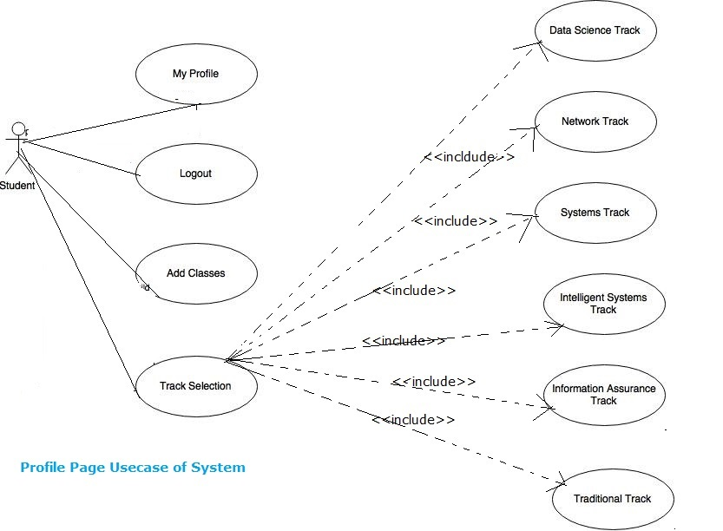

1. **Overall System flow Use-case model**:-

This is a use case which depicts overall system workflow where student should be able to use the system in efficient manner. User should be able to login to profile page and should be able to access degree plan & corresponding grades for the courses registered for. Also, user should be able to check core course requirement. A separate use case is designed for that.

A screen shot of this use case is shown below:-

