**Detailed Readme documentation by Amol Vaze**

* Technologies Used: - **HTML5, Bootstrap, JavaScript, JQuery Library.**
* The source for entire project can be found in files **index.html, test.js, data.json & styles.css**
* The **JSON** data used for the project was taken from: - <https://gist.github.com/RSpace/bba1b5067f79c6778cff> -given in PDF.
* **JQuery Autocomplete** Plugin is used for project.
* Screenshots are added to demonstrate system’s working.
* Project aims to satisfy the following functionalities.
  1. **Filtering while searching data**: -
     + - Application is able to search and filter out the given JSON details.
       - Application takes care of spaces and case of search query.
       - When searching/filtering is achieved, system is able to highlight matching text from organizations and/or work spaces.
       - Matching part of the text is being highlighted by yellow color as per Google search style.
       - When search results are cleared by moving cursor back, then when we hit one space, it shows all search results.
  2. **Keyboard navigation while searching the data:** -
* Depending on the Search Results content, horizontal and vertical scroll bar gets added to the drop down list.
* Clicking on active element ‘organization: workspace’, navigate to the appropriate link.
  1. **Scrolling mechanism**: -
     + - Regarding scrolling mechanism, as mentioned earlier, scroll bar is being added dynamically depending on size of list populated.
       - Component is having height of 80% of the viewport.
       - Resizing code is added in test.js to take care of resize issue.
  2. **Extra functions**: -
* On the navigation bar, there are few extra icons were added such as calendar.
* Cancel button in search box – to clear search results.
* Image of respective organization is displayed within search results list.

**Screenshots**

1. Screenshot for showing search results.

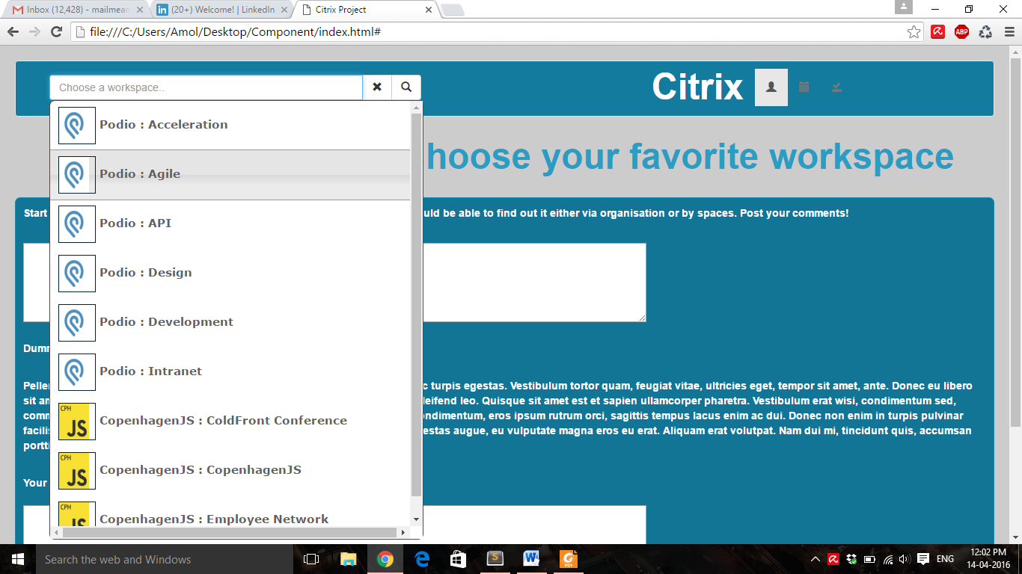

1. Screenshot for showing searching or filtering by Organization name shown with yellow coloured highlighting.

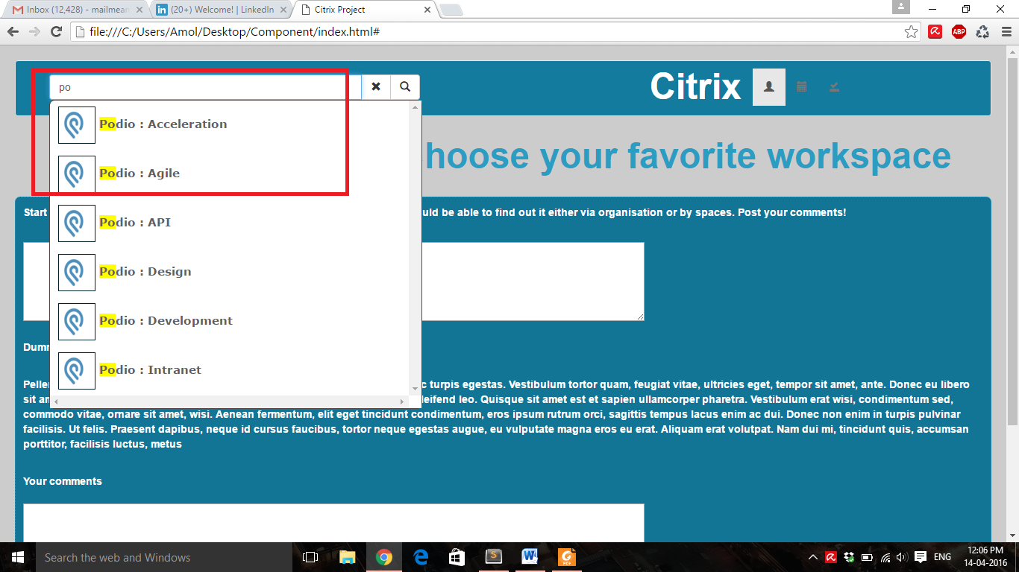

1. Screenshot for showing search results ignoring case & space both with yellow highlighting.

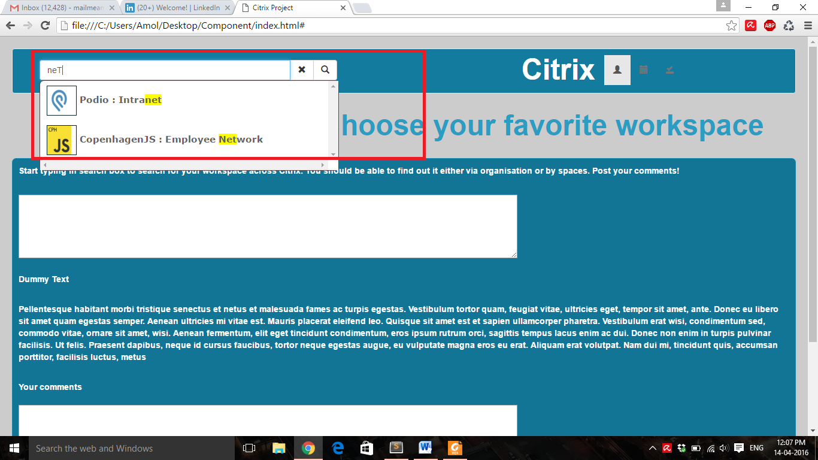

1. Screenshot for showing the active link after navigating.

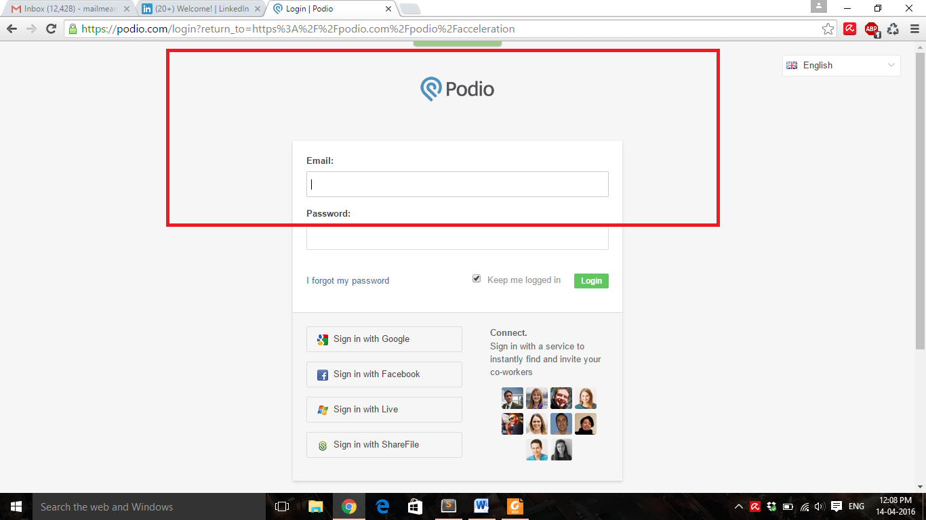

1. Screenshot after clearing typed text by clicking on Cancel button.

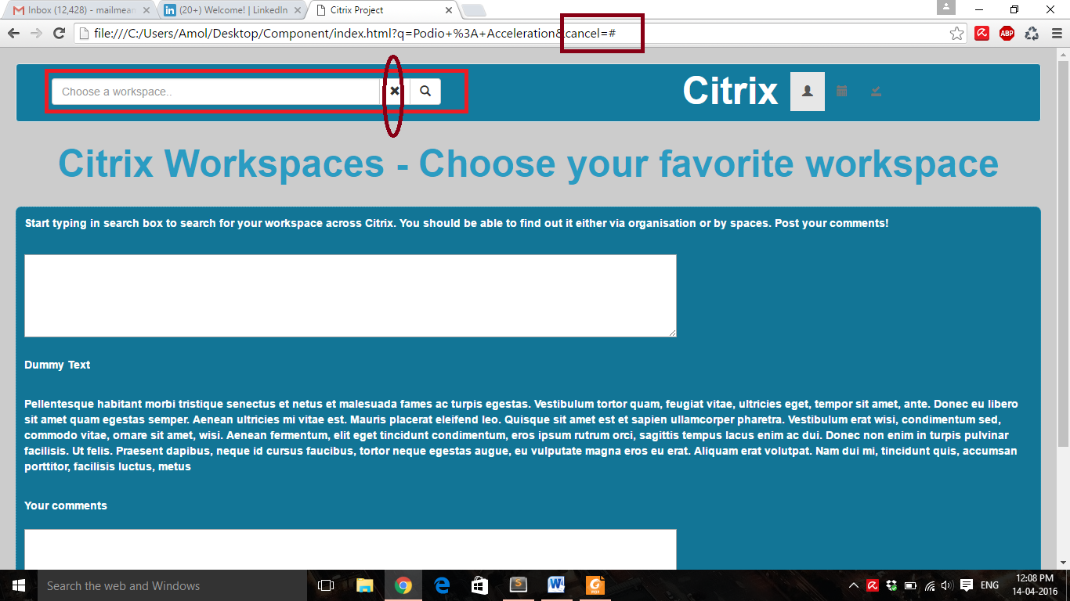

1. Screenshot for min search results & hence scrollbar has gone.

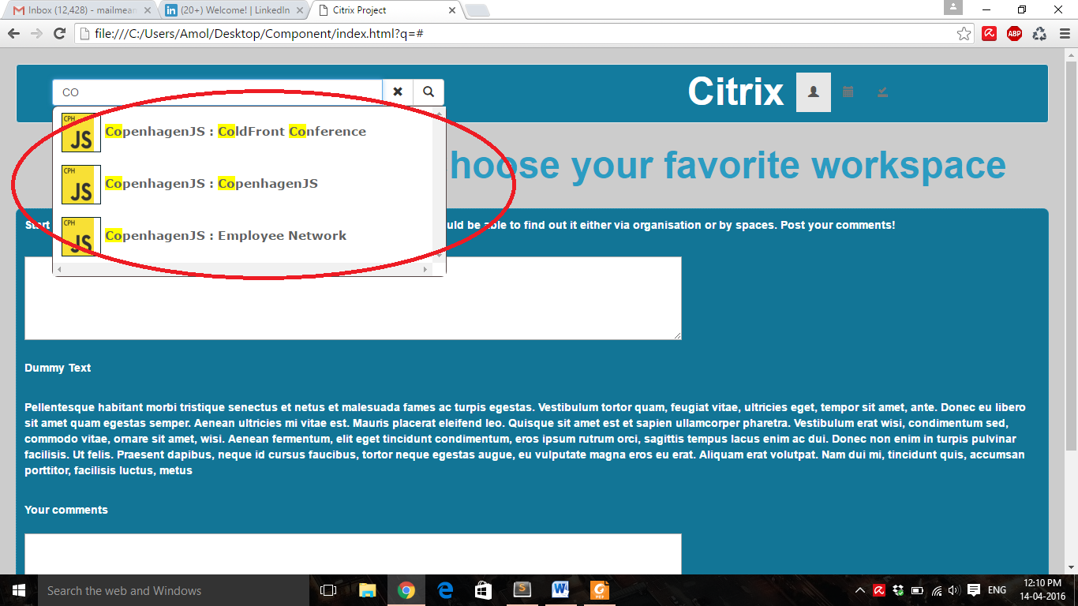

1. Screenshot showing date-picker calendar.

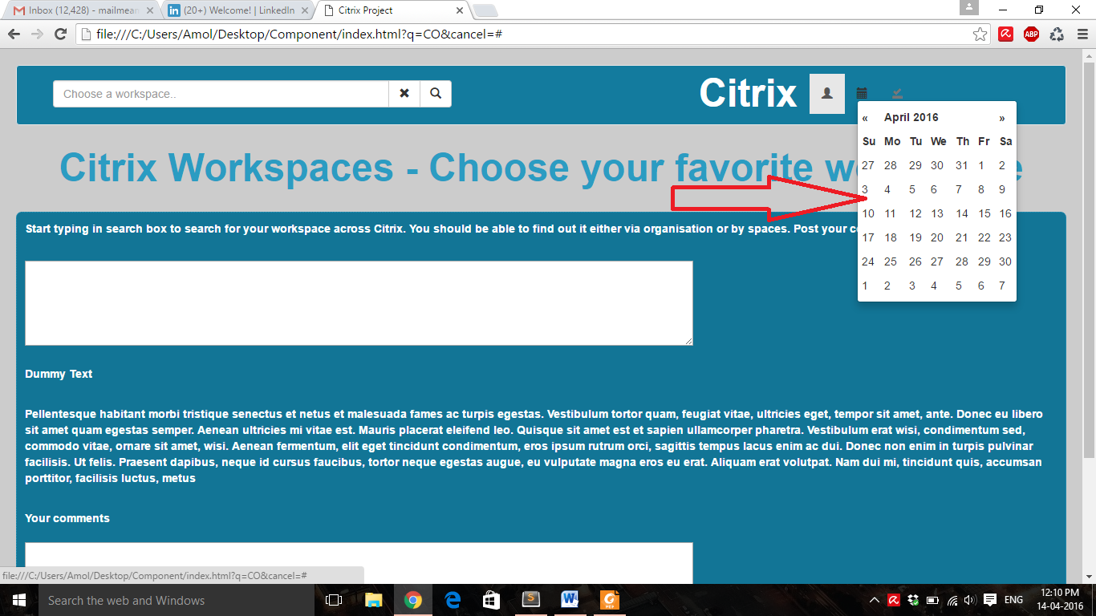

1. Screenshot showing search button implementation along with search box.

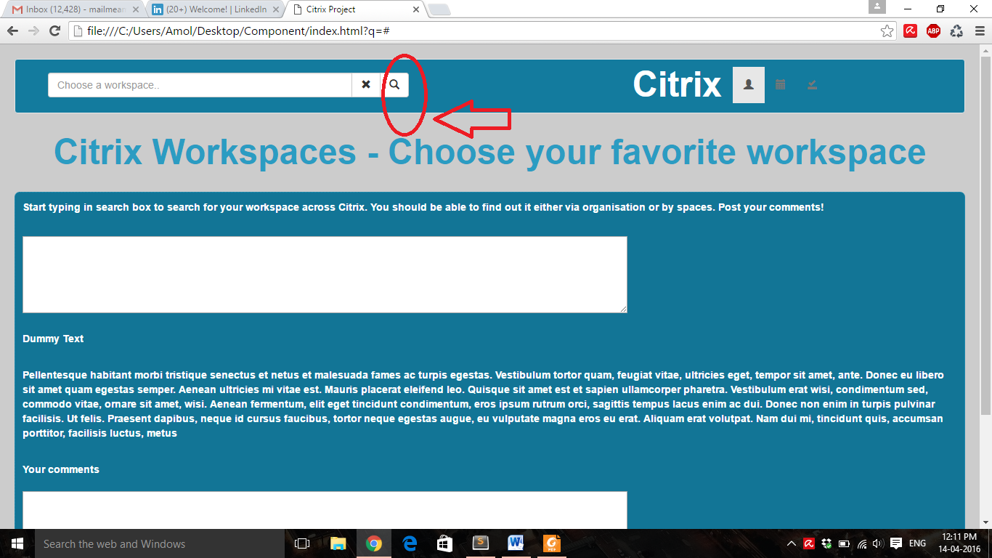

1. Screenshot showing no search results when something is typed not found.

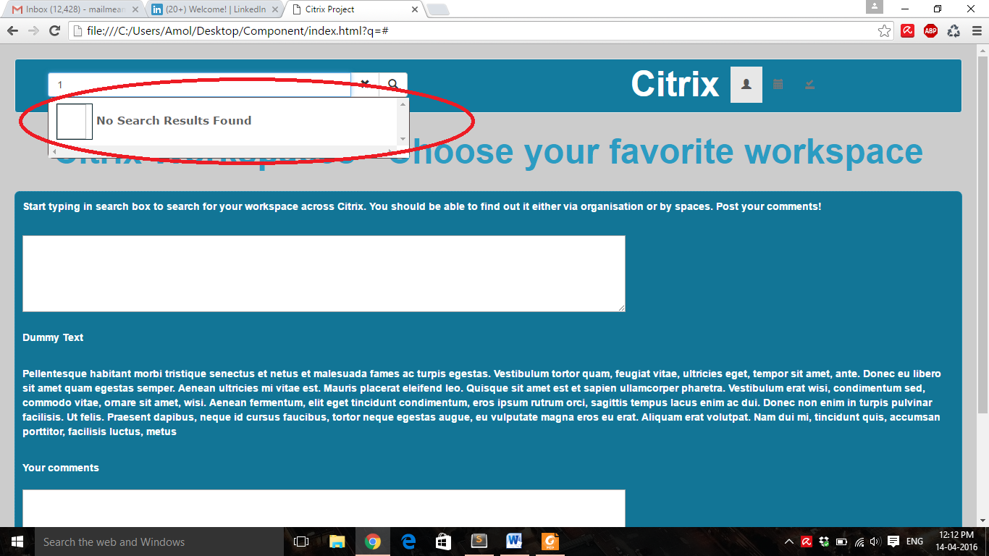

1. Screenshot showing search results when input field is cleared.

