CS 6301.0U1 – Web Programming Languages

Weekly Assignment No -02 by Amol Vaze (Net id :- asv130130@utdallas.edu)

Brief (Read Me)Documentation Of Assignment:-

* In this assignment of project-1, as per the question given, a new link for related photos has been added & then corresponding related images have been added.
* When we click on related image, the larger size of it will be opened in the new window.

HTML Code:-

<!DOCTYPE html>

<html>

<head lang="en">

<meta charset="utf-8">

<title>Share Your Travels -- New York - Central Park</title>

</head>

<body>

<header>

<h1>Share Your Travels</h1>

<h2>New York - Central Park</h2>

<nav>

<ul>

<li><a href="#description">Description</a></li>

<li><a href="#review">Reviews</a></li>

<li><a href="#related_photos">Related Photos</a></li>

</ul>

</nav>

</header>

<article>

<section>

<h3 id="description">Description</h3>

<p>Photo by Randy Connolly</p>

<p>This photo of Conservatory Pond in

<a href="http://www.centralpark.com/">Central Park</a> in

<a href="newyork.html">New York City</a> was

taken on October 22, 2011 with a Canon EOS 30D camera.

</p>

<figure>

<a href="images/large-central-park.jpg"><img src="images/central-park.jpg" alt="Central Park" title="Central Park"/></a>

<figcaption>Conservatory Pond in Central Park</figcaption>

</figure>

<p>Share: <br/>

<img src="images/social/email_16.png" alt="Email this to someone" />

<img src="images/social/rss_16.png" alt="Syndicated content" />

<img src="images/social/twitter_16.png" alt="Share this on Twitter" />

</p>

</section>

<section>

<h3 id="reviews">Reviews</h3>

<div>

<p>By Ricardo on <time>September 15, 2012</time></p>

<p>Easy on the HDR buddy.</p>

</div>

<hr/>

</section>

<section>

<h3 id="related_photos">Related Photos</h3>

<figure>

<a href="images/related-large1.jpg"><img src ="images/related-square1.jpg" alt="Large 1" title="related large 1"></a>

<a href="images/related-large2.jpg"><img src ="images/related-square2.jpg" alt=" Large 2" title="related large 2"></a>

<a href="images/related-large3.jpg"><img src ="images/related-square3.jpg" alt=" Large 3" title="related large 3"></a>

</figure>

</section>

</article>

<footer>

<p><em>Copyright &copy; 2013 Share Your Travels</em></p>

</footer>

</body>

</html>

Screenshots:-

Screenshot-1

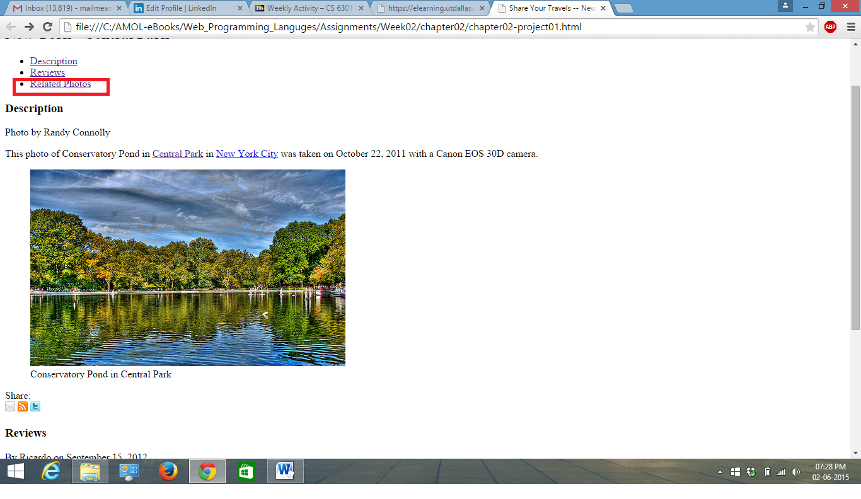

Screenshot-2

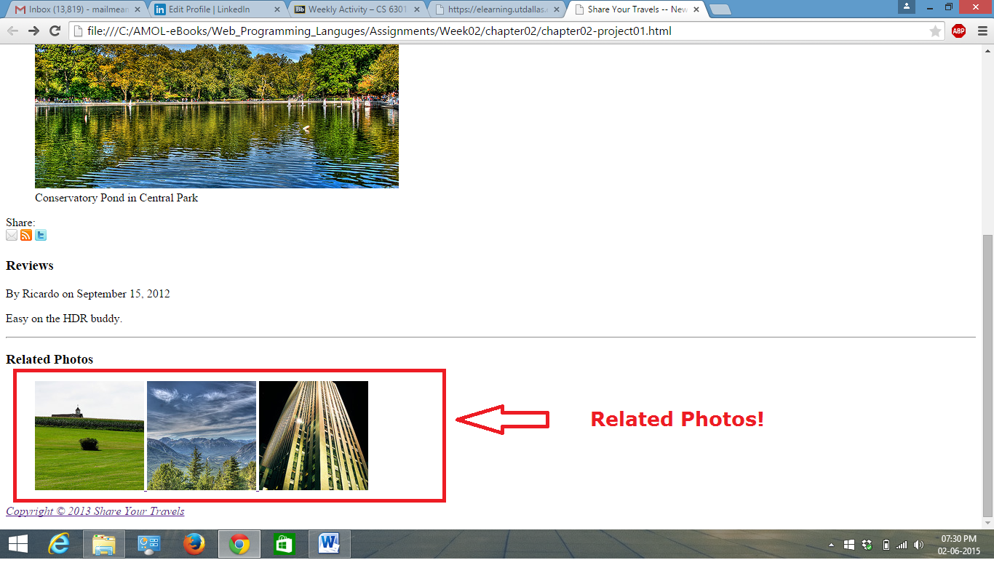

Screenshot-3

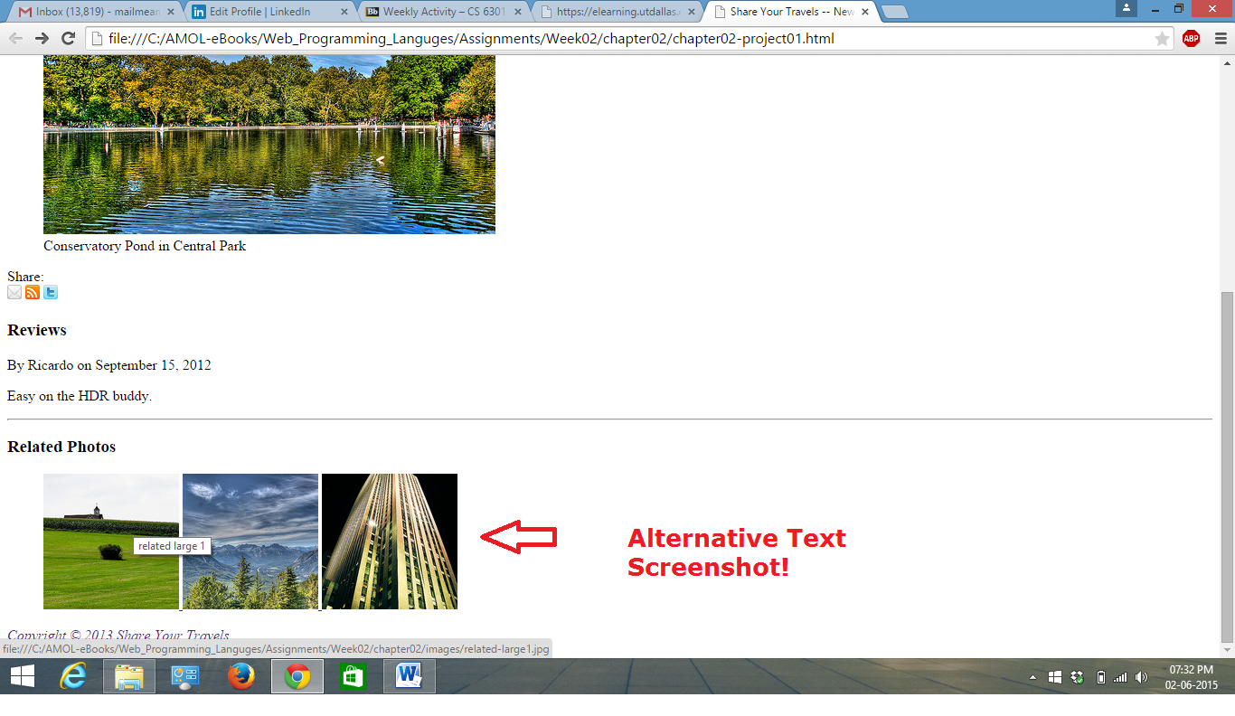

Screenshot-4

