**CS 6301.0U1 – Web Programming Languages**

Weekly Assignment No -06 by Amol Vaze (Net id :- [asv130130@utdallas.edu)/](mailto:asv130130@utdallas.edu)/)

Due Date July 11, 2015, 11.59 PM Midnight.

**Brief Documentation**

* This assignment involves downloading & installation of Selenium IDE using Firefox web browser. Download & installation is done as per the instructions given in the assignment question.
* Various test cases using Selenium IDE have been ran for UTD Degree Planner project and sample screenshots for various scenarios are attached below:-

This is a test case for login (HTML saved test case sample file.)

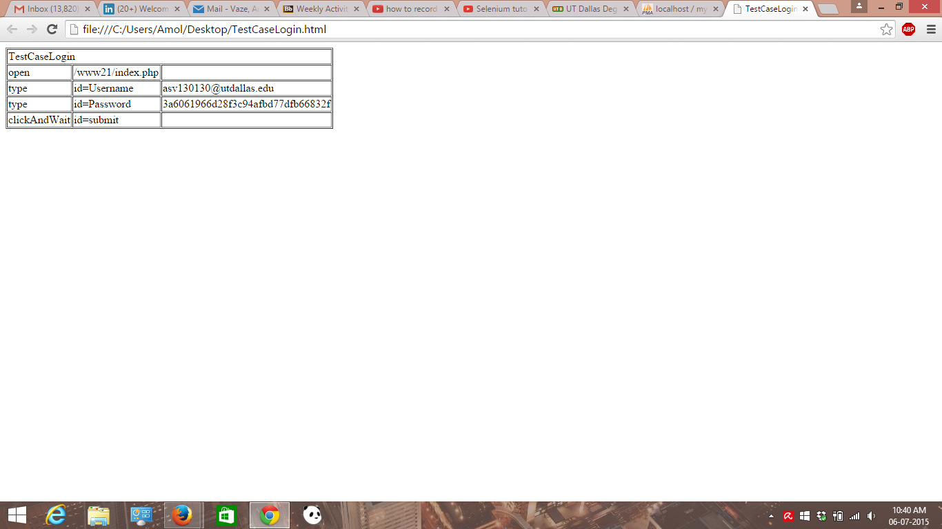

Below is test case for showing Selenium IDE installed in FireFox at RHS top corner.

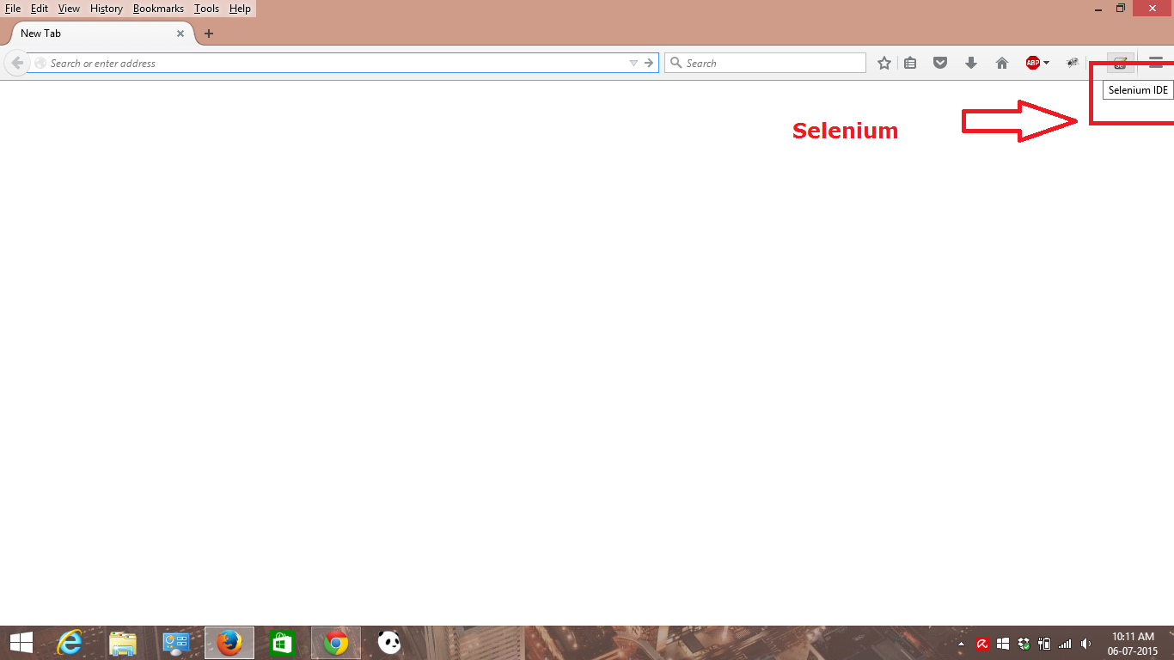

Below is screenshot for interface of IDE.

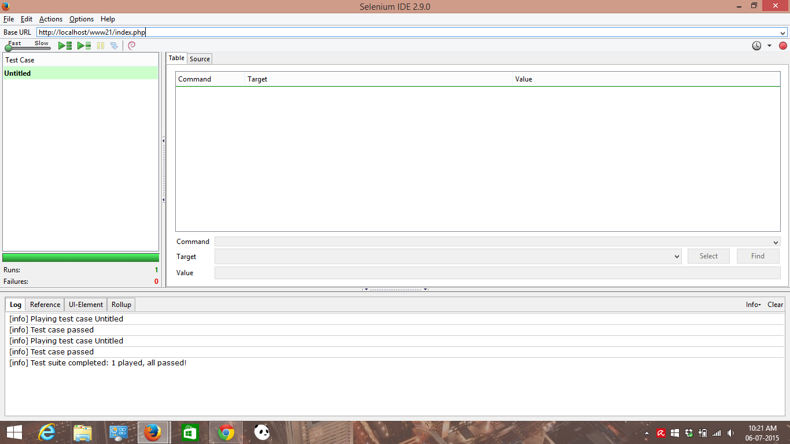

Below is Home page of Degree planner test case screen shot.

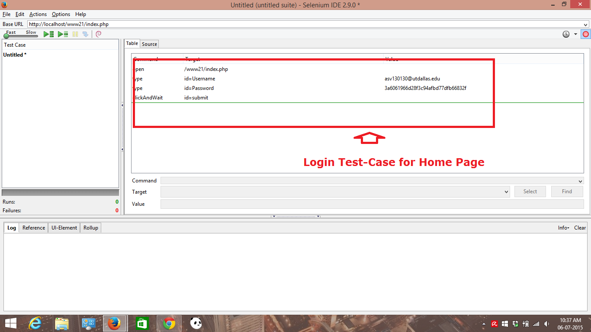

Login Test case again with details :-

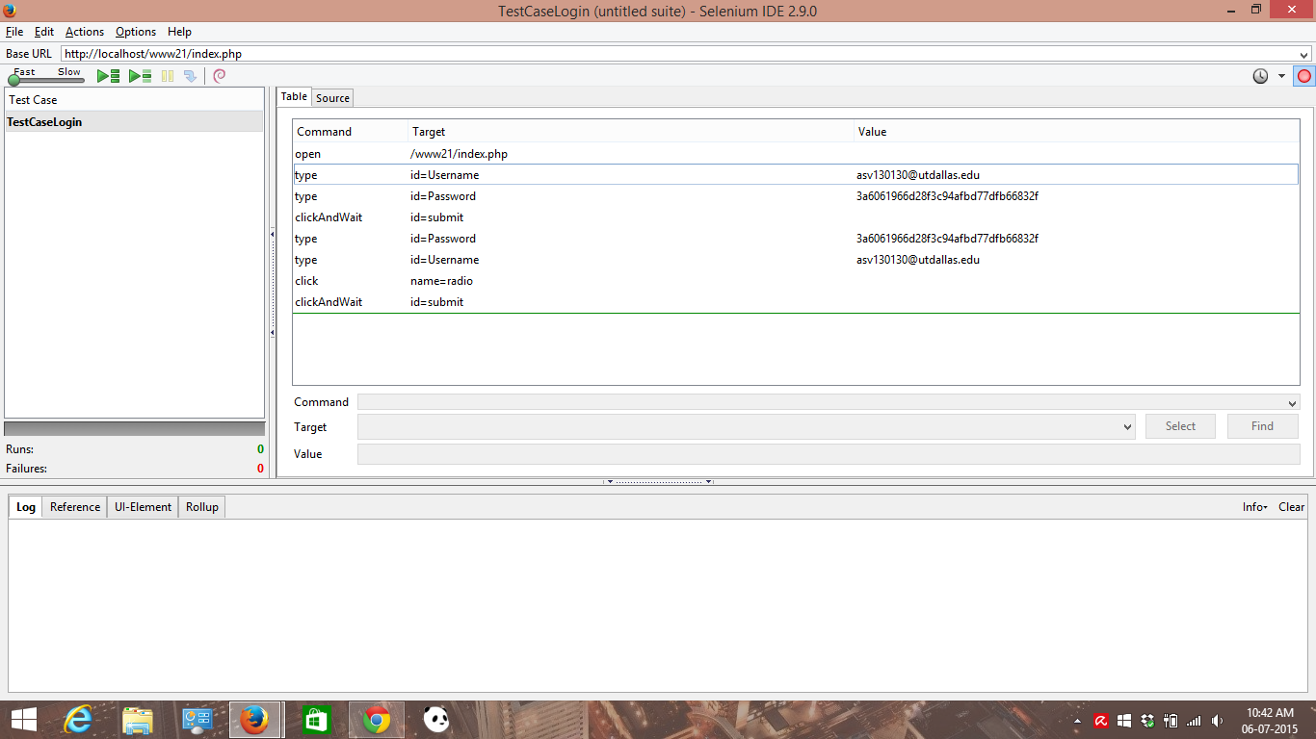

Login Test case with track & semester selection is shown below.

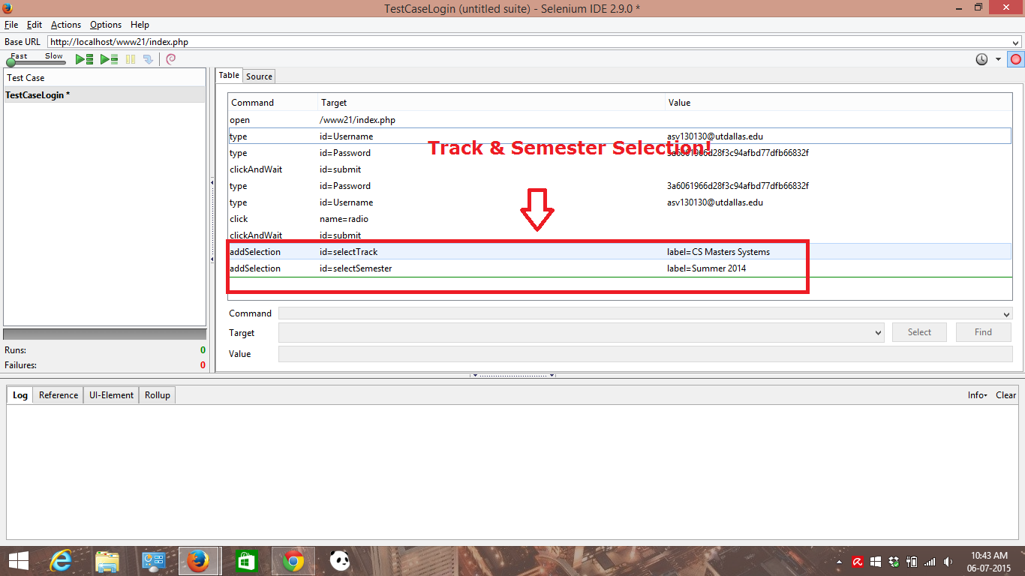

Below screenshot shows Test case for Add button click on profile page!

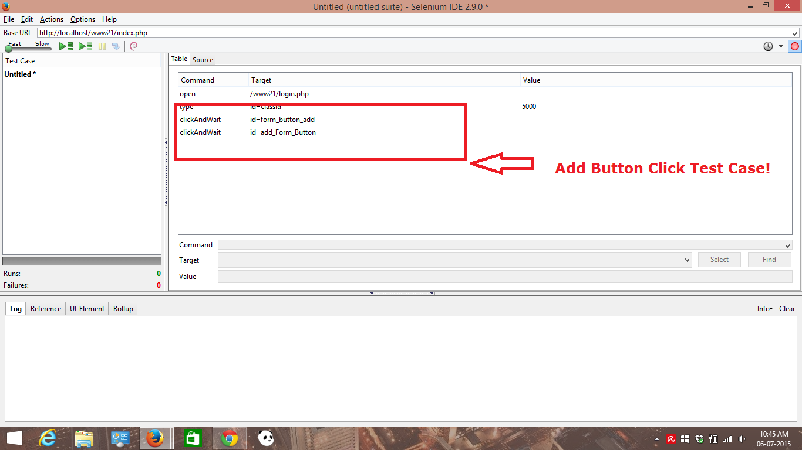

Below is test case for external link click & log out of the system!

