

**USER**

**MANUAL**

Database Backup Utility

**for SQL database backup**

Prepared by: Amol Wabale

June 2017

**Revision Sheet**

|  |  |  |
| --- | --- | --- |
| **Release No.** | **Date** | **Revision Description** |
| Rev. 0 | 15/7/2017 | User’s Manual Created |
|  |  |  |
|  |  |  |
|  |  |  |
|  |  |  |
|  |  |  |

**USER'S MANUAL**

Contents

1 GENERAL INFORMATION 1-1

1.1 System Overview 1-1

1.2 Acronyms and Abbreviations 1-1

2 SYSTEM SUMMARY 2-1

2.1 BackUp Settings 2-1

2.1.1 Server Credentials 2-1

2.1.2 Back Up Location 2-1

2.1.3 Database 2-2

2.1.4 Backup Parameters 2-2

2.1.5 Backup schedule and type 2-2

2.1.6 Security 2-2

2.2 Mail Settings 2-3

2.2.1 Recipient List 2-3

2.2.2 Mail From 2-3

2.2.3 Password 2-3

2.2.4 Host 2-3

2.2.5 Port 2-4

2.2.6 Enable SSL 2-4

2.3 Backup Logs 2-5

2.3.1 Backup log Summary 2-5

2.4 Dashboard 2-6

2.4.1 Service 2-6

2.4.2 Forgot zip password 2-6

2.5 Help 2-1

3 Configuring DATABASE BACK UTILITY Error! Bookmark not defined.

3.1 Backup Settings 3-1

3.2 Mail Settings 3-2

**1.0 GENERAL INFORMATION**

# GENERAL INFORMATION

## System Overview

Database Backup Utility is software that is used to backup SQL database automatically as per the schedule designed by the user. It consist of two parts Database backup utility Ui which is a desktop software used to set the backup configuration, and the second part consist of Database backup Utility Service which runs in the background and does the actual work of backup. The Utility provides functionality to take Full or Differential backup depending on the settings that you provide.

The mail feature provides the functionality to receive backup updates on your mail, you can add list of recipients to receive the mail accordingly.

## Acronyms and Abbreviations

DBU – Database Backup Utility.

**2.0 SYSTEM SUMMARY**

# SYSTEM SUMMARY

## BackUp Settings.PNGBackUp Settings

### Server Credentials

Enter the server name, user Id and password of which you would prefer to take database backup.

After entering the credentials click on Test Connection to check whether the connection is successful or not.

### Back Up Location

After successful server connection it is necessary to set the backup location, here you can give your local drive path or any path on network which is accessible, Back up (.bak) file will be stored in this location

### Database

Select the database that you want to back up by clicking on Select Database button. Selected database will be shown in the list box.

### Backup Parameters

Here in this section it is necessary to provide time for the backup. Time should be provided in 24 Hrs format.

### Backup schedule and type

In this section you can select backup type that is Full or Differential as per the day and the requirement.

### Security

In this section if you want to give password to the backup file than you can provide the password here.

## Mail Settings

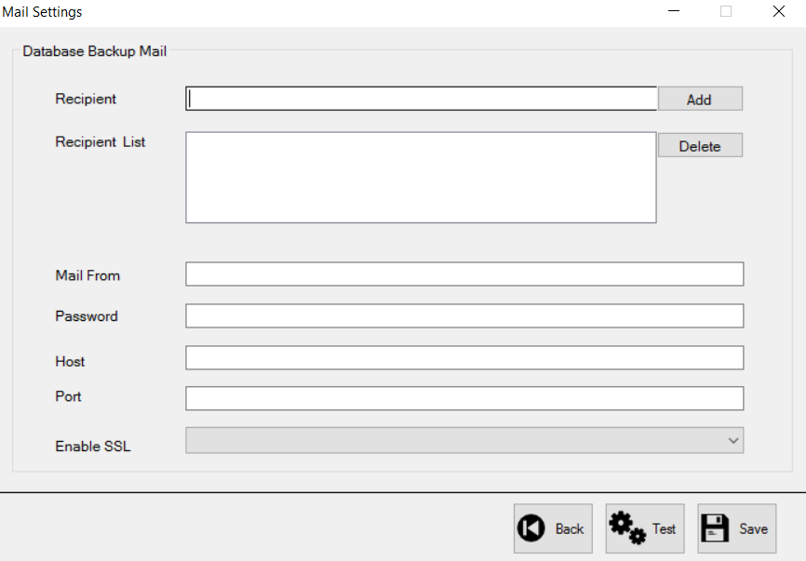

### Recipient List

Add recipient to recipient list, it is the list of mail who will receive the mail of backup status on every backup performed by the Utility, you can add multiple emails in this list.

### Mail From

Enter the mail from which you wish to send the mail, Utility will use this mail to send backup status to the recipient mail.

### Password

Enter the password of Mail from in order to authenticate it

### Host

Enter the host of mail.

E.g. if your mail id is of gmail, than host is smtp.gmail.com

### Port

Enter the port number, Port number should be numeric value

### Enable SSL

Enable ssl should be Boolean value either true or false depending on the host requirement for validation of credentials.

**Test Button**

You can also test the mail settings by clicking on test button, a test mail will be sent to the recipient list, if all the settings are correct

## Backup Logs

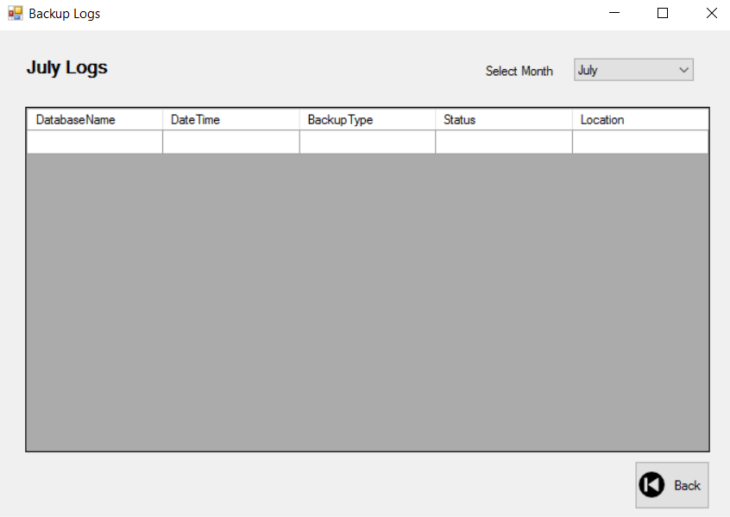

### Backup log Summary

In this screen you will get the complete details of backup that were taken month wise.

## Dashboard

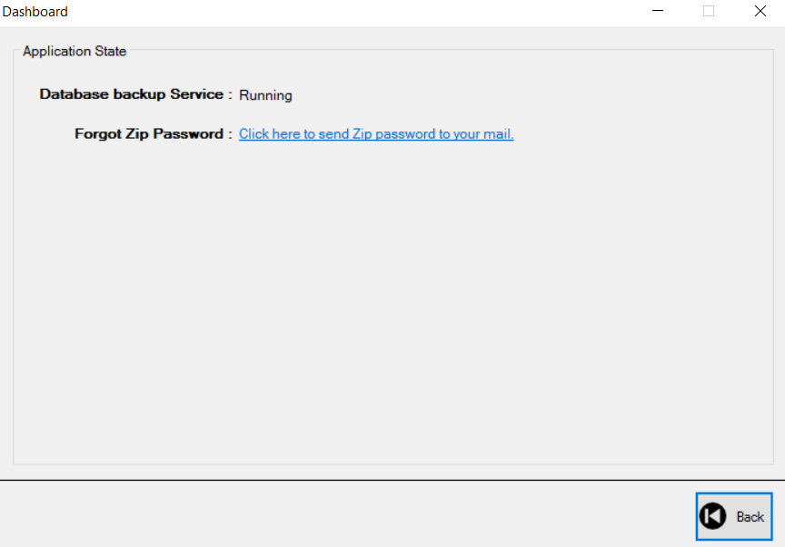

### Service

The Database backup service should show status as running when you save the backup settings for the first time. If the status shown here is stopped than there will be no back up taken. Please make sure to always check the status after saving the back settings.

### Forgot zip password

This functionality will send password on the mail of all the recipient in the list

## Help

This button will open user manual, currently that you are reading…

# Configuring Database Backup Utility

## Back Up CONFIG.pngBackup Settings

## Mail Settings

