Step 1:- Please go to “<https://github.com/amolzore/nisum-coding-test>”. Click on “Clone or download” button, to get git url as shown below.

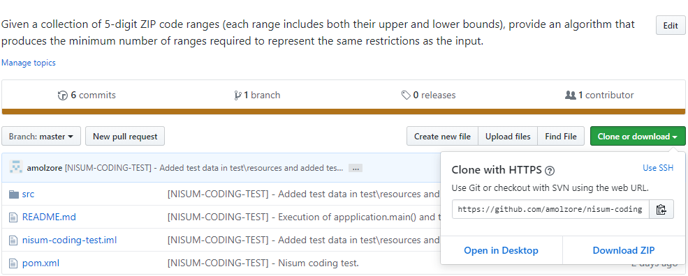

Step 2 :- Check-out an algorithim from git link. Chckout can be done in number of ways. One using git CLI ( i.e. git clone <https://github.com/amolzore/nisum-coding-test.git> ) and another using using editor and etc. To do from editor please open Intellij IDEA and click on “Git option of Check out from Version control” as shown in below screen.

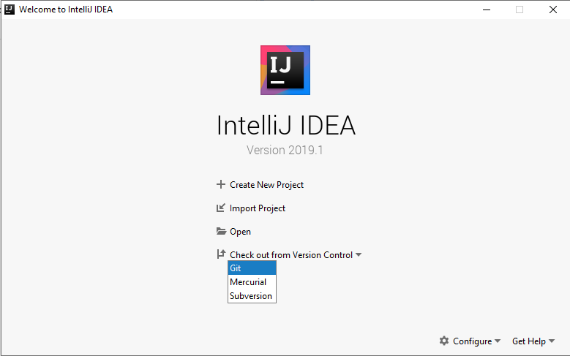

Step 3: Please enter the git url (#step 1), in the URL input box and Directory where algorithm will be checkout. Then click on “Test” button to verify the git link connection and then click on “Clone” button.

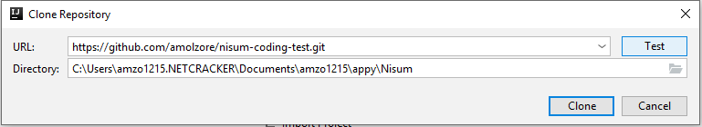

“Clone” button click start the project checkout (I.e. cloning). Please check below screen

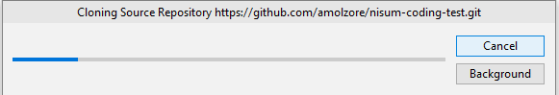

Step 4: Algorithm will be opened in the new window of Intellj editor. That looks likes

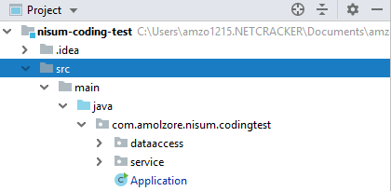

In the project explorer please open “Application” java file by double clicking on it. You can see on left hand side Application demo and it will looks like

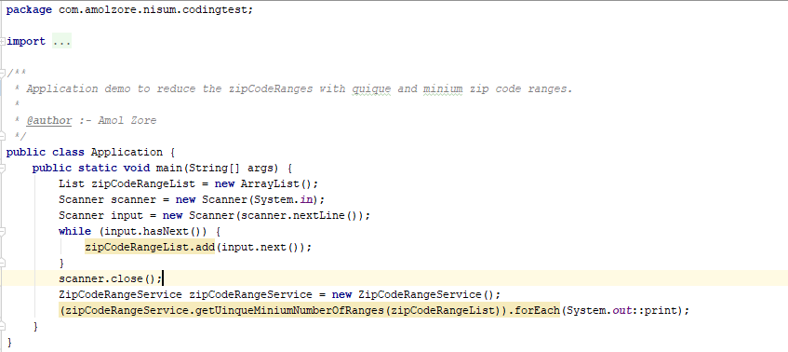

Step 4:- Right click on “Application” java file and select “Run Application.main()” as shown in screen

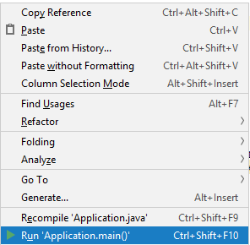

After that run tab will open as shown and there please enter the inputs “94133,94133] [94200,94299] [94226,94399]” and hit enter to get the unique minimum zip code numbers.

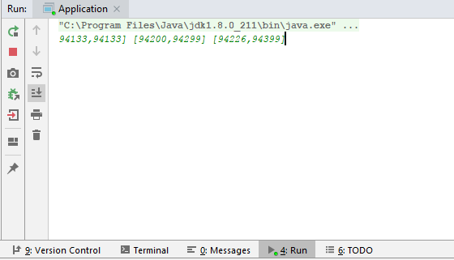

Out will be printed on terminal

