Portfolio — Ali Momen

Name: Ali Momen
Email: amomen@gmail.com
Phone: +31634397167
Location: Leiden, Netherlands
Last Update: 10/10/2025

Current Occupation: Just started Master’s program in Data Science and Artificial Intelligence at Leiden University
Portfolio statement: I combine a decade of production-grade database engineering and automation with teaching and applied analytics; my work focuses on reliable data infrastructure, reproducible analysis, and deployable analytics for high-stakes domains.

Selected projects

These projects were carried out for personal interests or from mostly the last 2 job positions

1. Automatic country-wide branch downtime report — Keshavarzi Bank (Jan 2021)
Role: Network engineer, (DBA & data automation).
Scope: Nationwide report consolidating branch availability metrics and automated alerting.
Tools & methods: T-SQL, R, scheduled jobs; reporting pipeline; clustered SQL Server environment.
Outcome / impact:
Contribution for the following: 100%
Reduced manual reporting effort and error and improved operational visibility for reporting outages for the bank’s more than 1700 branches country-wide (https://en.wikipedia.org/wiki/Bank_Keshavarzi_Iran). The incidents also are relatively numerous due to various reasons including power outage, unstable links, routers misconfigurations, and poor maintenance services. Our team was composed of 12 members. Manual reporting took more than an hour every day, was prone to errors, and was inaccurate with respect to the time it was delivered. The automated report was prepared and sent in a matter of seconds (Completely effortless and time reduction from over an hour to 10 seconds overall). The result, meaning the email body and spreadsheet attachment were dynamically generated and conditionally formatted. The English translation of an example figure of the spreadsheet file is below (Employer data has been replaced by sample data):
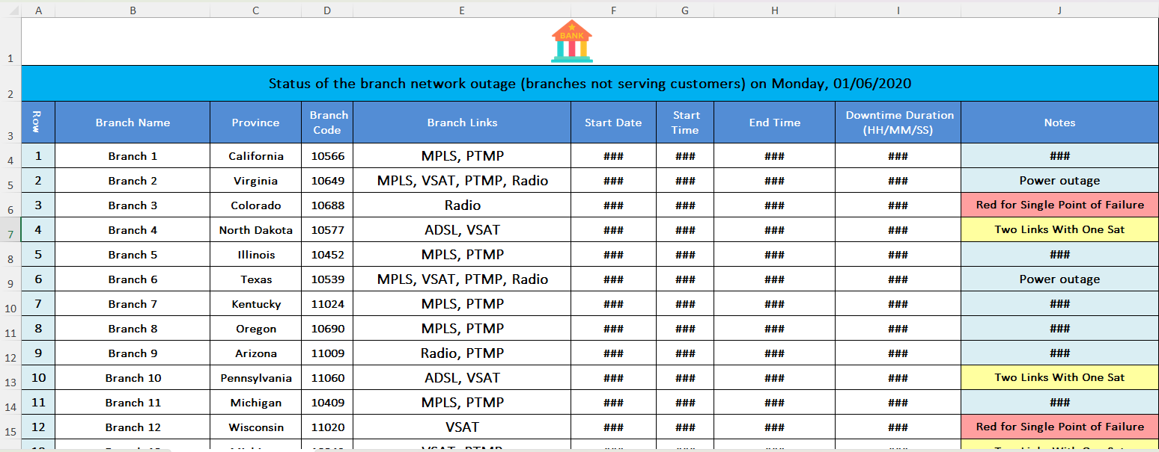
The part of the article that is allowed by the employer to be published publicly is on the link below:
https://github.com/amomen9/SQLServer-DBA-Tools/blob/main/Send%20Formatted%20Excel%20File%20with%20Email/README.md

2. SQL Server cluster administration, legacy-to-modern migrations, automation of dynamic database creation for every B2B customer, designing a procedure for the complex task of multi-tenant database migrations and new database creation — JobVision & HRCando (Nov 2021 – Nov 2023)
Role: Senior Database, Data Developer & Administrator; led migrations and cross-administration procedures
Scope: Plan and execute migrations from legacy systems to modern DBMS; implement HA/cluster patterns and cross-admin procedures.
Tools & methods: SQL Server clustering, migration scripts, CI/CD for DB deployments.
Outcome / impact:
Team members (Database Development and Administration, Data Reporting, ETL and BI Development, Data Analysis): 1 (myself)
Contribution for the following: 100%
- Improved reliability and maintainability of production systems. High quality data and schema legacy-to-modern migration (ETL) in a complicated and revolutionary migration task for an RDBMS with strict schema regulations, to cancel data loss for the current legacy system customers. The complexity was because the database system was turned into a multi-tenant database system with one database for every B2B customer from a monolithic database for all the customers. In the legacy system, much of the data was not normalized or was not in standard format and needed cleansing and transform. The relations had to be respected and new relations had to be defined, some data was transposed, schema changed significantly, and many multi-tenant databases had to be built out of one monolithic database.
- The proposed and carried out complicated multi-tenant B2B database migrations procedure and automated online database creation saved incredible time and effort and prevented data or schema inconsistencies and human errors while the same application connected to different B2B databases using ORM. The new databases were created in a matter of seconds. This also made this aim possible to allow the business operators to be able to create new databases with the required parameters from the application dashboard. By the time I left the company more than 220 B2B databases had been created on the instance.
The joint migration task with the developers team was also seamless, version controlled, fast, and easy-to-rollback in case of incidents and migration aborts by the b ackend developers team. It was being carried out online, and despite the high volume of databases (=220) the schema/data migrations did not typically take more than 1 minute for all of the databases serially.
- The sophisticated procedure of securely transferring and masking data from production to the test and staging environment for CI/CD purposes, making the developers able to also perform performance tests
- The proposed and carried out scheduled automated customer registration reports, made the managers and sales specialists capable not to miss important customer registrations and easily get their hands on their contact details. The moment a customer registered, the respective team was notified, and later as a daily report, the list of registered customers since the last report was dispatched to the team as a reminder. This is a sample of the report sent on a schedule that got its data from the database:
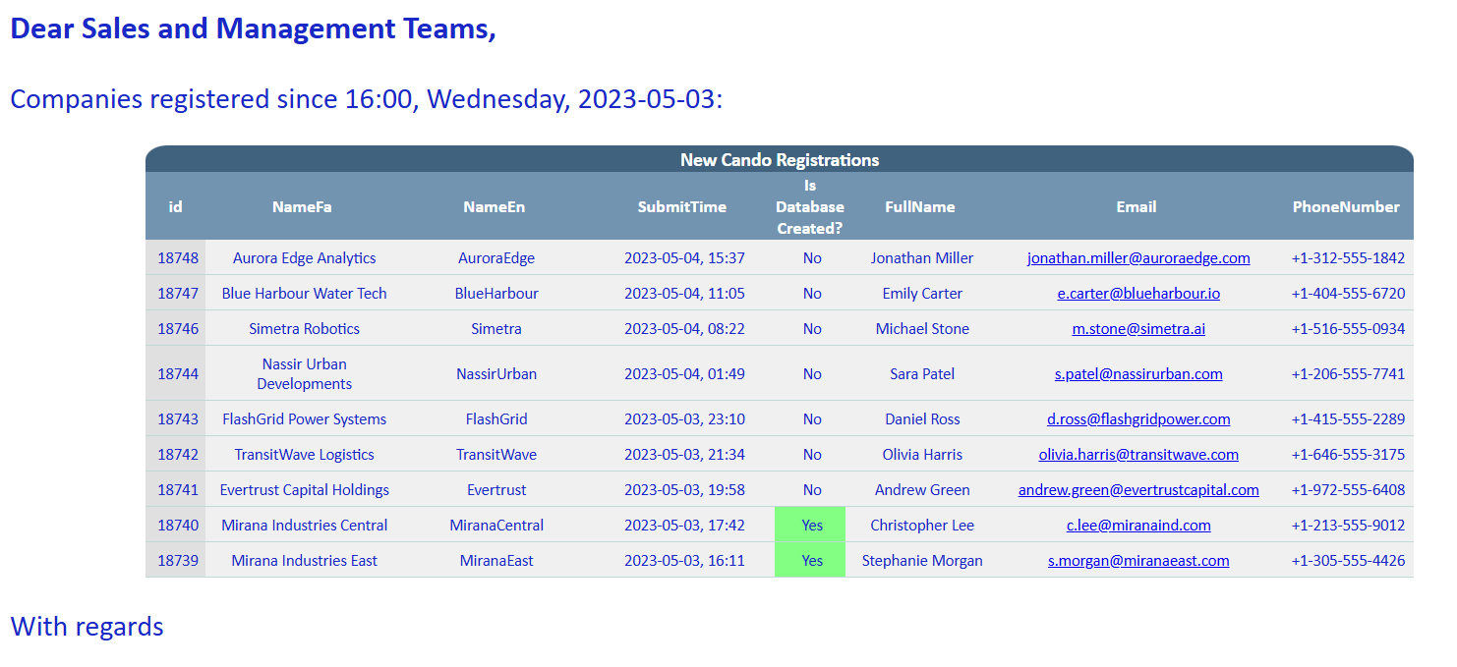

3. Automation & monitoring across multi-platform DB environments — Fanap Soft (Jun 2021 – Nov 2021)
Role: Database Administrator; automated processes via Bash and T-SQL; cross-platform monitoring
Scope: Implement automated maintenance, monitoring dashboards, and alerting across SQL Server, PostgreSQL, MySQL.
Tools & methods: Bash automation, monitoring tools (Zabbix, Red Gate, Grafana), T-SQL jobs.
Example of Automation Scripts:
Team members count: 4
My contribution to the following scripts: 100%
- PostgreSQL systemd Backup Automation:
- https://github.com/amomen9/PostgreSQL/blob/main/Backup/systemd%20Backup%20Automation/patroni.md
Scripts combined with systemd services to execute automatically:
- Drop Unused Index
- https://github.com/amomen9/PostgreSQL/tree/main/Bash%20Scripts/Index%20Maintenance/Drop%20Unused%20Indexes
- Reindex
- https://github.com/amomen9/PostgreSQL/tree/main/Bash%20Scripts/Index%20Maintenance/Index%20Rebuild/Reindex%20User%20Tables
- Purge Binary Logs
- https://github.com/amomen9/MySQL-MariaDB/blob/main/Purge%20Binary%20Logs/Readme.md

Grafana Monitoring:
Contribution: 100%
Creating and developing a customized PostgreSQL Grafana Monitoring dashboard and performing the following:
- Using the following exporters to gather the performance and status data of PostgreSQL services. This data was gathered and stored inside Prometheus for monitoring purposes.
Later, the Grafana dashboards used Prometheus as a data source to obtain the collected measures scraped by Prometheus and visualize them with various visuals, including time series visuals.
prometheus-haproxy-exporter
prometheus-node-exporter
prometheus-pgbouncer-exporter
prometheus-postgres-exporter
- Defining custom queries for prometheus-postgres-exporter to further define custom metrics. The Percona PMM monitoring module also provides useful queries.
- Keeping a base JSON as a dashboard template to further develop exclusive dashboards for various purpose PostgreSQL services
Sample figure of a 3-node PostgreSQL cluster Grafana monitoring dashboard utilizing Prometheus and direct postgres data sources.
This sample was our custom dashboard which is a development over the PostgreSQL exporter template dashboard which exists on the Grafana dashboards website.
The JSON for this dashboard exists on the following link on my GitHub PostgreSQL repository:
https://github.com/amomen9/PostgreSQL/blob/main/Monitoring/Grafana/DBA%20PostgreSQL%20Exporter-1760555550358.json
For an example clarification, the green node is the primary node which owns the floating Virtual IP Address (VIP). The nodes are the secondary nodes. This monitors which node is the primary node. It also serves as a health check for the nodes and the nodes that are not visible by the monitoring server will turn gray in the dashboard:
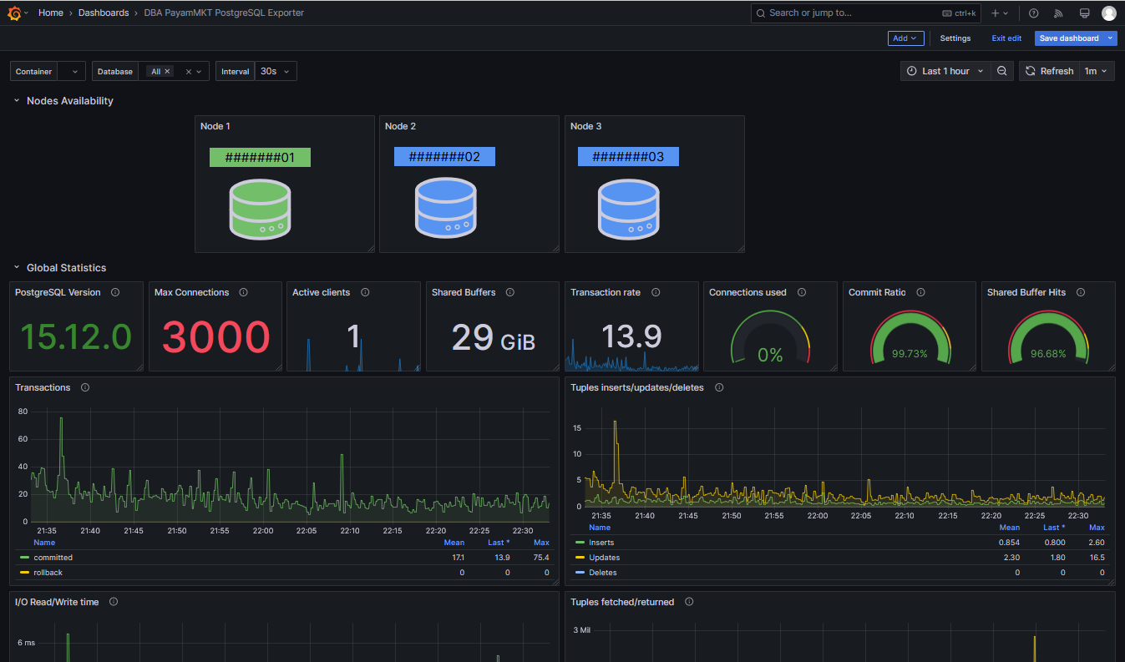

4. Network engineering and DB support — Keshavarzi Bank (Mar 2020 – Apr 2021)
Role: Network engineer, database developer & administrator; managed SQL Server clusters and Cisco troubleshooting
Scope: Maintain mission-critical systems, ensure high availability and secure connectivity.
Tools & methods: Cisco device troubleshooting, T-SQL analytics, cluster ops.
Team members: around 10
My contribution: varies on each task
- Investigating Branch outage reasons and altering the configurations of the network devices such as ACL, routing, tunnels, etc when necessary: Equal contribution between all team members.
- Working with network monitoring solutions such as WhatsUp, Solar Winds Orion, Op Manager, Bina, and PRTG: Equal contribution between all team members.
- Because many Network Monitoring tools such as Op Manager, WhatsUp, and Solar Winds Databases reside on open queryable DBMSs, I manually queried data and made very custom reports for traffic anomaly, link quality, outages, unusual behavior compared to the device’s common behavior (like extremely low or extremely high traffic at a particular time), server metrics, etc. My contribution: 100%
- The uptime improvement of the databases were made certain of by investigating and identifying the cause of the incidents and reporting them to the authorities to rectify the mechanism of the infrastructure for a better reliability. Some common causes were contended with to avoid their recurrence. Some device misconfiguration were resolved. The links behaviors were monitored, so that the weak links would be identified. Outdated and legacy network devices that needed to be replaced by more heavy duty models where reported. Servers metrics where monitored to avoid interruption of their service. Incident mean time to resolution was normally not more than 10 minutes (from the real time of incident to resolution) but the security measures of the system like VPN and multiple 2FAs blunted our reaction sometimes. And finally, junior team members were trained to be able to tackle their tasks faster and more efficiently which also improves RTO in the event of a disaster: Equal contribution between all team members.

5. International Students Office IT & International Communications Specialist — Sharif University (Feb 2015)
Role & scope: Technical support and communication systems for international office; implemented IT workflows
Team size: 2
Contribution for the following roles: 100%
Virtual infrastructure to host the International Students Office (ISO) website. Designing application forms and other parts of the website, which mechanized the manual application process that was unbefitting for a prestigious university. Correspondence with the international students in English, and following up their academic needs and issues.
The then International Students Office (ISO) website was removed and retired more than 7 years ago. One of the latest snapshots is the following
International Students Office (ISO) - Sharif University of Technology

6. Teaching and mentoring — Faratar az Danesh, Rouzbeh Institute, Polytechnic High School, Mofid Securities (Sep 2011–present)
Role: Instructor for RDBMS (PostgreSQL), Linux, DB administration; high-school mathematics and Olympiad coaching
Scope & methods: Course design, hands-on labs, mentoring DBA teams.
Outcome / impact: Trained DBAs and students who moved to production roles.
- Course: PostgreSQL for Database Developers and Administrators (FAD institute)
  - Course link to syllabus:
https://fad.ir/Course/Details/145
  - Course contents (Session recordings & slides):
shared DOCs
- Course: Advanced PostgreSQL for Database Administrators (FAD institute)
  - Course link to syllabus:
https://fad.ir/Course/Details/146
Course Poster:
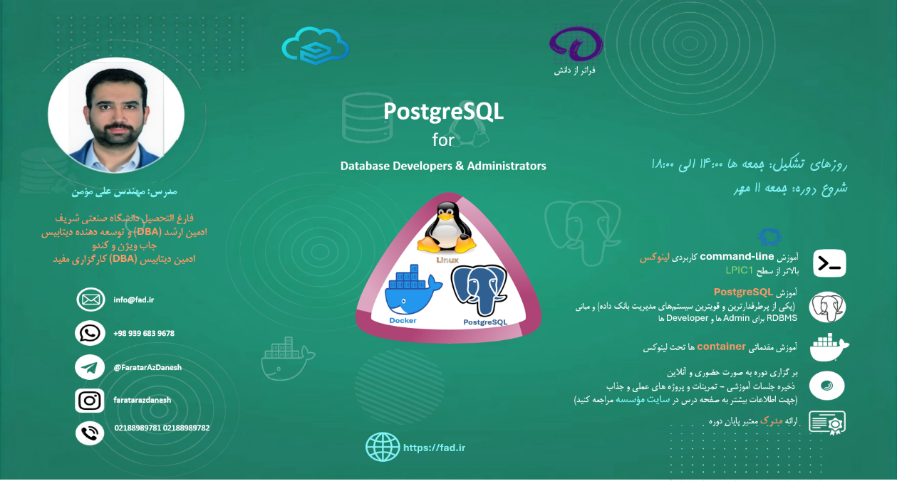
- Written document for PostgreSQL course on GitHub:
https://github.com/amomen9/PostgreSQL/tree/main/PostgreSQL%20Course
- Presentation:
  - Teaching training courses for the DBA team members on PostgreSQL (Mofid Securities)
  - Teaching Linux courses to the DBA Team members (Mofid Securities)
  - Delivering some presentations on Network concepts in Firewall, iptables (& nftables), SDN, Proxy & Reverse Proxy, SSL, DNS, CDN, NAT, etc.

Selected outputs and projects:
Many useful documents and scripts on GitHub:
https://github.com/amomen9
Examples:
- PostgreSQL useful scripts:
https://github.com/amomen9/PostgreSQL/tree/main/Useful%20Scripts
- MSSQL backup and restore history report
https://github.com/amomen9/SQLServer-DBA-Tools/tree/main/Backup%20%26%20Restore%20History%20Report
- MSSQL monitoring scripts
https://github.com/amomen9/SQLServer-DBA-Tools/tree/main/MonitorServer%20(WhatIsActive)
- MSSQL Partitioning Information
https://github.com/amomen9/SQLServer-DBA-Tools/tree/main/Partitioning%20View%20Info
- MSSQL Permissions
https://github.com/amomen9/SQLServer-DBA-Tools/tree/main/Permissions
- RedGate Overall Waits for MSSQL
https://github.com/amomen9/SQLServer-DBA-Tools/tree/main/RedGate%20Overall%20Waits
- MSSQL Restore Latest Backups Using msdb and sys.master_files
https://github.com/amomen9/SQLServer-DBA-Tools/tree/main/Restore%20Latest%20Backups
- MSSQL job info
https://github.com/amomen9/SQLServer-DBA-Tools/tree/main/sp_JobsInfo
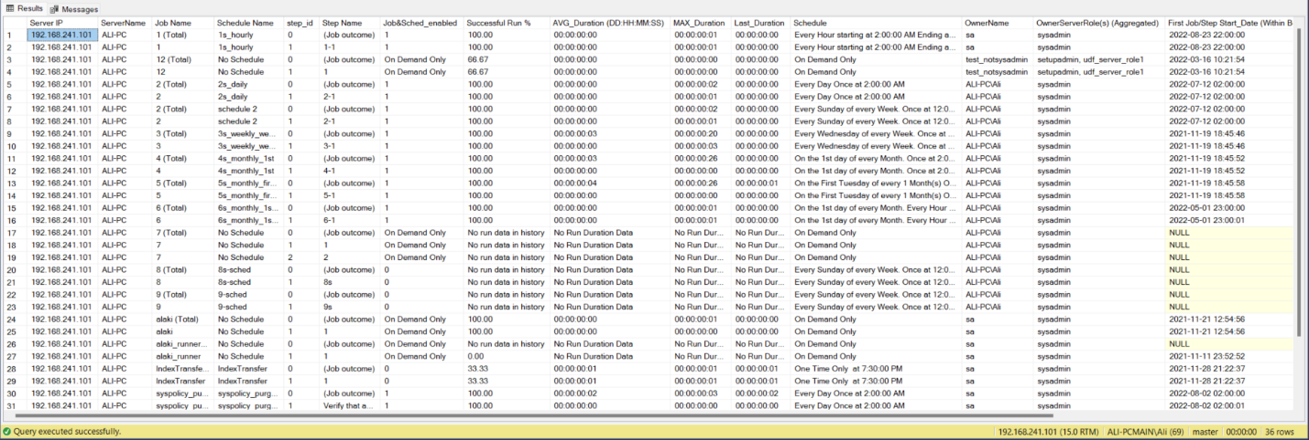
- PostgreSQL Patroni
https://github.com/amomen9/PostgreSQL/tree/main/Patroni
- PostgreSQL pgbouncer
https://github.com/amomen9/PostgreSQL/tree/main/PGBouncer
- PostgreSQL, a guide on how to upgrade the major version
https://github.com/amomen9/PostgreSQL/tree/main/PostgreSQL%20Major%20Version%20Upgrade
- PostgreSQL, Resetting WAL segment sizes
https://github.com/amomen9/PostgreSQL/tree/main/Resetting%20WAL%20Segments'%20Sizes%20-%20Doc
And many more.

Skills summary:
Programming & data science: Python; R; Stata; MATLAB; C/C++; Java
Databases & tools: Microsoft SQL Server (admin, clustering); PostgreSQL (cluster admin, Replication, HA, and Disaster Recovery concepts and tools); MySQL/MariaDB; MongoDB; T-SQL; Pl/PgSQL Data migrations; CI/CD; IaC
Other: Shell scripting (Bash), Windows Server, Cisco networks, BI (SSAS/SSIS), PowerShell, API & Web services, containerization/orchestration, version control
Languages: Persian (native) C2; English (fluent) C1; German (working) B1; French (basic) A2

Portfolio appendix — short CV
Linkedin URL:
https://www.linkedin.com/in/ali-momen
GitHub URL:
https://github.com/amomen9

Complete CV is submitted as one of the documents
Education: BSc Applied Mathematics, Sharif University of Technology, 2006–2014; GPA 12.42 / 20
Work experience (high level):
- Faratar az Danesh — Linux & RDBMS Instructor (Sep 2024 – Present)
- Mofid Securities — DBMS DBA – Senior Database Administrator and Developer – Automated processes developer (Nov 2023 – Present)
- JobVision & HRCando — Senior Database, Data Developer & Administrator (Nov 2021 – Nov 2023)
- Fanap Soft — Database Administrator (Jun 2021 – Nov 2021)
- Keshavarzi Bank — Network Engineer & DBA (Mar 2020 – Apr 2021)
- Iratec Kish & Savintf — Web Developer & DBA (May 2017 – Mar 2020)
- FanamoozSanat & HydraSanat-Tadbir — Full Stack Web Developer (May 2007 – Feb 2015)
Certifications: SQL Server administration; Microsoft BI SSAS/SSIS; PowerShell; API & Web Services; T-SQL; others listed in CV
References: Parviz Aghasadeghi (CEO, Faratar az Danesh) — aghasadeghi@fad.ir; Dr. Meghdad Velaei (CEO, JobVision) — m.velaei@jobvision.ir; Rasool Yekta (CTO, JobVision & HRCando); Mohsen Sayadian (DBA Lead, Mofid) — m.sayadian@emofid.com

