ILUMINAÇÃO

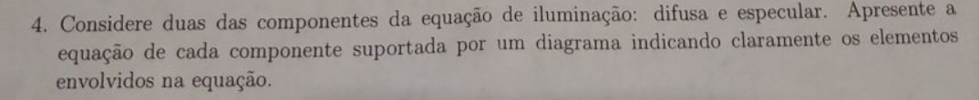

Figure 1 RAMIRES-APPROVED

TEXTURAS

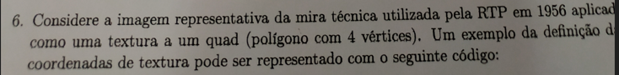

Figure 2 RAMIRES-APPROVED

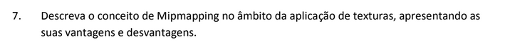

VIEW FRUSTRUM CULLING

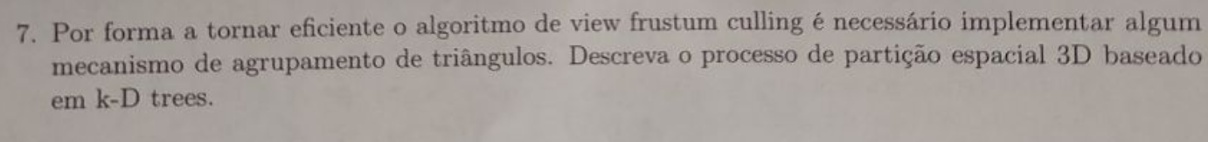

Figure 3 RAMIRES-APPROVED



