**Computer Engineering Department**

Name-Surname Student No. .

**Faculty of Engineering Mahidol University**

# LAB02: Digital Image Fundamentals

## Objectives

## Upon completion of this lab, you will be able to:

1. Understand the image sampling and quantization**.**
2. Describe the effect of reducing the spatial resolution on the quality of images.
3. Describe the effect of reducing the number of gray-levels on the quality of images.
4. Write a program to demonstrate the checkerboard effect and the false contouring effect.

## Exercises

Notation that you should create your own user-defined function in MATLAB. It means that you cannot call MATLAB built-in function, which generates output in the same manner as your own program. You can use the images provided in the folder **\Google Drive\EGCI486_Second(2015-2016)\LABs\LAB02** for your exercises.

## Image Sampling and Quantization

1.1 Write a program to demonstrate the checkerboard effect, with the following program name: Procheckerboard.m. Using this program on the image “moon_dark.bmp” should give you result as shown in Figure 1.

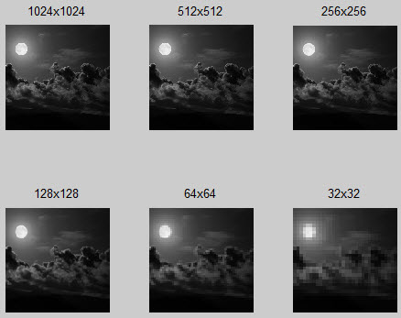

Figure 1: The effect result of reducing the spatial resolution.

m= imread('moon_dark.bmp')

[GG]= Procheckerboard(m)

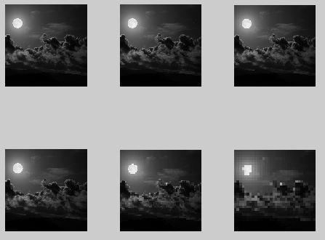

1.2 Write a program to demonstrate the false contouring effect, with the following program name: Procontouring.m. When this program is used with the image “moon_dark.bmp” result as shown in Figure 2.

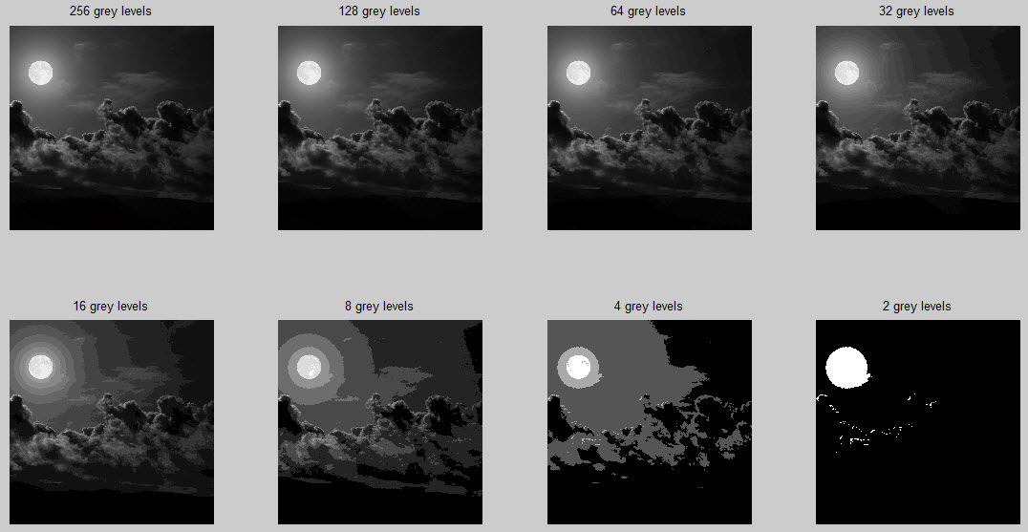

Figure 2: The effect result of reducing the gray-level resolution.

m= double(imread('moon_dark.bmp'))

Procontouring(m)

1.3 Write a program to create an image of a ramp, whose size is 256×256, having 256 different gray levels. The result is shown in Figure 3.

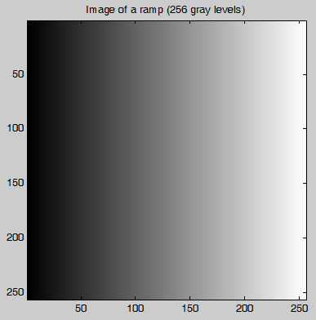

Figure 3: The result image by using 256 different gray levels.



## Question

1. If we have an image of size 400×430, having 32 different gray levels. How many bytes are needed to store this image?

|  |
| --- |
| ((400*430)*5)/8 = 107,500bytes |

1. What is the problem of “checkerboard pattern” that occurs in image sampling? Suggest a method to reduce the checkerboard pattern effect.

|  |
| --- |
| When the picture is so panelized so it look like it is composed of many square connect together. It happen when the image resolution become too low. We can solve this by increase the image resolution. |

1. What is the problem of “false contouring” that occurs in image quantization? Suggest a method to reduce the false contouring effect.

|  |
| --- |
| When the color that needed to represent the picture are not sufficient so the picture become not accurate since it lack the color depth. As a result the picture will have steps of color instead of smooth color. The problem can be fix by increasing the color shade that represent the picture. |

**What you need to submit:**

Prepare a zip file that contains the following:

1. A report containing the text in the form of a word document.

2. The MATLAB program for implementing part in the form of a matlab file (m-file extension).

Double check that you have included all of the above in the zip file. Email the zip file to the account **send2narit@hotmail.com** with the following subject line: **EGCI486_LAB02_yyy**, which xx is a number of LAB and yyy is the last 3 digits of the student identification number. Your email should reach us before Saturday 11:59 PM on the due date.

\*\***Please preserve a copy of your email and all your work until the end of the course.**