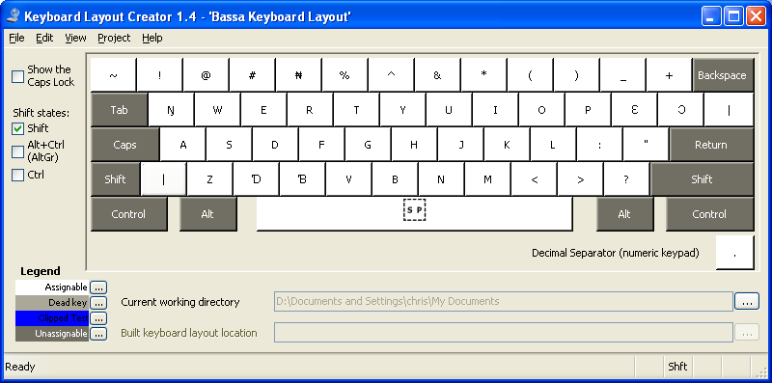

The diagram above shows the location of the keys. The layout is based on a normal QWERTY keyboard but a few non-used keys replaced. The keys: Q, X, C, [ and ] have been replaced with Ŋ, Ɗ, Ɓ, Ɛ, and Ɔ. The choice of keys to replace was based on an idea to of creating similar layouts for African layouts that share the same character set. In this case, the proposed layout was based on a proposed Duala keyboard layout, which shares the same set of extended characters. Combining characters are used for typing diacritic marks.
The following table shows the key sequence to produce the extended characters for Bassa, and replaced characters
Character | Key Sequence 1 | Key Sequence 2
Ŋ | Q
Ɗ | X
Ɓ | C
Ɛ | [
Ɔ | ]
Q | RAlt + Q | \ then Q
X | RAlt+X | \ then X
C | RAlt+C | \ then C
[ | RAlt + [ | \ then [
] | RAlt + ] | \ then \
\ |  | \ then \

Ie. to type Ɗ, simply press D. to type D, which is has been replaced because it’s not used in Bassa, either press RAlt + D together. RAlt + D is the Alt Key at the right hand of the keyboard or Ctrl+Alt key pressed together. Alternatively, D can be typed by using dead keys. To do so, press backslash, followed by D (\D)
The follow combining characters are defined for typing diacritic marks:
Name | Code Point | Access Key 1 | Key Access 2
Combining Grave Accent | U+0300 | AltGr + TILDE | \ then TILDE
Combining Acute Accent | U+0301 | AltGr + APOSTROPHE | \ then APOSTROPHE
Combining Circumflex Accent | U+0302 | AltGr + 6 | \ then 6
Combining Tilde | U+0303 | AltGr + Shift + TILDE | \ Then Shift TILDE
Combining Macron | U+0304 | AltGr + MINUS | \ then MINUS
Combining Breve | U+0306 | AltGr + 9 | \ then 9
Combining Dot Below | U+0323 | AltGr + 8 | \ then 8
Combining Diaeresis Below | U+0324 | AltGr + Shift+8 | \ then Shift 8

To type a diacritic mark, first type the base character you want to add a diacritic mark to then type the key sequence for the combining key from the above table.

Microsoft Keyboard Layout Creator
This format provides a keyboard layout for Microsoft Windows environment. The layout is as described above except there are no limitations on the number of diacritic marks that can be added to a base character. This limitation is due to the fact that there are no context information provided by the Microsoft keyboard layout creator. This solution is applicable to users who cannot afford to purchase Tavultesoft keyman to use the keyman solution below.
Linux Xkb
This format is used by linux X windows keyboard extension to provide a native keyboard support for Bassa. Like the Microsoft keyboard layout, context information are not available to provide diacritic marking constraints. In addition, deadkey key sequences are not available.
Tavultesoft Keyman
This provides a complete solution in terms of restricting the number of diacritic marks: limited to two. The layout is as described above. Both Ralt and dead key sequence are available.
Under linux, the KMFL + SCIM engine does not have the CAPS key behavior currently implemented and therefore press CAPS key does not provide the expected behavior as is on windows version of Tavultesoft keyman. As a workaround, Shift key should be used to type upper case letters.

Compilation and Installation
Microsoft Keyboard Layout Create:
- Go to http://www.microsoft.com/globaldev/tools/msklc.mspx to obtain the MKLC tool.
- Install the MKLC tool by following instructions provided by Microsoft.
- Lunch the MKLC tool from the Programs menu
- From the file menu, select the “Load Source File…” and use the File Open dialog box to locate and open the klc keyboard definition files in the windows folder.
- The selected keyboard layout is displayed. From the Project menu, select Validate menu. Windows may return with warning message. These are safe to ignore. If it fails, review the error log it provides you for a clue to resolving the problem. Eg. You cannot build a keyboard package that is currently installed on your computer. Contact kasahorow for assistance if you encounter any difficulties.
- Again, from the Project menu select “Build DLL and Setup Package”
- A setup package is created in your current working folder, which is “My Documents” by default.
- From windows explorer, navigate to your working folder and lunch the double click on the setup.exe file for your system architecture to launch the installation wizard. Follow the on-screen instructions to complete the installation.
- To select the installed keyboard for testing, navigate to the Control Panel and launch the “Regional and Language options” component.
- The Regional and Language Options window opens. Click the “Languages” tab, and click the “Details” button.
- The Text Services and Input Language window opens. Click the Add button to open the Add Input Language window.
- All the keyboards are currently assigned to English language for testing purposes, as not languages have locale support under windows.
- Select the “Keyboard Layout/IME” checkbox to activate installed keyboards drop down list.
- From the drop down list, select the keyboard you’ve just installed and click OK.
- Click OK again, to close the Text Services and Input Language window.
- A small keyboard icon will appear on windows task bar. Use this icon to switch between installed keyboards.

Linux Xkb
For testing purposes, all the proposed keyboard layouts are being distributed as a single file. This will appear under linux as one keyboard layout with many variants. After going to testing and acceptance, the keyboard definitions will be grouped by country and language with the respective currency symbol defined.
To install the African keyboards for linux, perform the following steps:
1. Copy the Africa X keyboard definition file “bassa” file to /etc/X11/xkb/symbols
2. Create a backup copy of your existing xorg.xml file in /etc/X11/xkb/rules/xorg.xml
3. Copy the “xorg.xml” file to /etc/X11/xkb/rules/xorg.xml
4. Use the gnome/KDE keyboard switcher to choose test the Bassa Keyboard

Tavultesoft keyman
Download Tavultesoft keyman Developer version to compile and install the *.kmn file
Detail instructions are provided on Tavultesoft website

KMFL+SCIM Engine
Install KMF and SCIM engine from http://kmfl.sourceforge.net/
Instructions are provided on their website. Instead of compiling from source, use the rpm file to install KMFL http://downloads.sourceforge.net/kmfl/kmfl-0.9.6-fc8.tar.gz?modtime=1203960629&big_mirror=0
After installation, restart X and use the SCIM applet to install the .kmn file

