Introduction 2
Objective 2
Approach 2
Limitations 3
Africa ISO 6438 5
Akan 8
Bambara 10
Baule 12
Bemba 14
Chichewa 16
Duala 18
Edo or Bini 21
Ewondo 23
Fulfulde (Pular, Pullaar, Pulle) 25
Ga 28
Gbe 30
Hausa 33
Igbo 36
Kikuyu 38
Figure 30: Igbo keyboard in AltGr stateKirundi 39
Kirundi 40
Krio 41
Lingala 43
Luganda (Ganda) 45
Luo (Dholuo) 47
Oromo (Galla) 48
Somali 49
Shona 50
Swahili 51
Tswana 52
Wolof 53
Yoruba 54
Southern Sotho (seSotho) 55
Xhosa 56
Zulu 57

Introduction
Localized input methods for computers are the first technological hurdle in any localization effort for a language. African languages have inconsistent and mostly non-existent input method support on the three major operating systems—Microsoft Windows, Apple Macintosh, and Linux. The aim of this project is to create a representative keyboard layout for all the major cross-border language clusters and to promote their availability and adoption by the relevant user communities and standards bodies.

Objective
As documented in the original proposal, there are two components to the project: a technical component and an advocacy role. This document highlights the progress of the technical component. The advocacy role is left to a different group.
The goal of this part of the project is to create keyboard layout for all major African languages. According to wikipedia, there are an estimated 2000 languages spoken in Africa, of which a hundred have been estimated to be major languages. Of these major languages, our focus for this phase of the project is limited to a subset of major languages available at the Pan–African website on localization:
http://www.panafril10n.org/wikidoc/pmwiki.php/PanAfrLoc/MajorLanguages
The ultimate goal is to cover all major languages and some minor languages as well, as time permit.

Approach
Our approach towards this project is guided by the fact that almost all users of these keyboards are multilingual and therefore will need to type in more than one language without changing keyboards. We have defined a generic keyboard layout that can be used to type in almost all African languages as well as English or French. It may need to be adapted to fit the French AZERTY keyboard layout, since it’s based on the QWERTY keyboard. For people working predominantly in a single African language, we have defined language specific keyboard layout, where the characters required by that language can be typed at the normal unshift state, without pressing any additional keys. Standard keys that are not required for a given language are redefined at the AltGr shift state.

Most African languages are tonal language, and most African languages uses extended characters that can only be represented uniformly with Unicode. For representing tonal marking with Unicode characters, combining characters are used. For historical reasons, pre-composed characters are available but not for all accented characters. We could use pre-composed characters whenever possible and use combining characters for all others but this will lead to inconsistency. Using dead keys isn’t an option at this point, since the complexity of some tonal system for languages like Yoruba, where there can be a tonal marking above and below a character, is difficult to implement using dead keys. Combining characters remains the best option for consistently implementing support for all tonal/accented characters across languages.
The combining diacritical marks that are needed for African languages and the keys associated with them are listed below:

Name | Code Point | Access Key
Combining Grave Accent | U+0300 | AltGr + TILDE
Combining Acute Accent | U+0301 | AltGr + APOSTROPHE
Combining Circumflex Accent | U+0302 | AltGr + 6
Combining Tilde | U+0303 | AltGr + Shift + TILDE
Combining Macron | U+0304 | AltGr + MINUS
Combining Breve | U+0306 | AltGr + 9
Combining Dot Below | U+0323 | AltGr + 8
Combining Diaeresis Below | U+0324 | AltGr + Shift+8

An accented character can be typed as follows: <Base Character> + <Combinig Character 1> + <Combining Character 2> + …

Limitations
A good keyboard layout design requires a usability study to best answer design questions and it’s best tackled by a national bodies. Since no such efforts or organizations are available or known, this work is guided mostly by our own intuitions and generic principles from existing keyboard designs, which may not necessarily be applicable to African languages. At the least, the proposed keyboard layouts in this project should serve as a launch pad, through which more work and research can be performed to answer keyboard design questions to better serve African languages.

We are further constrained by the types of physical keyboard available in the markets today and the number of keys available for key assignments. Current keyboards are designed for a specific market, it be English, French,etc. To be able to type African languages on these pre-existing keyboards, we rely on the fact that not all the keys on a physical keyboard are needed for a given African languages, and so they can be re-assigned to emit different symbols than what they were originally designed to emit. Secondly, current keyboards can operate at a third and fourth state (AltGr state), which can be used to introduce additional keys that a particular language supports.
There are new keyboards in the market such as the Optimus Maximus keyboard (http://www.artlebedev.com/everything/optimus/), which will solve this particular problem.

Enforcing Normalization – More to come

Africa ISO 6438
This keyboard layout serves as a generic multilingual keyboard layout for those who need to type in multiple languages. This design is driven by the need to type predominantly in the native system keyboard (it be English or French QWERTY or AZERTY keyboard), and still have access to characters require for many African languages without switching keyboards.
The Africa ISO 6438 layout is based on the ISO 6438 coded character set for African languages. The layout make accessible, through the AltGr key combination, characters needed to type in most African languages,
Figure 1 shows the keyboard layout in its normal state. This is the normal QWERTY keyboard layout with no modifications. Pressing down AltGr key activates the state AltGr state level shown in figure 2. The keys are typed by pressing down the AltGr key while pressing the assigned character key at the same time. This particular layout is based on the QWERTY keyboard but it can easily be adapted to fit the AWERTY or any other physical keyboard available in the market today.

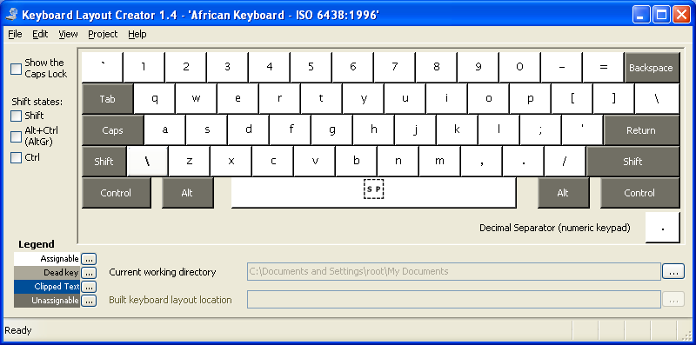
Figure 1: Normal state

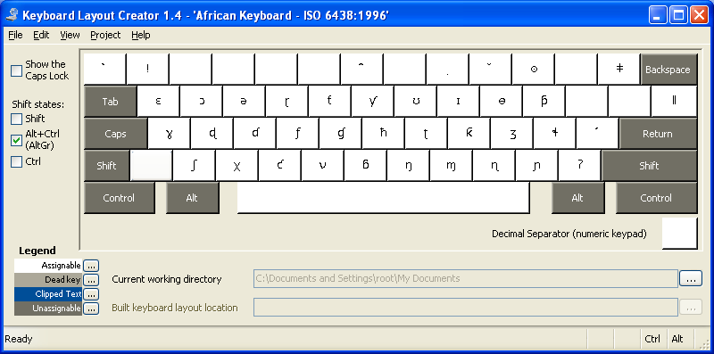
Figure 2: AltGr state

Key assignments were not based on any scientific methods or processes. The choice of key assignment was determined by similarity in sound, and shape of the character as compared to keys on QWERTY keyboard. For this reason, rigorous testing and feedback are needed to properly assign the location of each key.

The table below lists the names of their unicode code points used to define the layout:

Name | Character | Code Point | Access Key
LATIN CAPITAL LETTER B WITH HOOK | Ɓ | U+0181 | AltGr+Shift+B
LATIN SMALL LETTER B WITH HOOK | ɓ | U+0253 | AltGr + B
LATIN CAPITAL LETTER C WITH HOOK | Ƈ | U+0187 | AltGr+Shift+ C
LATIN SMALL LETTER C WITH HOOK | Ƈ | U+0188 | AltGr + C
LATIN CAPITAL LETTER D WITH HOOK | Ɗ | U+018A | AltGr+Shift+D
LATIN SMALL LETTER D WITH HOOK | ɗ | U+0257 | AltGr + D
LATIN CAPITAL LETTER AFRICAN D | Ɖ | U+0189 | AltGr+Shjit+S
LATIN SMALL LETTER D WITH TAIL | ɖ | U+0256 | AltGr+S
LATIN CAPITAL LETTER OPEN E | Ɛ | U+0190 | AltGr+Shift+W
LATIN SMALL LETTER REVERSED E | ɛ | U+025B | AltGr+W
LATIN CAPITAL LETTER REVERSED E | Ǝ | U+018E | AltGr+Shift+E
LATIN SMALL LETTER REVERSED E | ə | U+0259 | AltGr+E
LATIN CAPITAL LETTER F WITH HOOK | Ƒ | U+0191 | AltGr+Shift + F
LATIN SMALL LETTER F WITH HOOK | Ƒ | U+0192 | AltGr+F
LATIN CAPITAL LETTER G WITH HOOK | Ɠ | U+0193 | AltGr+Shift+G
LATIN SMALL LETTER G WITH HOOK | ɠ | U+0260 | AltGr+G
LATIN CAPITAL LETTER GAMMA | Ɣ | U+0194 | AltGr+Shift+A
LATIN SMALL LETTER GAMMA | ɣ |  | AltGr+A
LATIN CAPITAL LETTER H WITH STROKE | Ħ | U+0126 | AltGr+Shift+H
LATIN SMALL LETTER H WITH STROKE | Ħ | U+0127 | AltGr+H
LATIN CAPITAL LETTER I WITH STROKE | Ɨ | U+0197 | AltGr+Shift+I
LATIN SMALL LETTER I WITH STROKE | ɪ | U+026A | AltGr+I
LATIN CAPITAL LETTER K WITH HOOK | Ƙ | U+0198 | AltGr+Shift+K
LATIN SMALL LETTER K WITH HOOK | Ƙ | U+0199 | AltGr+K
LATIN SMALL LETTER L WITH BELT | ɬ | U+026C | AltGr+;
LATIN SMALL LETTER M WITH HOOK | ɱ | U+0271 | AltGr+M
LATIN SMALL LETTER N WITH RETROFLEX HOOK | ɳ | U+0273 | AltGr+<
LATIN CAPITAL LETTER N WITH LEFT HOOK |  | U+019d
LATIN SMALL LETTER N WITH LEFT HOOK | ɲ | U+0272 | AltGr+>
LATIN CAPITAL LETTER ENG | Ŋ | U+014A | AltGr+Shift +N
LATIN SMALL LETTER ENG | Ŋ | U+014B | AltGr+N
LATIN CAPITAL LETTER O WITH MIDDLE TILDE | Ɵ | U+019F | AltGr+Shift+O
LATIN SMALL LETTER BARRED O | ɵ | U+0275 | AltGr+O
LATIN CAPITAL LETTER OPEN O | Ɔ | U+0186 | AltGr+Shift+Q
LATIN SMALL LETTER OPEN O | ɔ | U+0254 | AltGr+q
LATIN CAPITAL LETTER P WITH HOOK | Ƥ | U+01A4 | AltGr+Shift+P
LATIN SMALL LETTER P WITH HOOK | Ƥ | U+01A5 | AltGr+P
LATIN SMALL LETTER R WITH TAIL | ɽ | U+027D | AltGr+r
LATIN CAPITAL LETTER ESH | Ʃ | U+01A9 | AltGr+Shift+Z
LATIN SMALL LETTER ESH | ʃ | U+0283 | AltGr+Z
LATIN CAPITAL LETTER V WITH HOOK | Ʋ | U+01b2 | AltGr+Shift + V
LATIN SMALL LTER V WITH HOOK | ʋ | U+028b | AltGr + V
LATIN CAPILTAL LETTER WITH RETROFLEX HOOK | Ʈ | U+01ae | AltGr+Shift+J
LATIN SMALL LETER T WITH RETROFLEX HOOK | ʈ | U+0288 | AltGr+J
LATIN CAPITAL LETTER T WITH HOOK | Ƭ | U+01ac | AltGr+Shift+T
LATIN SMALL LETTER T WITH HOOK | ƭ | U+01ad | AltGr+T
LATIN CAPITAL LETTER Y WITH HOOK | Ƴ | U+01b3 | AltGr+Shift+Y
LATIN SMALL LETTER Y WITH HOOK | ƴ | U+01b4 | AltGr+Y
LATIN CAPITAL LETTER UPSILON | Ʊ | U+01b1 | AltGr+Shift+U
LATIN SMALL LTTER UPSILON | ʊ | U+028a | AltGr + U
LATIN CAPITAL LETTER EZH | ʒ | U+01b7 | AltGr+Shift+L
LATIN SMALL LETTER EZH | Ʒ | U+0292 | AltGr+L
GREEK CAPITAL LETTER CHI | Χ | U+03a7 | AltGr+Shift+X
GREEK SMALL LETTER CHI | χ | U+03c7 | AltGr+X
Table 1:

Akan
The akan language is written using a latin-based orthography system and it was developed by the Ghana Bureau of Languages. The orthographic system is shown below:

Consonants:
Bb Dd Ff Gg Hh Kk Ll Mm Nn Pp Rr Ss Tt Ww Yy

Vowels:
Aa Ee Ɛɛ Ii Oo Ɔɔ Uu

The latin letters C, Q, V, J, X are not used in the standard akan writing system but they’re used for spelling borrowed words. In addition, two extra letters are introduced to the akan writing system, namely: Ɔ and Ɛ. Thus, the non-used letters must be accessible on the keyboard and the two new letters Ɔ and Ɛ must be placed such that they can be easily typed without the need for additional key presses. To maintain backward compatibility, the keys for Q and X were chosen as candidate keys for replacement for Ɔ and Ɛ and X and Q is accessible with AltGr key press combination. The table below shows the modified keyboard configuration for Akan.

Name | Character | Code Point | Access Key
LATIN CAPITAL LETTER OPEN E | Ɛ | U+0190 | Shift + Q
LATIN SMALL LETTER OPEN E | ɛ | U+025b | Q
LATIN CAPITAL LETTER OPEN O | Ɔ | U+0186 | Shift + X
LETTER SMALL LETTER OPEN O | ɔ | U+0254 | X
LATIN CAPITAL LETTER Q | Q | U+0051 | AltGr+Shift+Q
LATIN SMALL LETTER Q | q | U+0071 | AltGr + Q
LATIN CAPITAL LETTER X | X | U+0058 | AltGr+Shift+X
LATIN SMALL LETTER X | x | U+0078 | AltGr+X
Table 2:

The remaining key assignments are not shown for brevity, since their configuration did not change from the original QWERTY keyboard configuration.
Figure 3 below shows the resulting Akan keyboard in a normal state. As indicated, the Q and the X keys have been replaced with the Ɔ and Ɛ keys respectively. Figure 4 shows the Akan keyboard in AltGr state, where the X and the Q keys are redefined. In addition, a number of combining characters are made available for tonal marking, even though they’re not used in the standard akan writing system. The dollar sign has also been moved to AltGr state to make room for the country specific currency symbol.

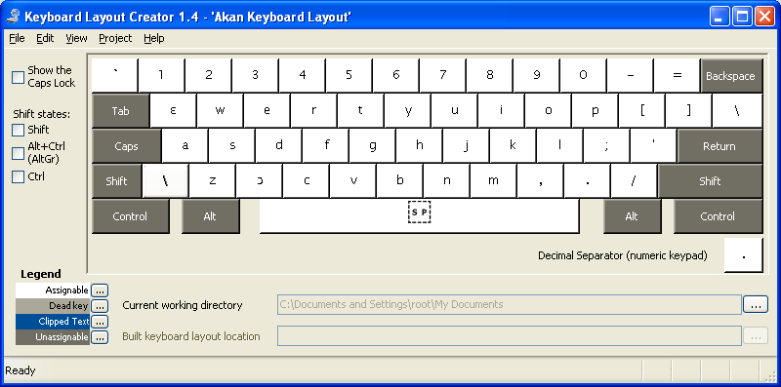
Figure 3: Akan Keyboard in normal state.

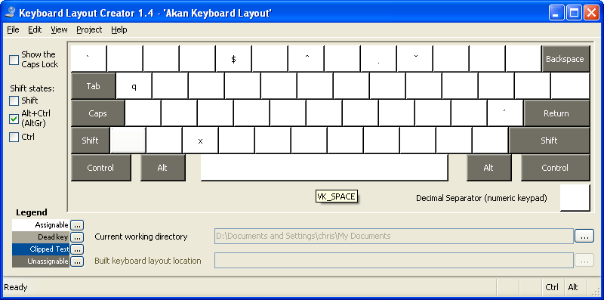
Figure 4: Akan Keyboard in AltGr State

Bambara
Bambara is a Mande language but shares some characteristics with the Kwa-group’s orthographic system.

Consonants:
Bb Cc Dd Ff Gg Hh Jj Kk Ll Mm Nn Ŋŋ ɲ Pp Rr Ss Tt Ww Yy Zz

Vowels:
Aa Ee Ɛɛ Ii Oo Ɔɔ Uu

Letters Q, X, V are not used and they have been replaced by three new letters in the Bambara alphabets: Ɛ, Ɔ, Ŋ. Ɛ and Ɔ occupies the space as in the Akan and Baule keyboard and Ŋ is assigned to the V key. There are no other keys left to assign ɲ to. The only feasible keys available at the normal un-shift key level are the left and right bracket keys. Our current thinking is that these keys will have very little use in everyday use of the keyboard and so the brackets can be relegated to the AltGr state level, to make room for assigning the ɲ key. As shown in figure 5, the left square bracket key has been redefined to be the ɲ key and left bracket “[“is accessible at the AltGr state, as show in figure 6.

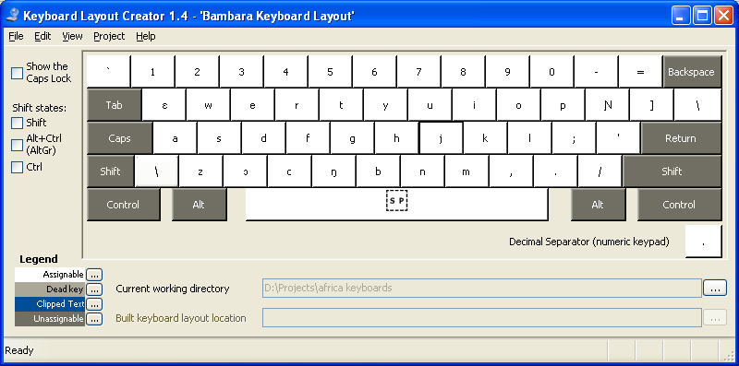
Figure 5: Normal state

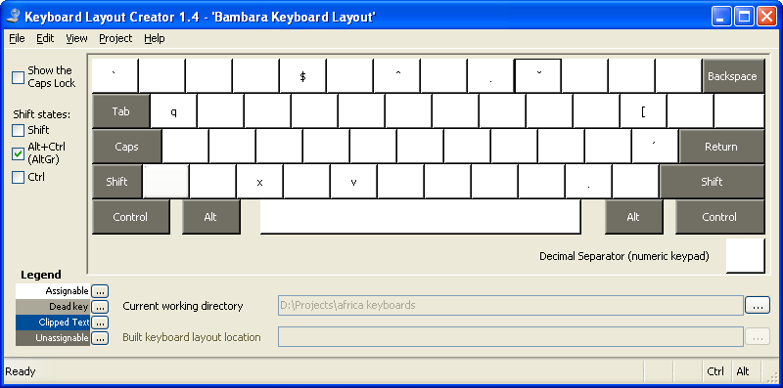
Figure 6: AltGr State.

Table 3 below shows the modified keyboard configuration for Bambara.

Name | Character | Code Point | Access Key
LATIN CAPITAL LETTER OPEN E | Ɛ | U+0190 | Shift + Q
LATIN SMALL LETTER OPEN E | ɛ | U+025b | Q
LATIN CAPITAL LETTER OPEN O | Ɔ | U+0186 | Shift + X
LATIN SMALL LETTER OPEN O | ɔ | U+0254 | X
LATIN CAPITAL LETTER ENG | Ŋ | U+014A | V
LATIN SMALL LETTER ENG | ŋ | U+014B | Shift + V
LATIN CAPITAL LETTER N WITH LEFT HOOK | ɲ | U+019d | [
LATIN SMALL LETTER N WITH LEFT HOOK | ɲ | U+0272 | Shift + [
LATIN CAPITAL LETTER Q | Q | U+0051 | AltGr+Shift+Q
LATIN SMALL LETTER Q | q | U+0071 | AltGr + Q
LATIN CAPITAL LETTER X | X | U+0058 | AltGr+Shift+X
LATIN SMALL LETTER X | x | U+0078 | AltGr+X
LATIN CAPITAL LETTER V | V | U+0056 | AltGr + Shift+V
LATIN SMALL LETTER V | v | U+0076 | AltGr + V
LEFT SQUARE BRACKET | [ | U+005b | AltGr + [
LEFT CURLEY BRACKETS | { | U+007b | AltGr + Shift + [
Table 3:

Baule
Buele, like the Akan language, is a member of the Kwa sub-group of languages and it’s written using a latin-based orthography system. The orthographic system for Baule is shown below:

Consonants:
Bb Dd Ff Gg Kk Ll Mm Nn Pp Ss Tt Vv Ww Yy Zz

Vowels:
Aa Ee Ɛɛ Ii Oo Ɔɔ Uu

The latin letters C, H, J, Q, R, X are not used in the standard Baule writing system but uses two additional letters not found on normal QWERTY keyboard: Ɔ and Ɛ.
Baule shares the same set of letters with Akan and other Kwa-group family of languages. As such, it suffices to use the same keyboard configuration as other members of the same family group.
Figure 7 below shows the Baule keyboard configuration, which is identical to the Akan keyboard. Keys that are not assigned to any letter are not removed and they can be used to type loan/borrowed words.
Figure 8 shows the same Baule keyboard when the AltGr key is pressed. Even though Baule does not use any tonal markings, combining keys for generating tonal markings as found in many African languages are left defined. Moreover, X and Q are reassigned to their corresponding keys at the AltGr state.

Table 4 below shows the modified keyboard configuration for Baule from the original QWERTY keyboard configuration.

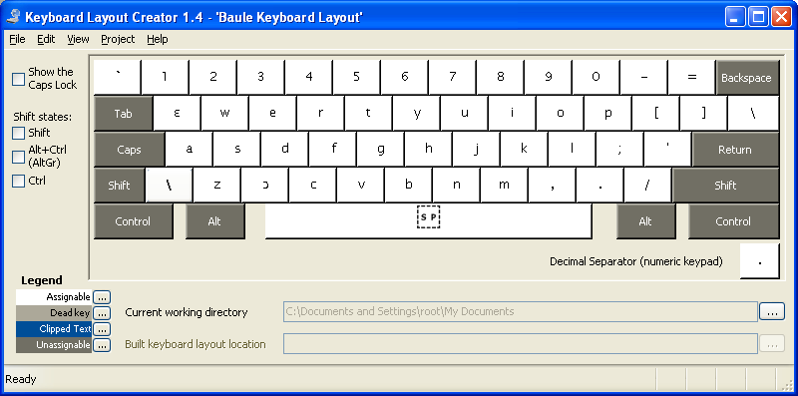Figure 7: Baule keyboard in a normal state.

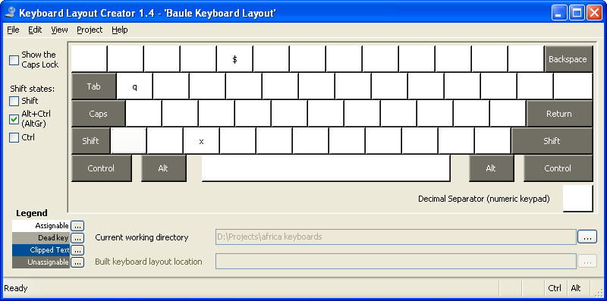
Figure 8: Baule keyboard in AltGr state.

Name | Character | Code Point | Access Key
LATIN CAPITAL LETTER OPEN E | Ɛ | U+0190 | Shift + Q
LATIN SMALL LETTER OPEN E | ɛ | U+025b | Q
LATIN CAPITAL LETTER OPEN O | Ɔ | U+0186 | Shift + X
LETTER SMALL LETTER OPEN O | ɔ | U+0254 | X
LATIN CAPITAL LETTER Q | Q | U+0051 | AltGr+Shift+Q
LATIN SMALL LETTER Q | q | U+0071 | AltGr + Q
LATIN CAPITAL LETTER X | X | U+0058 | AltGr+Shift+X
LATIN SMALL LETTER X | x | U+0078 | AltGr+X
Table 4: Baule keyboard configuration

Bemba
The orthographic system for Bemba is relatively simple and it only requires one additional characters that’s not available on the QWERTY keyboard: Ŋ

Consonants:
Bb Cc Dd Ff Gg Hh Jj Kk Ll Mm Nn Ŋŋ Pp Ss Tt Ww Yy

Vowels:
Aa Ee Ii Oo Uu

Digraphs are not represented above as separated unit as recommended by Unicode, unless there’s a good reason to do so:
http://unicode.org/faq/ligature_digraph.html

The keys for Q, R, V, X, Z are not used but are left in place for typing borrowed words. The V key is re-assigned to the Ŋ key and V is made accessible with the AltGr key combination. The choice of V key for Ŋ was an attempt to maintain similar key assignments whenever possible, as it was done for the Bambara keyboard layout.
The resulting keyboard configuration is shown below in figure 9. Figure 10 shows the key assignments at the AltGr state. Table 5 shows the keyboard configuration for Bemba.

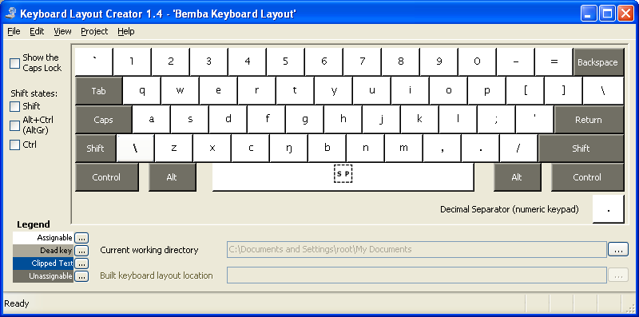
Figure 9: Bemba keyboard in normal state

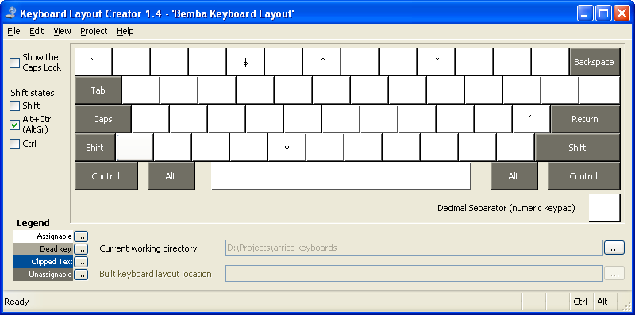
Figure 10: Bemba keyboard in AltGr shift state.

Name | Character | Code Point | Access Key
LATIN CAPITAL LETTER ENG | Ŋ | U+014A | Shift+V
LATIN SMALL LETTER ENG | ŋ | U+014B | V
LATIN CAPITAL LETTER V | V | U+0056 | AltGr+Shift+V
LATIN SMALL LETTER v | v | U+0076 | AltGr+V
Table 5:

Chichewa
Chichewa’s orthographic system is relatively simple. However, not all information are known at this point. For instance, we’re not sure whether the letters Q, V, and X are used. Some online documentations include them, while others do not. We’ve left these letters in place to cover all bases. Even if these letters are not used in the standard Chichewa orthographic system, they can still be used for typing loan words. In addition, some documentation on Chichewa/Nyanja includes the Latin letter ŋ in the Chichewa alphabets, while others do not. For these reasons, more investigations are needed to properly define the Chichewa keyboard layout.
The orthographic system that the current keyboard layout is based is described below:

Consonants:
Bb Cc Dd Ff Gg Hh Jj Kk Ll Mm Nn Ŋŋ Pp Qq Rr Ss Tt Vv Ww Ŵŵ Yy Zz
Vowels:
Aa Ee Ii Oo Uu

As shown in the figure 11 below, the letter Eng is located at where the left square bracket used to be and the square and curly brackets have been moved to the AltGr state level. In addition, W with a circumflex above it is required and it’s typed using Unicode character combination W + AltGr + 6. Ie W followed by the combining character ^.
Figure 12 shows the keyboard layout when at the AltGr shift level. As noted above, the left square bracket is redefined at the AltGr level to make room for the letter Eng. Combining characters are also defined at this level.

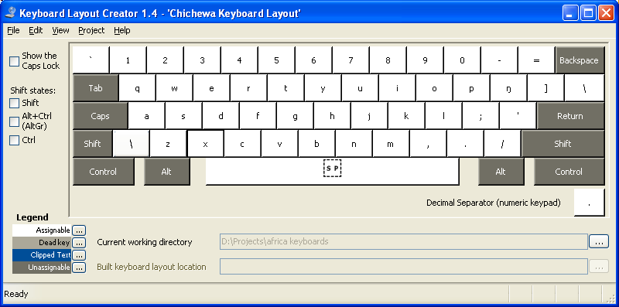
Figure 11: Chichewa keyboard in normal state

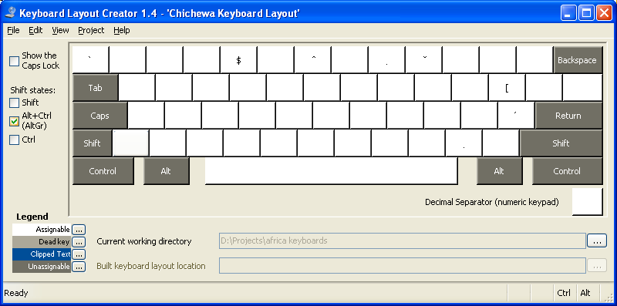
Figure 12: Chichewa keyboard in AltGr shift state

Name | Character | Code Point | Access Key
LATIN CAPITAL LETTER ENG | Ŋ | U+014A | Shift+X
LATIN SMALL LETTER ENG | ŋ | U+014B | X
LATIN CAPITAL LETTER X | X | U+0058 | AltGr+Shift+X
LATIN SMALL LETTER X | X | U+0078 | AltGr+X

Duala
Duala alphabets are as follows:
Consonants:
Bb Ɓɓ Cc Dd Ɗɗ Ff Gg Hh Jj Kk Ll Mm Nn Ŋŋ Ɲɲ Pp Ss Tt Ww Yy Zz
Vowels
Aa Ee Ɛɛ Ii Oo Ɔɔ Uu

Duala has more than 26 letters in its alphabets and as a result, some of the letters are assigned to unconventional locations on the keyboard.
Letters Q, X, V are not required in Duala and so their keys can be reassigned. Figure 13 shows the key assignments for Ɛ, Ɔ and Ŋ. Ɗ and Ɓ are assigned to the left and right square bracket keys, since there are no candidate keys for re-assignment. It’s assumed that the left and right square brackets would be less used and therefore can be replaced. The square brackets are accessible from the AltGr shift state.
Duala has three tones: high, low and falling-rising tone. A high tone is marked by an acute accent; a low tone is unmarked, and a falling-rising tone is marked by a caron (ˇ). These tonal marks can be typed by first typing the base character, followed by the combining character for a given diacritic mark.

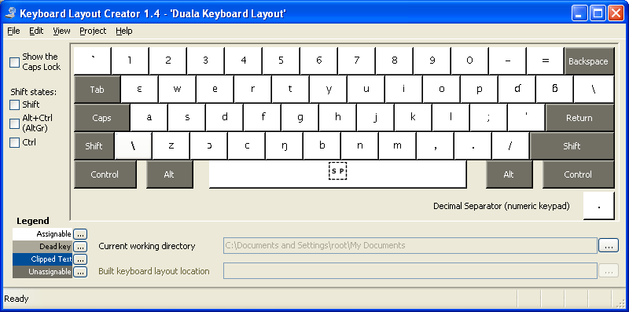
Figure 13: Duala keyboard in normal state

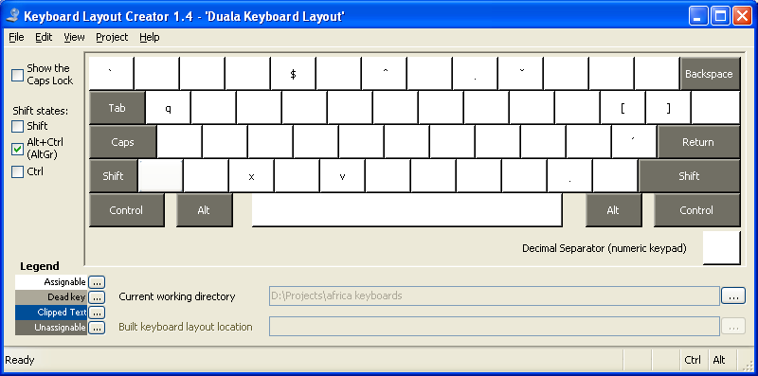
Figure 14: Duala Keyboard in AltGr shift state

The table below shows the key configuration for Duala. Keys that were not changed are not included in the table.

Name | Character | Code Point | Access Key
LATIN CAPITAL LETTER ENG | Ŋ | U+014A | Shift+V
LATIN SMALL LETTER OPEN ENG | ŋ | U+014B | V
LATIN CAPITAL LETTER OPEN E | Ɛ | U+0190 | Shift + Q
LATIN SMALL LETTER OPEN E | ɛ | U+025b | Q
LATIN CAPITAL LETTER OPEN O | Ɔ | U+0186 | Shift + X
LATIN SMALL LETTER OPEN O | ɔ | U+0254 | X
LATIN CAPITAL LETTER D WITH HOOK | Ɗ | U+018a | Shift + [
LATIN SMALL LETTER D WITH HOOK | ɗ | U+0257 | [
LATIN CAPITAL LETTER B WITH HOOK | Ɓ | U+0181 | Shift + ]
LATIN SMALL LETTER B WITH HOOK | ɓ | U+0253 | ]
LATIN CAPITAL LETTER V | V | U+0056 | AltGr+Shift+V
LATIN SMALL LETTER V | v | U+0076 | AltGr+V
LATIN CAPITAL LETTER Q | Q | U+0051 | AltGr+Shift+Q
LATIN SMALL LETTER Q | Q | U+0071 | AltGr+Q
LATIN CAPITAL LETTER X | X | U+0058 | AltGr+Shift+X
LATIN SMALL LETTER X | X | U+0078 | AltGr+X
LEFT CURLEY BRACKET | { | U+007b | AltGr + Shift + [
LEFT SQUARE BRACKET | [ | U+005b | AltGr + [
RIGHT CURLEY BRACKET | } | U+007d | AltGr + Shift + ]
RIGHT SQUARE BRACKET | ] | U+005d | AltGr + ]

Edo or Bini
Edo is spoken by an estimated 2.5 million people in Nigeria and in Benin. The orthographic system for the language is as follows:

Consonants:
Bb Cc Dd Ff Gg Hh Kk Ll Mm Nn Pp Rr Ss Tt Vv Ww Yy Zz
Vowels
Aa Ee Ii Oo Uu
Edo employs a number of diacritical markings to indicate tones. In particular, the following accented characters are defined:
Àà Áá Èè Éé Ẹẹ Ẹ̀ẹ̀ Ẹ́ẹ́ Ìì Íí Óó Ọọ Ọ̀ọ̀ Ọ́ọ́ Ùù Úú

These letters are typed by pressing the base key followed by one or more combining characters: AltGr + TILDE, AltGr + APOSTROPHE, AltGr + ASTERISK

Figure 15 below shows the keyboard layout for Edo. No modifications were made to the original QWERTY keyboard but combining characters were added at the AltGr shift level as shown in figure 16.

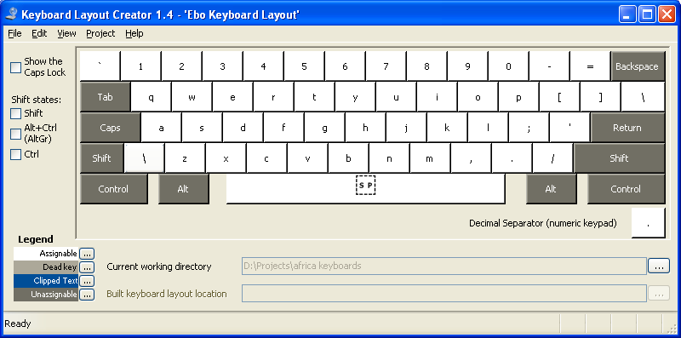
Figure 15: Edo keyboard in normal state
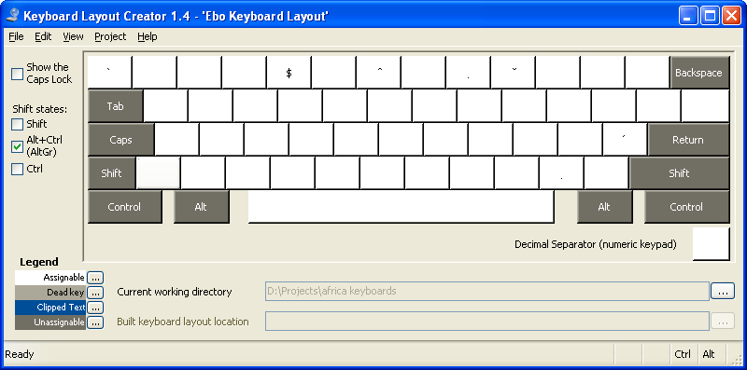
Figure 16: Edo keyboard in AltGr shift state

Ewondo
Ewondo is spoken primarily in Cameroon by an estimated 1,000,000 people. The language is written using Latin script with extended characters.

Consonants:
Bb Dd Ff Gg Hh Kk Ll Mm Nn Ŋŋ Pp Rr Ss Tt Vv Ww Yy Zz
Vowels
Aa Ee Ɛɛ Ǝə Ii Oo Ɔɔ Uu

Ewondo is a tonal language. The high tone is marked with an acute accent; the low tone is marked with a grave accent. A high-low tone is marked by a circumflex, and a low-high is marked by a caron.
Figure 17 shows the Ewondo keyboard with the extended characters defined. Letters Q, X, C, and J are not used in Ewondo are they have been replaced by Ɛ, Ɔ, Ǝ and Ŋ respectively.
Figure 18 shows the keyboard in the AltGr shift state, where the unused letters Q, X, C and J have been redefined. In addition, a number of combining diacritical marks have been define.

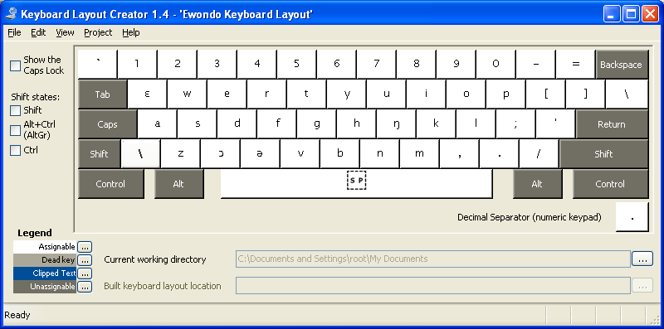
Figure 17: Ewondo keyboard in normal state

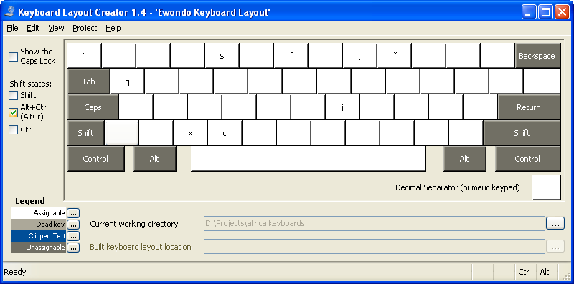
Figure 18: Ewondo keyboard in AltGr shift state

Name | Character | Code Point | Access Key
LATIN CAPITAL LETTER ENG | Ŋ | U+014A | Shift+J
LATIN SMALL LETTER ENG | Ŋ | U+014B | J
LATIN CAPITAL LETTER OPEN E | Ɛ | U+0190 | Shift + Q
LATIN SMALL LETTER OPEN E | ɛ | U+025b | Q
LATIN CAPITAL LETTER OPEN O | Ɔ | U+0186 | Shift + X
LATIN SMALL LETTER OPEN O | ɔ | U+0254 | X
LATIN CAPITAL LETTER REVERSE E | Ǝ | U+018e | Shift + C
LATIN SMALL LETTER SCHWA | ə | U+0259 | C
LATIN CAPITAL LETTER V | J | U+006a | AltGr+Shift+J
LATIN SMALL LETTER V | J | U+004a | AltGr+J
LATIN CAPITAL LETTER Q | Q | U+0051 | AltGr+Shift+Q
LATIN SMALL LETTER Q | Q | U+0071 | AltGr+Q
LATIN CAPITAL LETTER X | X | U+0058 | AltGr+Shift+X
LATIN SMALL LETTER X | X | U+0078 | AltGr+X
LATIN CAPITAL LETTER C | C | U+0043 | AltGr+Shift+C
LATIN SMALL LETTER C | C | U+0063 | AltGr+C

Fulfulde (Pular, Pullaar, Pulle)
Fulfulde is spoken throughout West Africa and it serves as national language in Guinea, Mali and Niger. The orthography system for Fulfulde is as follows:

Consonants:
Bb Ɓɓ Cc Dd Ɗɗ Ff Gg Hh Jj Kk Ll Mm Nn Ŋŋ Pp Qq Rr Ss Tt Ww Xx Yy Ƴƴ Zz
Vowels
Aa Ee Ii Oo Uu

The letter V is not required in Fulfulde Ɓ, Ɗ Ŋ, and Ƴ are added consonants to its orthography system. It’s suggested in Wikipedia on Fula language that the letters Q, X and Z are used for loan words but it’s not clear whether they’re part of standard Fulfulde writing system. If these characters are not used, they can be re-assigned to make room for other extended characters.
The extended characters are currently assigned to the key locations of V, [, ], and \ keys and the replaced characters have been re-assigned to the AltGr shift state as shown in figure 20. Figure 19, shows the Fulfulde keyboard in a normal state with the extra characters in their assigned key locations.
http://en.wikipedia.org/wiki/Fula_language

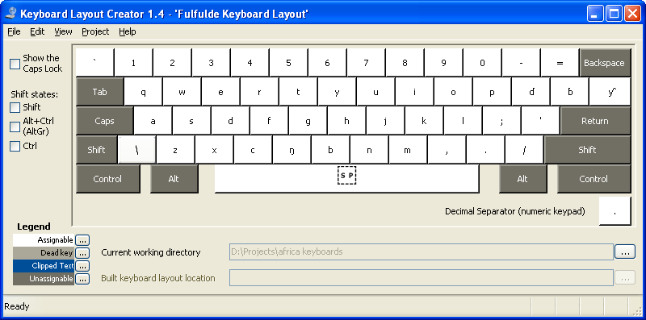
Figure 19: Fulfulde keyboard in a normal state

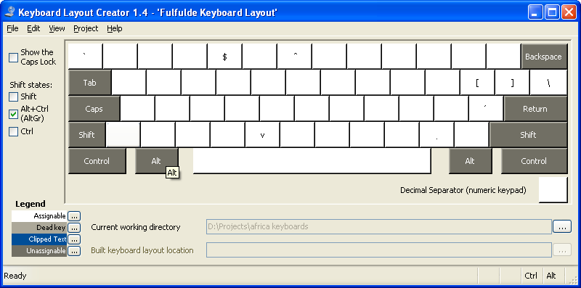
Figure 20: Fulfulde keyboard in AltGr state.

Name | Character | Code Point | Access Key
LATIN CAPITAL LETTER ENG | Ŋ | U+014A | Shift+V
LATIN SMALL LETTER ENG | ŋ | U+014B | V
LATIN CAPITAL LETTER D WITH HOOK | Ɗ | U+018a | Shift + [
LATIN SMALL LETTER D WITH HOOK | ɗ | U+0257 | [
LATIN CAPITAL LETTER B WITH HOOK | Ɓ | U+0181 | Shift + ]
LATIN SMALL LETTER B WITH HOOK | ɓ | U+0253 | ]
LATIN CAPITAL LETTER Y WITH HOOK | Ƴ | U+01b3 | Shift + \
LATIN SMALL LETTER Y WITH HOOK | ƴ | U+01b4 | \
LATIN CAPITAL LETTER V | V | U+0056 | AltGr+Shift+V
LATIN SMALL LETTER V | v | U+0076 | AltGr+V
LEFT CURLEY BRACKET | { | U+007b | AltGr + Shift + [
LEFT SQUARE BRACKET | [ | U+005b | AltGr + [
RIGHT CURLEY BRACKET | } | U+007d | AltGr + Shift + ]
RIGHT SQUARE BRACKET | ] | U+005d | AltGr + ]
VERTICAL PIPE | | | U+007c | AltGr+Shift + \
REVERSE SOLIDUS | \ | U+005c | AltGr + \

Ga
Ga is spoken mainly in Ghana by an estimated 600,000 people and it serves as one of the 10 national languages supported by the government of Ghana.
The writing system for Ga is relatively simple, with only three extended characters and no tonal mark designations in formal writing. The consonants and vowels for Ga are as follows:

Consonants:
Bb Dd Ff Gg Hh Jj Kk Ll Mm Nn Ŋŋ Pp Rr Ss Tt Vv Ww Yy Zz

Vowels:
Aa Ee Ɛɛ Ii Oo Ɔɔ Uu

The letters Q, X and C are not used and they have been replaced by the letters Ɛ, Ɔ and Ŋ in the keyboard layout, as shown in figure 21. Figure 22 shows the key assignments for the unused characters in the AltGr state.

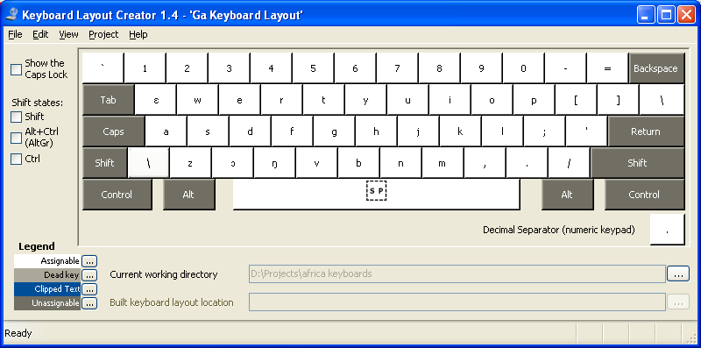
Figure 21: Ga keyboard in normal state.

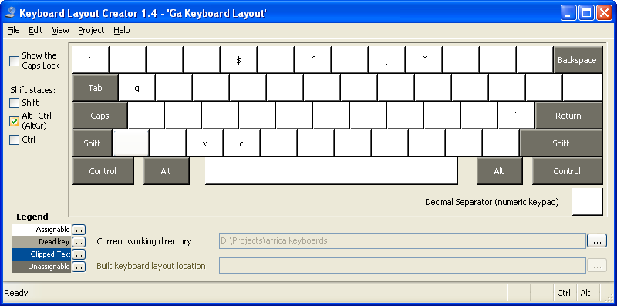
Figure 22: Ga keyboard in AltGr state.

Name | Character | Code Point | Access Key
LATIN CAPITAL LETTER OPEN E | Ɛ | U+0190 | Shift + Q
LATIN SMALL LETTER OPEN E | ɛ | U+025b | Q
LATIN CAPITAL LETTER OPEN O | Ɔ | U+0186 | Shift + X
LATIN LETTER SMALL OPEN O | ɔ | U+0254 | X
LATIN CAPITAL LETTER ENG | Ŋ | U+014a | Shift + C
LATIN SMALL LETTER ENG | ŋ | U+014b | C
LATIN CAPITAL LETTER Q | Q | U+0051 | AltGr+Shift+Q
LATIN SMALL LETTER Q | q | U+0071 | AltGr + Q
LATIN CAPITAL LETTER X | X | U+0058 | AltGr+Shift+X
LATIN SMALL LETTER X | x | U+0078 | AltGr+X
LATIN CAPITAL LETTER C | C | U+0043 | AltGr + Shift + C
LATIN SMALL LETTER C | c | U+0063 | AltGr + C

Gbe
Gbe is a family of related languages spoken in West Africa. Members of this language family include Ewe and Fon, and are spoken in Ghana, Benin, and Togo by an estimated 8 million people.
It’s not yet known, whether these related languages share the same writing system but for the purpose of this project, we assume that they do and this keyboard layout was derived from the Ewe alphabets.

Consonants:
Bb Dd Ɖɖ Ff Ƒƒ Gg Ɣɣ Hh Kk Ll Mm Nn Ŋŋ Pp Rr Ss Tt Vv Ʋʋ Ww Xx Yy Zz

Vowels:
Aa Ee Ɛɛ Ii Oo Ɔɔ Uu

Letters Q, C, and J are not used but seven extended characters are introduced. Since there are more keys than what’s available at the normal shift state, one of the key in the Gbe writing system must be located at the AltGr shift level. The alternative is to use of the punctuation keys, which will make this configuration less than ideal, since punctuation marks are required in most writing systems.

Figure 23 shows the proposed key configuration for Gbe in a normal state. Figure 24 shows the keyboard layout at the AltGr shift state. As shown in figure 24, the Ɣ key, which is one of the characters in the Gbe language is assigned at the AltGr state, because there are no available keys to assign it to.

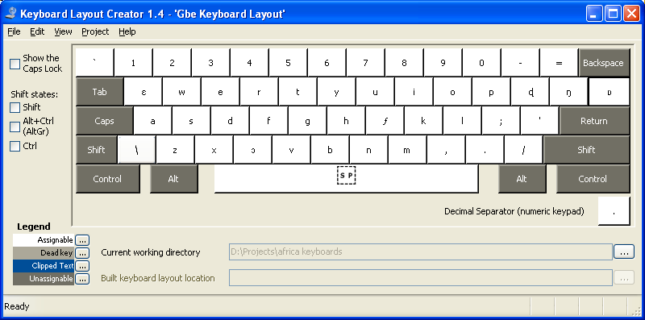
Figure 23: Gbe keyboard in a normal state.

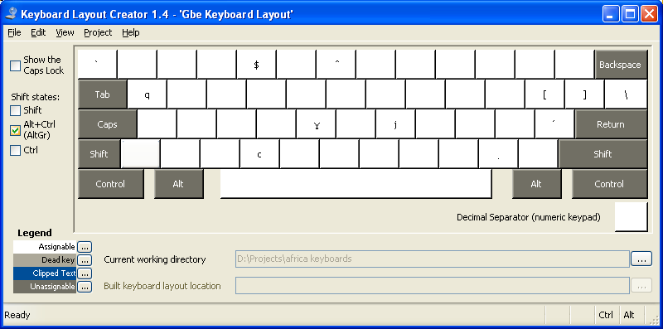
Figure 24: Gbe keyboard in AltGr shift state

Name | Character | Code Point | Access Key
LATIN CAPITAL LETTER OPEN E | Ɛ | U+0190 | Shift + Q
LATIN SMALL LETTER OPEN E | ɛ | U+025b | Q
LATIN CAPITAL LETTER OPEN O | Ɔ | U+0186 | Shift + C
LATIN SMALL LETTER OPEN O | ɔ | U+0254 | C
LATIN CAPITAL LETTER F WITH HOOK | Ƒ | U+0191 | Shift + J
LATIN SMALL LETTER F WITH HOOK | ƒ | U+0192 | J
LATIN CAPITAL LETTER GAMMA | Ɣ | U+0194 | AltGr + Shift + G
LATIN SMALL LETTER GAMMER | ɣ | U+0263 | AltGr + G
LATIN CAPITAL LETTER ENG | Ŋ | U+014A | Shift+[
LATIN SMALL LETTER OPEN E | ŋ | U+014B | [
LATIN CAPITAL LETTER V WITH HOOK | Ʋ | U+01b2 | Shift + ]
LATIN SMALL LETTER V WITH HOOK | ʋ | U+028b | ]
LATIN CAPITAL LETTER AFRICAN D | Ɖ | U+0189 | Shift + \
LATIN SMALL LETTER D WITH TAIL | ɖ | U+0256 | \
LATIN CAPITAL LETTER Q | Q | U+0051 | AltGr + Shift + Q
LATIN SMALL LETTER Q | q | U+0071 | AltGr + Q
LATIN CAPITAL LETTER C | C | U+0043 | AltGr+Shift+C
LATIN SMALL LETTER C | c | U+0063 | AltGr+C
LATIN CAPITAL LETTER J | J | U+004a | AltGr + Shift + J
LATIN SMALL LETTER J | j | U+006a | AltGr + J
LEFT SQUARE BRACKET | [ | U+005b | AltGr + [
LEFT CURLEY BRACKET | { | U+007b | AltGr + Shift + [
RIGHT SQUARE BRACKET | ] | U+005d | AltGr + ]
RIGHT CURLEY BRACKET | } | U+007d | AltGr + Shift + ]
VERTICAL LINE | | | U+007c | AltGr + \
REVERSE SOLIDUS | \ | U+005c | AltGr + Shift \

Hausa
Hausa is spoken by over 25million people and it’s widely spoken by millions more as a second language. Hausa can be written using Arabic script as Latin scripts; this keyboard layout is defined for Latin script only. The orthography system for Latin script is as follows:

Consonants:
Bb Ɓɓ Cc Dd Ɗɗ Ff Gg Hh Jj Kk Ƙƙ Ll Mm Nn Rr Ss Tt Ww Yy Ƴƴ Zz

Vowels:
Aa Ee Ii Oo Uu

Letters Q, X, V, and P are not used in Hausa but Ƙ, Ɗ, Ɓ, and Ƴ are required and they have been assigned as such, with the Q, X, V and P keys re-assigned at the AltGr shift level.
Long vowels and consonants are written by either doubling or by using the combining macron character, which is typed by pressing the base letter followed by AltGr + MINUS.
Hausa is also a tonal language with high, low and high-low tones. A High tone is indicated by an acute accent; a low tone is indicated by a grave accent and a high-low tone is indicated by a circumflex accent.
Figure 25 shows the proposed keyboard layout for Hausa and figure 26 shows the key configuration at the AltGr shift level. In addition, a number of combining characters are defined at the AltGr state for writing tonal markings.

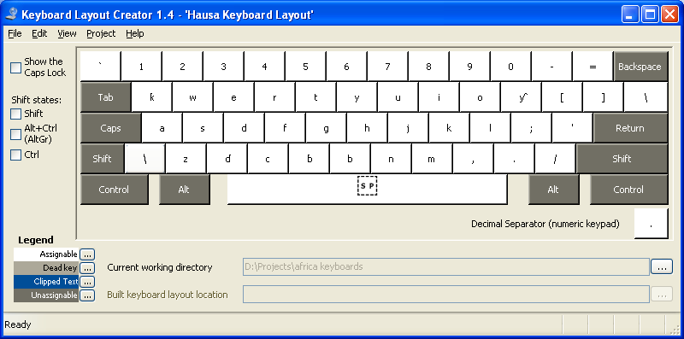
Figure 25: Hausa keyboard in normal state.

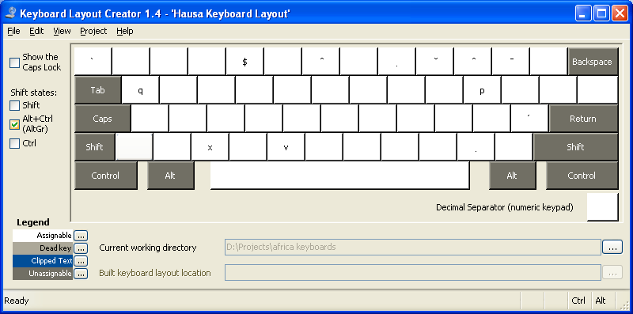
Figure 26: Hausa keyboard in AltGr state

Name | Character | Code Point | Access Key
LATIN CAPITAL LETTER D WITH HOOK | Ɗ | U+018a | Shift + X
LATIN SMALL LETTER D WITH HOOK | ɗ | U+0257 | X
LATIN CAPITAL LETTER K WITH HOOK | Ƙ | U+0198 | Shift + Q
LATIN LETTER SMALL K WITH HOOK | ƙ | U+0199 | Q
LATIN CAPITAL LETTER B WITH HOOK | Ɓ | U+0181 | Shift + V
LATIN SMALL LETTER B WITH HOOK | ɓ | U+0253 | V
LATIN CAPITAL LETTER Y WITH HOOK | Ƴ | U+01b3 | Shift + P
LATIN SMALL LETTER Y WITH HOOK | ƴ | U+01b4 | P
LATIN CAPITAL LETTER Q | Q | U+0051 | AltGr+Shift+Q
LATIN SMALL LETTER Q | q | U+0071 | AltGr + Q
LATIN CAPITAL LETTER X | X | U+0058 | AltGr+Shift+X
LATIN SMALL LETTER X | x | U+0078 | AltGr+X
LATIN CAPITAL LETTER C | C | U+0056 | AltGr + Shift + C
LATIN SMALL LETTER C | c | U+0076 | AltGr + C
LATIN CAPITAL LETTER P | P | U+0070 | AltrGr + Shift + P
LATIN SMALL LETTER P | p | U+0050 | AltGr + P

Igbo
The Igbo writing system does not introduce any additional characters than what’s available on a standard QWERTY keyboard, but with Igbo being tonal language requires certain characters to be marked to indicate tone. Specifically, Ị, Ọ, and Ụ (I, O, and U with dot below). The character set needed for Igbo are:

Consonants:
Bb Cc Dd Ff Gg Hh Jj Kk Ll Mm Nn Pp Qq Rr Ss Tt Vv Ww Xx Yy Zz

Vowels:
Aa Ee Ii Ịị Oo Ọọ Uu Ụụ

Figure 27 shows the normal QWERTY keyboard for Igbo and figure 28 shows the keyboard layout in AltGr state, where the combining characters are defined. In the case of Igbo, only the combining dot below character AltGr + ASTERIX) is required.

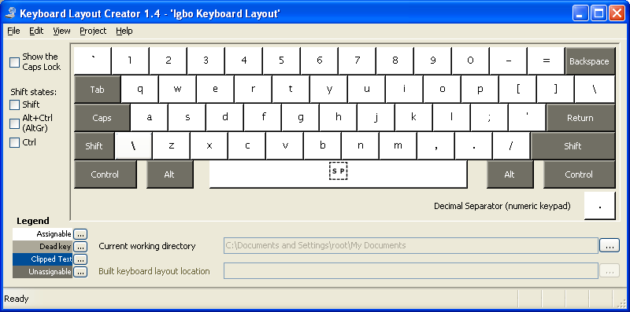
Figure 27: Igbo keyboard in normal state.

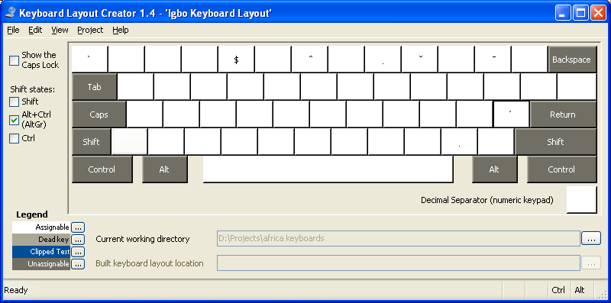
Figure 28: Igbo keyboard in AltGr state

Kikuyu
Kikuyu writing system does not introduce any additional characters than what’s available on a standard QWERTY keyboard but it requires I and U to be marked with combining tilde (ĩ, Ũ). The orthographic system for Kikuyu is as follows:

Consonants:
Bb Cc Dd Ff Gg Hh Jj Kk Ll Mm Nn Pp Qq Rr Ss Tt Vv Ww Xx Yy Zz

Vowels:
Aa Ee Ii Ĩĩ Oo Uu Ũũ

Figure 29 shows the normal QWERTY keyboard for Kikuyu and figure 30 shows the keyboard layout in AltGr state, where the combining characters are defined. In the case of Kikuyu, only the combining tilde character (AltGr + Shift + TILDE) is required.

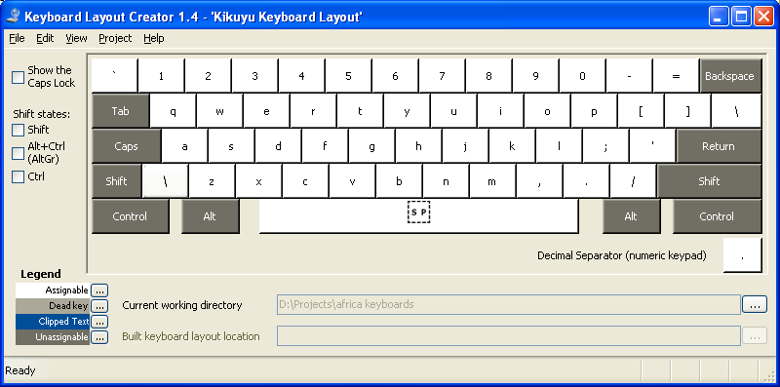
Figure 29: Kikuyu keyboard in normal state.

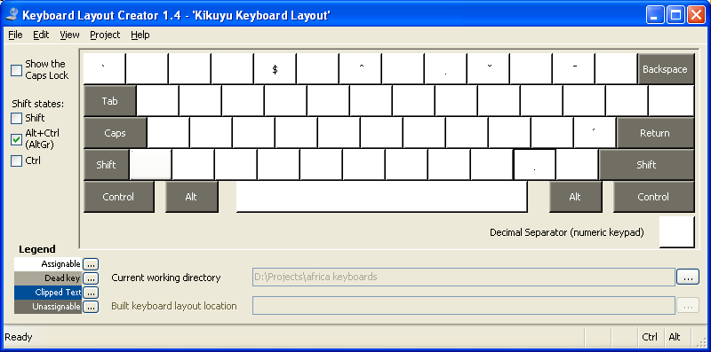

Figure 30: Igbo keyboard in AltGr state

Kirundi
Kirundi is spoken by an estimated 4.5 million people in Burundi, Uganda, Tanzania, Rwanda and Congo. Kirundi also serves as one of the official languages of Burundi. The orthographic system for Kirundi is as follows:

Consonants:
Bb Cc Dd Ff Gg Hh Jj Kk Ll Mm Nn Pp Qq Rr Ss Tt Vv Ww Xx Yy Zz

Vowels:
Aa Ee Ii Oo Uu

Kirundi does not require any extended characters and it’s not known whether any tonal markings are required but the normal diacritical markings found in most African languages are defined at the AltGr level.

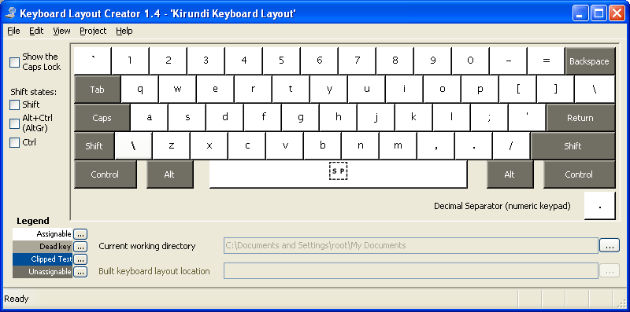
Figure 31: Kirundi keyboard in normal state.

Krio
The Krio language is written using a latin-based orthography system and its orthographic system is shown below:

Consonants:
Bb Cc Dd Ff Gg Hh Jj Kk Ll Mm Nn Pp Qq Rr Ss Tt Vv Ww Xx Yy Zz

Vowels:
Aa Ee Ɛɛ Ii Oo Ɔɔ Uu

Two additional characters are defined: Ɛ and Ɔ, however, all the keys on a QWERTY keyboard are used in Krio, leaving only the left and right square bracket keys for candidate replacement keys at the normal unshift level. The left and right square bracket keys are redefined at the AltGr shift level.
Figure 32 below shows the resulting Krio keyboard in a normal state. As indicated, the left square bracket and the right square bracket keys have been replaced with the Ɛ and Ɔ keys respectively. Figure 33 shows the same keyboard in AltGr state, where the left square bracket and the right square bracket keys are redefined.

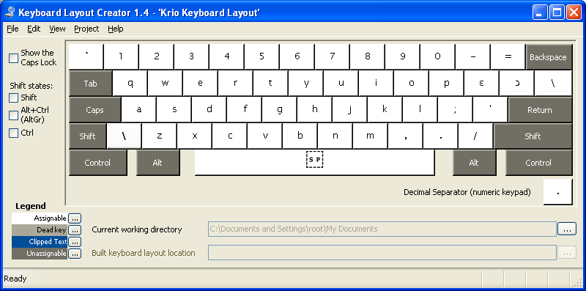
Figure 32: Krio keyboard layout in normal state

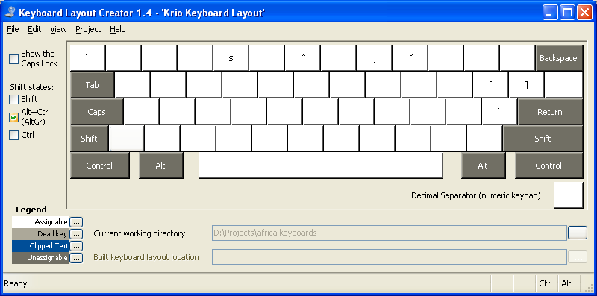
Figure 33: Krio keyboard in AltGr state

Name | Character | Code Point | Access Key
LATIN CAPITAL LETTER OPEN E | Ɛ | U+0190 | Shift + [
LATIN SMALL LETTER OPEN E | ɛ | U+025b | [
LATIN CAPITAL LETTER OPEN O | Ɔ | U+0186 | Shift + ]
LETTER SMALL LETTER OPEN O | ɔ | U+0254 | ]
LATIN CAPITAL LETTER Q | [ | U+005b | AltGr + [
LATIN SMALL LETTER Q | { | U+007b | AltGr + Shift + [
LATIN CAPITAL LETTER X | ] | U+005d | AltGr + ]
LATIN SMALL LETTER X | } | U+007d | AltGr+Shift + ]

Lingala
Lingala language is written using a latin-based orthography system and its orthographic system is shown below:

Consonants:
Bb Cc Dd Ff Gg Hh Kk Ll Mm Nn Pp Rr Ss Tt Vv Ww Yy Zz

Vowels:
Aa Ee Ɛɛ Ii Oo Ɔɔ Uu

The latin letters Q, J, and X are not used in Lingala writing system but two extended characters are needed: Ɛ and Ɔ, which are defined in place of Q and X; X and Q are accessible with AltGr key press combination. The table below shows the modified keyboard configuration for Lingala.

Figure 34 below shows the resulting Lingala keyboard in a normal state. As indicated, the Q and the X keys have been replaced with the Ɔ and Ɛ keys respectively. Figure 35 shows the same keyboard in AltGr state, where the X and the Q keys are redefined.
Lingala has four tones: acute accent for marking high tones, circumflex accent for marking descending tone, and a caron for marking ascending tone. Low tones are not marked.

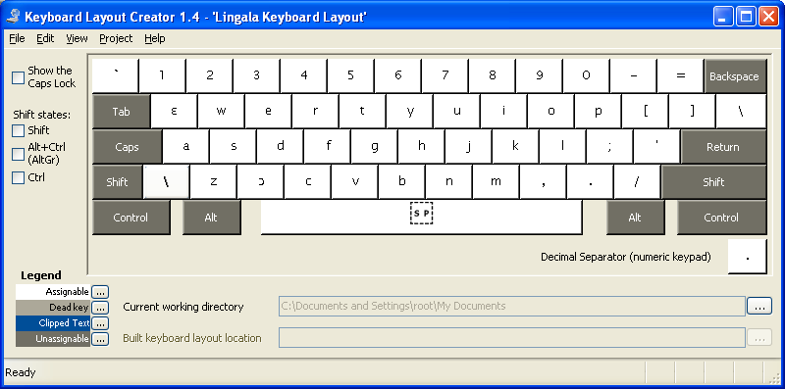
Figure 34: Lingala keyboard in normal state

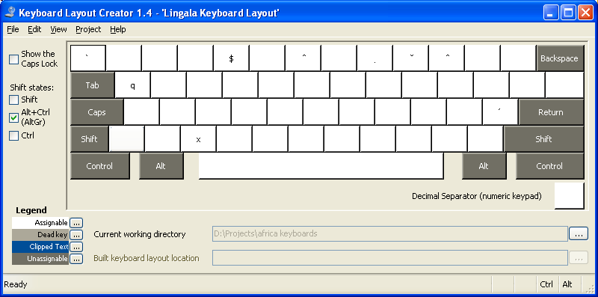
Figure 35: Lingala keyboard in AltGr state.

Name | Character | Code Point | Access Key
LATIN CAPITAL LETTER OPEN E | Ɛ | U+0190 | Shift + Q
LATIN SMALL LETTER OPEN E | ɛ | U+025b | Q
LATIN CAPITAL LETTER OPEN O | Ɔ | U+0186 | Shift + X
LETTER SMALL LETTER OPEN O | ɔ | U+0254 | X
LATIN CAPITAL LETTER Q | Q | U+0051 | AltGr+Shift+Q
LATIN SMALL LETTER Q | q | U+0071 | AltGr + Q
LATIN CAPITAL LETTER X | X | U+0058 | AltGr+Shift+X
LATIN SMALL LETTER X | x | U+0078 | AltGr+X

Luganda (Ganda)
Luganda language is written in both Latin and Arabic script but this particular layout is defined for the Latin script. The Latin-based orthography system is shown below:

Consonants:
Bb Cc Dd Ff Gg Hh Jj Kk Ll Mm Nn Ŋŋ Pp Rr Ss Tt Vv Ww Yy Zz

Vowels:
Aa Ee Ii Oo Uu

The latin letters Q and X are not used in Luganda writing system but the latin letter eng Ŋ is needed, which is defined in the place of X; X is accessible with AltGr key press combination. The table below shows the modified keyboard configuration for Luganda.

Figure 36 below shows the resulting Luganda keyboard in a normal state. As indicated, X key has been replaced with the Ŋ key. Figure 35 shows the same keyboard in AltGr state, where the X is redefined.
Tones are not marked in Luganda writings but combining characters are accessible from AltGr state, for cases when marking tones are necessary.

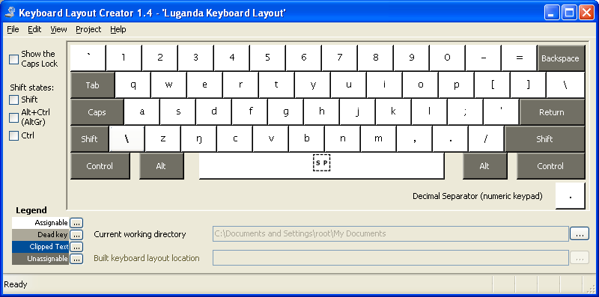
Figure 36: Luganda keyboard in normal state
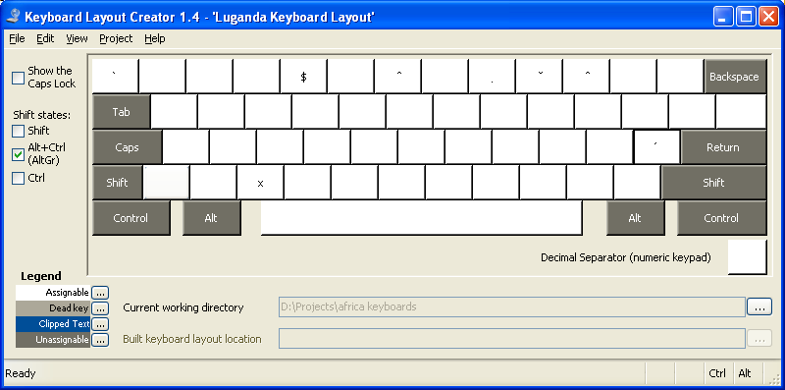
Figure 37: Luganda keyboard in AltGr state.

Name | Character | Code Point | Access Key
LATIN CAPITAL LETTER OPEN E | Ŋ | U+014a | Shift + x
LATIN SMALL LETTER OPEN E | ŋ | U+014b | X
LATIN CAPITAL LETTER X | X | U+0058 | AltGr+Shift+X
LATIN SMALL LETTER X | x | U+0078 | AltGr+X

Luo (Dholuo)
Luo is spoken in Kenya, Sudan and Tanzania by an estimated 3 million people. The Latin-based orthography system is shown below:

Consonants:
Bb Cc Dd Ff Gg Hh Jj Kk Ll Mm Nn Pp Rr Ss Tt Vv Ww Yy Zz
Vowels:
Aa Ee Ii Oo Uu

Note that the above list does not include digraphs, since they’ll not be defined in the proposed keyboard layout.
All the keys required for Luo are available on a normal QWERTY keyboard. It’s not known whether standard Luo writing requires tones to be marked. We need more information to clarify this.

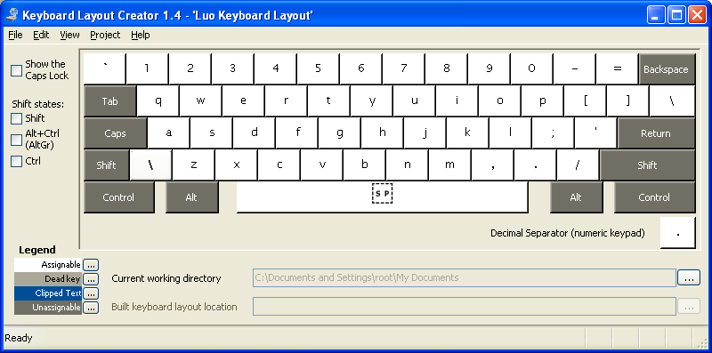
Figure 38: Luo keyboard in normal state

Oromo (Galla)
Oromo is spoken by an estimated 11 million people in Ethiopia. Standard Oromo orthographic system does not require any extended characters or accented characters but it does define a number of digraphs, which are not represented in the keyboard as a single unit.
Apart from combining diacritical markings that we have defined throughout this project for all African languages and currency symbol for Oromo users, no new modifications are required on standard QWERTY keyboards to type in Oromo.

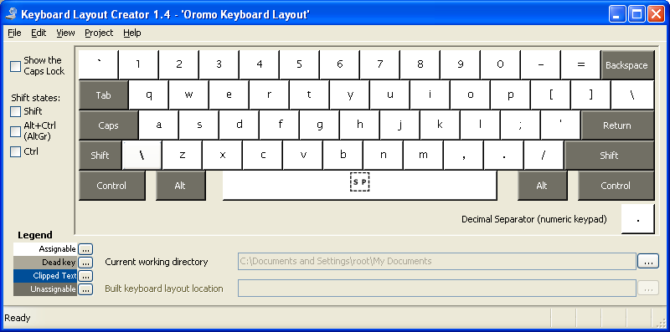

Somali
Somali is spoken by an estimated 6 million people in Somalia. Standard Somali orthographic system does not require any extended characters or accented characters but it does require a number of digraphs; and these are not represented in the keyboard as a single unit.
Apart from combining diacritical markings that we have defined throughout this project for all African languages and currency symbol for Somali users, no new modifications are required on standard QWERTY keyboards to type in Somali.

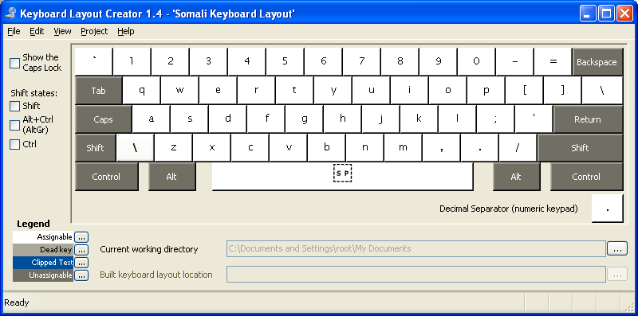

Shona
Shona is spoken by an estimated 9 million people in Zimbabwe.
Even though Shona is a tonal language, it’s not indicated in a standard writing. The orthographic system for Shona is shown below:

Consonants:
Bb Cc Dd Ff Gg Hh Jj Kk Ll Mm Nn Pp Qq Rr Ss Tt Vv Ww Xx Yy Zz
Vowels:
Aa Ee Ii Oo Uu

Digraphs are not included since they’ll not be defined on the keyboard as a single entity.

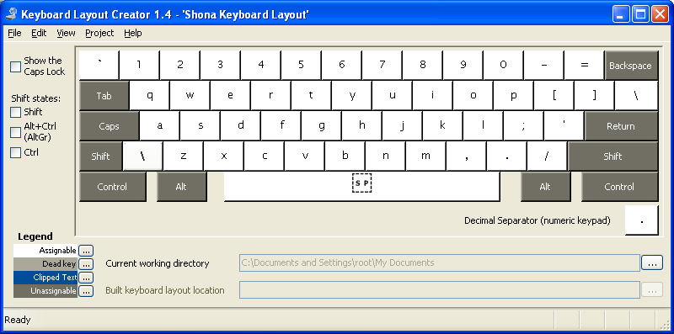

Swahili
Swahili is spoken in Eastern Africa by an estimated 35 million people. Swahili serves as one of the official language of Tanzania, Uganda and Kenya. Standard Swahili orthographic system does not require any extended characters or accented characters but it does require a number of digraphs; and these are not represented in the keyboard as a single unit.
Apart from combining diacritical markings that we have defined throughout this project for all African languages and currency symbol for Swahili users, no new modifications are required on standard QWERTY keyboards to type in Swahili.

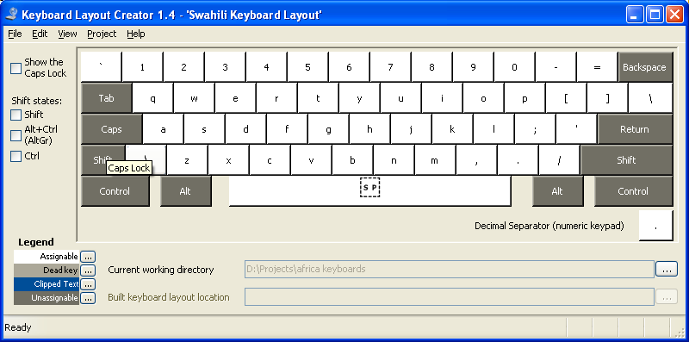

Tswana
Tswana is spoken by an estimated 3.3 million people in Botswana.
The orthographic system for Tswana is shown below:

Consonants:
Bb Cc Dd Ff Gg Hh Jj Kk Ll Mm Nn Pp Qq Rr Ss S̆s̆ Tt T̤t̤ Vv Ww Yy Zz
Vowels:
Aa Ee Êê Ii Oo Ôô Uu
Characters with combinig circumflex and combining breve are typed by first typing the base character followed by AltGr + 6 for circumflex and AltGr + 9 for breve.

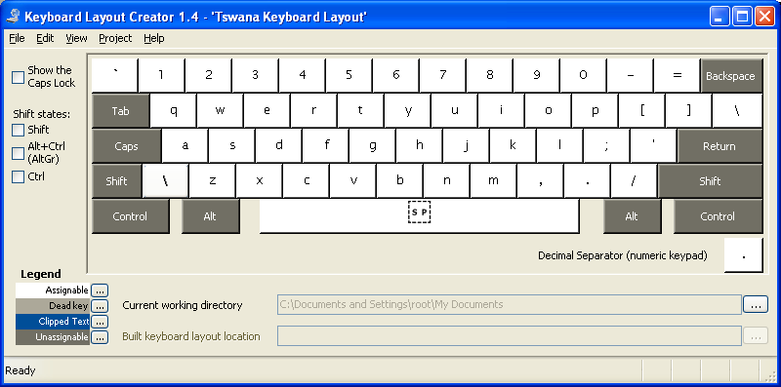

Wolof
Wolof is spoken by an estimated 2.6 million people in Senegal.
Even though wolof is not a tonal language, a number of diacritical markings are deployed in a standard Wolof writing system as shown:

Consonants:
Bb Cc Dd Ff Gg Hh H̤h̤ Jj Kk Ll Mm Nn Pp Qq Rr Ss Tt T̤t̤ Vv Ww Yy Zz
Vowels:
Aa Ââ Ăă Ee Èè Ii Oo Uu

Digraphs are not included since they’ll not be defined on the keyboard as a single entity.

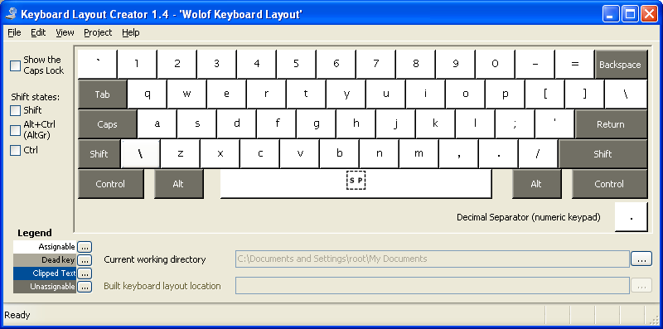

Yoruba
Yoruba is spoken by an estimated 22 million people in Nigeria, Benin, and Togo and it serves as one of the official languages of Nigeria.
The orthographic system of Yoruba introduces three new characters as shown:

Consonants:
Bb Cc Dd Ff Gg Hh Jj Kk Ll Mm Nn Pp Qq Rr Ss Ṣṣ Tt Vv Ww Yy Zz
Vowels:
Aa Ee Ẹẹ Ii Oo Ọọ Uu

Digraphs are not included since they’ll not be defined on the keyboard as a single entity.
Yoruba is a tonal language with three tones: a high tone is marked with an acute accent and low tone is marked with a grave accent. A mid tone is not marked in standard writing.
Characters with dot below are not represented in the keyboard as a single entity, but rather are typed using combining characters. For example, to type S with dot below, type S followed by AltGr + 8.

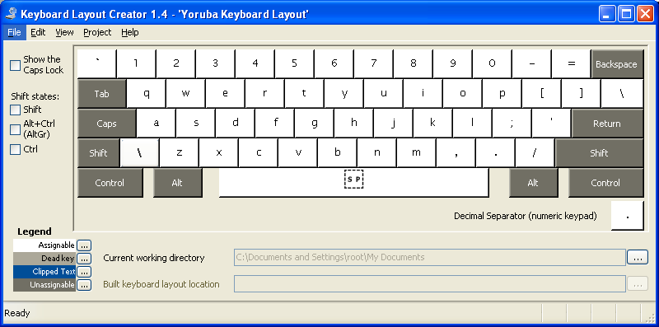

Southern Sotho (seSotho)
seSotho is one of the official languages of South Africa and it’s spoken by an estimated 4.2 million people in Lesotho, Botswana, South Africa, Namibia and Zambia. seSotho does not require any extended characters in standard writing. Though seSotho requires a number of digraphs and trigraphs, these are not represented in the keyboard as a single unit.
Apart from combining diacritical markings that we have defined throughout this project for all African languages and currency symbol for seSotho users, no new modifications are required on standard QWERTY keyboards to type in seSotho.

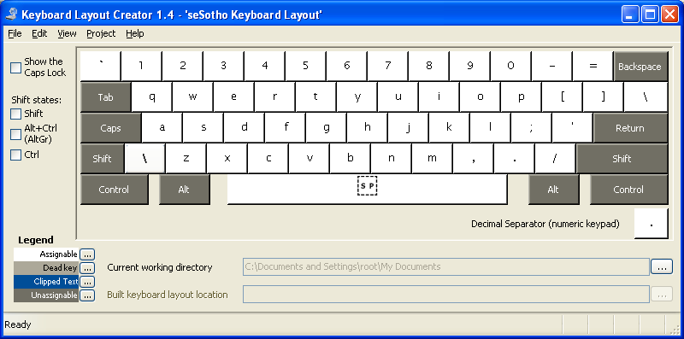

Xhosa
Xhosa orthographic system does not introduce any new characters and neither does it require tonal markings. Clicks are represented in standard Xhosa writing using three consonants, which do not require their own representation on a keyboard. A standard Xhosa keyboard design is still important since some symbols such as currency, needed by Xhosa users may not be available on standard QWERTY or AZWERTY keyboard.

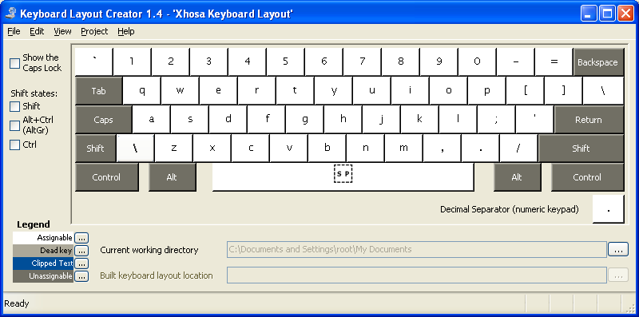

Zulu
Zulu orthographic system does not introduce any new characters and neither does it require tonal markings. A standard Zulu keyboard design is still important since some symbols such as currency, needed by Zulu users may not be available on standard QWERTY or AZWERTY keyboard.

