Introduction 2
Objective 2
Approach 2
Limitations 3
Africa ISO 6438 5
Akan 8
Bambara 10
Baule 12
Bemba 14
Chichewa 16
Duala 18
Edo or Bini 21
Ewondo 23
Fulfulde (Pular, Pullaar, Pulle) 25
Ga 28
Gbe 30
Hausa 33
Igbo 36
Kikuyu 38
Figure 30: Igbo keyboard in AltGr stateKirundi 39
Kirundi 40
Krio 41
Lingala 43
Luganda (Ganda) 45
Luo (Dholuo) 47
Oromo (Galla) 48
Somali 49
Shona 50
Swahili 51
Tswana 52
Wolof 53
Yoruba 54
Southern Sotho (seSotho) 55
Xhosa 56
Zulu 57

Africa ISO 6438
- Deadkey assigned to backslash key
- Moved “Latin Letter Literal Click” to the Right Square Bracket key to make room for the dead key. All other characters remain at the same position.
- Characters can be typed with Right Alt key or with the dead key sequences, including combining characters.

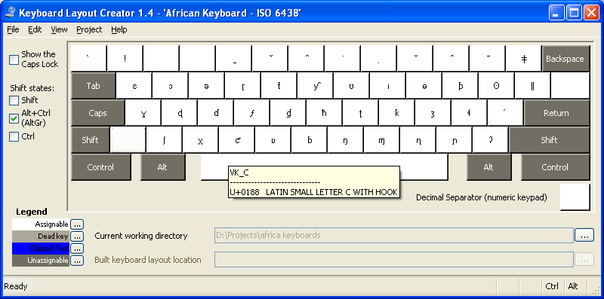

Akan
- Akan, Ga and Ewe keyboard will be used in the same geographic region and therefore should be similar.
- Moved Ɛ and Ɔ in akan layout to left and right square bracket key so they can share similar positioning.
- The replaced characters [, and ] can be typed with dead keys or Right-Alt.
- Dead key assigned to backslash key.

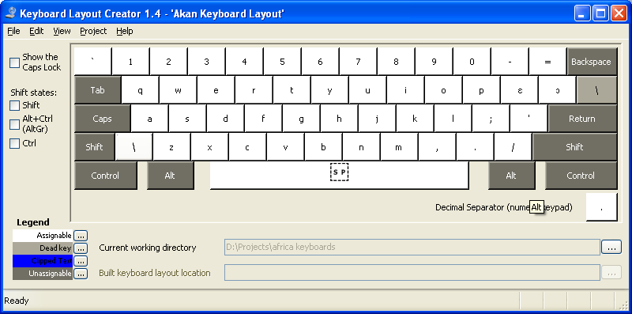

Bambara
- Moved Ɛ and Ɔ to left and right square key. This is to reduce the number of replaced ASCII characters and also to share similar layouts with other languages with Ɛ and Ɔ characters.
- Replaced characters [, ], x, and v can be typed with Right-Alt and dead keys.
- Dead key assigned to backslash key.

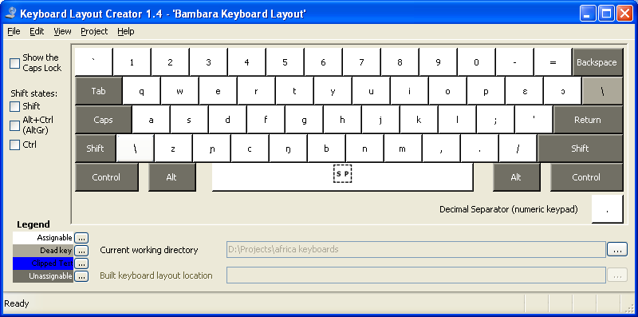

Baule
- Moved Ɛ and Ɔ to left and right square key. This is to reduce the number of replaced ASCII characters and also to share similar layouts with other languages with Ɛ and Ɔ characters.
- Replaced characters [, ], x, and v can be typed with Right-Alt and dead keys.
- Dead key assigned to backslash key.

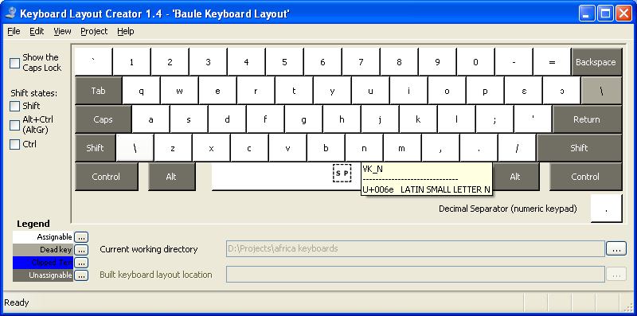

Bemba
- Moved ŋ to the left square bracket key to minimize number of replaced ASCII characters.
- All languages with similar set of characters will share the same positioning if possible.
- Replaced characters can be typed with Right-Alt and dead key.

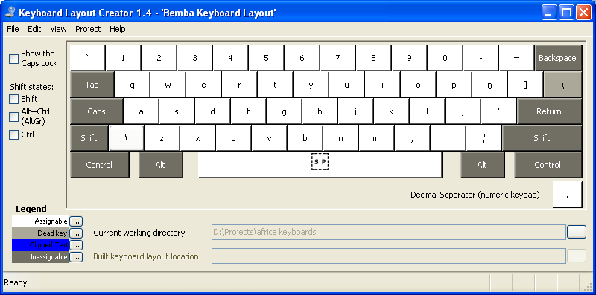

Chichewa
- Moved ŋ to the left square bracket key to minimize number of replaced ASCII characters.
- All languages with similar set of characters will share the same positioning if possible.
- Replaced characters can be typed with Right-Alt and dead key.

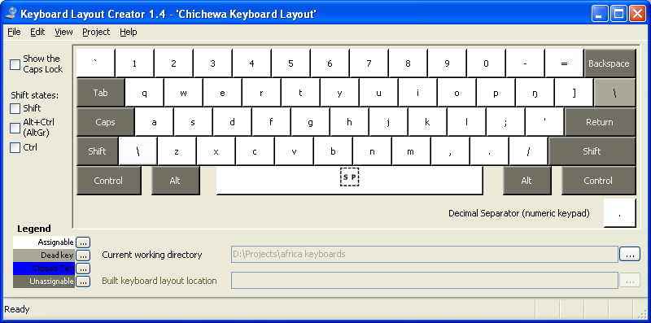

Duala
- Moved Ɛ and Ɔ to left and right square bracket keys to share similar positioning with other languages.
- Moved Ɗ and Ɓ to X and V keys so they can be closed to D and B. Since both sets of characters look similar they should be as close together as position to make it easier to remember.
- Replaced characters X, V, [, and ] can be typed with either Right-Alt, and dead keys.
- Dead key assigned to the backslash key.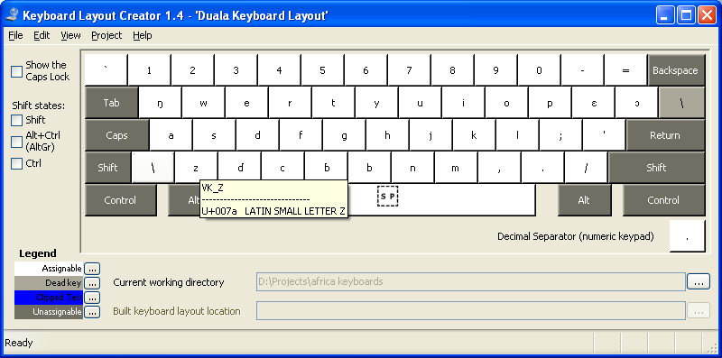

Edo or Bini
- No extended keys required but combining characters are defined for all layouts and they’re accessible from Right-Alt or dead keys.
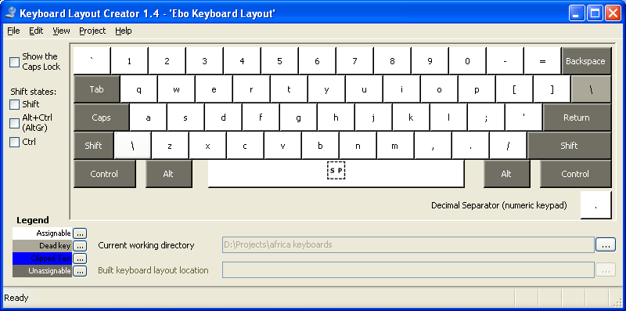

Ewondo
- Moved Ɛ and Ɔ to left and right square bracket keys to share similar positioning with other languages.
- Moved Ŋ to Q key to be similar to other layouts with the same character.
- Ǝ is left at the J key.
- Replaced characters are accessible with Right-Alt or dead keys

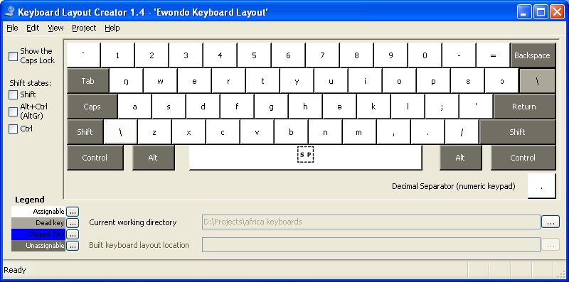

Fulfulde (Pular, Pullaar, Pulle)
- The backslash key is being used as the deadkey so the Ƴ key is moved to the third shift level of Y, since there are no available keys to assign to.
- Ɗ and Ɓ remains the same at the left and right square bracket keys.
- Replaced character V and the extended character Ƴ is accessible with Right-Alt or dead keys.

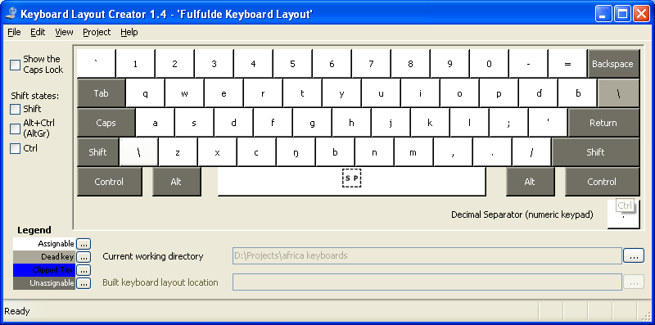

Ga
- Moved Ɛ and Ɔ to the left and right square bracket keys to share layouts with akan.
- Moved Ŋ to the Q key so it can share layouts with the Gbe layout.
- Replaced characters are accessible by Right-Alt or dead key.

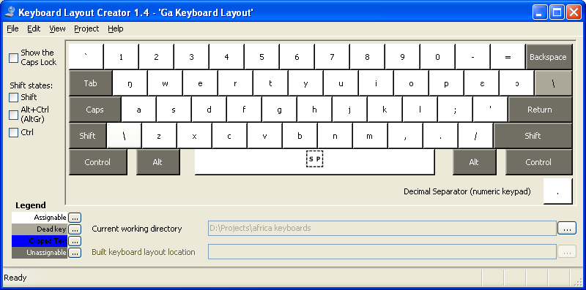

Gbe
- Shares the same positioning as Ga and Akan for Ɛ, Ɔ and Ŋ since they’re going to be used in the same geographic region.
- Moved Ɖ to the C key so it can be closed to D since they look similar.
- There are no available keys for Ɣ and Ʋ so they have been assigned at the third shift left, accessible with Right-Alt and dead keys.
- Ƒ is assigned to the remaining position at J.

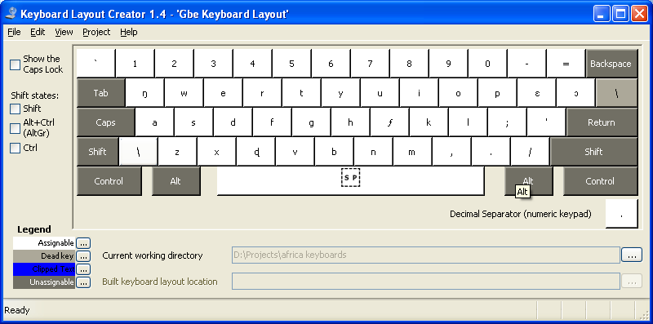

Hausa
- Moved Ɗ and Ɓ to X and V keys so they can be closed to D and B since they look similar.
- Ƙ and Ƴ are assigned to the left and right square bracket keys to reduce the number of replaced characters.
- Replaced characters are accessible with the Right-Alt or deadkeys.

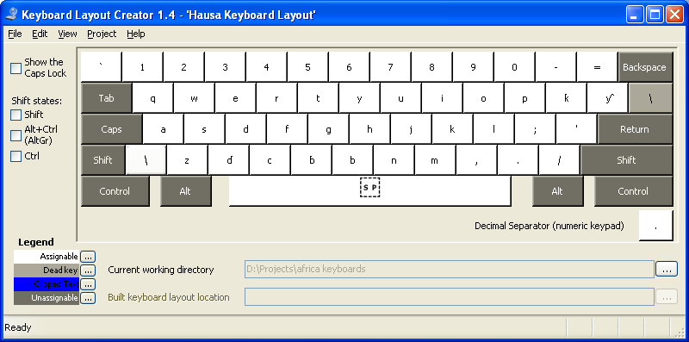

Krio
- Moved Ɛ and Ɔ to the left and right square bracket keys to look similar to other languages with the same extended characters.
- Replaced characters [ and ] are accessible with the Right-Alt or dead keys.

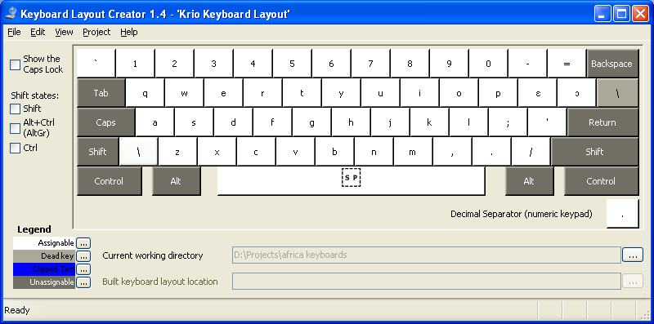

Lingala
- Moved Ɛ and Ɔ to the left and right square bracket keys to look similar to other languages with the same extended characters.
- Replaced characters [ and ] are accessible with the Right-Alt or dead keys.

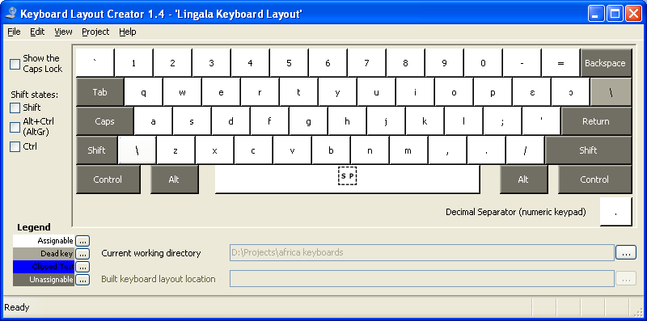

Luganda (Ganda)
- Moved Ŋ to the left square bracket key to reduced number of replaced ASCII characters.
- The left square bracket key is accessible with Right-Alt or dead key.

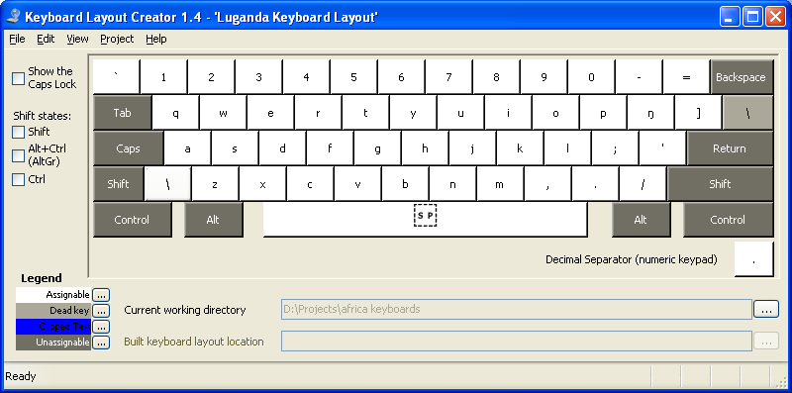

Luo (Dholuo)
- Added dead key support for typing combining characters. Right-Alt is still available for accessing combining characters.

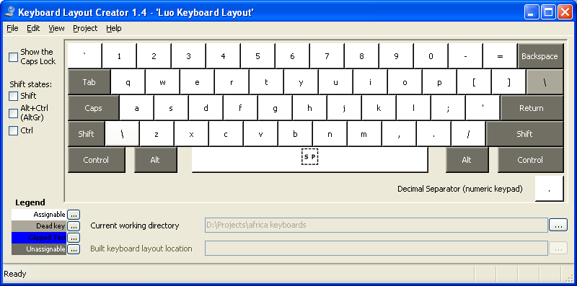

Oromo (Galla)
- Added dead key support for typing combining characters. Right-Alt is still available for accessing combining characters.

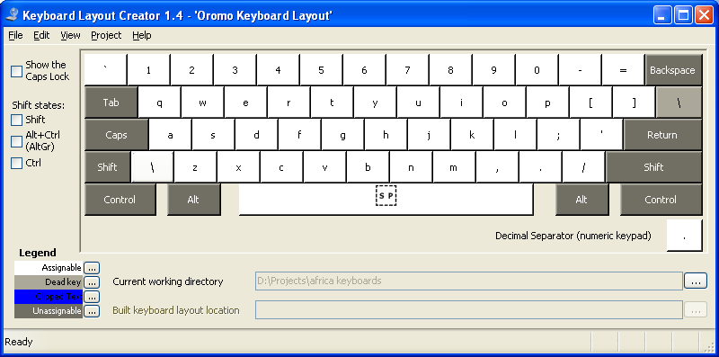

Somali
- Added dead key support for typing combining characters. Right-Alt is still available for accessing combining characters.

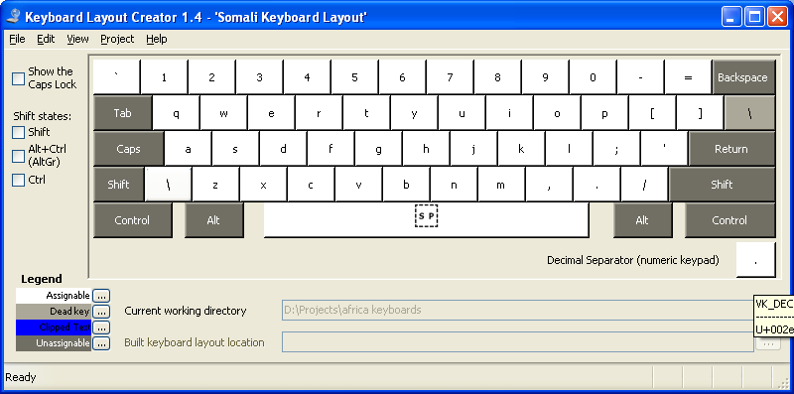

Shona
- Added dead key support for typing combining characters. Right-Alt is still available for accessing combining characters.

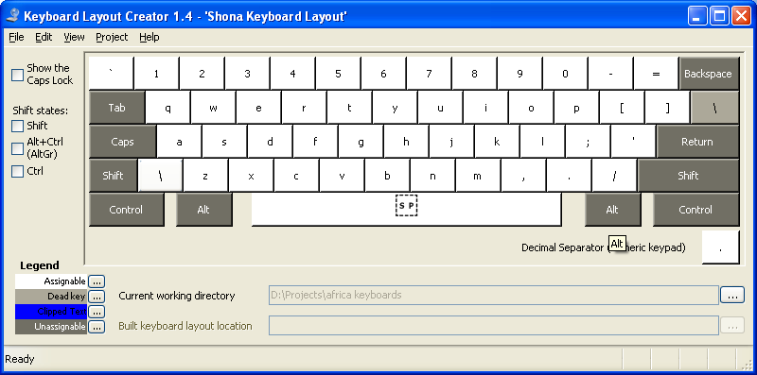

Swahili
- Added dead key support for typing combining characters. Right-Alt is still available for accessing combining characters.

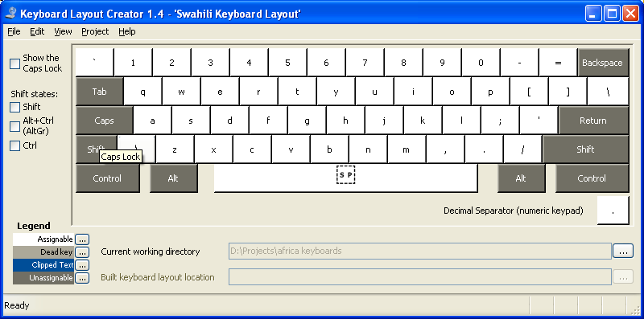

Tswana
- Added dead key support for typing combining characters. Right-Alt is still available for accessing combining characters.

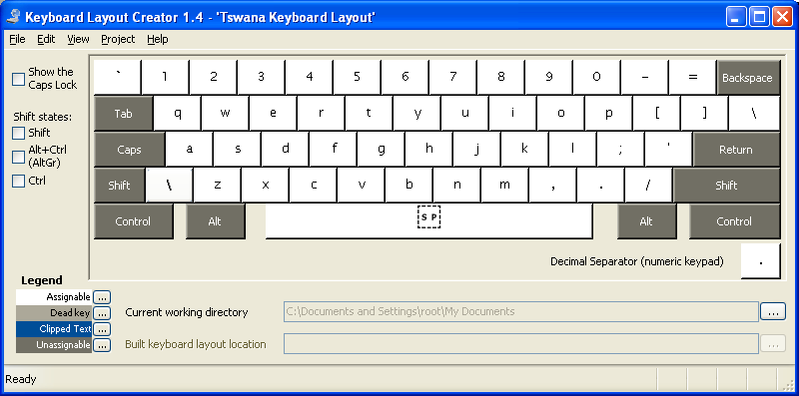

Wolof
- Added dead key support for typing combining characters. Right-Alt is still available for accessing combining characters.

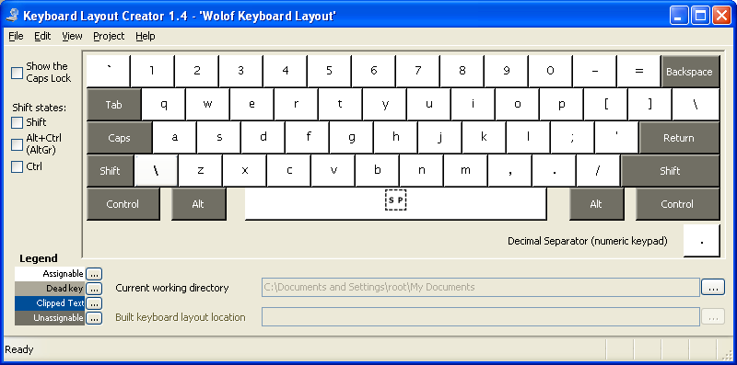

Yoruba
- Added dead key support for typing combining characters. Right-Alt is still available for accessing combining characters.

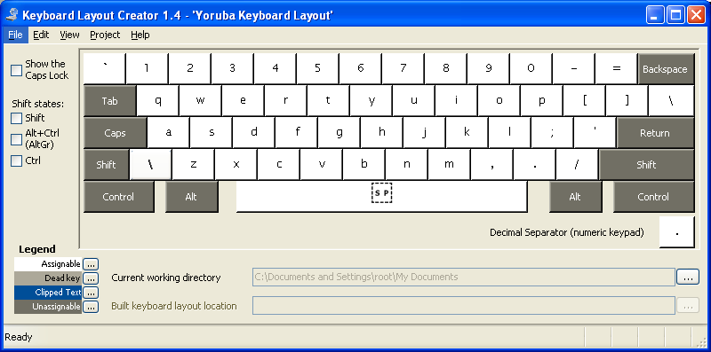

Southern Sotho (seSotho)
- Added dead key support for typing combining characters. Right-Alt is still available for accessing combining characters.

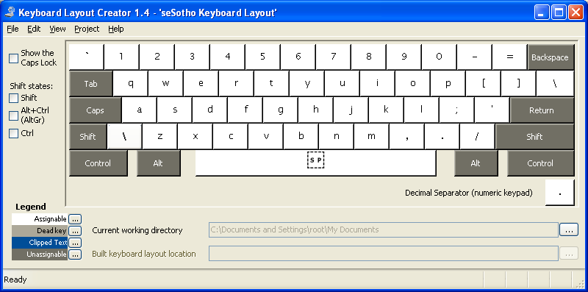

Xhosa
- Added dead key support for typing combining characters. Right-Alt is still available for accessing combining characters.

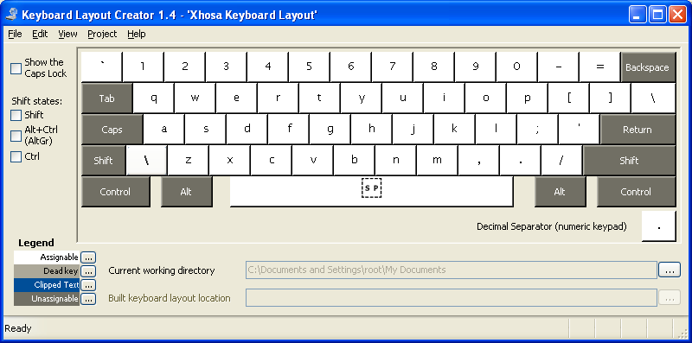

Zulu
- Added dead key support for typing combining characters. Right-Alt is still available for accessing combining characters.

