PYGLARA
PRENSADOS Y GALVANIZADOS DE LARA, S.A.
Hot-Dip Galvanizing | Copper Electroplating | Barquisimeto, Venezuela

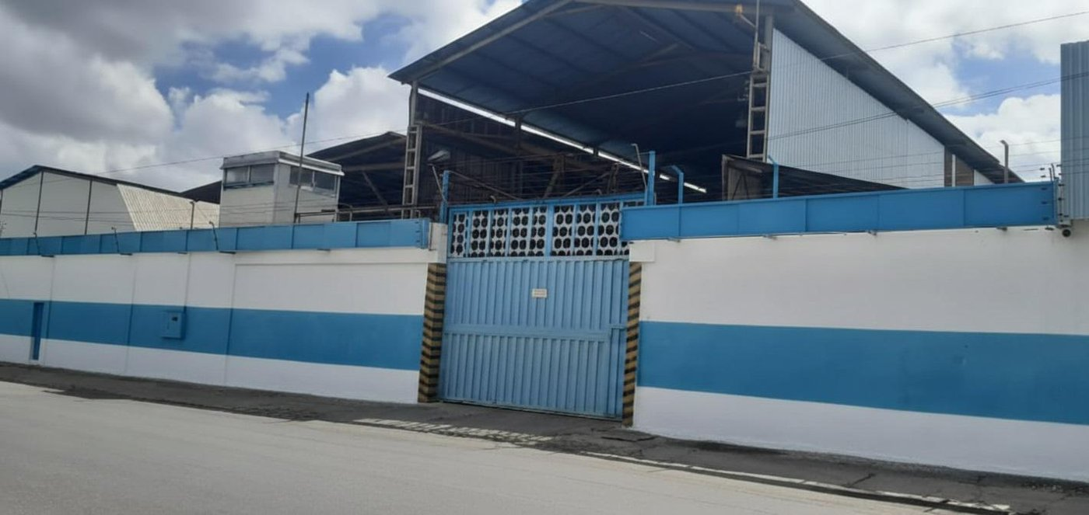
PYGLARA facility — Zona Industrial I, Barquisimeto
THE LEADING GALVANIZER IN VENEZUELA
German Pilling kettles • COVENIN 1212-81 • ASTM A123 • ASTM A153
1,440 TM/month installed capacity • 36+ years of operational expertise
1,440 TM  Installed monthly capacity | 2 of 2  Active galvanizers in Venezuela | 50+  Years of Pilling kettle technology

Who We Are
Prensados y Galvanizados de Lara, S.A. (PYGLARA) is a turnkey hot-dip galvanizing and copper electroplating facility in the heart of Venezuela's industrial corridor. Founded by the Ballesteros family, 100% Venezuelan capital, with clean title and over three decades of operational history under the technical leadership of Ing. Miriam — a plant engineer with 36+ years of galvanizing experience.
Our plant sits on ~3,640 m² across two industrial warehouses in Zona Industrial I, Barquisimeto — the same complex as CORPOELEC Lara, SASGO, GEDISA and Industrias Marullo. We operate under Venezuelan national standard COVENIN 1212-81 and international standards ASTM A123 (zinc coatings on iron and steel products) and ASTM A153 (zinc coatings on hardware).
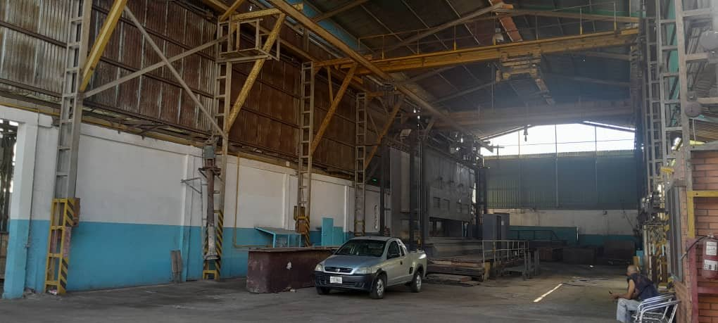  Main galvanizing hall — 7 m Pilling kettle installed | 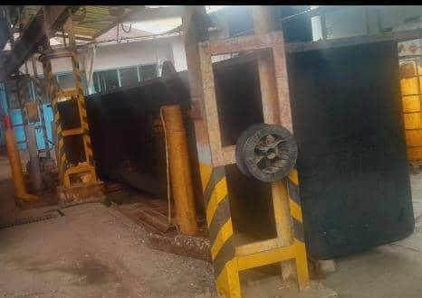  Furnace and kettle housing — German engineering

What Makes Us Different
- German-engineered kettles by W. Pilling Riepe GmbH & Co. KG — the global reference for hot-dip galvanizing equipment
- Only 2 active galvanizers in the entire country. Every other project is still in installation phase.
- Zero domestic competitors for copper-clad ground rods — a unique product line we already produced at scale for ENELVEN (now CORPOELEC Zulia)
- 36+ years of institutional knowledge retained in the plant's technical leadership
- Strategic location: 3 hours to Puerto Cabello, equidistant to Caracas, Maracaibo, and Puerto La Cruz
- Full COVENIN 1212-81 / ASTM A123 / ASTM A153 compliance — SENIAT-audited financial history 2005-2019

What We Do

1. Hot-Dip Galvanizing (Primary Service)
A service-only model: the client brings the steel, we galvanize it and return the finished product with certified zinc coating. Our installed capacity of 1,440 TM per month — with a best-actual month of 300 TM — places PYGLARA among the largest active galvanizers in Venezuela.
- 7 m Pilling kettle — structural steel, poles, towers, pletinas  - 9 m Pilling kettle — oversized work, unmatched regionally  - 3.5 m kettle — cable trays, solar mounts, crash barriers  - 65 cm centrifuge — nails, fasteners, small hardware (active now)  - Pricing based on 10% zinc absorption, charged by weight | 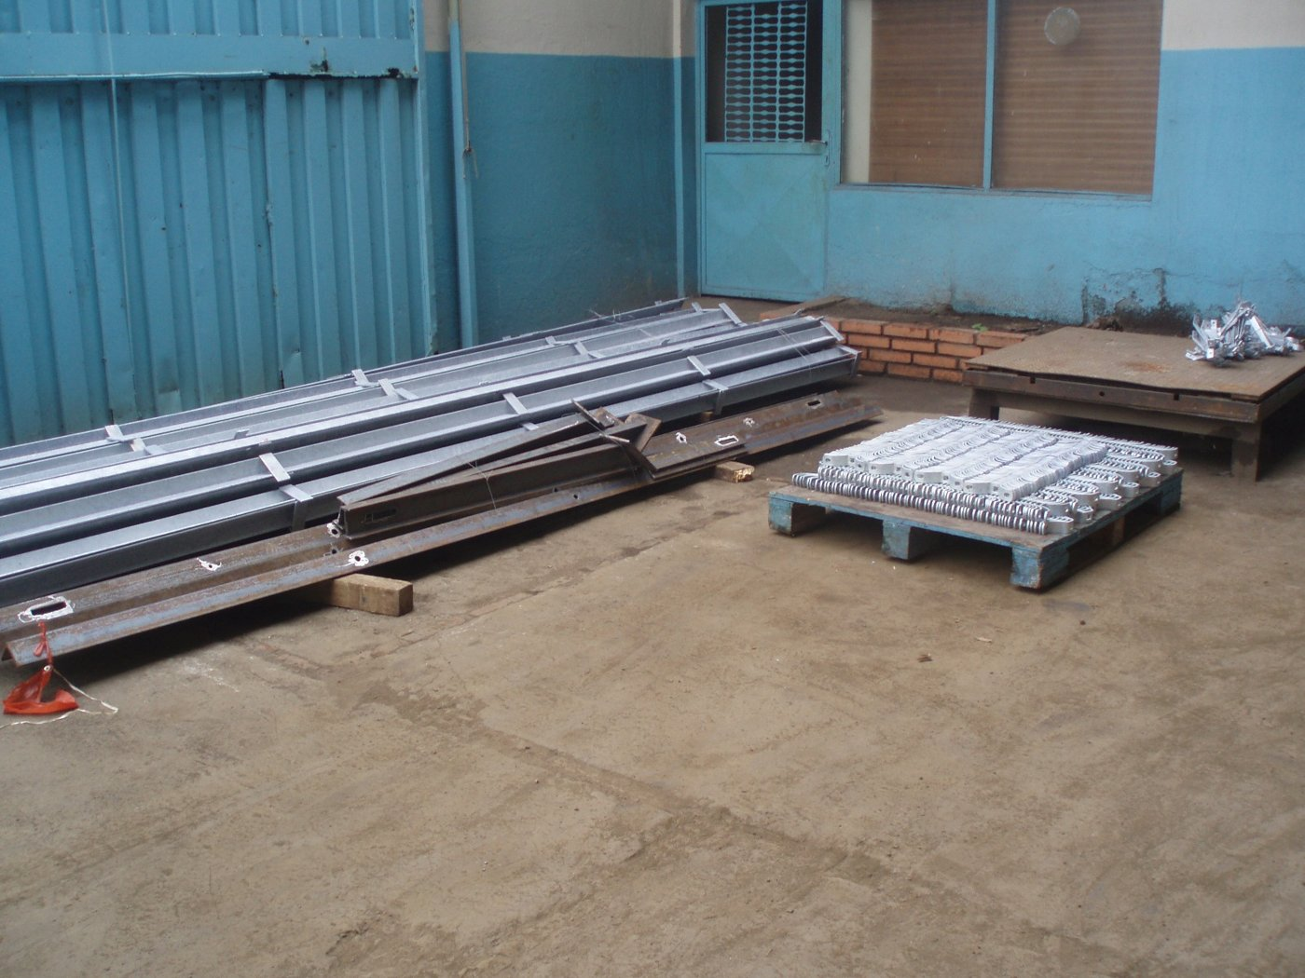  Galvanized structural members — ready for shipment  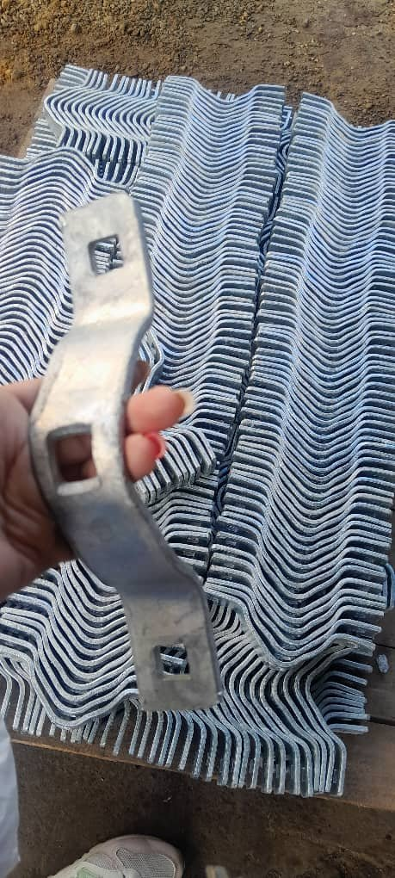  Finish quality — ASTM A153 hardware

2. Copper Electroplating (Secondary Service)
A 24-hour continuous-cycle line producing up to 936 copper-clad ground rods per day. Copper thickness 300 µm ± 50, with nickel used only as the base adhesion layer. Sizes from 5/8" to 1" diameter and 1.2 m to 3 m length.
Historical reference: PYGLARA delivered 20,000 copper-clad ground rods to ENELVEN (now CORPOELEC Zulia) in 2004–2005 — approximately $168,000 in a single contract. There is no other domestic producer of this product in Venezuela today.
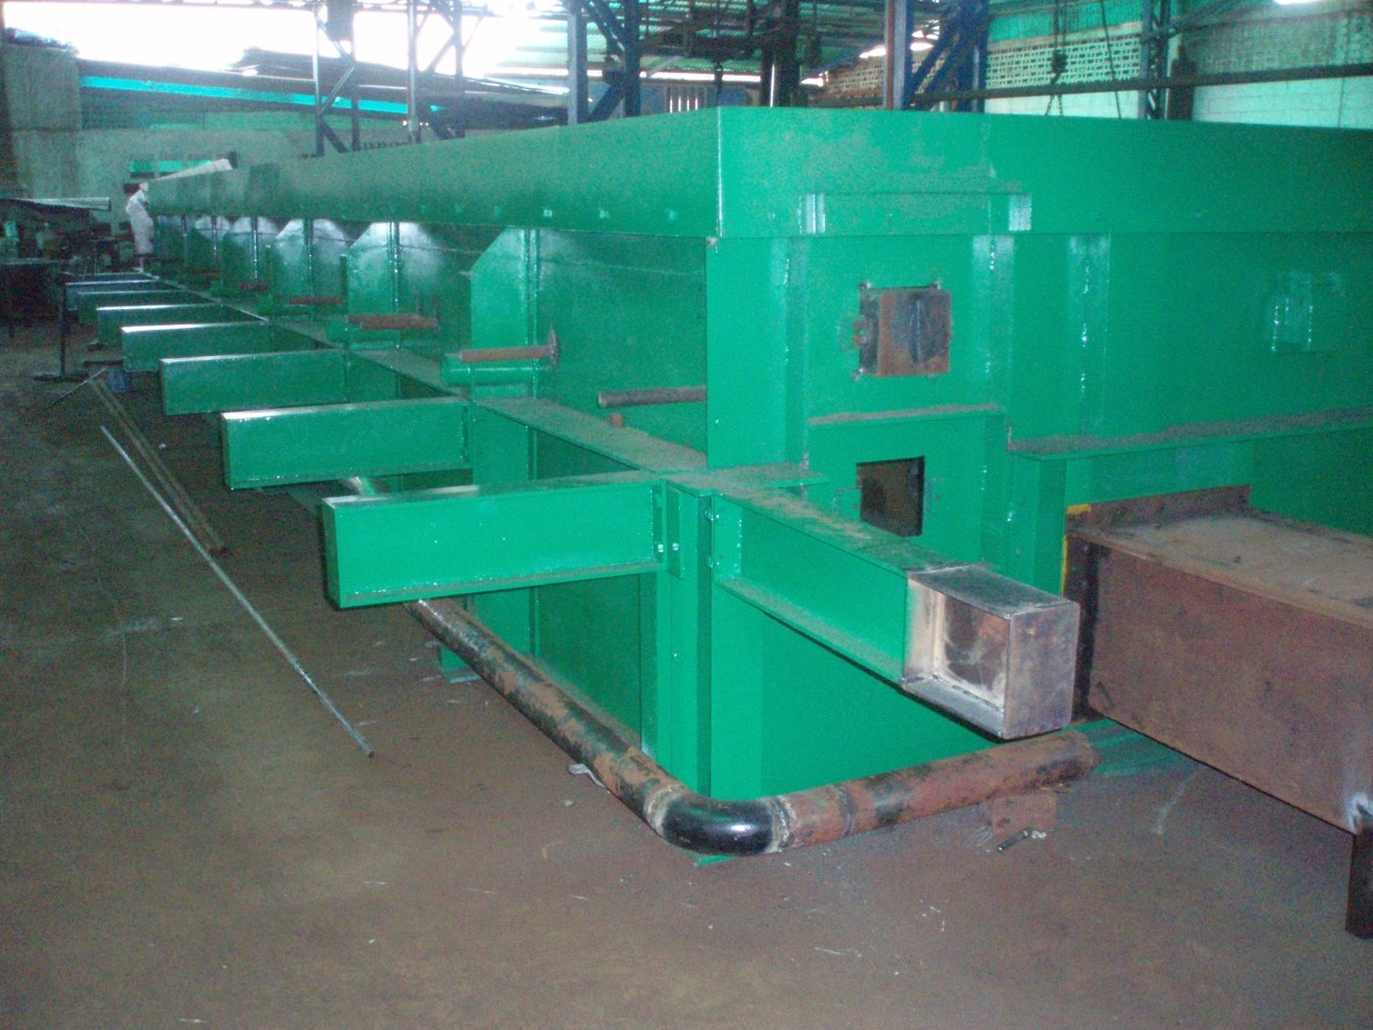  Copper electroplating tanks — 10 tanks, 6 three-phase rectifiers | Plant Assets  - 2 warehouses, ~3,640 m² total  - 3 Clark forklifts (2,500 kg)  - 2 overhead cranes (2–5 TM)  - Industrial scale + QC lab  - 66 kVA contracted power  - PDVSA Gas contract (active)

Why We Are the Best Positioned in Venezuela
Venezuela's oil sector is reopening. Rystad Energy projects $183 billion in oil & gas capex through 2040, with fabrication and construction as the #1 service segment at $41B. PDVSA's pipelines have not been updated in 50 years. Every kilometer of new infrastructure — transmission towers, pipe racks, platforms, ground grids — requires galvanizing and copper grounding.
PYGLARA is the only Venezuelan galvanizer with all four of the following at the same time:
Capability | PYGLARA | Average Competitor
German Pilling kettles (7 m + 9 m) | Yes | No — smaller local builds
Installed capacity 1,440 TM/month | Yes | Typically under 500 TM
Copper electroplating line | Yes — unique in country | None
COVENIN 1212-81 + ASTM A123 + A153 | Full compliance | Partial or informal
36+ years institutional know-how | Yes | Mostly new entrants
3h to Puerto Cabello + central logistics | Yes | Coastal / peripheral
Active, not in installation phase | Yes | Most are still installing

Value Creation for Venezuela
- Import substitution — every ton galvanized domestically saves scarce USD that would otherwise leave the country
- Employment — at full capacity, PYGLARA directly employs 15 skilled workers plus indirect logistics, transport, and supply chains
- Infrastructure reliability — galvanized steel lasts 50+ years without maintenance, essential for remote oil & gas and electrical grids
- National standards leadership — operating under COVENIN, ASTM A123 and A153 raises the quality floor for the entire domestic supply chain
- Strategic sovereignty — Venezuela cannot rebuild its grid, its pipelines, or its ports without a working galvanizer at industrial scale

Contact Us
PYGLARA | Prensados y Galvanizados de Lara, S.A.
Calle 26, entre Av. 1ra y 2da, Galpón No. 25-90
Zona Industrial I, Barquisimeto, Estado Lara 3001, Venezuela
Phone: +58 424 571 5349 Instagram: @pyglarasa
Commercial contact: Andrés Montbrún — amontbrun98@gmail.com
Technical contact: Ing. Miriam — via commercial contact

