PRENSADOS Y GALVANIZADOS
DE LARA, S.A.
Company Profile & Technical Documentation
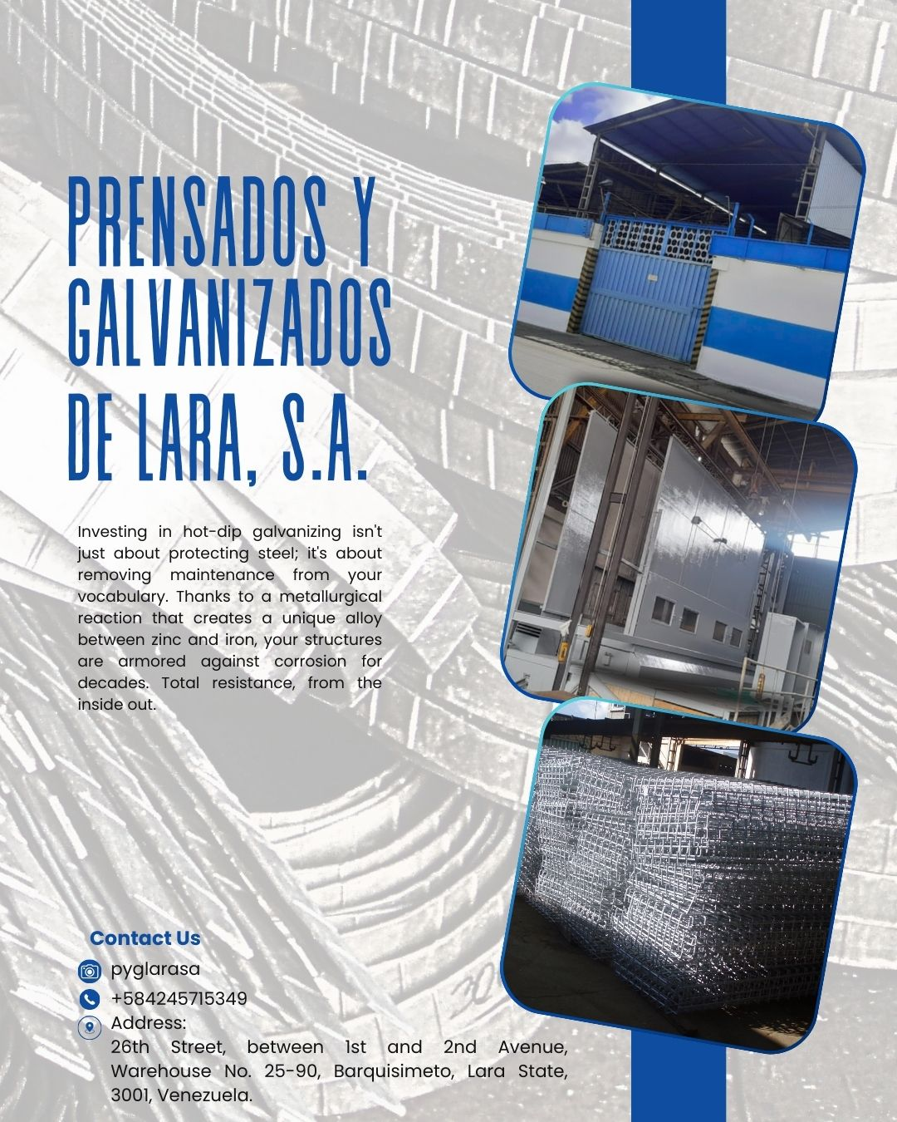

Barquisimeto, Lara State, Venezuela
26th Street, between 1st and 2nd Avenue, Warehouse No. 25-90, 3001
Phone: +584245715349 | Instagram: @pyglarasa

1. Company Overview
Prensados y Galvanizados de Lara, S.A. is a 100% Venezuelan company and a leader in hot-dip galvanizing services. The company guarantees superior protection against rust and abrasion, extending the lifespan of metal structures and reducing maintenance costs.
Investing in hot-dip galvanizing creates a unique alloy between zinc and iron, armoring structures against corrosion for decades with total resistance from the inside out.
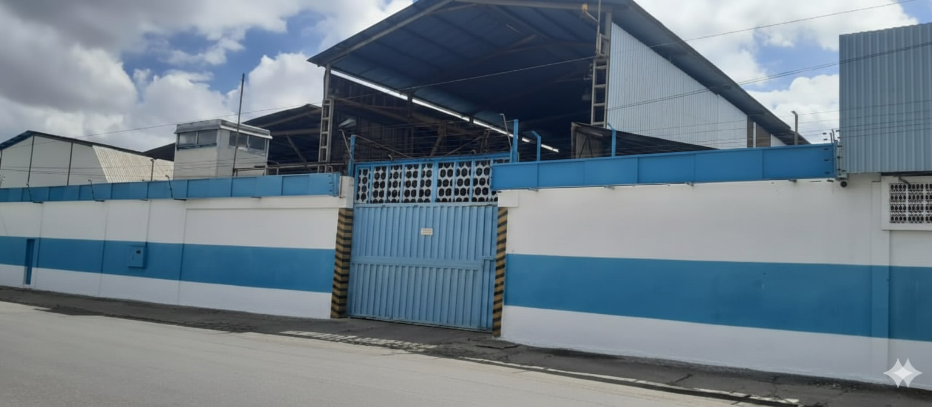
Factory exterior view - Barquisimeto, Venezuela

1.1 Hot-Dip Galvanizing Process
Raw Materials:
- Zinc (Zn): Special High Grade (99.9%) ingots, melted at 450°C to form alloy layers
Chemical Inputs for Preparation:
- Pickling Agents (Hydrochloric Acid / HCl): Most voluminous input after zinc. Removes surface rust and mill scale.
- Flux (Zinc Ammonium Chloride): Removes last traces of oxide, prevents re-oxidizing, and facilitates molten zinc wetting.

2. Installed Production & Galvanizing Machinery
The facility combines cutting-edge infrastructure with high-performance logistics, designed to handle projects of any scale with competitive turnaround times.

2.1 Specialized Infrastructure (Kettle Dimensions)
Kettle Type | Dimensions | Application
Large-Format Pilling Kettle | 7.00 x 0.80 x 1.40 m | Long profiles & large-scale structures
Mid-Range Kettle | 3.00 x 0.60 x 1.00 m | Intermediate parts & industrial hardware
Precision Kettle | 65 x 65 x 65 cm | Small parts & fasteners
Installed production capacity: 400 tons per month.
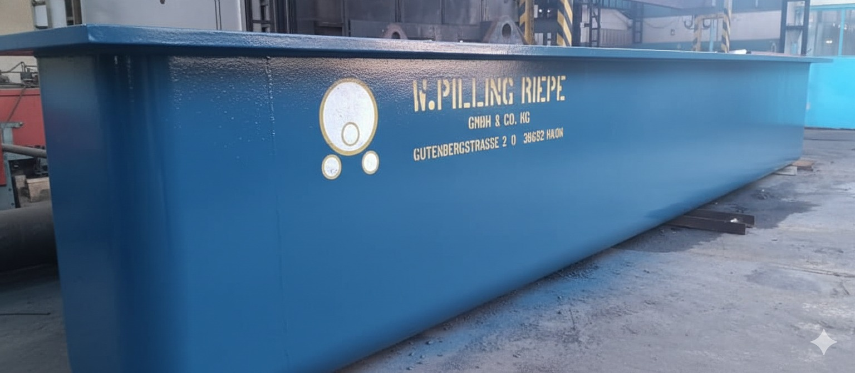
W. Pilling Riepe galvanizing kettle (new condition) - GmbH & Co. KG, Germany
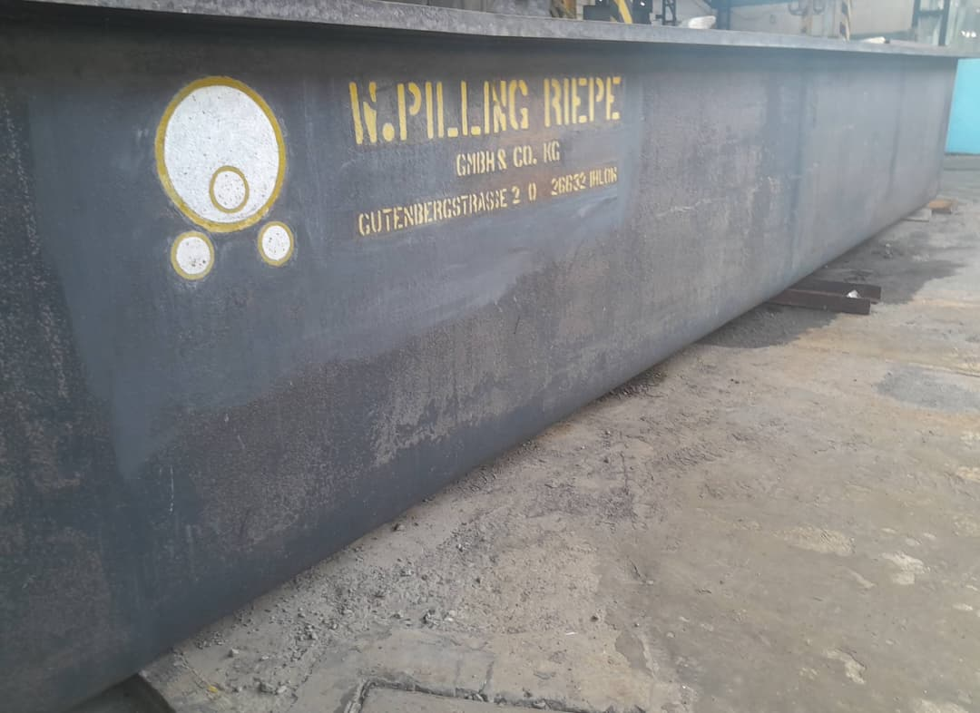
W. Pilling Riepe galvanizing kettle (in service)

3. Facility & Equipment Gallery

3.1 Galvanizing Furnace Structure
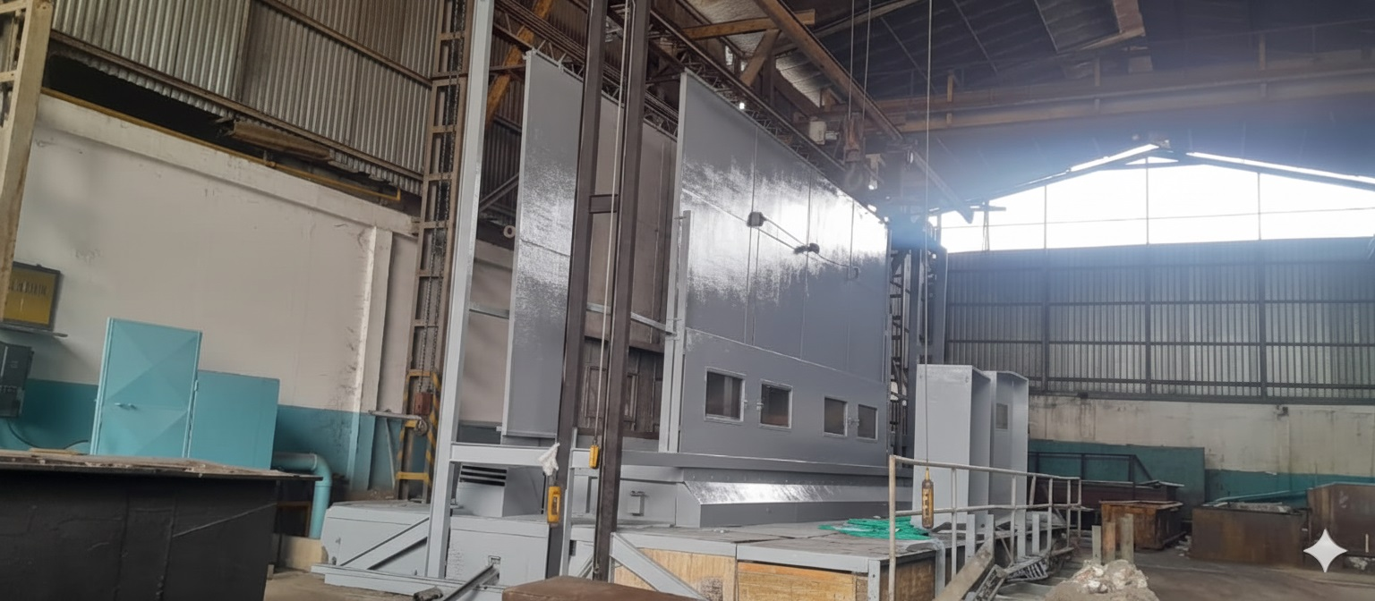
Main galvanizing furnace structure

3.2 Chemical Treatment Tanks & Transformers
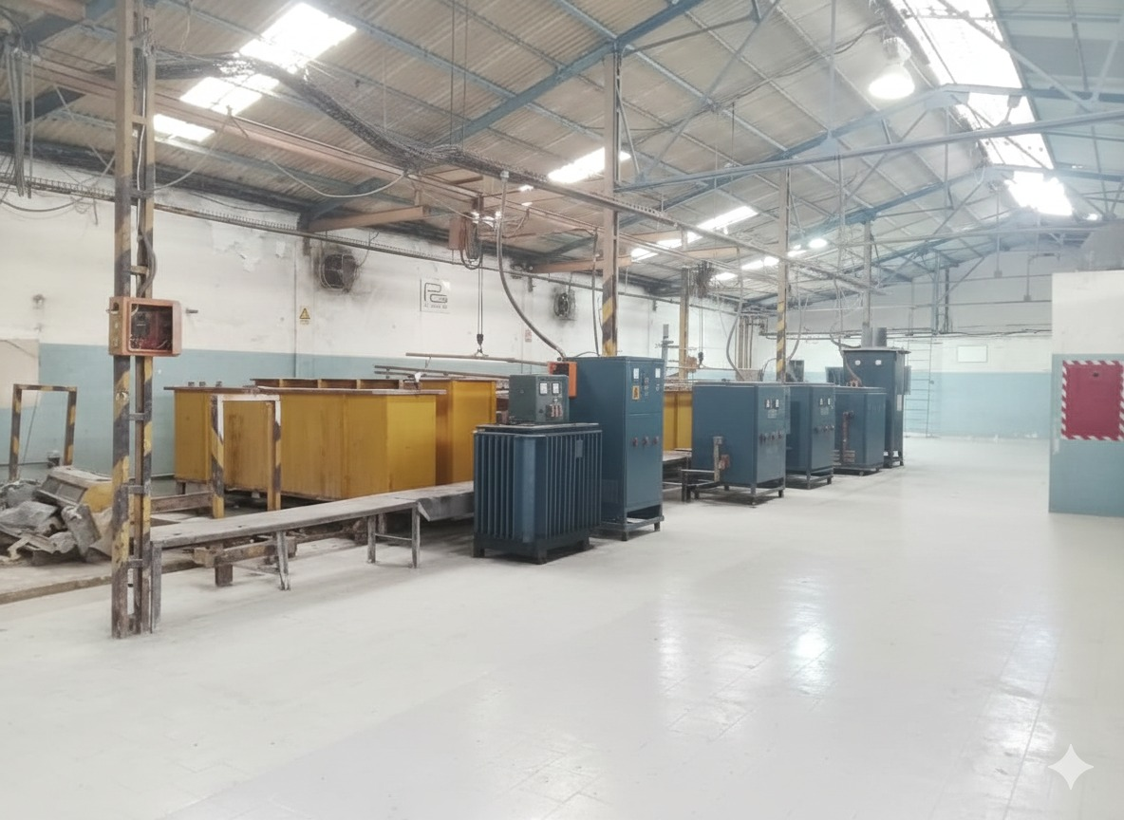
Chemical treatment tanks and transformers (renovated)
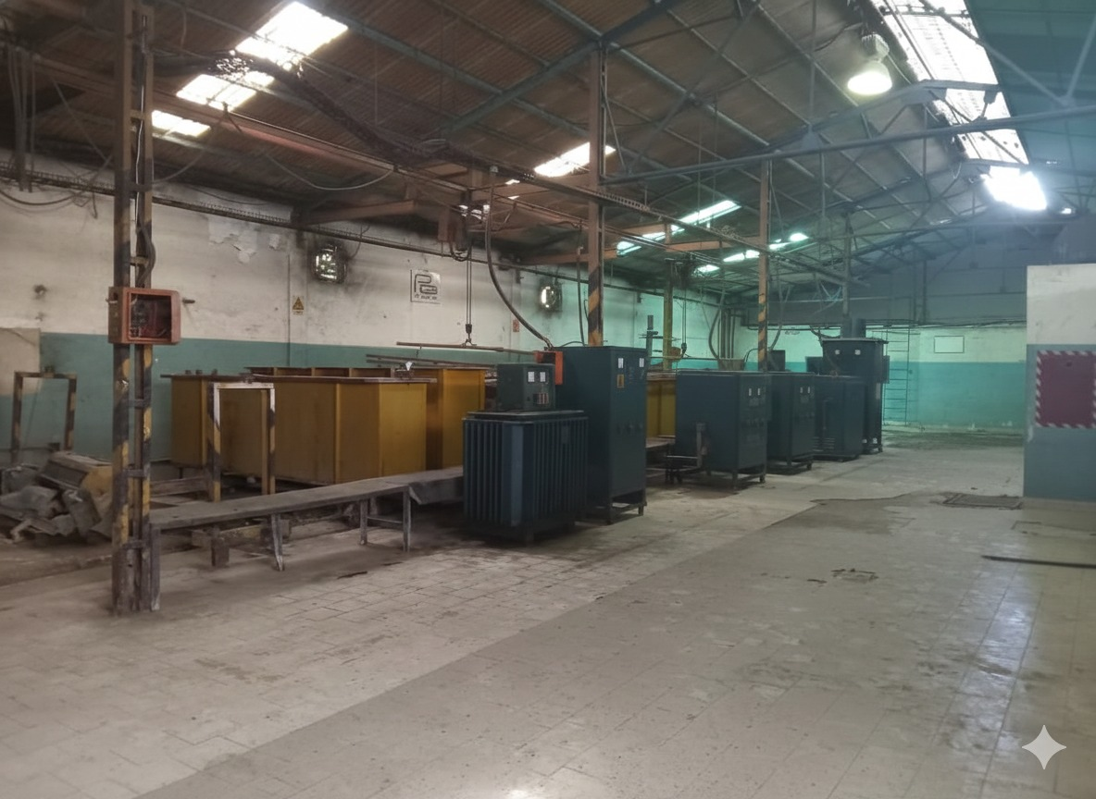
Chemical treatment area - operational view

3.3 Pickling Treatment Line
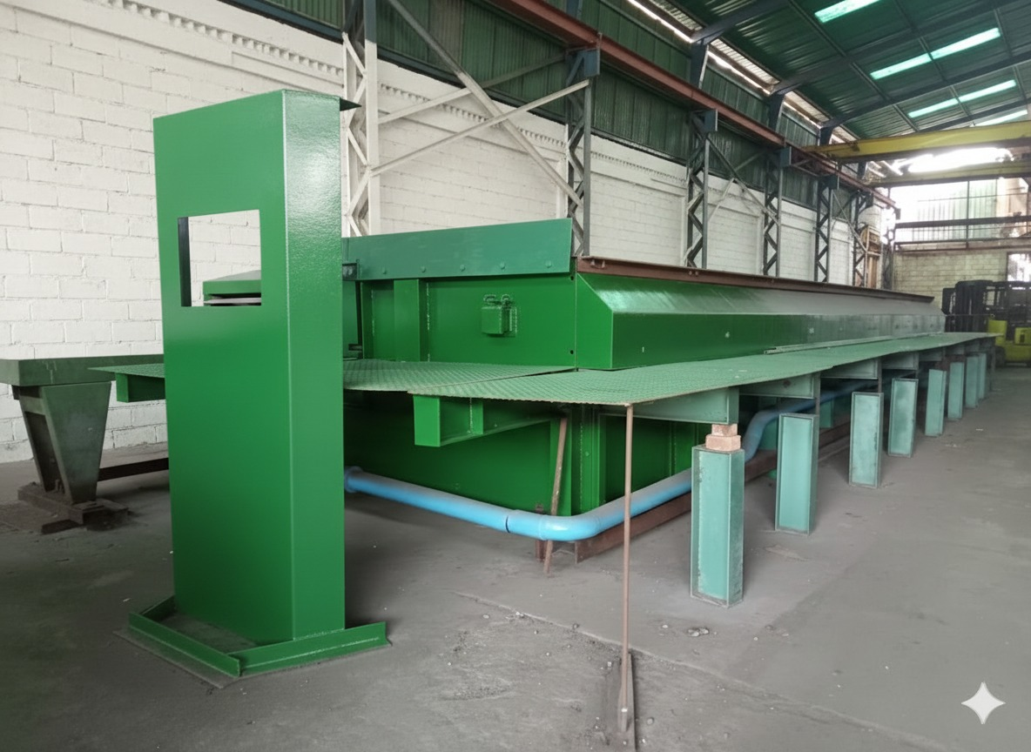
Green pickling/chemical treatment line - front view
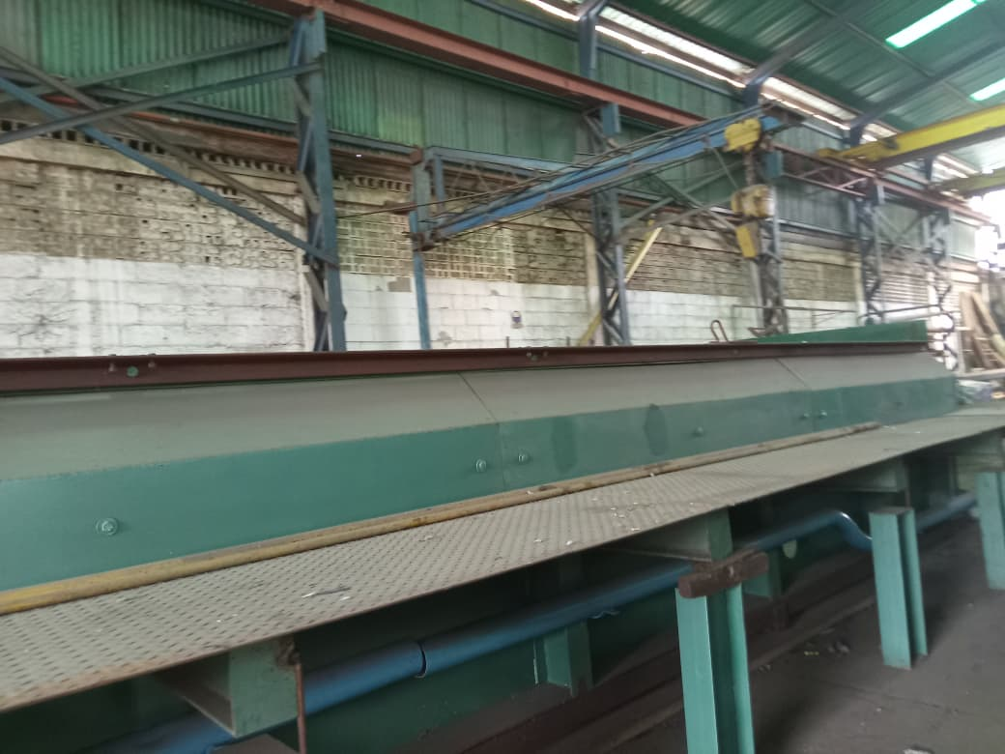
Pickling treatment line - side view

3.4 Small Parts Galvanizing Station
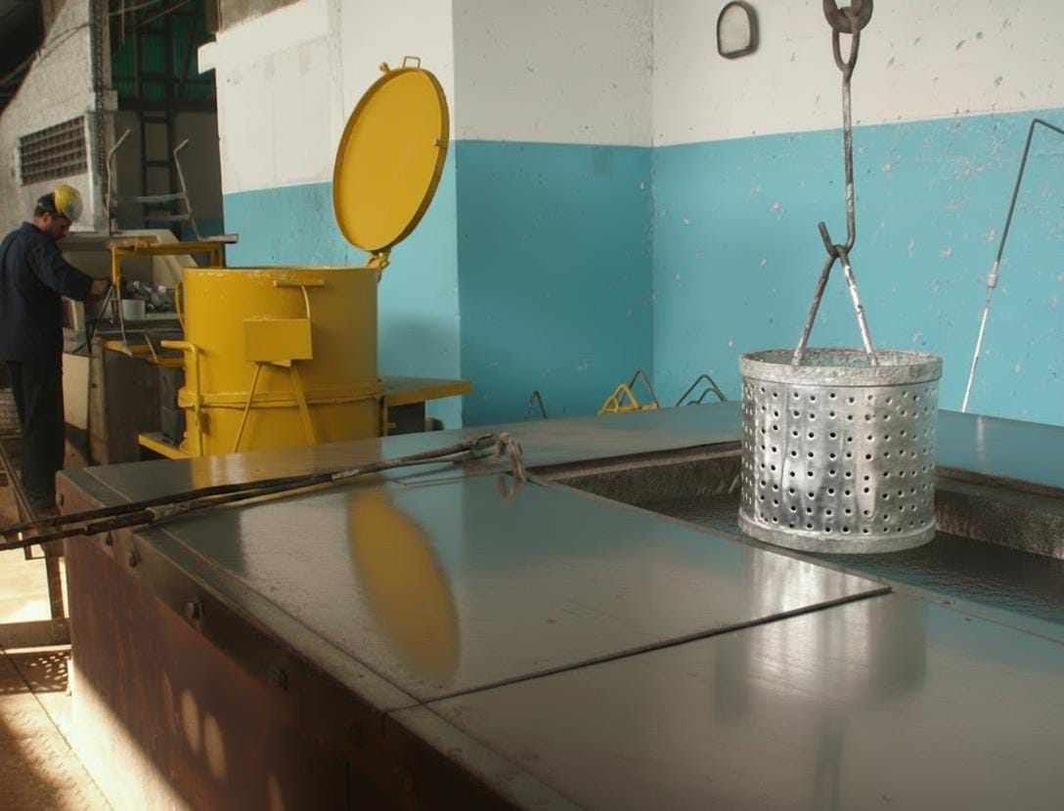
Precision kettle with perforated basket for small parts

4. 9-Meter Machinery for Installation
Detailed cost breakdown for the 9-meter galvanizing furnace system:

4.1 Major Equipment Costs (USD)
Description | Qty | Unit Price ($) | Total ($)
Structure for Galvanizing Furnace | 1 | 285,000 | 285,000
Refractory Ceramics, Mineral Wool & Anchors | — | 65,000 | 65,000
Kettle/Caldron (9m x 80cm x 1.40m, 2" thick) | 1 | 80,000 | 80,000
Fabricated Metal Structure | 1 | 100,000 | 100,000
Plans & Assembly Consultancy | 1 | 40,000 | 40,000
TOTAL |  |  | 570,000

4.2 Key Combustion Components
The furnace system includes 4x Hauck RSV120 burners, 4x Kromschröder pulse-fired butterfly valves, Spencer air combustion fan (375 CFM @ 16 OSI, 5hp TEFC motor), Allen Bradley starter equipment and MicroLogix PLC, 12x Conbraco test cocks, Honeywell DC330/DC230 temperature controllers, and Honeywell DC230L bath limit controller.

4.3 Control Panel Board
Control panel (30" wide x 36" high x 16" deep) includes Honeywell temperature controllers, Monarch 2-channel paperless recorder, Kromschröder PF 19 pulse/flame safety rack, Eagle signal timer, Edwards main control furnace alarm, Allen Bradley selector switch, push buttons, pilot lights, and MicroLogix PLC.

4.4 Refractory Materials
Includes 1,200 sq ft of 1" thick ceramic fiber (#8 density), 600 sq ft of 2" thick ceramic fiber (#6 density), 1,200 sq ft of 2" thick mineral wool blocks, 310 stainless steel stud sets (8", 6", 4", 2" sizes), 100 lbs of 310 stainless steel mesh, and 900 lbs of insulating mortar.
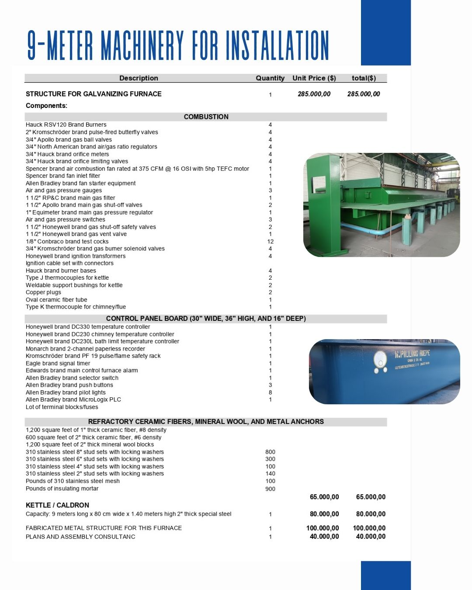
Original 9-meter machinery specification sheet

5. Installed Production Capacity

5.1 Raw Material Requirements
Material | Quantity | Price (USD) | Total (USD)
Zinc SHG 99.9% | 140 Tons / Year | $3,600.00 | $504,000.00
Hydrochloric Acid | 5 Tons / Month | $1,173.91 | $5,869.56
Ammonium Chloride | 1 Ton / Month | $2,300.00 | $2,300.00

5.2 Galvanizing Yield with 140 Tons of Zinc
- High-efficiency scenario (7% coating): Up to 2,000 tons of steel (large/heavy parts, structural beams)
- Standard scenario (10% coating): 1,400 tons of steel (medium profiles, pipes, general ironwork)

5.3 Fixed Monthly Expenses
Item | Amount / Month
Gas | $1,800
Electricity | $200
Security | $1,200
Salaries / Wages | $2,300
Cleaning / Maintenance | $100
TOTAL | $5,600

6. Copper Electrolytic Plant
The company also includes an electrolytic copper plant for manufacturing electrical grounding rods. These rods range from 5/8" to 1" in diameter and 1.20m to 3m in length.
The plant has an installed capacity of 936 rods per day on a continuous 24-hour production cycle. The facility manufactures standardized grounding rods featuring a high-purity copper layer with a thickness of 300 µm ± 50. Quality is certified through rigorous controls applied to both the manufacturing process and the finished product.

6.1 Chemical Inputs Required
Item (Spanish) | English Translation | Quantity / Details
Ácido | Acid | 5,000 kg / month
Cloruro de Amonio | Ammonium Chloride | 1,000 kg / month (startup)
Planta de Cobre | Copper Plant | 4 tons electrolytic copper (for 4 tanks)
Sulfato de Níquel | Nickel Sulfate | 600 kg
Cloruro de Níquel | Nickel Chloride | 120 kg
Ácido Bórico | Boric Acid | 100 kg
Níquel en Briquetas | Nickel Briquettes | 1,000 kg
Cesta de Titanio | Titanium Basket | —
Baños de Cobre | Copper Baths | 3,600 Copper Sulfate bath
Ácido Sulfúrico | Sulfuric Acid | 900
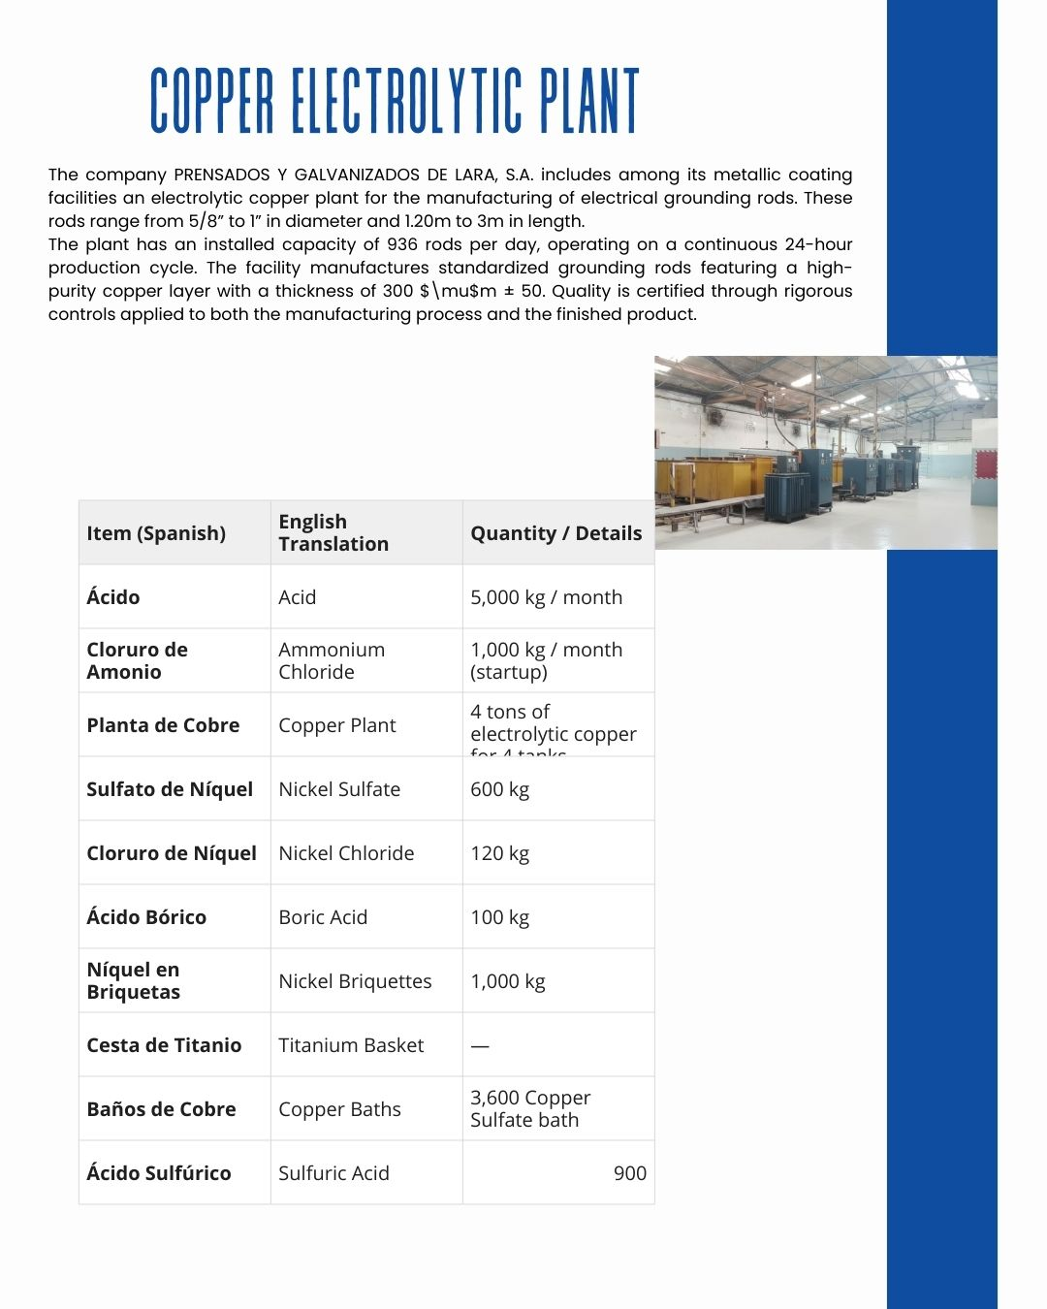
Original copper electrolytic plant specification sheet

7. Original Source Documents
The following are the original source document pages as provided:

7.1 Company Information Page
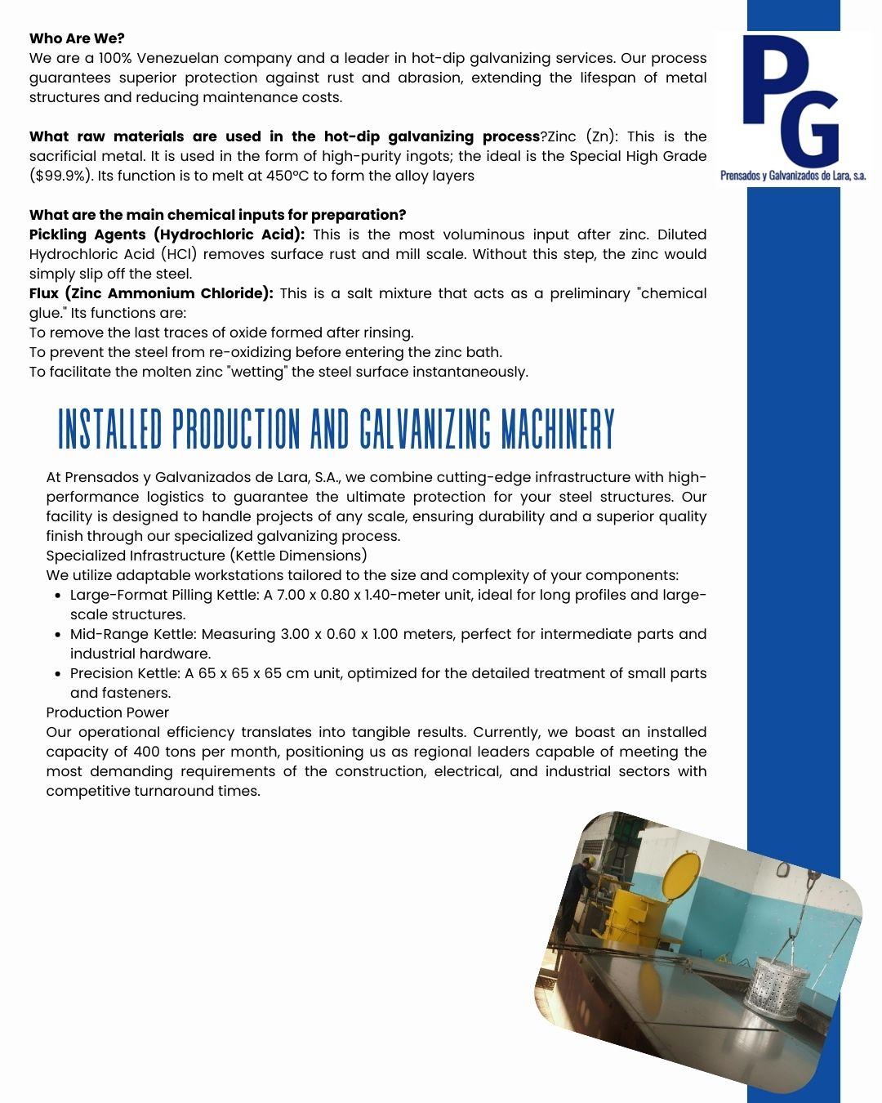

7.2 Production Capacity Page
