PRENSADOS Y GALVANIZADOS DE LARA, S.A.
Extracted Data Report
Barquisimeto, Lara State, 3001, Venezuela | +584245715349 | @pyglarasa

1. Company Overview
100% Venezuelan company and leader in hot-dip galvanizing services. Guarantees superior protection against rust and abrasion, extending the lifespan of metal structures and reducing maintenance costs.
Address: 26th Street, between 1st and 2nd Avenue, Warehouse No. 25-90, Barquisimeto, Lara State, 3001, Venezuela.

1.1 Hot-Dip Galvanizing Process
Raw Material: Zinc (Zn) — Special High Grade (99.9%) ingots, melted at 450°C to form alloy layers.
Chemical Inputs:
- Pickling Agents (Hydrochloric Acid / HCl): Removes surface rust and mill scale.
- Flux (Zinc Ammonium Chloride): Removes last traces of oxide, prevents re-oxidizing, facilitates molten zinc wetting.

2. Specialized Infrastructure (Kettle Dimensions)
Kettle Type | Dimensions | Application
Large-Format Pilling Kettle | 7.00 x 0.80 x 1.40 m | Long profiles & large-scale structures
Mid-Range Kettle | 3.00 x 0.60 x 1.00 m | Intermediate parts & industrial hardware
Precision Kettle | 65 x 65 x 65 cm | Small parts & fasteners
Installed production capacity: 400 tons per month.

3. 9-Meter Machinery for Installation

3.1 Major Equipment Costs (USD)
Description | Qty | Unit Price ($) | Total ($)
Structure for Galvanizing Furnace | 1 | 285,000 | 285,000
Refractory Ceramics, Mineral Wool & Anchors | — | 65,000 | 65,000
Kettle/Caldron (9m x 80cm x 1.40m, 2" thick) | 1 | 80,000 | 80,000
Fabricated Metal Structure | 1 | 100,000 | 100,000
Plans & Assembly Consultancy | 1 | 40,000 | 40,000
TOTAL |  |  | 570,000

3.2 Key Combustion Components
4x Hauck RSV120 burners, 4x Kromschröder pulse-fired butterfly valves, 4x Apollo gas ball valves, 4x North American air/gas ratio regulators, 4x Hauck orifice meters, 4x Hauck orifice limiting valves, Spencer air combustion fan (375 CFM @ 16 OSI, 5hp TEFC motor), Spencer fan inlet filter, Allen Bradley fan starter equipment, 3x air and gas pressure gauges, 1x 1-1/2" RP&C main gas filter, 2x 1-1/2" Apollo main gas shut-off valves, 1x 1" Equimeter main gas pressure regulator, 3x air and gas pressure switches, 2x 1-1/2" Honeywell gas shut-off safety valves, 1x 1-1/2" Honeywell gas vent valve, 12x 1/8" Conbraco test cocks, 4x 3/4" Kromschröder gas burner solenoid valves, 4x Honeywell ignition transformers, ignition cable set with connectors, 4x Hauck burner bases, 2x Type J thermocouples for kettle, 2x weldable support bushings for kettle, 2x copper plugs, 1x oval ceramic fiber tube, 1x Type K thermocouple for chimney/flue.

3.3 Control Panel Board (30" x 36" x 16")
1x Honeywell DC330 temperature controller, 1x Honeywell DC230 chimney temperature controller, 1x Honeywell DC230L bath limit temperature controller, 1x Monarch 2-channel paperless recorder, 1x Kromschröder PF 19 pulse/flame safety rack, 1x Eagle signal timer, 1x Edwards main control furnace alarm, 1x Allen Bradley selector switch, 3x Allen Bradley push buttons, 8x Allen Bradley pilot lights, 1x Allen Bradley MicroLogix PLC, lot of terminal blocks/fuses.

3.4 Refractory Materials
1,200 sq ft of 1" thick ceramic fiber (#8 density), 600 sq ft of 2" thick ceramic fiber (#6 density), 1,200 sq ft of 2" thick mineral wool blocks, 800x 310 SS 8" stud sets with locking washers, 300x 310 SS 6" stud sets, 100x 310 SS 4" stud sets, 140x 310 SS 2" stud sets, 100 lbs of 310 SS mesh, 900 lbs of insulating mortar.

4. Installed Production Capacity

4.1 Raw Material Requirements
Material | Quantity | Price (USD) | Total (USD)
Zinc SHG 99.9% | 140 Tons / Year | $3,600.00 | $504,000.00
Hydrochloric Acid | 5 Tons / Month | $1,173.91 | $5,869.56
Ammonium Chloride | 1 Ton / Month | $2,300.00 | $2,300.00

4.2 Galvanizing Yield with 140 Tons of Zinc
- High-efficiency scenario (7%): Up to 2,000 tons of steel (large/heavy parts, structural beams)
- Standard scenario (10%): 1,400 tons of steel (medium profiles, pipes, general ironwork)

4.3 Fixed Monthly Expenses
Item | Amount / Month
Gas | $1,800
Electricity | $200
Security | $1,200
Salaries / Wages | $2,300
Cleaning / Maintenance | $100
TOTAL | $5,600

5. Copper Electrolytic Plant
Manufactures electrical grounding rods (5/8" to 1" diameter, 1.20m to 3m length). Copper layer thickness: 300 µm ± 50. Installed capacity: 936 rods/day on continuous 24-hour cycle.

5.1 Chemical Inputs Required
Item (Spanish) | English | Quantity / Details
Ácido | Acid | 5,000 kg / month
Cloruro de Amonio | Ammonium Chloride | 1,000 kg / month (startup)
Planta de Cobre | Copper Plant | 4 tons electrolytic copper (4 tanks)
Sulfato de Níquel | Nickel Sulfate | 600 kg
Cloruro de Níquel | Nickel Chloride | 120 kg
Ácido Bórico | Boric Acid | 100 kg
Níquel en Briquetas | Nickel Briquettes | 1,000 kg
Cesta de Titanio | Titanium Basket | —
Baños de Cobre | Copper Baths | 3,600 Copper Sulfate bath
Ácido Sulfúrico | Sulfuric Acid | 900

Annex - Photographic Reference
The following images correspond to the original source documents and facility photographs referenced throughout this report.

Image 1 - Company Information & Installed Production/Galvanizing Machinery
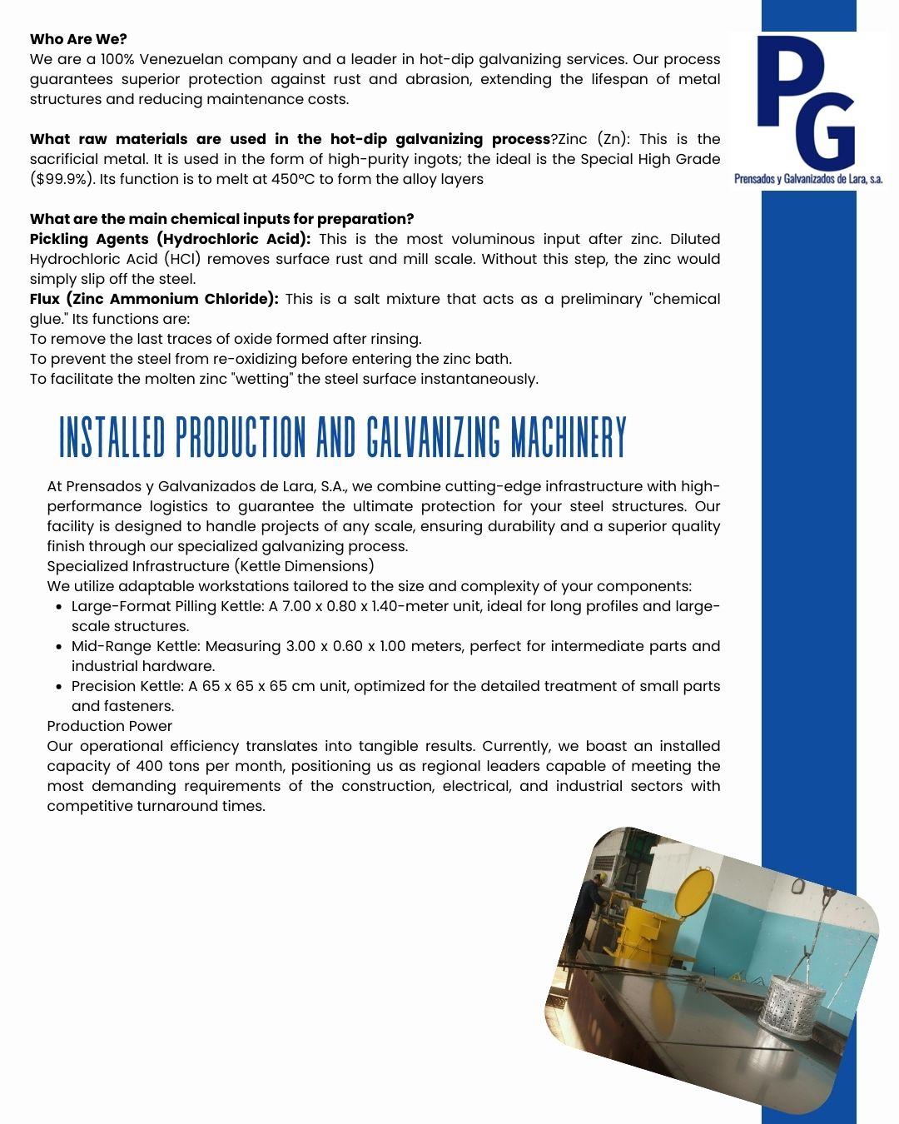

Image 2 - 9-Meter Machinery for Installation (Specifications & Costs)
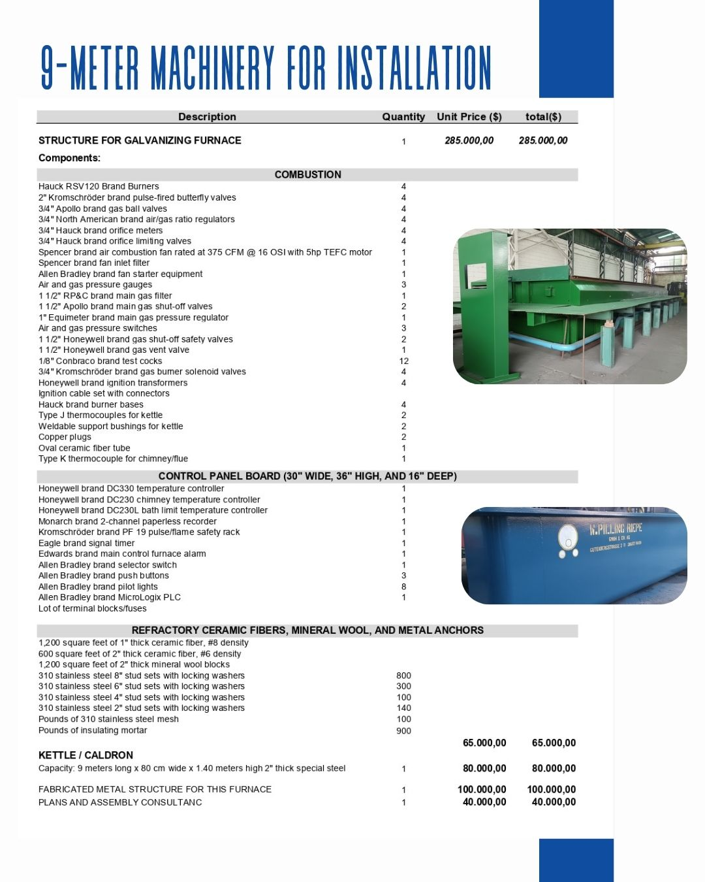

Image 3 - Installed Production Capacity & Fixed Expenses
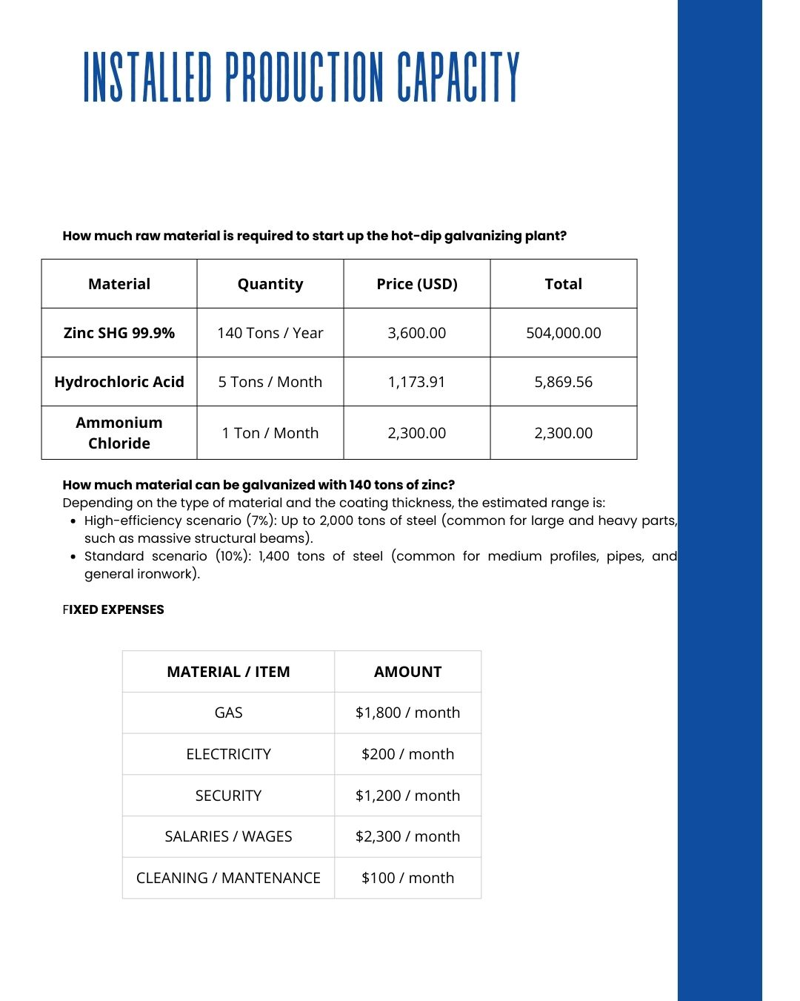

Image 4 - Company Cover Page (Prensados y Galvanizados de Lara, S.A.)
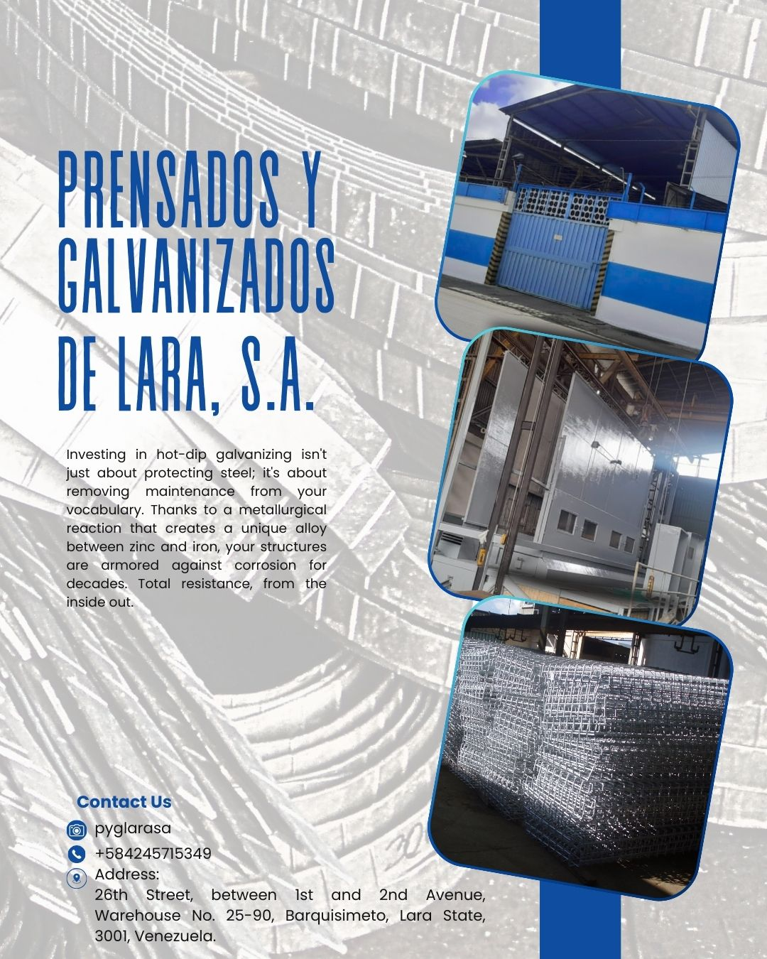

Image 5 - W. Pilling Riepe Galvanizing Kettle (New / Painted)
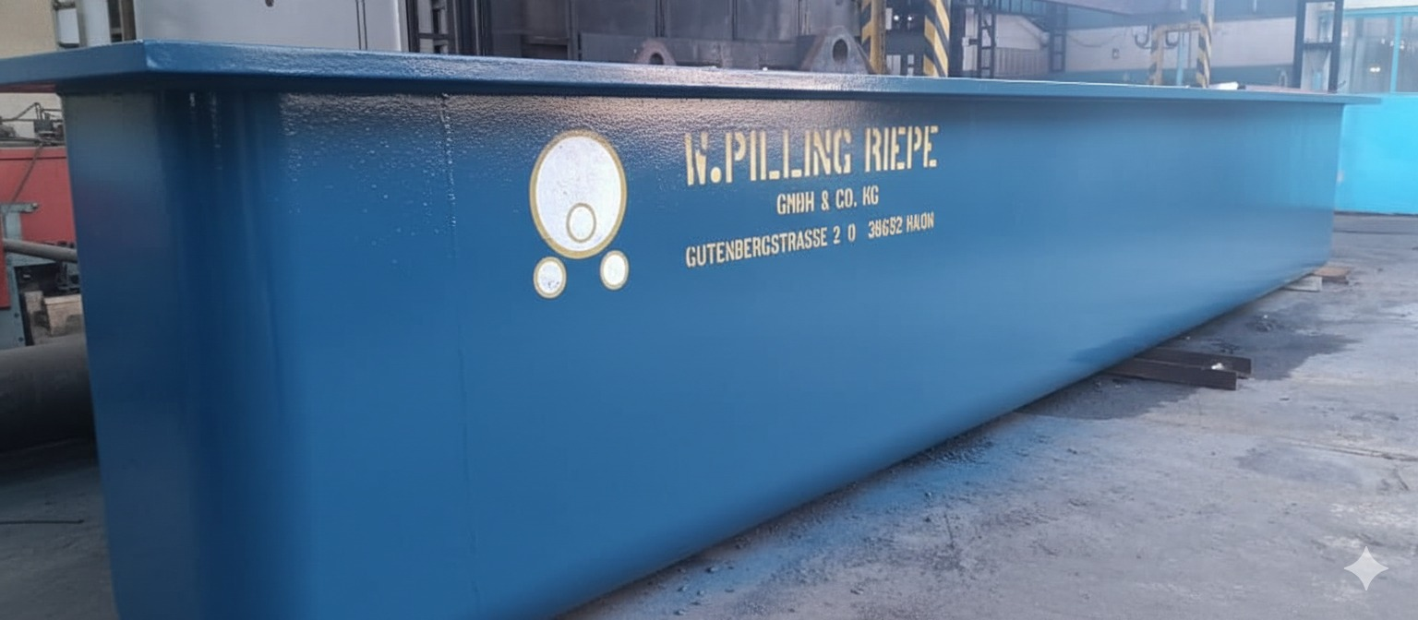

Image 6 - W. Pilling Riepe Galvanizing Kettle (In Service)
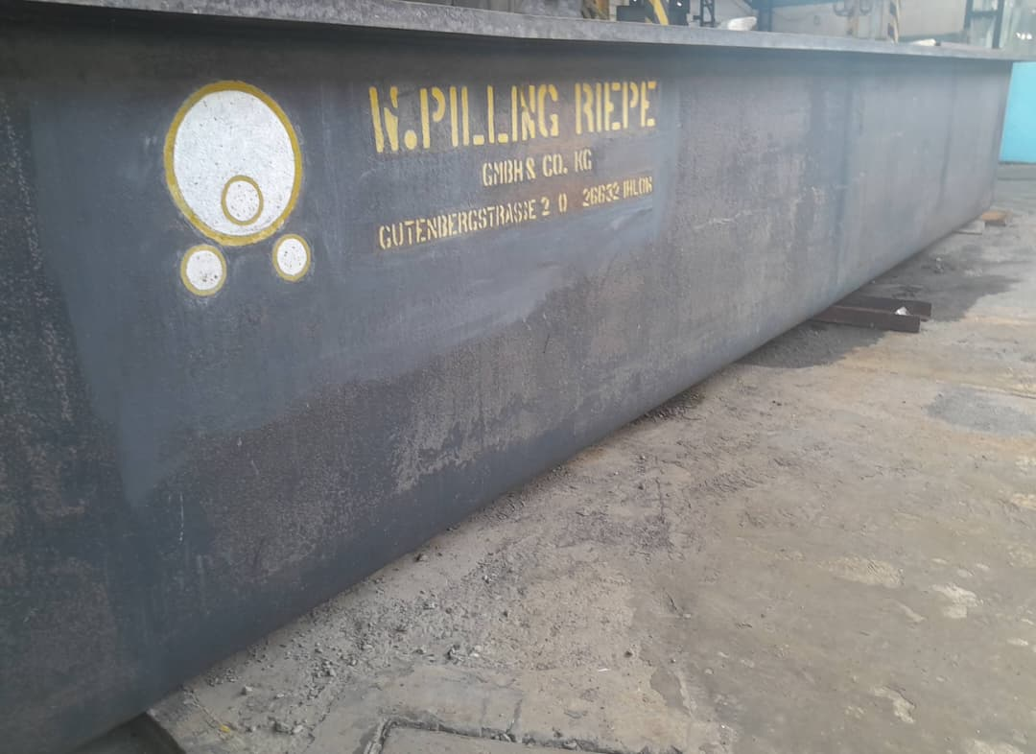

Image 7 - Chemical Treatment Tanks & Transformers (Renovated)
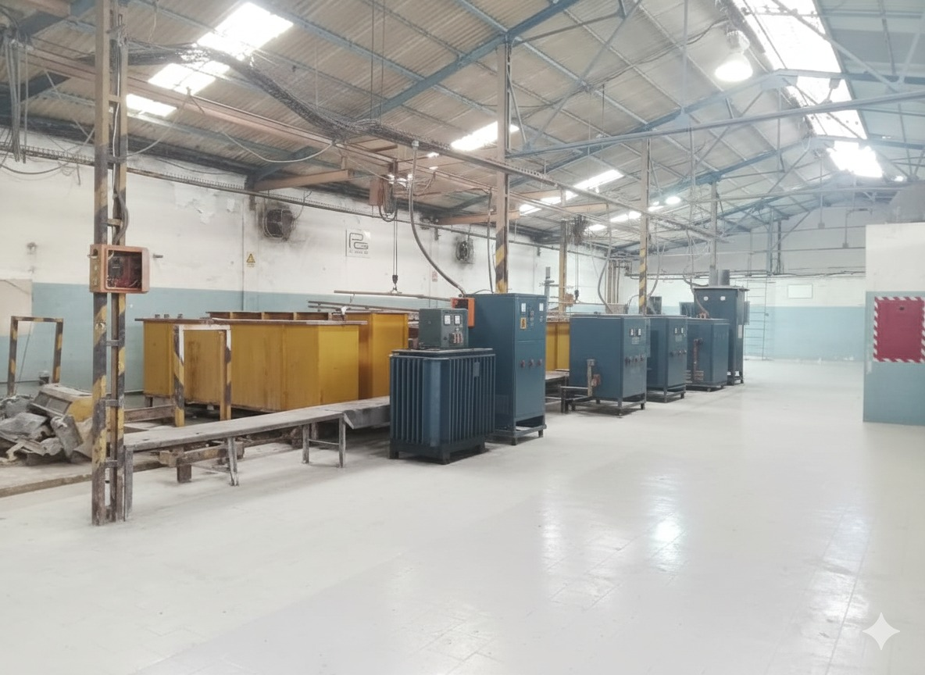

Image 8 - Chemical Treatment Tanks & Transformers (Operational)
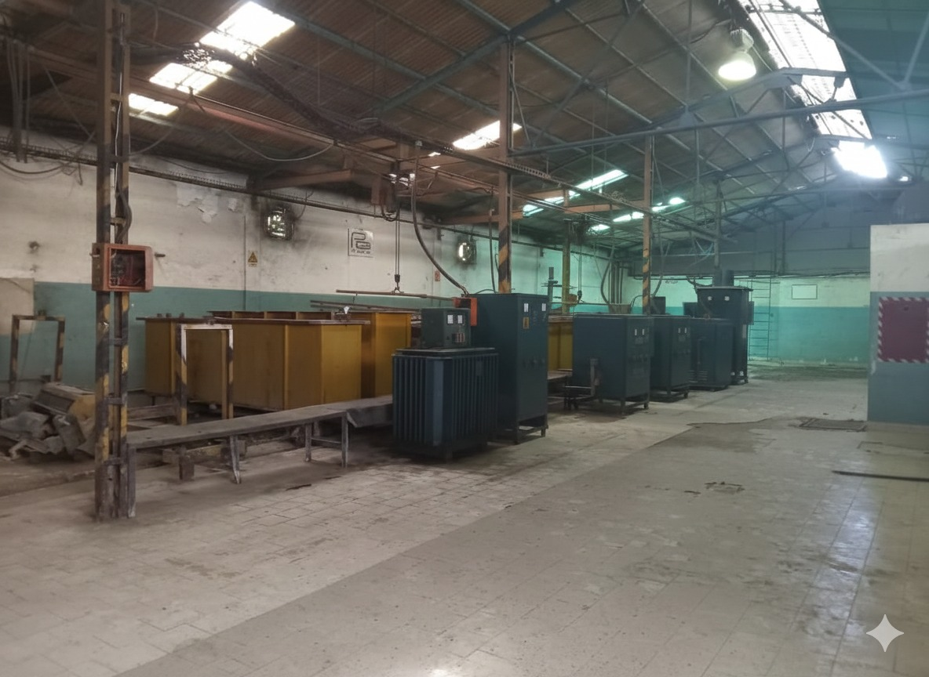

Image 9 - Pickling/Chemical Treatment Line (Front View)
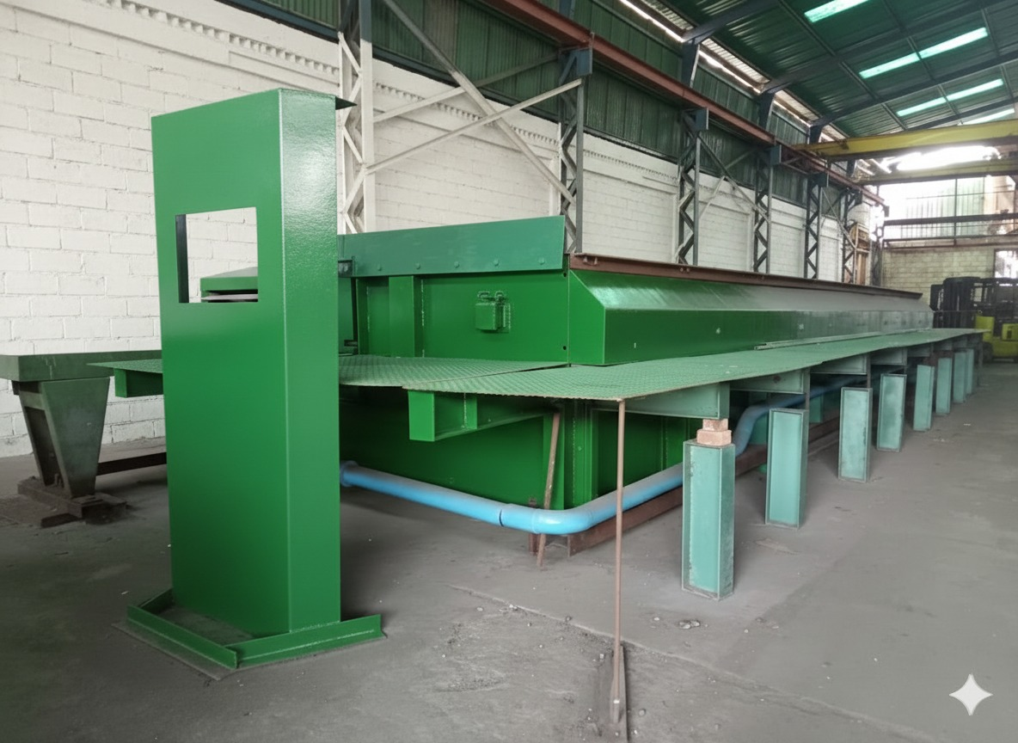

Image 10 - Pickling/Chemical Treatment Line (Side View)
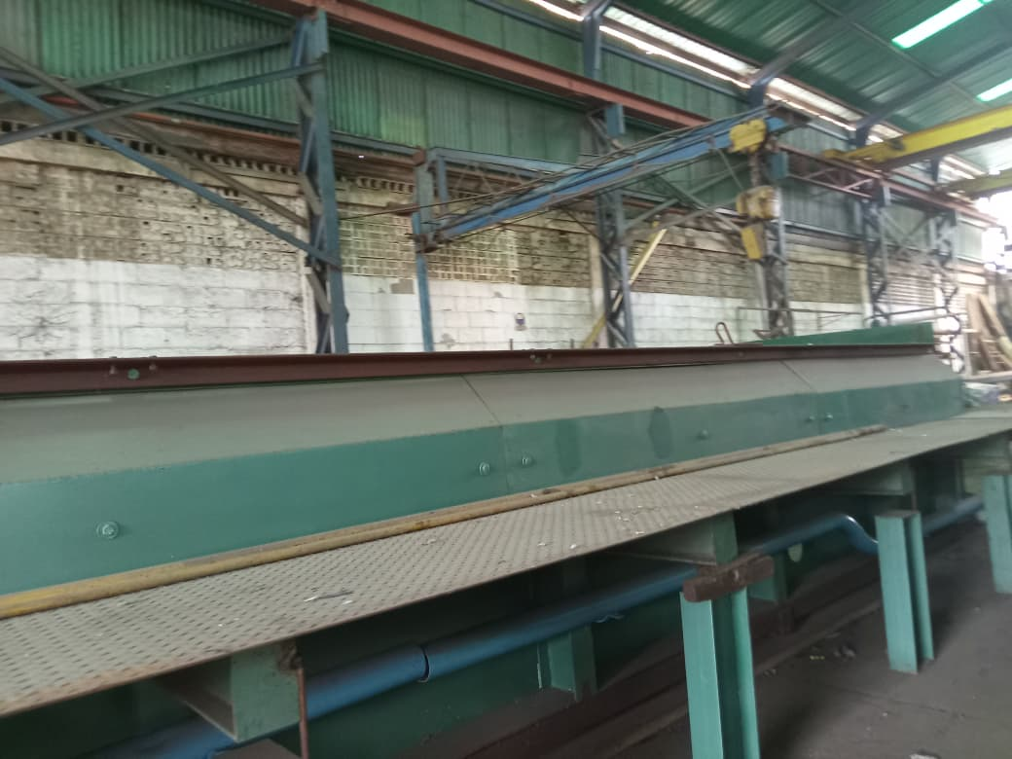

Image 11 - Precision Kettle with Perforated Basket (Small Parts)
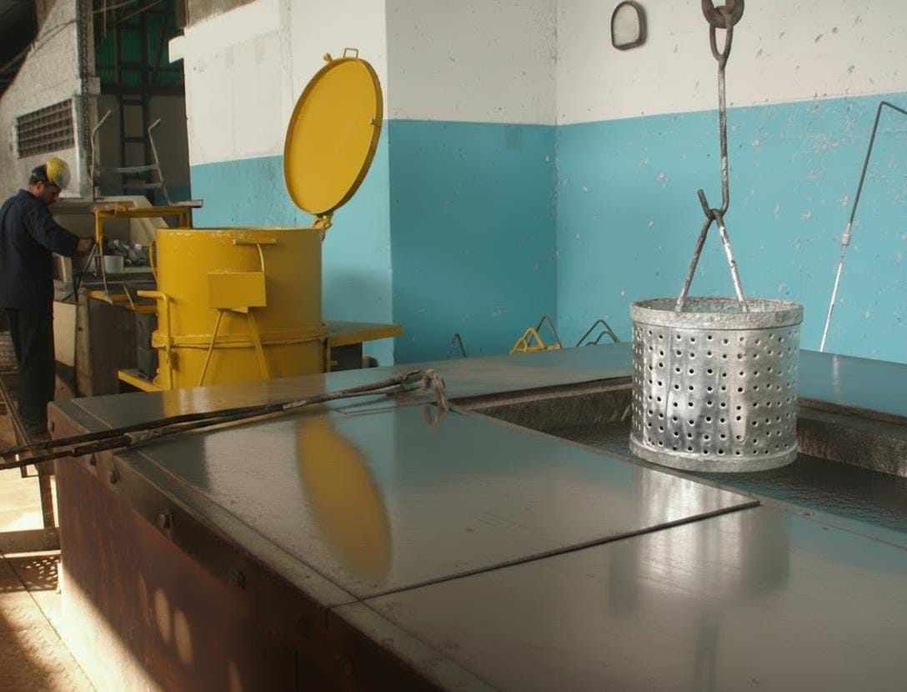

Image 12 - Main Galvanizing Furnace Structure
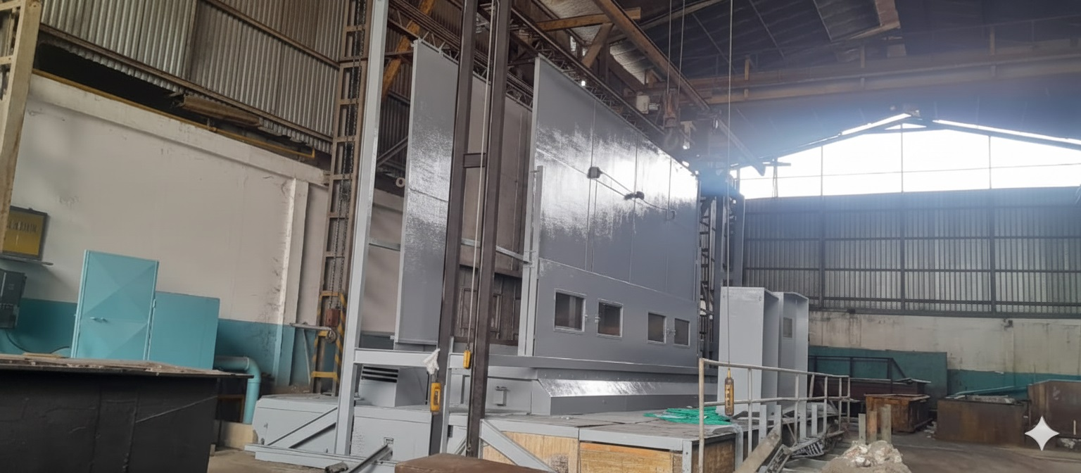

Image 13 - Copper Electrolytic Plant Specifications
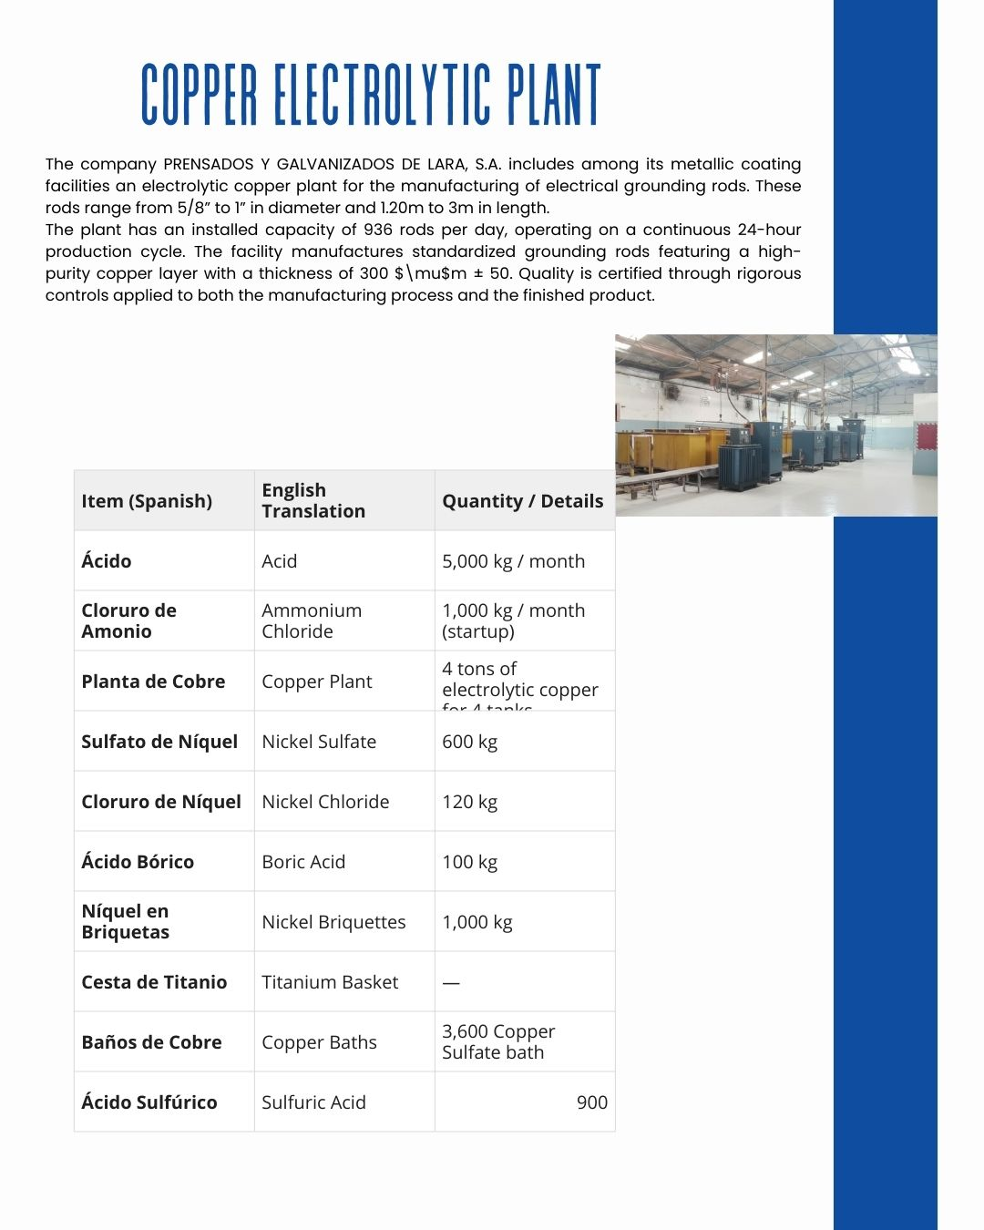

Image 14 - Factory Exterior View
