Project: E-Commerce Transactional Web Application
Report date: October 18, 2026
REST API
IMPLEMENTATION & TESTING REPORT
Quiz 2 — Spring Boot • Java 21 • JPA • Spring Security • Swagger

1. Executive Summary
The backend milestone establishes a Spring Boot REST API foundation for the Um Hamza e-commerce project. The current implementation includes Product and Vendor REST endpoints, request DTOs, validation, controller/service/repository separation, JPA persistence configuration for Microsoft SQL Server, centralized exception handling, Spring Security protection, and Swagger/OpenAPI documentation.
Previously recorded verification evidence shows six Maven tests passing, successful authenticated access to the Product API with HTTP 200, an HTTP 401 response for an unauthenticated protected API request, a validation rejection with HTTP 400, and the Swagger UI returning HTTP 200. Screenshots below support selected parts of this evidence.

2. Technology and Architecture
- Java 21; Spring Boot 4.0.8.
- Spring Web MVC for REST endpoints.
- Spring Data JPA / Hibernate and Microsoft SQL Server JDBC.
- Spring Security for current development access control.
- springdoc-openapi / Swagger UI.
- Maven Wrapper for build and test commands.

3. Implemented API Scope
Area | Status | Evidence / notes
Product API | Implemented | CRUD routes, DTO validation, JPA entity, service/repository layers, optimistic locking via @Version.
Vendor API | Implemented | CRUD routes with DTO/service/repository separation.
Validation / errors | Implemented | An invalid product pricing request previously returned HTTP 400; centralized exception handling is present.
SQL Server persistence | Configured | Connection settings are read from environment variables; Hibernate schema mode is validate.
API security | Implemented for this milestone | Protected API routes require authentication; an unauthenticated request previously returned HTTP 401.
Swagger/OpenAPI | Implemented | Swagger UI route /swagger-ui/index.html previously returned HTTP 200.
Database-backed users and roles | Future phase | Current authentication uses a temporary in-memory development user.
Customer, Order, Payment, Invoice resources | Future phase | Not claimed as completed in this milestone.

4. API Surface and Swagger Walkthrough
Current resources include Product and Vendor. The Product API follows the standard CRUD pattern:
- GET /api/products — list products.
- GET /api/products/{id} — retrieve one product.
- POST /api/products — create a product.
- PUT /api/products/{id} — update a product.
- DELETE /api/products/{id} — delete a product.
- Equivalent CRUD operations are implemented for /api/vendors.
To demonstrate Swagger, run the backend and open http://localhost:8080/swagger-ui/index.html. Expand Product or Vendor, inspect parameters and response schemas, then use Try it out. Protected API requests require the configured development credentials. Never include real passwords in screenshots or submitted documentation.

5. Verification Evidence

5.1 Swagger UI / OpenAPI documentation
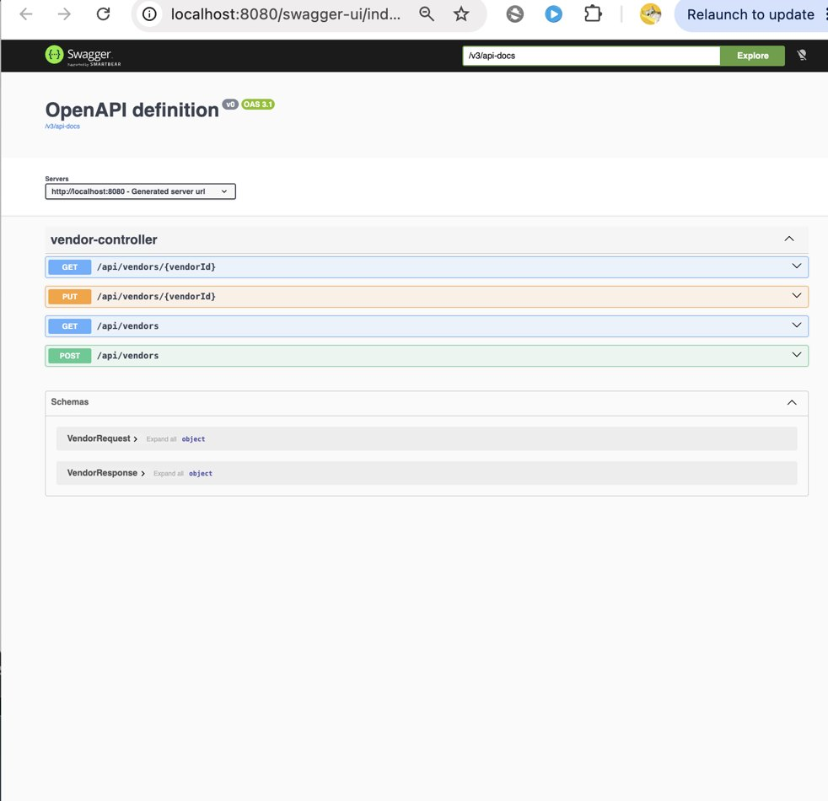
Figure 1. Swagger UI opened locally at /swagger-ui/index.html. This demonstrates that the documentation interface is reachable and available for endpoint inspection.

5.2 Authenticated Product API and unauthorized request
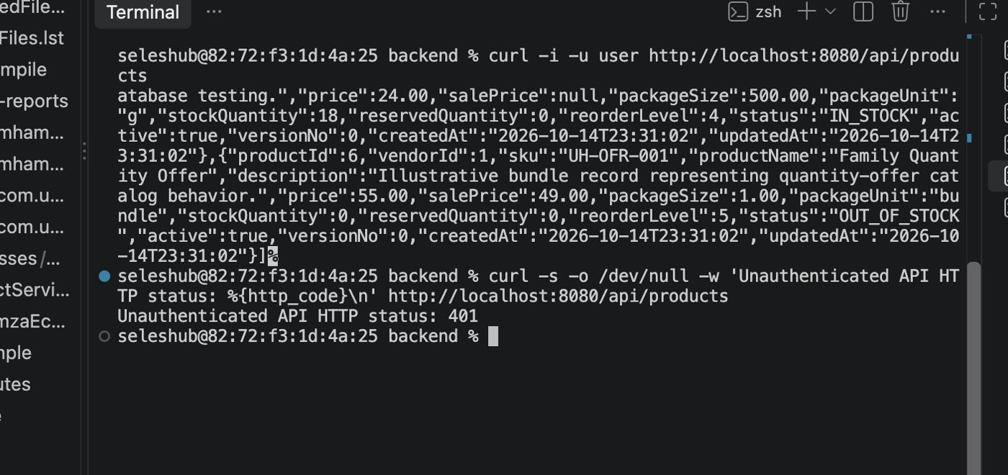
Figure 2. Terminal evidence shows a Product API request using HTTP Basic credentials and an unauthenticated request receiving HTTP 401. The response includes product data.

5.3 Security and Swagger status checks
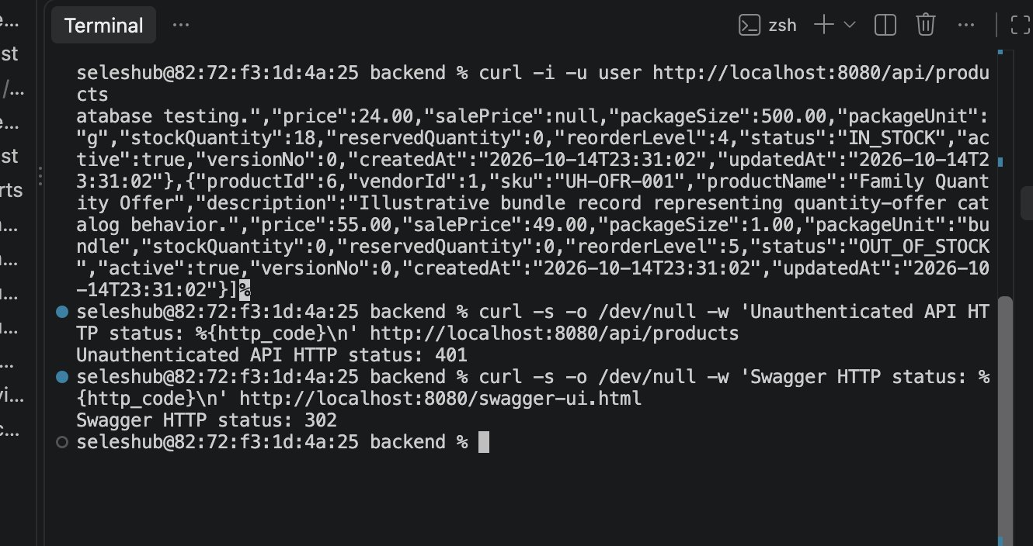
Figure 3. Additional terminal checks record protected API behavior and a successful Swagger HTTP status.

5.4 Runtime API and Swagger verification
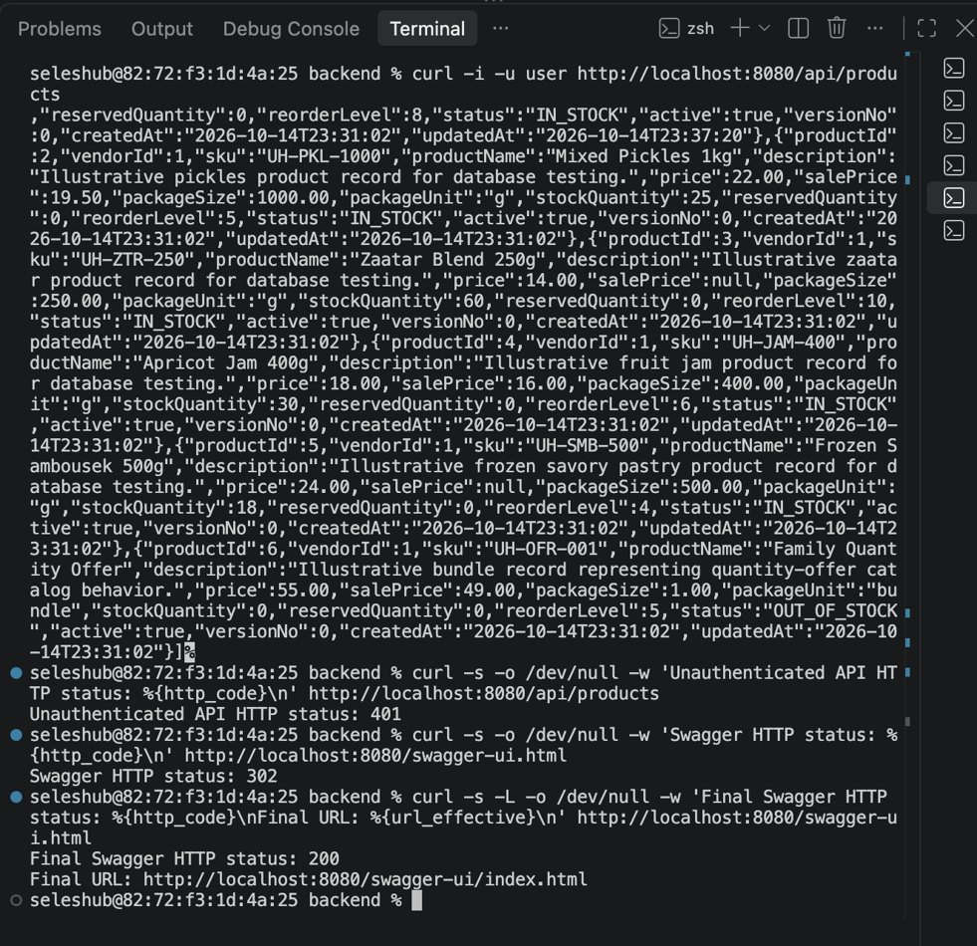
Figure 4. Successful runtime checks from the development session: an unauthenticated API request returned HTTP 401, Swagger redirected to its UI route, and the final Swagger URL returned HTTP 200. The six-test Maven result is recorded separately in the project verification notes; this image is runtime evidence, not a Maven test report.

5.5 Repository hygiene checks
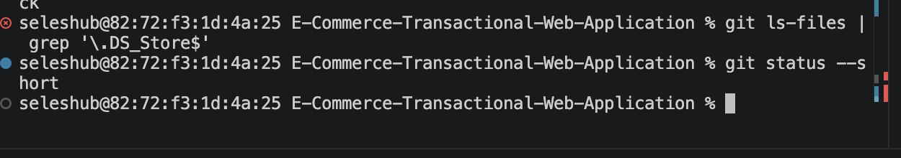
Figure 5. Repository checks were used to review intended changes and check for tracked .DS_Store files. Actual local credentials must remain outside version control.

6. Challenges, Fixes, and Lessons Learned
Challenge / risk | Why it matters | Action / lesson
Portable database configuration | Local database settings differ between machines. | Centralized JDBC URL and credentials in environment variables; documented placeholder-only backend/.env.example.
Authentication behavior | A successful request alone does not prove anonymous access is blocked. | Checked authenticated access and a separate unauthenticated request returning HTTP 401.
API discoverability | Endpoints are harder to assess without an API contract. | Added Swagger/OpenAPI and checked that the Swagger UI route was reachable.
Submission hygiene | Local metadata and secrets can accidentally be committed. | Checked repository status and tracked .DS_Store files; kept real local credentials out of the example file.
These notes summarize engineering concerns and documented actions. They do not attempt to invent or reconstruct every earlier terminal error.

7. Current Limitations and Work in Progress
- Replace the temporary in-memory development account with persistent users and secure password hashing.
- Implement and verify database-backed authorization for ADMIN, VENDOR, and CUSTOMER roles.
- Complete Customer CRUD endpoints and related tests.
- Implement Order, OrderItem, Invoice, and Payment resources required by the full-semester specification.
- Build and connect the React/Vite frontend; the current repository snapshot does not establish a completed frontend.
- Implement and test a complete purchase transaction with rollback guarantees and inventory concurrency handling.
- Expand integration tests for CRUD, validation, authorization, database behavior, and rollback scenarios.
- Verify CORS behavior and final clean-machine setup instructions.
These are roadmap items, not claims about the exact Quiz 2 rubric. The full-semester specification is broader than the REST API milestone.

8. Reproducibility and Safe Configuration
- Use Java 21 or newer and the Maven Wrapper in backend/.
- Start SQL Server and configure the intended database before launching the backend.
- Use backend/.env.example as a reference; set DB_URL, DB_USERNAME, DB_PASSWORD, and APP_DEV_PASSWORD locally. Do not commit actual credentials.
- Run the backend using the command documented in README.md.
- Open /swagger-ui/index.html and authenticate when testing protected endpoints.
- Use a disposable test database for destructive CRUD tests.

Closing Statement
This milestone provides a working foundation for the project’s REST API and documents current evidence for API access, authentication behavior, validation, testing, and Swagger documentation. Future phases will extend this foundation toward the full transactional e-commerce workflow.

