DATABASE COMPLETION
E-Commerce Transactional Web Application Project
Final Database Documentation: Conceptual Schema, Logical Schema & Physical SQL Server Implementation

Course:
420-951-VA TRANSACTIONAL WEB APPLICATIONS

Teacher: Alip Mohammed
Student Name: Amina Ayad Al Halabieh
Student ID: 6367025

1. Database Completion Scope
For this Database Completion milestone, I am focusing only on the three database deliverables required for the e-commerce application: the conceptual schema, the logical schema, and the physical implementation using Microsoft SQL Server.
The implemented database uses SQL Server through a dedicated Docker container and is accessed from Visual Studio Code. The assignment requires proper tables, primary keys, foreign keys, appropriate data types, NOT NULL rules, unique constraints, referential integrity, reproducible SQL scripts, and the required Product inventory/status trigger.
- Conceptual Schema: identify the business entities, relationships, cardinalities, and rules.
- Logical Schema: define relations, attributes, keys, constraints, and normalization decisions before physical creation.
- Physical Implementation: create the SQL Server database, tables, sample data, trigger, and verification tests.

2. My Database Design Approach
I started by understanding how the Um Hamza e-commerce process should represent customers, products, shopping, orders, payments, delivery, and product reviews. I then separated application actors from persistent data entities and moved from the conceptual model to the logical relational design before creating the SQL Server database.
This order was important for me because it reduced the risk of creating tables too early and then discovering that an important relationship, historical value, or integrity rule had been missed. I used the database design and normalization concepts I learned in my coursework to decide where each business fact belongs and how repeating or many-to-many information should be represented.

3. Business Context and Database Boundaries
My database is designed around Um Hamza Foodstuff Factory as the vendor/business. The data model is intended to support an e-commerce catalog and transaction process for customers purchasing food products.
Business area | Database representation
Accounts and roles | USERS and ROLES; customer/vendor profiles where required
Catalog | PRODUCTS, CATEGORIES, PRODUCT_CATEGORIES, PRODUCT_IMAGES
Customer shopping | SHOPPING_CARTS, CART_ITEMS, FAVORITES, ADDRESSES
Ordering | ORDERS, ORDER_ITEMS, ORDER_STATUS_HISTORY
Financial records | PAYMENTS, REFUNDS, INVOICES
Fulfillment | DELIVERIES
Verified feedback | REVIEWS linked to purchased ORDER_ITEMS
Inventory | PRODUCTS.stock_quantity, reserved_quantity, reorder_level, status

I intentionally do not store a Guest as a permanent customer record. A guest is an unauthenticated access state; once registration succeeds, the persistent identity is represented by USER + CUSTOMER + ROLE(CUSTOMER). Likewise, Admin is represented by USER + ROLE(ADMIN), rather than by a redundant ADMIN table.

4. Actors and Access Model
Although the Database Completion milestone is database-focused, I included the actors that explain why the database contains the records it does. I distinguish actors from tables so that the model stays normalized and does not create tables simply because a role exists.
Actor | Access / responsibility | Persistent database treatment
Guest | Browse, search, view products; register or log in; temporary cart behavior. | No permanent Guest table.
Customer | Maintain profile/addresses; cart/favorites; place orders; view order/invoice information; review eligible purchases. | USERS + CUSTOMERS + ROLES.
Vendor | Um Hamza business user; manage products/inventory; review incoming orders; approve/reject; update fulfillment information. | VENDORS + USERS + ROLES.
Admin | System administration; manage users/roles and maintain core business data. | USERS + ROLES.

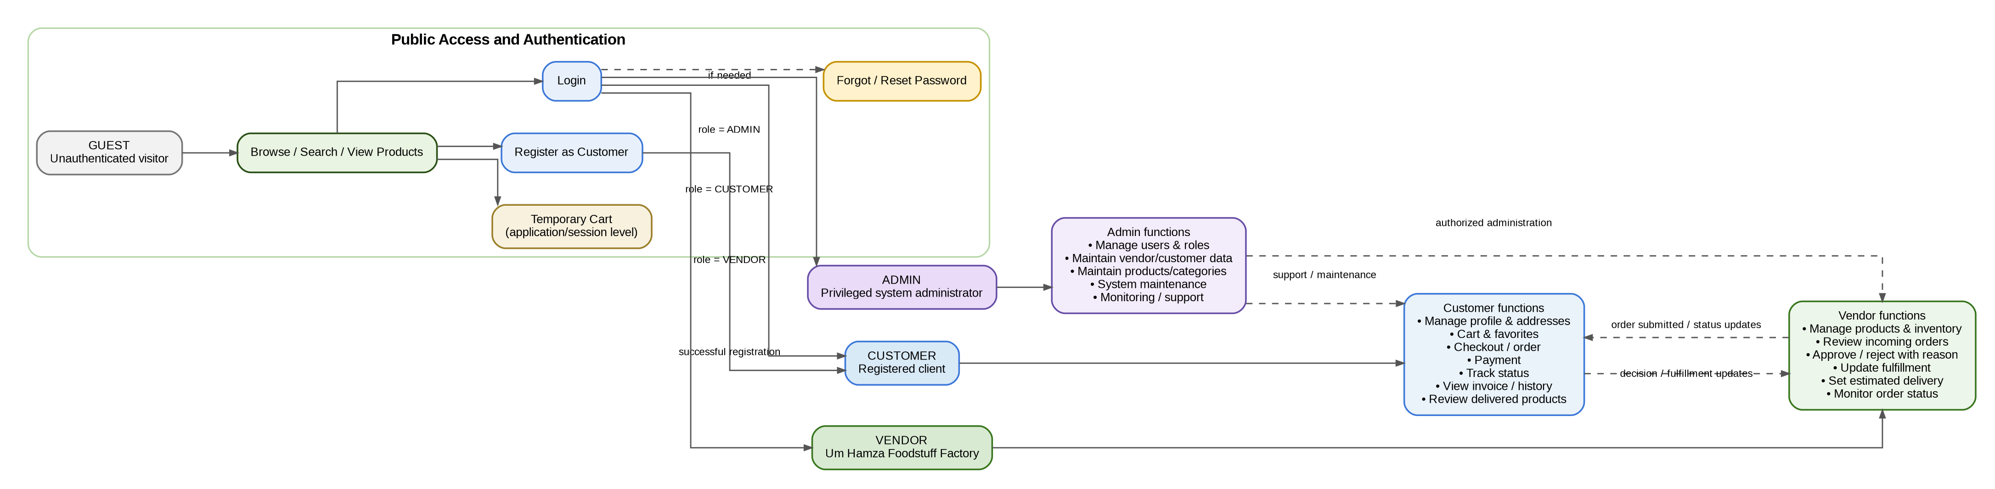
Figure 1. Actor and access flow used to define the database boundary.
The most important transition in this model is Guest → Customer. The guest is not persisted simply for browsing, while a successful registration creates the persistent account/profile structure needed for customer transactions.

5. UML Supporting Models
I used UML-style supporting models only where they clarify the database design. These diagrams are not replacing the ERD; they help explain who interacts with the data and how an order's status is expected to change.
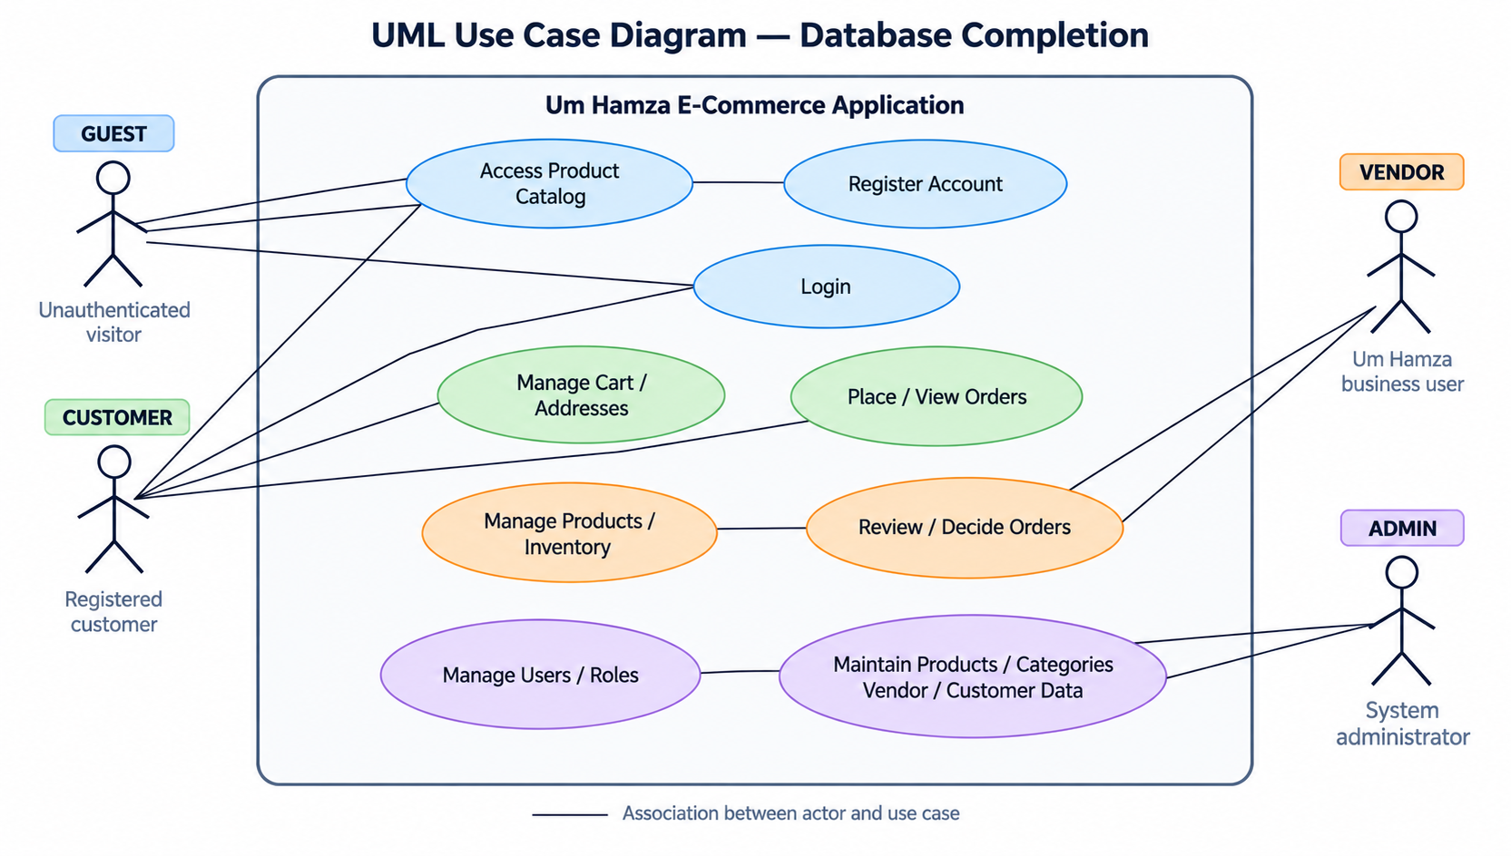
Figure 2. UML Use Case Diagram — database-relevant actors and functions.
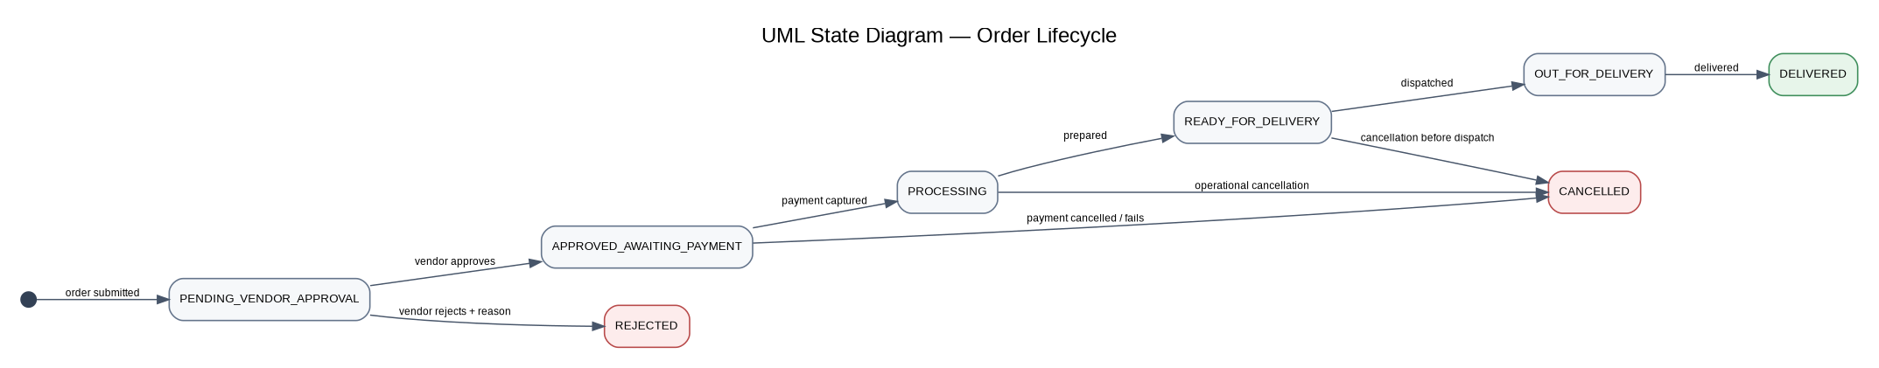
Figure 3. UML State Diagram — order lifecycle represented by the ORDER.status domain.
The state model is directly reflected in the logical/physical ORDER and ORDER_STATUS_HISTORY design. Keeping the current status in ORDERS and the history in ORDER_STATUS_HISTORY lets me preserve both the current business state and the sequence of important changes.

6. Conceptual Schema
My conceptual model identifies the persistent information required by the business without tying the design to SQL Server syntax. The model contains 20 persistent entities. The Guest and Admin actors remain visible at the application level, but Guest is not a persistent entity and Admin is represented through the role-based identity model.
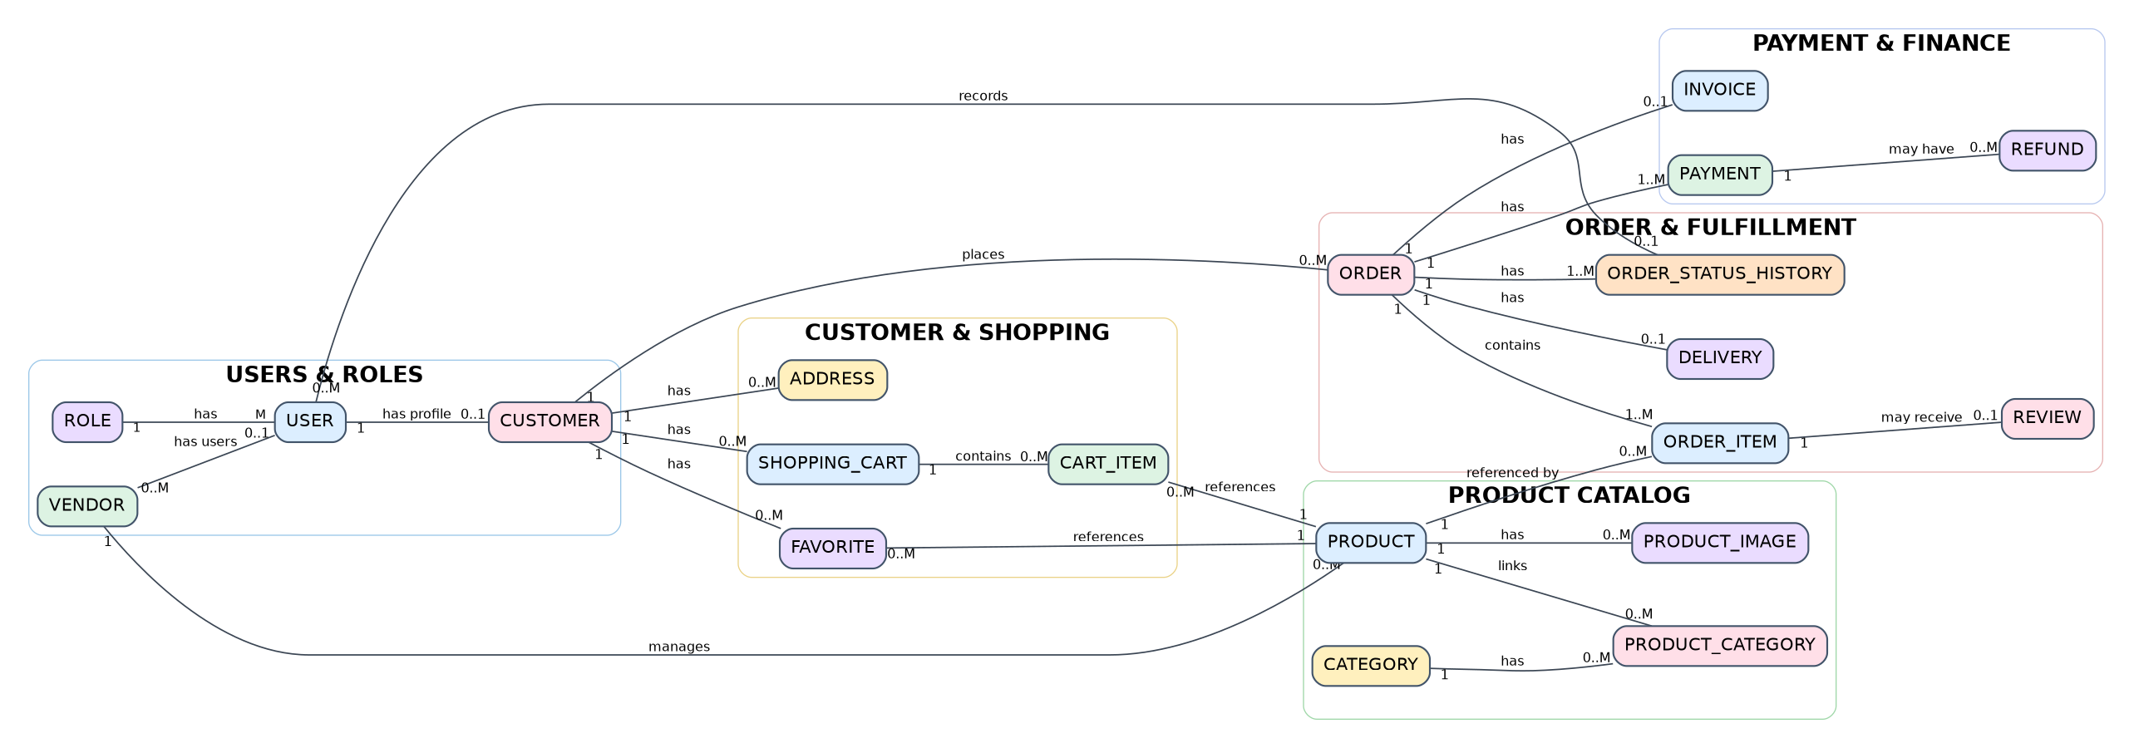
Figure 4. Conceptual ERD for the Um Hamza e-commerce database — entities, relationships, and cardinalities only.

6.1 Core Conceptual Relationships
- ROLE 1:M USER
- VENDOR 1:M USER (each USER belongs to 0..1 VENDOR)
- USER 1:0..1 CUSTOMER
- CUSTOMER 1:0..M ADDRESS
- CUSTOMER 1:0..M SHOPPING_CART
- SHOPPING_CART 1:0..M CART_ITEM
- PRODUCT 1:0..M CART_ITEM
- CUSTOMER 1:0..M FAVORITE; PRODUCT 1:0..M FAVORITE
- VENDOR 1:0..M PRODUCT
- PRODUCT 1:0..M PRODUCT_CATEGORY; CATEGORY 1:0..M PRODUCT_CATEGORY
- PRODUCT 1:0..M PRODUCT_IMAGE
- CUSTOMER 1:0..M ORDER
- ORDER 1:1..M ORDER_ITEM
- PRODUCT 1:0..M ORDER_ITEM
- ORDER 1:1..M ORDER_STATUS_HISTORY
- USER 0..M ORDER_STATUS_HISTORY (history entry may have 0..1 USER)
- ORDER 1:M PAYMENT
- PAYMENT 1:0..M REFUND
- ORDER 1:0..1 INVOICE
- ORDER 1:0..1 DELIVERY
- ORDER_ITEM 1:0..1 REVIEW

6.2 Conceptual Decisions I Made
- I resolve Product–Category and Customer–Product Favorites using associative entities rather than repeating values.
- A customer may have multiple shopping carts over time, but only one ACTIVE shopping cart at a time.
- I keep ORDER_ITEM separate so an order can contain multiple products and the historical unit price remains attached to the order.
- I keep ORDER_STATUS_HISTORY so important status transitions and vendor rejection reasons are not overwritten.
- I keep PAYMENT and REFUND separate from ORDERS so financial records can have their own lifecycle.
- I keep DELIVERY separate so fulfillment information can evolve without duplicating order or customer data.
- I attach REVIEW to ORDER_ITEM so a review can represent a verified purchase rather than an unverified product comment.

7. Logical Schema
I converted the conceptual model into a relational logical schema before writing the physical SQL Server tables. The logical schema defines the relations, key attributes, foreign-key relationships, required values, controlled domains, and historical fields that the physical implementation must preserve.
This is the stage where I define the PK/FK structure and other implementation constraints that are not shown on the conceptual ERD.

7.1 Logical Design Conventions
- Core entities use surrogate BIGINT identity primary keys.
- Associative relations use composite primary keys where the relationship itself is the identifier.
- Foreign keys use *_id naming and are explicitly constrained.
- Monetary values use DECIMAL(12,2).
- Quantities use INT.
- Timestamps use DATETIME2(0).
- User-entered text uses NVARCHAR.
- Activation flags use BIT.
- Finalized business records are retained; deactivation/status is preferred over destructive deletion.

7.2 Logical Schema Overview — Attributes, PKs, FKs and Integrity Rules
Table | Key attributes | Integrity / design purpose
ROLES | role_id, role_name, description | PK role_id; UNIQUE role_name; controlled role values
USERS | user_id, role_id, vendor_id, email, password_hash, is_active, timestamps | PK; FK role/vendor; UNIQUE email
CUSTOMERS | customer_id, user_id, first_name, last_name, phone, timestamps | PK; FK user; UNIQUE user_id
VENDORS | vendor_id, business_name, contact_name, email, phone, address data, is_active, timestamps | PK; UNIQUE business_name
ADDRESSES | address_id, customer_id, address details, address_type, is_default, timestamps | PK; FK customer; controlled address type
CATEGORIES | category_id, category_name, description, parent_category_id, is_active, timestamps | PK; UNIQUE category_name; self-FK
PRODUCTS | product_id, vendor_id, sku, product_name, description, price, sale_price, package data, stock, reserved, reorder, status, is_active, version_no, timestamps | PK; FK vendor; UNIQUE SKU; stock/price/status checks
PRODUCT_CATEGORIES | product_id, category_id | Composite PK; FKs product/category
PRODUCT_IMAGES | image_id, product_id, image_url, alt_text, display_order, is_primary, created_at | PK; FK product
SHOPPING_CARTS | cart_id, customer_id, status, timestamps | PK; FK customer; one ACTIVE cart per customer  The physical implementation allows multiple historical cart records while enforcing at most one ACTIVE cart per customer.
CART_ITEMS | cart_item_id, cart_id, product_id, quantity, added_at | PK; FKs cart/product; UNIQUE(cart,product)
FAVORITES | favorite_id, customer_id, product_id, created_at | PK; FKs customer/product; UNIQUE(customer,product)
ORDERS | order_id, order_number, customer_id, delivery_address_id, order_date, subtotal, discount, tax, shipping, total, status, timestamps | PK; FKs customer/address; UNIQUE order_number
ORDER_ITEMS | order_item_id, order_id, product_id, quantity, unit_price, line_total, created_at | PK; FKs order/product; historical price captured
ORDER_STATUS_HISTORY | history_id, order_id, changed_by_user_id, status, comment, changed_at | PK; FKs order/user; status domain
PAYMENTS | payment_id, order_id, payment_method, status, authorized_amount, captured_amount, currency, provider reference, safe card metadata, timestamps | PK; FK order; payment-status domain
REFUNDS | refund_id, payment_id, amount, reason, status, provider_reference, processed_at, created_at | PK; FK payment; refund-status domain
INVOICES | invoice_id, order_id, invoice_number, issue_date, subtotal, discount, tax, shipping, total, status, created_at | PK; FK order; UNIQUE order/invoice number
DELIVERIES | delivery_id, order_id, delivery_status, delivery_method, estimated/actual date, notes, timestamps | PK; FK order; UNIQUE order_id
REVIEWS | review_id, order_item_id, rating, comment, timestamps | PK; FK order_item; UNIQUE order_item; rating 1–5

7.3 Status and Domain Rules
Domain | Allowed values / rule
ROLES.role_name | ADMIN, VENDOR, CUSTOMER
PRODUCTS.status | IN_STOCK or OUT_OF_STOCK
SHOPPING_CARTS.status | ACTIVE or CHECKED_OUT
ORDERS.status | PENDING_VENDOR_APPROVAL; APPROVED_AWAITING_PAYMENT; PROCESSING; READY_FOR_DELIVERY; OUT_FOR_DELIVERY; DELIVERED; REJECTED; CANCELLED
PAYMENTS.status | AUTHORIZED; CAPTURED; FAILED; CANCELLED; REFUNDED; PARTIALLY_REFUNDED
REFUNDS.status | PENDING; PROCESSING; COMPLETED; FAILED; CANCELLED
INVOICES.status | ISSUED or VOID
DELIVERIES.delivery_status | PENDING; PROCESSING; READY_FOR_DELIVERY; OUT_FOR_DELIVERY; DELIVERED; DELAYED
ADDRESSES.address_type | HOME, WORK, OTHER
REVIEWS.rating | 1 through 5

8. Normalization and Data Integrity
I reviewed the logical schema using the normalization concepts from my database coursework. My main goal was to avoid repeating groups, duplicated facts, and update anomalies while keeping the relational structure understandable.
Design check | How I applied it in my database
1NF — atomic data | Individual product, customer, address, payment, and order values are stored as attributes rather than lists.
1NF — repeating groups | Multiple order items, cart items, product images, categories, payments, and refunds are represented by related rows.
2NF | Associative relations such as PRODUCT_CATEGORIES use the relationship keys together as the composite key.
3NF | Category descriptions stay in CATEGORIES; vendor details stay in VENDORS; customer details stay in CUSTOMERS; order-line data does not repeat customer/vendor data.
Historical accuracy | ORDER_ITEMS.unit_price stores the price used for the historical order instead of depending on the current product price.
Auditability | ORDER_STATUS_HISTORY stores prior statuses and comments instead of overwriting them.

8.1 Referential Integrity and Deletion
- Foreign keys prevent child records from referencing non-existent parent records.
- Core records such as customers, vendors, products, and finalized orders are designed for retention rather than destructive deletion.
- Products can be deactivated when no longer offered while remaining available to historical ORDER_ITEMS.
- Historical order addresses remain meaningful because the referenced address record is retained.
- Finalized financial and transaction records are protected from destructive parent deletion.

9. Physical SQL Server Implementation
I implemented the logical schema in Microsoft SQL Server using a dedicated Docker container and Visual Studio Code. I intentionally used a new host port, 14330, so this project remains isolated from an older SQL Server project that was using host port 1433.
Environment item | Implemented value
Host platform | Apple Silicon Mac
Database engine | Microsoft SQL Server 2022 Developer container
Container name | umhamza-sqlserver
Host connection | localhost,14330
Container SQL Server port | 1433
Database | UmHamzaECommerce
Storage | Docker volume umhamza-sqlserver-data
Development client | Visual Studio Code MSSQL extension

9.1 Physical Creation Sequence
- Create the SQL Server database.
- Create the 20 relational tables in foreign-key-safe order.
- Insert representative sample data.
- Create the required Product inventory/status trigger.
- Insert one linked test order for relationship verification.
- Run the final verification queries.

9.2 Required Inventory Trigger
The physical database includes TR_PRODUCTS_SyncStatus on PRODUCTS. It synchronizes Product status from inventory quantity and is written as a set-based trigger so one UPDATE statement can affect multiple products.
Condition | Status
stock_quantity = 0 | OUT_OF_STOCK
stock_quantity > 0 | IN_STOCK

I verified the trigger using two products in a single UPDATE statement. The result showed Akkawi Cheese at quantity 0 with OUT_OF_STOCK and Zaatar Blend at quantity 7 with IN_STOCK. I then rolled the transaction back and confirmed the original quantities and statuses were restored.

10. Database Testing and Evidence
The following screenshots are my execution evidence from the actual Docker + SQL Server + VS Code environment. I selected evidence that demonstrates the database being created, populated, tested, and verified rather than including unrelated screenshots.

10.1 SQL Server Docker Container Running
Shows the dedicated umhamza-sqlserver container running with host port 14330 mapped to container port 1433.
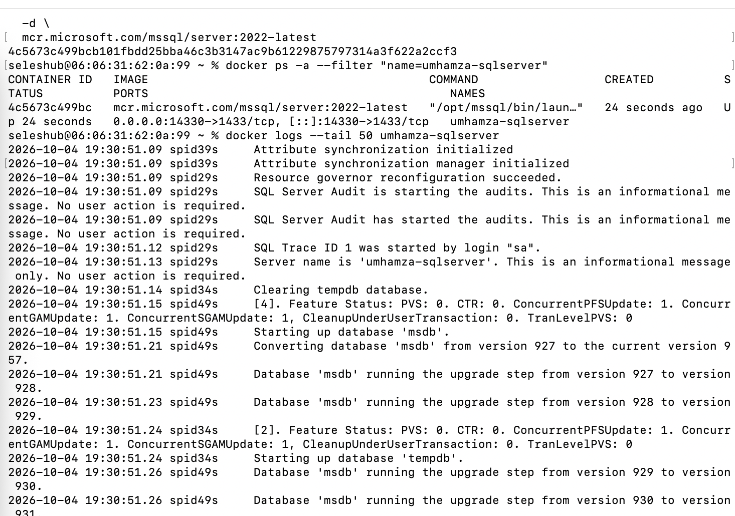
Evidence 1. SQL Server Docker Container Running — 01_SQL_Server_Container_Running.png
10.2 UmHamzaECommerce Database Created
Shows successful execution of CREATE DATABASE and the new UmHamzaECommerce database in VS Code.
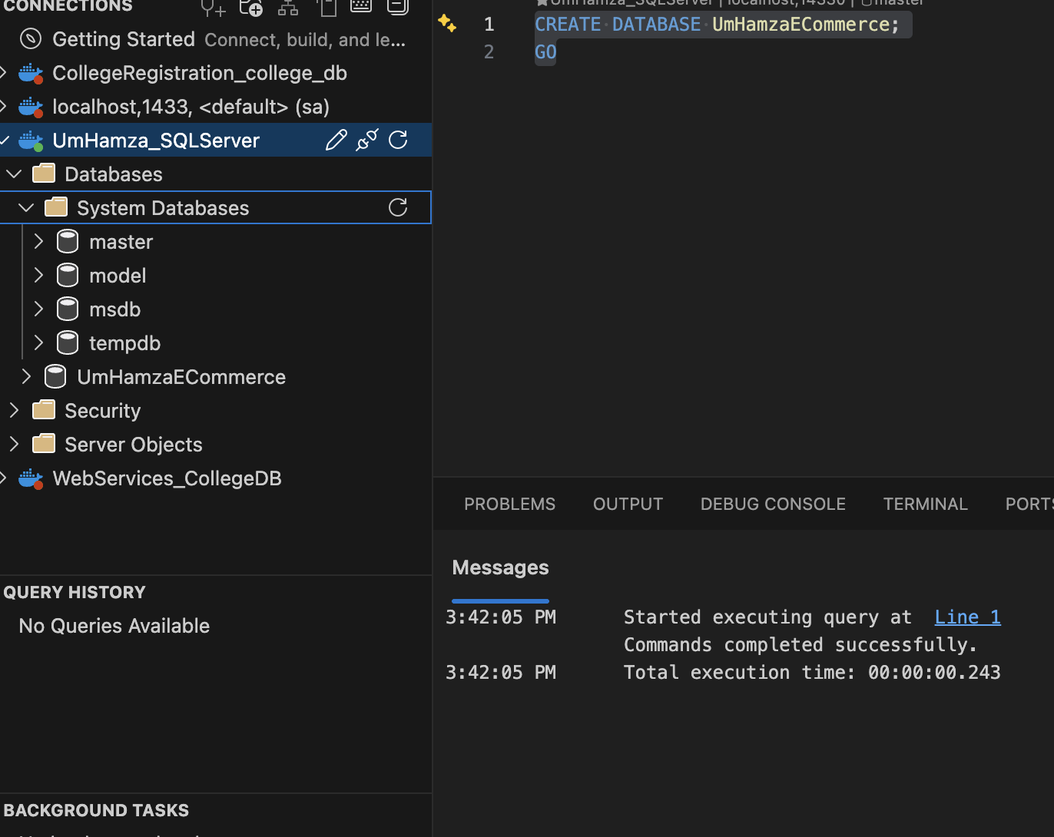
Evidence 2. UmHamzaECommerce Database Created — 03_UmHamzaECommerce_Database_Created.png
10.3 Database Tables Created Successfully
Shows the populated Tables node and successful execution messages after creating the physical schema.
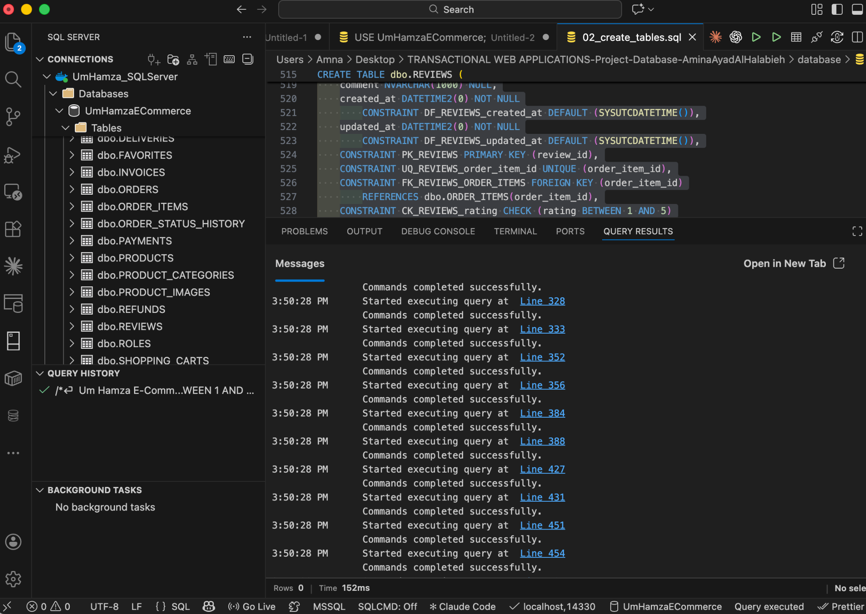
Evidence 3. Database Tables Created Successfully — 04_Tables_Created_Successfully.png
10.4 Sample Data Inserted Successfully
Shows successful INSERT operations for the representative Database Completion sample data.
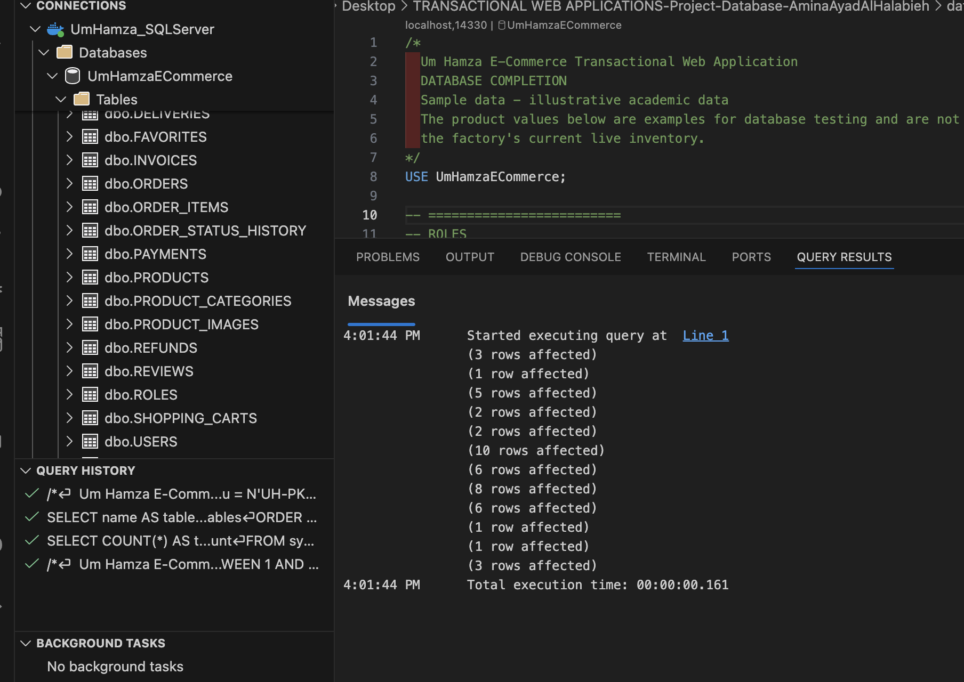
Evidence 4. Sample Data Inserted Successfully — 05_Sample_Data_Inserted.png
10.5 Sample Data Verification
Shows record counts, roles, vendor users, and product data returned from the implemented database.
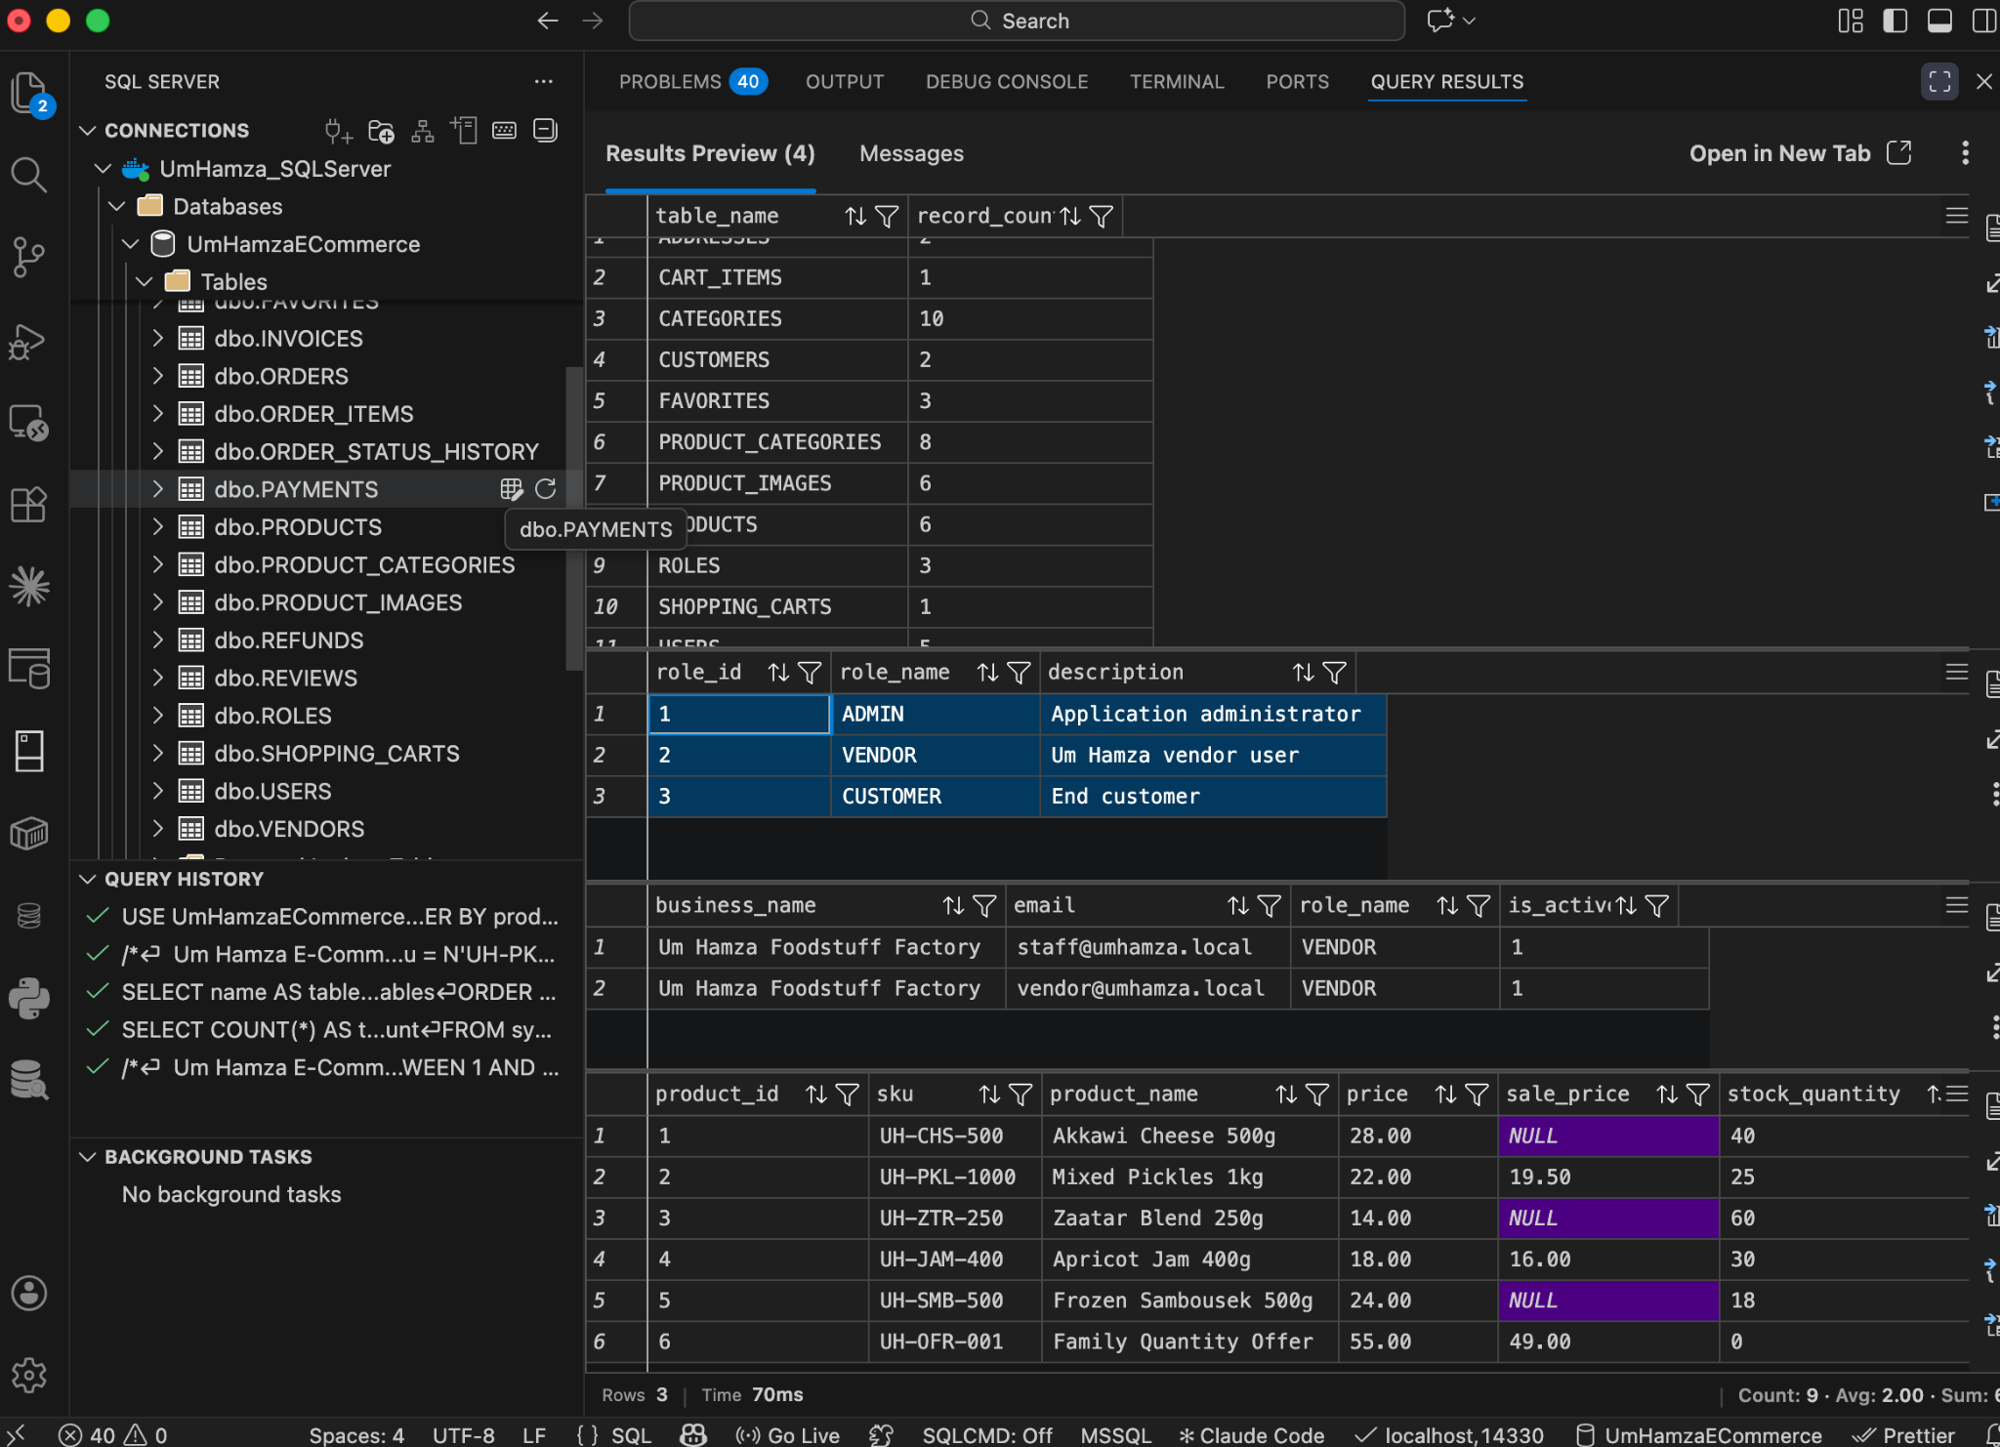
Evidence 5. Sample Data Verification — 06_Sample_Data_Verification.png
10.6 Inventory Status Trigger Created
Shows successful creation of the required TR_PRODUCTS_SyncStatus SQL Server trigger.
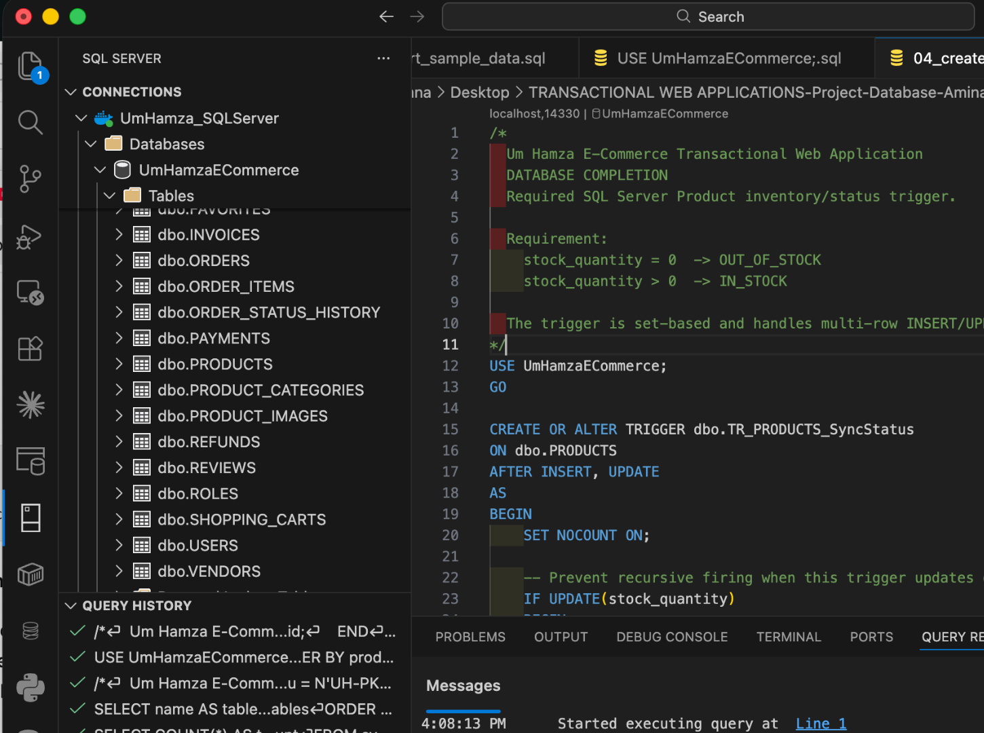
Evidence 6. Inventory Status Trigger Created — 07_Inventory_Trigger_Created.png
10.7 Multi-Row Inventory Trigger Test
Shows two products updated in one statement, automatic status synchronization, and rollback to the original values.
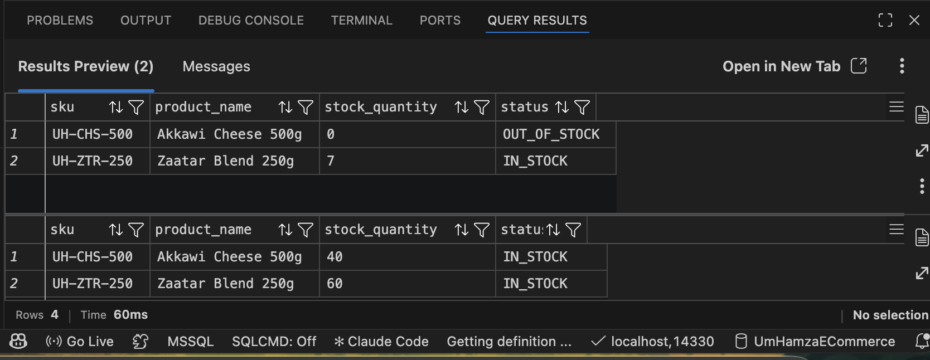
Evidence 7. Multi-Row Inventory Trigger Test — 08_MultiRow_Inventory_Trigger_Test.png
10.8 Test Order Relationship Data Created
Shows successful creation of the linked test order data used to verify customer, address, order, order-item, and product relationships.
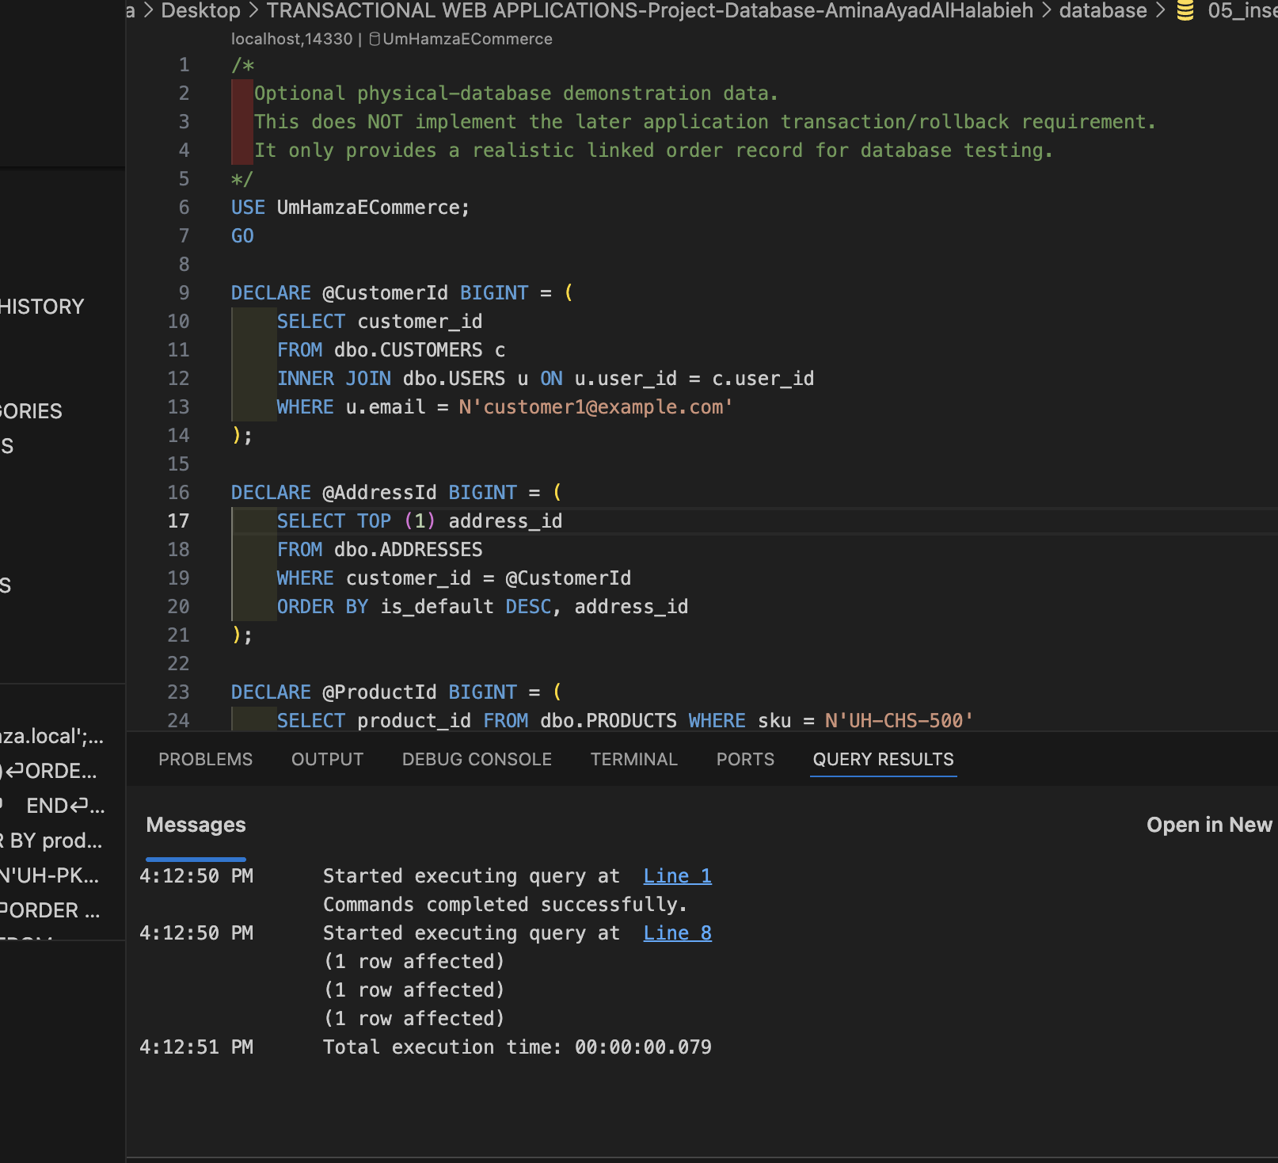
Evidence 8. Test Order Relationship Data Created — 09_Test_Order_Created.png
10.9 Final Database Verification
Shows final verification results including product status, the multi-row trigger test, order relationship output, and foreign-key inspection.
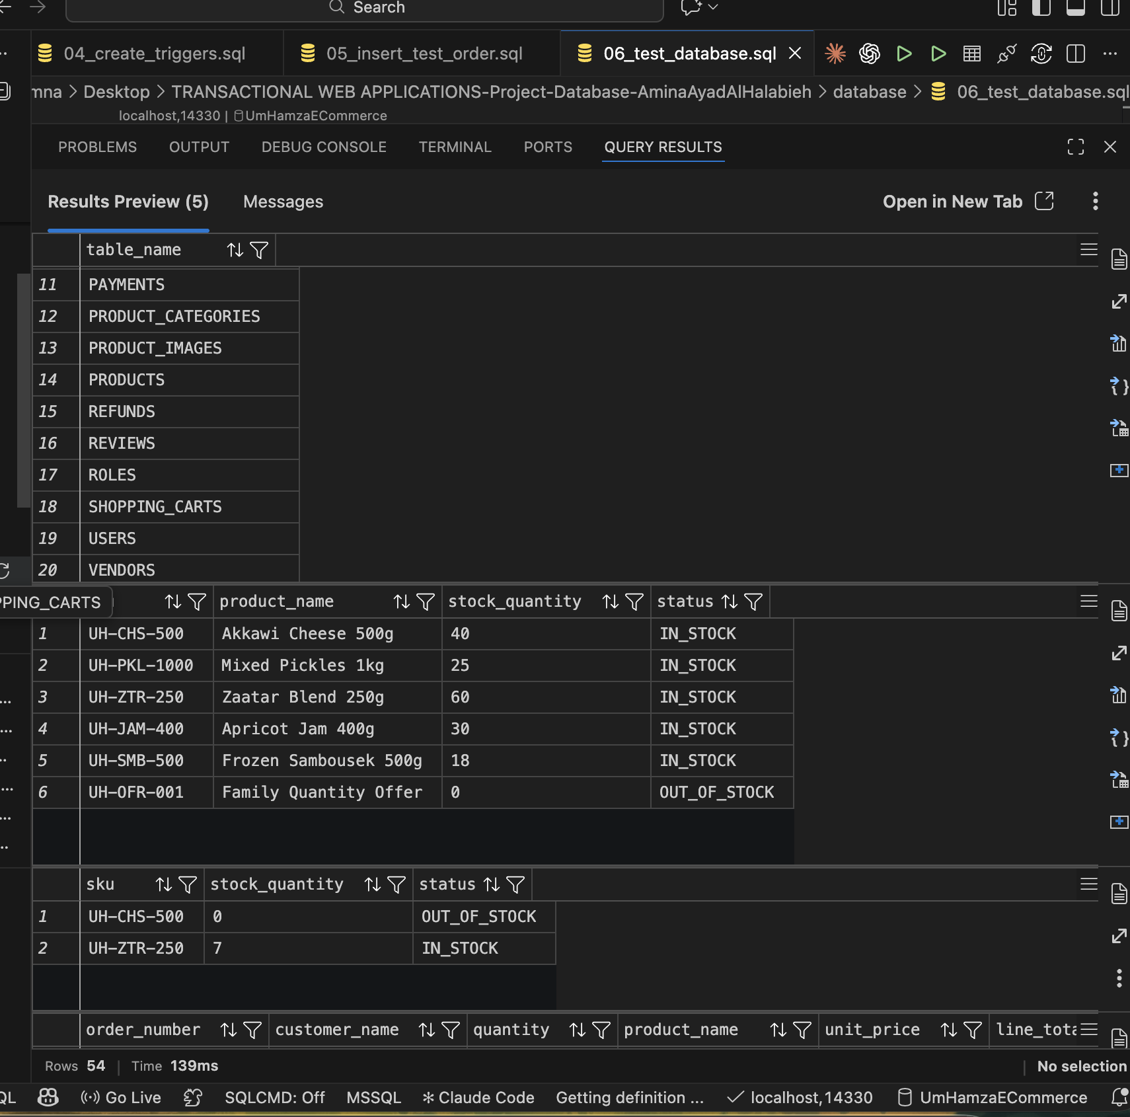
Evidence 9. Final Database Verification — 10_Final_Database_Verification.png

11. Reproducible Database File Structure
I organized the database scripts so another person can recreate the physical database in the correct order. The files are separated by responsibility instead of putting the entire implementation into one large script.
database/
├── 01_create_database.sql
├── 02_create_tables.sql
├── 03_insert_sample_data.sql
├── 04_create_triggers.sql
├── 05_insert_test_order.sql
├── 06_test_database.sql
└── README.md
This organization also makes troubleshooting easier because database creation, table structure, data loading, trigger creation, and testing can be executed and verified separately.

11.1 Security of Database Files
- No real production credentials are included in the submitted SQL scripts.
- No full payment card number or CVV is stored.
- The physical database stores only safe payment references and optional card brand/last-four metadata.
- The Docker SQL Server password is not written into the project documentation.

12. Final Database Completion Checklist
- Conceptual schema documented.
- Formal conceptual ERD included.
- Guest, Customer, Vendor, and Admin access model explained.
- Guest correctly treated as an unauthenticated state rather than a permanent table.
- Admin correctly represented through USER + ROLE(ADMIN).
- 20 persistent entities defined.
- Logical schema documented with keys, constraints, and relationship implementation.
- Normalization reviewed.
- Microsoft SQL Server database created.
- 20 SQL Server tables created successfully.
- Primary and foreign keys implemented.
- Unique, NOT NULL, CHECK, and referential-integrity rules implemented where appropriate.
- Representative sample data inserted.
- Required Product inventory/status trigger implemented.
- Multi-row trigger behavior verified.
- Test order relationship verified.
- Final database verification executed successfully.
- Reproducible SQL scripts organized.
- Evidence screenshots captured and titled.

My Database Completion Reflection
Completing this database from the beginning helped me understand why the conceptual and logical stages should come before physical implementation. I started with an empty SQL Server environment, created a dedicated Docker container, connected it through Visual Studio Code, and then implemented the database in controlled steps.
I used the ideas I learned from requirements analysis, UML, database design, normalization, relationships, and CRUD to make decisions about what belongs in the database and what should remain an application-level concept. In particular, separating the Guest actor from the persistent Customer entity helped me avoid creating a database table that would not represent meaningful long-term data.
The final database is therefore not only a collection of tables. It is a structured model of the business data with defined relationships, integrity rules, historical information, inventory behavior, and reproducible setup scripts. I verified the implementation directly in SQL Server rather than treating the design as complete before testing it.

