LAB 5: User Interface Design, First Working Prototype, and Deliverable I Preparation
Pawdopt v2: Pet Adoption and Rehoming Management System
From high-fidelity wireframes to the first working ASP.NET Core MVC prototype
Students | Amina Ayad Al Halabieh and Isabela Sierra Chinchilla
Student IDs | 6367025 / 6358655
Course | System Development 420-940-VA Week 5 Summer 2026
Instructor | Pejman Azadi
Date | June 11, 2026

1. Project Summary for Week 5
Pawdopt v2 is a web-based pet adoption and rehoming platform built with ASP.NET Core MVC, Razor Views, HTML, CSS, JavaScript, and SQL Server with Entity Framework Core. It serves the four roles defined since Assignment 2 — Guests browse listings freely, Adopters search, filter, favourite, and apply for pets, Rehomers list pets through a guided wizard that requires a vaccination document (FR-5), and Administrators verify those documents and approve every listing before it goes live (FR-6). Together, these two rules address the core problem the project set out to solve: pet rehoming today happens on unverified classified-ad sites, while Pawdopt gives shelters and private owners a trusted, bilingual platform where every listing is document-verified and every application follows a structured lifecycle.
The prototype makes four user stories visible for Deliverable I: US-1 (browsing and filtering pets as a Guest or Adopter), US-2 and US-3 (registration with role selection and email verification gating login), US-4 (submitting and tracking a structured adoption application), and US-8 (listing a pet through the step-by-step wizard). Three screens are featured: the shared Landing page, the Adopt listings page led by Amna, and the Rehome New Listing wizard led by Isabela.
A note on our prototype technology: the Week 5 outline calls for a first working C# prototype with event-driven behaviour. Rather than building a throwaway demo, we chose to present our actual ASP.NET Core MVC application from the team's shared GitHub repository, since it was already further along than a prototype needs to be. The event-driven C# requirement is fully met — every button click posts a form that triggers a controller action — and Section 4 maps each lab requirement to its web equivalent so nothing from the rubric is skipped. We practice the Windows Forms approach separately in the Week 6 CRUD lab.

2. Wireframes and Interface Plan
High-fidelity wireframes were produced in HTML/CSS for every screen of the platform before implementation (desktop and mobile). The wireframes below cover the three featured screens, plus the document-upload step that implements FR-5. At the wireframe stage the product carried the original “Pawdopt” text logo and emoji placeholders for pet images; the visual identity was refined during implementation (see Section 5).

Screen 1 — Landing page (shared)
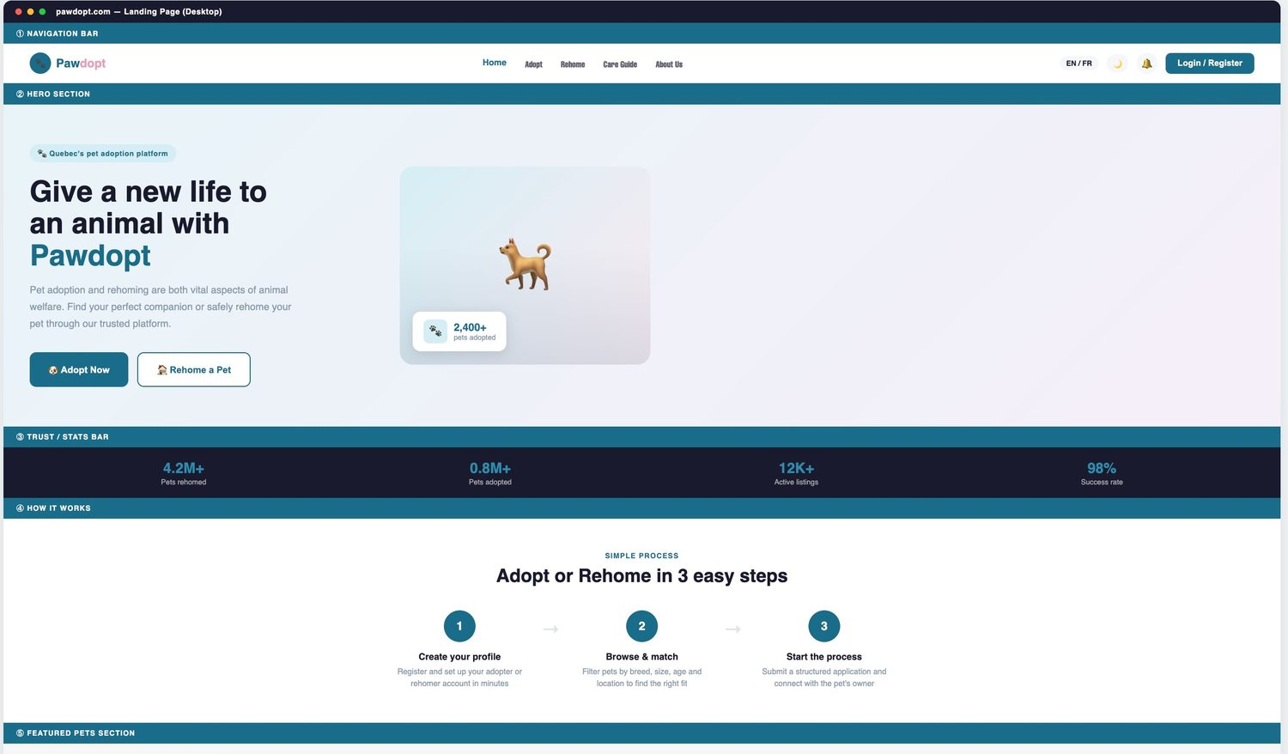
Figure 2.1 — Wireframe: Landing page hero, trust statistics bar, and “3 easy steps” process section.
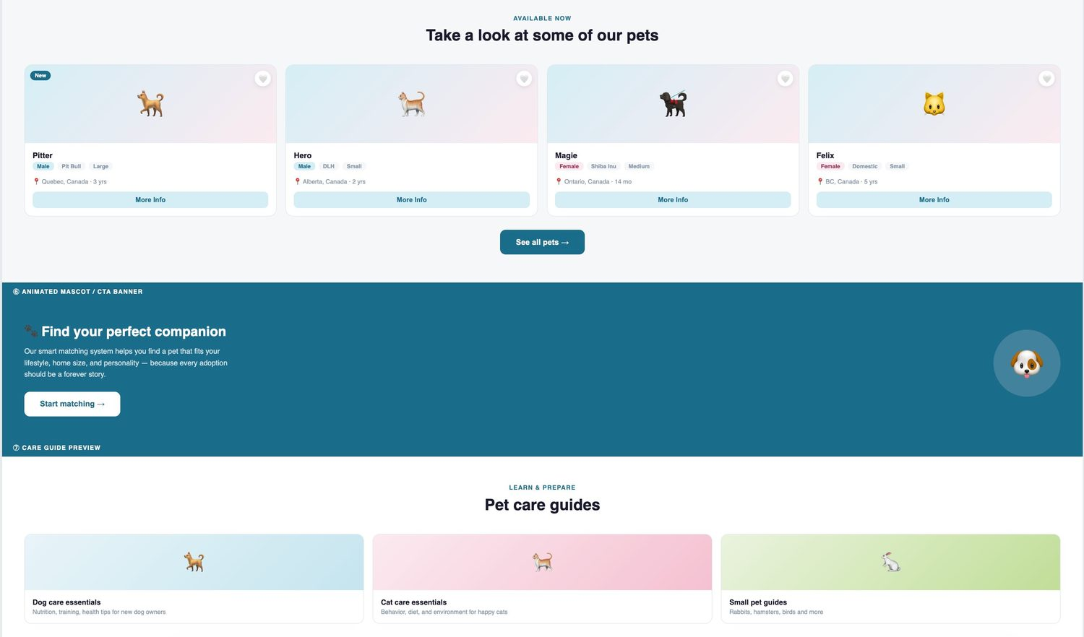
Figure 2.2 — Wireframe: Featured pets grid, matching call-to-action banner, and care-guide preview.
Purpose: the landing page is the entry point for all four roles. It must explain the platform in one glance, route visitors to the two main flows (Adopt Now / Rehome a Pet), and build trust through statistics and testimonials. Supported user story: US-1, since guests reach the listings from here without logging in. Control rationale: two prominent buttons for the two primary actions, a sticky navigation bar with EN/FR toggle and Login/Register (US-2), card components for featured pets, and an accordion for FAQs to keep the page scannable.

Screen 2 — Adopt listings page (Amna)
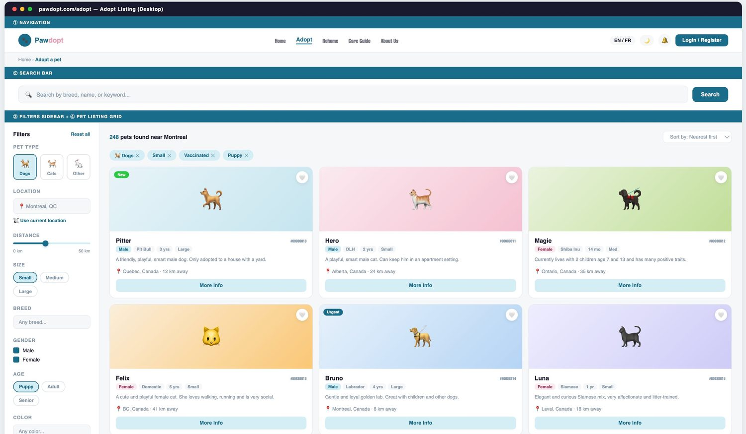
Figure 2.3 — Wireframe: Adopt page with search bar, filters sidebar, active filter chips, and the pet listing grid.
Purpose: this is the core Adopter screen where pets are discovered. Supported user story: US-1 (browse and filter). Control rationale: a search text box for keyword queries; a filters sidebar using button groups (pet type, size, age), checkboxes (gender), a distance slider, and free-text breed input, because each control type matches the data type it filters; removable filter chips so the user always sees the active query; a result counter for immediate feedback; and a card grid with a More Info button per pet leading to the detail page and the application wizard (US-4).

Screen 3 — Rehome New Listing wizard (Isabela)
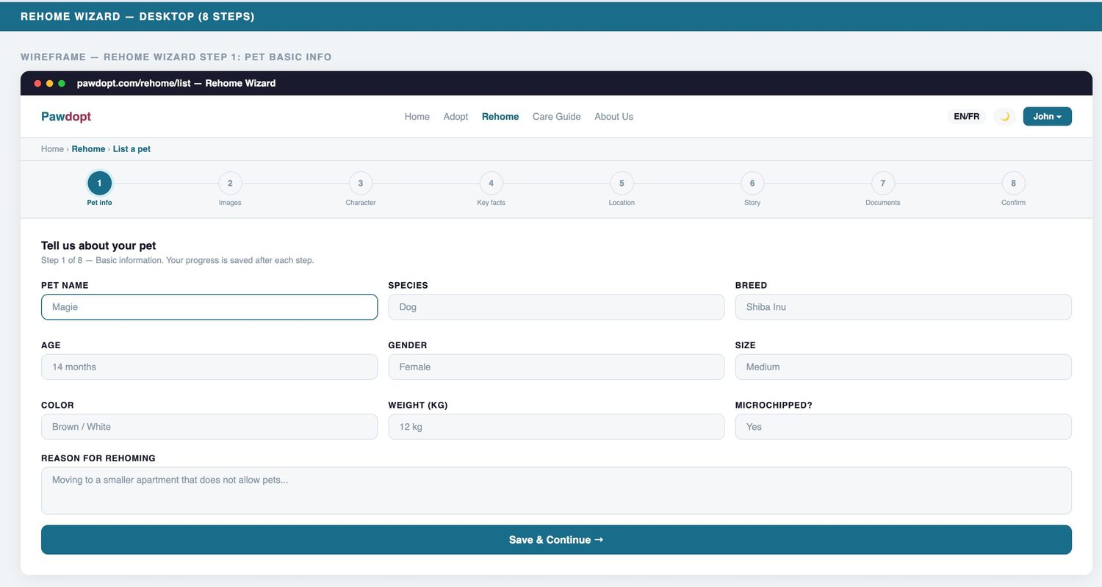
Figure 2.4 — Wireframe: Rehome wizard Step 1 “Tell us about your pet” with progress stepper across the top.
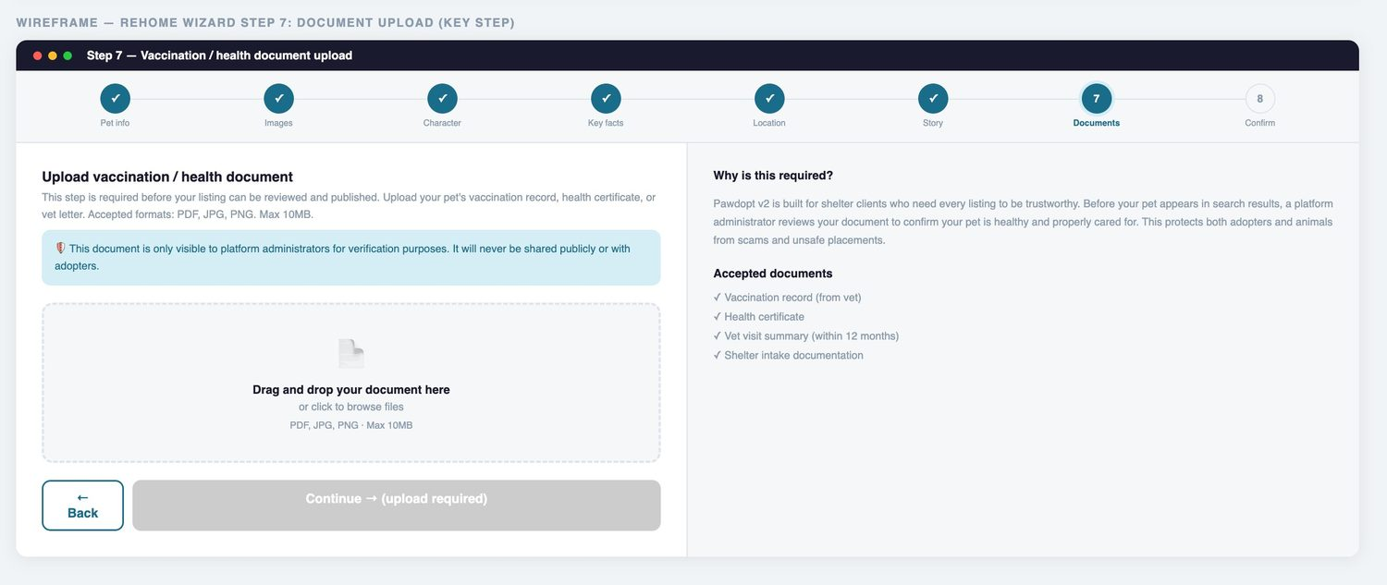
Figure 2.5 — Wireframe: Document upload step implementing FR-5 — the Continue button stays disabled until a vaccination/health document is provided.
Purpose: the wizard lets a Rehomer create a complete, verified listing without being overwhelmed by one giant form. Supported user stories: US-8 (step-by-step listing) and FR-5/FR-6 (mandatory document upload feeding the admin approval queue). Control rationale: a progress stepper shows position and saved progress; each step groups related fields (basic info, photos, character, location, story, documents, confirmation); text boxes and dropdowns capture structured data; a drag-and-drop zone handles file upload with format and size constraints stated inline; and the disabled Continue button is itself a validation message, making the FR-5 rule impossible to miss.

Supporting wireframe — Adoption application wizard (Amna)
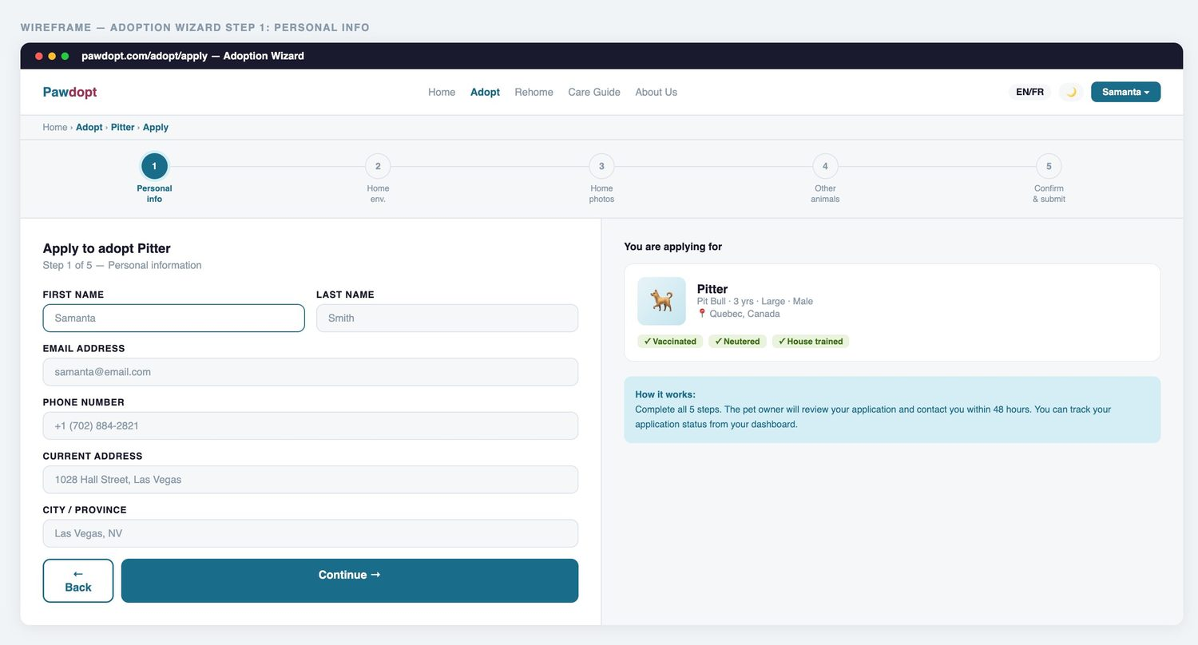
Figure 2.6 — Wireframe: Adoption wizard Step 1 with the “You are applying for” context card (US-4).
Although not one of the three featured screens, the adoption wizard is included because it is the Adopt-side mirror of the rehome wizard and the source of the Applications lifecycle modelled in the Lab 4 state transition diagram.

3. Screen Layout Decisions
Landing page. The layout follows a vertical storytelling flow: hero with a single headline and two action buttons, then trust statistics, then the three-step process, then featured pets, and finally FAQs and the footer. The hero places text on the left and imagery on the right, matching natural left-to-right reading order, and the two primary buttons are differentiated by fill (solid teal for Adopt, outlined for Rehome) so the page has one visually dominant action. Section labels in small teal caps (“SIMPLE PROCESS”, “AVAILABLE NOW”) create a consistent rhythm that helps users skim.
Adopt page. A fixed left sidebar holds every filter while the right region holds results, the standard e-commerce pattern users already know. Filters are ordered from broadest to narrowest (type, location, distance, size, breed, gender, age), the result count and sort dropdown sit directly above the grid where the eye lands after filtering, and pet cards repeat an identical internal layout (photo, name, badge tags, location, More Info button) so the grid stays scannable. Status badges (New, Urgent) sit on the photo corner where they cannot be confused with filter chips.
Rehome wizard. The stepper sits at the top of every step so progress is always visible, and the form region is centred with one card per step to focus attention. Fields are arranged in a three-column grid for short structured inputs (name, species, breed, age, gender, size) and full-width for long text (reason for rehoming), which keeps related controls on one visual line. Primary navigation (Save & Continue) is a full-width or right-aligned teal button at the bottom, with the secondary Back button visually lighter, so the safe default action is always the most prominent. This layout supports clarity and usability by showing the user exactly where they are, what is required, and what happens next.

4. C# Event-Driven Behavior
In a Windows Forms prototype, behaviour is attached to button Click events; in the ASP.NET Core MVC prototype, the same event-driven pattern is implemented through HTTP form posts that trigger controller action methods. The table of equivalences is: Submit button with validation → form POST to a [HttpPost] action with server-side checks; Clear button → the “Reset all” filters control on the Adopt page; MessageBox feedback → inline validation states, disabled buttons with explanatory labels, and a dedicated Success confirmation page; opening a second form → RedirectToAction navigation between wizard steps. The following excerpts are taken directly from RehomeController.cs in the shared repository.

Submit with validation and navigation — Step 1 of the rehome wizard
[HttpPost, Authorize, ValidateAntiForgeryToken] // Runs only for logged-in users and blocks forged form submissions.
public async Task<IActionResult> SaveStep1(
string petName, string species, string breed, string age,
string gender, string size, string? color, decimal? weight,
string? microchipped, string? reason) // Receives every input control of the Step 1 form.
{
var listing = new PetListing
{
RehomerId = _userManager.GetUserId(User)!, // Binds the listing to the logged-in Rehomer (Users -> Pets relationship from the class diagram).
Name = petName ?? string.Empty, // Defensive null handling on every field.
Species = species ?? "dog",
Breed = breed ?? string.Empty,
Age = age ?? string.Empty,
Gender = gender ?? "male",
Size = size ?? "medium",
Microchipped = microchipped ?? "unknown",
Reason = reason,
Status = "Draft", // The listing starts in the Draft state from the Lab 4 state transition diagram.
CreatedAt = DateTime.UtcNow
};
_context.PetListings.Add(listing); // Saves the new draft through Entity Framework Core.
await _context.SaveChangesAsync();
return RedirectToAction("Images", new { id = listing.Id }); // Event-driven navigation: clicking Save & Continue opens the next screen (Step 2).
}
When the Rehomer clicks Save & Continue, the browser posts the form to SaveStep1. The [Authorize] attribute is the first validation rule (only logged-in Rehomers may list pets), [ValidateAntiForgeryToken] protects against forged posts, null-coalescing defaults protect every field, and the redirect to the Images action is the web equivalent of opening the second form. The new listing is created in the Draft state, exactly as modelled in the Lab 4 state transition diagram.

Step-level safety validation — the GetDraft guard
// Helper: every wizard step re-validates the request before showing or saving anything.
private async Task<PetListing?> GetDraft(int id)
{
var userId = _userManager.GetUserId(User); // Identifies the logged-in user.
return await _context.PetListings
.FirstOrDefaultAsync(l => l.Id == id // The listing must exist,
&& l.RehomerId == userId // belong to this Rehomer (no one can edit someone else's draft),
&& l.Status == "Draft"); // and still be editable (Draft state only).
}
// If any rule fails, the step redirects back to NewListing instead of crashing or leaking data:
var listing = await GetDraft(id);
if (listing == null) return RedirectToAction("NewListing");
Every subsequent step (Images, Character, Location, Story, Documents, Confirm) begins with this guard. It enforces three rules at once: the record must exist, it must belong to the logged-in user, and it must still be a Draft. This prevents users from editing other people's listings or modifying a listing that has already been submitted for review — a stronger version of the “check before update” validation the lab requires.

Publish with user feedback and admin notification — FR-6 in action
[HttpPost, Authorize, ValidateAntiForgeryToken]
public async Task<IActionResult> Publish(int id) // Runs when the Rehomer confirms the final summary (Step 8).
{
var listing = await GetDraft(id);
if (listing == null) return RedirectToAction("NewListing");

listing.Status = "Pending"; // Draft -> Pending Review: FR-6, no listing goes live without admin approval.
listing.PublishedAt = DateTime.UtcNow;

await NotifyAdmins( // Creates one in-app notification per administrator.
type: "new_listing",
title: $"New listing awaiting approval: {listing.Name}",
body: $"A rehomer has submitted a new listing for {listing.Name} ({listing.Breed}). Please review.",
link: "/Admin");

await _context.SaveChangesAsync();
return RedirectToAction("Success"); // User feedback: a dedicated confirmation screen replaces the WinForms MessageBox.
}
Publishing transitions the listing from Draft to Pending (the Pending Review state from Lab 4), creates a notification for every administrator so the approval queue is never silent, and redirects the user to a Success page, which is the web prototype's success message. On the client side, the Adopt page adds further event-driven behaviour in JavaScript: typing in the search box, clicking a filter chip, or pressing Reset all re-runs the filter pipeline over the twelve pet objects defined in pawdopt-data.js and re-renders the grid with an updated result count, giving the user immediate feedback without a page reload.

5. Testing and Interface Improvements
The prototype was tested by walking each role through its main task: a guest browsing from the landing page to a pet detail, an Adopter filtering and starting an application, and a Rehomer creating a listing end-to-end. The screenshots below show the current working interface, followed by the improvements made between the wireframe stage and the implemented version.
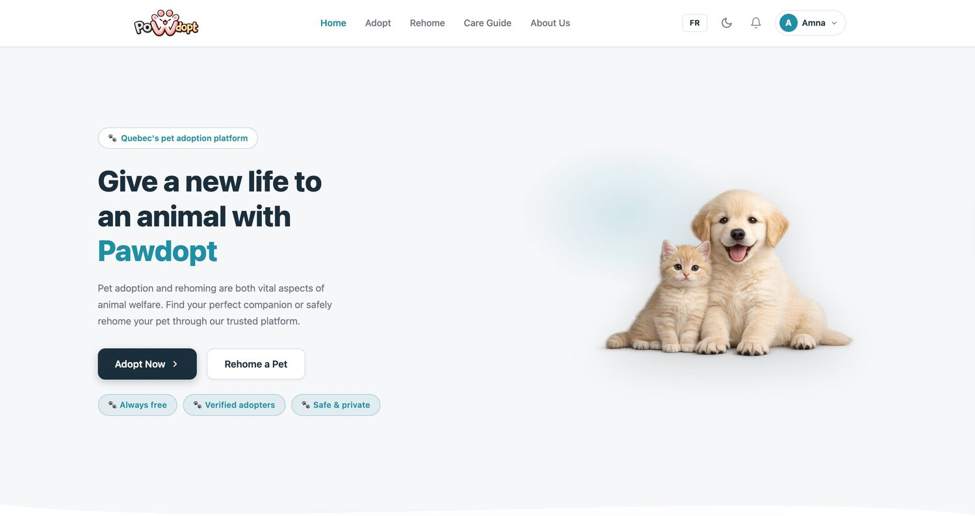
Figure 5.1 — Working landing page: rebranded PoWdopt logo, real photography, logged-in state (Amna), FR/EN toggle and dark-mode control.
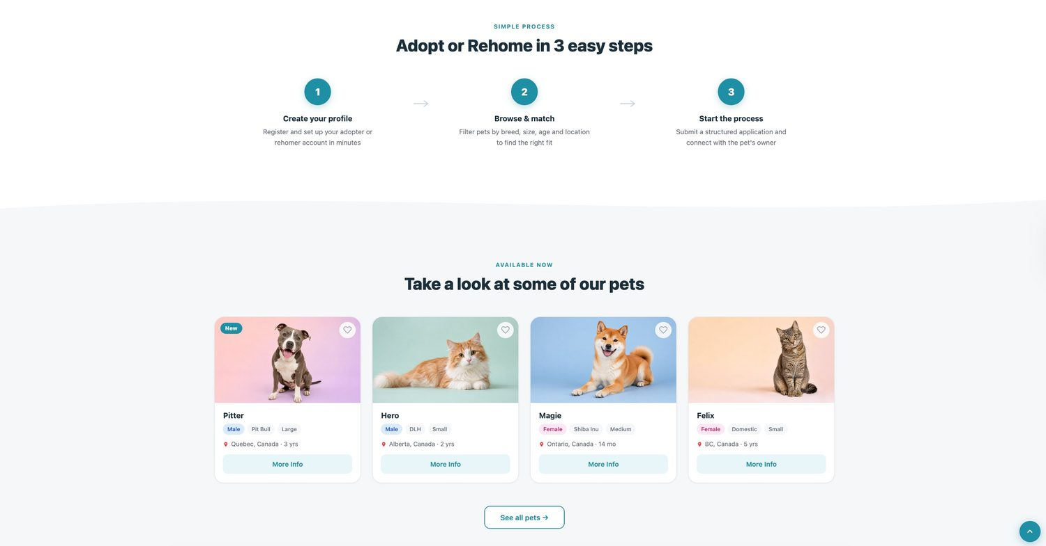
Figure 5.2 — Working “3 easy steps” section and featured pets with real images and badge system.
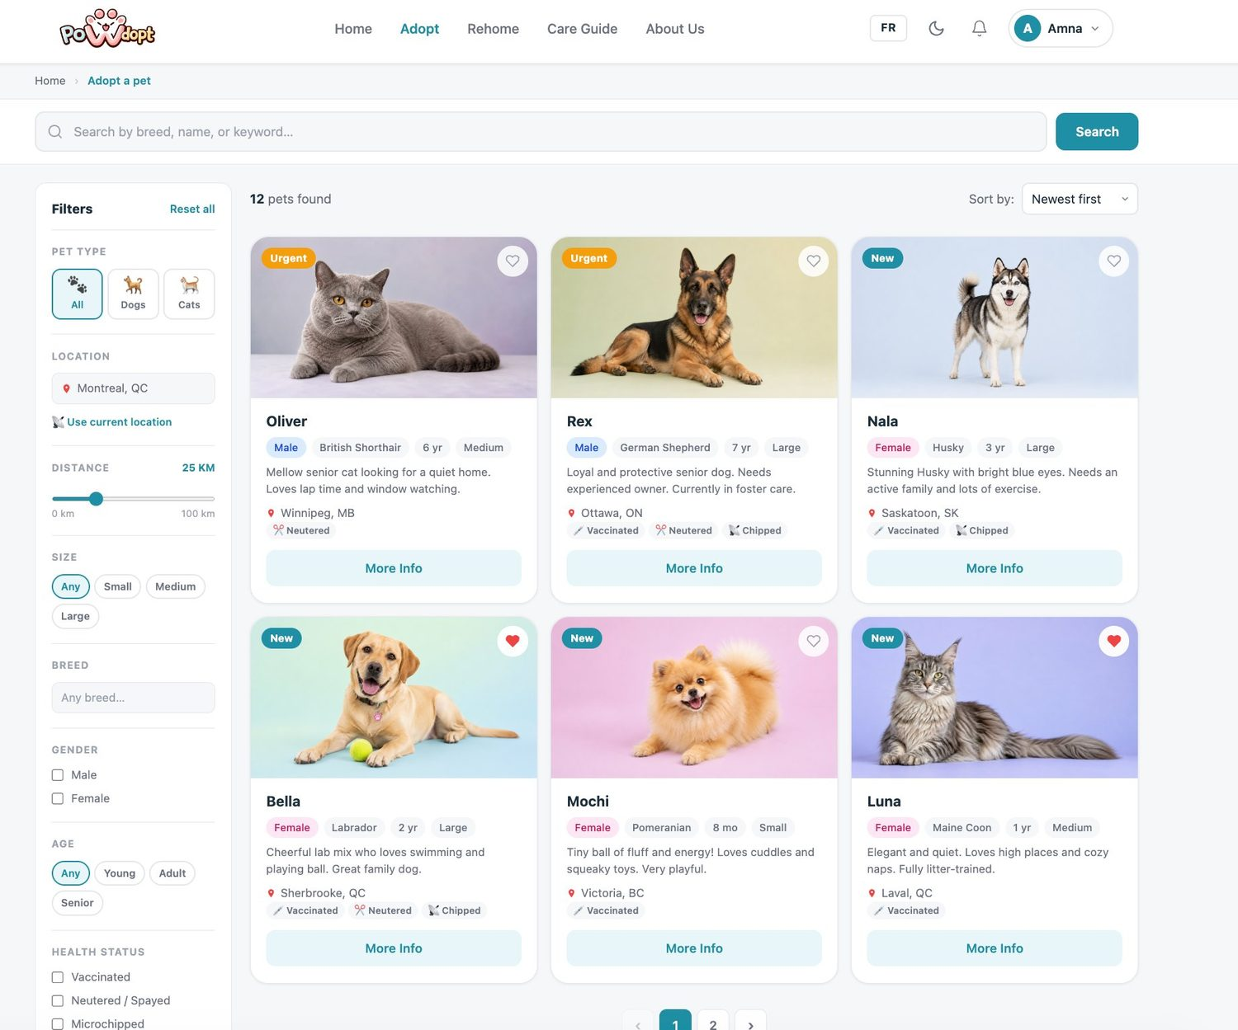
Figure 5.3 — Working Adopt page: live result count (“12 pets found”), functional filters, health-status tags, favourites hearts, and pagination.
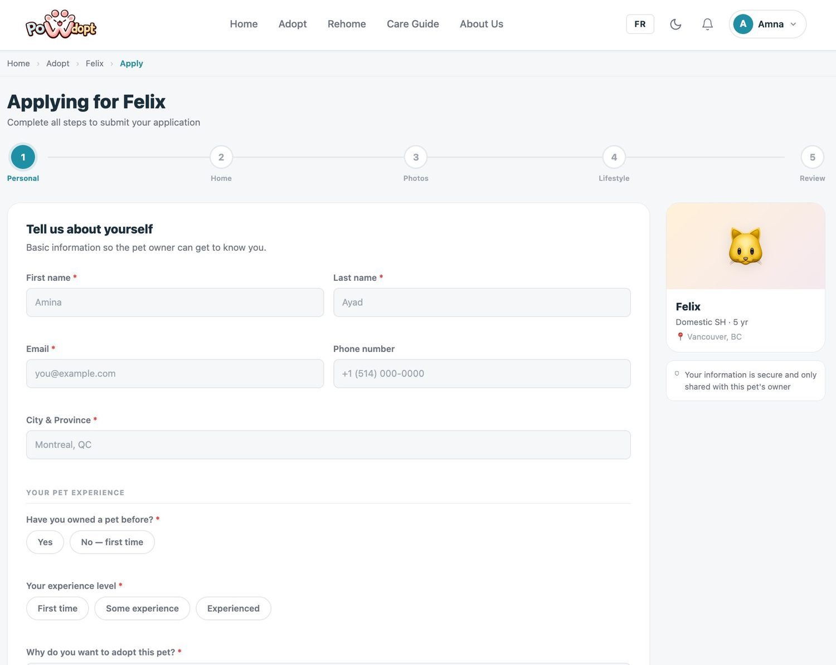
Figure 5.4 — Working adoption wizard (Applying for Felix): required-field markers, pet context card, and privacy note.
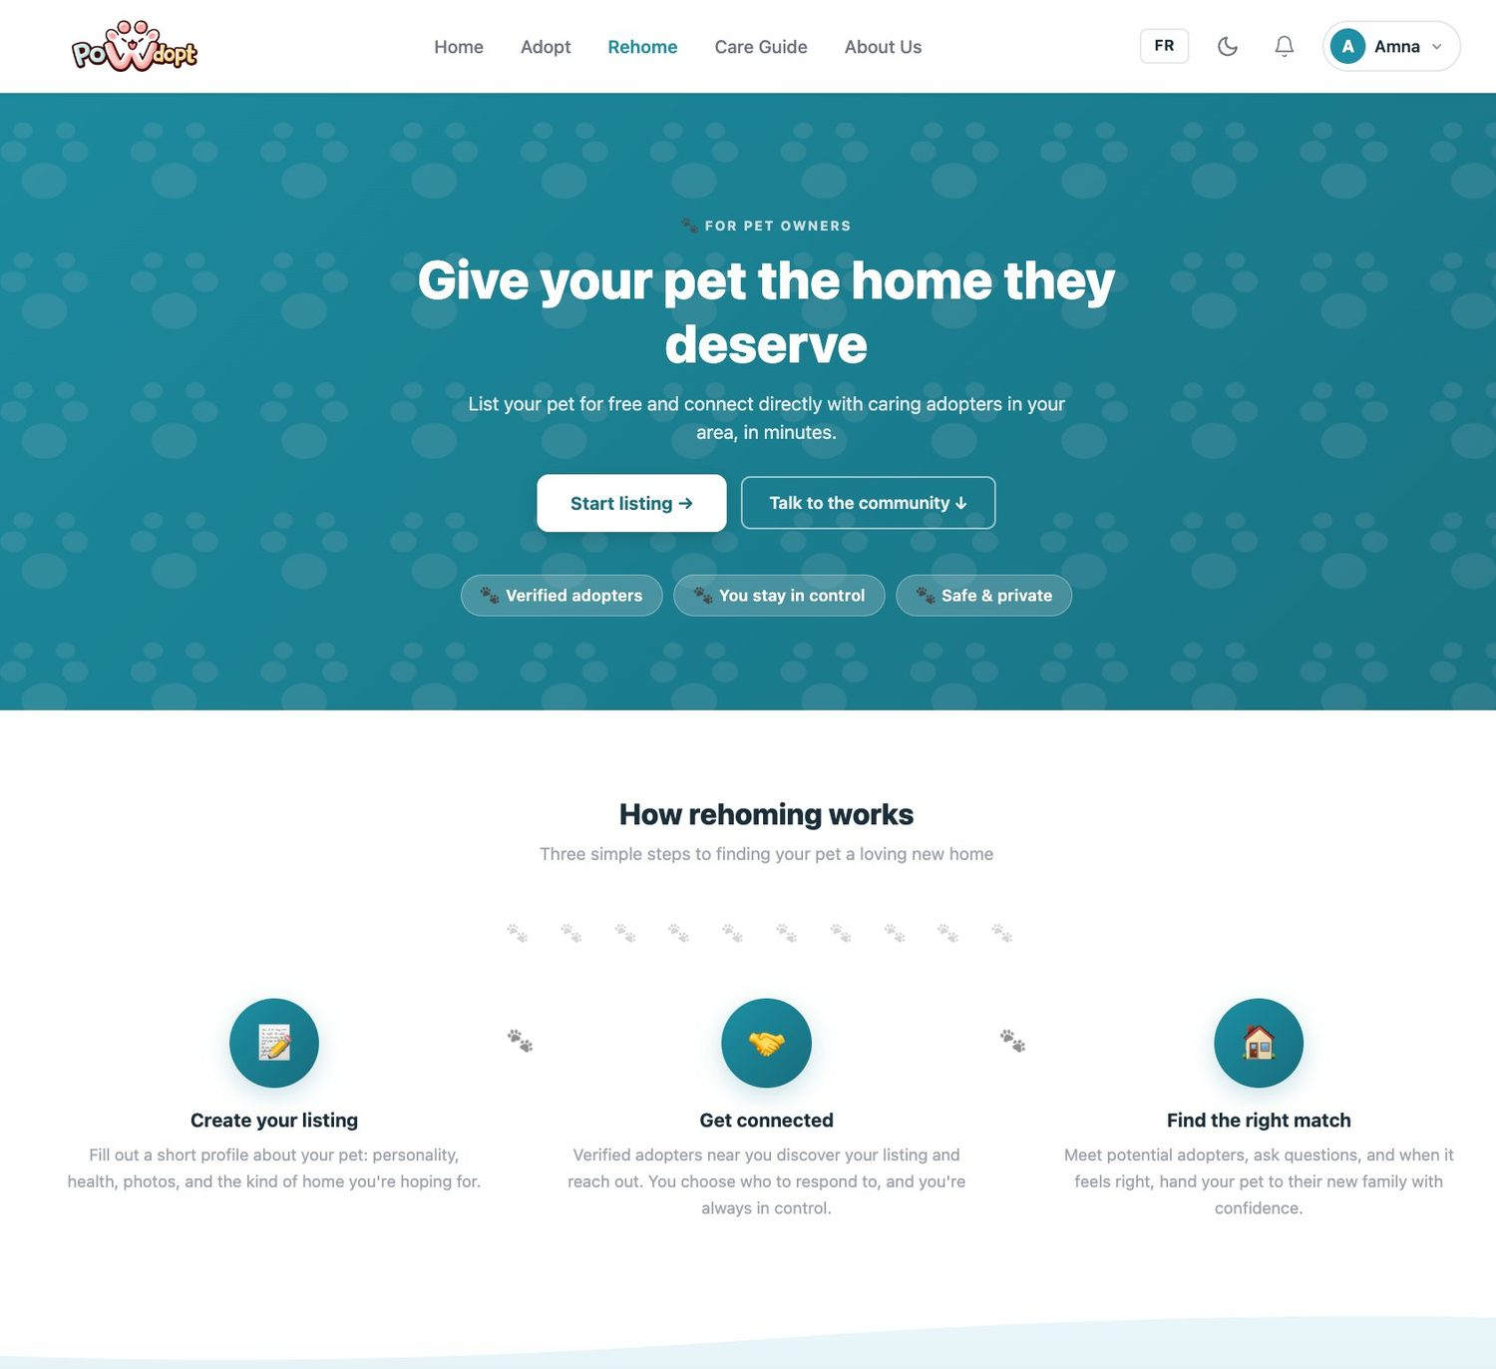
Figure 5.5 — Working Rehome landing: role-targeted hero, trust badges, and “How rehoming works”.
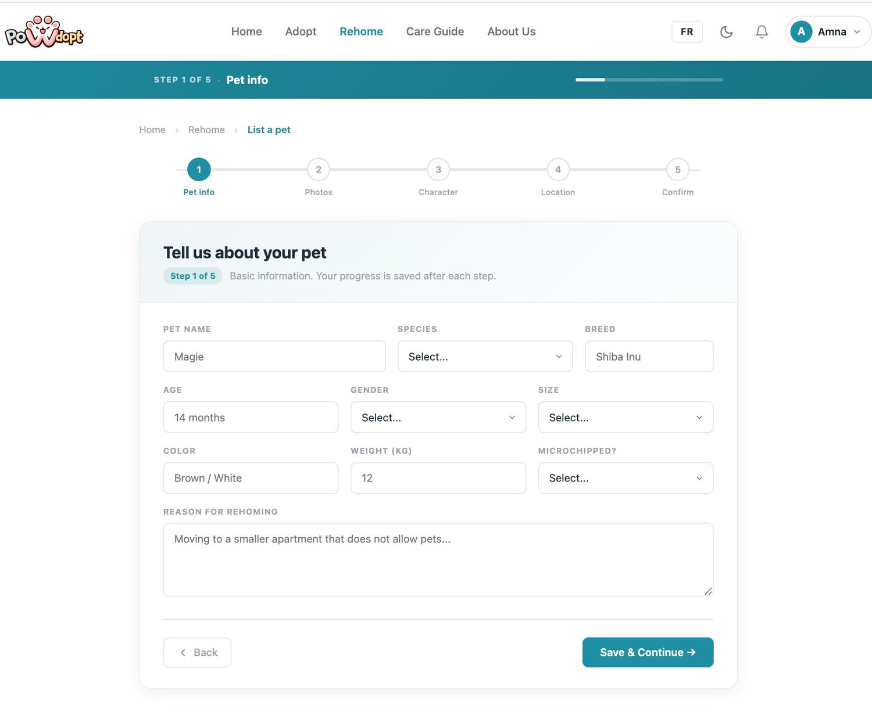
Figure 5.6 — Working rehome wizard Step 1 of 5: progress bar in the header, stepper, structured field grid, and Save & Continue.
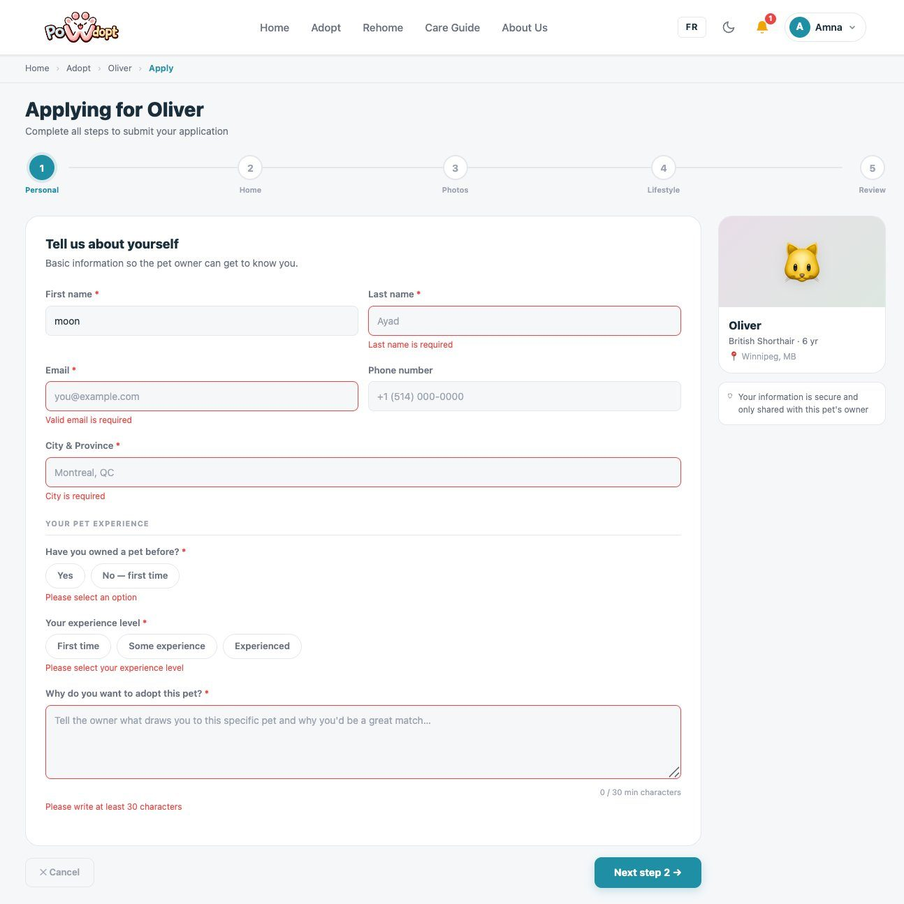
Figure 5.7 — Validation messages: attempting to continue past the adoption wizard Step 1 with empty required fields stops the submission and flags every missing input inline (“Last name is required”, “Valid email is required”, “Please select an option”), including a 30-character minimum on the motivation field, preventing incomplete applications from entering the system.
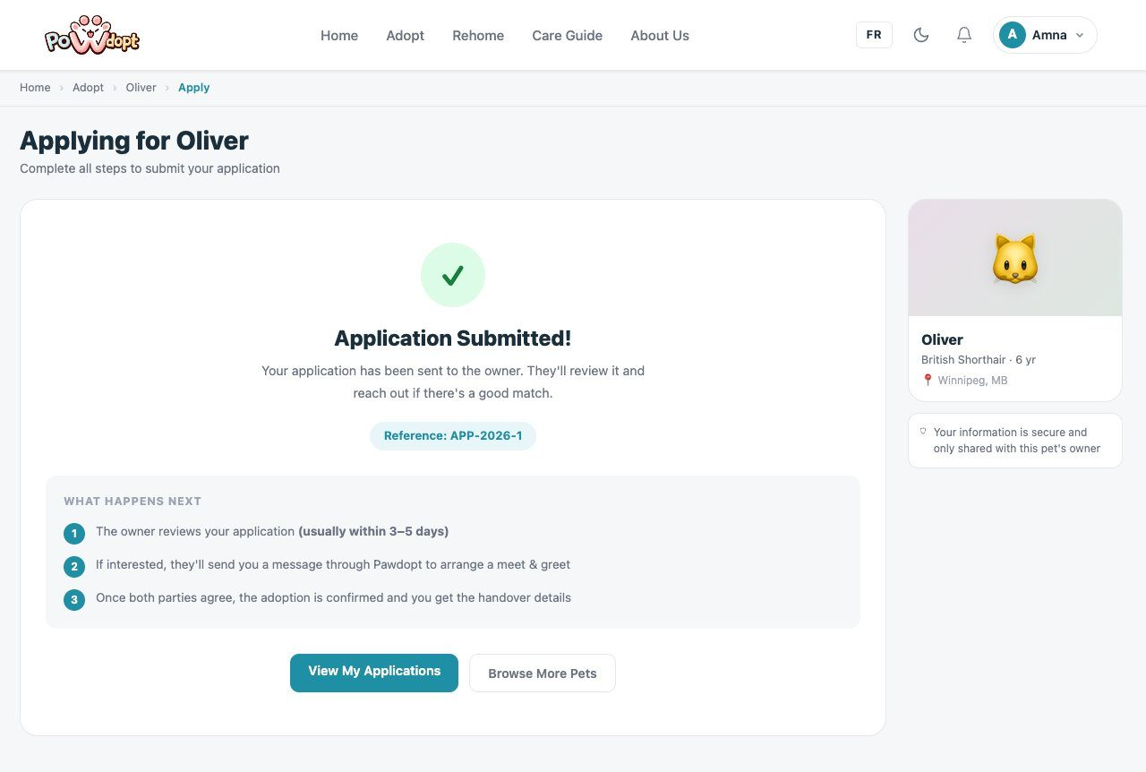
Figure 5.8 — Success message (Adopt side): the “Application Submitted!” confirmation with reference number APP-2026-1. The application enters the Submitted state from the Lab 4 state transition diagram, and the “what happens next” steps set expectations for the owner-review stage (US-4).
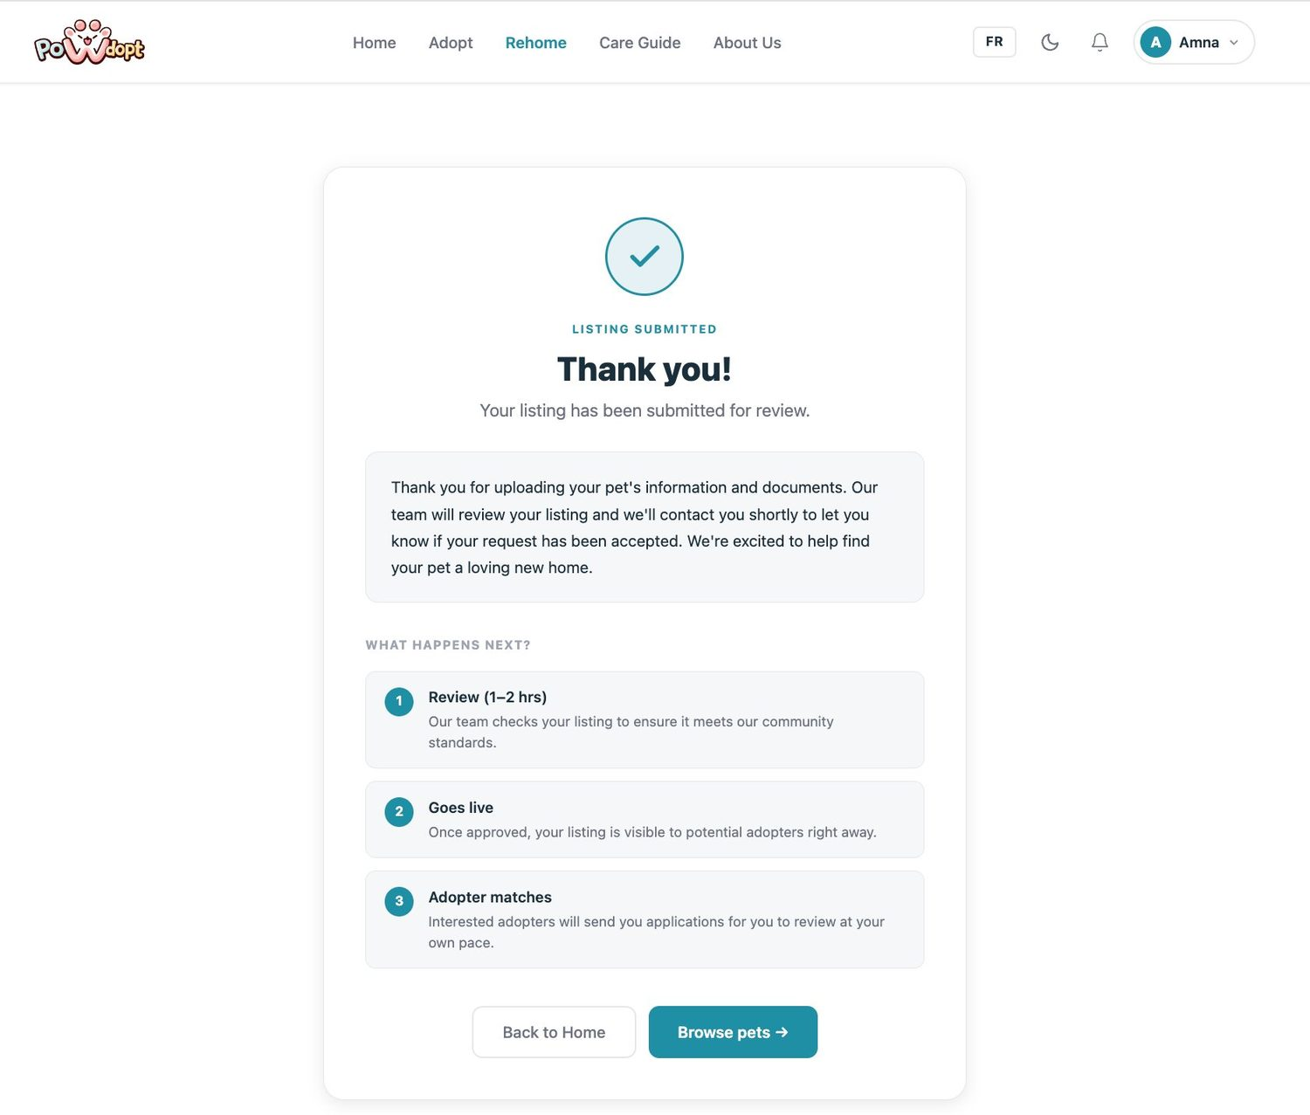
Figure 5.9 — Success message (Rehome side): the “Thank you!” confirmation rendered by the Success view that the Publish action redirects to (Section 4). The three follow-up steps — review, goes live, adopter matches — communicate the FR-6 admin approval gate to the Rehomer.

Observations made during testing
- The emoji placeholders used in the wireframes communicated layout well but undermined trust; testers expected to see the actual animal before clicking More Info.
- The original “Pawdopt” text logo was visually flat against the teal navigation bar and did not read as a brand.
- The eight-step rehome wizard from the wireframes felt long; testers lost momentum around the middle steps.
- Filter changes on the Adopt page needed visible confirmation that something had happened.

Improvements performed after testing
- Rebranded to the PoWdopt paw logo and replaced every emoji placeholder with real pet photography across the landing, Adopt, and detail pages.
- Consolidated the rehome wizard into a streamlined five-step flow (Pet info, Photos, Character, Location, Confirm) with a progress bar added to the page header, while keeping the document upload requirement (FR-5) intact before submission.
- Added a live result counter and removable filter state to the Adopt page so every filter action produces immediate visible feedback, plus a favourites heart on each card persisting to the Adopter's saved list.
- Added required-field markers (red asterisks) and contextual reassurance (“Your information is secure and only shared with this pet's owner”) to the adoption wizard after testers hesitated at the personal-information step.

Items still requiring improvement later
- Real photo upload preview thumbnails in the rehome wizard Step 2 (currently the files upload without an in-form preview).
- Server-side ModelState validation messages rendered inline next to each field, replacing the current minimal feedback on invalid posts.
- The admin approval dashboard (wireframed) is not yet connected to the live notification records created by NotifyAdmins.
- And more like activating messaging and email verivication ..etc

6. Deliverable I Notes
- User stories already visible in the prototype: US-1 (guest browsing and filtering on the Adopt page), US-2/US-3 (registration, email verification, and role-based login shown by the logged-in navigation state), US-4 (the five-step adoption application wizard with status tracking), and US-8 (the rehome listing wizard with the FR-5 document requirement).
- Elements that currently work in the interface: full landing page with bilingual toggle and dark mode, Adopt page filtering/search/sort with live result counts and favourites, pet detail pages with owner messaging panel, the adoption application wizard, the rehome wizard saving a Draft listing step by step through Entity Framework Core, and the publish flow that sets the listing to Pending and notifies administrators (FR-6).
- Parts that remain only partially complete: the admin review dashboard is wireframed but not wired to the live data; photo previews and inline server-side validation messages are pending; messaging is interface-complete but not yet persisted end-to-end.
- Improvements planned before or during Deliverable I: connect the admin approval queue to the Notifications and Documents tables, add inline validation feedback on every wizard step, and seed the database so the demo shows realistic volumes.
- First item to be demonstrated if the prototype is presented in class: the complete adoption journey — landing page, filter on the Adopt page, open a pet detail, submit an application, followed by the Rehomer side accepting it, because this single path touches both team members' work and four user stories in under three minutes.

What can be shown in Deliverable I
- Working landing page (shared) with bilingual toggle, dark mode, and role-aware navigation
- Working Adopt listings page with live filtering, search, sorting, and favourites
- Working pet detail page with the Apply to Adopt and Message Owner actions
- Working five-step adoption application wizard (US-4)
- Working rehome listing wizard with draft saving and the FR-5 document requirement
- Validation behaviour (required fields, authorization guards) and the Success confirmation page
- Navigation between all screens through controller redirects
- Wireframe-to-implementation screenshots for the report

